RISD U-Grad Mission (design is …)

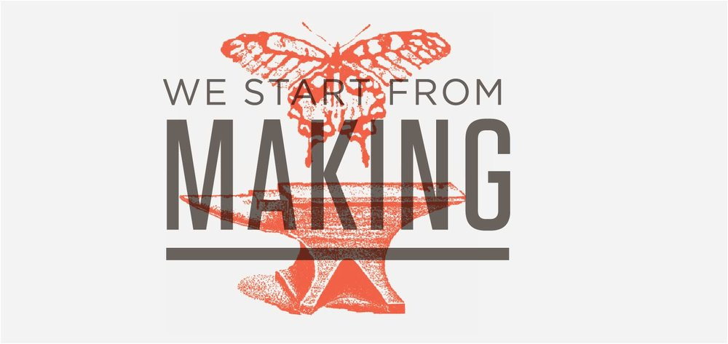

Design is an organized form of creativity!

An idea is not a design. Designs are developed out of ideas through an iterative process in which designers assess options, take controlled risks, work to validate concepts, and react to what is emerging.

Finding inspiration

Inspiration can come from many sources - from pure ideation, exposure to materials, understanding the needs of others, emerging technologies, and strange connections. Throughout the sophomore year, you will be charged wit seeking design inspiration from different sources. Over time, you will see how those different inspirations yield different outcomes
Maintaining flow

Developing a design is hard work. The design process is rarely straightforward - ideas can run aground, insights lead us in unexpected directions, and refining demands great effort. Working with instructors and classmates, you will be exposed to a wide variety of methods for getting started, for refining insights, and for overcoming obstacles. You will develop methods to maintain your enthusiasm and determination.
Managing process

It takes a special discipline to get things done. Every course in the sophomore year offers assignments and techniques to help you order your operations, manage your time, set benchmarks, and meet deadlines.

Design is a team sport

To create new products, services, platforms, or visions, designers must work with experts and rely on teams of fabricators, marketers, and engineers to bring those new ideas to the public.

communication

good designs ask and answer a question. as a student, you will learn to describe the research process that you used to identify and answer those questions and to describe your design development process.
collaboration

teamwork is difficult but crucial. in the spring semester, you will learn how to divide your labor, how to build on each other's work, and how to manage your relationships.
reputation

to be successful in industrial design you must behave professionally and treat others with integrity and respect. in our department, you begin building your professional reputation the first day you enter the building.

Design is a mixed media practice

Every designed artifact aspires to do many things at once - to appeal to the eye; be understandable; to be economically assembled; to speak to the moment in which it is conceived; to be timeless. For designers to be able to develop artifacts that achieve these ambitions, they must be adept at drawing, modeling, making, and moving fluidly across these media.

Drawing

Designers draw accurately, geometrically, imaginatively, and organically. you will use drawing to explore and to communicate your ideas, intentions, and instructions so that others can help realize your projects. the design principles studios, especially in the fall, will change the way you draw.
modeling

control models, mock-ups, works-like models, appearance models, and assembly models are just some of the models we use to explore and communicate form, function, mechanisms, and fabrication. throughout the sophomore year, you will be exposed to ways that modeling plays a role in every step of the design process.
Making

through working with real materials and building functional prototypes, designers learn to develop ideas with precision and control, and to craft objects with rigor and integrity. you will practice these ways of working in wood and
metal.
Design is a public endeavor

We do not design for ourselves. Through articats, services, and platforms designers seek to solve problems and create new value - in people's lives, communities, and for organizations. To accomplish this demands that we look outside of ourselves for design inspiration and to validate our ideas. Research is an essential component in creating things that are useful for others.

market research

as service professionals, designers must be able to link their design decisions to market opportunities - whether or not those opportunities are profit driven. in the sophomore year, you are introduced to market and marketing analysis

User research

through user research and human-centered design, you will learn the importance of anchoring your design decisions in real human needs and insights. in design principles you will be introduced to some of the modes of user research.

