**Printer Anatomy Quiz** Name:________________________________

Match feature name to number on image

|  |  |  |
| --- | --- | --- |
|  | **FEATURE:** | **Number** |
| 1 | Einsy Rambo Board (brain: poorly marked) |  |
| 2 | Extruder Stepper |  |
| 3 | Filament Spool |  |
| 4 | Heat Bed |  |
| 5 | LCD Knob |  |
| 6 | LCD Panel |  |
| 7 | Power Supply |  |
| 8 | Printer Frame |  |
| 9 | Reset Button |  |
| 10 | SD Card Slot |  |
| 11 | Spool Holder |  |
| 12 | USB Port (brain tap: poorly marked) |  |
| 13 | X-Axis |  |
| 14 | X-Axis stepper |  |
| 15 | Y-Axis |  |
| 16 | Z-Axis Stepper (there are 2) |  |
| 17 | Z-Axis |  |
| 18 | Z-Axis Threaded Drive Rod |  |
|  |  |  |

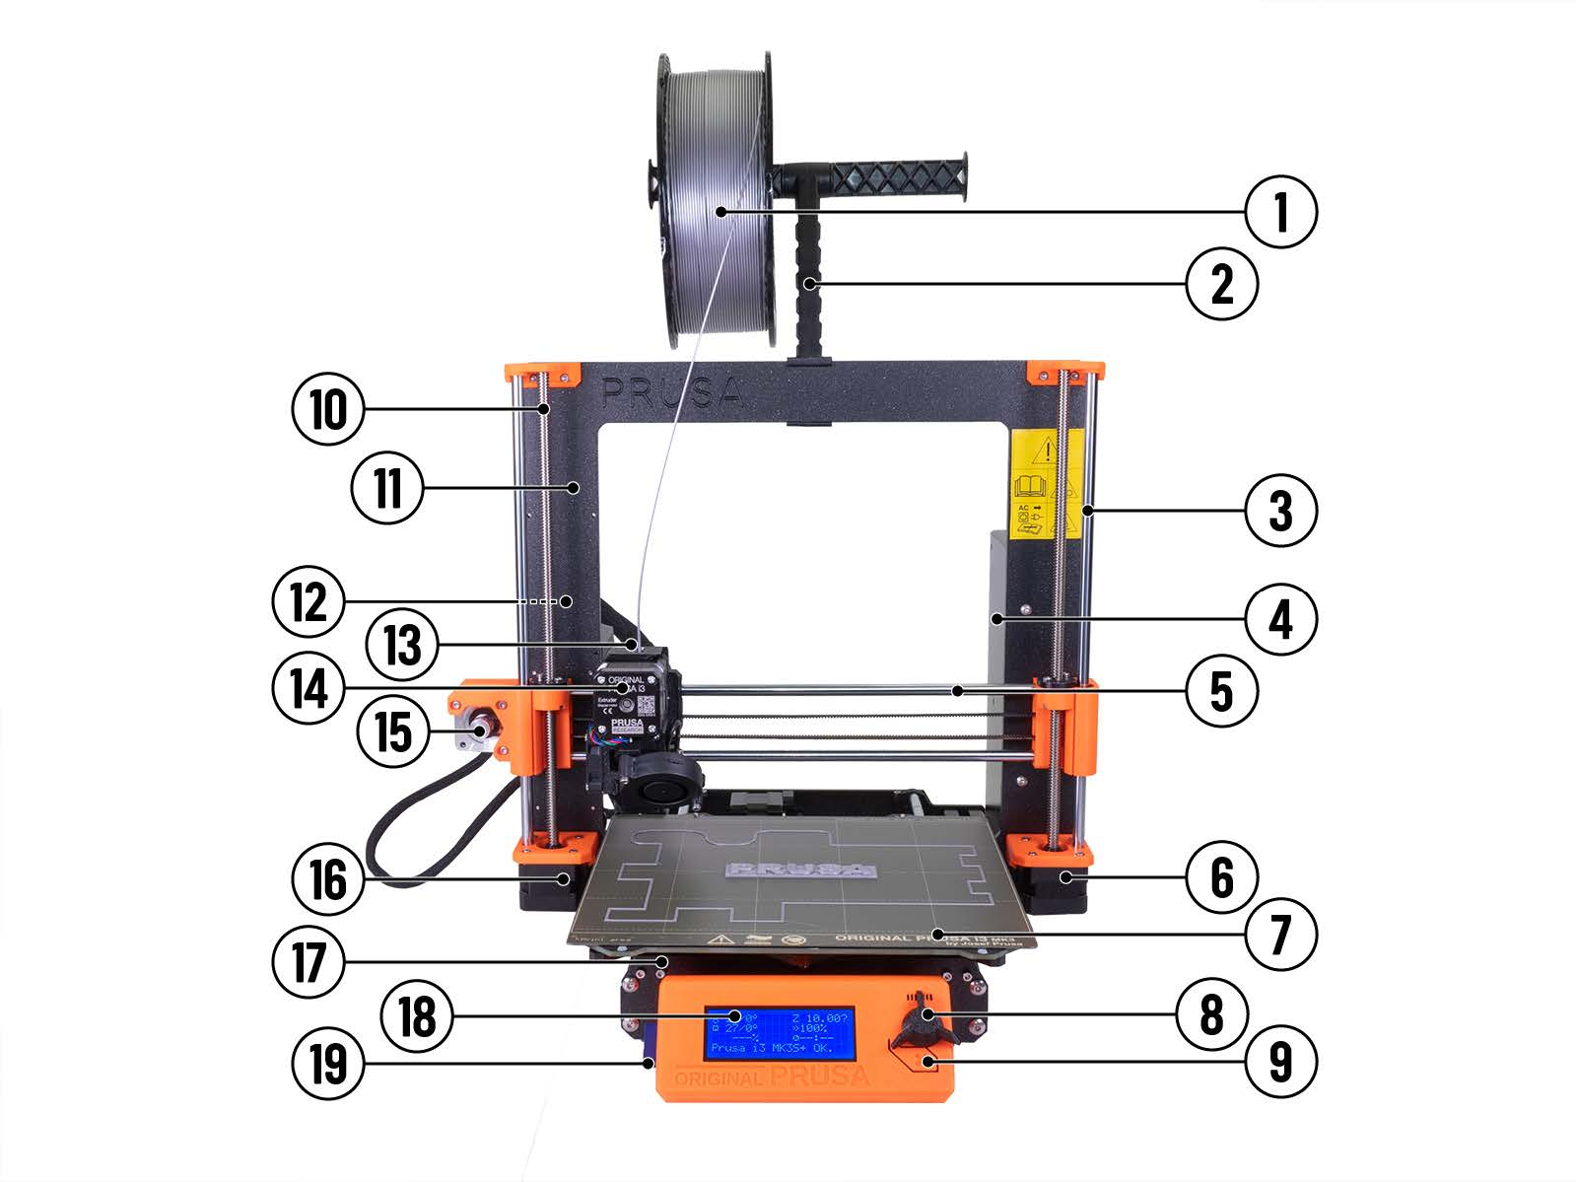

Extruder Head Anatomy:

|  |  |  |
| --- | --- | --- |
|  | **FEATURE:** | **Letter** |
| 1 | Cold End |  |
| 2 | Cooling Fan |  |
| 3 | Heat Break |  |
| 4 | Heater Cartridge Mount |  |
| 5 | Heat Sink |  |
| 6 | Heater Block |  |
| 7 | Hot End |  |
| 8 | Nozzle |  |
| 9 | PTFE (Teflon) liner |  |
| 10 | Thermister (sensor) rough location |  |
|  |  |  |

