Is this GitHub Project Maintained? Measuring the Level of Maintenance Activity of Open-Source Projects

Anything useful for our work?

Khondhu et al. [23] use an one-year inactivity threshold to classify dormant projects on SourceForge. -> but arbitrary

in our view, unmaintained projects do notnecessarily need to be dead, deprecated, or archived

we proposed a machine learning model to identify unmain-tained GitHub projects, using as features standard metrics provided by GitHub, e.g., number ofcommits, forks, issues, and pull requests. Then, we validated the proposed model with the principaldevelopers of 129 projects, achieving a precision of 80%

The goal is to investi-gate the survival probability over time of the projects classified as unmaintained by the proposedmachine learning model. Moreover, we analyze the survival probability of these projects underdifferent perspectives (e.g., organizational or individual account, programming language, and appli-cation domain).

In our dataset, active projectsare composed by 74% of organizational projects and 26% of user projects. By contrast, unmain-tained projects consists of 37% and 63% of organizational and user projects, respectively

In total, weconsider 13 features, as described in Table 1. The feature values are collected using GitHub’s officialAPI.

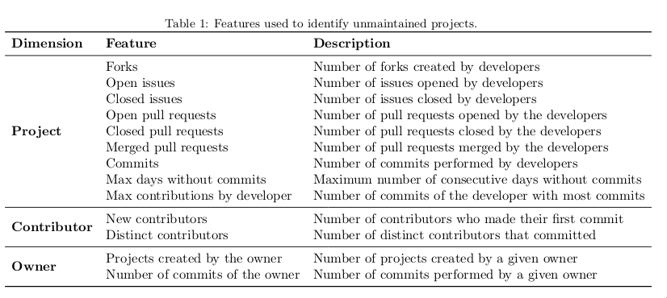

Best results(in bold) when the features are collected during 2 years, in intervals of 3 months.

Table 6 showsthe top-5 most important feature

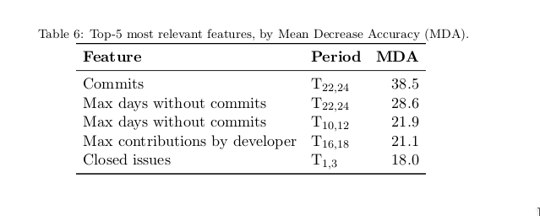

First, we build a script to download the README (the main page of GitHub’sprojects) and search for a list of sentences that are commonly used to declare the unmaintained stateof GitHub projects.

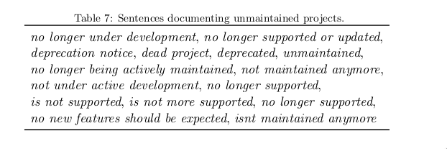

We implemented a Chrome extension calledisMaintainedto indicate whether a GitHub projectis actively maintained or not. This extension is publicly available at the Chrome Store.12It onlyinstalls a small icon on the right side of a repository’s page. The projects classified asunmaintainedhave a red icon.

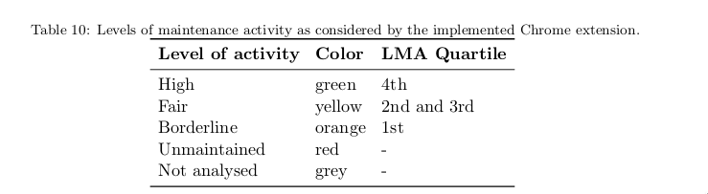

Thisextension is publicly available at:https:// chrome.google.com/ webstore/ search/ ismaintained