**Department Guide for MEASURE**

Faculty of Engineering, McMaster University

July 30, 2021

**by**

Evan Situ, Michelle Zheng, Spencer Smith, Andrew Aran

**Modification Log**

|  |  |  |  |
| --- | --- | --- | --- |
| **Version** | **Modification Date** | **Author** | **Comments** |
| 3.01 | July 30, 2021 | Andrew Aran | * Updated curriculum mapping process * Updated instructions for accessing Annual & YoY Attribute reports * Moved Updating Courses & Program Maps to Admin Guide * Moved Updating Measured Indicators to Admin Guide |
| 3.00 | January 9, 2020 | Andrew Aran | * Initial Draft |

Click here to view previous modification log.

Table of Contents

Introduction 5

Prerequisites 6

Windows 6

System Requirements 6

About the Vena Add-In 6

Installing Vena Add-In for Windows Users 6

Enabling Trust Access to the VBA Project Object Model 7

Other Operating Systems 9

Instructions to Access a Virtual Machine: 9

Questions/Comments/Technical Support: 9

Annual Timeline 10

Accessing Vena 13

Changing Vena Password 13

Department Input 14

Measured Indicators Input 14

Viewing the Measured Indicators Template 14

Curriculum Mapping Input 15

Curriculum Committee Recommendations Input 15

Vena Program Review 18

Reports 19

Accessing the Reports 19

CEAB Annual Attribute Report 20

Viewing the Annual Attribute Report 20

CEAB YoY (Year over Year) Attribute Report 21

Viewing the YoY Attribute Report 21

Rubric Entry Report 22

Faculty and Curriculum Committee Recommendations Report.xlsm 23

Attribute Map Report 24

Attribute Map Summary Report 24

Indicator Map Report 25

Historical Course Measurement Report 25

Historical Program Measurement Report 26

Course Report 27

Cascade 27

Generating a Mass Course Report 27

CourseList – Rubric Input Template 29

Updating the CourseList 29

Appendix I: Previous Modification Log 32

# Introduction

The Department Guide describes part of MEASURE (McMaster Engineering Accreditation System for UndeRgraduatE).

MEASURE’s purpose is to:

* Facilitate the continual improvement of the curriculum of the programs offered by the Faculty of Engineering
* Assist with generating accreditation reports for the Canadian Engineering Accreditation Board (CEAB)

MEASURE is built using corporate performance management software, (Vena) that combines Excel spreadsheets, a central database, and workflow management.

This document outlines the MEASURE tasks that take place at the departmental level. Specifically, each department will annually update the following:

* Review Course offering
* Review Mapping between courses and programs
* Review Measurement map
* Review and populate the department’s continuous improvement plan

The Vena Department Representative will be responsible for completing each task listed above.

Additional information on MEASURE can be found in the Administrator’s Guide and in the Instructor’s Guide. The latest version of all these documents, along with other resources, are available at <http://measure.mcmaster.ca>

Issue Reporting: <https://www.eng.mcmaster.ca/forms/measure-issue-tracking>

Technical Support: [measure@mcmaster.ca](mailto:measure@mcmaster.ca)

# Prerequisites

The departmental templates are currently compatible for the Windows operating system. Enhancements will be implemented in the future to enable macOS compatibility.

## Windows

### System Requirements

|  |  |  |
| --- | --- | --- |
|  | **Recommended** | **Minimum** |
| **Operating System** | Latest version of Windows 10 (64-bit) | Windows 7 (32-bit) |
| **MS Office** | Office 2016 or newer   * Click [here](https://www.mcmaster.ca/uts/licensing/msemployees.html) for instructions to download Office (via UTS) | Office 2010 |
| **.NET** | Latest version of .NET | 4.5 |
| **Browser** | Latest version of:   * Internet Explorer * Microsoft Edge * Mozilla Firefox * Google Chrome | * Internet Explorer 10+ * Microsoft Edge * Mozilla Firefox 12.0+ * Google Chrome |
| **RAM** | 16 GB | 4 GB |
| **CPU** | 2+ Cores | -- |
| **Reference:** | <https://support.venasolutions.com/hc/en-us/articles/115000622006-Vena-Add-In-System-Requirements> | |

### About the Vena Add-In

Vena uses both Microsoft Excel and the Vena website (<https://vena.io>) to give users access to the various templates and accreditation reports. Before users can update their course data in Excel, they will need to install the Vena Add-In for Microsoft Excel. This Add-In provides functionality to Excel that allows users to view, edit, and save their rubric data to the Vena cloud.

### Installing Vena Add-In for Windows Users

1. Visit the add-in website <http://addin.vena.io/release/vena.application>
2. Save the **vena.application** file
3. Double-click the **vena.application** file



1. Run the installer. The following dialog box will appear:

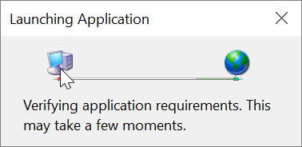

1. When the application has loaded, press **Install**

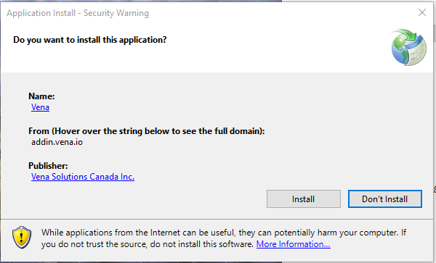

1. When the installation has completed, the following dialog box will appear. **Close** this dialog box to complete the installation.

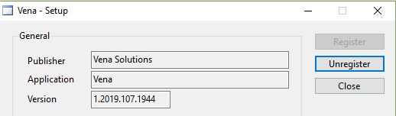

1. To ensure Vena has successfully installed, open Microsoft Excel, and confirm the Vena tab has been added.

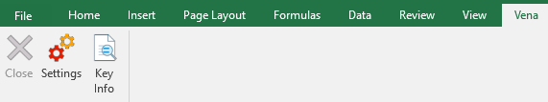

### Enabling Trust Access to the VBA Project Object Model

After installing the Excel Vena Add-in, access to the VBA project object model will need to be trusted for Vena to run properly.

1. Open **Excel**
2. Select a **Blank Workbook**
3. Select **File**

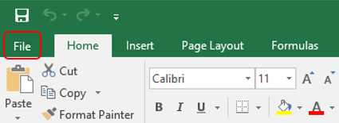

1. On the bottom of the left menu, select **Options**

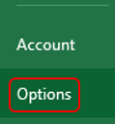

1. Select **Trust Center**
   1. Select **Trust Center Settings**

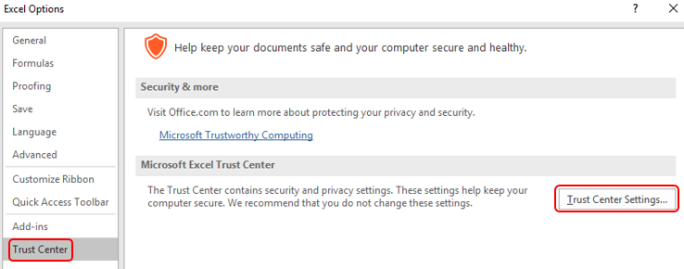

1. Select **Marco Settings**
2. Ensure that **Disable all macros with notification** is selected
3. Check the box next to **Trust access to the VBA project object model**

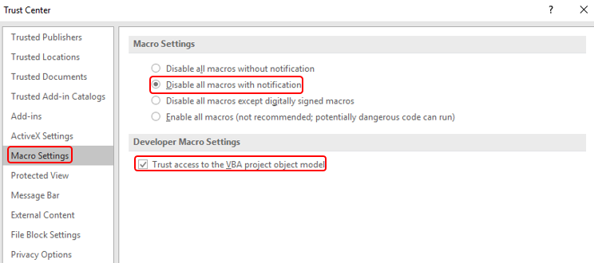

1. Close all instances of Excel for the settings to take effect.

## Other Operating Systems

The Vena Departmental Templates are currently compatible for Windows users with Microsoft Office. Users who do not have a compatible operating system and/or Microsoft Office will need to access Vena using a virtual machine.

### Instructions to Access a Virtual Machine:

<https://www.eng.mcmaster.ca/sites/default/files/vminstruct.pdf>

### Questions/Comments/Technical Support:

[measure@mcmaster.ca](mailto:measure@mcmaster.ca)

# Annual Timeline

The table below summarizes the typical tasks performed during the course of an academic year.

Department Representative responsibilities are highlighted in **green**.

The timeline table shows an entry for adding courses, but no time slot for deleting courses that are no longer offered. This is because courses are not deleted, since deleting them will remove all the historical data associated with the course. Courses can be removed from a specific program but should not be removed from the Vena database. Courses that are no longer offered should be moved to unmapped, as described in the appropriate section below.

|  |  |  |  |  |
| --- | --- | --- | --- | --- |
| **Date** | **Task Description** | **Section** | **Template** | **Task Owner** |
| January | * Instructor enters rubric and continuous improvement plan for Term 1 | Instructor Guide | Rubric Input Template | Instructor |
| January | * Instructor reviews the continuous improvement plan from the previous year for Term 1 | Instructor Guide | Rubric Input Template and Curriculum Committee Recommendations Report (Prev. Year) | Instructor |
| January | * Review current rubric entry status * Contact instructors who have yet to complete their Vena rubric entry | Click here | Rubric Entry Report | Department |
| April | * Update global variable and point to Term 2 (after Term 1 data entry is complete) | Admin Guide | See Administrator’s Guide | Associate Dean’s Office |
| May | * Instructor enters rubric and continuous improvement plan for Term 2 | Instructor Guide | Rubric Input Template | Instructor |
| May | * Instructor reviews continuous improvement plan from the previous year for Term 2 | Instructor Guide | Rubric Input Template and Curriculum Committee Recommendations Report (Prev. Year) | Instructor |
| May | * Review current rubric entry status * Contact instructors who have yet to complete their Vena rubric entry | Click here | Rubric Entry Report | Department |
| May | * Curriculum committees review (this year) course reports and continuous improvement plan reports | Click here  [Click here](https://www.eng.mcmaster.ca/resources#measure) | Course Report and  Rubric Input Template (Instructor Guide) | Department |
| August | * Archive previous year * Start New Academic Year * Update global variable and point to Term 1 (after Term 2 data entry is complete) | Admin Guide | See Administrator’s Guide | Associate Dean’s Office |
| August | * Review Measurement Mapping | Click here | Measured Indicators Input Template | Department |
| August | * Update Curriculum Mapping   + Consult with Instructors | Click here | External Spreadsheet  **Now handled outside of Vena** | Department |
| August | * Update Curriculum Recommendations | Click here | Curriculum Committee Recommendations Input Template | Department |
| August | * Review Programs in Vena * Notify Associate Dean’s Office if changes are needed | Click here | Login Vena🡪 Modeler🡪 Members🡪 Program | Department |
| August | * Add/Update/Un-map courses in the Vena Database * **Do not delete Courses** | Click here | Login Vena🡪 Modeler🡪 Members🡪 Program | Department |
| September | * Faculty reviews departmental committee reports from prior year * Prepare/review Graduate Attribute Report | Admin Guide | See Administrator’s Guide | Associate Dean’s Office |
| December | * Execute Backup and Restore Process | Admin Guide | See Administrator’s Guide | Associate Dean’s Office |

Throughout the year, the departmental representatives can review reports generated by MEASURE. These reports will be useful for filling out the CEAB questionnaire in accreditation years.

The reports include the following:

* CEAB Annual Attribute Report
* CEAB YoY Attribute Report
* Rubric Entry Report
* Faculty and Curriculum Committee Recommendations Report
* Attribute Map Report
* Attribute Map Summary Report
* Indicator Map Report
* Course Report (for any course)

Using MEASURE, it is also possible to view the historical data through:

* Historical Course Measurement Report
* Historical Program Measurement Report

# Accessing Vena

1. Open a web browser
2. Visit <https://vena.io>
3. In the email textbox, enter your McMaster email address (i.e. [macid@mcmaster.ca](mailto:macid@mcmaster.ca))
4. Your password has been previously communicated. If you do not remember, or do not have an account, please contact Measure Support ([measure@mcmcaster.ca](mailto:measure@mcmcaster.ca))

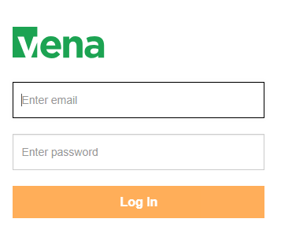

# Changing Vena Password

Your password can be changed by clicking the user’s name in the upper right corner of the screen and then selecting “Change Password”.

You will be prompted to enter the current and new password.

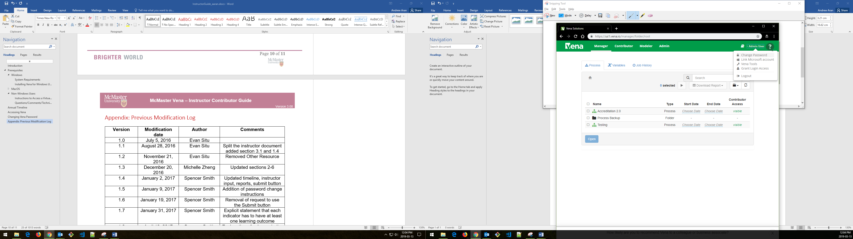

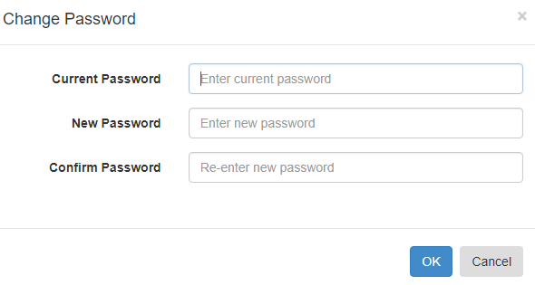

# Department Input

Each department needs to update its measurement map (subsection 1 below) and a curriculum map (subsection 2 below). The measurement map for each year identifies what needs to be measured for that year. The curriculum map summarizes where the indicators are offered, and at what level, in each program.

Although it might appear that information is duplicated between the two templates, this is not actually the case. Not all indicators are measured, and not every measured indicator is part of the curriculum map. This second case occurs when a course does not explicitly teach an indicator, but it is measured. This might happen in a capstone course, for instance, where a presentation related indicator is measured, even though this indicator is not explicitly taught in the course.

## Measured Indicators Input

**As of the 2020-2021 year, the measurement mapping is now updated by the Administrator.**

The Measured Indicators template can still be accessed in READ-ONLY.

For measurement mapping changes, contact [measure@mcmaster.ca](mailto:measure@mcmaster.ca).

**Note for the Administrator**: Before removing a measured indicator from a course, be sure to FIRST delete ALL the line items pertaining to the indicator in the Rubric Input Template. For the current year, you’ll need to check all sections (1-10) for each term (1-3) and ensure there is no rubric data pertaining to the indicator.

For more information, review the Administrator Guide.

### Viewing the Measured Indicators Template

1. Under Contributor view, select your department’s **Measured Indicators** task

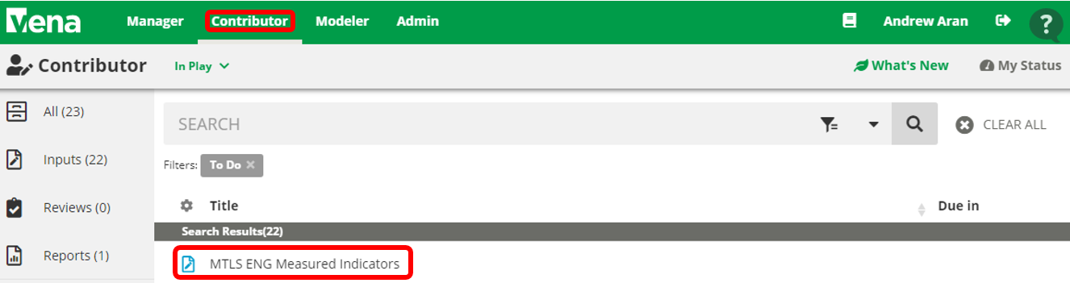

1. Select **View** beside the **Measured Indicators Input Template.xlsm**



1. A pop-up will appear to save the template. Click **save** and remember the saved location of the template.
2. Open the Excel File
   1. If prompted, press **Enable Editing** in the Excel spreadsheet



* 1. If prompted, press **Enable Content** to allow Macros



1. Select the Program, Year, and press OK

**\*\*\*The measured indicators map should only be updated for the current year\*\*\***

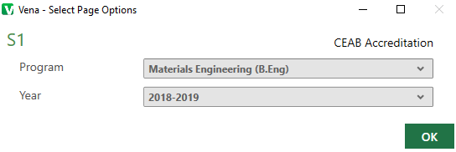

1. Updating the Measurement Map

**For measurement mapping changes, contact** [**measure@mcmaster.ca**](mailto:measure@mcmaster.ca)**.**

Note: When an **M** is placed between an indicator and course, the indicator will be available in the Rubric Input Template and enable users to enter learning outcomes (rows) for that indicator. To learn more about the Rubric Input Template, please review the Instructor Guide.

|  |  |
| --- | --- |
| **Example:** Measured Indicators Template updated to display the indicator in the Rubric Input Template | |
| **Measured Indicators Template** |  |
| **Rubric Input Template** |  |

## Curriculum Mapping Input

The curriculum map is a summary of how our program maps to the CEAB attributes (and our indicators).

**As of 2020-2021, the curriculum mapping is now handled outside of Vena.**

For curriculum mapping inquiries, please contact the Graduate Attribute Committee.

## Curriculum Committee Recommendations Input

At the end of the academic year, the Curriculum Committee will provide recommendations for the upcoming year regarding their programs and courses.

Example: At the end of 2018-2019 year, users will enter recommendations in 2018-2019 and to be reviewed during the 2019-2020 year.

The recommendations can be entered into the Curriculum Committee Recommendations Template.

1. Under Contributor view, select your department’s **Curriculum Committee Recommendations** task

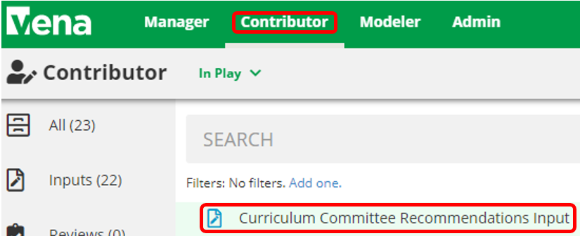

1. Select **Check Out** beside the **Curriculum Committee Recommendations Input Template.xlsm**

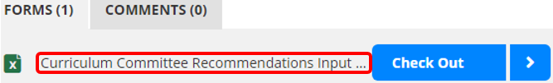

1. A pop-up will appear to save the template. Click **save** and remember the saved location of the template.
2. Open the Excel File
   1. If prompted, press **Enable Editing** in the Excel spreadsheet



* 1. If prompted, press **Enable Content** to allow Macros



1. Select the Program and Year

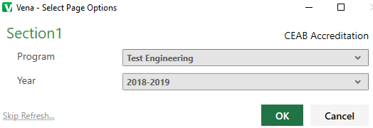

1. Recommendations Input
   1. Users can enter their program and course recommendations

OR

* 1. If they prefer to attach a file, they can do so by:
     1. Select a cell
     2. Click **Comments**
     3. In the **Comments** section, click **Details** Tab
     4. Click the **Add** **Comment** button
     5. Click the **paper clip** and attach your file
     6. Click **Upload** when asked to upload the file as a comment
     7. Include text in the selected cell such as ‘**See attached file**’ to notify users the template contains attachments

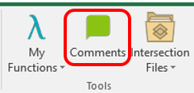

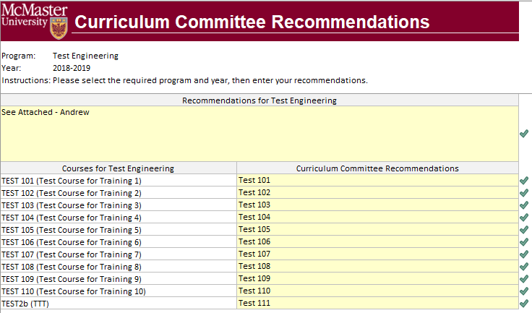

1. When the recommendations have been updated, click **Save Data** under the **Vena Tab**

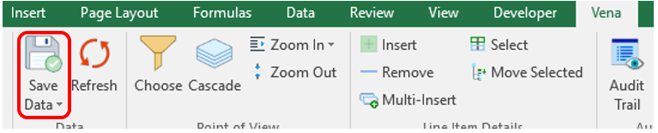

1. Closing and Checking in the Template
   1. When closing the template, you will be prompted to **Check-in**
   2. Select **Yes**

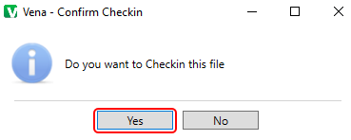

# Vena Program Review

Prior to the start of the academic year, Department Representatives will need to review their programs in Vena to ensure the courses are correctly mapped.

Please consult with the Associate Dean’s Office, your department, and MEASURE Support ([measure@mcmaster.ca](mailto:measure@mcmaster.ca)) before requesting any changes to a course or program in Vena.

If you do not see the Modeler tab, contact MEASURE Support ([measure@mcmaster.ca](mailto:measure@mcmaster.ca)).

1. Under the Modeler View, select **Data Modeler** 🡪 **Members** 🡪 **Programs**

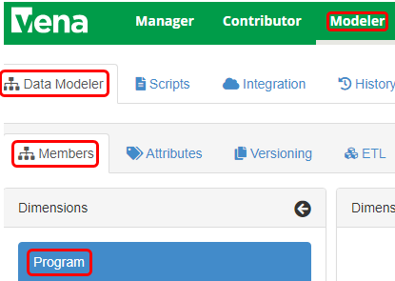

1. Expand **Program**



1. Expand the program that will be reviewed



1. Expand each level to review the courses

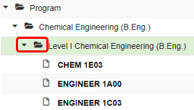

# Reports

The data in the MEASURE database is viewed using spreadsheet reports. The purpose of the reports is to transform the information into a form that is suitable for review – including by the CEAB when necessary. Reports can be viewed for any year where the data has been entered.

The Vena Reports are best viewed using a Windows-based operating system.

## Accessing the Reports

1. Ensure the Contributor tab is selected

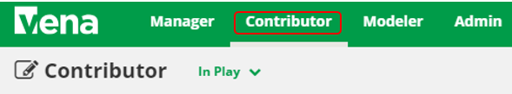

1. On the left side, click **Reports** (the centre section will reload to only display Reports)

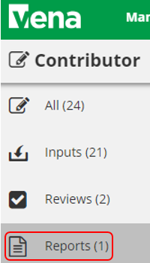

1. Click **Reports**

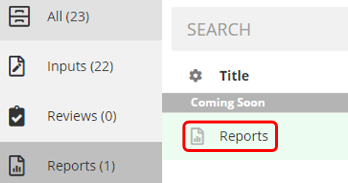

## CEAB Annual Attribute Report

This multi-page report provides a detailed snapshot of how the program is progressing for the current year. It includes an overall program summary and a separate report for each Graduate Attribute at the course level.

The report is built off a calculated average with a set order of operations, rather than directly based on the average of total students per outcome. At each level, the total is aggregated. For example, at the Section level, all sections are aggregated together, and from there, all terms are aggregated together to get a Yearly Average for all Sections per Course.

The order of operations for the calculation is:

1. LID’s (Learning Outcome)
2. Indicator
3. Attribute
4. Section
5. Year
6. Program

### Viewing the Annual Attribute Report

1. Select **View** next to **CEAB Annual Attribute Report.xlsm**
2. **Save** and **open** the Excel file
   1. If prompted, **Enable Content** and **Enable Macros**
3. Select the **Program** and press **OK**

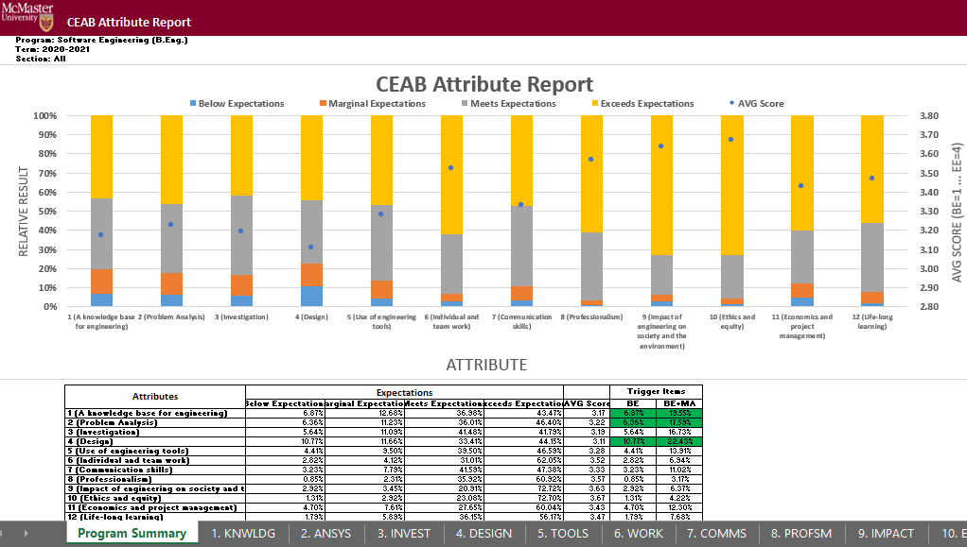

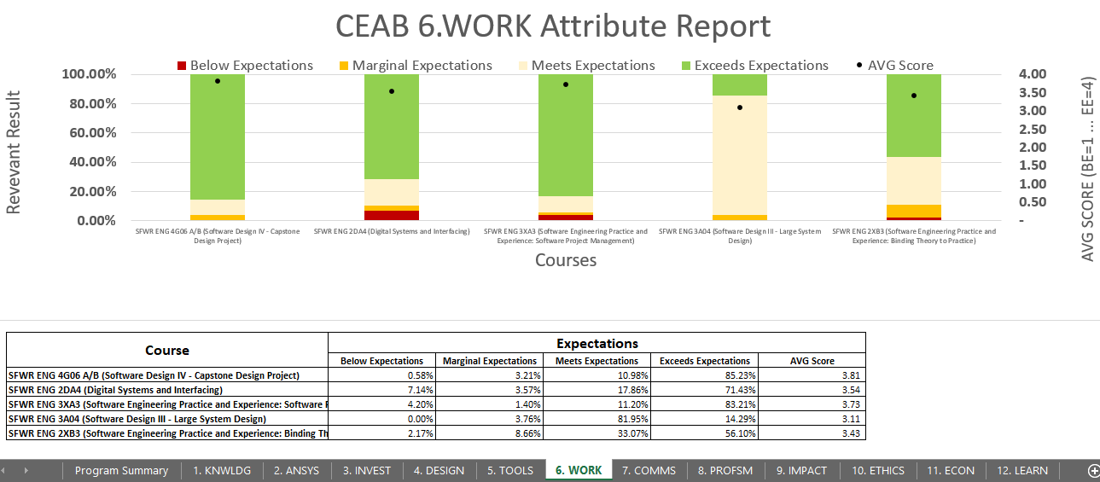

## CEAB YoY (Year over Year) Attribute Report

This report provides a look into the Average Score per Attribute, at a Program level, comparing it year over year. The Choose option that pops up allows you to choose the ending year that you’d like to view.

Prior to 2020-2021, the previous average scores were calculated based on the archived data of the # of students in each attribute/outcome. Starting in 2020-2021, the calculation is calculated on the new average process, as detailed in the CEAB Attribute Report section above.

The data for the current year, or most recent year is not automatically calculated. This YoY report uses archived data as it’s source. As a result, the archiving process must be executed to see the current year data. Note that this means the entire process must be completed, and the data from step 7a of the Vena Template Automation Average ETL must be executed. This is imperative to the process.

Please refer to the One Time Fix – ETL section of the CEAB Attribute Report.

### Viewing the YoY Attribute Report

1. Select **View** next to **CEAB YoY Attribute Report.xlsm**
2. **Save** and **open** the Excel file
   1. If prompted, **Enable Content** and **Enable Macros**
3. Select the **Program**, latest **Year**, and press **OK**

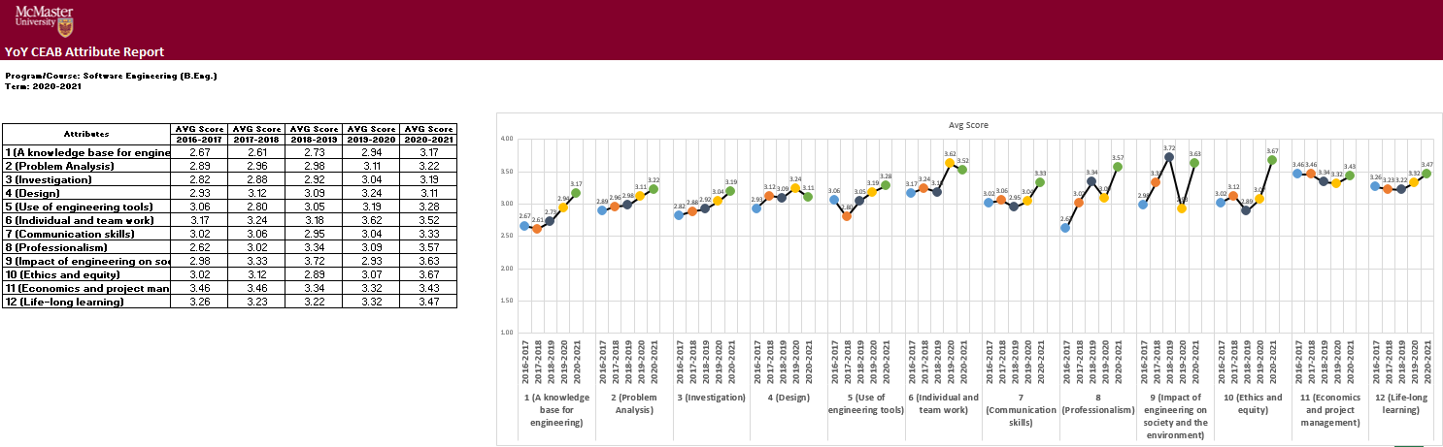

## Rubric Entry Report

The Rubric Entry Report monitors the progress of the rubric input. The report lists all the courses from a selected program. The report will display:

|  |  |
| --- | --- |
| **Column Name** | **Description** |
| Course | * Course name |
| Status | * Displays the current status of the rubric input   + Options: BLANK, Not Started, WIP, Fully Complete |
| Measure Required? | * **If Yes**: At least (1) graduate attribute for a course is being measured for the year * **If No**: The course does not have any graduate attributes measured for the year |
| Instructor Name | * Name of instructor teaching the course |
| Rubric Updated By | * The last user to update the rubric input template for the course |
| Last Rubric Save Time | * The last time the rubric input template was saved |

1. Press **View** next to CEAB Attribute Report
2. Select a Program, Term, and Section
3. **Download** and remember the saved location of the report
4. If prompted, **Enable Content** and **Enable Macros**

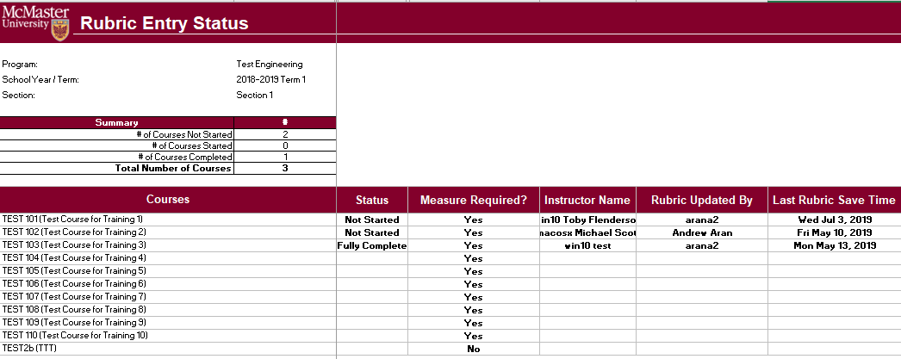

## Faculty and Curriculum Committee Recommendations Report.xlsm

Displays the recommendations from the curriculum committee at both course and program level. This report can be viewed for any year where data is available. The data comes from the feedback provided in the Curriculum Committee Recommendations Input Template.

1. Press **View** next to Faculty and Curriculum Committee Recommendations Report
2. Select a Course/Program and Year
3. **Download** and remember the saved location of the report
4. If prompted, **Enable Content** and **Enable Macros**

To view an attached file:

* 1. Select the cell containing an attachment

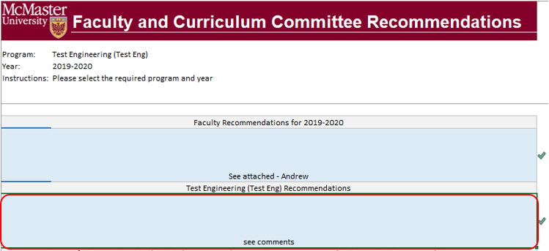

* 1. Click on **Comments** under **Vena** Tab
  2. On the right-hand side, select the attached file

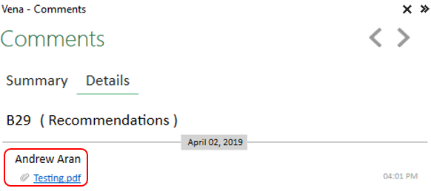

1. For macOS users, click  under Vena Comments
   1. On the right-hand side, select the attached file

## Attribute Map Report

Indicates the measure level at the attribute level. If a different indicator level appears, the highest level will appear: I(ntroduced) 🡪 D(eveloped) 🡪 A(pplied)

1. Press **View** next to Attribute Map Report
2. Select a Program and Term
3. **Download** and remember the saved location of the report
4. If prompted, **Enable Content** and **Enable Macros**

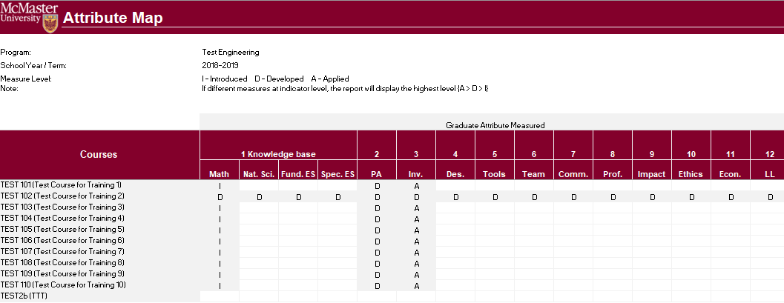

## Attribute Map Summary Report

Similar to the Attribute Map Report, instead of showing the actual level (I, D, A), the summary report will only display the “X” to indicate that the specific course is measured at the specific attribute.

1. Press **View** next to Attribute Map Summary Report
2. Select a Program and Term
3. **Download** and remember the saved location of the report
4. If prompted, **Enable Content** and **Enable Macros**

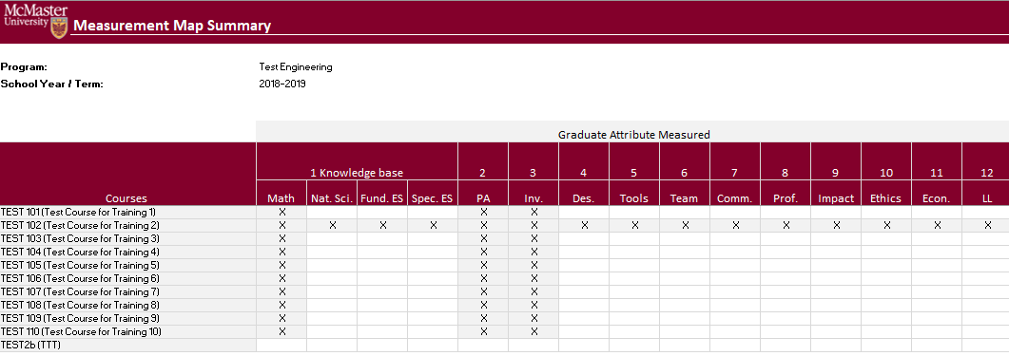

## Indicator Map Report

Indicates the measure level at the indicator level.

1. Press **View** next to Indicator Map Report
2. Select a Program and Term
3. **Download** and remember the saved location of the report
4. If prompted, **Enable Content** and **Enable Macros**

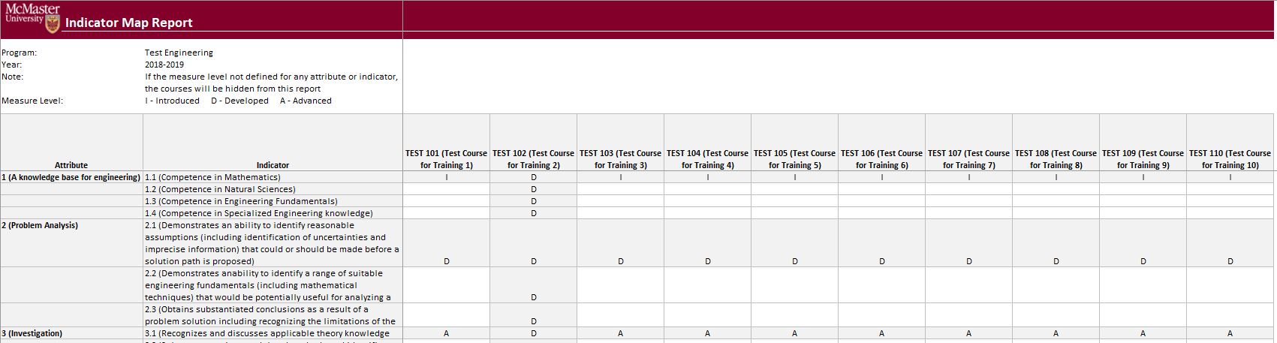

## Historical Course Measurement Report

Shows the historical trend for each course at different levels (indicator, attribute and all).

1. Press **View** next to Historical Course Measurement Report
2. **Download** and remember the saved location of the report
3. Select a Course (and Graduate Attribute if necessary)
4. If prompted, **Enable Content** and **Enable Macros**

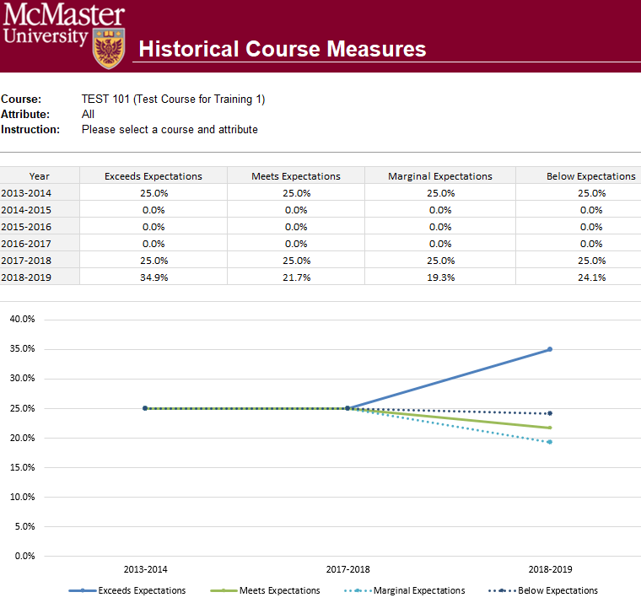

## Historical Program Measurement Report

Shows the historical trend for each program at different levels (indicator, attribute and all).

1. Press **View** next to Historical Program Measurement Report
2. **Download** and remember the saved location of the report
3. Select a Program (and Graduate Attribute if necessary)
4. If prompted, **Enable Content** and **Enable Macros**

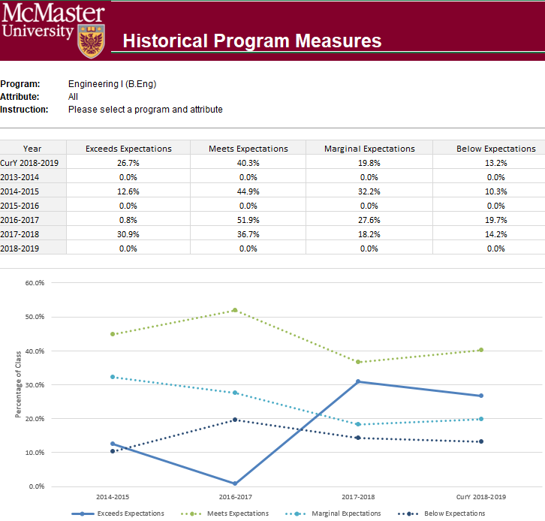

## Course Report

Displays the course outcome, recommendations from the curriculum committee, the continuous improvement plan, and charts generated from the rubric entry. Every course for which rubric data is entered will have a corresponding Course Report.

## Cascade

**\*\*\* Vena Feature currently available to Windows Users only \*\*\***

The cascade feature enables users to generate the same Vena report for multiple courses or programs. This feature eliminates the need to manually generate the same report for multiple courses.

### Generating a Mass Course Report

The steps below will show how to create

1. Select Contributor → Reports → Course Reports → **View**
2. Download and open the Course Report
   1. Click **Enable Editing** and **Edit Content** if the pop-up appears
3. Select a Course (belonging to the program), Year, Term, Section
4. Select the Vena Tab then click **Cascade**



1. For dimension, select **Program**

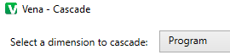

1. Select the courses belonging to the program (hold shift + click)

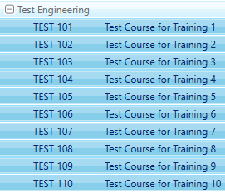

1. Change option from Cascade to Sheet to **Cascade to File**



1. Choose a location to save the files
2. Click **OK**
3. The Cascade feature will take approximately 5-10 minutes to complete

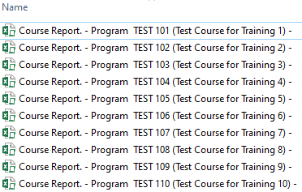

# CourseList – Rubric Input Template

When a course is updated, added, or removed, the CourseList sheet in the Rubric Input Template will need to be updated as well. The CourseList sheet is responsible for validating the course name, term, and section against the Vena database. If there is a discrepancy, the rubric input template will display an error message to the user.

## Updating the CourseList

The following steps will need to be completed as a Vena Manager. Only the Vena Manager has the capability to update the template for all users.

**\*\*\* Vena Manager mode can only be accessed by a Windows-based operating system \*\*\***

1. Under Manager view, select Home 🡪 **Accreditation 2.0**

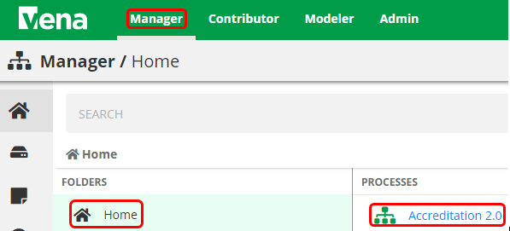

1. On the left panel, select **Files Library**

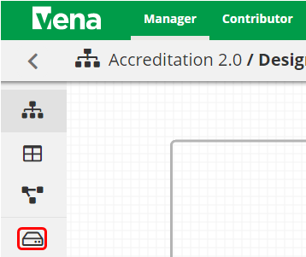

1. Select **Input Forms**

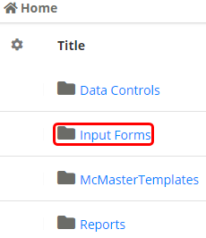

1. Updating the **Windows and macOS Rubric Input Template**

When updating the course information, both templates will need to be updated.

* 1. Select **Rubric Input Template – Windows.xlsm**



* 1. A pop-up will appear to save the template. Click **save** and remember the saved location of the template.
  2. Open the Excel File
     + If prompted, press **Enable Editing** in the Excel spreadsheet



* + - If prompted, press **Enable Content** to allow Macros



* 1. Select a Course, Year, and Section
     1. The choices selected will not matter since we will be updating the template
  2. Right-click the **Outcome_Measurement** sheet 🡪 select **Unhide** 🡪 select **CourseList** 🡪 select **OK**

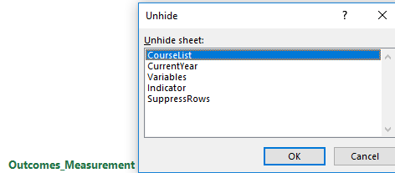

* 1. Update the **Course**; **Term**; **Section** in the spreadsheet (Columns A-C)

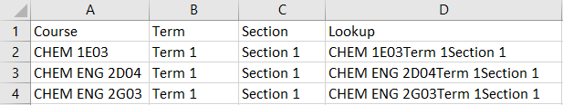

* 1. Copy the Excel formula in **Column D** down
  2. Hide the **CourseList** sheet
  3. Under the Vena tab, click **Save Template**

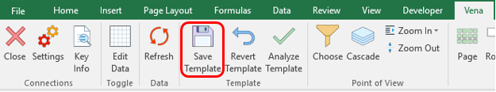

* 1. Close the **Rubric Input Template**

1. Repeat steps 1-5 for **macOS Rubric Input Template**

# Appendix I: Previous Modification Log

|  |  |  |  |
| --- | --- | --- | --- |
| **Version** | **Modification date** | **Author** | **Comments** |
| 1.0 | July 5, 2016 | Evan Situ |  |
| 1.1 | August 28, 2016 | Evan Situ | Split the instructor document |
| 1.2 | August 28, 2016 | Evan Situ | Added Section 6 and 4.1 and 1.4 |
| 1.3 | October 19, 2016 | Michelle Zheng | Edited Section 6 |
| 1.4 | October 28, 2016 | Evan Situ | Added New Section 5: Add New Course |
| 1.5 | November 8, 2016 | Michelle Zheng | Added introduction, moved sections around, general modifications based on Spencer’s notes |
| 1.6 | November 15, 2016 | Spencer Smith | Additions to introduction, clarification of timeline, editing/rearranging of sections, added title page |
| 1.7 | November 21, 2016 | Evan Situ | Added section Updating Valid Course Information |
| 1.8 | November 21, 2016 | Evan Situ | Removed Other Resource |
| 1.9 | November 29, 2016 | Michelle Zheng | Added Section 6.3 |
| 2.0 | December 16, 2016 | Spencer Smith | Update Section on Validation Rules, Added Rubric Entry Report |
| 2.1 | January 2, 2016 | Spencer Smith | Move Curriculum Committee Recommendations Report to Instructor Guide |
| 2.2 | April 29, 2019 | Andrew Aran | Added instructions to access CEAB Attribute Report and Drill Down Feature |