**Department Guide for MEASURE**

Faculty of Engineering, McMaster University

April 29, 2019

**by**

Evan Situ, Michelle Zheng, Spencer Smith, Andrew Aran

**Modification Log**

|  |  |  |  |
| --- | --- | --- | --- |
| **Version** | **Modification date** | **Author** | **Comments** |
| 1.0 | July 5, 2016 | Evan Situ |  |
| 1.1 | August 28, 2016 | Evan Situ | Split the instructor document |
| 1.2 | August 28, 2016 | Evan Situ | Added Section 6 and 4.1 and 1.4 |
| 1.3 | October 19, 2016 | Michelle Zheng | Edited Section 6 |
| 1.4 | October 28, 2016 | Evan Situ | Added New Section 5: Add New Course |
| 1.5 | November 8, 2016 | Michelle Zheng | Added introduction, moved sections around, general modifications based on Spencer’s notes |
| 1.6 | November 15, 2016 | Spencer Smith | Additions to introduction, clarification of timeline, editing/rearranging of sections, added title page |
| 1.7 | November 21, 2016 | Evan Situ | Added section Updating Valid Course Information |
| 1.8 | November 21, 2016 | Evan Situ | Removed Other Resource |
| 1.9 | November 29, 2016 | Michelle Zheng | Added Section 6.3 |
| 2.0 | December 16, 2016 | Spencer Smith | Update Section on Validation Rules, Added Rubric Entry Report |
| 2.1 | January 2, 2016 | Spencer Smith | Move Curriculum Committee Recommendations Report to Instructor Guide |
| 2.2 | April 29, 2019 | Andrew Aran | Added instructions to access CEAB Attribute Report and Drill Down Feature |

**Table of Contents**

1. Introduction 4

2. Pre-requisites 4

3. Annual Timeline 4

4. Check Out and Check In Files 6

5. Add New Course 7

6. Edit Courses and Programs Mapping 8

7. Department Input 12

8. Curriculum Committee Recommendations 15

9. Reports 17

10. Updating Valid Course Information 23

11. Rubric Entry Report 25

12. Other Vena Resources 25

# Introduction

This document describes part of MEASURE (McMaster Engineering Accreditation System for UndeRgraduatE). MEASURE’s purpose is to facilitate the continual improvement of the curriculum of the programs offered by the Faculty of Engineering. MEASURE will also assist with generating accreditation reports for the Canadian Engineering Accreditation Board (CEAB).

MEASURE is built using corporate performance management software (Vena) that combines Excel spreadsheets, a central database and workflow management.

This document outlines the MEASURE tasks that take place at the departmental level. Specifically, each department will annually update the following: which courses they offer, the mapping between courses and programs, their curriculum map, their measurement map and their continuous improvement plan. These tasks will be completed by the Vena designate in each department.

Additional information on MEASURE can be found in the Administrator’s Guide and in the Instructor’s Guide. The most up to date version of all these documents, along with other resources, are available at: <http://measure.mcmaster.ca/>

# Pre-requisites

1. Access to McMaster’s Vena server <https://vena.io/> . You will need a user account (your e-mail address) and a password.
2. Modeler role access (necessary for adding courses and changing the mapping between courses and programs)
3. Microsoft Excel (2013 or later is recommended)
4. Installed Vena Excel add-in <http://addin.vena.io/release/vena.application>
5. Windows operating system or a Windows virtual machine (virtual machine instructions for Mac user instructions are available at: <http://measure.mcmaster.ca/> )

# Annual Timeline

The table below summarizes the typical tasks performed by each department during the course of an academic year. For each task the following is listed: the time of year when it typically occurs, the section of this report where details are given, the MEASURE template (spreadsheet) that applies, and the task owner. The departments own most of the tasks listed, but for context, abridged versions of the responsibilities of the Associate Dean’s office and the instructors are included.

|  |  |  |  |  |
| --- | --- | --- | --- | --- |
| **Date** | **Task** | **Section** | **Template** | **Owner** |
| Summer | Archive previous year, Roll over to new year | Admin Guide | See Administrator’s Guide | Assoc Dean |
| Summer | Add new courses to the MEASURE database (**do not delete old courses, until moving them to unmapped!**) | 5 | Login Vena 🡪 Modeler 🡪 Members 🡪 Program | Department |
| Summer | Changes to programs (mapping b/w courses and programs) | 6 | Login Vena 🡪 Modeler 🡪 Members 🡪 Program | Department |
| Summer | Update validation data for courses, terms, sections combinations | To Add | To Add (validation data already up to date for 2016-2015) | Department |
| Summer | Curriculum mapping (requires consultation with instructors) | 7.1 | Curriculum Mapping Input Template | Department (Attributes Committee) |
| Summer | Measurement mapping | 7.2 | Measured Indicators Input Template | Department (Attributes Committee) |
| September | Faculty reviews departmental continuous improvement plan report from previous year, writes report | Admin Guide | See Administrator’s Guide | Assoc Dean |
| Dec/Jan | Instructors enter rubric and course report for Term 1 | Instruct  Guide | See Instructor’s Guide | Instructors |
| Apr/May | Instructors enter rubric and course report for Term 2 | Instruct  Guide | See Instructor’s Guide | Instructors |
| May | Curriculum committees review course reports, generate continuous improvement plan report | 8 | Course Report, Curriculum Committee Recommendations Input Template | Department |
| May/June | Department’s plan curriculum revisions | -- | -- | Department |

Throughout the year the departmental representatives can look at the reports generated by MEASURE. These reports will also be useful for filling out the CEAB questionnaire in accreditation years. The reports include the following: Curriculum Committee Recommendations Report, Attribute Map Report, Attribute Map Summary Report, Indicator Map Report and the Course Report (for any course). Using MEASURE it is also possible to view the historical data through the Historical Course Measurement Report and the Historical Program Measurement Report. All of the reports are summarized in Section 9, except for the Curriculum Committee Recommendations Report, which is given in the Instructor Guide.

The timeline table shows an entry for adding courses, but no time slot for deleting courses that are no longer offered. This is because courses are not deleted, since deleting them will remove all of the historical data associated with the course. Courses can be removed from a specific program, but should not be removed from the Vena database. Courses that are no longer offered should be moved to unmapped, as described in the appropriate section below.

# Check Out and Check In Files

While using MEASURE, you will frequently have to do the following: checkout a template (spreadsheet), make changes to the template, save it, and then check it back in. This section describes how to do this in general.

* 1. To see the files available to you, click on the Contributor Tab and navigate to the My Tasks section of the screen.

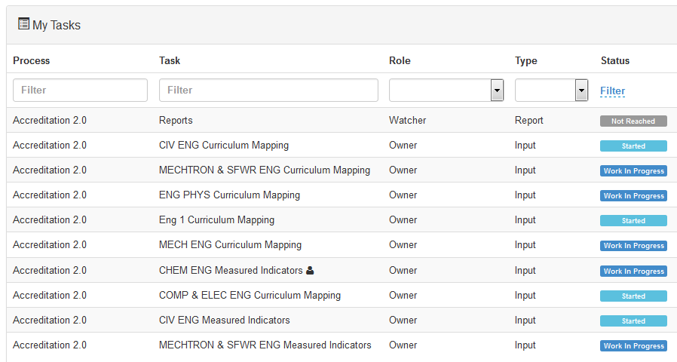

* 1. Check out a file to work on it. This will lock the file so that others only have view access.
     1. Open the file  
        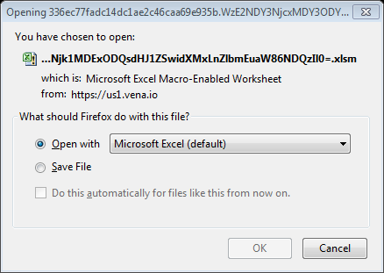
     2. Enable Editing  
        
     3. Select the program and year you are entering data for  
        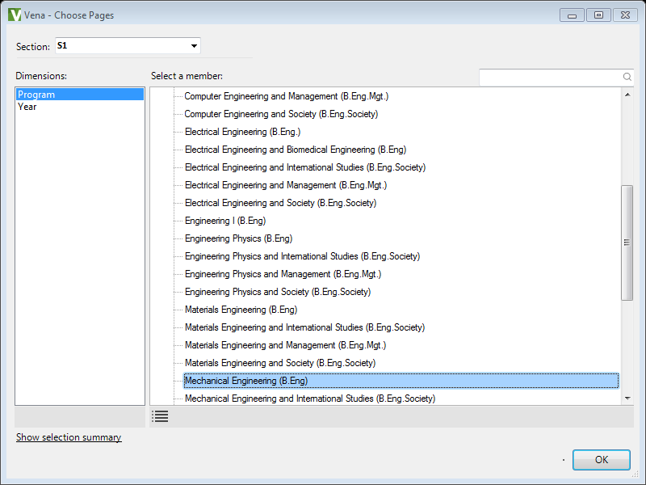
     4. Enable Content  
        
  2. Check in a file when you are done working on it. This will allow others to make additional edits.

# Add New Course

New courses are added to MEASURE as they are offered, but courses that are no longer offered **should not be deleted**. They can be removed from the program map, but if the course is actually deleted all of the associated historical data will be lost.

* 1. Login Vena 🡪 Modeler 🡪 Members 🡪 Program

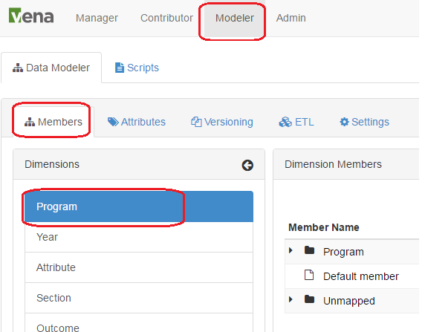

* 1. Expand the Program list 🡪 Select the program you want to add course 🡪Select the level 🡪 right click on the level🡪select “Add Child”

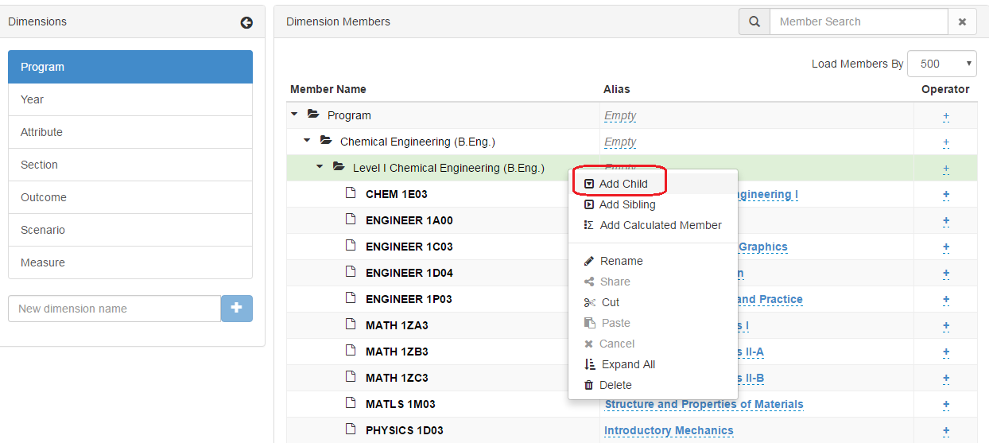

* 1. Fill in the course code and description
  2. You can follow section 6.1 and 6.2 to move or copy the course to another program.

# Edit Courses and Programs Mapping

* 1. Move Courses

Login to Vena as Modeler or Admin, Click on “Modeler” at the top navigation bar, Click on “Program” at the left navigation bar, Expand the “Member Name” 🡪Right Click at a course or program you would like to move🡪Click “Cut” 🡪Select destination parent member🡪Right Click then choose “Paste”

The above process can also be done by dragging and dropping the child member to the parent member

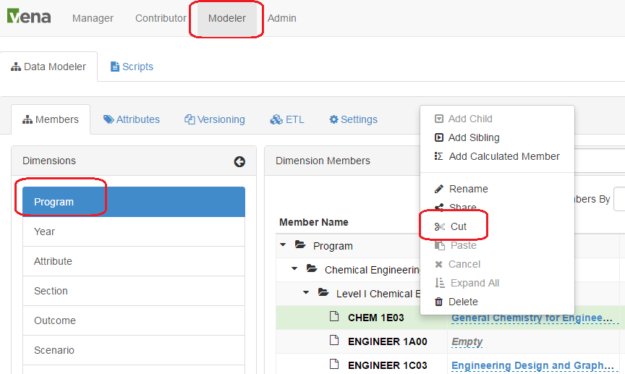

* 1. Copy Courses

Login to Vena as Modeler or Admin, Click on “Modeler” at the top navigation bar, Click on “Program” at the left navigation bar, Expand the “Member Name” 🡪Right Click at a course you would like to copy 🡪Click “Share” 🡪Select destination parent member🡪Right Click then choose “Paste”

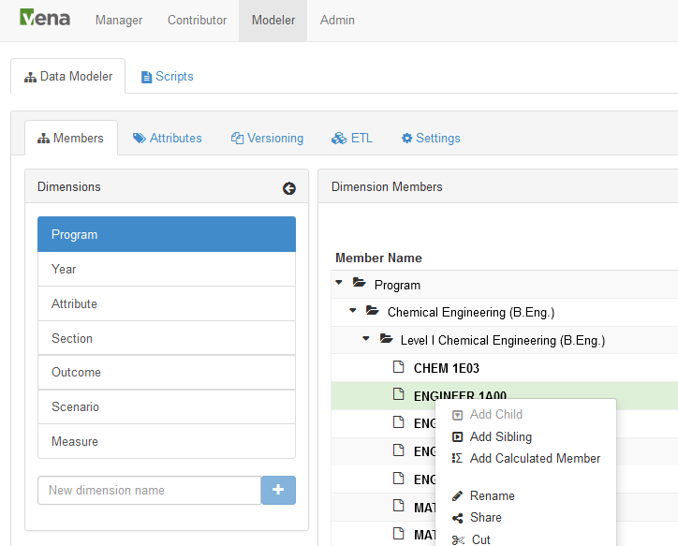

* 1. Remove Courses From Program Mapping (Removal From **All** Programs)
     1. Right click on the course you want to remove from the mapping and select ‘Cut’

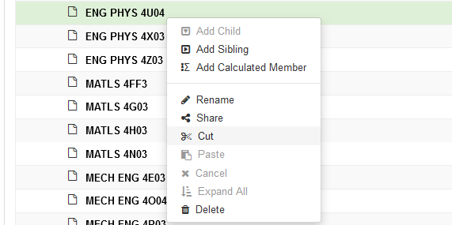

* + 1. Right click on the Unmapped folder and select ‘Paste’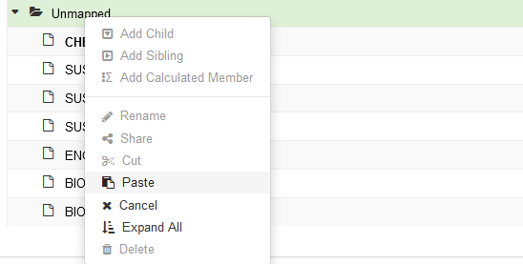
    2. If this course is shared between programs then you can delete it from each program mapping

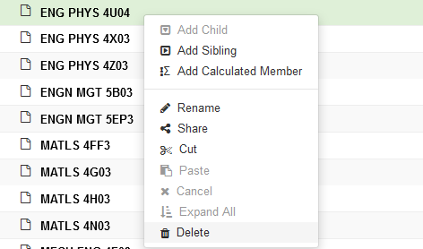

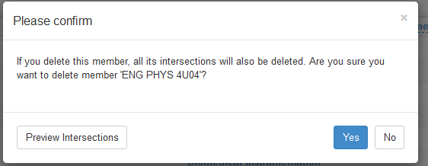

* 1. Remove Course From Program Mapping (Removal From **One** Program)
     1. If the course is removed from one program, but still offered in others, we can delete it from the program





# Department Input

Each department needs to enter their curriculum map (subsection 1 below) and a measurement map (subsection 2 below). The curriculum map summarizes where the indicators are offered, and at what level, in each program. The measurement map for each year identifies what needs to be measured for that year. Although it might appear that information is duplicated between the two templates, this is not actually the case. Not all indicators are measured, and not every measured indicator is part of the curriculum map. This second case occurs when a course does not explicitly teach an indicator, but it is measured. This might happen in a capstone course, for instance, where a presentation related indicator is measured, even though this indicator is not explicitly taught in the course.

1. Curriculum Mapping Input
   * 1. Check out “Curriculum Mapping”
     2. On the open Excel Sheet 🡪 Select the Program and the Year that you want to enter information. You should be entering data for the current year.
     3. The curriculum mapping is centralized at the program level, and it is using the previous year information as a starting point for the current year; therefore, some of the information is prepopulated 🡪 select the level of each course at the indicator level (I – Introduced, D – Developed, A – Applied) 🡪 Click “Save Data” under “Vena” Tab and “Check in” the file.

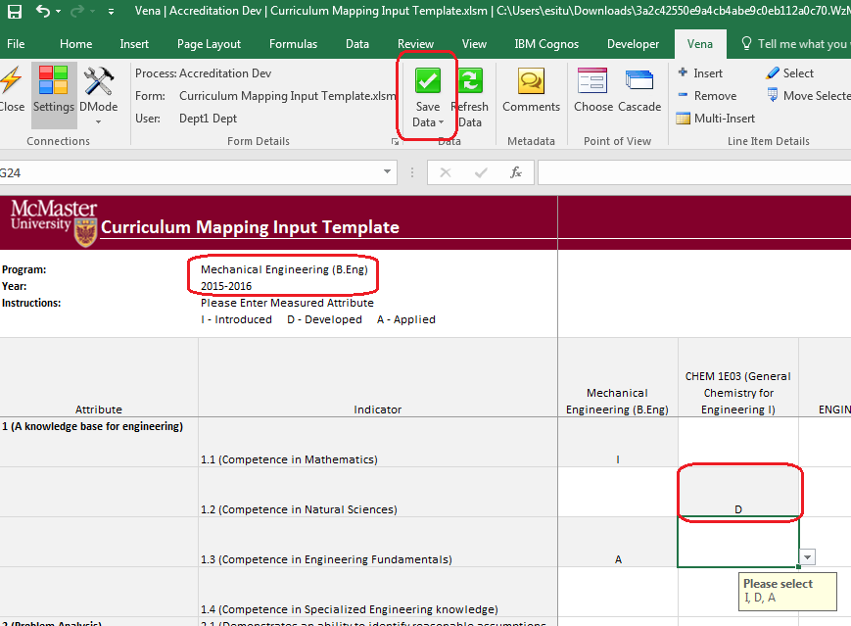

1. Measured Indicators Input
   * 1. Check out “Measured Indicators”

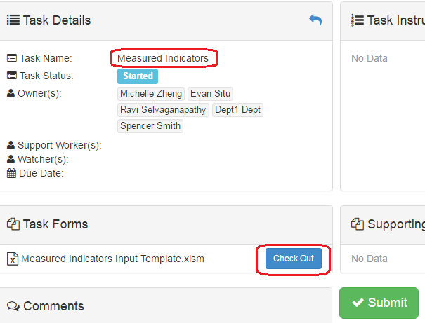

* + 1. On the open Excel Sheet 🡪 Select the Program and the Year that you want to enter information. You should be entering the information for the current year.

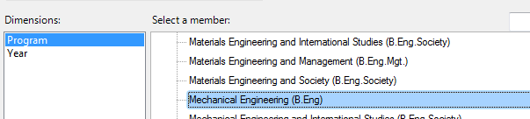

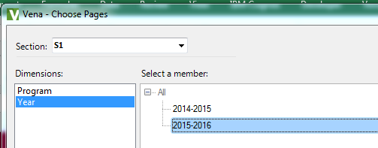

* + 1. The measured indicator map is centralized at program level, and it is using the previous year’s information as the starting point for the current year, therefore some of the information is prepopulated 🡪 enter an “M” to the in the intersection of indicator and course to indicator the measuring of the course 🡪 Click “Save Data” under “Vena” Tab and “Check in” the file.

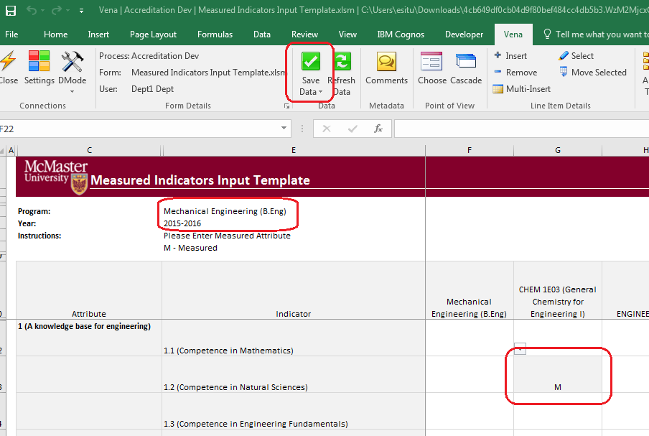

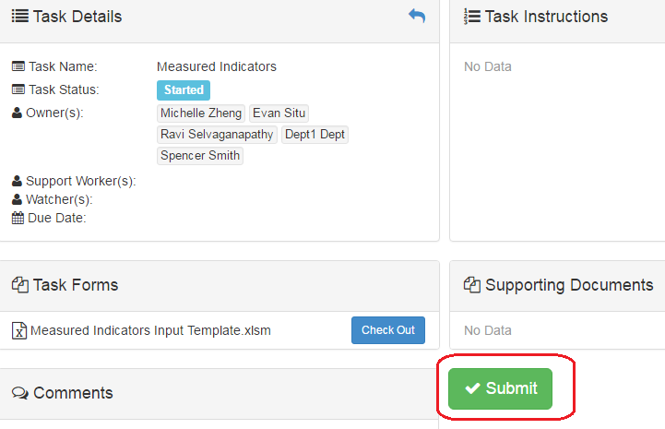

# Curriculum Committee Recommendations

* 1. Check out “Curriculum Committee Recommendations Input Template”

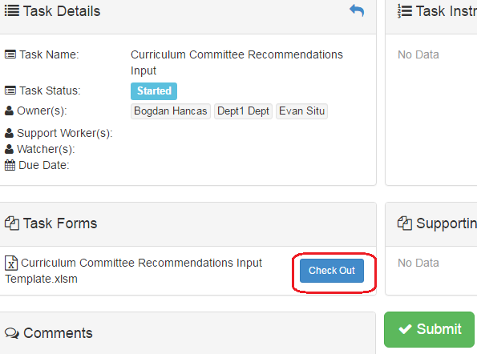

* 1. Once the Excel template is open 🡪 select program and year

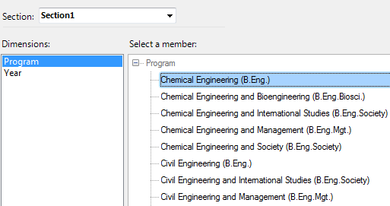

* 1. Enter recommendations for the program and courses

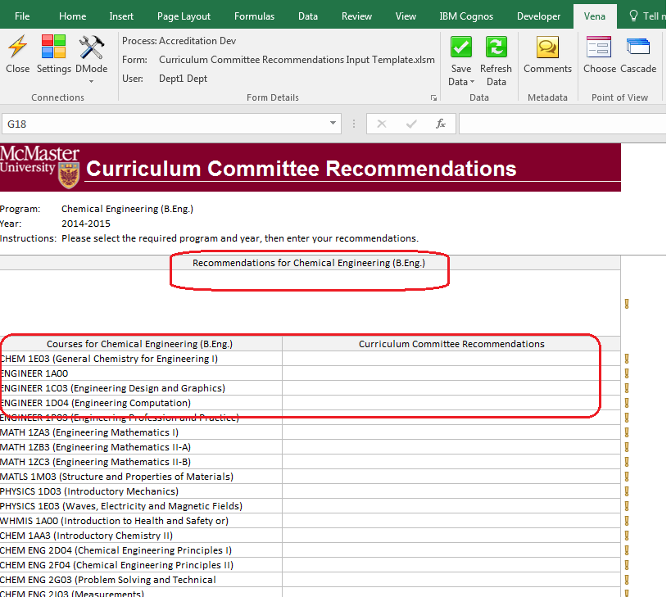

* 1. Departments may decide to not enter their recommendations as text in the Curriculum Committee Recommendations template. They may prefer to capture this information in a Word or pdf report. Therefore, there is an option to attach a file to the recommendations (Course and Program level)

Click “Comments” under “Vena” Tab🡪 On the pop-up windows, click “Attach File” to choose the file you want to attach 🡪 click “Add”

When attaching a file as a comment, please write text in the associated field to let future readers know that additional information is available as a comment. Something like the following would be fine: “For additional information, please see report attached to this cell”.

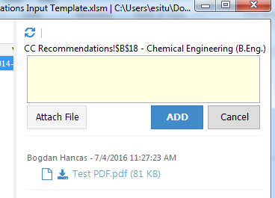

* 1. Click “Save Data” under “Vena” Tab and “Check in” the file

# Reports

The data in the MEASURE database is viewed using spreadsheet reports. The purpose of the reports is to transform the information into a form that is suitable for review, including by the CEAB when necessary. Reports can be viewed for any year where the data has been entered.

Reports are viewed from the Contributor tab by selecting Accreditation 2.0 and then selecting Reports. Clicking on Reports under My Tasks will show the screenshot shown below. Most of the report types are described in this section. However, given their interest for instructors, how to view the Curriculum Committee Recommendation Report, Course Reports and Measurement Map Report, are described in the Instructor manual. The details of the other reports are given below.



* 1. Attribute Map Report

Indicated the measure level at the attribute level, if different indicator level appears, the highest level will show up A > D > I.

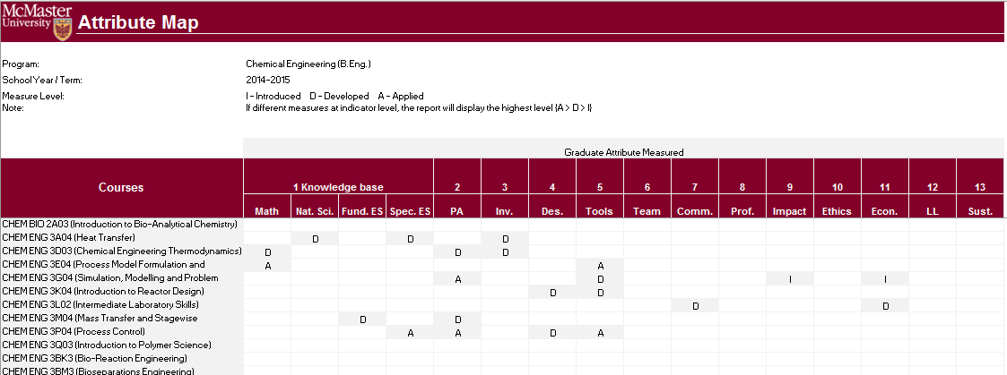

* 1. Attribute Map Summary Report

Similar to the Attribute report, instead showing the actual level (A, D, I), the summary report will only show the “X” to indicate that the specific course is measured at the specific attribute.

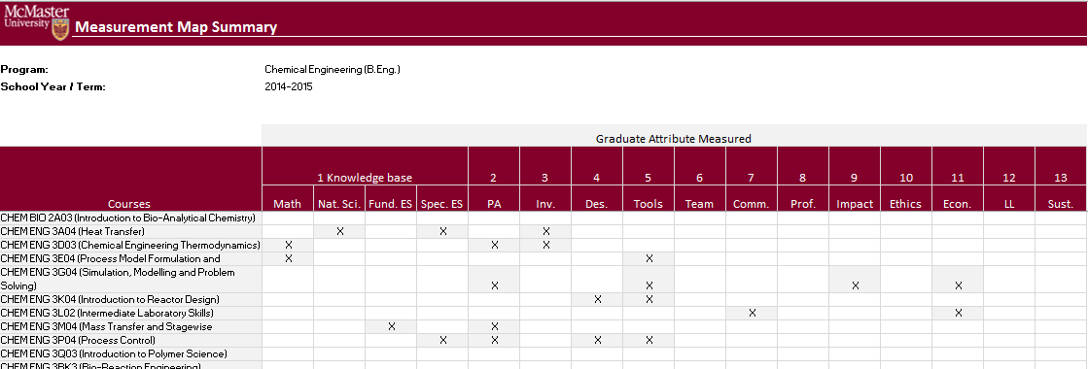

* 1. Indicator Map Report

Indicates the measure level at the indicator level (Lowest level in the hierarchy)

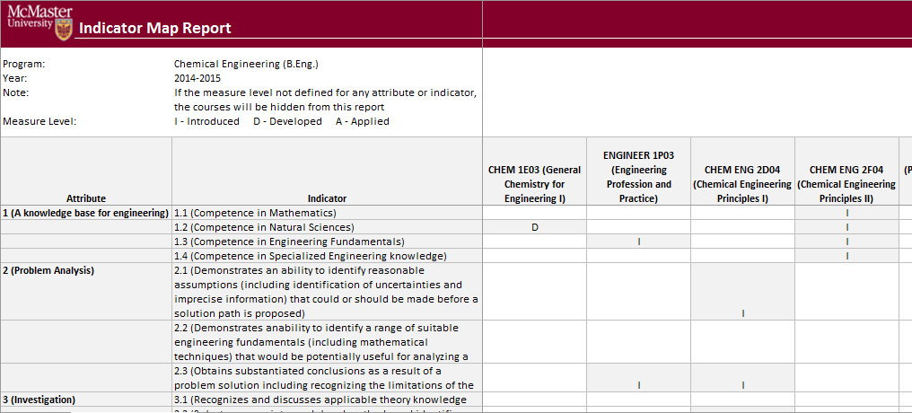

* 1. Historical Course Measurement Report

Shows the historical trend for each course at different levels (indicator, attribute and all)

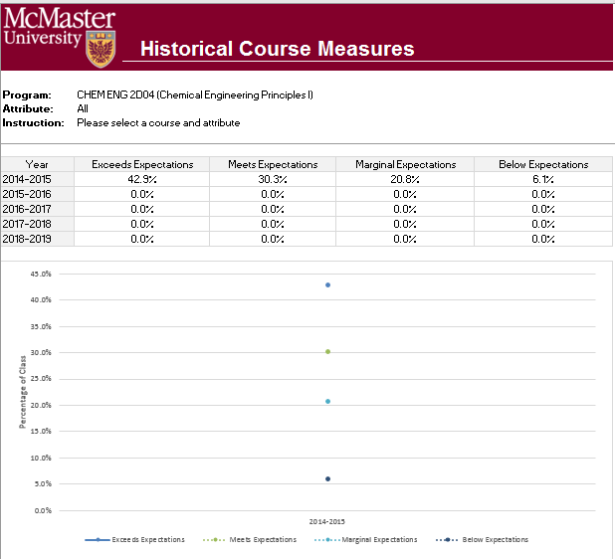

* 1. Historical Program Measurement Report

Shows the historical trend for each course at different levels (indicator, attribute and all)

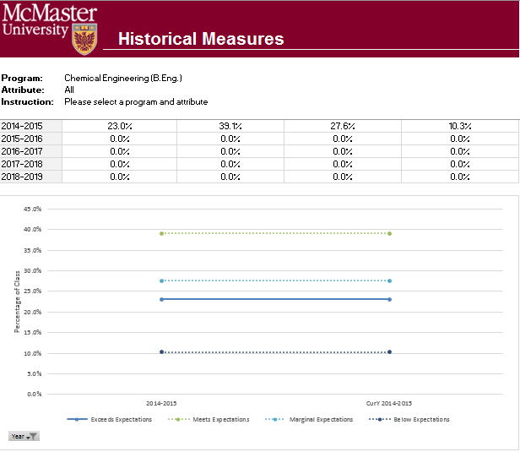

* 1. Course Report

Shows the course outcome and recommendations from curriculum committee, instructors also enter their continuous improvement plan information through the course report. Every course for which rubric data is entered will have a corresponding Course Report.

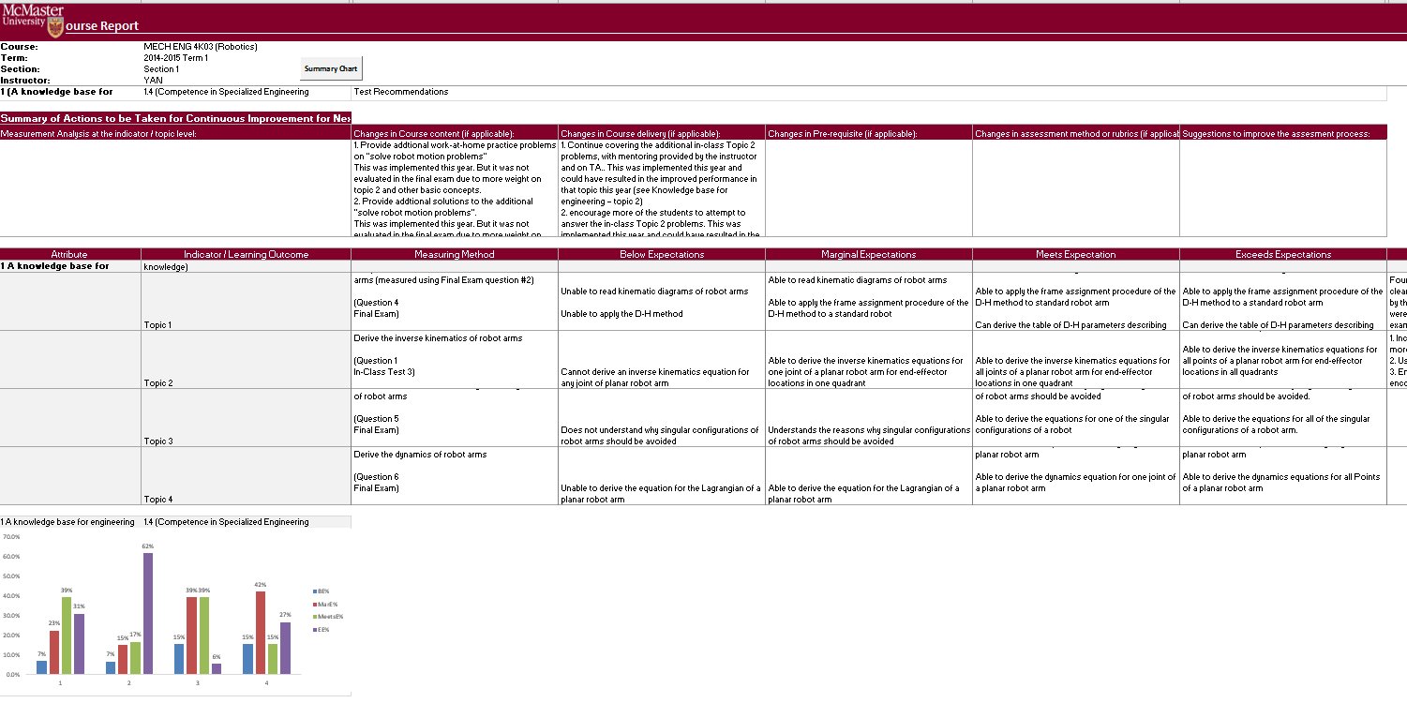

* 1. CEAB Attribute Report

The CEAB Attribute Report displays the attribute results of a given program/course by year or term. Each bar in the report represents a Graduate Attribute. The bar may divide into 4 expectations.

The line indicates the average score for each attribute where 1 = Below expectations and 4 = Exceeds expectations.

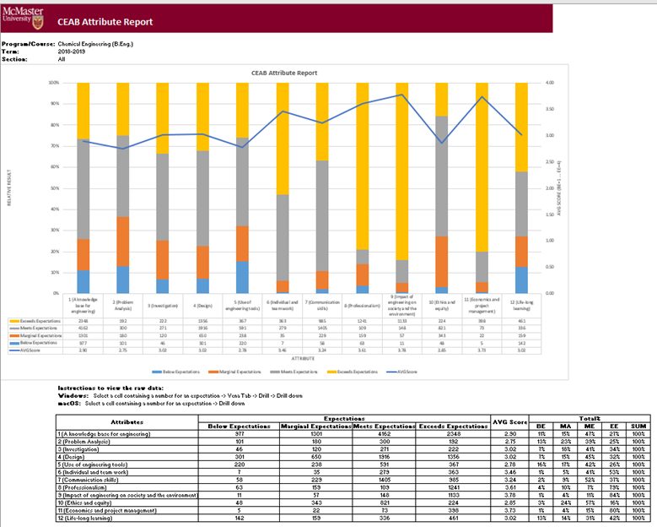

Vena’s Drill Down Feature

The drill down feature enables users to view the raw data making up the sum of a selected expectation.

1. Open the **CEAB Attribute Report**
2. Select a Course/Program, Term, and Section
3. Select a cell intersecting an Attribute and Expectation
   1. 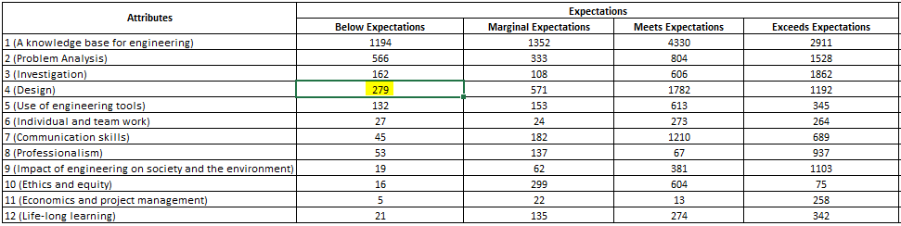
4. Select Drill Down
   1. For Windows users, select Vena Tab 🡪 Drill 🡪 Drill Down
   2. 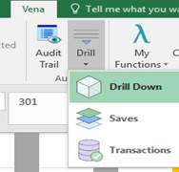
   3. For macOS users, select Drill Down
   4. 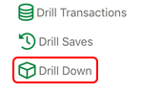
5. A new Excel worksheet will be generated displaying a breakdown of the data by course, year, attribute, section, value, etc.
   1. The sum of the value column will equal the value of the selected cell

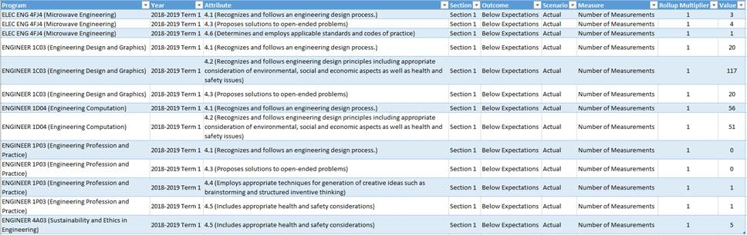

# Updating Valid Course Information

The following steps need to be done as a Manager, so that the edited template is seen by everyone. The steps below are started from selecting the “Rubric Input Template” from the Files Library tab on the Manager screen.

1. Download “Rubric Input Template”, under Vena Tab select “Edit Template”

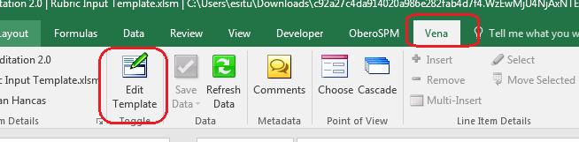

1. Right click on the sheet navigation area then unhide the “CourseList” sheet in the “Rubric Input Template”

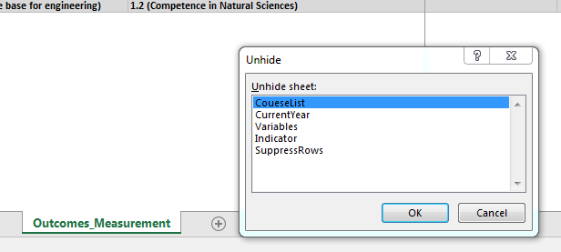

1. Update the Course; Term; Section in the table (Column A-C)

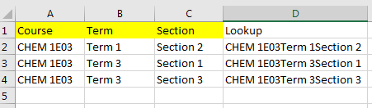

1. Copy the Excel formula in “Column D” down
2. Hide the ““CourseList” sheet”
3. Under the Vena tab, click “Save Template”

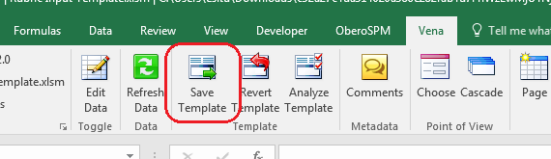

The names in the course list need to match the names from the database of courses. These names can be found using the following steps:

1. Modeler/ETL/Export.
2. Under “What would you like to export” select “Hierarchy”
3. Under “Which format would you like to export into” select “CSV file”
4. Check “Include column headers in export?”
5. Click the Export button
6. Click Open when the file is available.
7. The information on the courses is given several pages down in the spreadsheet, after the programs and years are listed.

# Rubric Entry Report

A quick way to monitor the progress on rubric input is via the “Rubric Entry Report”. This report is accessed from the Contributor screen by Selecting the Reports Task. The relevant template is “Rubric Entry Report.” This report lists all courses with an indication on whether it has been started. The report cannot tell whether the rubric is complete, but it can tell whether it has been started.

# Other Vena Resources

* 1. To submit an issue, please fill out <http://goo.gl/forms/I3kDnsUl46>
  2. For Vena training or user manuals, please refer to <http://docs.vena.io/>
  3. For other help please contact:

Michelle Zheng <mailto:zhengm2@mcmaster.ca>