**Admin Guide for MEASURE**

Faculty of Engineering, McMaster University

April 29, 2019

**by**

Evan Situ, Michelle Zheng, Spencer Smith, Andrew Aran

**Modification Log**

|  |  |  |  |
| --- | --- | --- | --- |
| **Version** | **Modification date** | **Author** | **Comments** |
| 1.0 | July 4, 2016 | Evan Situ |  |
| 1.1 | August 29, 2016 | Evan Situ | Added section 6 and 8 and 1.4 |
| 1.2 | September 13, 2016 | Evan Situ | Added 9. Updating a Global Variable |
| 1.3 | September 16, 2016 | Evan Situ | Added Section 10 Force Check-In |
| 1.4 | September 26, 2016 | Evan Situ | Added 11.Update Course Information Input Template |
| 1.5 | October 20, 2016 | Michelle Zheng | Minor edits |
| 1.6 | November 16, 2016 | Michelle Zheng | Added title page and Section 7 |
| 1.7 | November 29, 2016 | Michelle Zheng | Updated Section 4 |
| 1.8 | December 16, 2016 | Spencer Smith | Changing template property for concurrent contributors |
| 1.9 | January 19, 2017 | Spencer Smith | Clarification of submitting rubric and course reports |
| 1.9.1 | April 19, 2017 | Spencer Smith | Note about protected cells |
| 1.9.2 | April 12, 2018 | Spencer Smith | Addition on adding superuser permissions |
| 1.9.3 | April 18, 2018 | Andrew Aran | Updated screenshots for:   * 4. Add User * 5. Assign User to Process * 7. Faculty Recommendations * 8. Start New Academic Year * 9. Historical Program Measurement Archive * 11. Updating a Global Variable * 13. Update Course Information Input Template |
| 1.9.4 | May 3, 2018 | Andrew Aran | * Updated Global Variable Process * Updated the order of the tasks in the instructions |
| 1.9.5 | October 15, 2018 | Andrew Aran | * Added Contract Renewal Interval to timeline * Added backup and restore interval to timeline |
| 1.9.6 | April 29, 2019 | Andrew Aran | * Added instructions to access CEAB Attribute Report and Drill Down Feature |

Top of Form

Bottom of Form

Table of Contents

1. Introduction 5

2. Pre-requisites 5

3. Annual Timeline 5

4. Add User 8

5. Assign User to Process 10

6. Department Input 11

7. Faculty Recommendations 12

8. Historical Program Measurement Archive 15

9. Historical Program Measurement Report 18

10. Start New Academic Year 19

11. Updating a Global Variable 23

12. Update Course Information Input Template 25

13. Changing Concurrent Contributor Templates to Enable the Choose Option 26

14. Unsubmit 26

15. Force Check-In 26

16. Vena Contract Renewal 28

17. Backup and Restore Process 28

18. CEAB Attribute Report 28

19. Other Vena Resources 30

# Introduction

This document is part of MEASURE (McMaster Engineering Accreditation System for UndeRgraduatE). MEASURE is intended to facilitate the continual improvement of the curriculum of the programs offered by the Faculty of Engineering. The MEASURE system will also be used to assist with generating reports for the Canadian Engineering Accreditation Board (CEAB).

This specific document outlines the information needed to Administer MEASURE. The tasks described here are for maintaining MEASURE at the faculty level. Usually these tasks will be completed by the Office of the Associate Dean. Example tasks include adding users, changing passwords, archiving data etc.

In the future the templates may need to be changed. In some cases, portions of the templates are locked and the sheet itself is protected. In these cases, it will be necessary to know the password. The password is kept separate from this document, since this document is publically accessible.

Additional information on MEASURE can be found in the Departmental Guide and in the Instructor’s Guide. The most up to date version of all these documents, along with other resources, are available at: <http://measure.mcmaster.ca/>

# Pre-requisites

1. Access to McMaster Vena <https://vena.io/>. You will need a user account (your e-mail address) and a password.
2. Admin access to McMaster Vena to Add or Remove user
3. Modeler/Admin access to run the ETL (Extract, Transform and Load) process
4. “AcademicYearTemplate.csv” to pass parameter into the ETL process
5. Microsoft Excel (2013 or later is recommended)
6. Installed Vena Excel add-in <http://addin.vena.io/release/vena.application>
7. Windows operating system or a Windows virtual machine (virtual machine instructions for Mac user instructions are available at: <http://measure.mcmaster.ca/> )

# Annual Timeline

The table below summarizes the typical tasks performed by the Associate Dean’s office, departments and instructors during the course of an academic year. For each task, the following is listed: the time of year when it typically occurs, the section of this report where details are given, the MEASURE template (spreadsheet) that applies, and the task owner. The section where details can be found also includes information on which document holds the information. In this context, the prefix A, D, and I mean Administrator’s Guide, Departmental Guide, and Instructor’s guide, respectively.

|  |  |  |  |  |
| --- | --- | --- | --- | --- |
| **Date** | **Task** | **Section Guide** | **Template** | **Task Owner** |
| Summer | Archive previous year data | A5 | Academic Year Template | Assoc Dean |
| Summer | Data copied over to next academic year | -- | (Automated Process) | Assoc Dean |
| Summer | Update global variable to the new year and term | A11 | Input Variables Template | Assoc Dean |
| Summer | Add new courses to the MEASURE database (**do not delete old courses until moving them to unmapped!**) | D5 | Login Vena 🡪 Modeler 🡪 Members 🡪 Program | Department |
| Summer | Changes to programs (mapping b/w courses and programs) | D6 | Login Vena 🡪 Modeler 🡪 Members 🡪 Program | Department |
| Summer | Update validation data for courses, terms, sections combinations | To Add | To Add to Departmental guide | Department |
| Summer | Curriculum mapping (requires consultation with instructors) | D7.1 | Curriculum Mapping Input Template | Department (Attributes Committee) |
| Summer | Measurement mapping | D7.2 | Measured Indicators Input Template | Department (Attributes Committee) |
| Aug/Sep | Instructor reviews continuous improvement plan from the previous year and assigned indicators | I3.1 | Curriculum Committee Recommendations Report (Previous Year), Measurement Map Report, Rubric Input Template | Instructor |
| September | Faculty reviews departmental continuous improvement plan report from previous year, writes report | A7 | Faculty Recommendations Input Template | Faculty |
| Dec/Jan | Instructor enters rubric and their continuous improvement plan for Term 1 | I2 | Rubric Input Template, Course Report | Instructor |
| Dec/Jan | Instructor reviews continuous improvement plan from the previous year and assigned indicators | I3.1 | Curriculum Committee Recommendations Report (Previous Year), Measurement Map Report? Rubric Input Template? | Instructor |
| March | Update global variable for the new term (after Term 1 data entry is complete) | A11 | Input Variables Template | Assoc Dean |
| Early May | Instructor enters course reports for Term 2 | I2 | Rubric Input Template, Course Report | Instructor |
| May | Curriculum committees review course reports, generate continuous improvement plan report | D8 | Course Report, Curriculum Committee Recommendations Input Template | Department |
| June | Meeting of continuous improvement committee (external advisors students) |  | Historical Course Measurement Report, Historical Program Measurement Report, Course Reports | Department |
| June | Departments plan curriculum revisions |  |  | Department |
| All Year | Add/Remove manage users | A4 |  | Assoc Dean |
| Ad-Hoc | View Historical Data | A9 |  |  |
| Ad-Hoc | Assign Users to Process | A5 |  |  |
| Ad-Hoc | Report writing |  | Attribute Map Report, Attribute Map Summary Report, Course Report, Curriculum Committee Recommendations Report, Historical Course Measurement Report, Historical Program Measurement Report, Indicator Map Report, Faculty Recommendations Input Template |  |
| Every 3 Years | Vena Contract Renewal | A16 |  | Assoc Dean |
| 2-3 Times a year | Backup and Restore Process | A17 |  | Vena |

The timeline table shows an entry for adding courses, but no time slot for deleting courses that are no longer offered. This is because courses are not deleted, since deleting them will remove all of the historical data associated with the course. Courses can be removed from a specific program, but should not be removed from the Vena database. Courses that are no longer offered should be moved to unmapped, as described in the Departmental Guide.

# Add User

* 1. Login to <https://ca3.vena.io/administrator>
  2. Under “Admin” 🡪 “Users” 🡪 “Add User”

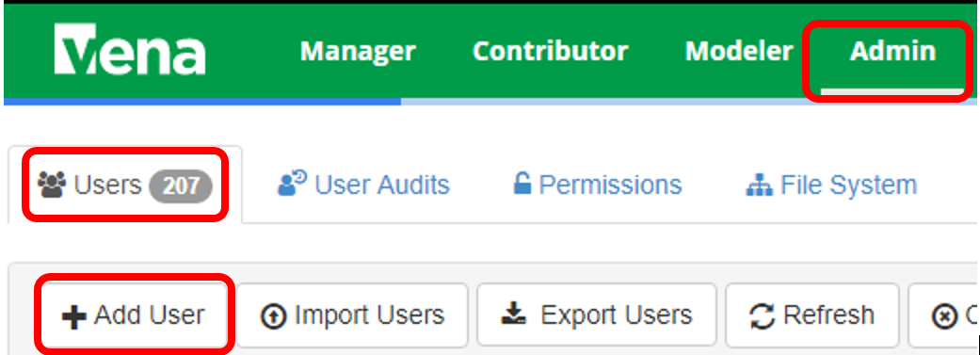

* 1. Fill in the user information and select the login types 🡪 Click “Save”

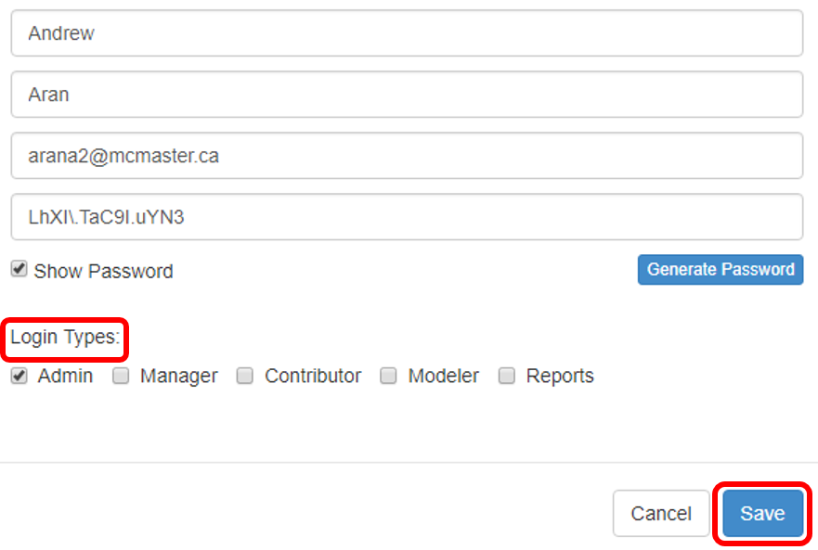

* 1. For department representatives in the modeler role, give them the appropriate permissions:  
     Click Admin 🡪 Click Permissions 🡪 Click on Modelers 🡪 Click on Manage 🡪 Search for user name and add it

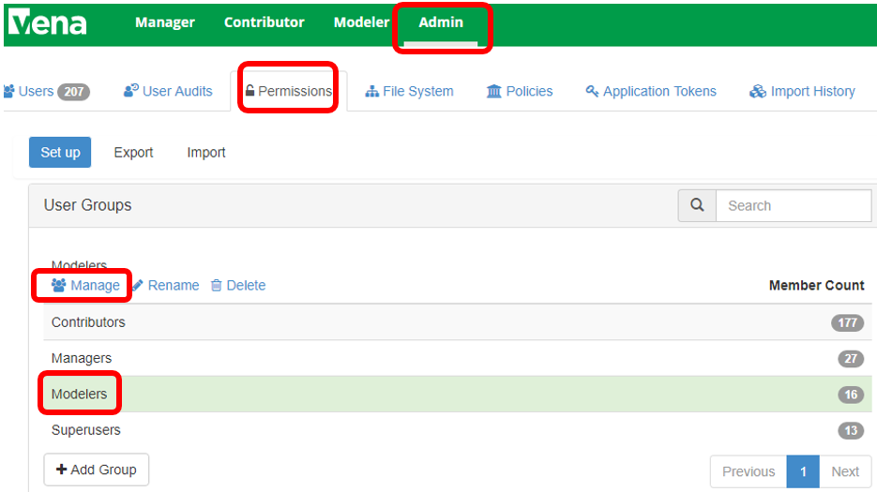

* 1. For Superusers, give them the appropriate permissions:

Click Admin 🡪 Click Permission 🡪 Click on Superusers 🡪 Click on Manage 🡪 Search for user name and add it

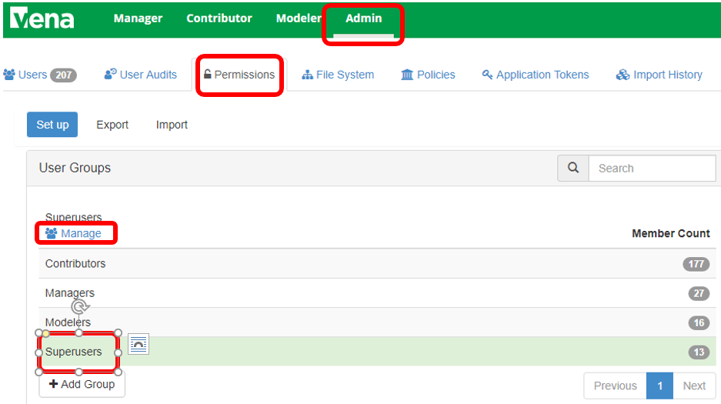

# Assign User to Process

* 1. After login to Vena 🡪 Under “Manager” 🡪 Click “Process” 🡪Click Accreditation 2.0 🡪 Click “Open”

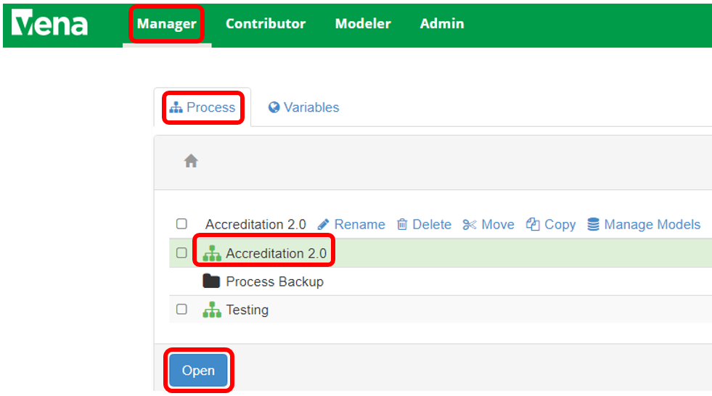

* 1. Under “Manager” 🡪 Click “Designer – Accreditation 2.0” 🡪 Double-click on the task or activities you want to assign users to

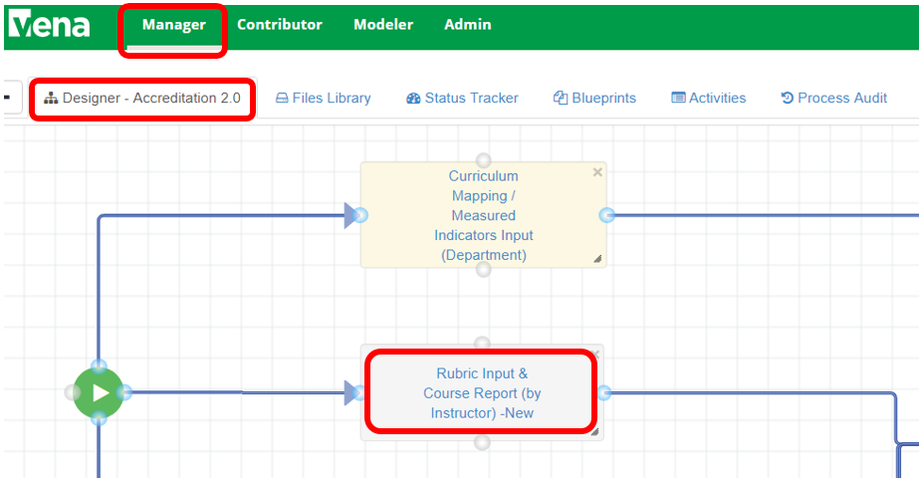

* 1. Double Click on the Task 🡪on the “Task Detail” windows 🡪 Click “Users”🡪Type the User name that you want to add (you can add users to different roles in the process (Owners, Support Workers, Watchers), please refer to the detail documentation for the differences of each role 🡪 Click “Save”. This step is particularly relevant for adding instructors as Support Workers for the “Rubric Input & Course Report (by Instructor)” Task. By adding the instructors as Support Workers, they will not have access to the Submit button.

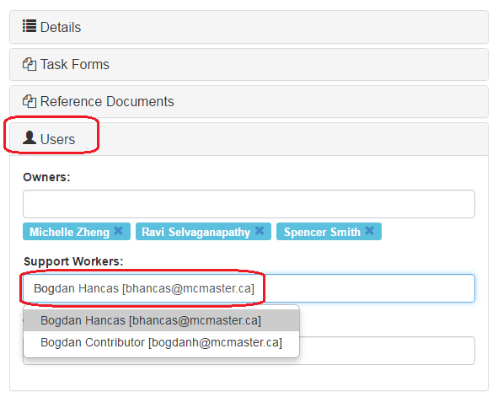

# Department Input

1. Update Current Year Variable
   * 1. The current year variable drives some of the reports, therefore it is important to update this variable at the beginning of the process
     2. After logging in to Vena 🡪 Select Task “Update Current Year Variables”🡪Check Out the input template, when you Check Out a file you are the only one who can edit it

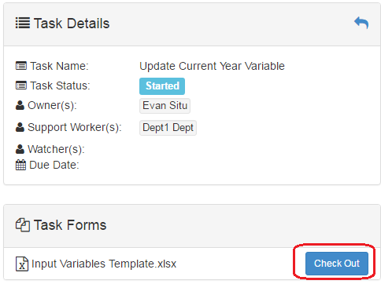

* + 1. Enter the current academic year in the format (yyyy-yyyy) and current year default in the format (yyyy-yyyy Default)🡪 Click “Save Data” under “Vena” Tab and “Check In” the file 🡪Submit the process at Vena front end to finish this task

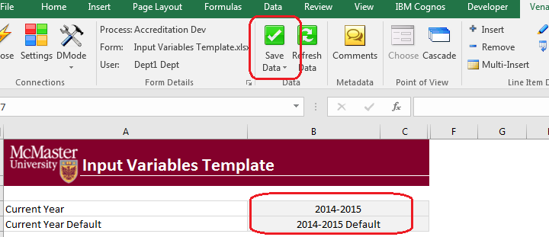

* + 1. After Submit the process, the status should show as “Submitted”

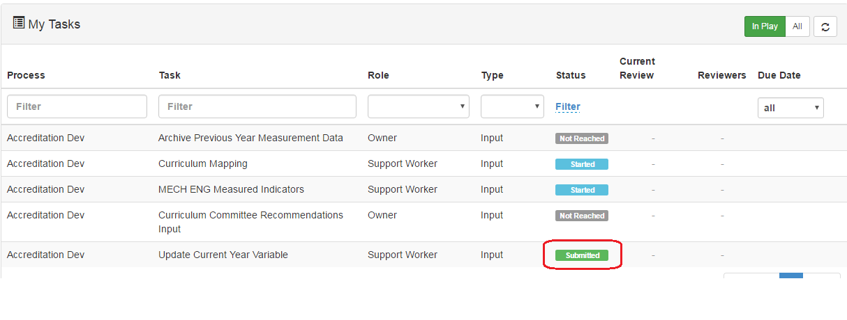

# Faculty Recommendations

* 1. Check out “Faculty Recommendations Input Template”  
     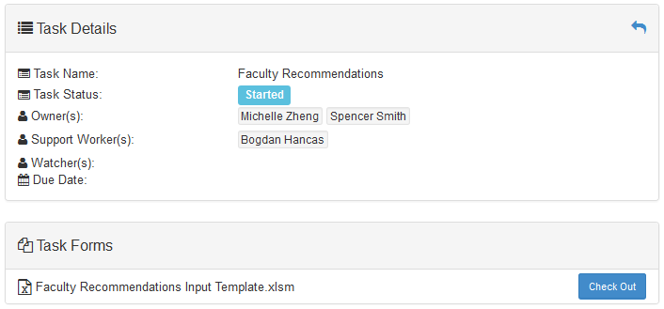
  2. Once the Excel template is open 🡪 Select the year

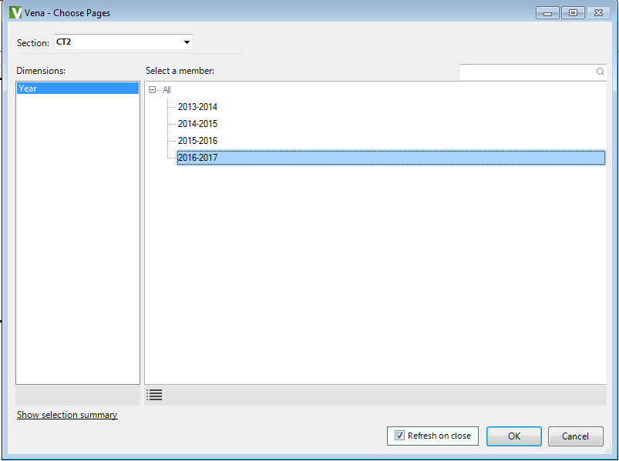

* 1. Enter the faculty recommendations

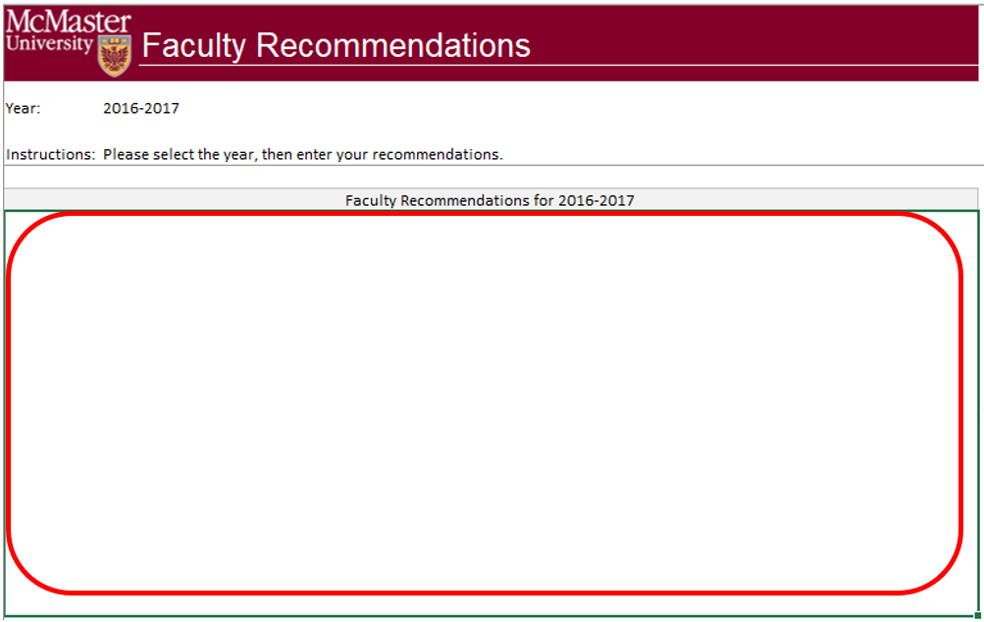

* 1. Recommendations can be entered as text in the Faculty Recommendations template or captured in a Word or pdf report. Therefore, there is an option to attach a file to the recommendations
  2. To attach a file to your recommendations,
     1. Click the “Vena” Tab
     2. Click the empty section below the “Faculty Recommendations for 2016-2017”
     3. Click “Comments”
     4. In the “Comments” section, click “Details” Tab
     5. Click the “Add Comment” button

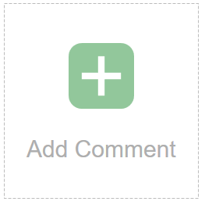

* + 1. Click the paper clip and attach your file
    2. Click “Upload” when asked to upload the file as a comment

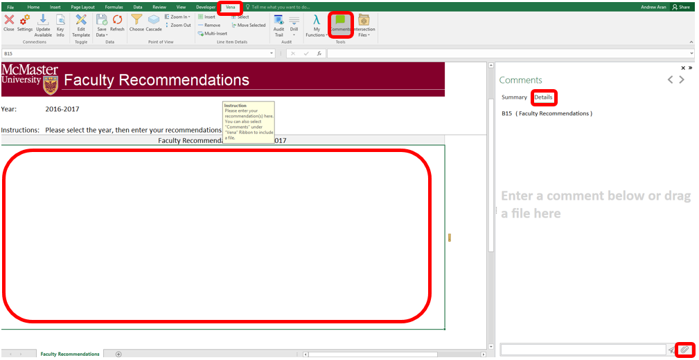

Note: When attaching a file as a comment, please write text in the associated field to let future readers know that additional information is available as a comment. Something similar to the following would be fine: “For additional information, please see report attached to this cell”.

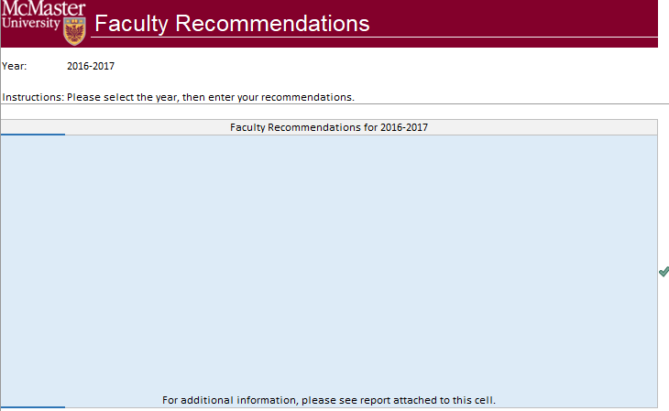

* 1. Click “Save Data” under “Vena” Tab and “Check in” the file

# Historical Program Measurement Archive

* 1. Please only archive the program measurement when the program is fully completed. The purpose of archiving the program measurement data is to track the historical trend of a program.
  2. The purpose of archiving the data is so that the historical program measurement report can be generated.
  3. Before generating the archive, the task owner for “Rubric Input & Course Report (by Instructor)” should click on the Submit button on the contributor’s interface. It may be necessary to do a forced check-in first, since not all instructors will remember to check in their templates. The enabled submit button will look like the following picture:



* 1. Open the input template “AcademicYearTemplate.csv” 🡪enter the new academic year data in cell “A1” (format yyyy-yyyy) 🡪 Save

Example: If rolling over to 2018-2019 Year, enter 2017-2018 in the Cell.

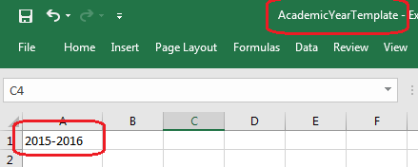

* 1. Click on “Modeler” 🡪 “Data Modeler” 🡪 “ETL” 🡪 “Templates”🡪Click the “Run” button () on “Historical Program Measurement Archive”
  2. On the open windows, click “Choose File”🡪select the “AcademicYearTemplate.csv” from step 4 🡪 Click “Import”

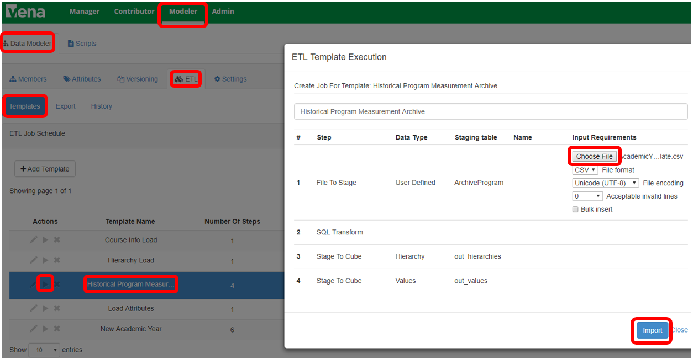

* 1. You will now see the ETL Status “RUNNING” 🡪 once the ETL job is completed, the status will become “COMPLETED” (it will take about 5-10 minutes to complete the ETL job, you can click the refresh button above the “Status” to refresh)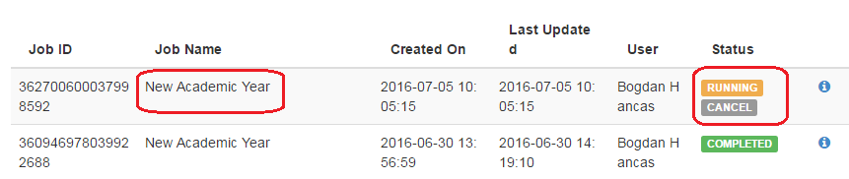

# Historical Program Measurement Report

Once the archive is completed, the historical program data will be available in the “Historical Program Measurement Report”. (The historical program measurement report will not work for any year’s data that has not yet been archived.)

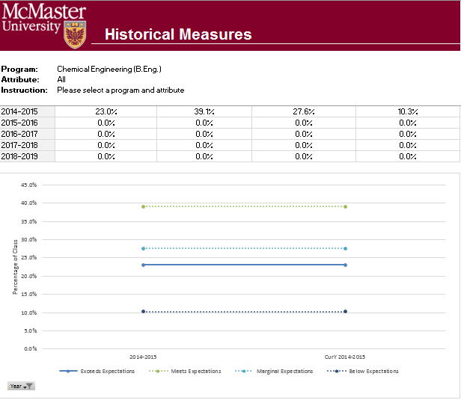

# Start New Academic Year

* 1. Since the current year’s curriculum mapping, measured as well as rubric information will be used as the starting point for a new academic year. An automated ETL process in Vena is built to accomplish this task.
  2. Open the input template “AcademicYearTemplate.csv” 🡪enter the new academic year data in cell “A1” (format yyyy-yyyy) 🡪 Save



* 1. Click on “Modeler” 🡪 “Data Modeler” 🡪 “ETL” 🡪 “Templates”🡪Click the “Run” button () on “New Academic Year”

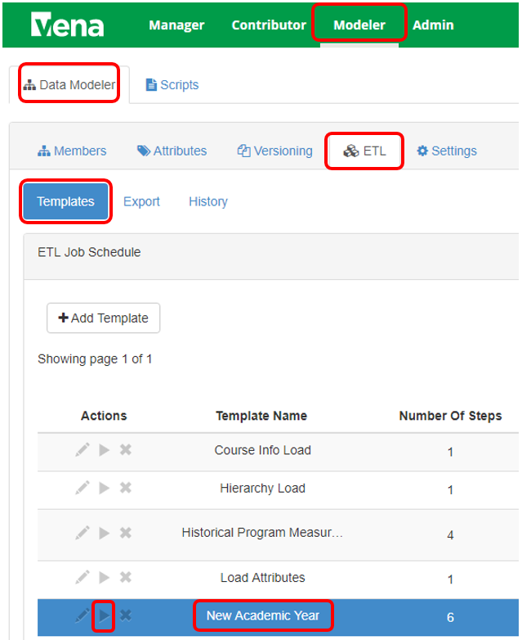

* 1. On the open windows, click “Choose File”🡪select the “AcademicYearTemplate.csv” from step 2 🡪 Click “Import”

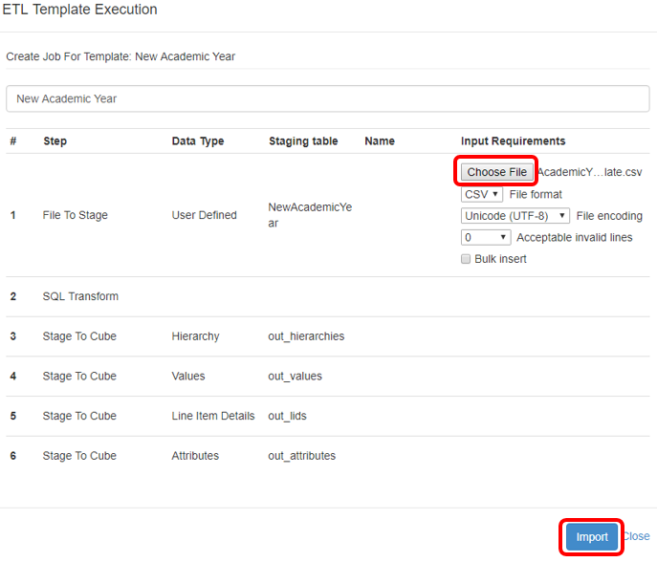

* 1. You will now see the ETL Status “RUNNING” 🡪 once the ETL job is completed, the status will become “COMPLETED” (it will take about 5-10 minutes to complete the ETL job, you can click the refresh button above the “Status” to refresh)



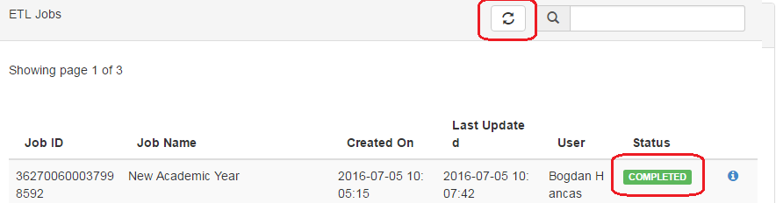

* 1. After the ETL is completed, you should see the data appear under the “Year” dimension

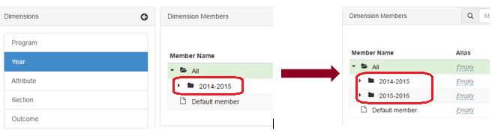

# Updating a Global Variable

Below are the steps to successfully update a Global Variable:

(Updating the term global variable will help prevent entering the incorrect term/year in the input templates)

* 1. Open your Vena Global Variable template “Input Variables Template” (you can find this template at Manager🡪Files Library, under the folder Data Controls)

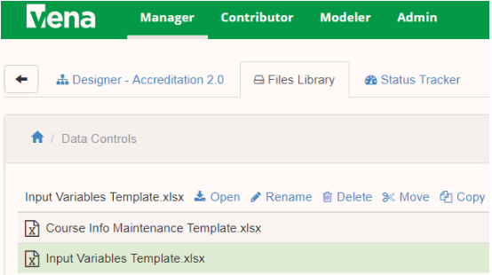

* 1. Select the cell with the value of the Global Variable 🡪Click “Edit Template”

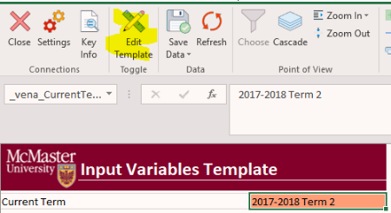

* 1. Click on Add/Edit Variable -> Process Variables -> Add/Edit (must be in Edit Template mode)

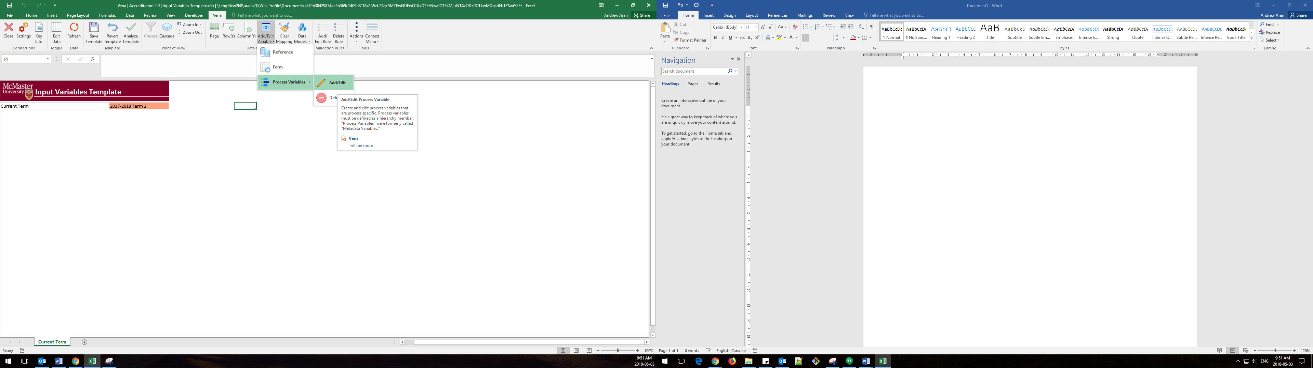

* 1. Update the respective variable with the new member (only a single member can be in a global variable).

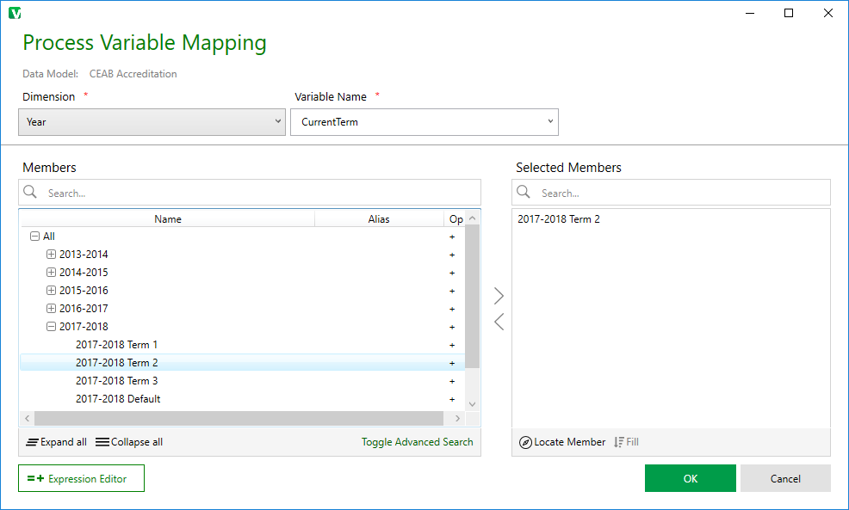

* 1. Close the variable window and Save Template

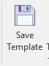

# Update Course Information Input Template

In order for the name of the instructor to show up on the course report, the “Course Information Input Template” will need to be updated each term.

* 1. Sign into Vena.io 🡪Under Manager🡪Files Library🡪Data Controls🡪Open the “Course Information Input Template”

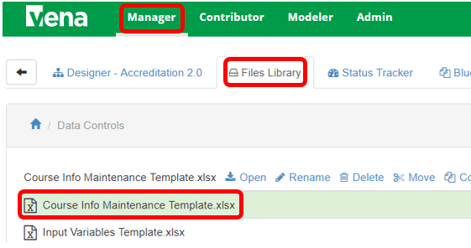

* 1. Under “Vena” Tab, Click “Choose”🡪 Pick the course and the year you want to edit

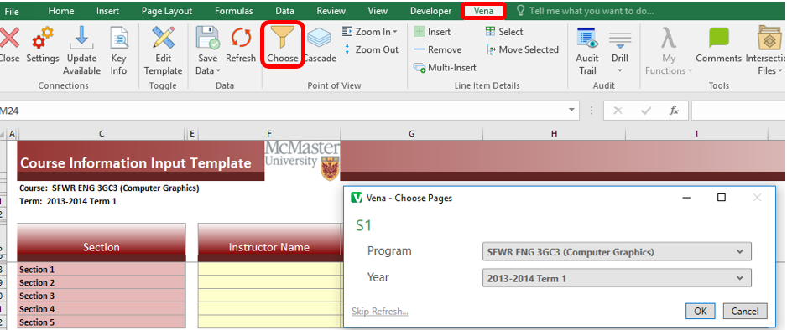

* 1. Enter the required information 🡪 Click “Save Data”

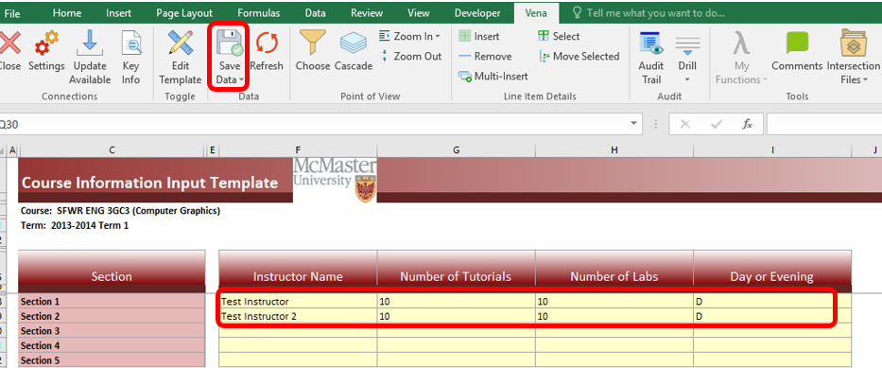

# Changing Concurrent Contributor Templates to Enable the Choose Option

For the concurrent access templates (rubric template and course report template) the template property is current set to hybrid. As a consequence, the Choose option in Vena toolbar is unavailable (greyed out). This seems like the least confusing option for instructors, but if we want to enable Choose, we just need to change the template property. This is done by switching to the Manager role, selecting the File Library, selecting the template of interest from the list, clicking on Set Template Property and selecting Central, instead of Hybrid.

# Unsubmit

If a task is inadvertently submitted, it is now possible to “unsubmit” it. This is done by first pausing the process, then going to the status tracker. The submitted task is then selected and using a right click the Restart option is chosen. After this the process has to be unpaused.

# Force Check-In

A task has been checked out by a user who is unavailable and it needs to be checked back in. Please follow the following steps:

* 1. Login as a Manager
  2. Go to “Status Tracker”
  3. Find the checked-out task assigned to the user
  4. Right click on the status of the task and hit Force Check-In

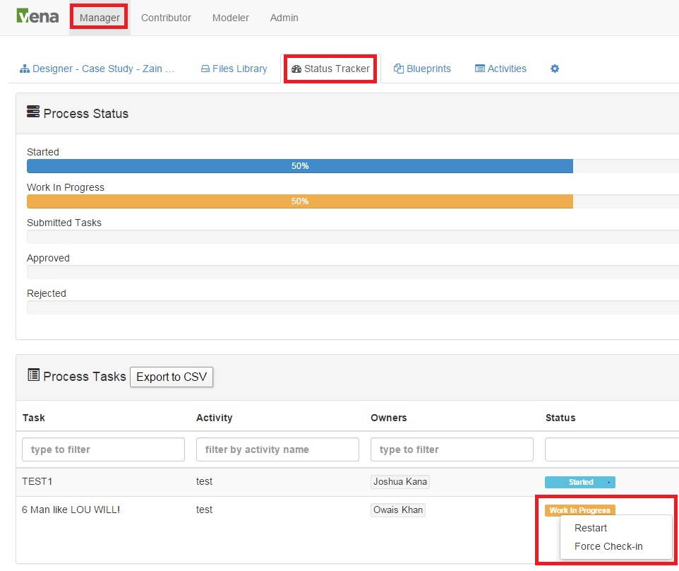

# Vena Contract Renewal

McMaster / Vena Contract renewed: June 29, 2017.

Term Start date: June 20, 2017

Term End Date: June 20, 2020

Vena agrees to provide Subscriber with a renewal quote ninety (90) days prior to the end of the initial three year term, and Subscriber agrees to provide written notice either of Subscriber’s intent to renew or Subscriber’s intent not to renew within thirty (30) days of receipt of such renewal quote. Additionally, in the event that the Parties renew for any additional one year terms, either party may elect to not renew the subscription by giving at least ninety (90) days’ written notice to the other party prior to the end of the then-current Term.

# Backup and Restore Process

Main goal of backup/recovery plan is to maintain data integrity

McMaster IT can assist with the backup/recovery process, but Vena will need to write the test data, test the integrity, and provide results every 3 months.

If client (McMaster University) requests to migrate between cloud tenants and/or clone a production environment to a sandbox, they will need to open support ticket

<https://venasupport.zendesk.com>

1. Process is executed every 3 months
2. Vena obtains a copy of the user’s data
3. Restores the data in another geographical location
4. Verify the test data (inserts test data prior to backing up and confirm test data is still there after it is restored)
5. Vena sends the results of the backup/restore process to McMaster IT

# CEAB Attribute Report

The CEAB Attribute Report displays the attribute results of a given program/course by year or term. Each bar in the report represents a Graduate Attribute. The bar may divide into 4 expectations.

The line indicates the average score for each attribute where 1 = Below expectations and 4 = Exceeds expectations.

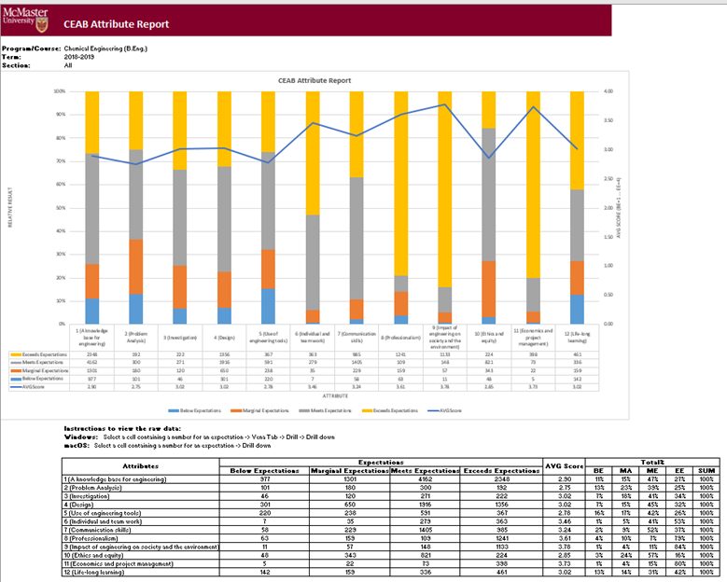

Vena’s Drill Down Feature

The drill down feature enables users to view the raw data making up the sum of a selected expectation.

1. Open the **CEAB Attribute Report**
2. Select a Course/Program, Term, and Section
3. Select a cell intersecting an Attribute and Expectation
   1. 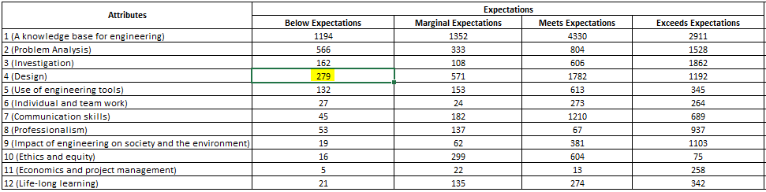
4. Select Drill Down
   1. For Windows users, select Vena Tab 🡪 Drill 🡪 Drill Down
   2. 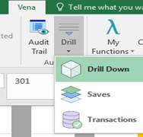
   3. For macOS users, select Drill Down
   4. 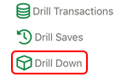
5. A new Excel worksheet will be generated displaying a breakdown of the data by course, year, attribute, section, value, etc.
   1. The sum of the value column will equal the value of the selected cell

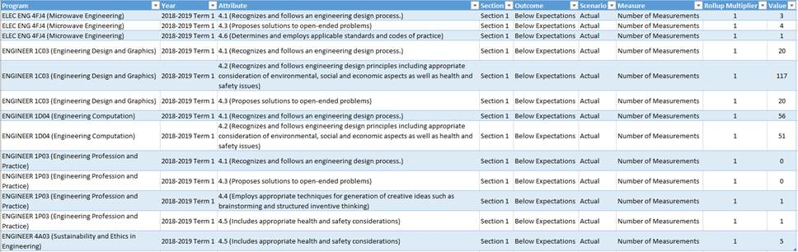

# Other Vena Resources

* 1. To submit an issue, please fill out <http://goo.gl/forms/I3kDnsUl46>
  2. For Vena training or user manual, please refer to <http://docs.vena.io/>
  3. For other helps please contact:
* Bogdan Hancas: [bhancas@venasolutions.com](mailto:bhancas@venasolutions.com)
* Evan Situ: [esitu@venasolutions.com](mailto:esitu@venasolutions.com)