**Modification Log**

|  |  |  |  |
| --- | --- | --- | --- |
| **Version** | **Modification date** | **Author** | **Comments** |
| 1.0 | July 5, 2016 | Evan Situ |  |
| 1.1 | August 28, 2016 | Evan Situ | Split the instructor document added section 3.1 and 1.4 |
|  |  |  |  |

**Table of Contents**

1. Pre-requisites 2

3. Instructor Input 3

4. Reports 8

5. Other Vena Resources 10

# Pre-requisites

1. Access to McMaster Vena <https://vena.io/>
2. Microsoft Excel 2013 or later is recommended
3. Installed Vena Excel add-in <http://addin.vena.io/release/vena.application>
4. Windows operating system
5. Mac user instructions can be found at: <http://measure.mcmaster.ca/>
6. **Annual Timeline**

|  |  |  |  |  |
| --- | --- | --- | --- | --- |
| **Date** | **Task** | **Section Guide** | **Template** | **Task Owner** |
| Early Summer | Archive previous year data | A5 |  | Assoc Dean? |
| Summer | Data copied over to next academic year | A4 |  | Assoc Dean? |
| Summer | Add new courses | A7 |  | Assoc Dean, Department |
| Summer | Changes to programs (mapping b/w courses and programs) | D5 |  | Department |
| Summer | Assign instructors to courses | ? |  | Department |
| Summer | Curriculum mapping, will require consultation and verification with Instructors | D2.3 | Curriculum Mapping Input Template | Department Attributes Committee |
| Summer | Measurement mapping | D2.2 | Measured Indicators Input Template | Department Attributes Committee |
| Aug/Sep | Instructor reviews continuous improvement plan from the previous year | I3.1 | Curriculum Committee Recommendations Report (Previous Year) | Instructor |
| Jan | Instructor enters rubric and their continuous improvement plan for Term 1 | I2 | Rubric Input Template, Course Report | Instructor |
| Dec/Jan | Instructor reviews continuous improvement plan from the previous year | I3.1 | Curriculum Committee Recommendations Report (Previous Year) | Instructor |
| Early May | Instructor enters course reports for Term 2 | I2 | Rubric Input Template, Course Report | Instructor |
| May | Curriculum committees review course reports, generate continuous improvement plan report | I4, D3 | Course Report, Curriculum Committee Recommendations Input Template | Department |
| June | Meeting of continuous improvement committee (external advisors students) |  |  | Department |
| June | Departments plan curriculum revisions |  |  | Department |
| September | Faculty reviews departmental committee reports, writes report |  | ? | Faculty |
| All Year | Add/Remove manage users | A2 |  | Assoc Dean? |
|  | View Historical Data | A6 |  |  |
|  | Assign Users to Process | A3 |  |  |

# Instructor Input

* 1. Rubric Input
     1. Click on Task “Mech Eng Rubric / Course Report” 🡪 Check out “Rubric Input Template”

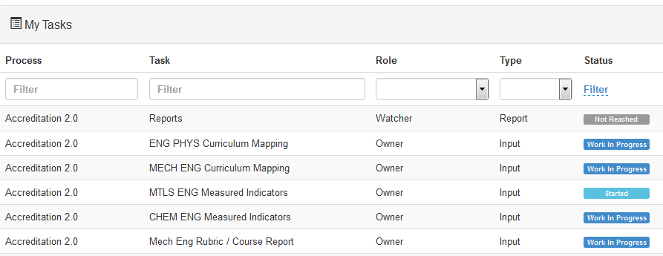

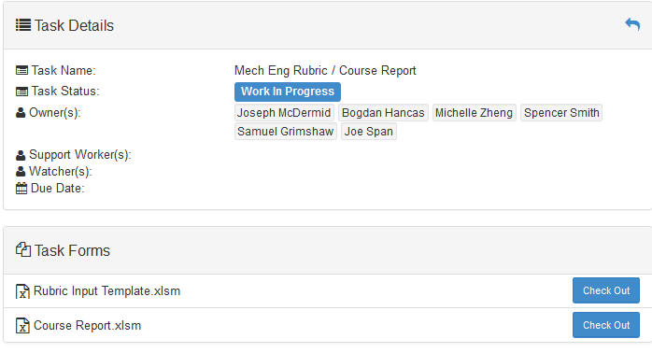

* + 1. Open the file with Microsoft Excel

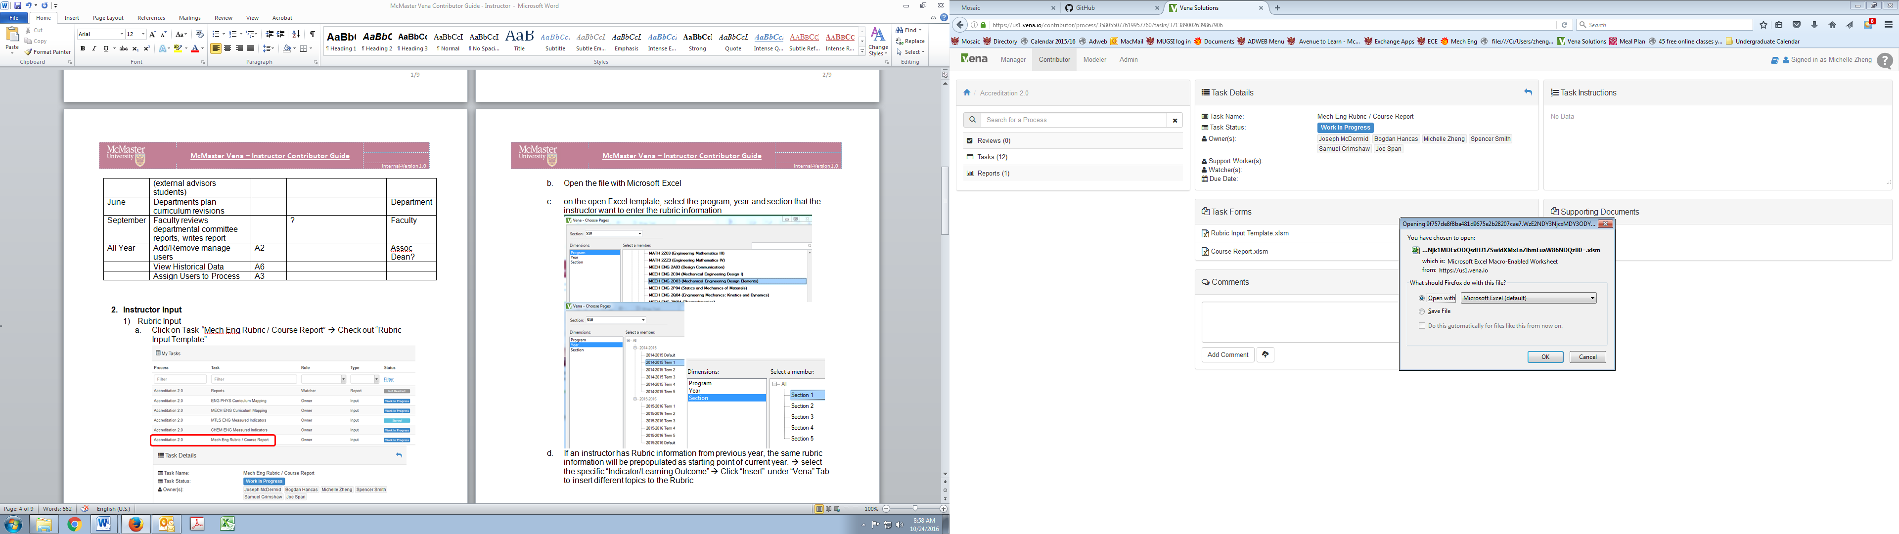

* + 1. Enable editing in the Excel spreadsheet



* + 1. In the open Excel template, select the program, year and section that the instructor wants to enter the rubric information

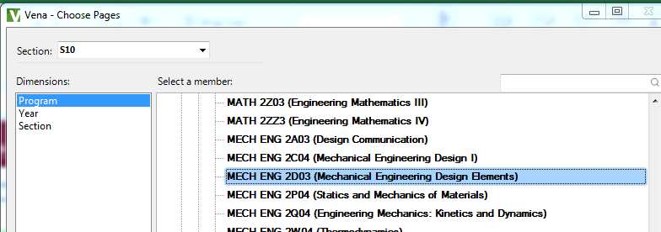

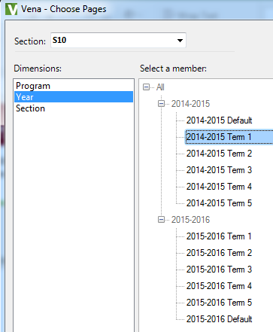 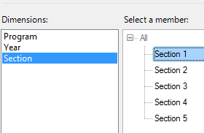

* + 1. Once the spreadsheet has opened, enable the contents of the spreadsheet

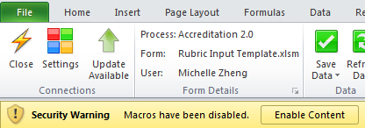

* + 1. If an instructor has Rubric information from previous year, the same rubric information will be prepopulated as starting point of current year.
    2. To add topics (rows) 🡪 select the specific “Indicator/Learning Outcome” 🡪 Click “Insert” under “Vena” Tab to insert different topics to the Rubric

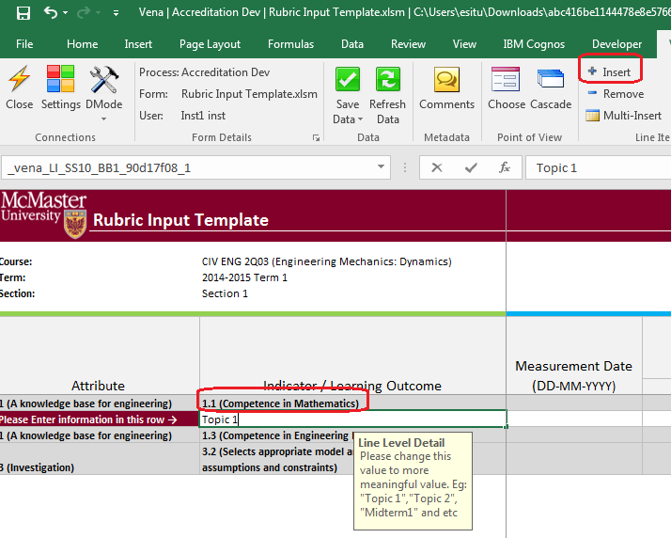

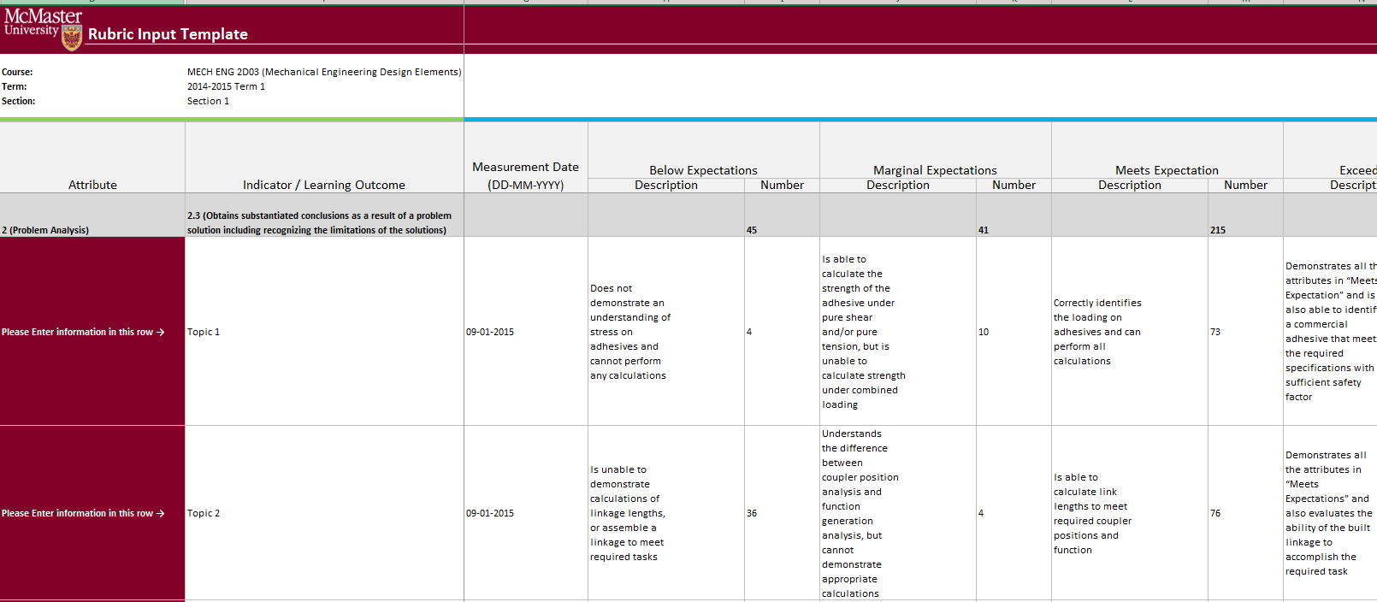

* + 1. An instructor also has the option to attach sample files to the system.

On the right of the Rubric input template 🡪Enter the file name 🡪 click “Comments” under “Vena” tab.

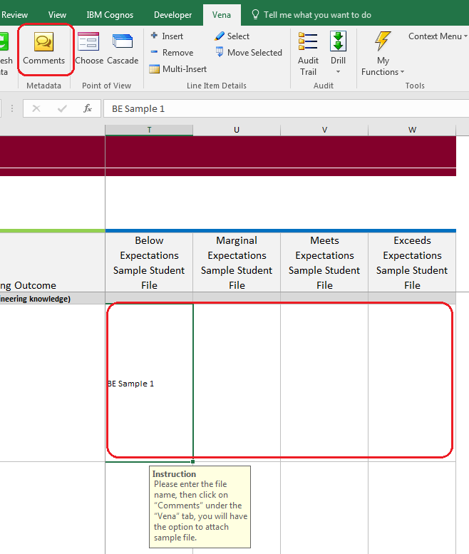

* + 1. On the pop-up windows, click “Attach File” to choose the file you want to attach 🡪 click “Add”

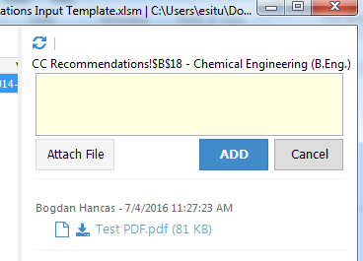

* + 1. Click “Save Data” under “Vena” Tab and “Check in” the file

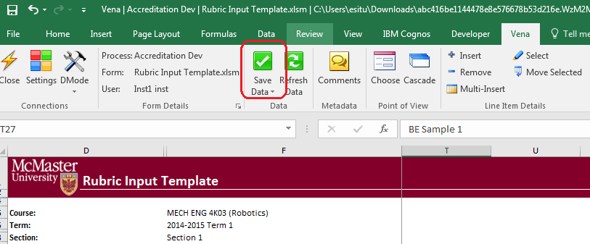

* + 1. Click “Submit” on the Vena front end to finish this task

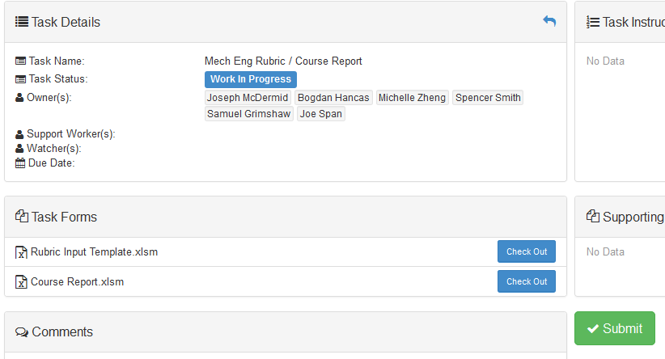

# Reports

* 1. Curriculum Committee Recommendations Report
     1. Shows the recommendations from curriculum committee at both course and program level.
     2. If an attachment is included from curriculum committee, it can be viewed by select the program recommendation area🡪Click on “Comments” under “Vena” Tab (see below picture)

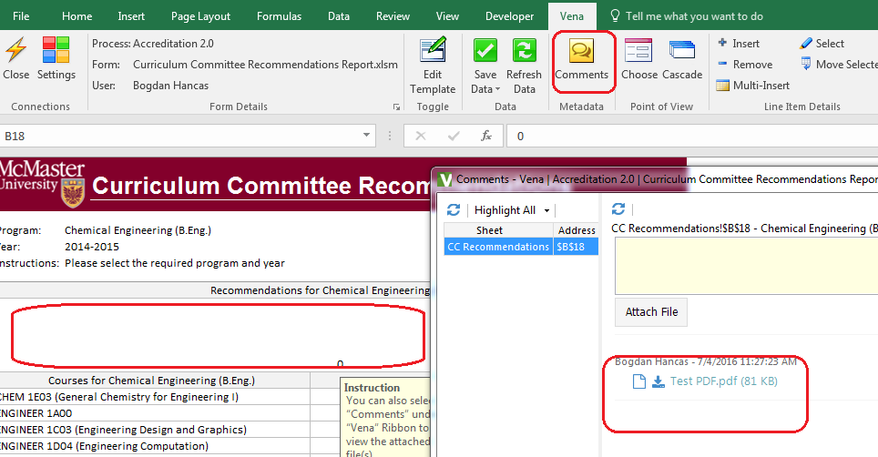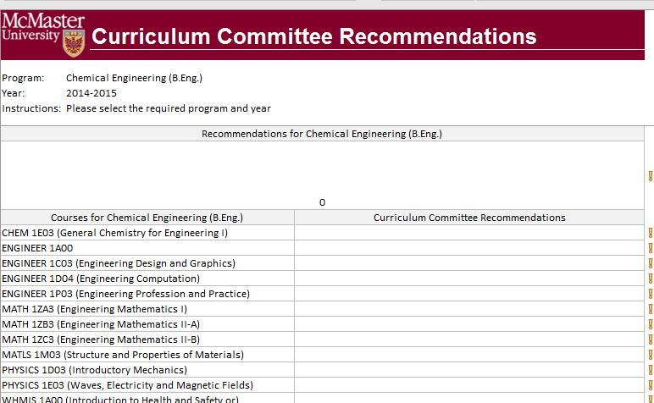

* 1. Course Report

Shows the course outcome and recommendations from curriculum committee, instructors also have the option to enter continuous improvement plan from the course report

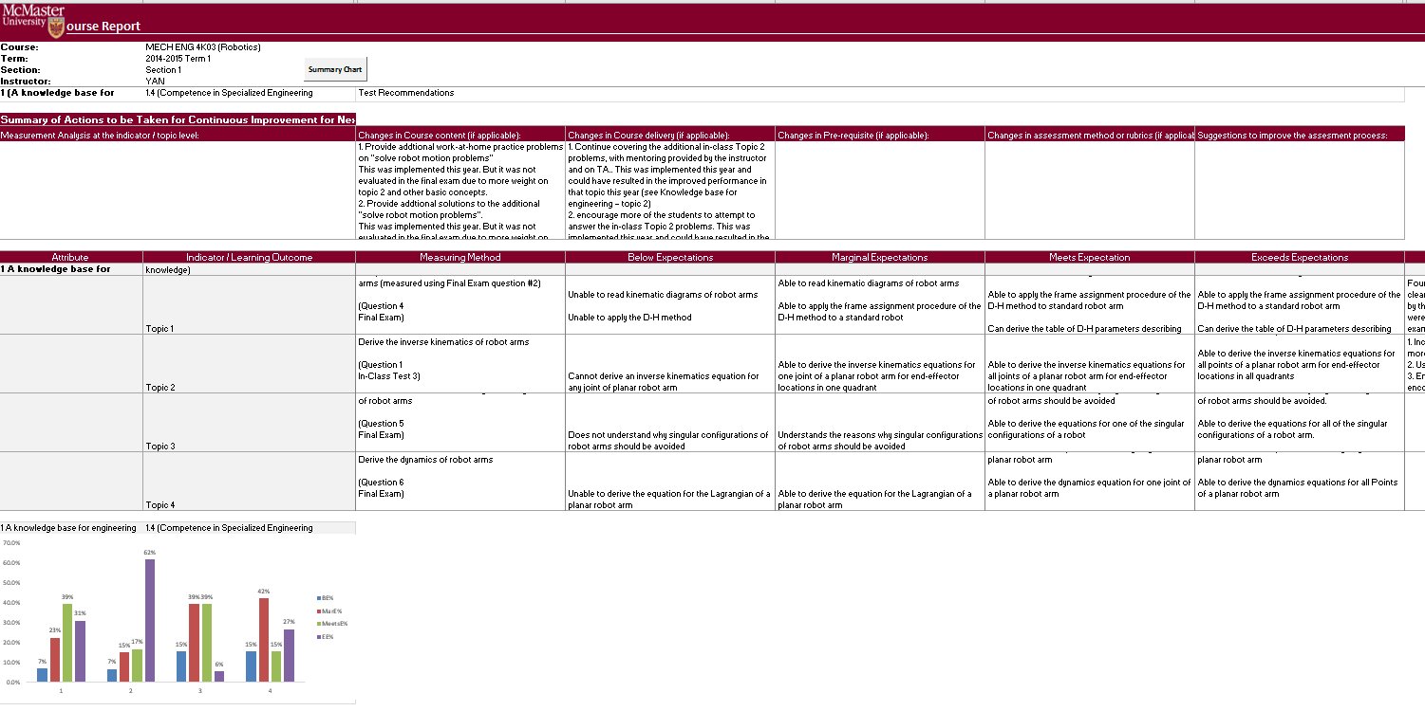

# Other Vena Resources

* 1. For detail documentation, please refer to the previous document.
  2. For Vena training or user manual, please refer to <http://docs.vena.io/>
  3. For other helps please contact:
* Bogdan Hancas: [bhancas@venasolutions.com](mailto:bhancas@venasolutions.com)
* Evan Situ: [esitu@venasolutions.com](mailto:esitu@venasolutions.com)