**Human Computer Interaction Assignment**

**Part 3: Interface Design**

**Student Name:** Seán Smith

**Student ID:** 10339513

**Student Name:** Feargal Karney  
**Student ID:** 10352155

**Motivation for Design**

Following on from our previous report, our website will be designed to provide customers with the ability to rent a movie from our online store. We are motivated to design a respectable website that provides easy functionality and usability to customers of all age groups.

Making a wesbite usable is core to the success of our goals. Designing for usability purporses is of utmost importance when attempting to maintain and increase potential customer satisfaction. Our intentions are to make our website easy to use and making sure that the user can locate what he or she needs without any extensive effort. First impressions are vital to the success of our operations as we want all users to engage with what our website has to offer in a simplistic manner.

We wish to motivate our users to undertake the services we have planned specifically for them. Motivational strategies such as guidence would convince our customers to spend more time on our website than other online competitors. If our users are correctly motivated, we will receive positive feedback and will be motivated as a business to progress in our services.

Due to the service in which we provide, our target audience will range from any particular age. Due to this, our motivation will be based on visualization. Our website will provide an extensive range of movies for all users, however presenting those movies in a fashionable format is what separates our users in terms of age. Our findings listed in our previous report have found that there is strong correlation between young adults and mature adults. We focused strongly on elderly users of the web and the difficulties they encounter with Web interaction. Therefore our motivation towards design techniques will be based on the simplistic interaction of our website and the appearance of our website in terms of layout visualization.

**Choice of Specific Components of the Interface**

We need to define a set of interfaces to specific components so that we can completely change the underlying infrastructure, as more components evolve or become available. We will eventually be in a position to easily change the components of our website and provide strong compatibility between our components and our web application. In order for this process to proceed, we must identify dependencies between components. This will assist in making sensible decisions regarding the choice and code for the framework providing the web application.

The following is a list of components to be used within our website to increase functionality and usability. These features will play a vital role in assisting our elderly users in achieving their aims upon the website.

We incorporate many features introduced in HTML5 in order to provide optimal interaction between our website and our users. These features mainly require the use of common browsers such as Google Chrome or Mozilla Firefox. As our previous report has indicated, 45% of elderly users use Google Chrome and 31% use Mozilla Firefox.

We have combined the features of HTML5 with Twitter’s Bootstrap design. This is a sleek, intuitive and powerful front-end framework, which implements faster and easier web development. Bootstrap includes a CSS file with pre-defined definitions which extend the normal features used within HTML5. It improves the visualization of our layout design. However to adapt Bootstrap to our intended layout, we have edited the provided CSS file with our own code. This is a powerful technique in terms of web development.

1. **Checkbox**

This component will be rarely used within our website and will only be used when requesting information from the user in which we can predict an answer by providing an optional choice. Such as gender or credit card type, these requested answers have a limited choice which we can provide our users to enter. By choosing this procedure, we can reduce possible spelling errors or increase the users understanding of the requested input.

1. **Buttons**

Buttons are common feature in our design technique of our website. Buttons are an excellent choice in narrating all our users (including elderly users) and helping them understand how to proceed throughout the website and accomplish their intended goals. Visually buttons are more simplistic to interact upon due to the clickable area being larger and more accessible than radio buttons or checkboxes. We have decided to use the same color for every button on our website. The reason for this is to reduce the complexity for the user, as they may believe they are required to remember what color the buttons purpose it. As elderly users suffer from memory and vision impairment, this technique overcomes these challenges.

1. **Container Field**

Within every page of our website, we use a container field. This is a

secondary background on top of our original background. We have decided to use this component to indicate to the user that the information provided on this page, is located within this field. This reduces the complexity of the overall page and reduces the search time of the users. The color of both backgrounds will be similar but strong shading in the color will be used in the field background, in order to grab the user’s attention, which is its intended purpose.

1. **Link**

As our users expand their search upon our website, once they have successfully located their movie of choice, they may wish to rent that selected movie. Our website will provide a clickable picture to transfer our users to a page related to the payment procedure. This functionality will assist users of all age groups to reach their target destination on the website. However, we wish to avoid the use of text links, as it has been reported to be difficult task for elderly users. Our buttons provided throughout the page are all links and the colors used helps assist our users in understanding there functionality.

1. **Navigation bar**

We will provide our users with a fully flexible and interactive navigation bar. As this is a big advantage to HTML5 design, it can provide a robust and efficient procedure to search the website in an interactive environment for our users. The coloring technique being used is considered a main priority as it affects the problem factors experienced by elderly users. Designing a functional and clever navigation bar will help overcome those challenges often experienced. We believe a black background is a strong indicator of its importance. As a user scrolls over a word on the bar, the word will change to white to indicate the page they want to click on. Sign in and registration buttons will be located on the bar to reduce searching time for our users. The button colors are a strong green color with white text to make easily readable and our input boxes are colored white which is makes it easily viewable.

1. **Footer**

We use a component provided by HTML5 for legal and understandable purposes. Our footer component provides information about each section of the website, such as who wrote it, date, and copyright data.

1. **Bold Text**

When providing our users with contact information, or requesting payment information, we must highlight each section of information with strong bold text to narrate our users to their desired information or requested input.

1. **Combination Boxes**

The use of combination boxes plays a limited role in the functionality of our website. During the registration process, we will require the users date of birth. As this can has strict limited values for input, elderly users could be unsure of the format in how to provide this information. By using combination boxes for this procedure, the user simply clicks on the data relevant to their answer. The size of our combination boxes are large, the reason for this is to enlarge the clickable area in order to increase simplicity for our elder users who find it difficult to interact with the mouse.

1. **Icons**

We intend to use icons within our clickable buttons in order to signify that by clicking the provided button will advance to the next step of the user’s goal. Bootstrap provides a wide selection of icons to use within HTML. However to avoid complexion, we have chosen to stick to one icon.

1. **Text Input**

Elderly users are documented to rely heavily on keyboard interaction rather than mouse usability. We believe reducing the user of the mouse would be advantageous for us when requesting payment, login or registration details. Assistance in terms of placeholders is provided for input request and in terms of visualization, they are strongly identified by color.

1. **Placeholders**

As we use input boxes on many pages for multiple purposes, we align our boxes with the input being requested by the user. However as our previous report indicates, this may be a challenging procedure for our elderly users and we intend to assist them in every possible way. By using placeholders, we repeat the query being asked within the input area. As the user begins typing their answer, the query disappears. This is a strategic advantage for our users in terms of visibility and understanding.

1. **Images**

Within our collection page and each page designated to a genre, we use images to signify the movies that are available to rent by the user. Each image is assigned a link, which progresses to the payment page, thus advancing the renting process for the user. Each image is assigned the same width and height and is aligned appropriate in order to implement maximum efficient design layout capabilities.

**User Experience Evaluation**

In order for us to create a well defined interface which accomplishes the tasks which elderly users find challenging, we must experience first-hand of how an elderly user interacts with a website. This assessment will assist in our approach in designing an efficient website suited to interaction within the elderly community.

The outside user has provided sufficient information into the difficulties he experienced in completing the following tasks. The results of these assessments confirm vision impairment is the source of interaction difficulty for elderly users. Although these tasks may appear relatively easy from our point of view, it provided us with a knowledgable and ideal approach to our user interface design.

It must be noted that the results of these assessments are not statisically significant but these are anecdotal evidence that do not confirm, nor deny the statistics recorderd in previous documentation.

***Evaluation 1***

**Date:** 01/12/2012 **Location:** Outside user’s household

**Time:** 19:30

**Reviewer:** Seán Smith, aged 21

**Outside User:** Fintan Smith, aged 67

**Exercise:** Create an account on Facebook

**Tasks undertaken:**

1. Go to [www.facebook.com](http://www.facebook.com)
2. Fill in required details
3. Click ‘sign up’
4. Click ‘skip this step’
5. Fill in profile information
6. Click “save and continue”
7. Find “DCU” facebook page
8. Logout of account

**Results:** This is a timed procedure

Task Reviewer Outside User

1. 9 seconds 35 seconds

2. 36 seconds 1 minute 30 seconds

3. 2 seconds 7 seconds

4. 5 seconds 14 seconds

5. 27 seconds 43 seconds

6. 2 seconds 2 seconds

7. 6 seconds 24 seconds

8. 4 seconds 3 minutes 18 seconds

**Comments:**

Task Comment

4. User had difficulty locating ‘skip this step’ link due to text size

being too small.

5. Buttons not understandable on side of input box.

Buttons are related to pubic or private settings.

This created complexity for the user.

8. Unable to locate “Logout” on main bar of home page.

This required assistance from assessment reviewer to

complete this task.

**Suggestion from outside user:** On Home page, “Login” button clearly identifiable.

On Logout page, a “Logout” button should be provided

on main bar for similiar simplicity.

***Evaluation 2***

**Date:** 02/12/2012 **Location:** Outside user’s household

**Time:** 15:30

**Reviewer:** Feargal Karney, aged 20

**Outside User:** Fintan Smith, aged 67

**Exercise:** Log in and watch a selected movie on Netflix

**Tasks undertaken:**

1. Go to [www.netflix.com/ireland](http://www.netflix.com/ireland)
2. Click “member sign in”
3. Enter email and password details
4. Unclick “remember me”
5. Click “continue”
6. Scroll over “Genres” on navigation bar
7. Click “Thrillers”
8. Locate “The Usual Suspects”
9. Click on movie

**Results:** This is a timed procedure

Task Reviewer Outside User

1. 10 seconds 37 seconds

2. 2 seconds 15 seconds

3. 12 seconds 42 seconds

4. 1 second 19 seconds

5. 1 second 3 seconds

6. 2 seconds 9 seconds

7. 2 seconds 23 seconds

8. 12 seconds 24 seconds

9. 2 seconds 1 second

**Comments:**

Task Comment

2. “member sign in” button not identifiable, due to color

scheme used.

4. Unable to locate “remember me” option due to text size being

too small.

7. Navigation bar difficult to interact with due to sub-menu

disappearing when mouse moved too quickly.

**Suggestion from outside user:** Important querier, such as “remember me” option

should be underlined or highlighted in bold to help

attract attention of user.

Poor color scheme used on “member sign in” button and background resulted in vision difficulty

* “member sign in” button – dark red
* background color - red

**Layout of Interface**

In relation the the previous listed components, the goal of our design is ensure the user has completed his/her desired task. The two tasks in particular are:

* Register/sign up to website.
* Order a movie to rent.

While focusing our main attention towards these tasks, we must design an overall layout for the website. Problem barriers listed in our previous report indicate the challenges we encounter in terms of our elderly users. Concentration, memory, visualization, interaction and functional limitations have proven to be the main issues experienced by elderly users who attempt to interact with the Web. By taking their age-related issues, such as AMD, cataracts and neurological symptomsm, into consideration, we have designed an appealing interface that reduces the effects of these issues to a minimum.

The solutions to these problems, in terms of layout, are listed below.

* Uncomplicated registration process.
* Simplistic and narative website layout.
* Strong use of colors in design.
* Reduction in unnecessary website features.
* Large text to increase visability.
* Bold text to indicate importance.

The following are mockups of each page of the website and a description of the layout and how to overcomes the challenges experienced by elderly users.

***Home Page***

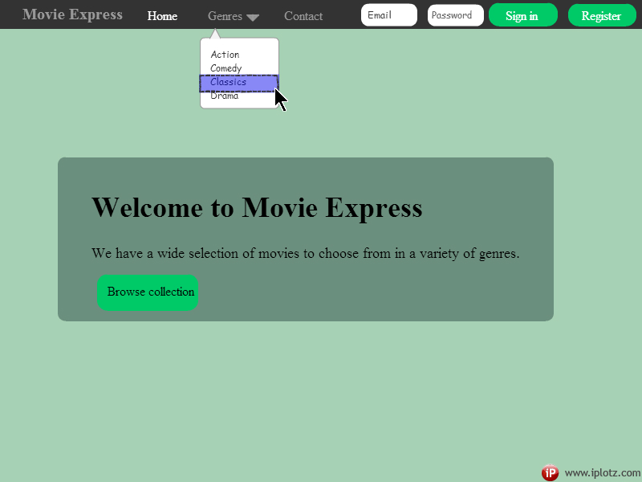

***Collection Page***

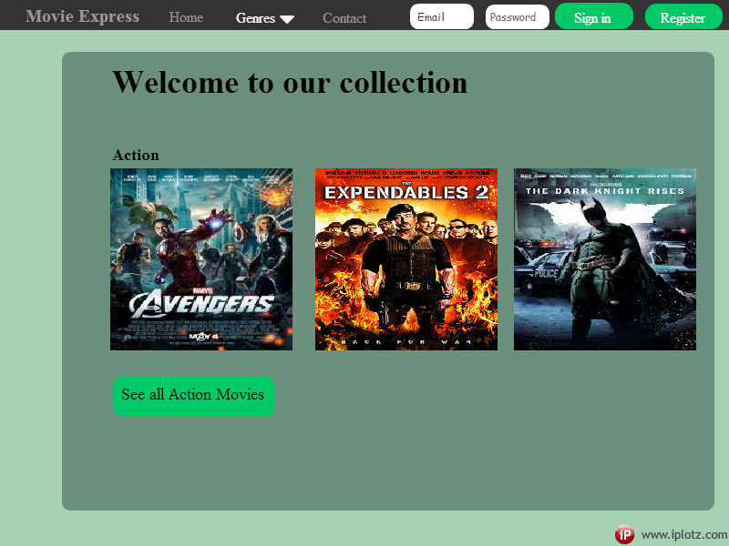

***Contact Page***

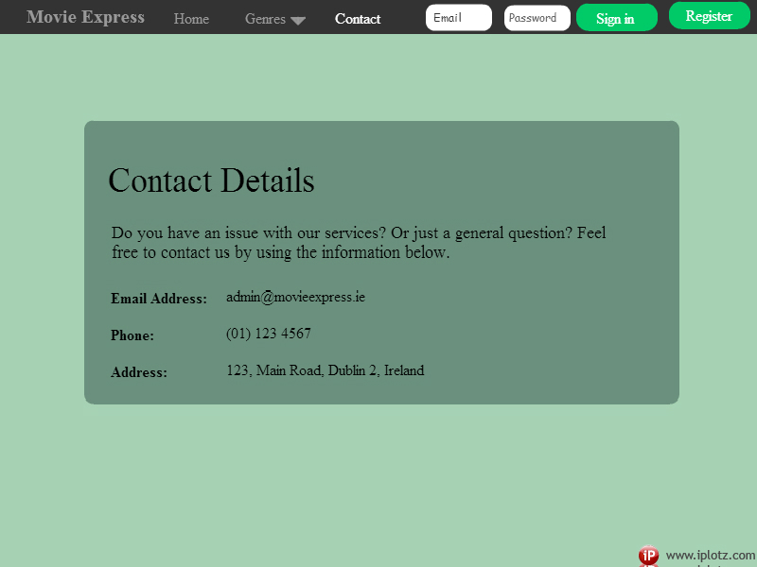

***Confirmation Sign In Page***

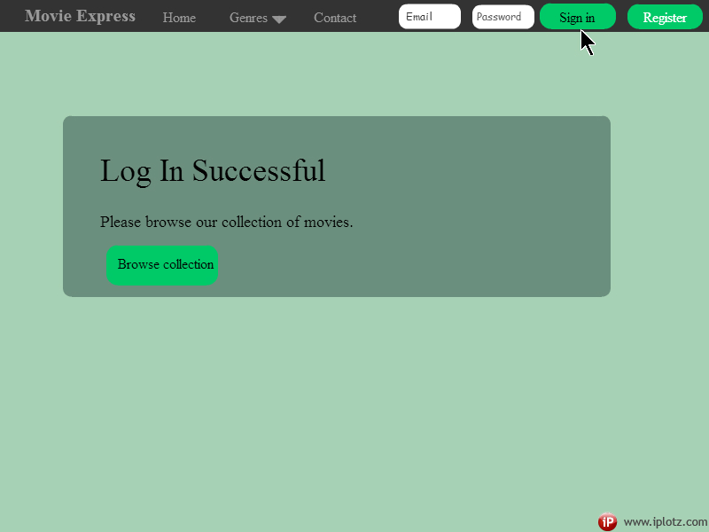

***Registration Page***

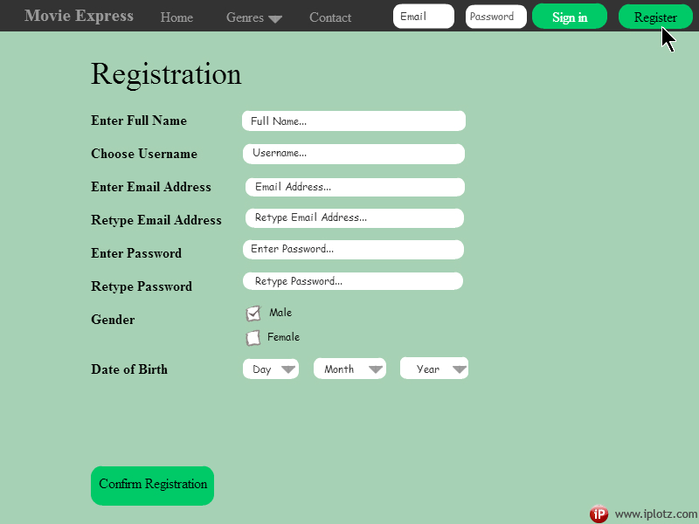

***Confirmation Registration Page***

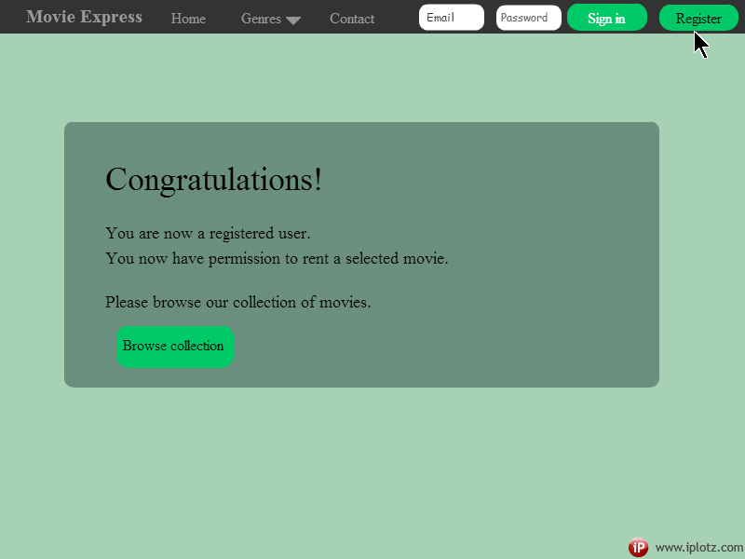

***Payment Page***

