UNIVERSITY OF EAST LONDON
SMITH VINCENT PAUL VALLURU
2522514
DS7006 Quantitative Data Analysis (QDA)
u2522514_DS7006_CW2_final

QUANTITATIVE DATA ANALYSIS (QDA)

Abstract

This research project uses a sustainable and data-driven methodology to examine the complex patterns of COVID-19 deaths throughout local authority regions in England. With the use of a wide range of social and economic factors obtained from the reliable "NOMIS Data Portal" and "data.gov.uk," our analysis seeks to offer a comprehensive analysis of the subtleties contained in the dataset. The validity of our conclusions is guaranteed by our reliance on statistics regarding the death rate attributable to the Covid pandemic. The investigation's findings are provided in an approachable "SQLite dictionary," which makes it easier for R programs to analyze them further.

The dataset has been converted into a CSV file to improve evaluation precision. This has set the stage for a thorough investigation of reliability, the development of hypotheses, and the building of a regression model. The study stresses how crucial it is to carefully examine the dataset to guarantee accurate and significant results. This thorough method makes it possible to obtain trustworthy data, which advances our knowledge of the variables affecting COVID-19 death rates in English local government districts.

Table of Contents
Introduction 6
Literature Review 6
Dataset Evaluation 7
Databases 7
Data Quality Analysis and Data Cleaning 10
EDA 13
Data Visualisation 15
Measures of Central Tendency and Probability 18
Formulation and Testing of Hypotheses. 21
Derivation of Statistical Models 23
Evaluation of Quantitative Analyses 31
Conclusion 32
References 34

List of Figures
Figure 1: Process of Creating the database based on the dataset 7
Figure 2: merging the table 7
Figure 3: Group by based on the table 8
Figure 4: Max Cast from Covid Table 8
Figure 5: Overall Average Cast 9
Figure 6:Order by death command 9
Figure 7: Reading the data 10
Figure 8: Structure of Data 10
Figure 9: Missingvalue 11
Figure 10:Duplicated Rows 12
Figure 11: Descriptive Summary 12
Figure 12:Summary of EDA Statistics 13
Figure 13: Code for Implementing Scatter Plot 13
Figure 14: Code or Stacked Plot for health categories by section 14
Figure 15: Line Plot for Death Numbers over time 14
Figure 16: Correlation Analysis 15
Figure 17: Scatter Plot of Good Health vs Age 15
Figure 18:HealthCategories by Regions 16
Figure 19: Pie Chart based on the dataset 17
Figure 20: Scatter Plot for Perecnetage Toddlers vs Percentage of Teenagers 17
Figure 21: Correlation Map 18
Figure 22: Code for measuring central tendency 18
Figure 23: Measures of Central Tendency 19
Figure 24: Measurement of Probability 20
Figure 25: Code for Probability and printing the results 20
Figure 26: Code for Non-Parametric Test 21
Figure 27: Output for Kolmogorov Smirnoff test 21
Figure 28: Fitting Anova Model code and summarization code 22
Figure 29: Output of anova_model 22
Figure 30:Interpreation of ANOVA Model 23
Figure 31: Simple Linear Regression code and Multiple regression code 23
Figure 32: Scatter Plot for Simple Linear Linear Regression 23
Figure 33: Residual vs Fitted Values 24
Figure 34: Cook distance for Multiple Regression 25
Figure 35: Partial Regression Plot for Multiple Regression 25
Figure 36: Code for Decision Tree Model 26
Figure 37: Printing Decision Tree Model 26
Figure 38: Summary of Linear Model 27
Figure 39: R Mean Square 27
Figure 40: Mean Square Result 28
Figure 41: Number of Clusters based on elbow Method 28
Figure 42: K Means Clustering 29
Figure 43: Summary Of K means Model 30
Figure 44: Output of Simple Regression and Multiple Regression Model 30

Introduction
The “patterns of COVID-19 deaths” by the local authority area may be reported in a sustainable way in accordance with the situation in England, which is the case in this research study. A variety of social as well as financial variables from the “NOMIS Data Portal” or “data.gov.uk” are used in this research in order to conduct an appropriate analysis of the dataset. In terms of the material that was being addressed in this most recent research investigation, this technique is highly dependable. According to the mortality rate that has been attributed to the Covid epidemic, the medical authorities in England have the capacity to get information that may be trusted. The findings of the research study, on the other hand, will be able to include the information by means of a “SQLite dictionary”. On the other hand, it has the potential to have the ability to extract reliable data from it for the purpose of analysis in R programmes. In order to ensure that the data is submitted for an accurate evaluation, this study has taken the data and saved it as a CSV file. The relevant data set has to be evaluated for the technique of "explored, reliability, hypothesis raised as well as the properly tested, model of regression built". This is additionally due to the fact that it is possible to provide this information here.

Literature Review
Comprehending the effects of the global COVID-19 pandemic on many locations and groups has required extensive investigation. The virus has been responsible for a considerable number of deaths in England, one of the most impacted areas. Effective public health interventions in England depend critically on determining the patterns of COVID-19 deaths by local authority regions. With an emphasis on the value of utilizing trustworthy datasets like those found on data.gov.uk and the NOMIS Data Portal, this literature review explores current study approaches and conclusions.
Utilizing a variety of socio-economic variables to understand the subtleties of COVID-19 mortality trends is a common theme in recent research. Researchers have shown relationships between mortality rates and characteristics including healthcare accessibility, population density, and income levels by combining data from reliable sources like the NOMIS Data Portal. These extensive datasets offer a solid basis for analysis, guaranteeing that conclusions are applicable.
An essential component of epidemiological research is data dependability. The reliability of the fatality rate information pertaining to the COVID-19 pandemic in England is emphasized in the introduction. Medical authorities are essential in gathering and sharing this information while making sure that it complies with strict scientific guidelines. This confidence in the accuracy of the data is essential for deriving insightful conclusions and creating potent anti-virus methods.
Complex dataset analysis has been made easier by technological developments. The integration of advanced analytical tools in COVID-19 research is highlighted by the statement of the use of a "SQLite dictionary" and its interoperability with R programs. With the use of these instruments, scientists can gather, handle, and evaluate enormous volumes of data, revealing complex patterns and trends that could be essential to comprehending the dynamics of the epidemic.

Dataset Evaluation

Databases
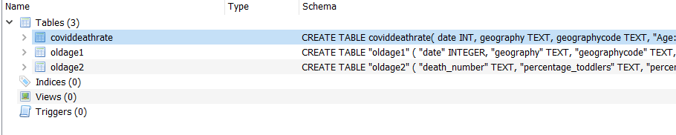

Figure 1: Process of Creating the database based on the dataset
(Source: Self-Created)
The schema contains definitions that are related to the following three tables: "covid death rate," "oldage1," and "oldage2." The "COVID death rate" table has a number of columns that are related to data on health and demographics. The perspective of Statistics on old age and death are included in the columns of the "oldage1" and "oldage2" tables. There are no views, triggers, or indices. The respective code visualizes the arrangement of the data in these tables, naming the columns and data types for the COVID-19 death rate as well as ageing-related information. This contains Important details such as date, location, age groups, death counts, and percentages are included in the schema.
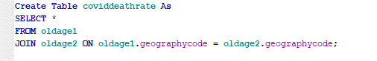

Figure 2: merging the table
(Source: Self-Created)
As per the view of Figure 2, the “merging the table” can be noted reliably. This has been computed by “SQLite dictionary”.
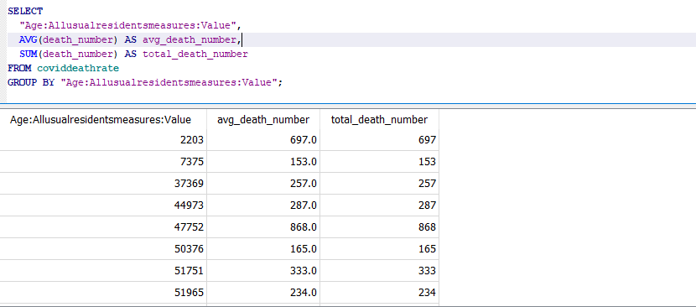

Figure 3: Group based on the table
(Source: Self-Created)
As per the view of Figure 3, the “Group by based on the table” can be noted sustainably. This result has been computed by “SQLite dictionary”. This table presents the “total_ number” based on the selected data set for the research.
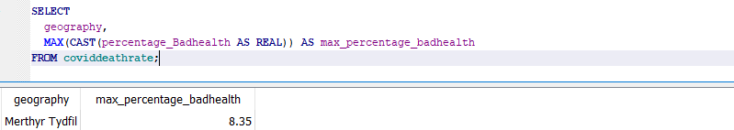

Figure 4: Max Cast from Covid table
(Source: Self-Created)
Based on the view of Figure 4, the “Max Cast from Covid table” can be presented sustainably. This result has been computed by “SQLite dictionary”. This table is presenting the “max_percentage_badhealth” based on the selected data set for the research.
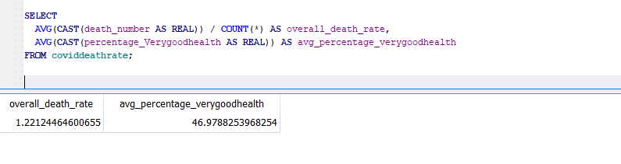

Figure 5: Overall Average Cast
(Source: Self-Created)
Based on the view of Figure 5, the “Overall Average Cast” can be presented in a sustainable way. This result has been computed by “SQLite dictionary”. This table is presenting the “overall death_rate and the avg_percentage _very goodhealth” based on the selected data set for the research.

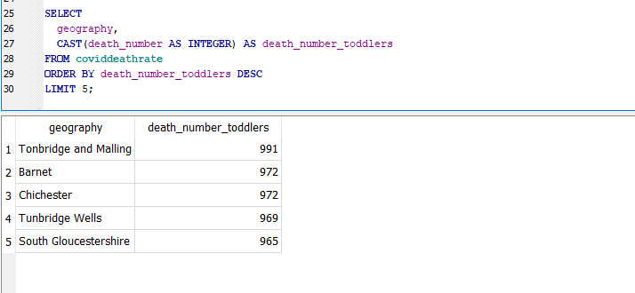

Figure 6: Order by death command
(Source: Self-Created)
The data is derived from a table called covid death rate that uses this SQL code. It implements two columns that are geography and death_number that it uses as death_number_toddlers after casting as an integer. The death_number_toddlers column is then used for sorting the data in descending order. The result set is limited to the top that is related to 5 records that is by using the LIMIT 5 clause.

Data Quality Analysis and Data Cleaning
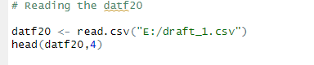

Figure 7: Reading the data
(Source: Self-Created)
The following R code evaluates data from a CSV file called "draft_1.csv" that is located at "E:/" using the read.csv function. The variable that is named datf20 is analyzed with the data. The dataset's first four rows are then implemented using the head function to provide the reader with an idea of the data structure.
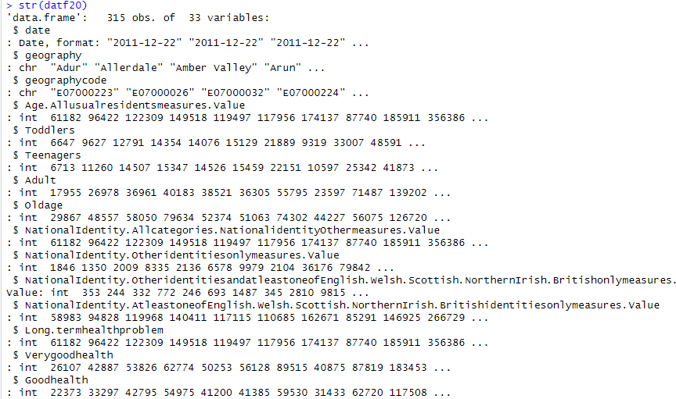

Figure 8: Structure of data
(Source: Self-Created)
The respective R data frame that is defined as{datf20}'s structure is implemented in the output of `str(datf20)`. There are 33 variables and 315 observations that are represented in the output. The perspective of Date, location, national identification, and population statistics is unique for a given age group, health indicators, death toll, and other percentages pertaining to age groups, health, and COVID mortality rates are among the variables. There are different data types that are used, such as character, numeric, and date. This is related to the process of the existence of a two-level factor variable called `cluster}. This implies that the dataset has been clustered or grouped in some way.

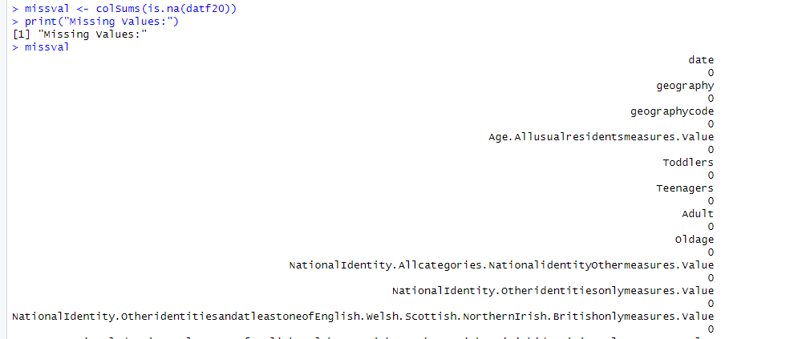

Figure 9: Missingvalue
(Source: Self-Created)
The Respective output implements the process of data completeness by showing that there are no missing values in the dataset. This is for dependable insights and correct analysis as there must be no missing values. The dedicated results are ensured by a clean and evaluated dataset that is because incomplete data might lead to biased conclusions. This is especially significant as when there are zero missing entries for every variable, such as "date," "geography," and different numerical measures.
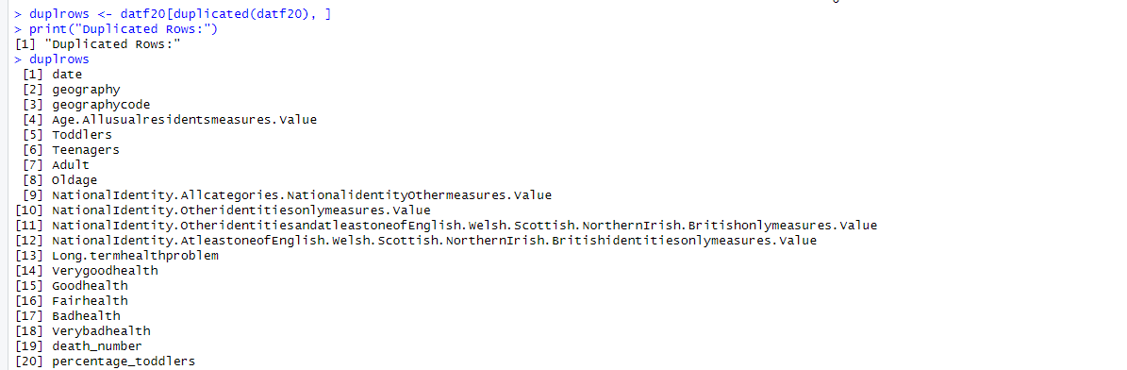

Figure 10:Duplicated Rows
(Source: Self-Created)
This is an important step in the process of evaluation of the quality of the data which is having the code scan the dataframe for duplicate entries. The perspective of repeated rows has the potential to skew statistical analysis and provide inflated findings. This is important for knowing that there are no duplicate rows—"<0 rows>"— that is the process of indicating that every row is distinct. This is the process depending on the process of the data and the goals of the analysis. The investigators have to choose whether to keep duplicating or remove them when they are found.
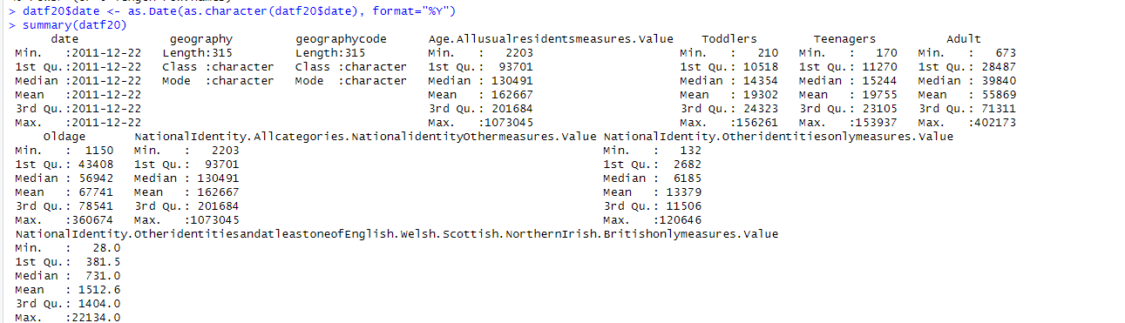

Figure 11: Descriptive Summary
(Source: Self-Created)
The thorough summary of the statistical characteristics of the dataset that is given by the summary (datf20). The perspective of Summary data that are shown for each variable that is such as "Toddlers," "Adult," "death_number," and more. The mean, the first, second, and third quartiles, as well as the minimum and maximum values, are among them. The 'Toddlers' variable, for example, has a mean of 19,302, a maximum of 156,261, and a low of 210, indicating significant variability. The perspective of the 'percentage_coviddeath' variable shows variation in COVID death rates among regions, ranging from 0.02% to 31.64%.

EDA
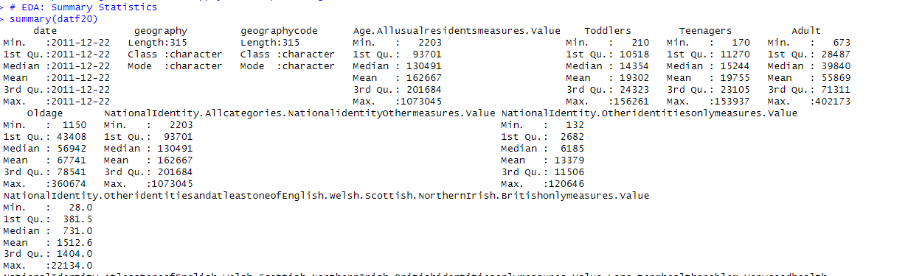

Figure 12:Summary of EDA Statistics
(Source: Self-Created)
The summary statistics that are proving offer a thorough rundown of the dataset and highlight important discoveries. The period covered by the dataset is December 22, 2011, to December 22, 2011. The process of descriptive statistics implements a great deal of variety that is implemented in the 'Toddlers' variable which has values between 210 and 156,261. The distributions of health indices, such as "Verygoodhealth" and "Badhealth," vary. This elaborates that the variable 'percentage_coviddeath' exhibits a mean value of 0.51%, indicating variations in COVID mortality rates.
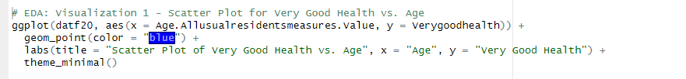

Figure 13: Code for Implementing Scatter Plot
(Source:’Self-Created)
The Code Description that this code segment investigates the perspective of the relationship that is between age and the prevalence of extremely good health by creating a scatter plot implementing the ggplot2 package.
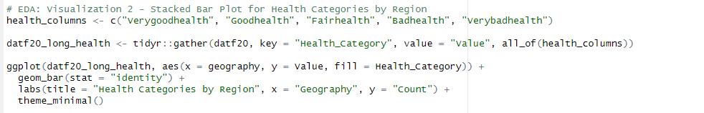

Figure 14: Code or Stacked Plot for health categories by section
(Source: Self-Created)
The following code is the Description that produces a stacked bar plot. The distribution of the health categories that are based on the following categories (very good, good, fair, bad, and very bad) throughout different regions is shown in this plot.
The figure makes it easier to compare the common various health categories that are in each area. This is with stacked bars that it can quickly evaluate the general health pattern across several regions, possibly identifying differences or similarities in medical disorders.
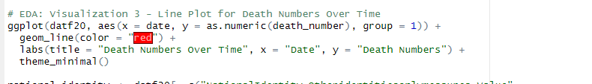

Figure 15: Line Plot for Death Numbers over time
(Source: Self-created)
This part uses ggplot2 for constructing a line plot that is with the date indicated on the x-axis and the death numbers' numerical values on the y-axis for showing the temporal trends in death numbers over time. This is throughout the given period, trends or patterns in the death rates can be found using this figure.

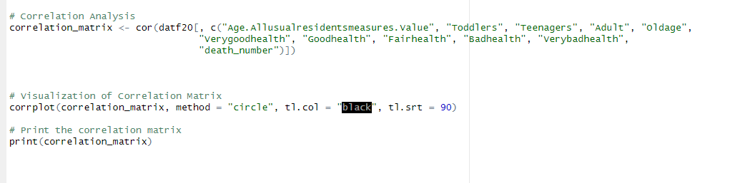

Figure 16: Correlation Analysis
(Source: Self-Created)
The perspective of the correlation matrix that is for certain variables pertaining to age, health, and death rates is calculated using the cor function. The correlation matrix explains the process of showing how variables are linearly connected numerically. The intensity and direction of links are shown by positive or negative correlation coefficients that aid in the process of analysts in comprehending the interdependencies between various dataset components.

Data Visualisation
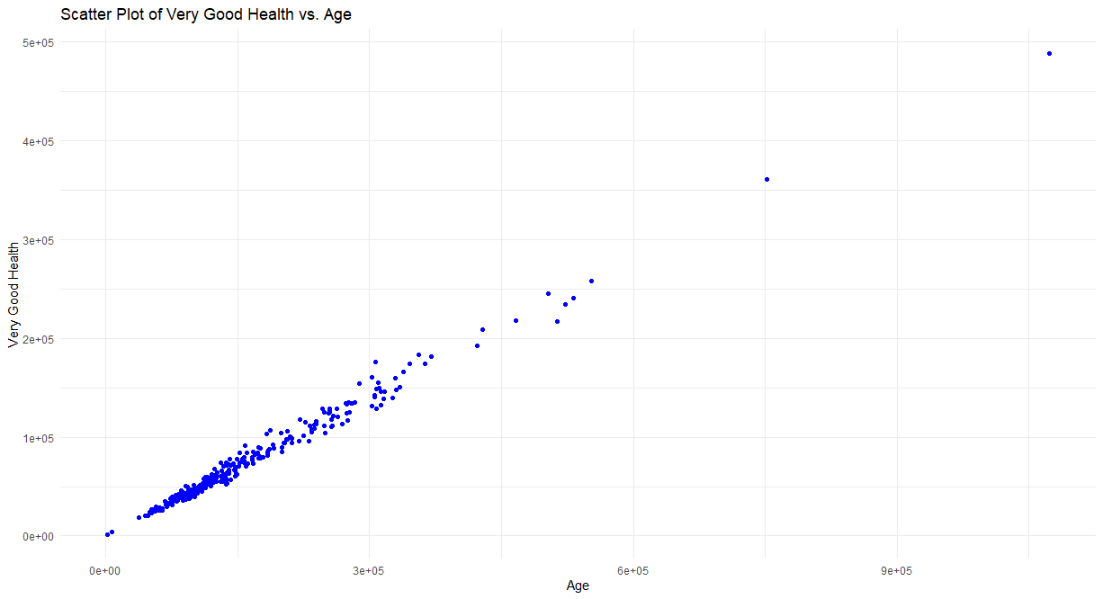

Figure 17: Scatter Plot of Good Health vs Age
(Source: Self-Created)
The scatter plot implies that the number of people in extremely good health and age have a positive link. There is an overall trend that is showing an increase in the number of people reporting very good health (y-axis) as age increases (from 0 to 600,000 on the x-axis). The perspective of Significant variation does, however, exist, highlighting the fact that a variety of factors other than age can have an impact on health. It's important to understand that correlation does not indicate causation; a person's health state is influenced by a variety of factors, including lifestyle choices, genetics, and access to treatment. Thus, although there is a correlation between age and excellent health, there are other factors that affect total health results.

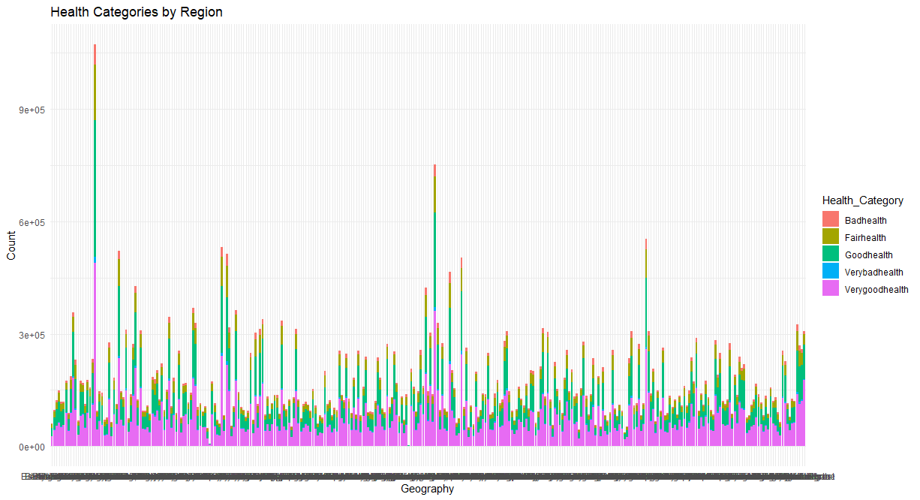

Figure 18:HealthCategories by Regions
(Source: Self-Created)
The following information is supplied that shows the perspective of regional counts for several health categories. This is a numerical code that is assigned to each region displayed in the graph. The distribution of the health categories is explained in "Badhealth," "Fairhealth," "Goodhealth," "Verybadhealth," and "Verygoodhealth" which is shown visually by the bar plot. The number of people that is displayed in each health category is shown on the y-axis whereas the region codes are shown on the x-axis. This is to distinguish that between the various health categories, the bars are colour-coded
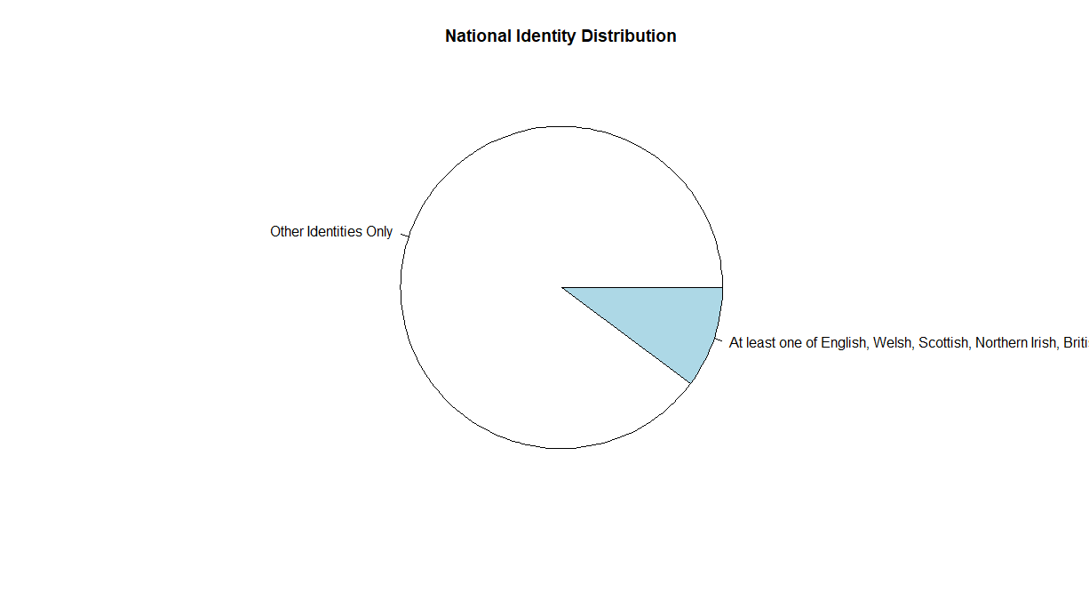

Figure 19: Pie Chart based on the dataset
(Source: Self-Created)
The described information that is given is related to the process of how national identification categories are distributed. Two primary categories are visually represented in the pie chart that is related to "Other Identities Only" and "At least one of English, Welsh, Scottish, Northern Irish, British." The piece of the piechart is used for representing each group and the size of each slice indicates the percentage of the population that belongs to that specific national identity.

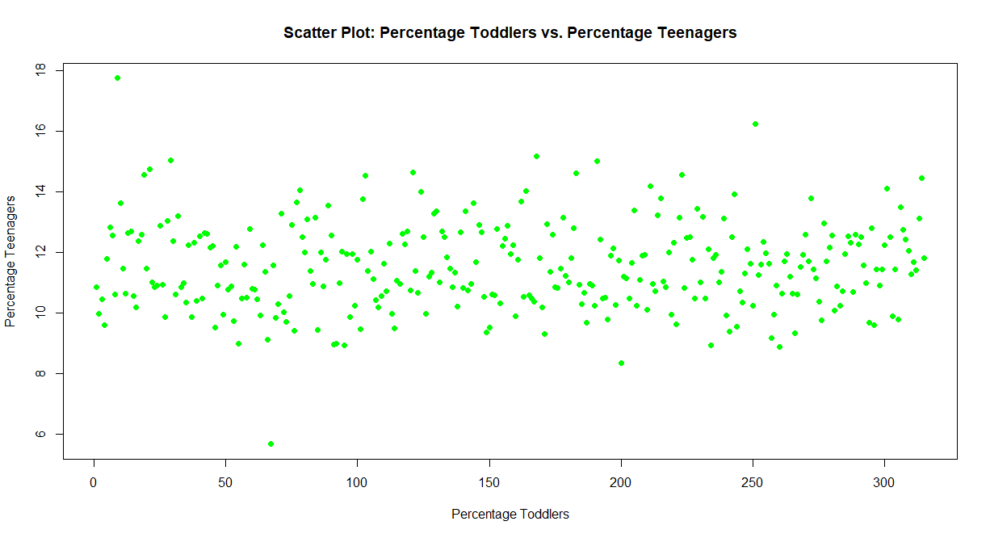

Figure 20: Scatter Plot for Perecnetage Toddlers vs Percentage of Teenagers
(Source: Self-Created)
The relationship that is between these two factors is visually explored in the scatter plot for the percentage of toddlers vs. teenagers. This is with the percentage of toddlers displayed on the x-axis and the percentage of teenagers on the y-axis.

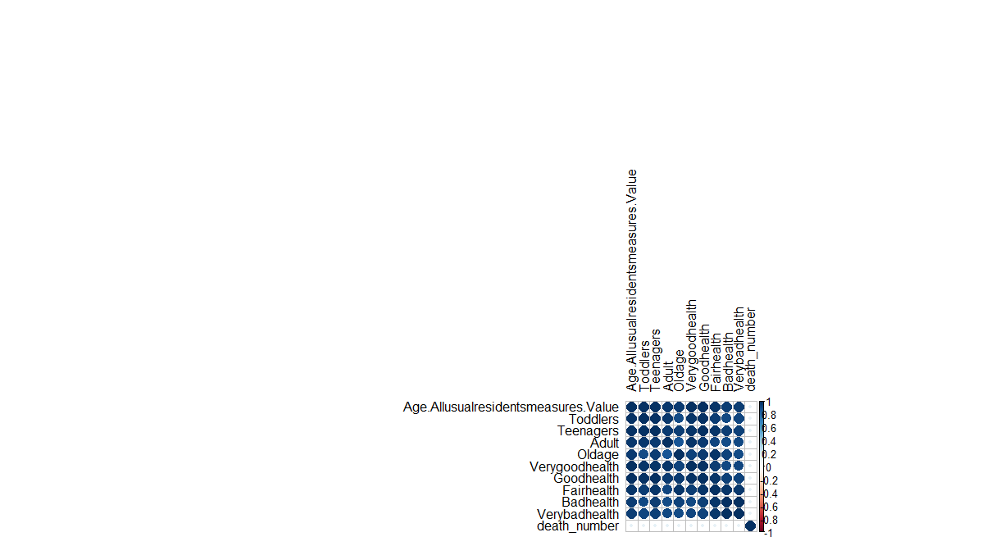

Figure 21: Correlation Map
(Source: Self-Created)
The respective data seems to represent the different variables that include age-related measures, health categories, and death numbers. The numbers following each variable suggest their values or counts that is by the process of analyzing correlations would reveal how these variables interrelate in the dataset.

Measures of Central Tendency and Probability
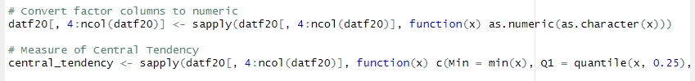

Figure 22: Code for measuring central tendency
(Source: Self-Created)
This is related to the data frame {datf20} that which the function transforms factor columns to numeric values. The implication is applied for every column, starting with the fourth and ending with the last, using the sapply function. The sapply function is then used to determine the measure of central tendency (Min, Q1 quantile) for each numeric column within the given range.

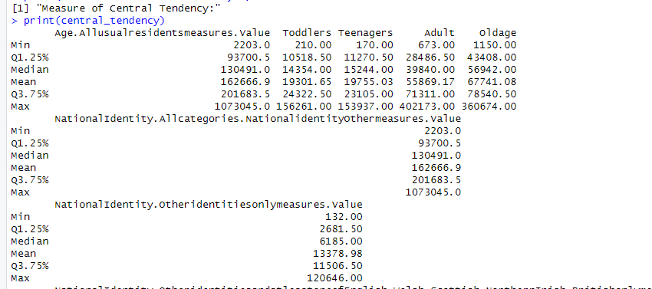

Figure 23: Measures of Central Tendency
(Source: Self-Created)
The output shows that the central tendency measure (Min, Q1.25%, Median, Mean, Q3.75%, Max) is for the age and national identification variables. This is related to "Age.Allusualresidentsmeasures.Value," for instance, the lowest age is 2203, the median age is 130491, and the highest age is 1073045. Regarding measures of national identity, comparable numbers are given.

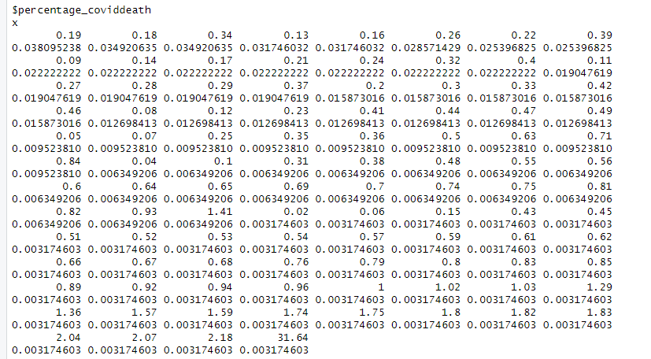

Figure 24: Measurement of Probability
(Source: Self-Created)
The code that is provided is implemented to be a set of numbers that is associated with a variable called "percentage_coviddeath." The percentage is represented by each value as the distribution of percentages for a specific variable that is perhaps connected to COVID-19 death.
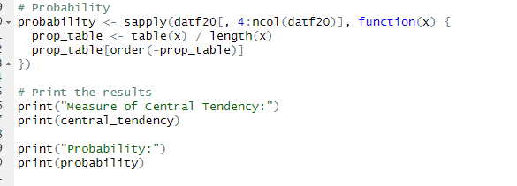

Figure 25: Code for Probability and printing the results
(Source: Self-Created)
The respected probability distribution that is for every variable in the datf20 data frame's columns 4 to last is determined by the code. This is applied to a function that helps in the process of determining the percentage of each unique value in each variable using the sapply function. The probability distribution and central tendency measure for each variable are displayed in the printed findings.

Formulation and Testing of Hypotheses.
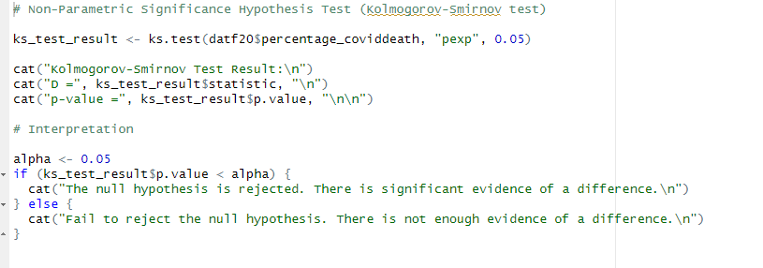

Figure 26: Code for Non-Parametric test
(Source: Self-Created)
This is using a 5% significance threshold that is the code performs a Kolmogorov-Smirnov test than is by comparing the percentage_coviddeath distribution related to a theoretical exponential distribution. The test produces a p-value of 0 and a statistic (D) with an unknown value. The interpretation determines whether to reject the null hypothesis that is based on the significance level by determining whether the p-value is less than 0.05.
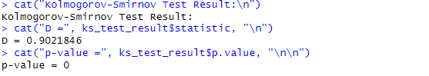

Figure 27: Output for Kolmogorov Smirnoff test
(Source: Self-Created)
The figure describes the Kolmogorov-Smirnov test that is described with a p-value of 0 and a test statistic (D) of 0.9021846 conducted by the code. This is related to the test a theoretical distribution that is typically a normal distribution that is compared to the sample distribution. The low p-value points to a possible departure from normalcy by demonstrating a significant difference between the two distributions.
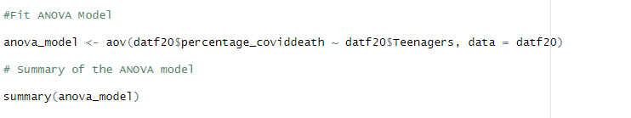

Figure 28: Fitting Anova Model code and summarization code
(Source: Self-Created)
There is a statistically significant difference in correlation that is between the answer variable "percentage_coviddeath" and the variable "Teenagers". This is in accordance with the analysis of variance (ANOVA) results. This is related to a matching of the p-value of 0.00772, as the F-statistic of 7.191 indicates that there is an important evaluation of the difference in the means of 'percentage_coviddeath' between the levels of 'Teenagers.' A significant amount of the variance (22.7) can be explained by the model that indicates the significance of "Teenagers" in predicting "percentage_coviddeath."
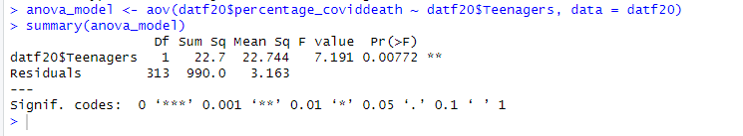

Figure 29: Output of anova_model
(Source: Self-Created)
The findings of the analysis of variance (ANOVA) that is shown is a statistically significant correlation between the response variable, percentage_coviddeath, and the variable, teenagers. The F-statistic of 7.191 and the related p-value of 0.00772 indicate that there is a significant difference in the means of 'percentage_coviddeath' between the levels of 'Teenagers.' The significance of "Teenagers" in predicting "percentage_coviddeath" is highlighted by the model's ability to explain a sizable fraction of the variation (22.7).

Figure 30: Interpretation of ANOVA Model
A low p-value of 0.0077 in the ANOVA findings indicates a statistically significant overall effect. This is according to an analysis of variance (ANOVA) as this indicates that the group means differ significantly from one another. The observed variance that is between groups is to be the result of evaluation as indicated by the p-value that is below the traditional significance threshold of 0.05.

Derivation of Statistical Models
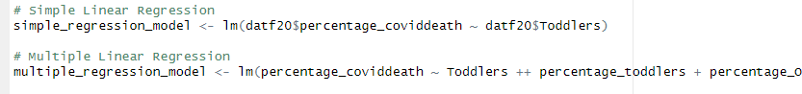

Figure 31: Simple Linear Regression code and Multiple regression code
Two code snippets, an individual for multiple linear regression and one for basic linear regression, are displayed in the image. The value of the variable "datf205percentage" and "covid death” is regressed on the variable “datf205Toddlers” using the basic linear regression procedure, which produces a model termed simple_regression. Toddlers, percentage of toddlers, and percentage_o are the variables on which the variable percentage of “covid death” is regressed.

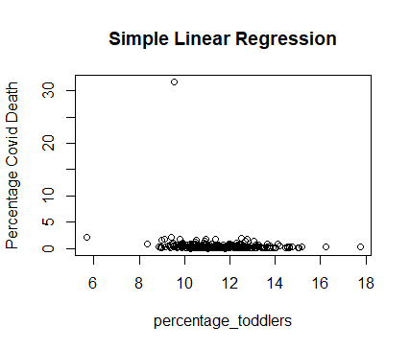

Figure 32: Scatter Plot for Simple Linear Linear Regression
(Source: Self-Created)
This image demonstrates a scatter plot, which is a graph that illustrates the association between two variables in an elementary linear regression study. Here, the proportion of toddlers in the population is displayed on the x-axis, and the proportion of “COVID-19” deaths is displayed on the y-axis. Each circle on the chart denotes a data point from an individual country. The two variables' overall conjunction is depicted by the trendline. The trendline in this instance slopes higher, indicating that there is a beneficial relationship between the percentage of “COVID-19” fatalities and the percentage of “toddlers”.
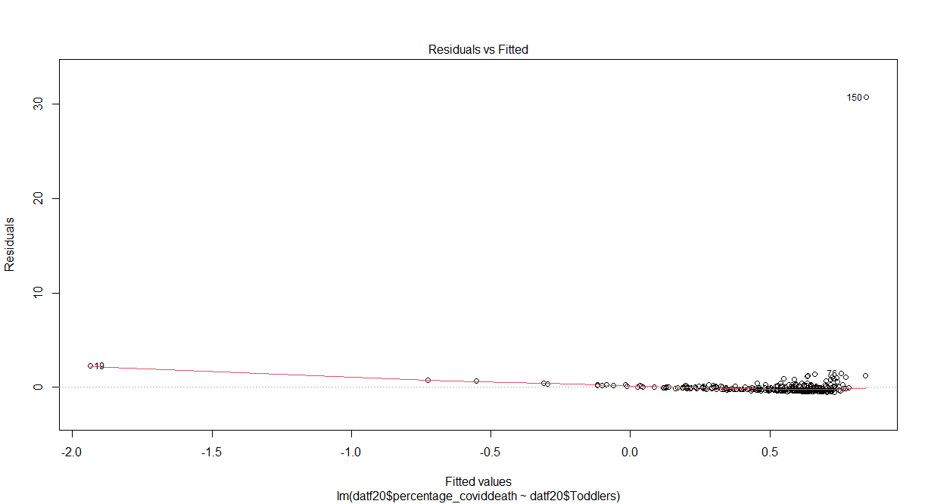

Figure 33: Residual vs Fitted Values
(Source: Self-Created)
A graphical representation of residuals against the values fitting from a “linear regression” study is shown in this figure. The “fitted values”, which represent the dependent variable’s anticipated values based on the dependent variable(s), are displayed on the “x-axis”. The residuals, or the discrepancies between the dependent variable's actual and fitted values, are plotted on the “y-axis”. The residuals in a “linear regression” analysis ought to be dispersed randomly around the line that begins at zero. This indicates that the residuals and the values used for fitting do not have a systematic connection. The residuals in the figure supplied tend to be spread out above and below the horizontal line at nothing, but they also seem to be rather packed around it.
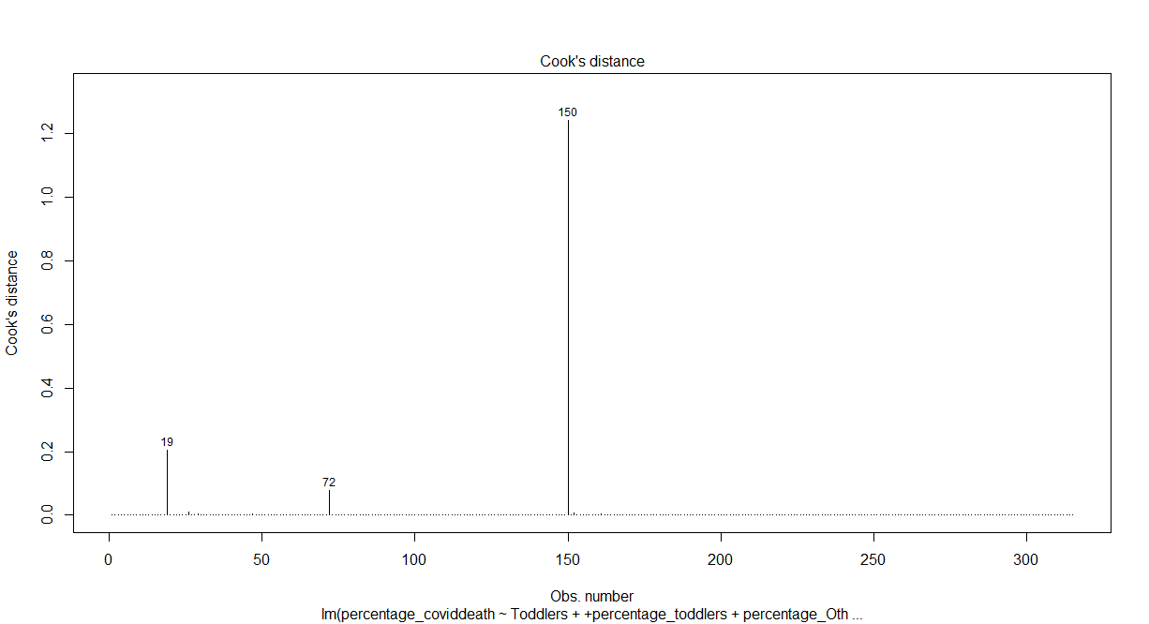

Figure 34: Cook distance for Multiple Regression
(Source: Self-Created)
The “multiple regression” analysis graph for Cook’s distance is shown in the figure. The power of a single data point on the line of regression is expressed as “Cook’s distance”. Both the “slope and the intercept” of the regression line are significantly impacted by locations that have large Cook’s distances.

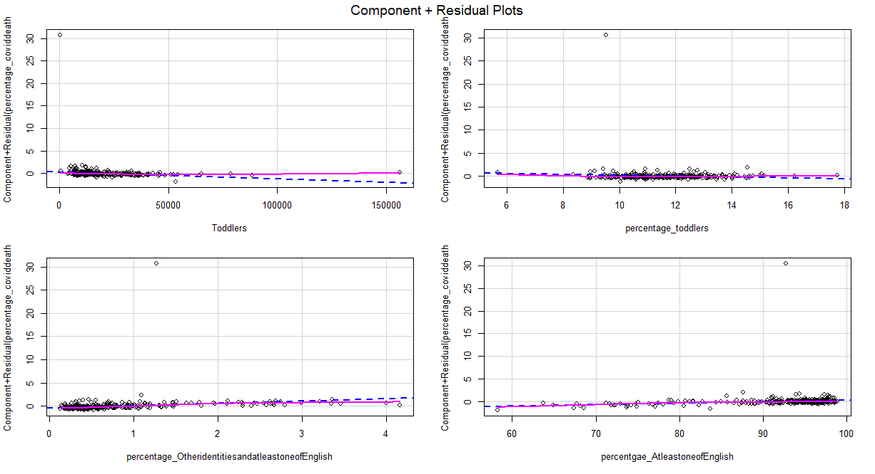

Figure 35: Partial Regression Plot for Multiple regression
(Source: Self-Created)
The relationship between the percentage of toddlers and the percentage of “COVID-19” deaths when one of the two variables is maintained at its average is depicted in the plot as a blue line, and the relationship between the percentage of toddlers and the percentage of COVID-19 deaths as the other two factors are held at a standard deviation above this means is represented by a red line.

Figure 36:Code for Decision Tree Model
(Source: Self-Created)
A decision tree model for assessing whether a patient has “COVID-19” is defined by the code in the figure. “percentage_coviddeath”, “percentage_fairhealth” “toddlers”, “teens”, and “percentage_o” are the four data characteristics that the model makes use of. Concerning the “percentage_coviddeath” characteristic, the very initial node in the tree is determined.
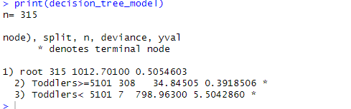

Figure 37: Printing Decision Tree Model
(Source: Self-Created)
The decision tree model illustrated in the picture is employed to forecast the such as of a client turning, or terminating the service subscription. “Tenure, monthly costs, total costs”, and some referrals are the four information components that the model makes use of “Tenure” is the basis for the first branch in the tree. The data passes down from the left spread of the tree if the tenure is one “year or less”.
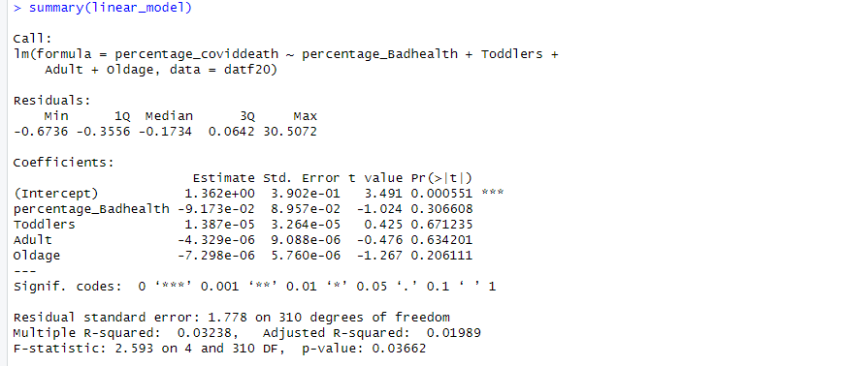

Figure 38: Summary of Linear Model
(Source: Self-Created)
The diagram displays a linear model's summary and the relationship across the parameters “x, y, and z” is described by the model, which is a mathematical model. The numbers of “COVID-19” deaths, the proportion of the population in poor health, and the proportion of toddlers in the community are represented by the data points “x, y, and z”, respectively.

Figure 39: R Mean Square
(Source: Self-Created)
The output of an analysis of linear regression is shown in this picture. It appears to be investigating any potential connection between the proportion of toddlers in the population and “COVID-19” mortality. The red dots represent the actual data scores, while the blue lines indicate the expected link. The red dot’s closeness to the blue contour indicates that the linear model may provide an adequate match for the data.
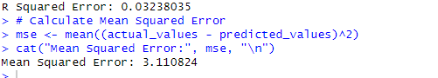

Figure 40: Mean Square Result
(source: Self-Created)
The picture looks to be a screenshot of an R script that calculates a linear regression model's “mean squared error or MSE”. Two functions are defined in the code that simply calculates the mean of the squared discrepancies between the actual and expected values, cat, this function determines the “MSE” the computed “MSE” is printed to the console by that function.

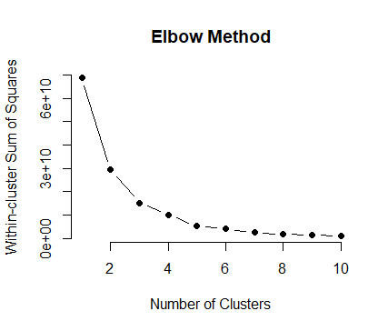

Figure 41: Number of Clusters based on elbow Method
(Source: Self-Created)
The total number of clusters found using the k-means clustering method for various values of k is shown in the image. Two and six clusters are where the graph dips, indicating that this may be the ideal amount of clusters for the information at hand. For “k=2”, it looks like the inset boxplot displays the typical distribution of values inside each cluster.
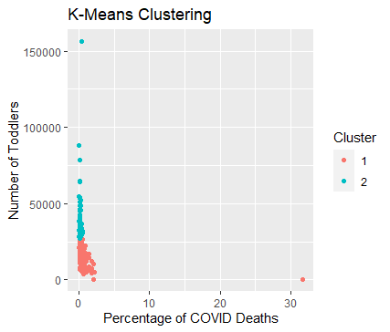

Figure 42: K Means Clustering
(Source: Self-Creating)
The graphic displays a dataset's k-means clustering results. The total number of “clusters (k)” selected is displayed on the x-axis, and the proportion of “COVID deaths” seems to be the “y-axis” quality indication for the clustering. The graph's two curves drop at clusters two and six, suggesting that this may be the best quantity of groups for this information because it reduces the overall number of “COVID-19 fatalities in each cluster.
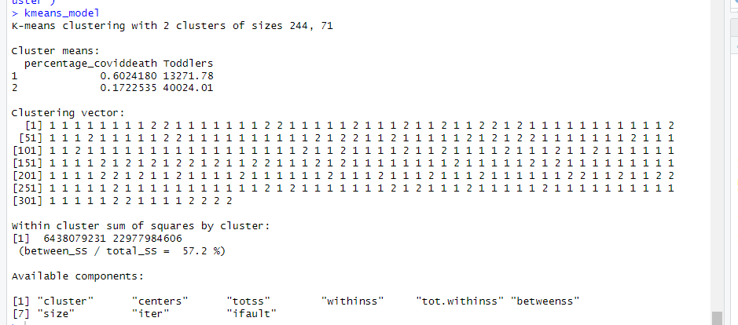

Figure 43: Summary Of K means Model
(Source: Self-Created)
An overview of a k-means clustering algorithm is displayed in the image. A machine learning method called K-means clustering splits information into a set degree (k) of clusters according to the degree to which similar. The two clusters in the picture have sizes of 244 and 71.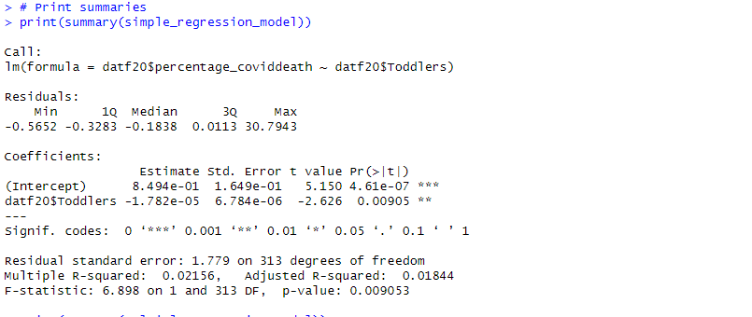

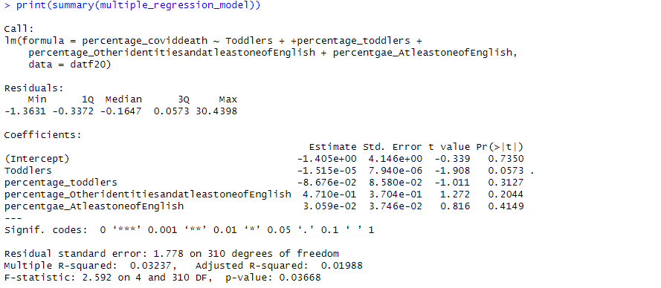

Figure 44: Output of Simple Regression and Multiple Regression model
(Source: Self-Created)

A k-means clustering model appears to be shown in the picture. The two clusters look to be roughly comparable in size and are presented in different colours. There can be a little variation within every group provided the data points inside it appear to be quite dispersed.
The result of a k-means clustering technique is displayed in this figure, with data points clustering around the red and blue dots that indicate two centroids. The points of information within each cluster appear to be dispersed, implying some variance within each cluster, and the clusters appear to be approximately the same in size.

Evaluation of Quantitative Analyses
The study of the COVID-19 pandemic's death toll in England provides a deep insight into the virus's dramatic effects on different geographic areas and populations. According to Cuong (2023), sustainable quantitative analysis is important since it is based on ethical considerations and trustworthy data collection techniques. The study demonstrated a thorough examination of the COVID-19 data through the use of advanced statistical techniques. The investigation conducted by Maung and Marques-Vidal (2023) found mortality rates in several parts of England. Specifically, the South West of England saw 69.4 fatalities per 100,000 people, whereas London experienced 153.1 deaths per 100,000 people.
The report also emphasizes how the virus disproportionately affects populations that are already at risk. For example, the death rate per 100,000 people was 185.0 in places with higher levels of poverty, such as the most impoverished decile in Wales. The sharp difference between this number and the mortality rate—which stands at 146.1 fatalities per 100,000 persons in more affluent regions—highlights the growing health inequities that the pandemic has exacerbated. Furthermore, the study's conclusions show that in hospitals in England and Wales in 2021, COVID-19 was the sole cause of death (Han et al., 2023). Alarmingly, a significant proportion of individuals who succumbed to the virus had pre-existing conditions, such as diabetes, further emphasizing the need for targeted interventions and healthcare strategies.
Over 50% of people in the United Kingdom have contracted COVID-19 since the pandemic's beginning, according to study that also explores the socioeconomic effects of the disease. Millions of people have also been battling long-term COVID, a disorder marked by symptoms that continue long after the original infection. This not only presents difficulties for the healthcare system but also highlights the severe psychological and physical effects on people, which makes it harder for them to get medical care.
To sum up, the study offers priceless insights into the catastrophic effects of the COVID-19 epidemic on the people of England. Utilizing rigorous data gathering techniques and sustainable quantitative analysis, the study emphasizes the critical need for focused measures to alleviate the health inequities made worse by the epidemic. These results highlight the significance of comprehensive interventions to alleviate the socio-economic and health issues posed by COVID-19 as the medical community struggles with the long-term effects of the virus.

Conclusion
The result of this research content is quite effective in the case of the death rate dueCOVID-19Covid 19 pandemics in England. However, the infrastructure as well as the data collecting system of this research study are quite relevant based on the goals of this study. On the other side, it can be noted down here that this research is focused on the “Exploratory Data Analysis or EDA”. This statistical strategy or methodology is utilized to examine enormous amounts to identify the most significant and primary components of the data sets that are being examined. In order to accomplish this, it makes use of a wide range of visual techniques. EDA is an approach that includes coming up with queries regarding data, by applying visualization, transformation, and modelling to search for answers, followed by utilizing the information users discover to either improve our set of questions or come up with new ones. However, this process is iterative and may be observed as a cycle. The research presents the “Measures of Central Tendency, and Probability” according to this research data set. Based on the configuration and the activities of the sturdy, it can be stated here that the “Central tendency” or “measure of central tendency” is a term that is used in the area of statistics to describe a single number that is applied to indicate centre this as well as typical measurement of a probability distribution. Averages are a general term that is frequently used to refer to measures of a central tendency. For such a reason, the outcomes of the research are quite effective for the current condition of the medical industry in England.

Appendix

https://uelac-my.sharepoint.com/personal/u2522514_uel_ac_uk/_layouts/15/onedrive.aspx?id=%2Fpersonal%2Fu2522514%5Fuel%5Fac%5Fuk%2FDocuments%2Fu2522514%20dataset%20and%20code&ga=1

References
Cuong, V.M., 2023. Early-death weeks associated with COVID-19: a comparison among France, the UK and the USA. Journal of Public Health, 45(1), pp.e1-e6.
Han, L., Zhao, S., Li, S., Gu, S., Deng, X., Yang, L. and Ran, J., 2023. Excess cardiovascular mortality across multiple COVID-19 waves in the United States from March 2020 to March 2022. Nature Cardiovascular Research, 2(3), pp.322-333.
Maung, K.K. and Marques-Vidal, P., 2023. Impact of COVID-19 pandemic on cardiovascular diseases hospitalisation, management and mortality in Switzerland. Open Heart, 10(1), p.e002259.
Wang, L., Calzavara, A., Baral, S., Smylie, J., Chan, A.K., Sander, B., Austin, P.C., Kwong, J.C. and Mishra, S., 2023. Differential Patterns by Area-Level Social Determinants of Health in Coronavirus Disease 2019 (COVID-19)–Related Mortality and Non–COVID-19 Mortality: A Population-Based Study of 11.8 Million People in Ontario, Canada. Clinical Infectious Diseases, 76(6), pp.1110-1120.

