UNIVERSITY OF EAST LONDON
SMITH VINCENT PAUL VALLURU
2522514
DS7001 Mental Wealth: Professional Life (Data Ecology)
u2522514_DS7001_CW_final

AI IN AGEING POPULATION SUPPORT: EXAMINING GOVERNMENT

INTERVENTIONS IN USING AI TO SUPPORT ELDERLY POPULATIONS AND HEALTHCARE

Table of Contents
1. Introduction 4
1.1 Overview 4
1.2 Problem statements 5
1.3 Aims and Objectives: 6
2. Literature review 7
2.1 Introduction 7
2.2 Historical Context: 8
Justification for the use of AI in providing support for the aging population: 9
Government Interventions: 10
2.3 Challenges and Future Directions: 10
Ethical considerations: 11
Efficacy and practice supported by evidence: 11
Affordability and ease of access: 11
The process of workforce transformation: 11
2.4 Limitations: 11
2.5 Summary 11
3. Methods 12
3.1 Formulating the Search Approach: 12
Academic databases 12
Reports and websites from the government: 12
Reports from businesses and nonprofits: 12
Media coverage and news articles: 12
3.2 Evaluation and Selection of Sources: 13
Relatability: 13
Credibility: 13
Currency: 13
3.3 Information Extraction and Synthesis: 13
4. Critical discussion 14
Power Imbalances: 15
Algorithmic Bias and Fairness Crisis: 15
The Social Ripple: 16
Call for Harmonious Collaboration: 17
5. Conclusion 17
6. References 19

1. Introduction

1.1 Overview
As the total populace ages, there will be an expanded interest for social and wellbeing administrations. The interest for medical care and other social administrations is rising, and legislatures are finding it hard to keep up. The presentation of man-made intelligence, nonetheless, may altogether affect how we give care to the old. The principal objective of the exploration is to pinpoint potential areas in which computerized reasoning could upgrade administrative guidelines concerning senior consideration. By looking at current projects and guidelines, we can acquire extra knowledge into the possible effects of artificial intelligence on the prosperity and strength of the senior populace.
Around the world, there is a developing segment pattern that can't be halted - the rising number of old individuals. With the expansion in future and abatement in rates of birth, state run administrations are confronted with the essential undertaking of safeguarding the government assistance and distinction of their old populace. This requires reinforcing current emotionally supportive networks and taking on progressive arrangements, with Man-made consciousness (computer based intelligence) arising as a strong impetus for change.
Envision houses with vision, expecting occupants' necessities with gentle updates for meds or temperature changes in light of constant wellbeing information. Consider wearable advances that give early alerts of conceivable wellbeing perils, taking into account proper activity and preventive treatment. Consider fake friends that give friendship and cerebral excitement, countering the devastating confinement that plagues numerous seniors. This is certainly not a future dream, yet rather a rising reality formed by artificial intelligence in the help of maturing individuals.
These are the very issues that this paper investigates. It will take a gander at current taxpayer supported initiatives all over the planet and see what worked and what didn't in that frame of mind for medical care and aiding more established individuals. It can see state of the art computer based intelligence applications that are made to assist more seasoned individuals with issues like cognitive decline and overseeing long haul diseases. It can have a basic discussion about morals issues, information security, and including all clients. This will make way for the mindful and accommodating utilization of man-made intelligence in this significant region.
There are moves on the way to a future in which artificial intelligence empowers our seniors to improve with age and with respect. Notwithstanding, by utilizing cautious planning, cultivating open talk, and keeping a steadfast commitment to moral norms, it is feasible to really ride the silver wave and change innovation into a considerable accomplice in building a general public that qualities and supports all periods of presence.

1.2 Problem statements
The maturing of the total populace is coming down on friendly administrations and medical care frameworks around the world. This adjustment of socio economics causes issues in regions, for example, senior consideration, medical services supplies, and asset designation. The public authority needs to concoct imaginative ways of ensuring that senior residents can progress in years autonomously and with pride in their own homes. This examination plans to research how computerised reasoning (artificial intelligence) can improve both the physical and psychological well-being of senior residents while smoothing out the conveyance of medical care administrations.
a. Moral Problem:
As the total populace ages at a rate that has never been seen, nations deal with an enormous issue: how to safeguard the wellbeing and regard of their more established individuals. The deluge of new individuals comes down on conventional emotionally supportive networks, and that implies that novel thoughts are expected to tackle the issue. Computerized reasoning (man-made intelligence) is going to fundamentally impact how seniors are really focused on and made a difference.
Be that as it may, using man-made intelligence in this touchy field involves an unpredictable organization of intricacies. There is no deficiency of moral quandaries, including the sensitive matter of information security and the chance of algorithmic inclination and double-dealing.
b. Secret of Adequacy:
Viability is as yet an unsettled condition, while computer based intelligence has verifiable guarantee to upgrade senior consideration, transforming that potential into genuine benefits is a troublesome undertaking. Many promising advances are still in their beginning phases, without the development and adaptability expected for standard reception. Moreover, incorporating computer based intelligence with current medical services frameworks and unique information networks is a significant test.
c. The requirement for inclusivity:
The computerised hole represents a huge gamble of hindering a significant extent of the older populace from getting to and profiting from trend setting innovation. UIs ought to focus on instinct and openness, with incorporation as a focal guideline. Executing socially delicate techniques is vital for ensuring that simulated intelligence actually associates with fluctuated networks and addresses their unmistakable prerequisites and inclinations.
d. Absence of strategy arrangement:
Computer based intelligence develops quicker than administrative and legitimate designs, making a troubling hole. Clear moral standards and broad principles for senior consideration man-made intelligence are earnestly required. To keep man-made intelligence a worker, information security, straightforwardness, responsibility, and algorithmic predisposition should be tended to.
At an intersection, the medical care labour force tracks down itself. In a future overwhelmed by man-made brainpower, medical care faculty should have the essential capabilities to participate in useful coordinated efforts with these modern devices. It is vital for execute upskilling drives and exhaustive preparation projects to improve the advantages of human-computer based intelligence organizations and guarantee a consistent progress.
e. Labor force Modernization:
Taking on these issues requires an ensemble of cooperating. State run administrations need to start to lead the pack by making moral rules, subsidising studies, and empowering connections between general society and confidential areas. Dependable turn of events and client focused plan ideas should be given main concern by everybody in the business. The examination bunches need to zero in on making their medicines powerful and open to everybody, and they need to incorporate morals into all aspects of them. At last, getting bunches included and paying attention to what clients need to say is vital for ensuring that man-made intelligence arrangements are acknowledged as well as invited.
The capability of using man-made intelligence to help the maturing populace is significant; in any case, the cycle is confounded by moral intricacies, inquiries of adequacy, and the need to guarantee inclusivity. By moving toward these snags with quickness, expectation, and enduring devotion to virtues, it can ensure that computerised reasoning arises as a considerable colleague in developing an impending time where each period of presence is regarded and reinforced.

1.3 Aims and Objectives:
This research project has the following aims and objectives:
- Assess Government Initiatives: Examine existing government programs and policies aimed at incorporating AI in aging population support, identifying their scope and effectiveness.
- Evaluate Impact on Healthcare: Investigate how AI interventions influence healthcare delivery, cost-effectiveness, and the overall quality of healthcare services for the elderly.
- Analyse Elderly Well-being: Assess the impact of AI-supported services on the well-being and quality of life of elderly individuals, including their social, emotional, and physical aspects.
- Identify Challenges and Opportunities: Identify challenges and opportunities in implementing AI solutions for ageing population support, taking into consideration ethical and privacy concerns.

2. Literature review

2.1 Introduction
The research depends on a careful writing survey to get data about government drives and the capability of man-made brainpower in supporting the maturing populace. Studies, reports, and articles from academic sources, official distributions, and medical services associations can be in every way remembered for this survey. It will offer an exhaustive assessment of current projects and guidelines, as well as what they mean for senior residents and medical care. Without utilising essential information assortment strategies, the survey of the writing will give a basic blend of the information that is at present open, working with an exhaustive comprehension of the topic.
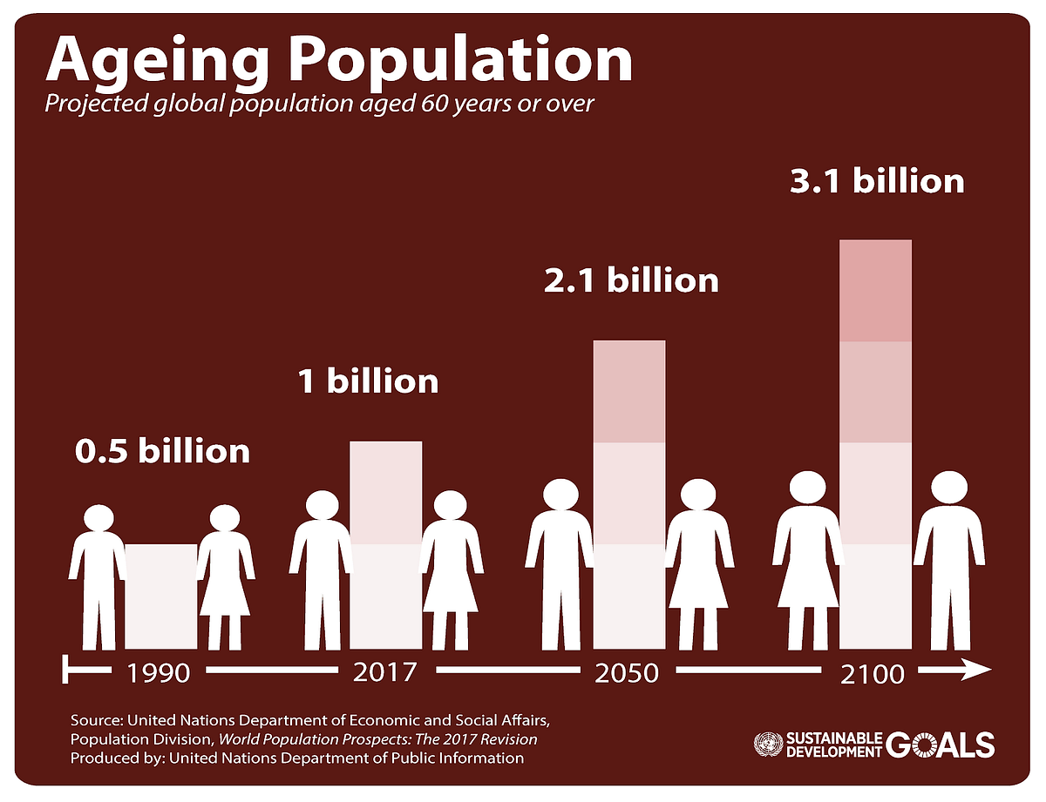
Figure 1: Aging population
(Source: Xing et al., 2021)
The all out people are getting older quickly, which is a significant issue for states and clinical benefits structures. Since people are living longer and having fewer adolescents, the amount of additional laid out people is growing quickly. Because of this change in the general population, we need to come up with better ways to deal with the prosperity and individual fulfilment of additional laid out people. Man-made thinking (PC based knowledge) is shown as an important gadget around here, with the ability to help seniors with getting better clinical thought, experience in isolation, and speak with others. This composition focuses on looking at the undeniable underpinning of mimicked knowledge in supporting a developing people, the reasoning behind including PC based knowledge around here, and the different ways the public authority is correct now using reproduced insight to help care for the old.

2.2 Historical Context:
The notion of artificial intelligence in the realm of ageing assistance is not new. The first investigations started in the 1980s, using expert systems specifically tailored for the purpose of diagnosing and overseeing chronic illnesses.
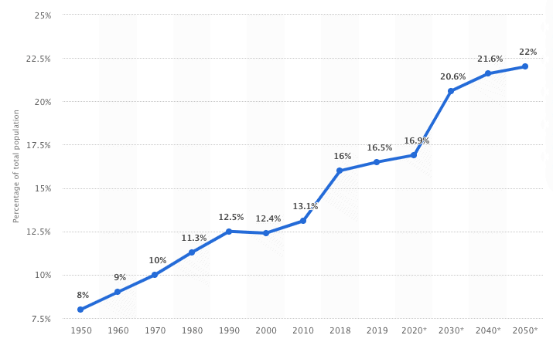
Figure 2: Historical data in senior healthcare
(Source: Stypinska, 2022)
In any case, the expansive execution of this innovation was hindered by the limitations of low handling power and information accessibility. The flood in artificial intelligence research lately, along with progress in huge information, AI, and advanced mechanics, has renewed this area. The rising requirement for reasonable answers for help a rising old populace further drives the inspiration for the utilisation of man-made brainpower.

Justification for the use of AI in providing support for the aging population:
Several reasons contribute to the emphasis on AI in supporting the aging population. A detailed discussion has been done related to that.
Tackling healthcare obstacles:
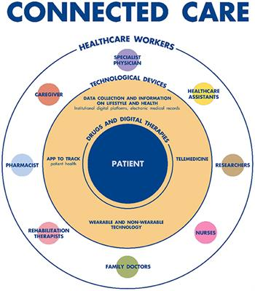
Figure 3: Connected care
(Source: Chu et al., 2022)
AI applications may help address healthcare difficulties by aiding in the management of chronic diseases, facilitating early diagnosis, and developing personalized treatment regimens. This has the potential to decrease healthcare expenses and enhance clinical results.
Promoting independent living:
AI-powered devices may help seniors with daily tasks like medication management, fall detection, and smart home technologies, allowing them to remain independent for longer periods while preserving their quality of life.
Addressing social isolation:
AI companions and digital assistants may mitigate loneliness and provide social engagement for elderly individuals who are alone, therefore enhancing their psychological and emotional welfare.
Addressing the shortage of carers
AI technologies have the potential to support carers by offering companionship, monitoring, and reminders; in doing so, they can reduce the burden on them and improve the standard of care they deliver.

Government Interventions:
Governments all over the world are constantly looking into how AI can be used to help older people in several ways:
Research and development funding:\
Government elements are distributing assets towards innovative work, explicitly focusing on the creation and assessment of computerised reasoning (artificial intelligence) applications in the field of matured care through research tasks and coordinated efforts between general society and confidential areas (Chu et al., 2022). Illustrative occasions remember the Public Foundation for Maturing in the US and the Develop UK Dementia and Neurodegenerative Program.
Testing and deploying AI solutions:
Government entities are allocating funds towards research and development endeavours, specifically targeting the creation and evaluation of artificial intelligence (AI) applications in the field of aged care via research projects and collaborations between the public and private sectors (Chu et al., 2022). Illustrative instances include the National Institute on Ageing in the United States and the Innovate UK Dementia and Neurodegenerative Programme.Certain governments are piloting initiatives to assess and gauge the efficacy of AI-driven technologies in practical contexts. Japan's Pepper robots are used in nursing homes to provide social contact and assistance to patients.
Creating ethical frameworks and rules:
Recognizing the possible ethical problems around AI's application in healthcare, governments are developing rules and legislation to safeguard data privacy, transparency, and algorithmic fairness (Chou et al., 2023). The European Union's General Data Protection Regulation (GDPR) is a prime example.
Increasing digital knowledge and access:
To close the digital gap, governments are starting programs to help older people learn how to use technology better and make sure everyone has equal access to AI-powered tools. This group includes projects like the UK's Ageing Better in a Digital World program.

2.3 Challenges and Future Directions:
The deployment of artificial intelligence for the support of an aging population faces a number of hurdles, notwithstanding the potential benefits:

Ethical considerations:
Ethical concerns like as safeguarding data privacy, addressing algorithmic prejudice, and preventing the exploitation of vulnerable persons need meticulous deliberation and the establishment of strong ethical frameworks.

Efficacy and practice supported by evidence:
A thorough examination of AI technologies' efficacy and integration into current healthcare systems is critical for successful adoption.

Affordability and ease of access:
Ensuring equal access to AI technologies for all older persons, regardless of money or technical proficiency, necessitates resolving concerns of cost and usability.

The process of workforce transformation:
Healthcare personnel must acquire the necessary skills and expertise to properly interact with AI technologies and manage the evolving elder care scenario. The prospects of AI in providing care for the aging population depend on effectively tackling these difficulties and guaranteeing responsible and ethical development and use of the technology. To ensure a future where AI enhances the well-being of older persons, it is crucial to maintain ongoing research, foster cooperation among governments, businesses, and academia, and actively include the public.

2.4 Limitations:
This research review focuses mostly on government initiatives in AI to help the aging population. A more thorough analysis would look at the larger picture, including non-governmental activities, private sector innovations, and research achievements in a variety of geographic situations.

2.5 Summary
AI can possibly fundamentally change medical care for the elderly in any case, it is fundamental to focus on dependable and moral progression, along with solid government contribution, to involve this innovation for the benefit of more established people all in all successfully. By successfully tending to the challenges and embracing the ideal conditions, we can ensure that simulated intelligence empowers older people to go through the maturing system nimbly and with deference, adding to a future that is more comprehensive and strong for everybody. This survey of the writing gives a careful examination of the manners by which states have utilised simulated intelligence to help medical services frameworks and the older populace. The goal is to work with future arrangement choices and medical care methodologies by assessing the aftereffects of recently distributed drives. The outcomes can ultimately assist legislatures and medical services suppliers with pursuing instructed choices in regards to the coordination of simulated intelligence into administrations for more established individuals, guaranteeing that the old get the consideration and support they merit while tackling the developing difficulties of a maturing segment.

3. Methods
AI in Ageing Population Support: Inspecting Government Mediations," the accompanying conversation dives into the procedure used to create the survey. It makes sense of the exploration systems, determination rules, and data handling strategies that support the offered examination.

3.1 Formulating the Search Approach:
It has been critical to utilize a careful pursuit procedure to get relevant and current data. The accompanying assets and online data sets have been woven into the structure.

Academic databases
Scholastic data sets like Scopus, Web of Science, PubMed, and Google Researcher worked as entries to get to peer-explored papers, gathering procedures, and book sections. The pursuit has been refined by utilizing pertinent terms, for example, "Computer based intelligence and maturing," "government mediations," "senior consideration," and "moral contemplations," alongside Boolean administrators.

Reports and websites from the government:
Strategy records, financing projects, and pilot projects connected with simulated intelligence and maturing have been tracked down on the authority sites of public and global government organizations like the World Health Organisation (WHO), the European Union (EU), and national health ministries.

Reports from businesses and nonprofits:
Reports from both the business and non-benefit areas and the sites of simulated intelligence firms, associations zeroing in on maturing, and think tanks give brilliant bits of knowledge into present patterns, specialized leap forwards, and pilot organizations.

Media coverage and news articles:
An extensive survey of noticeable news associations and specific periodicals about innovation, medical care, and maturing has been directed to distinguish late progressions and public discoursed concerning artificial intelligence (AI) in this field.

3.2 Evaluation and Selection of Sources:
From that point onward, the assets that have been recently gotten have gone through a rigid screening process, which has been examined below:

Relatability:
Each thing went through a fastidious assessment to determine its similarity with the survey's accentuation on government drives and its commitment to grasping the current situation and hardships.

Credibility:
The assessment of the source's position and unwavering quality incorporated different variables, including the ability of the creator, the standing of the distribution, and its adherence to laid-out research norms.

Currency:
Emphasis has been put on recent papers and studies that represent the rapidly changing area of AI and its use in supporting the ageing population.
In the end, a wide variety of sources, such as academic research, government papers, industry studies, and news stories, were chosen in order to present a comprehensive and well-rounded view of the subject matter.

3.3 Information Extraction and Synthesis:
Finding significant themes and trends:
Recognizing repetitive patterns and creating techniques in government drives across numerous countries and regions.
Studying particular interventions:
Initiatives including research funding, pilot initiatives, ethical frameworks, and digital literacy courses are all assessed and evaluated.
Assessing possibilities and challenges:
Analysing the challenges encountered in the implementation of AI technologies and suggesting possible directions for future advancement.
Employing a qualitative methodology:
data from many sources was then amalgamated to construct a coherent storyline and provide a thorough depiction of the contemporary circumstances.
1. Clearness and Rigour:
Transparency: Giving clear and exact references to empower the ability to enable and check data, consequently laying out trust in the provided information.
Balance and objectivity: Keeping away from individual biases and objectively introducing contentions, covering both the potential benefits and issues of AI implementation in aging assistance.
Logical progression and consistency: Coordinating the survey in a way that advances clear getting it and coordinates the peruser through the examination in a methodical way.
The reason for this study was to give a comprehensive, critical, and evidence-based survey of the current scene and future directions of government drives in artificial intelligence to give help to a maturing population.
2. Tapestry of Elements and Dynamics:
There are five important elements such as orchestrate, threads which are the government inventions are discussed below:
Research and development funding: Governments serve as catalysts, supporting the emerging area of AI for ageing care via funding in research programs, public-private collaborations, and innovation centres. This aspect establishes the framework for scientific developments while also encouraging cooperation between academics and industry.
Executing and Deploying AI Solutions: Governments start experimental runs projects to evaluate the common sense and viability of computer-based intelligence innovation, in actuality, situations, going past hypothetical systems (Wilmink et al., 2020). This viewpoint, which frequently involves coordinated efforts with medical care suppliers and senior communities, fills in as an association between research and commonsense execution. It offers significant data and knowledge that might be utilized to upgrade and work on existing practices.
Improvement of ethical frameworks and guidelines: Considering the way that the utilization of artificial intelligence in medical services is full of intricacies, legislatures have a fundamental impact in the definition of ethical standards and administrative systems (Xing et al., 2021). Counting this part safeguards against the possibility of biases, breaches in data privacy, and algorithmic discrimination, so ensuring that the improvement of artificial intelligence for more established people is both capable and human-focused.

4. Critical discussion
Information, the soul of the computerized time, courses through a complicated biological system known as the information biology. This intertwined network, which incorporates gathering, capacity, investigation, and use, fills in as the reason for information science's perplexing calculations. While the likely benefits of this dance are clear, going from changing medical care to enhancing asset the board, a more critical look shows dinky oceans overflowing with impediments and conceivable social surprises.

Power Imbalances:
The genuine information itself is the main part of the information environment. This information is assembled from a wide assortment of sources, remembering connections for online entertainment stages, monetary exchanges, wellbeing data, and, surprisingly, our proactive tasks. Because of the consistent assortment of this collection, worries about power awkward nature have been raised. The way that these solicitations are being made features the likelihood that associations, legislatures, or even malicious people could exploit what is happening, which is a wagered on the security and freedom of people. The outrage encompassing Cambridge Analytica fills in as a grave sign of the potential outcomes that the improper utilization of data might have on options and the manner by which general assessment is impacted.

Algorithmic Bias and Fairness Crisis:
Information science, outfitted areas of strength for with, dives into this immense expanse of information, searching for examples and bits of knowledge. In any case, computations, like mirrors, reflect the inclinations natural in the data on which they are taught. Unrestrained, these predispositions might create one-sided results, supporting social variations. Consider a reenacted knowledge credit support system taking into account true data that injuries explicit masses; the implications may stun. Ensuring sensibility in computations requires taking care of the two data inclinations and algorithmic arrangement, a problematic moral tightrope dance for data scientists.
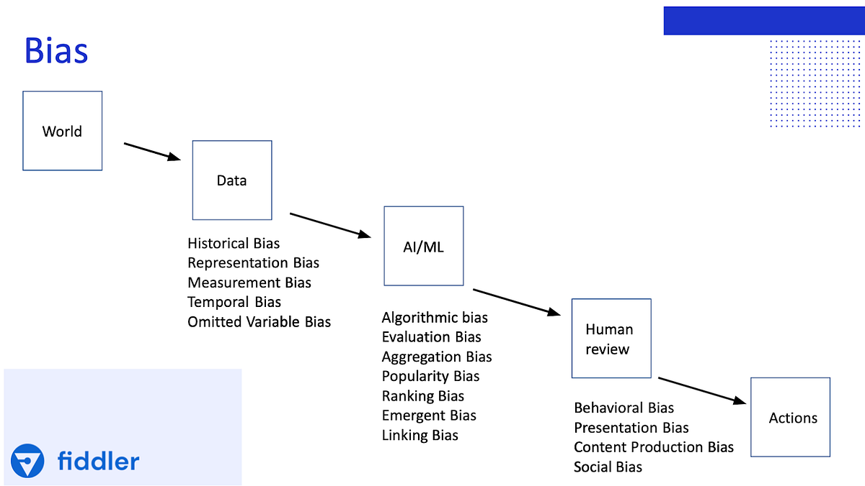
Figure 4: Understanding of Biasness
(Source: Lee and Yoon, 2021)
Security Mystery and Trust Misfortune: Shoppers frequently experience the security Catch-22, where they value the simplicity of online administrations yet additionally voice misgivings over the insurance of their own information. The separation starts from an absence of both straightforwardness and the leaders of individual data. The consistent loss of confidence in data driven systems could achieve certifiable repercussions. Envision what is going on when one is denied fundamental organizations like clinical consideration or banking in light of stresses around the sharing of individual data. Laying out trust requires the execution of strong data security shows despite direct correspondence and client fortifying, enabling clients to appreciate and manage their data presence.

The Social Ripple:
The effect of data science and data science goes quite far past the area of individual insurance and worth.
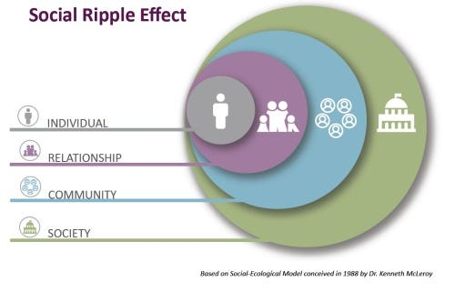
Figure 5: Social ripple effect
(Source: Loveys et al., 2022)
Work robotization driven by information-driven forward leaps can possibly increment joblessness and fuel current financial imbalances. Also, the spread of "deepfakes" and disinformation exercises does whatever it takes to undermine trust in impartial cycles and associations. Investigating these social waves needs proactive authoritative interventions, careful man-made insight moral new development, and government-subsidized preparing endeavors to augment progressed capability and care.

Call for Harmonious Collaboration:
Taking on a helpful methodology is principal. Information researchers, states, innovation organizations, and common society should cooperate to make a dependable and moral information biological system. Data organization systems that emphasis on straightforwardness, obligation, and individual honors are basic. Also, interest in the innovative work of protection-saving advances and artificial intelligence reasonableness devices might help mitigate risks and encourage certainty.
Inevitably, the significance of the data ecosystem cannot be disregarded. By recognizing the ambiguous nature of data science and approaching it with careful analysis and collaborative efforts, we may use its potential to create a future that is fair, safe, and focused on human well-being. It should aim for a future in which data is used to empower rather than exploit, where algorithms prioritize justice, and where social growth aligns harmoniously with the complex patterns of the data-driven world.

5. Conclusion
This review of the literature provides a thorough analysis of the ways in which governments have used AI to support healthcare systems and the elderly population. Our goal is to work with future arrangement choices and medical services techniques by assessing the consequences of recently distributed drives. The outcomes can ultimately assist states and medical care suppliers with pursuing instructed choices in regards to the joining of simulated intelligence into administrations for more established individuals, guaranteeing that the old get the consideration and support they merit while settling the developing difficulties of a maturing segment. The embroidery of maturing unfurls before us, its distinctive strings polluted with the silver murmurs of time. Inside its rich weave, one more wonder emerges: the shining strings of Computerized reasoning (man-made intelligence), proclaiming a future wherein development embraces knowledge and age transforms into an ensemble of possible results. Regardless, similarly as with any prominent piece of workmanship, this weaved craftsmanship contains difficult situations that need careful idea and master execution. Legislatures, as the modelers of society, play a vital part in molding the outline of this impending period. They helpfully direct the investigation cycle, empowering headway environments where momentous personalities envision reenacted knowledge plans unequivocally expected for the necessities of more seasoned people. These plans are made and maintained through money related resources and joint endeavors and are executed as pilot projects. They are painstakingly attempted in veritable circumstances to assess their ampleness and assemble critical data. Subsequently, the embroidery turns out to be more vigorous, upgraded by the firsthand encounters of more established grown-ups and medical services experts. Nonetheless, innovation alone is deficient. Moral systems, interlaced with strings of transparency, information security, and equity, safeguard the most helpless from potential predispositions and algorithmic bias. These fine strings, marvelously woven by government officials and ethicists, ensure that simulated intelligence is a weapon for strengthening as opposed to double-dealing.

6. References
Abdi, S., de Witte, L. and Hawley, M., 2020. Emerging technologies with potential care and support applications for older people: review of gray literature. JMIR aging, 3(2), p.e17286.
Al Nahian, M.J., Ghosh, T., Uddin, M.N., Islam, M.M., Mahmud, M. and Kaiser, M.S., 2020, September. Towards artificial intelligence driven emotion aware fall monitoring framework suitable for elderly people with neurological disorder. In International conference on brain informatics (pp. 275-286). Cham: Springer International Publishing.
Al-Mistarehi, A.H., Mijwil, M.M., Filali, Y., Bounabi, M., Ali, G. and Abotaleb, M., 2023. Artificial intelligence solutions for health 4.0: overcoming challenges and surveying applications.
Chou, Y.H., Lin, C., Lee, S.H., Chang Chien, Y.W. and Cheng, L.C., 2023. Potential Mobile Health Applications for Improving the Mental Health of the Elderly: A Systematic Review. Clinical Interventions in Aging, pp.1523-1534.
Chu, C.H., Nyrup, R., Leslie, K., Shi, J., Bianchi, A., Lyn, A., McNicholl, M., Khan, S., Rahimi, S. and Grenier, A., 2022. Digital ageism: Challenges and opportunities in artificial intelligence for older adults. The Gerontologist, 62(7), pp.947-955.
Hsu, W.C.J., Liou, J.J. and Lo, H.W., 2021. A group decision-making approach for exploring trends in the development of the healthcare industry in Taiwan. Decision Support Systems, 141, p.113447.
Kumar, S., Underwood, S.H., Masters, J.L., Manley, N.A., Konstantzos, I., Lau, J., Haller, R. and Wang, L.M., 2023. Ten questions concerning smart and healthy built environments for older adults. Building and Environment, 244, p.110720.
Lee, D. and Yoon, S.N., 2021. Application of artificial intelligence-based technologies in the healthcare industry: Opportunities and challenges. International Journal of Environmental Research and Public Health, 18(1), p.271.
Loveys, K., Prina, M., Axford, C., Domènec, Ò.R., Weng, W., Broadbent, E., Pujari, S., Jang, H., Han, Z.A. and Thiyagarajan, J.A., 2022. Artificial intelligence for older people receiving long-term care: a systematic review of acceptability and effectiveness studies. The Lancet Healthy Longevity, 3(4), pp.e286-e297.
Stypinska, J., 2023. AI ageism: a critical roadmap for studying age discrimination and exclusion in digitalized societies. AI & society, 38(2), pp.665-677.
Wilmink, G., Dupey, K., Alkire, S., Grote, J., Zobel, G., Fillit, H.M. and Movva, S., 2020. Artificial intelligence–powered digital health platform and wearable devices improve outcomes for older adults in assisted living communities: Pilot intervention study. JMIR aging, 3(2), p.e19554.
Xing, F., Peng, G., Zhang, B., Li, S. and Liang, X., 2021. Socio-technical barriers affecting large-scale deployment of AI-enabled wearable medical devices among the ageing population in China. Technological Forecasting and Social Change, 166, p.120609.

