**HTTP**

HTTP is the foundation of data communication for the World Wide Web, where hypertext documents include hyperlinks to other resources that the user can easily access, for example by a mouse click or by tapping the screen in a web browser.

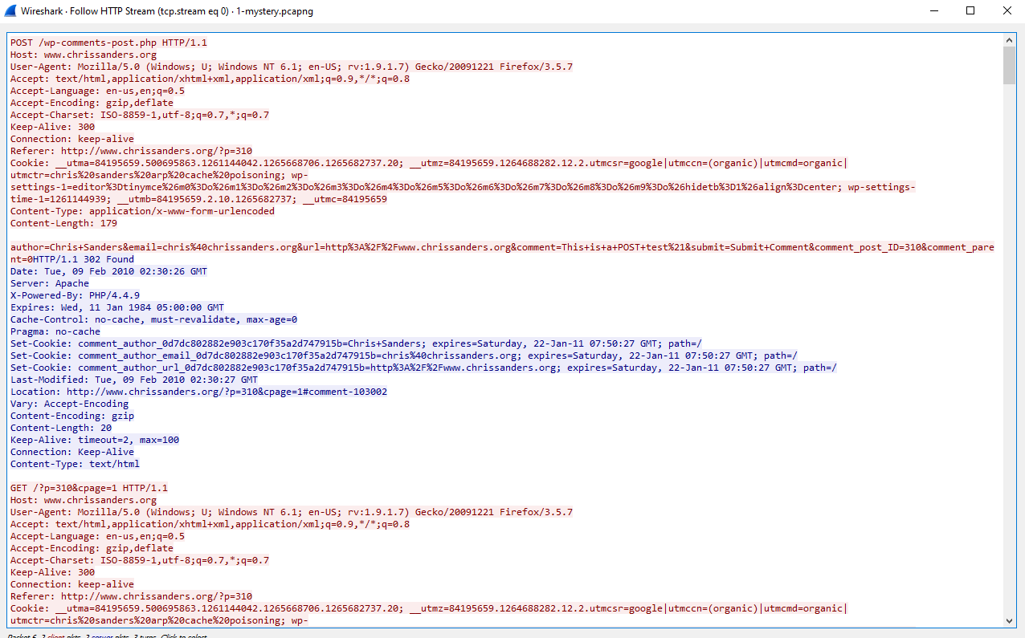

172.16.16.128, the local user, was sending and receiving information to 69.163.176.56, a remote server, using the HTTP protocol.

The local user was looking at www.chrissanders.org

The local user was communicating on port 80 on the remote servers web server and receiving information back on port 1989.