Practical 5
Aim: Netflix Analysis
Step 1: Click on the Text File and add the Netflix csv file.
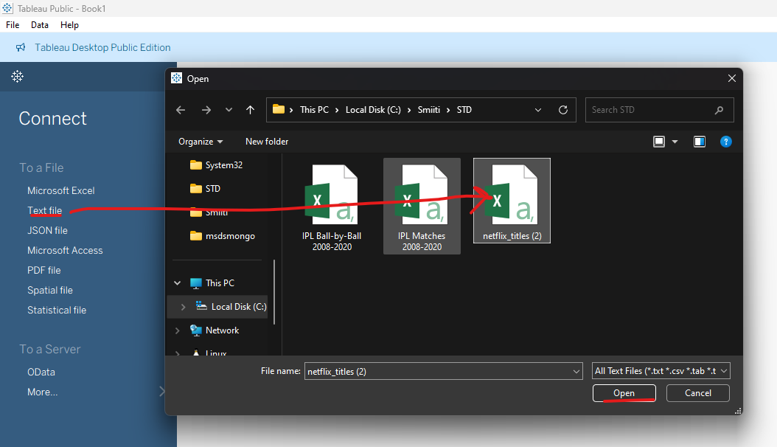
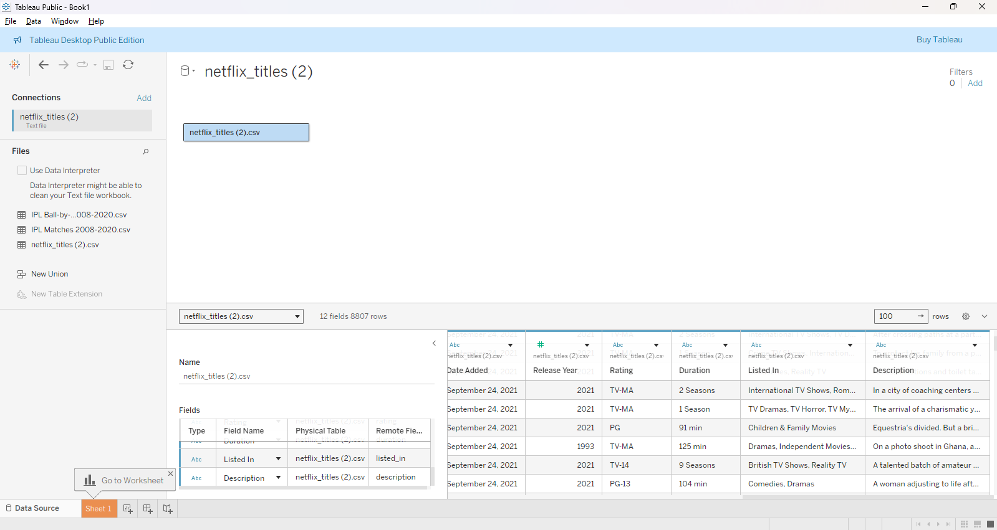

- New Worksheet: Title ‘Total Movies and TV Shows by Year’
Step 1: Change the ‘date added’ col right click change data type convert to date.
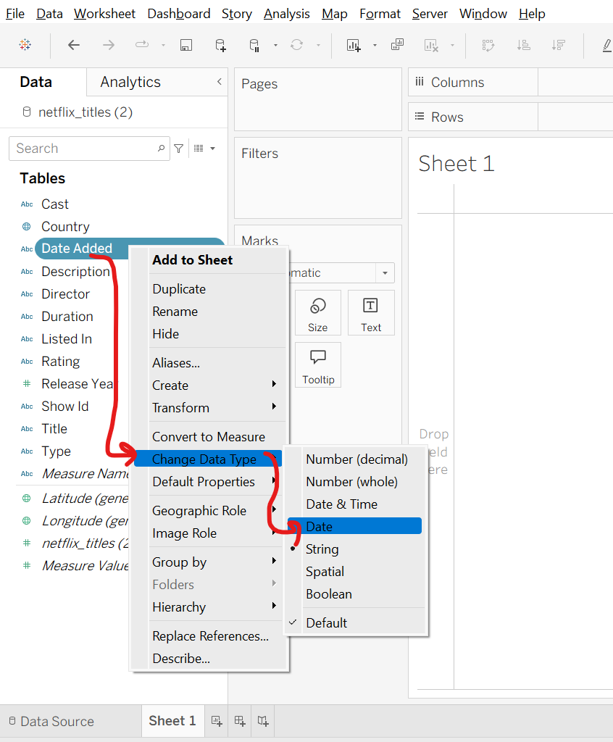

Step 2: Drag and drop ‘date added’ col in columns.
Step 3: Drag and drop ‘show id’ col in rows make it to count by right click measures count.
Step 4: Drag and Drop ‘Type’ col in Label under marks.
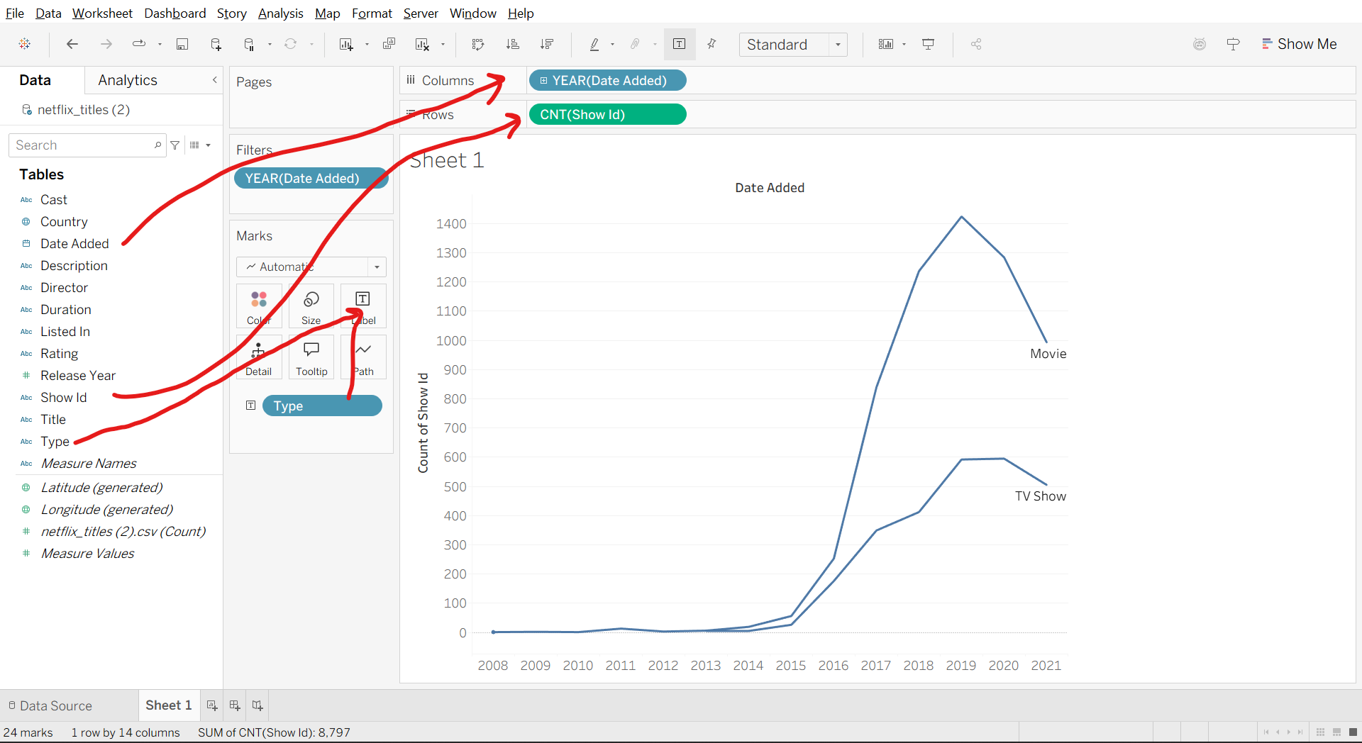
Step 5: Press ctrl key and drag year from columns and drop into filters. select Years uncheck Null Apply ok.
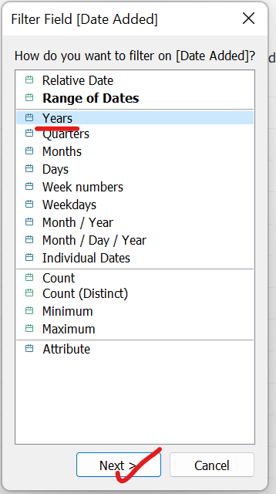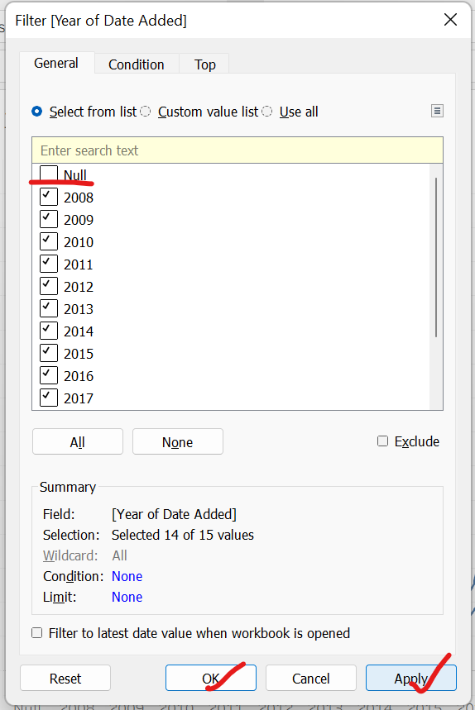
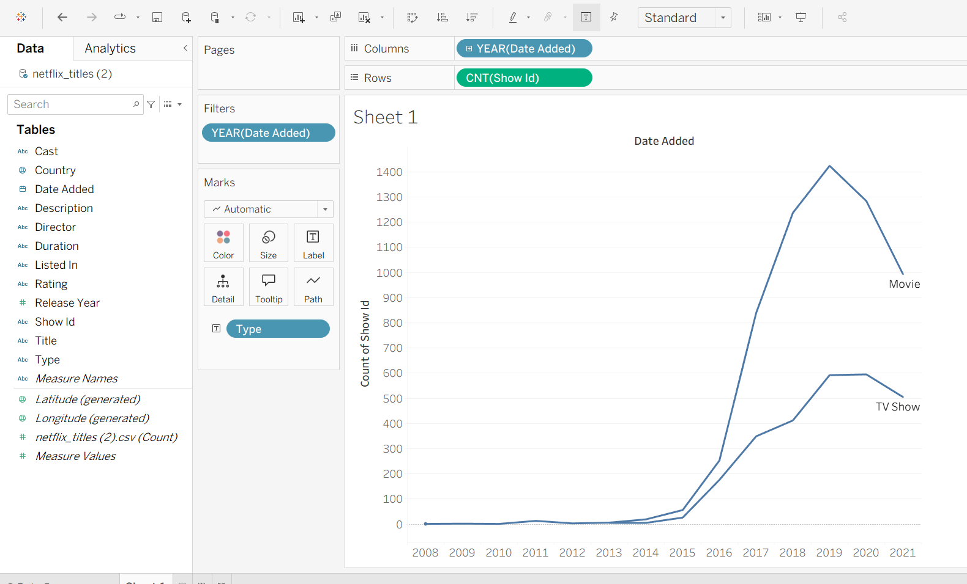
Step 6: Under Marks, in automatic drop-down list select Area. change the color.
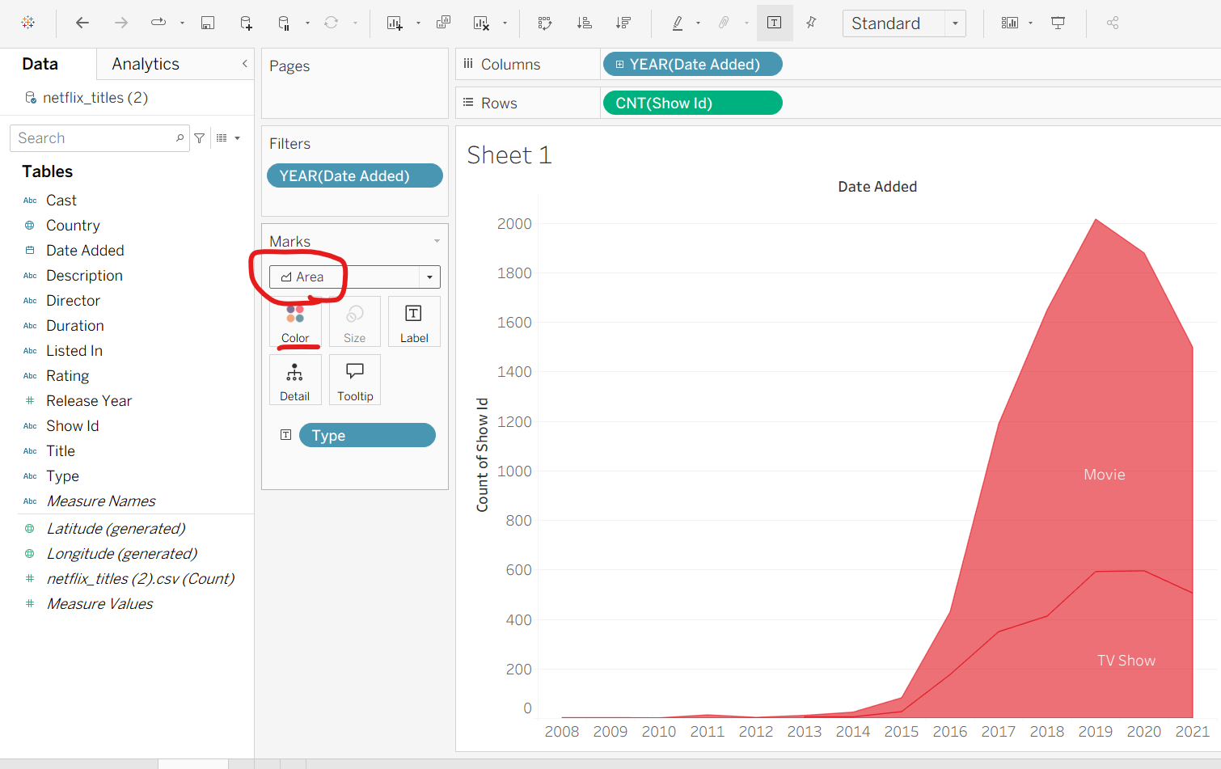
Step 7: Change the title of the sheet ‘Total Movies and TV Shows by Year’ format it.
Format the background, remove grid lines, bg color, etc.
Copy type in colors and click on color edit colors… under automatic dropdown list select red and assign colors for each as suitable. apply ok.
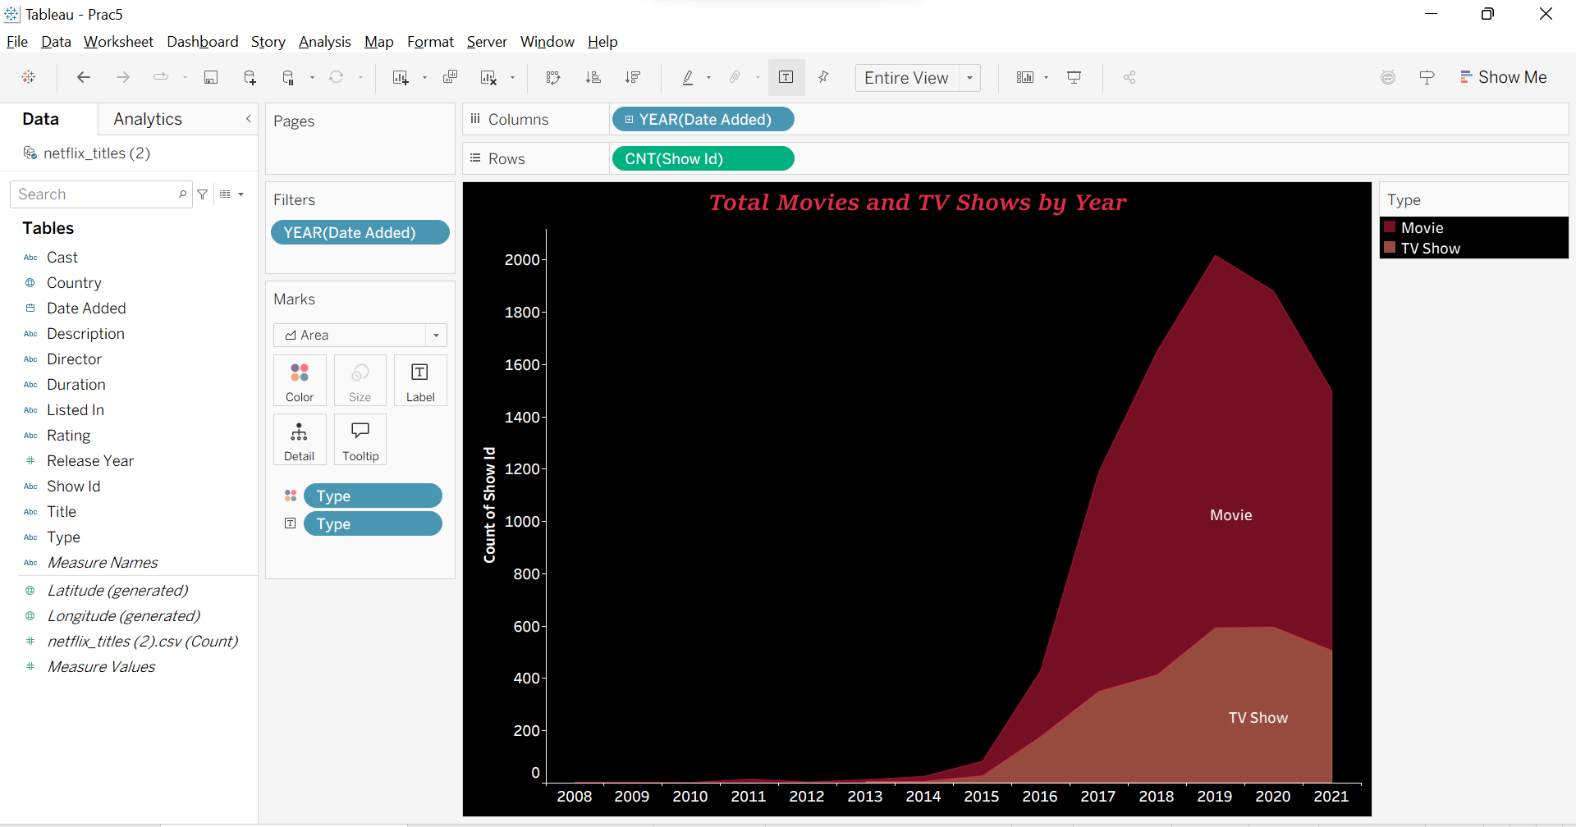

- New Worksheet: Title – ‘Total Movies & TV Shows by Country’
Step 1: Double click on country col in tables automatically a world map will be generated. Under marks in dropdown list select map.
Step 2: Click on ‘699 unknown’ Click on filter data.
Right click on sheet and select format. shading sheet worksheet, pane, total pane, grand total pane select black
In main menu map background maps select dark.

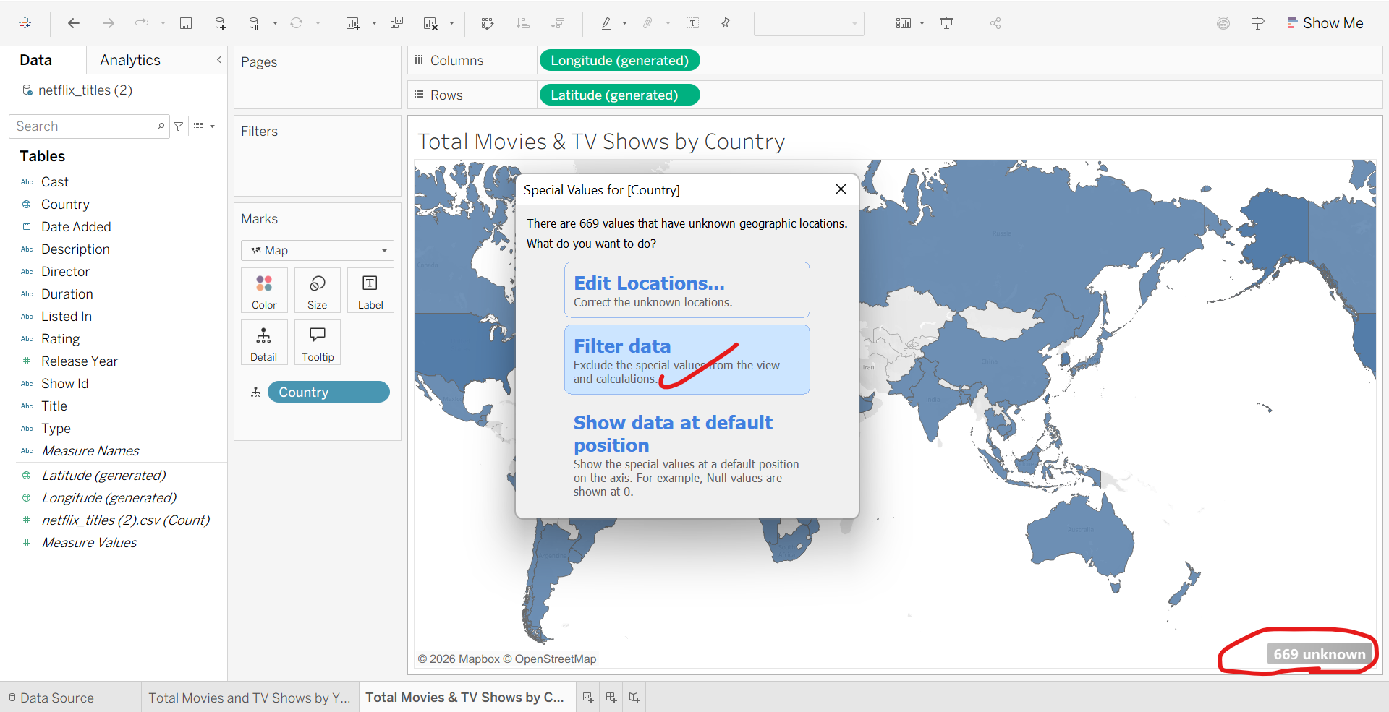
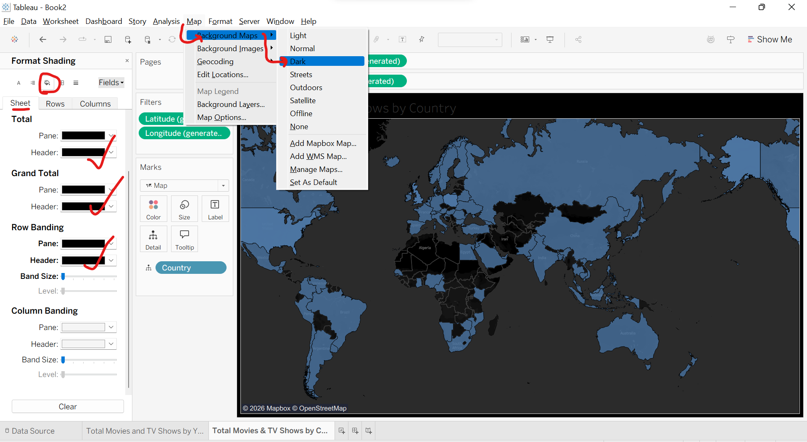
Step 3: Click on color under marks select red color Drap show id into colors under marks select count.
A gradient will be shown light color(low count) , Dark color (high count).
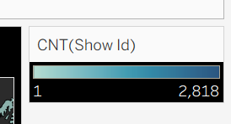
Click on color under marks edit colors change the colors as suitable.
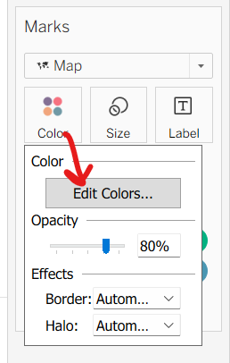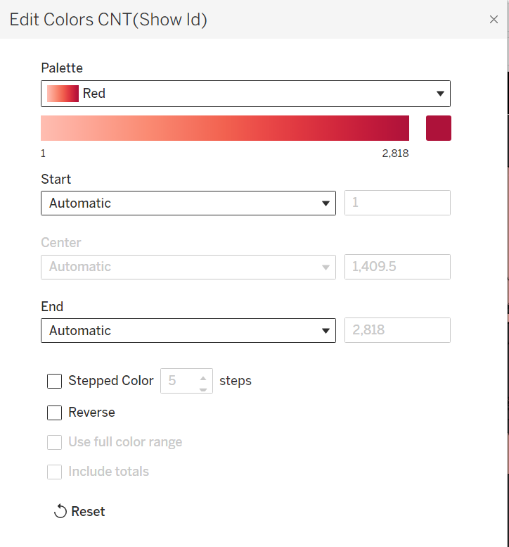
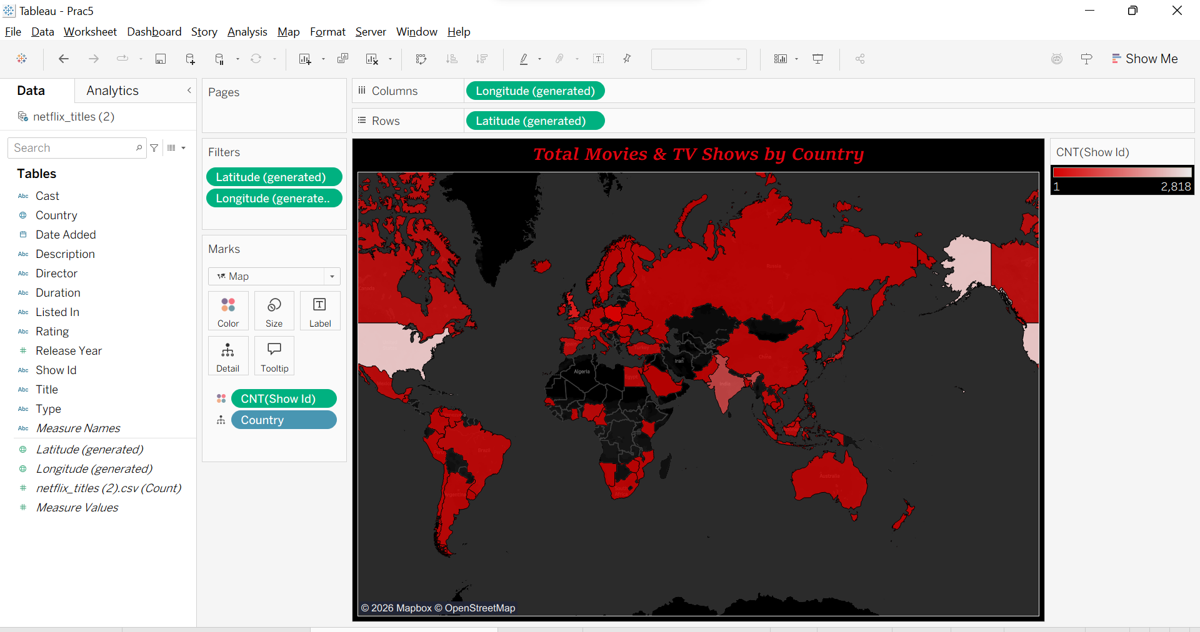

- New Worksheet: Title – ‘Top 10 Genre’
Step 1: Drag ‘listed In’ col and drop into rows
Step 2: Drag and drop ‘show id’ col into Text right click ‘measure’ count.
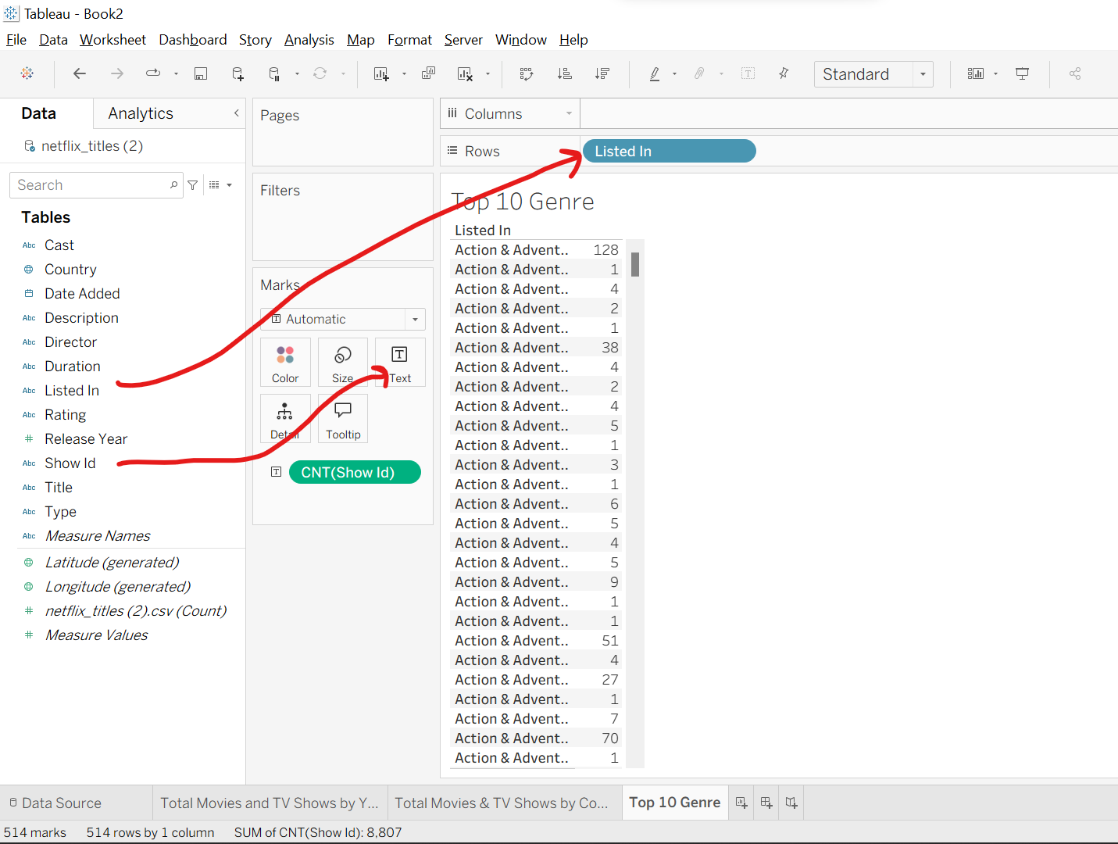
Step 3: In rows right click listedin filter top menu select by field apply ok.
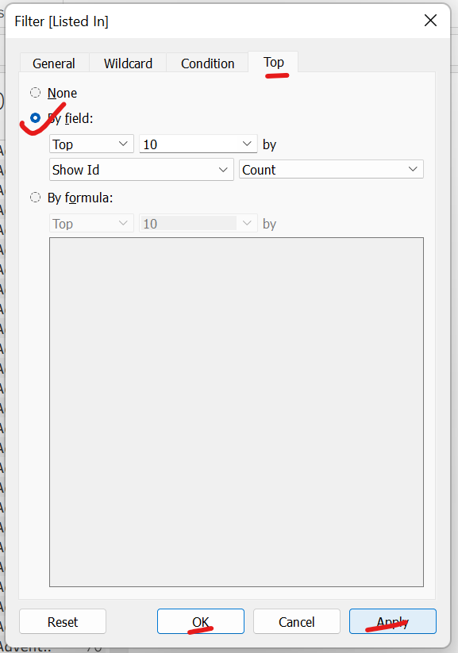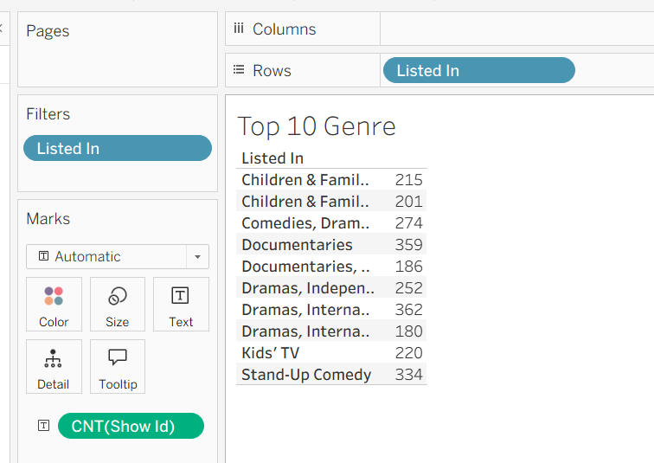
Step 4: Show me - bar graph select desc order.
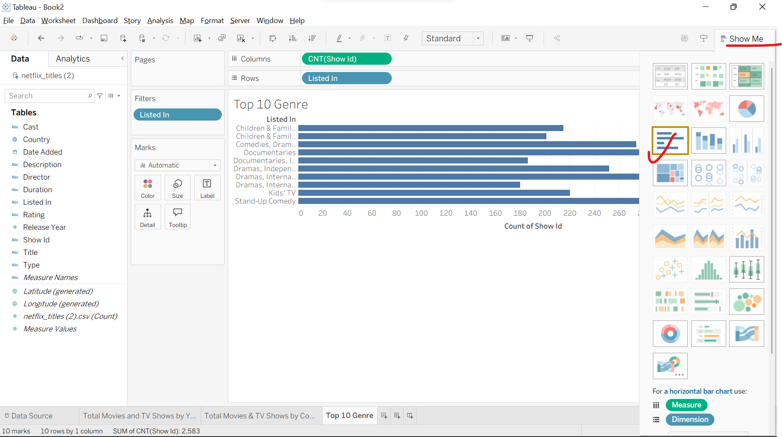
Step 5: For labels drag and drop show id into label and select count in measures. Right click on worksheet format.
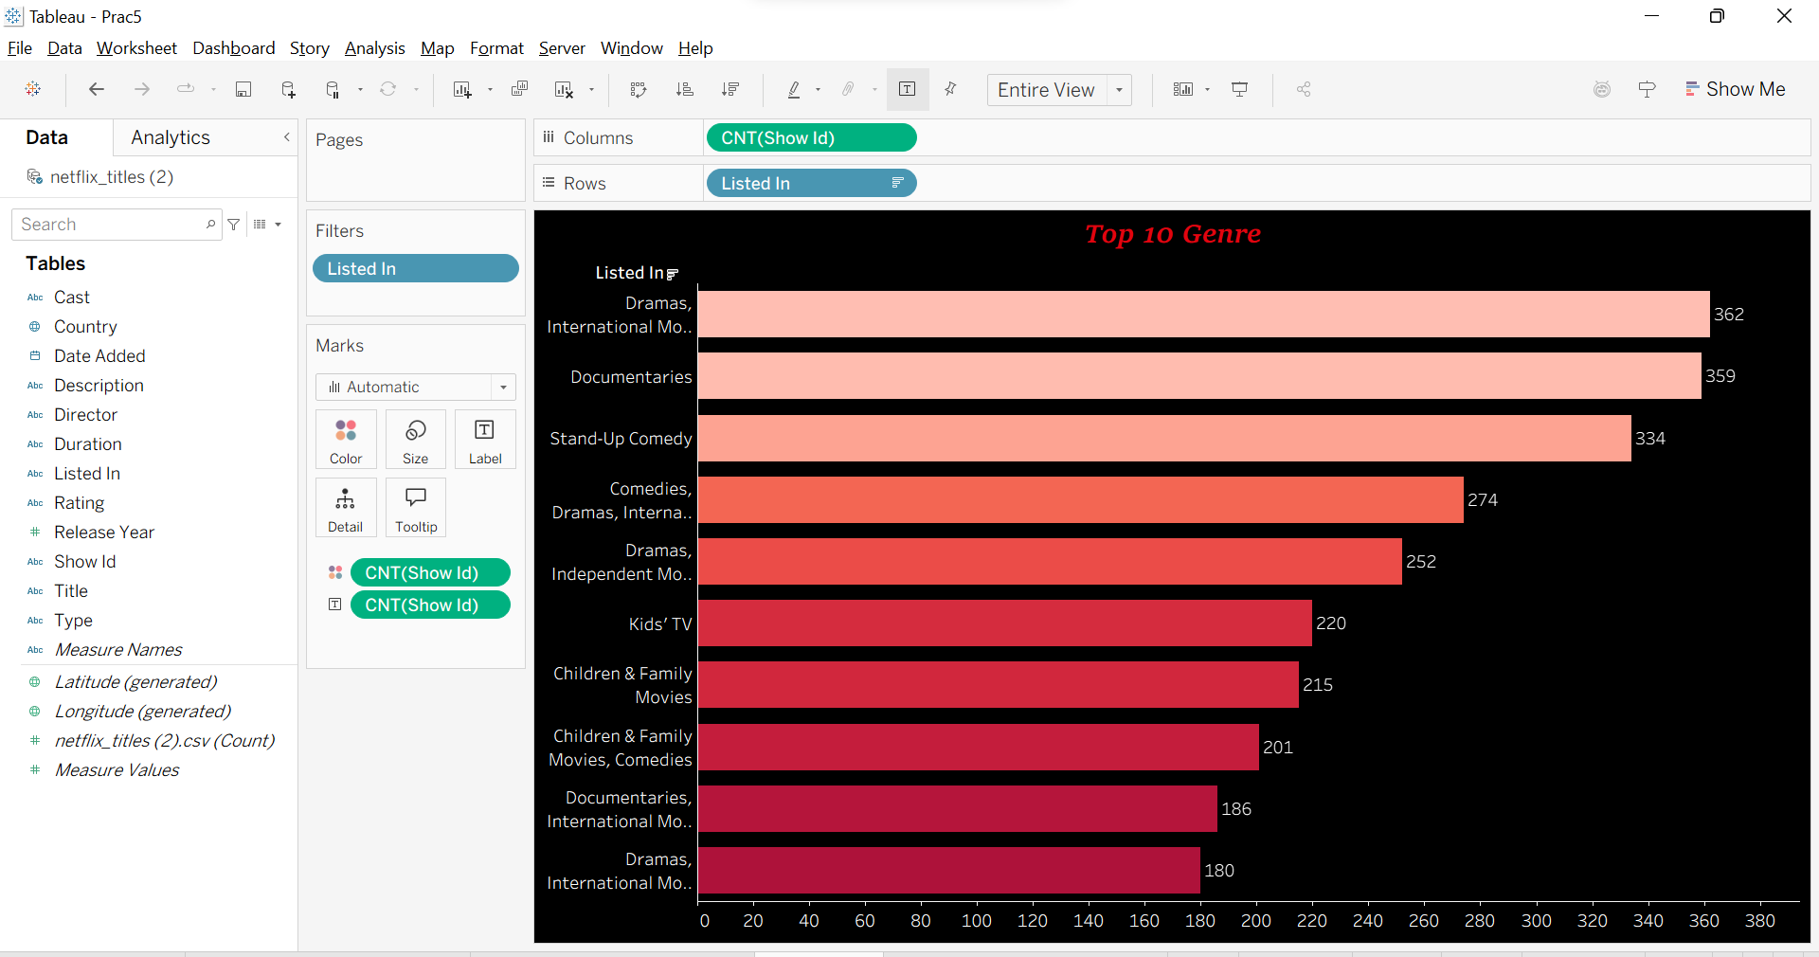

- New Worksheet: Title – ‘Movies and TV Shows Distribution’
Step 1: Drag and drop ‘Type’ col into Text
Step 2: Drag and drop ‘Show id’ col measures count (distinct)
Step 3: Show me select bubbles
Step 4: convert Type measures count
Step 5: Drag and drop ‘Type’ col in text Format
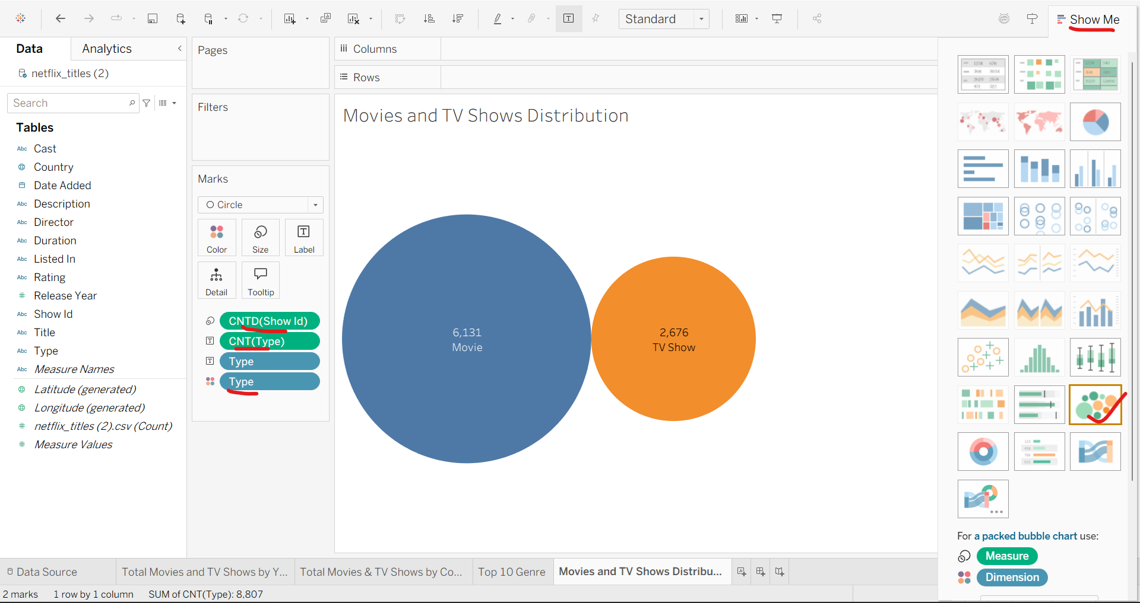
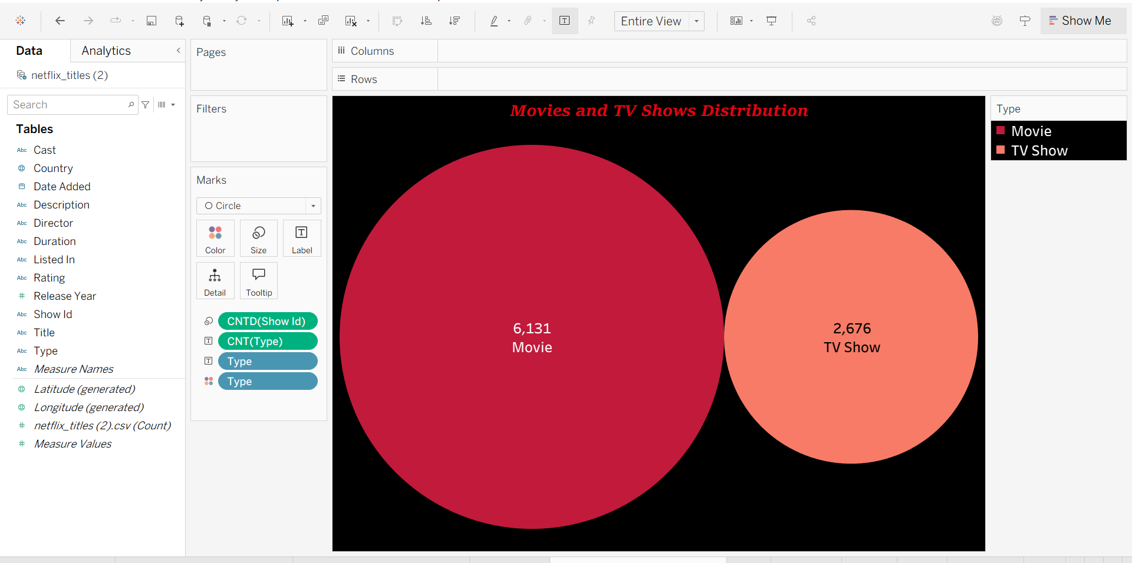

- New Worksheet: Title – ‘Rating’
Step 1: Duplicate the previous sheet and rename it as Rating. Remove all the cols under marks.
Step 2: Drag and drop ‘Type’ col in filters select all apply ok.
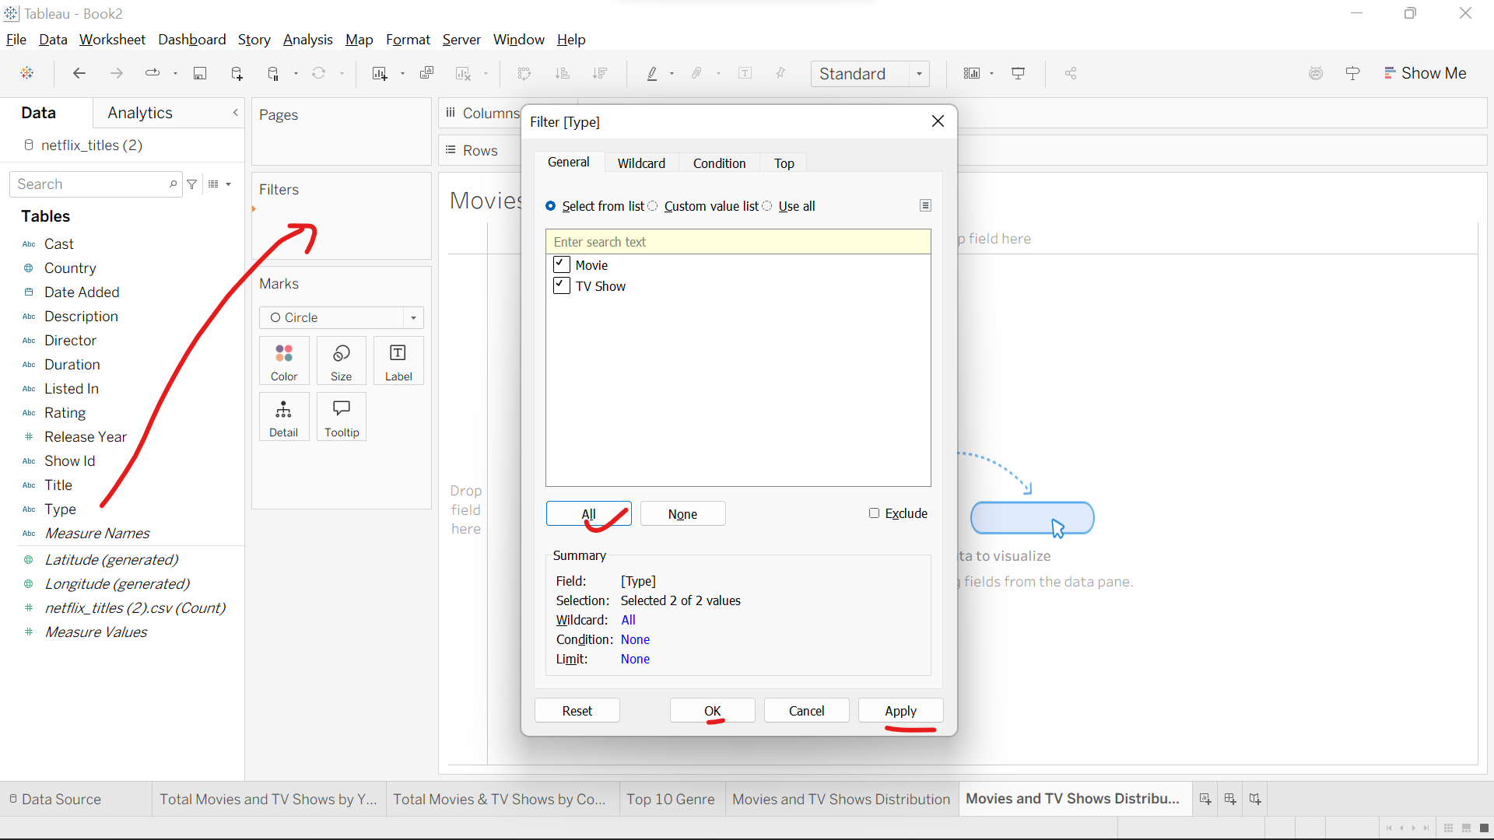
Step 3: Drag and drop ‘Title’ col in filters select ‘select from list’ select all apply ok.
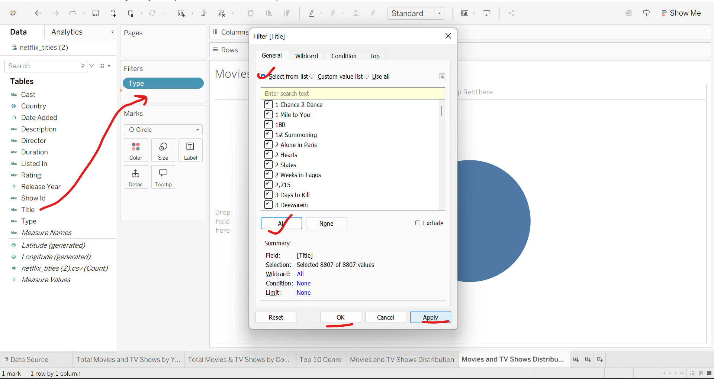
Step 4: In filters right click type apply to worksheets all using this data source, same for Title also
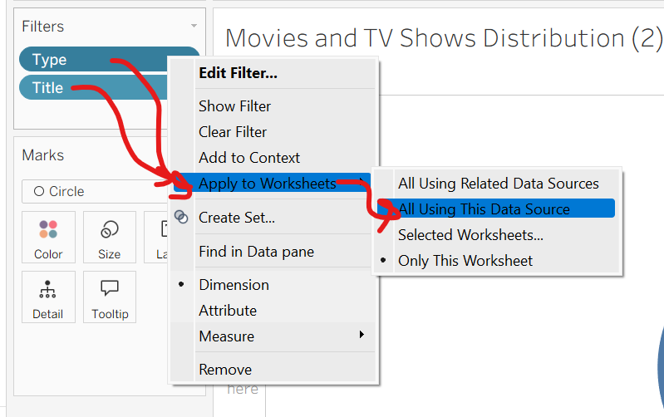
Step 5: Right click type in filters show filter
Right side filter dropdown select ‘single value dropdown’
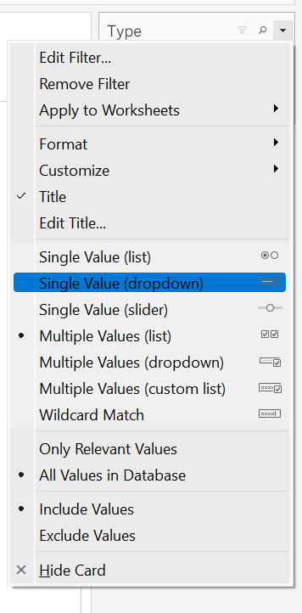
Step 6: Right side filter dropdown format this filter or set control On left side font red, body red under marks color select red
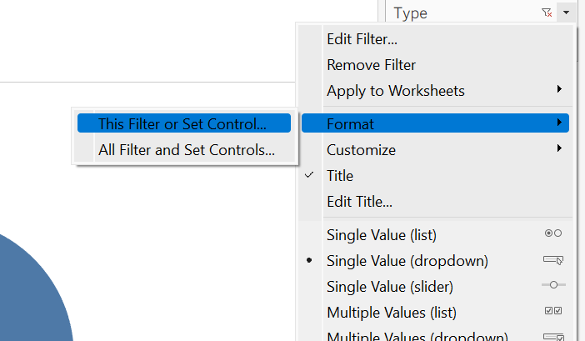
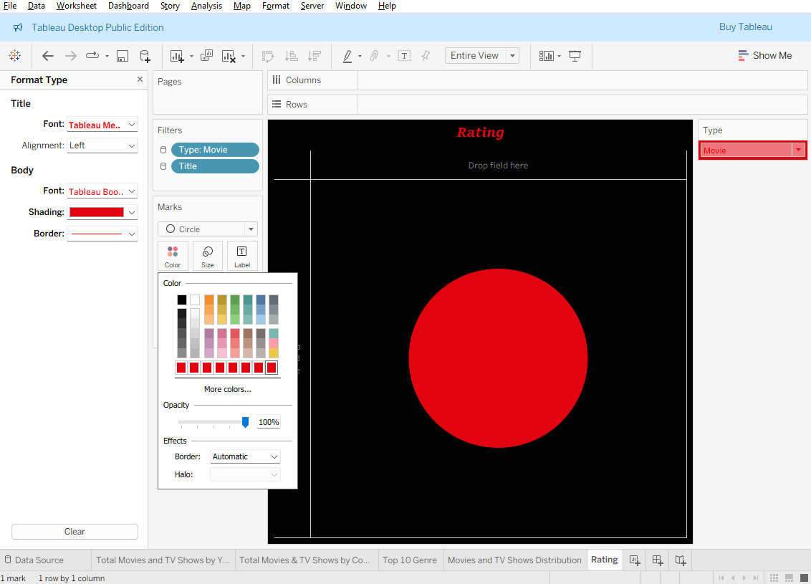
Step 7: Drag and drop ‘Description’ col into text Under marks in dowpdown select ‘Circle’ Color red
Now you can see the description for the type and title respectively
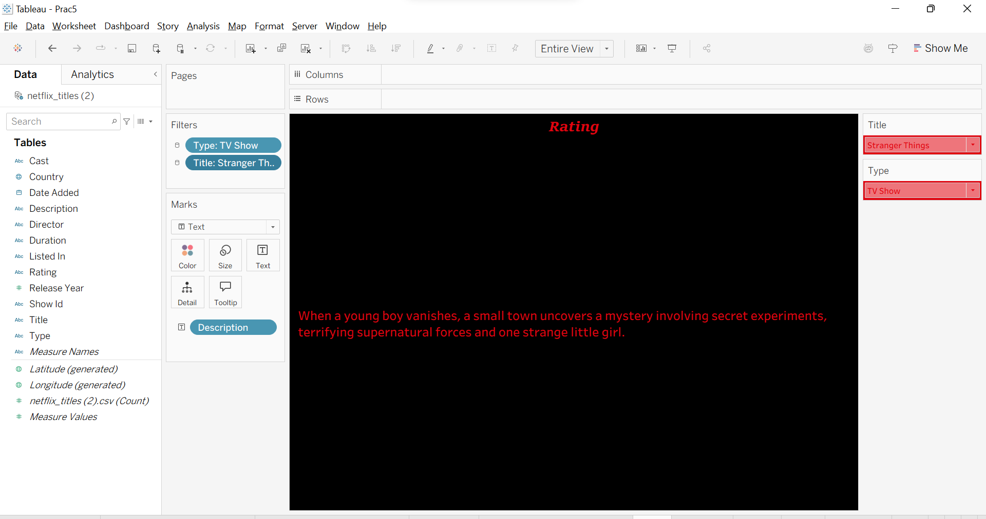

- New Worksheet: Title – ‘Date Added’
Step 1: Duplicate the previous sheet and rename it as ‘Date added’ Remove description under marks and added date added into label.
Step 2: Add ‘Date Added’ col in Text under Marks.
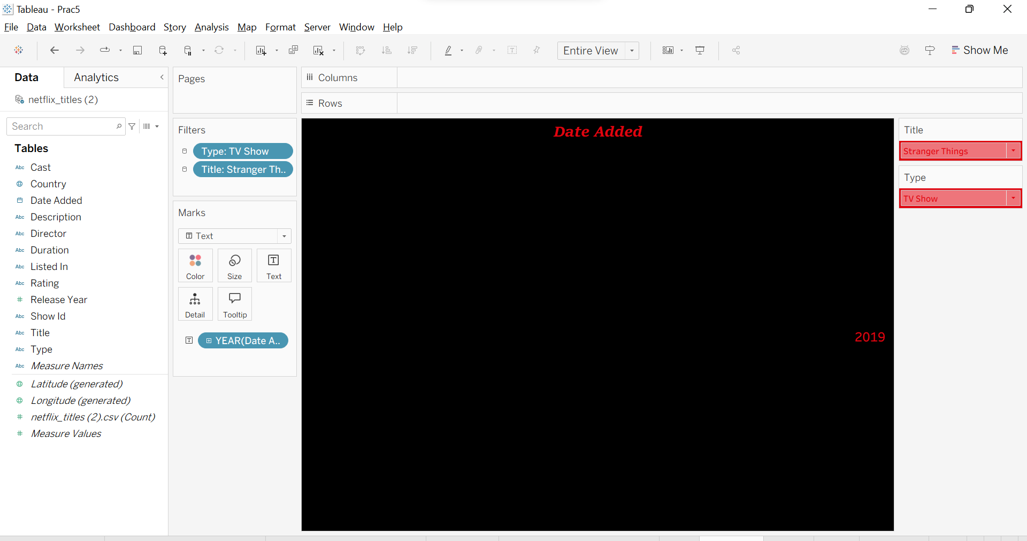

- New Worksheet: Title – ‘Duration’
Step 1: Duplicate the previous sheet and rename it as Duration Remove date added under marks and add duration into label
Step 2: Add ‘Duration’ col in Text under Marks.
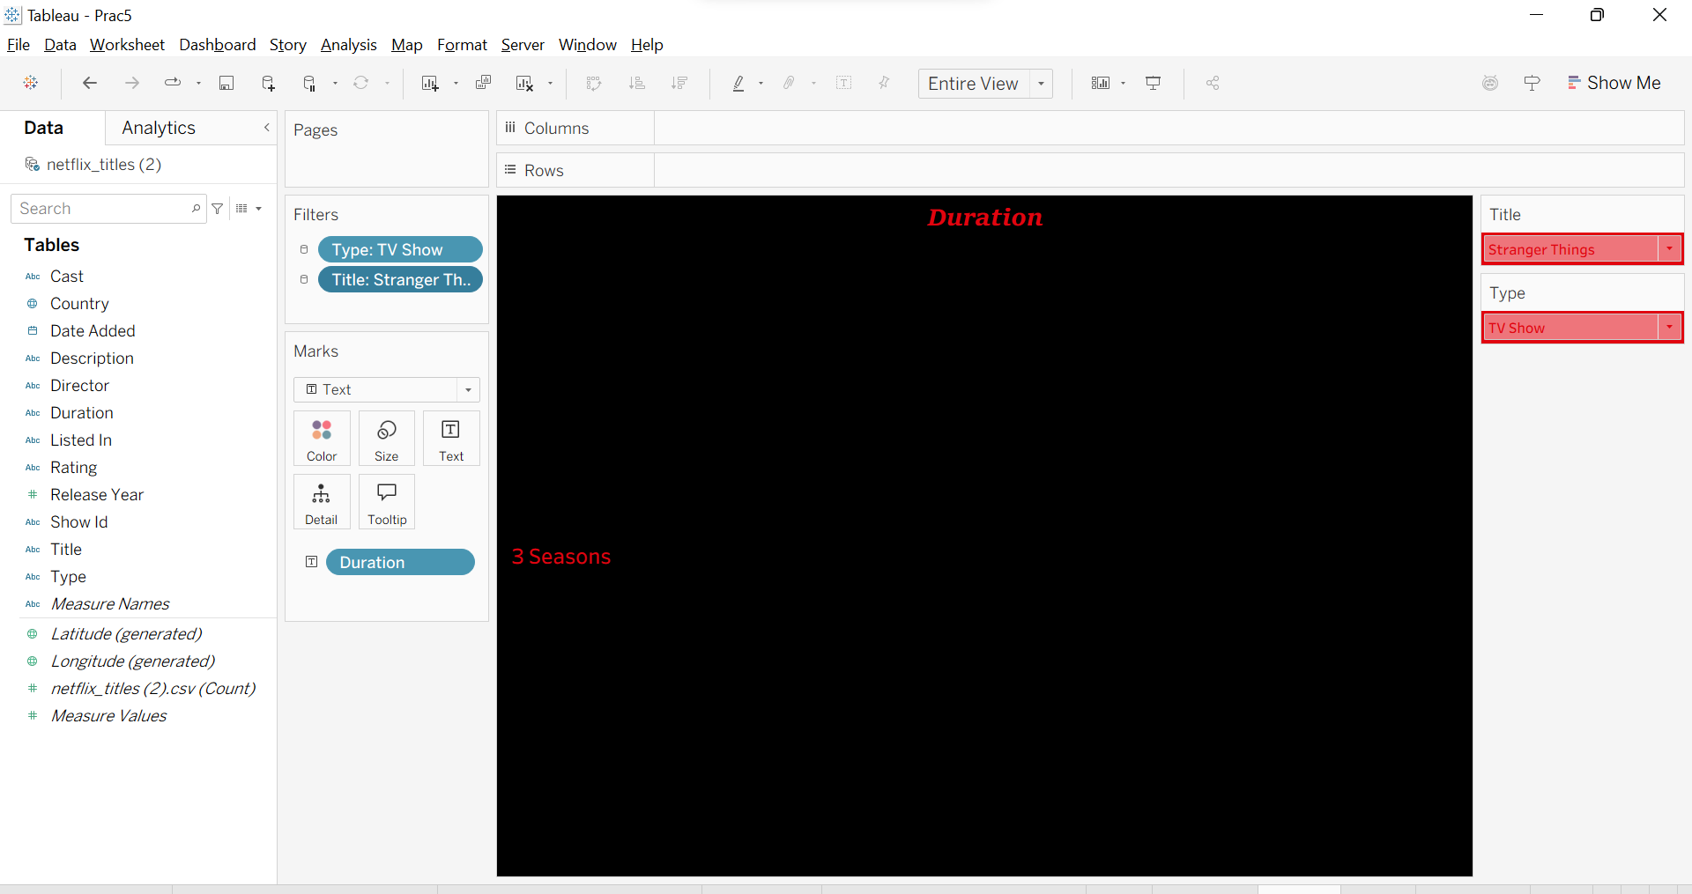

- New Worksheet: Title – ‘Ratings’
Step 1: Duplicate the previous sheet and rename it as Duration Remove duration under marks and added duration into label
Step 2: Add ‘Rating’ col in Text under Marks.
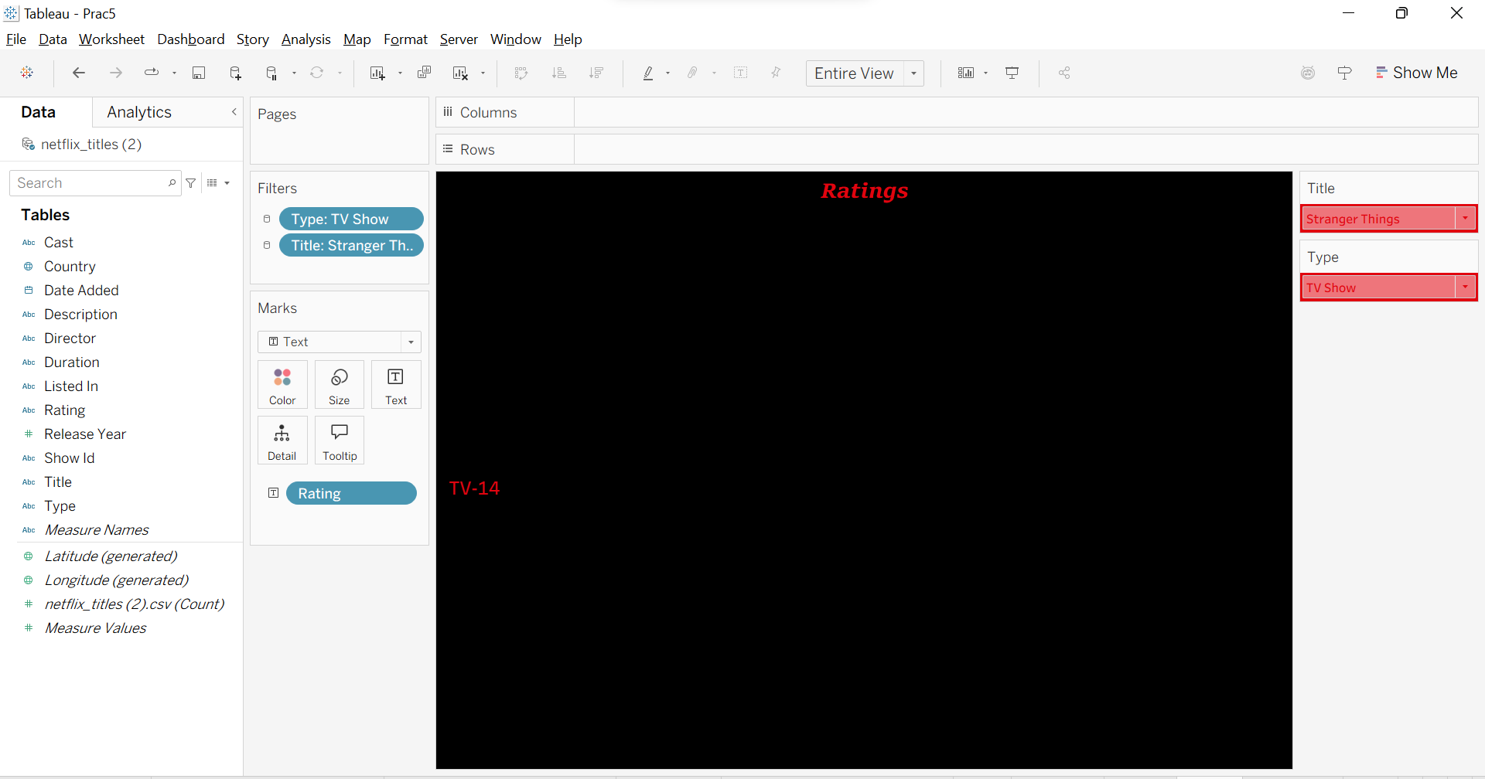

- New Worksheet: Title – ‘Release Year’
Step 1: Duplicate the previous sheet and rename it as Duration Remove rating under marks and add release year into label
Step 2: Add ‘Release Year’ col in Text under Marks.
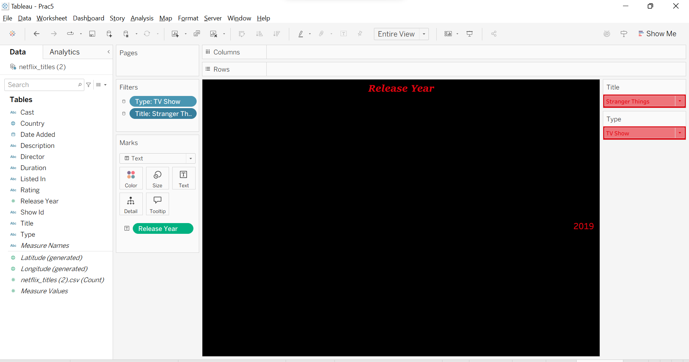

- New Worksheet: Title – ‘Genre’
Step 1: Duplicate the previous sheet and rename it as Duration Remove Release year under marks and add genre into label
Step 2: Add ‘Genre’ col in Text under Marks.
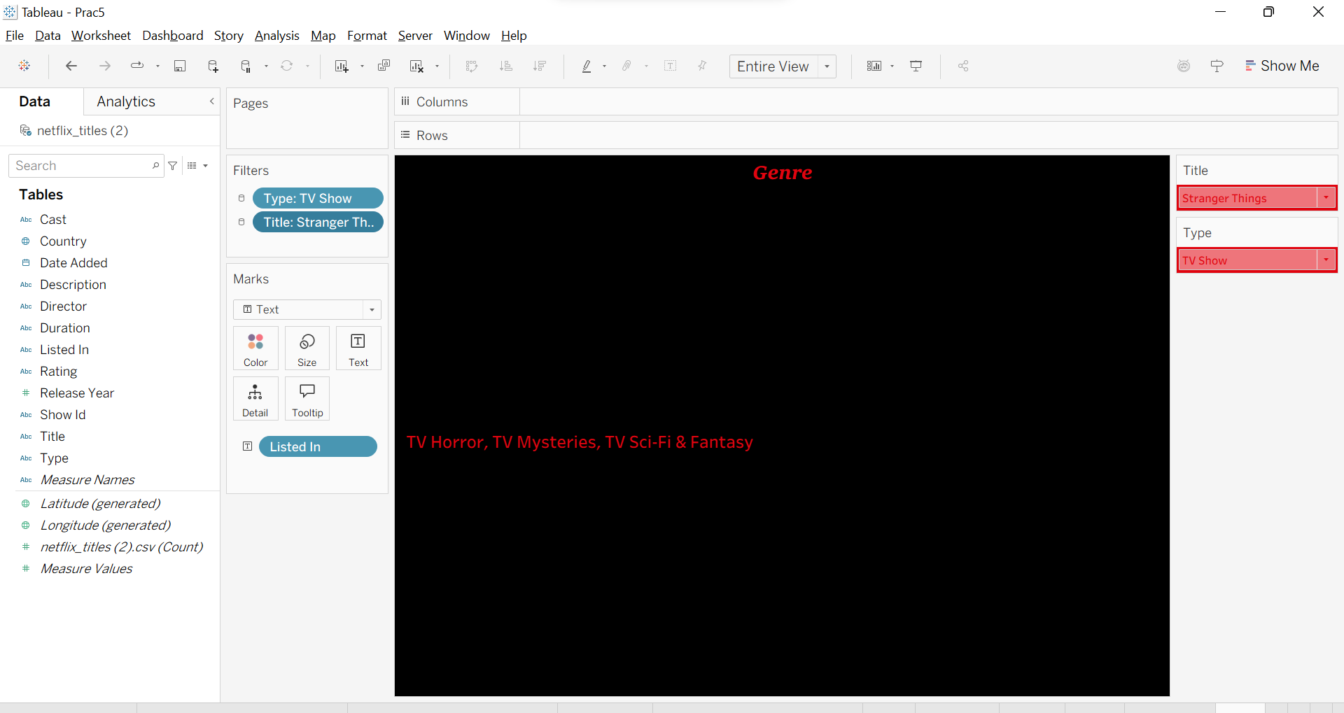

- Create Dashboard: Netflix Analysis
Step 1: In Menu, Dashboard Format select ‘Black’
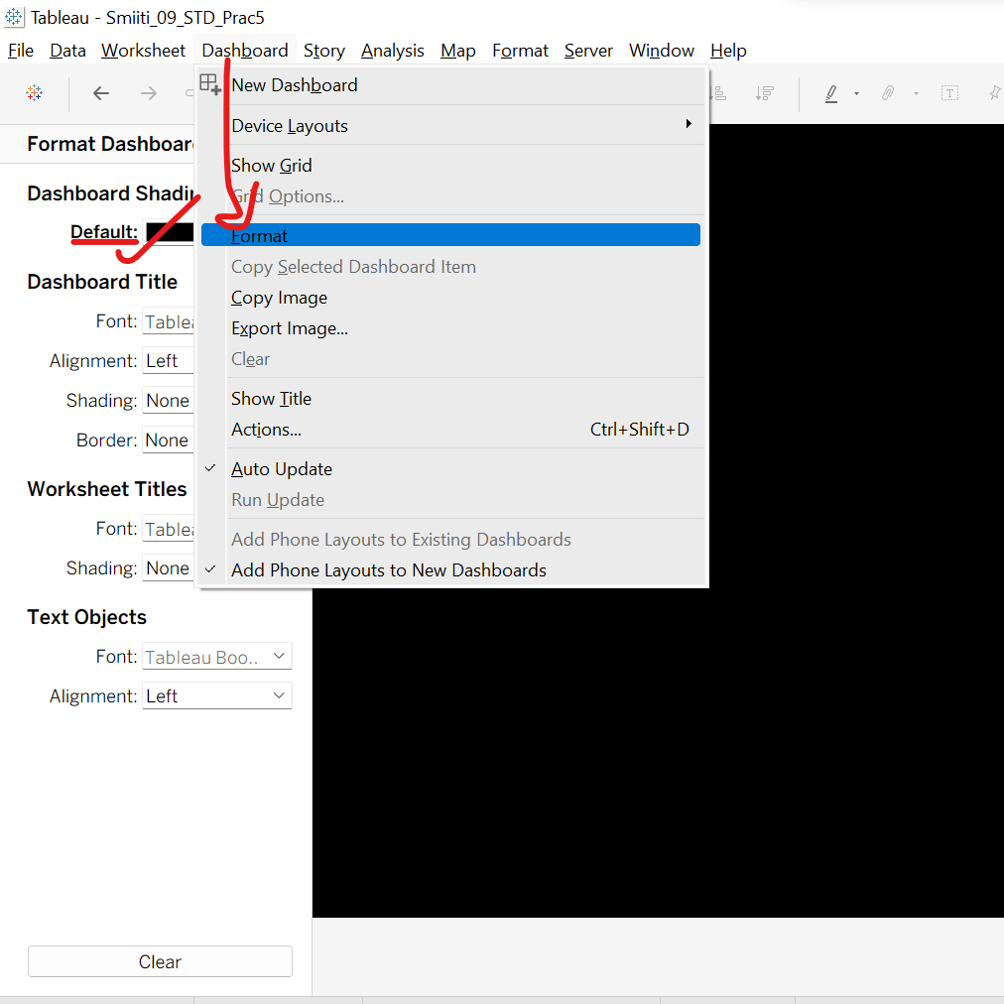
Step 2: Set the size for the canva dashboard and select floating.
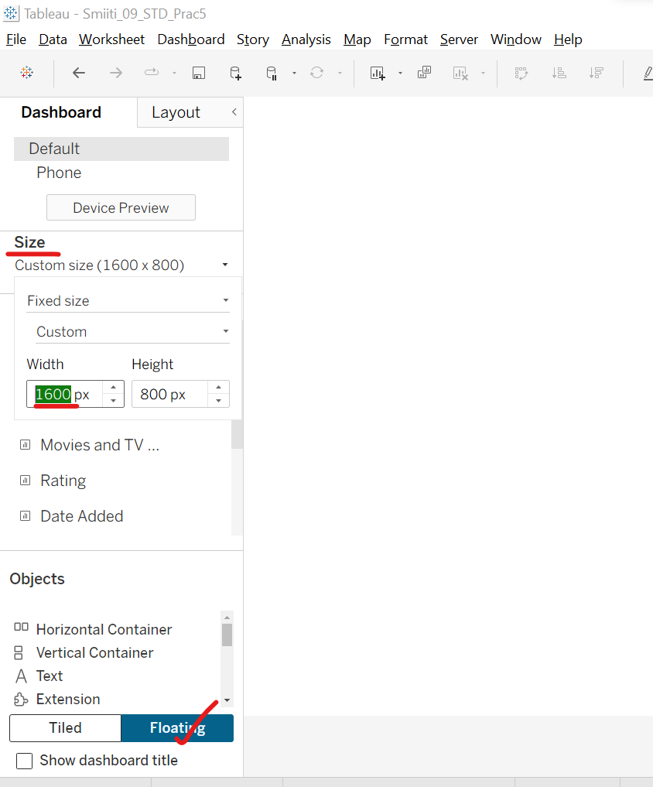
Step 3: Go to ‘Rating’ sheet on the right-side filters,
Type - dropdown small arrow, apply to worksheets selected to worksheets select the sheets shown below image and click ok.
And do same for Title filter.
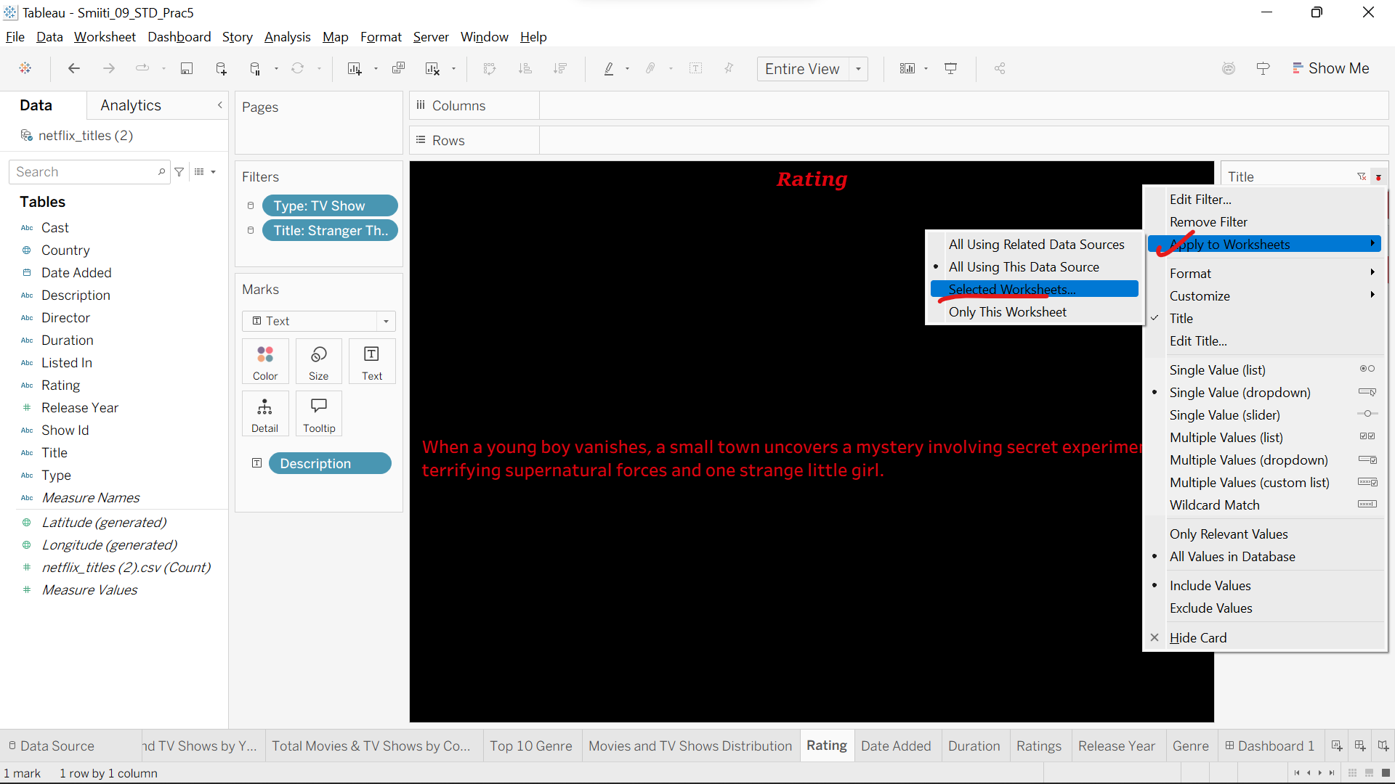
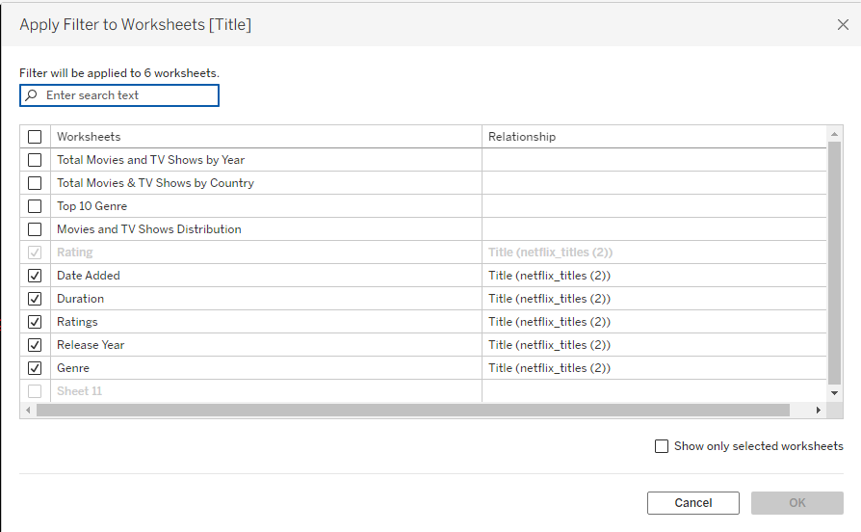
Step 4: Except Rating sheets, Add all the sheets to the dashboard and Format it.
Step 5: Download a logo of Netflix under Objects at the left side bar double click the ‘Image’ and select the downloaded image place it in the Dashboard.
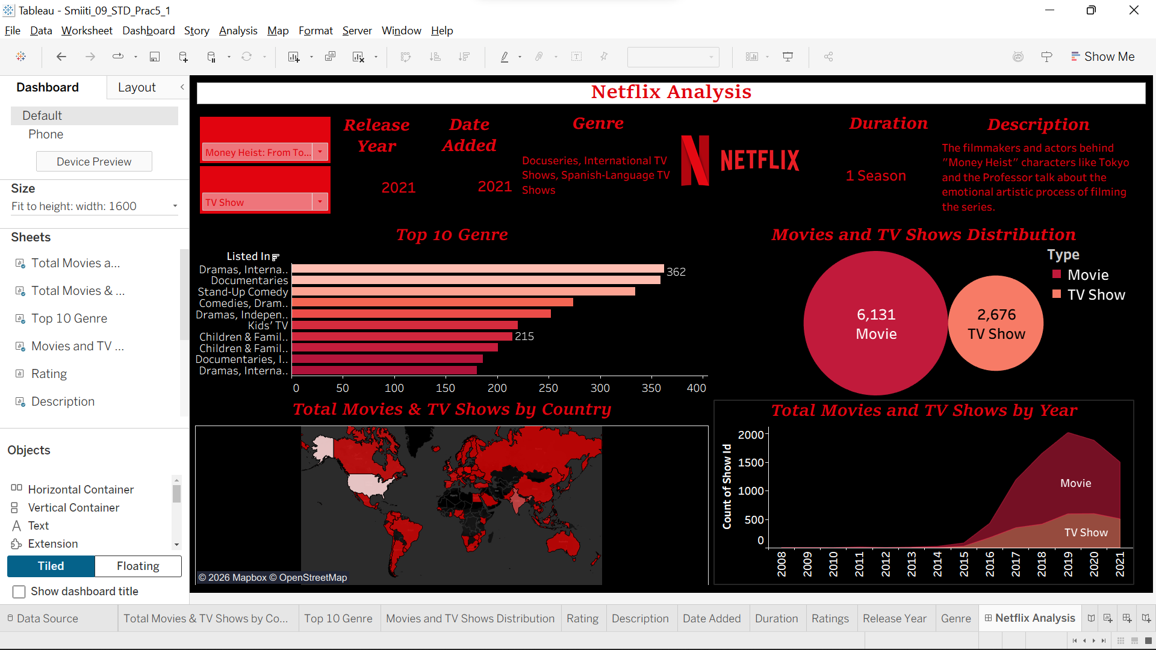
- Create Story: Netflix Analysis
Step 1: Take a new ‘story’ sheet.
Step 2: Drag and drop Movies and TV show Distribution – bubble chart. Provide a Caption for this chart.
Caption: Movies make up most of the Catalog - about 6100 compared to 2700 TV shows. So, Netflix is still more of a movie platform than a TV one.
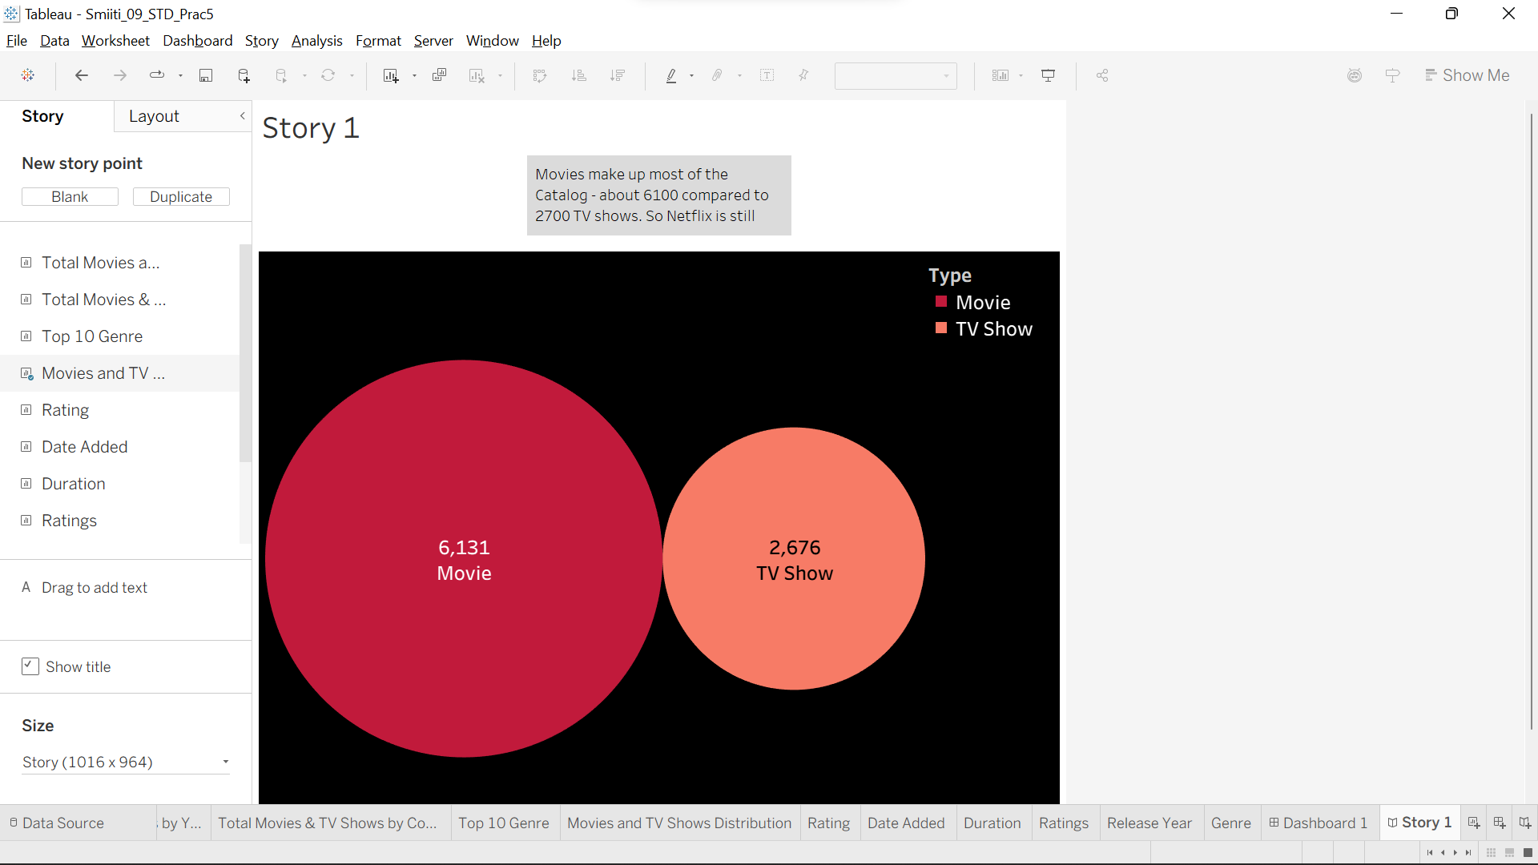
Step 3: Drag and drop Total Movies and TV shows by year – Area chart. Provide a Caption for this chart.
Caption: The Movie grew fast from 2015 to 2019, that's when the Netflix was expanding into new countries. The levels went off after 2019.
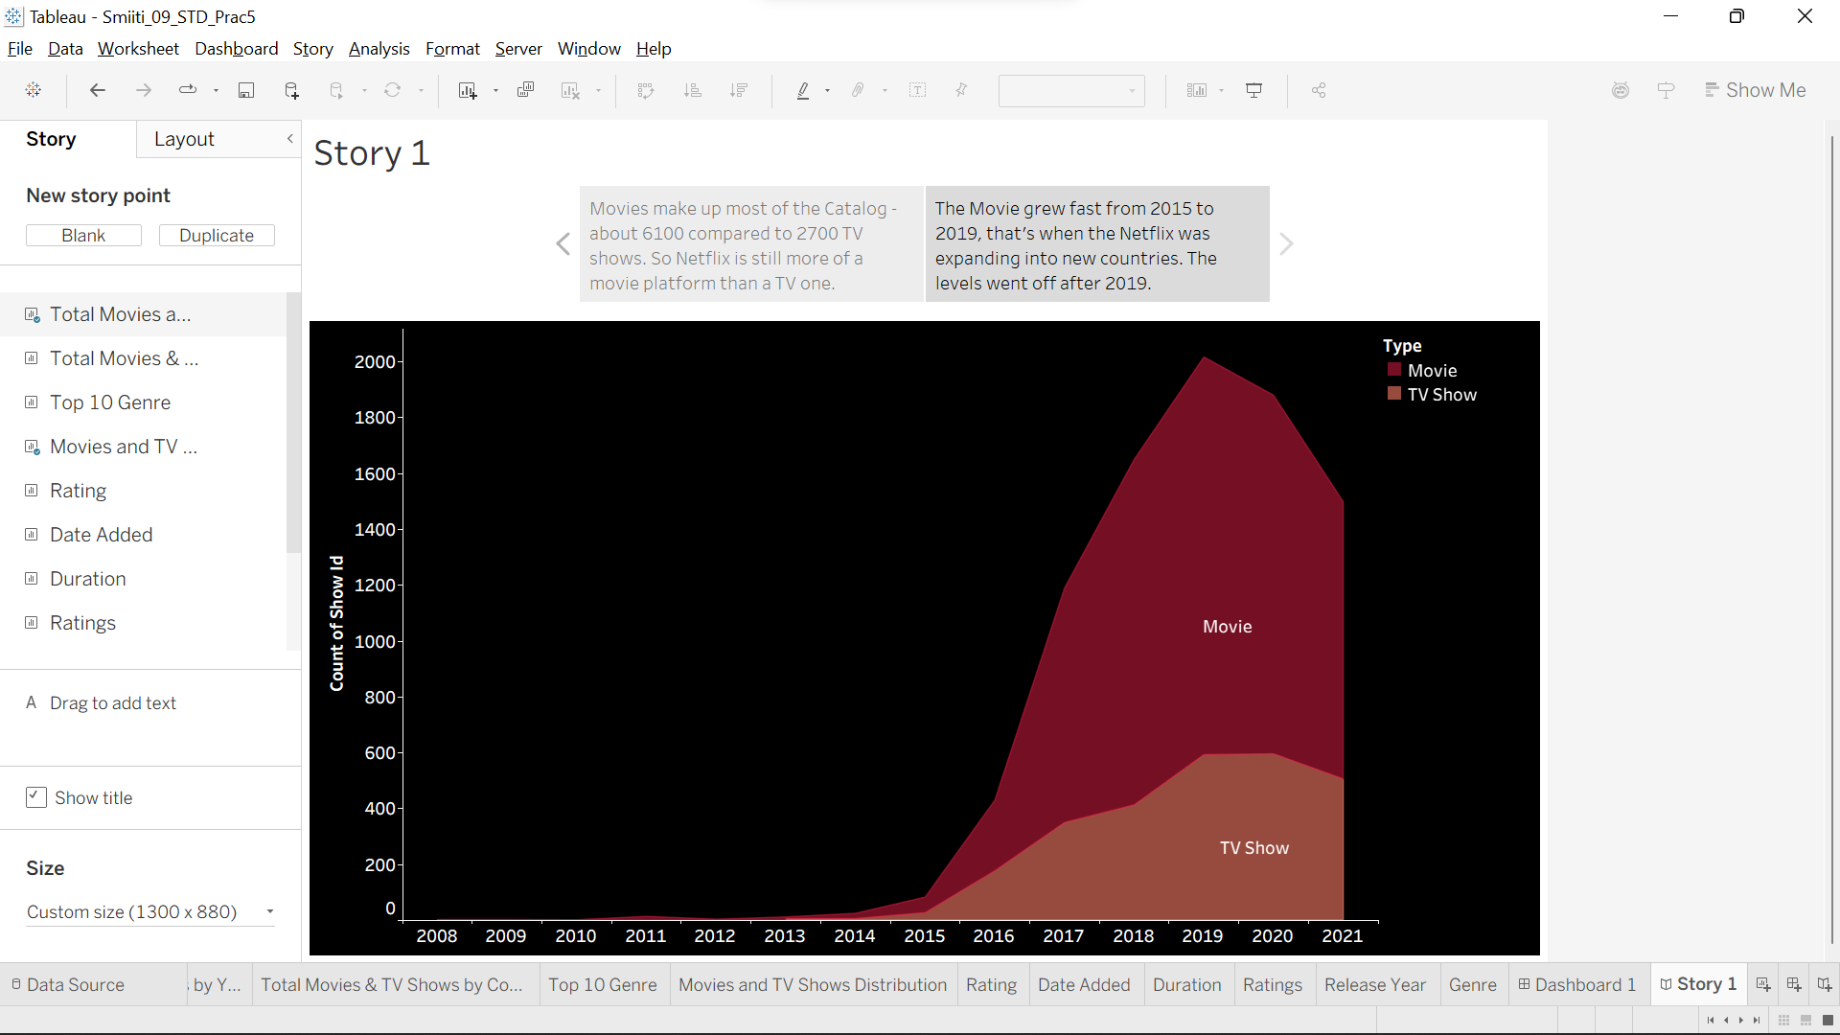
Step 4: Drag and drop Top 10 Genre – Bar chart. Provide a Caption for this chart.
Caption: The Top Genres are mostly Dramas and Documentaries. Comedy special's also show up a lot - kid's content is there but not so common.
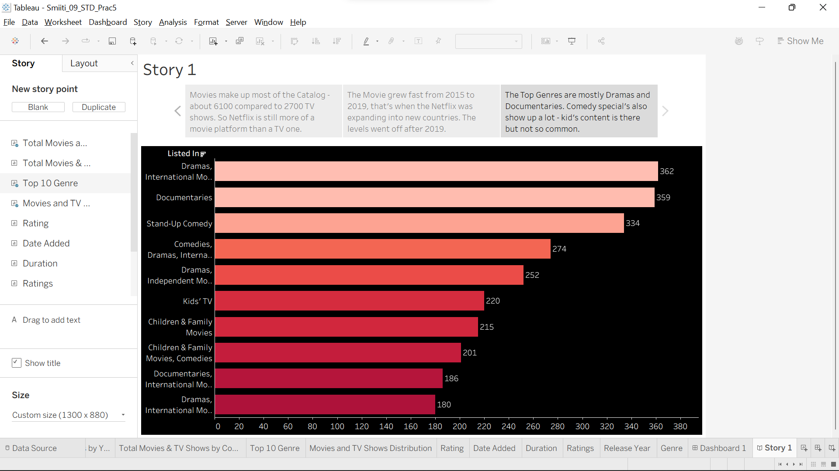
Step 5: Drag and drop Total movies and TV Shows by Country. Provide a Caption for this chart.
Caption: Most Netflix titles are still made in the US, but Russia and India stand out as the next biggest sources of content.
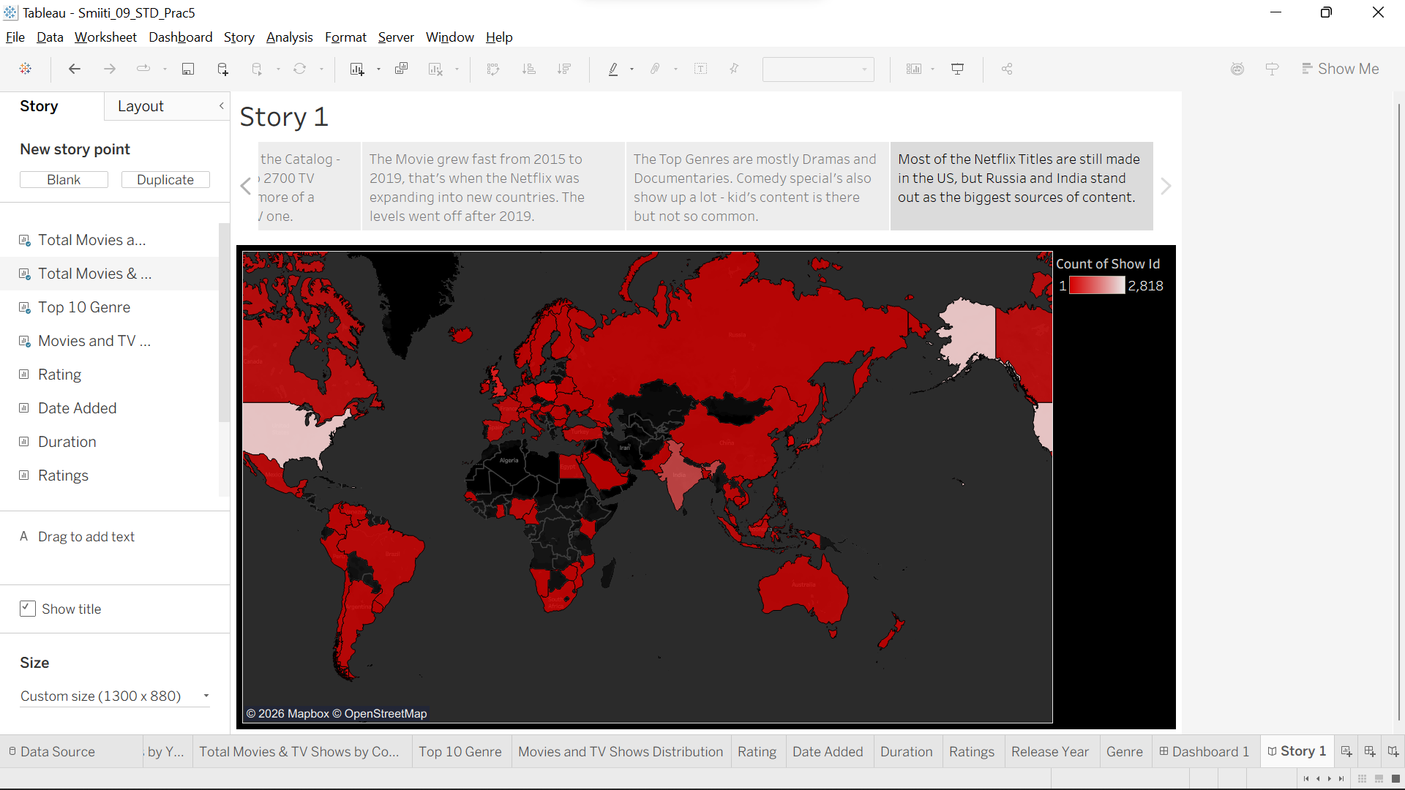
Step 6: Format the Title.
If you want you can change the Layout of the of the captions.
