

FACULTY OF TECHNOLOGY AND ENGINEERING

DEVANG PATEL INSTITUTE OF ADVANCE TECHNOLOGY AND RESEARCH
DEPARTMENT OF INFORMATION TECHNOLOGY

A.Y. 2026-27 [ODD]

LAB MANUAL

CSUC201:DSA



Practical 7
Problem 1
A government office has a token counter that issues tokens to visitors. The counter can hold at
most n tokens at a time. New visitors join from one end and are served from the other end in the
order they arrived. If the counter is full, no new token can be issued, and if it is empty, no one
can be served. Given a sequence of join and serve operations, implement this fixed-capacity
token system and print the current front token after each operation. Report an error if an
operation cannot be performed.
Describe how your solution tracks the front and rear of the queue. What happens to your front
and rear pointers over time as join and serve operations keep happening, and does your
solution handle the case where space appears to run out even though slots have been freed?

Code:
https://github.com/smitmalaviya80-sys/FDSA-Batch-A.git

OutPut:
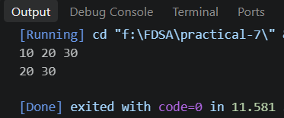

Problem Faced:
I have faced problem in this practical is first of all , remove and add element than need to travesel pointer top so that is a troubleling part so than need to delete also check every time stack empty or not that is a problem I faced

Key Question:
Problem 1: In a simple array queue, the front points to the first element and rear points to the last inserted element. Both move only forward, so when elements are removed from the front, those empty positions are not reused. Eventually, rear reaches the last array position and the queue reports full even though there are free spaces at the beginning.

Problem-2:
A hospital emergency ward receives patients continuously and attends to them strictly in the
order they arrived, with no upper limit on how many can be waiting at once. New patients are
added at the back and the doctor always attends to the patient at the front. Given a sequence of
arrive and attend operations, implement this unlimited patient queue and print the current front
patient after each operation.
Describe how your solution differs from Problem 1 in how it manages capacity. What happens in
your solution when the attend operation is called on an empty ward with no patients waiting?

Code:

https://github.com/smitmalaviya80-sys/FDSA-Batch-A.git

Output:
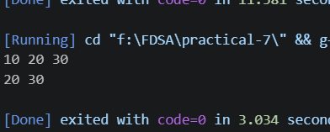

Problem Faced:
nothing to faced because I learn part 1 so that is very helpful.

Key Question:
Problem 2: If arrive operations are much more frequent than attend, the linked list will continuously grow and consume more memory. This can eventually cause high memory usage or an out-of-memory problem. The consequence is invisible in the queue code because there is no fixed capacity check; each new node is simply allocated dynamically.

