Practical-6:
Problem-1
A cafeteria stacks clean trays on a fixed-size counter. New trays are always placed on top, and
customers always take from the top. The counter can hold at most n trays at a time — if it is full,
no more trays can be added, and if it is empty, no tray can be taken. Given a sequence of place
and take operations, implement this fixed-capacity tray stack and print the current top tray after
each operation. Report an error if a place or take operation cannot be performed.
Describe how your solution tracks whether the stack is full or empty. What are the exact
conditions you check before a push and before a pop, and what does your program do when
those conditions fail?

Code:

Output:
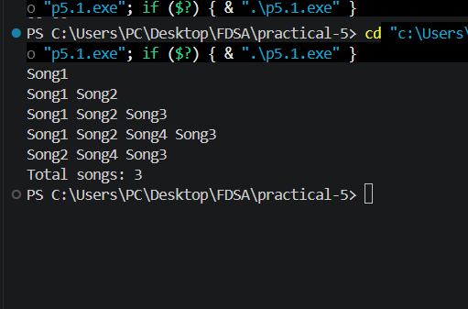

Problem Faced:-
I faced problem on this after first insert that is some time I forgot the step but now I remember a first link next then prev and than prev node link current and next node link with prev(current)

Key question
1. [Problem 1] A doubly linked list maintains two links per node instead of one. When
deleting the front node, explain why having a backward link on the second node creates
a responsibility that did not exist in a singly linked list — and what goes wrong if you
forget to handle it.

- When deleting the front node of a doubly linked list, the second node becomes the new head. We must set its prev pointer to NULL, because it should no longer point to the deleted node. In a singly linked list, this step is not required because there is no prev link. If we forget it, the new head may point to a deleted node, causing a dangling pointer and possible program errors or crashes.

Problem-2
A group of students are sitting in a circle playing a passing game. A token starts at the first
student and is passed around the circle one student at a time. Students can join the circle at any
position and leave at any time, and the circle must remain unbroken after every join or leave.
Given a sequence of join, leave, and display operations, implement them on both a singly
circular and a doubly circular linked list and print the current circle after each operation.
Describe how your solution ensures the circle stays unbroken after a student leaves. What is
the one case where breaking the circle is most likely to happen as a bug, and how did you
handle it?

Code:
Output:
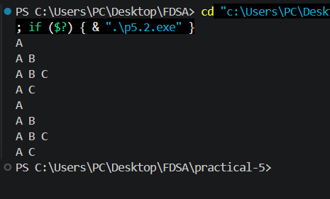
Problem faced:
Also I have faced problem in this code is to joint circular link list and doubley link to join at end to first.
Key question:
2. [Problem 2] If your traversal of the circular list does not stop at the right moment, it will
loop forever. Without referencing any specific code, explain what condition must be true
at the moment you stop, and why that condition would fail if you set the last node's link to
null.

- In a circular linked list, traversal should stop when you reach the starting node again, because the last node points back to the first node. If the last node's link is set to NULL, the circle is broken, so the traversal would stop at NULL instead of detecting that it has returned to the starting node.

