

FACULTY OF TECHNOLOGY AND ENGINEERING

DEVANG PATEL INSTITUTE OF ADVANCE TECHNOLOGY AND RESEARCH
DEPARTMENT OF INFORMATION TECHNOLOGY

A.Y. 2026-27 [ODD]

LAB MANUAL

CSUC201:DSA



Practical-9

Problem-1:
A disaster relief team needs to inspect all buildings in a city after an earthquake. The city is
mapped as a network where buildings are connected by roads. One team starts at a building
and goes as deep into each road as possible before backtracking, while a second team spreads
out level by level — first checking all buildings directly connected to the start, then all buildings
two roads away, and so on. Given the city map as a graph and a starting building, implement
both exploration strategies and print the order in which buildings are visited by each team.
Describe how the order of buildings visited differs between the two strategies on the same
graph. What data structure does each strategy rely on to decide which building to visit next, and
how does that structure cause the difference in order?
Code
Output:
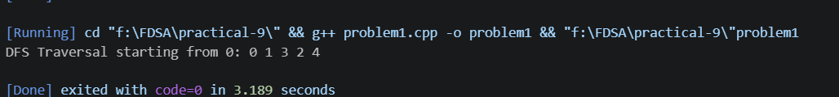

Key question
Problem 1: If the building is very close to the starting point, BFS will usually find it sooner because it explores nearby nodes level by level. If the building is very far and deep along one path, DFS may find it sooner because it explores deeply before backtracking. The actual time depends on the network structure and the building's position.
Problem 2: Recursive DFS can fail on a very large city map because the computer has a limited call stack. Too many recursive calls can cause a stack overflow. To avoid this, DFS can be rewritten using an explicit stack data structure instead of recursion, allowing the program to manage large searches more safely.

