

FACULTY OF TECHNOLOGY AND ENGINEERING

DEVANG PATEL INSTITUTE OF ADVANCE TECHNOLOGY AND RESEARCH
DEPARTMENT OF INFORMATION TECHNOLOGY

A.Y. 2026-27 [ODD]

LAB MANUAL

CSUC201:DSA



Practical-8

Problem-1:
A company stores its organizational hierarchy as a tree — the CEO at the top, managers below,
and employees at the leaves. Different departments need the hierarchy printed in different
orders: HR wants each manager printed between their left and right sub-teams, the archive
department wants each manager printed before their sub-teams, the payroll department wants
each manager printed after all their sub-teams are listed, and the floor manager wants everyone
printed level by level from top to bottom. Given a binary tree representing the hierarchy,
implement all four printing orders and display the result of each.
Describe how your solution for level-by-level printing differs from the other three. What
additional structure did you need to use, and why does the same recursive approach that works
for the other three not directly apply here?

Code:
https://github.com/smitmalaviya80-sys/FDSA-Batch-A.git

Output:
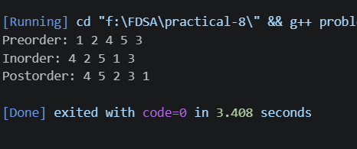
Problem Faced:
I have beed faced problem particular this practical is how to convert in-order to pre and post order syntex and I faced which type of code are arrange and how to find root node and where to place root node.

Key Question:
Problem 1: Preorder alone is generally not enough to reconstruct the original tree because it only tells us the order in which nodes are visited. We would need additional information, such as the inorder traversal, or structural information like null-child markers, to uniquely reconstruct the tree.

Problem-2:
A school library uses a system where every book is assigned a unique code when it arrives.
Books are organized so that at any shelf position, all books to the left have smaller codes and
all books to the right have larger codes. This arrangement lets staff find any book quickly by
always knowing which direction to look. Given a sequence of book codes arriving one by one,
insert each into the correct position and print the inorder sequence after all insertions are
complete.
Describe how your solution decides where to place each new book code. What property of the
final inorder sequence tells you whether all insertions were performed correctly?

Code:
https://github.com/smitmalaviya80-sys/FDSA-Batch-A.git

Output:
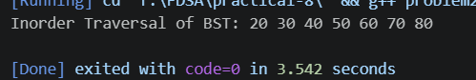
Problem Faced:
In this practical I faced problem is find root node and how arrange and how to given tree to convert BST tree (binary search tree).
Key Question:
Problem 2: If the inorder traversal of a BST is not sorted, there may be an error in either the insertion logic or traversal logic. To isolate it, first check the tree structure and insertion results, then test the inorder traversal on a simple known BST. If the tree is correctly built but the output is unsorted, the error is in the traversal; otherwise, it is likely in the insertion logic.

