

FACULTY OF TECHNOLOGY AND ENGINEERING

DEVANG PATEL INSTITUTE OF ADVANCE TECHNOLOGY AND RESEARCH
DEPARTMENT OF INFORMATION TECHNOLOGY

A.Y. 2026-27 [ODD]

LAB MANUAL

CSUC201:DSA



Practical-10
Problem-1:
A small parking lot has exactly 10 numbered slots (0 to 9). Assign each vehicle to a slot using Linear Probing if collision occurs
Code:
https://github.com/smitmalaviya80-sys/FDSA-Batch-A.git

Output:
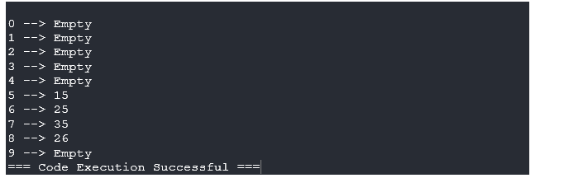
Problem faced:
Linear probing handles collisions easily but leads to primary clustering, grouping elements together heavily which impacts search and insertion performance drastically.

Key question:
1. If five consecutive vehicle registrations all end in the same digit, trace where each one gets placed. Why is this clustering effect a structural weakness?
--> They will be placed sequentially in contiguous blocks (e.g., 5, 6, 7, 8). This "Primary Clustering" drastically worsens collision probability over time because any new slot mapping nearby will just merge and expand the blocked chain further.

Problem-2:
A library uses a system with 10 shelves numbered 0 to 9. Implement hashing with Chaining to map multiple books correctly to the same shelf
Code:
https://github.com/smitmalaviya80-sys/FDSA-Batch-A.git

OutPut:
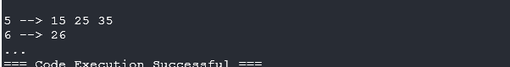
Problem faced:
Chaining resolves clustering by using Linked Lists for indexes that collide. It uses dynamic memory efficiently at the cost of additional pointer memory overhead.

Key question:
2. Suppose all book codes are multiples of 10. Predict what the final shelf layout would look like.
--> All books would stack endlessly inside index 0. The hashmap behaves like an inefficient O(n) linked list instead of an O(1) hashmap. The hash function must uniformly distribute data based on the characteristics of the input structure.

Problem-3:
A university assigns student IDs to storage slots using a two-step rule. Implement Double Hashing.

Code:
https://github.com/smitmalaviya80-sys/FDSA-Batch-A.git

Output:
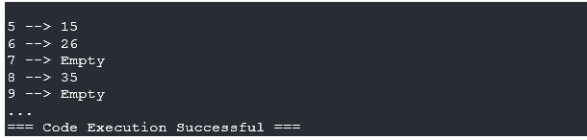
Problem Faced;
Double hashing avoids clustering by generating alternative skip paths for collisions instead of just skipping to the next immediate adjacent slot.

