

FACULTY OF TECHNOLOGY AND ENGINEERING

DEVANG PATEL INSTITUTE OF ADVANCE TECHNOLOGY AND RESEARCH
DEPARTMENT OF INFORMATION TECHNOLOGY

A.Y. 2026-27 [ODD]

LAB MANUAL

CSUC201:DSA



Practical-6:
To implement stack using array and linked list, and apply stack-based logic to expression conversion, evaluation, and bracket validation problems.
Problem 1:
A cafeteria stacks clean trays on a fixed-size counter. New trays are always placed on top, and
customers always take from the top. The counter can hold at most n trays at a time — if it is full,
no more trays can be added, and if it is empty, no tray can be taken. Given a sequence of place
and take operations, implement this fixed-capacity tray stack and print the current top tray after
each operation. Report an error if a place or take operation cannot be performed.
Describe how your solution tracks whether the stack is full or empty. What are the exact
conditions you check before a push and before a pop, and what does your program do when
those conditions fail?

Code :
https://github.com/smitmalaviya80-sys/FDSA-Batch-A.git

Output :
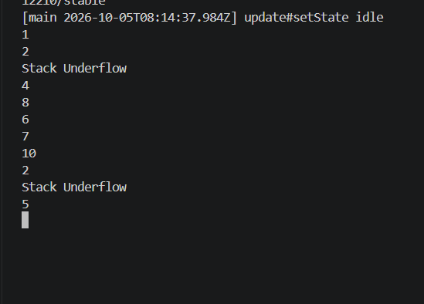
Problem faced:
In this practical I faced the problem is the stack implementation and also revice underflow and overflow condition
Key question :
Problem 1: The front and rear pointers should move back to the beginning of the array when they reach the last position, using modulo logic. The array is full when the next position of rear is equal to front, i.e. (rear + 1) % size == front.
Problem -2:
A web browser keeps track of pages visited so that the back button always returns to the most
recently visited page. Unlike a fixed counter, the browser has no hard limit on how many pages
it can remember — it grows as the user visits more pages and shrinks as they press back.
Given a sequence of visit and back operations, implement this unlimited page history and print
the current page after each operation.
Describe how your solution differs from Problem 1 in how it handles memory. What happens in
your solution when the user presses back on the very first page with no history left?
Code:
https://github.com/smitmalaviya80-sys/FDSA-Batch-A.git

Output:
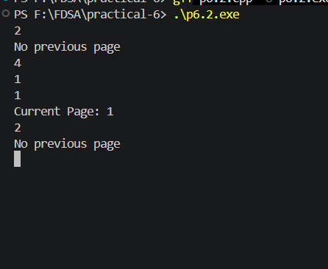
Problem faced:
Most important thing is the implement the previous practical using push and pop functions.
Key question :
Problem 2: Yes, a linked-list stack can still run out of space. Its actual limit depends on the available memory (RAM) of the system. This limit is invisible in the code because nodes are created dynamically using memory allocation until the system can no longer provide enough memory.

Problem-3:
A calculator application receives arithmetic expressions typed by users in the usual way —
numbers and operators written in between, with brackets to control priority (e.g. 3 + 4 * 2 or (3 +
4) * 2). Internally the calculator needs to convert each expression into a form where operators
appear after their operands, so it can evaluate them without needing to re-read brackets. Given
an infix expression, convert it to the equivalent postfix form and print the result.

Code:
https://github.com/smitmalaviya80-sys/FDSA-Batch-A.git

OutPut:
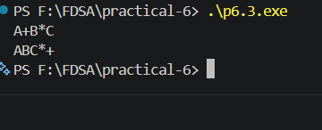
Problem Faced:
I faced some conditions like isalnum(),priority(),,isempty() this thing all are I faced the problem in this practical.
Key Question:
Problem 3: If all operators had equal precedence, operators such as * and / would not be processed before + and -. This would produce an incorrect postfix expression and therefore could lead to an incorrect result when the postfix expression is evaluated.

