Practical-1
Part-A
Problem-1
(a) Define an enum Coin with constants ONE, TWO, FIVE, TEN.
(b) In main, set a snack price of 15 and a running total of 0; create a Scanner.
(c) Loop: read a coin name, use a switch expression to convert the Coin to its value
(ONE→1, TWO→2, FIVE→5, TEN→10), add it to the total, and print the total so
far.
(d) Stop the loop once the total reaches 15 or more.
(e) Print the change to return (total − 15).
Expected output: TEN then FIVE prints “Paid. Change: 0”; TEN then TEN prints
“Paid. Change: 5”.
import java.util.Scanner;
public class vendingmachine{
enum Coin{
ONE,
TWO,
FIVE,
TEN
}

public static void main(String[] args) {

int total=0;
int snackprice=15;
Scanner sc=new Scanner(System.in);

while (total<snackprice) {
System.out.println("enter the coin:");

String input = sc.next().toUpperCase();
Coin coin = Coin.valueOf(input);

int value=switch(coin){
case ONE-> 1;
case TWO-> 2;
case FIVE-> 5;
case TEN-> 10;
};
total+=value;
}

System.out.println("total change: " + (total-snackprice));
sc.close();
}
}

Output:
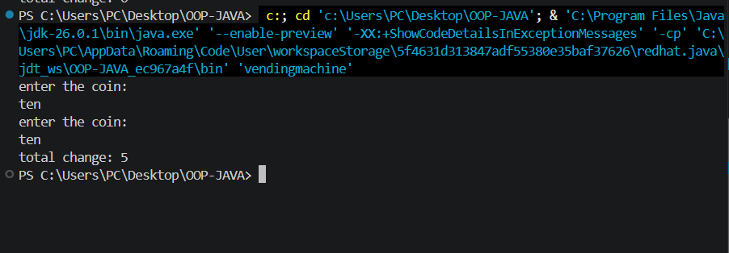

Learning:-
Problem-2
(a) Define a record Vehicle(String number, String type).
(b) In main, keep a running toll total and three counters (bike, car, truck).
(c) Loop until the user types “done” for the number: build a Vehicle, use a switch
expression on its type for the toll (bike→20, car→50, truck→150), add to the total,
and increment that type’s counter.
(d) After the loop, print the total toll and the type with the highest count.
Expected output: two cars + one bike → “Total toll: 120”, “Most frequent: car”.
import java.util.Scanner;

public class TollBooth {

record Vehicle(String number , String type){}

public static void main(String[] args){

Scanner sc=new Scanner(System.in);

int totaltoll=0;
int bikecount=0;
int carcount=0;
int truckcount=0;

while (true) {
System.out.println("enter the vehicle number or done");
String number=sc.next();

if(number.equalsIgnoreCase("done")){
break;
}

System.out.println("enter the type of vehicle");
String type=sc.next().toLowerCase();

Vehicle vehicle=new Vehicle(number, type);
int input=switch(vehicle.type()){
case "bike"->{
bikecount++;
yield 20;
}

case "car"->{
carcount++;
yield 50;
}

case "truck"->{
truckcount++;
yield 120;
}

default->{
System.out.println("invalid input ");
yield 0;
}

};
totaltoll+=input;
}

String mostfeq;

if(bikecount>=carcount && bikecount>=truckcount){
mostfeq="bike";
}else if(carcount>=bikecount && carcount>=truckcount){
mostfeq="car";
}else{
mostfeq="truck";
}

System.out.println("totaltoll: " + totaltoll);
System.out.println("most frequent:- " + mostfeq);

}
}

Output:-
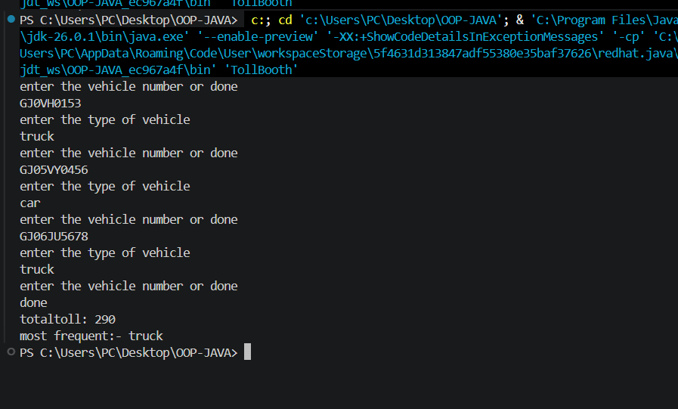

Part-B
MiniBank-1:
MiniBank is the console banking application you will build across the whole semester. In
this first lab you set up your tools and create the project and its menu shell — the screen the
user navigates. Every later lab attaches one real banking feature behind these menu options.
1. Set up your environment: open the project in GitHub Codespaces (or install JDK 17+ and
an IDE locally), and create a private GitHub repository named oop-minibank-<rollno>;
add the faculty as a collaborator.
2. Create a public class named MiniBank that contains the main method.
3. Define a record named BankInfo with two String fields, name and branch (a record is a
short, read-only class; Java auto-generates its constructor and field accessors). Print one
BankInfo object as the application header.
4. Define an enum named MenuOption with the constants OPEN_ACCOUNT, DEPOSIT,
WITHDRAW, TRANSFER and EXIT — these are the actions MiniBank will offer.
5. Display the numbered menu to the user and read the chosen number with a Scanner.
6. Use a switch expression on the choice to print a short placeholder for that option (for
example, “Deposit — to be implemented in a later lab”). Keep showing the menu in a
loop until the user selects EXIT, then print a goodbye message.

import java.util.Scanner;
public class MiniBank {

//used to declare constent
enum MenuOption{
OPEN_ACCOUNT,
DEPOSIT,
WITHDRAW,
TRANSFER,
EXIT
}
//record store banking info work as database
record Bankinfo(String name , String branch){}
public static void main(String[] args) {

//used to take input from the user if i declared scanner packet that mandatory to declare this liner this work as take a input from system
Scanner sc=new Scanner(System.in);
//created record objrct here
Bankinfo bank=new Bankinfo("axis", "surat");

System.out.println("==================================");
System.out.println(" MINI BANK SYSTEM");
System.out.println("==================================");
System.out.println(bank);
System.out.println();

while (true) {
System.out.println("1.open account");
System.out.println("2.deposit");

System.out.println("3.withdraw");

System.out.println("4.transfer");

System.out.println("5.exit");
//take a input from user nextINT mean only int input will be consider
int input= sc.nextInt();

if(input >5 || input<1){
System.out.println("invalid input");
continue;
}
//created enum class object
MenuOption menu= MenuOption.values()[input-1];
//used switch loop
String message=switch(menu){
case OPEN_ACCOUNT->"open account to be implimented in later lab";

case DEPOSIT->"open account to be implimented in later lab";
case WITHDRAW->"open account to be implimented in later lab";
case TRANSFER->"open account to be implimented in later lab";
case EXIT->"Good Bye";
};

System.out.println(message);
System.out.println();
//here show if the given input from user is exit then break the loop
if(menu==MenuOption.EXIT){
break;
}

}

sc.close();

}
}

Output:-
