Software Requirements Specification
for
HireSmart
Prepared by Pooja Malhotra
Organization: TalentAI
Date Created: 02/02/2026

1. Introduction

1.1 Purpose
The purpose of HireSmart is to automatically screen resumes to shortlist candidates.

1.2 Intended Audience
This document is intended for:
- Admin
- Recruiter
- Development Team
- Stakeholders

1.3 Project Scope

Included in scope:
- Resume upload
- Skill extraction
- Candidate ranking

Excluded from scope:
- Hardware manufacturing
- Third-party marketing

1.4 Document Conventions
- Standard IEEE formatting
- Bold text for UI elements

1.5 References
- GDPR: General Data Protection Regulation

2. Overall Description

2.1 Product Perspective
HireSmart is a standalone Web Application for the Recruitment sector, aimed at automatically screening resumes to shortlist candidates.

2.2 Product Features
- Resume upload
- Skill extraction
- Candidate ranking

2.3 User Classes and Characteristics

Admin
- Tech-savvy
- Frequent use for managing user accounts and system settings

Recruiter
- Tech-savvy
- Frequent use for uploading resumes and shortlisting candidates

2.4 Operating Environment
- Cloud-based infrastructure

2.5 Design and Implementation Constraints
- Use of Python as the backend language
- SQL database
- Cloud deployment
- GDPR compliance

2.6 User Documentation
- User Manual for Recruiter and Admin
- System Documentation for Developers

2.7 Assumptions and Dependencies

Assumptions:
- Users have basic computer skills and access to the internet

Dependencies:
- Cloud service providers
- SQL database management system
- Python libraries and frameworks

3. System Features

3.1 Resume Upload
Description: Allows recruiters to upload resumes for candidate screening.

Stimulus/Response Sequences:
Stimulus: Recruiter selects a resume file and clicks the upload button
Response: System uploads the resume to the database and triggers skill extraction.

Functional Requirements:
- The system shall validate the uploaded file format to ensure it is a supported type.
- The system shall store the uploaded resume in a secure database.

3.2 Skill Extraction
Description: Automatically extracts skills and relevant information from uploaded resumes.

Stimulus/Response Sequences:
Stimulus: System completes the upload of a resume
Response: System analyzes the resume content to extract skills and relevant information.

Functional Requirements:
- The system shall use natural language processing to identify key skills from the resume text.
- The system shall store the extracted skills in the candidate's profile.

3.3 Candidate Ranking
Description: Ranks candidates based on their skills and relevance to the job requirements.

Stimulus/Response Sequences:
Stimulus: Recruiter inputs job requirements and clicks the rank button
Response: System analyzes candidate skills and experience to provide a ranked list.

Functional Requirements:
- The system shall compare candidate skills with job requirements to determine relevance.
- The system shall display a ranked list of candidates based on their matching skills and experience.

3.4 User Authentication
Description: Ensures only authorized users can access the system.

Stimulus/Response Sequences:
Stimulus: User attempts to log in with credentials
Response: System verifies credentials and grants access if valid.

Functional Requirements:
- The system shall validate user credentials against a secure authentication database.
- The system shall implement GDPR compliant authentication and access controls.

4. External Interface Requirements

4.1 User Interfaces
The HireSmart web application features a responsive design built with React 18 and TypeScript, supporting modern web browsers (Chrome 90+, Firefox 88+, Safari 14+) and mobile devices (iOS 14+, Android 10+). The interface includes real-time dashboards with WebSocket updates, role-based access control (Admin, Recruiter), and progressive web app capabilities with service worker caching.

User Interface Architecture:
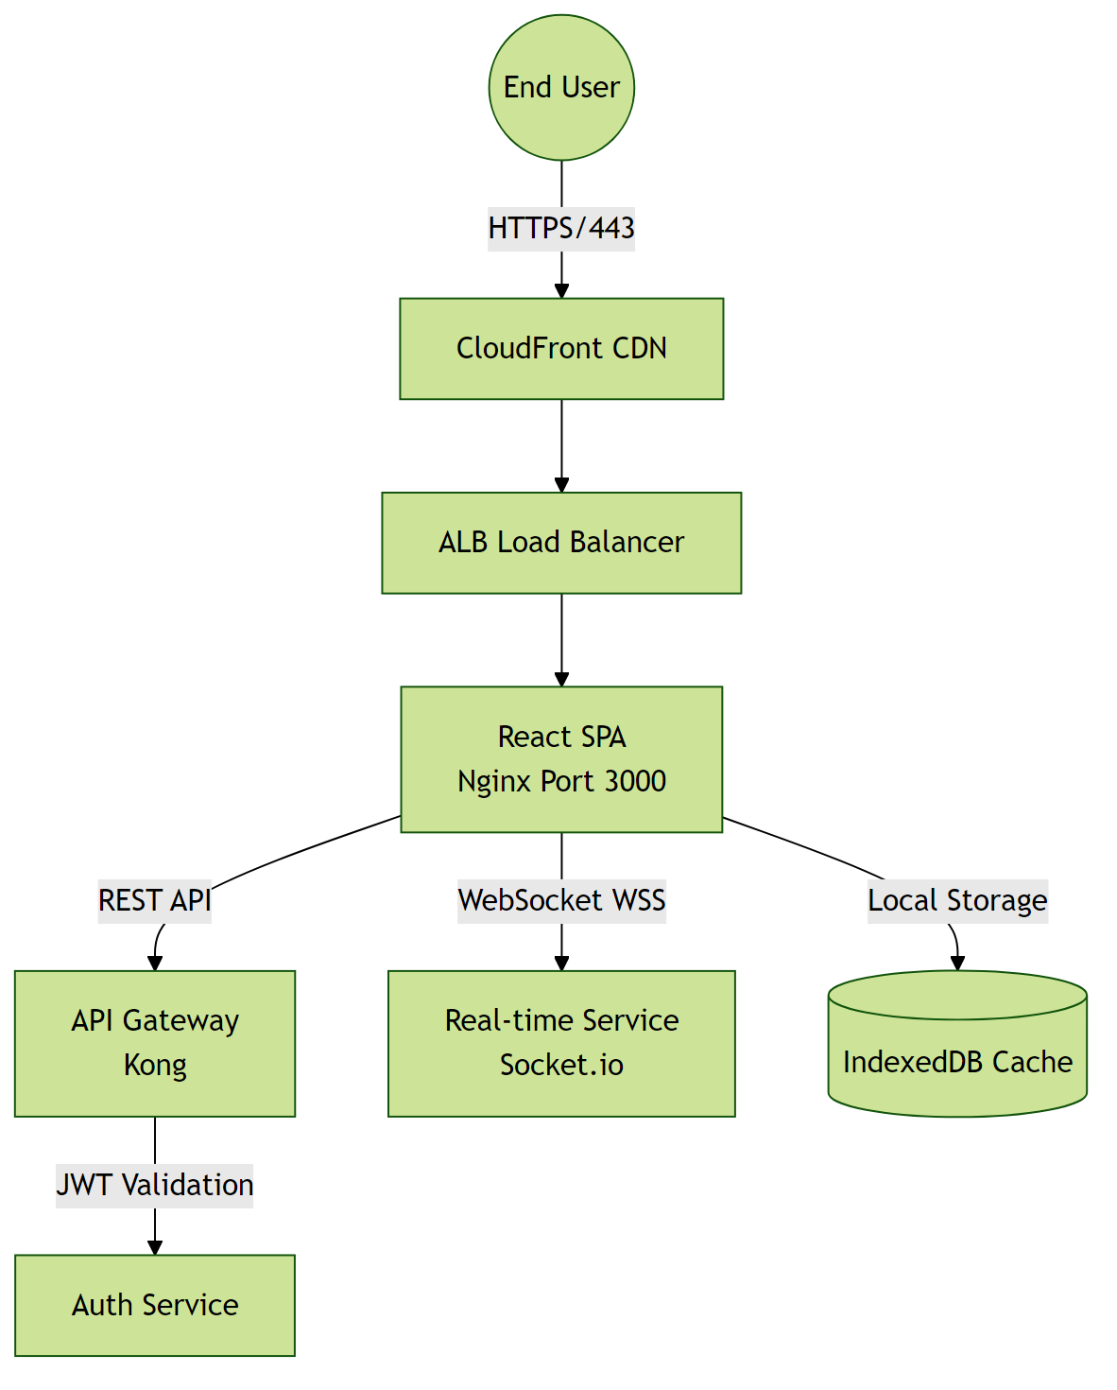

4.2 Hardware Interfaces
This software system operates entirely in a cloud-native environment with no direct hardware integrations. All infrastructure is virtualized and managed through containerization (Docker/Kubernetes).

Hardware Interface Architecture:
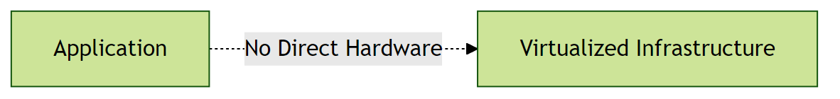

4.3 Software Interfaces
Primary database: PostgreSQL 15 with PgBouncer connection pooling (max 100 connections). The system uses Python as the preferred backend, interacting with the database via SQL queries. Authentication is handled through an external service with OAuth 2.0. File storage is managed through AWS S3 with presigned URL generation (1-hour expiration).

Software Interface Architecture:
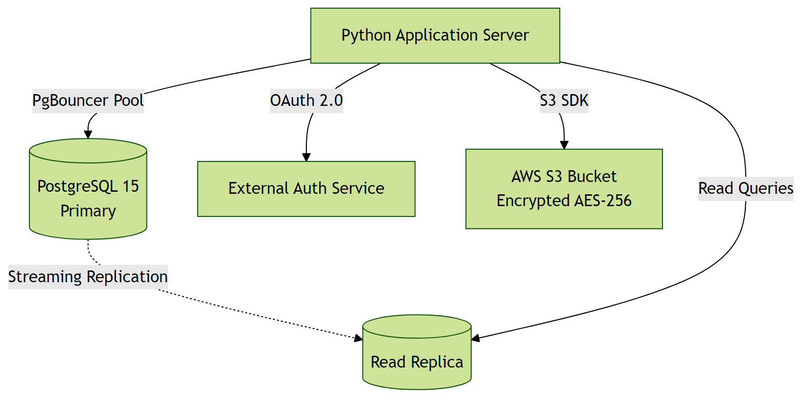

4.4 Communication Interfaces
All client-server communication is encrypted via TLS 1.3 with Perfect Forward Secrecy (PFS). REST API uses HTTPS on port 443 with rate limiting (100 req/min per IP). Internal microservice communication uses gRPC over mTLS with Istio service mesh. API versioning is handled via URL path (/v1/, /v2/). CORS is enabled for whitelisted domains only.

Communication Interface Architecture:
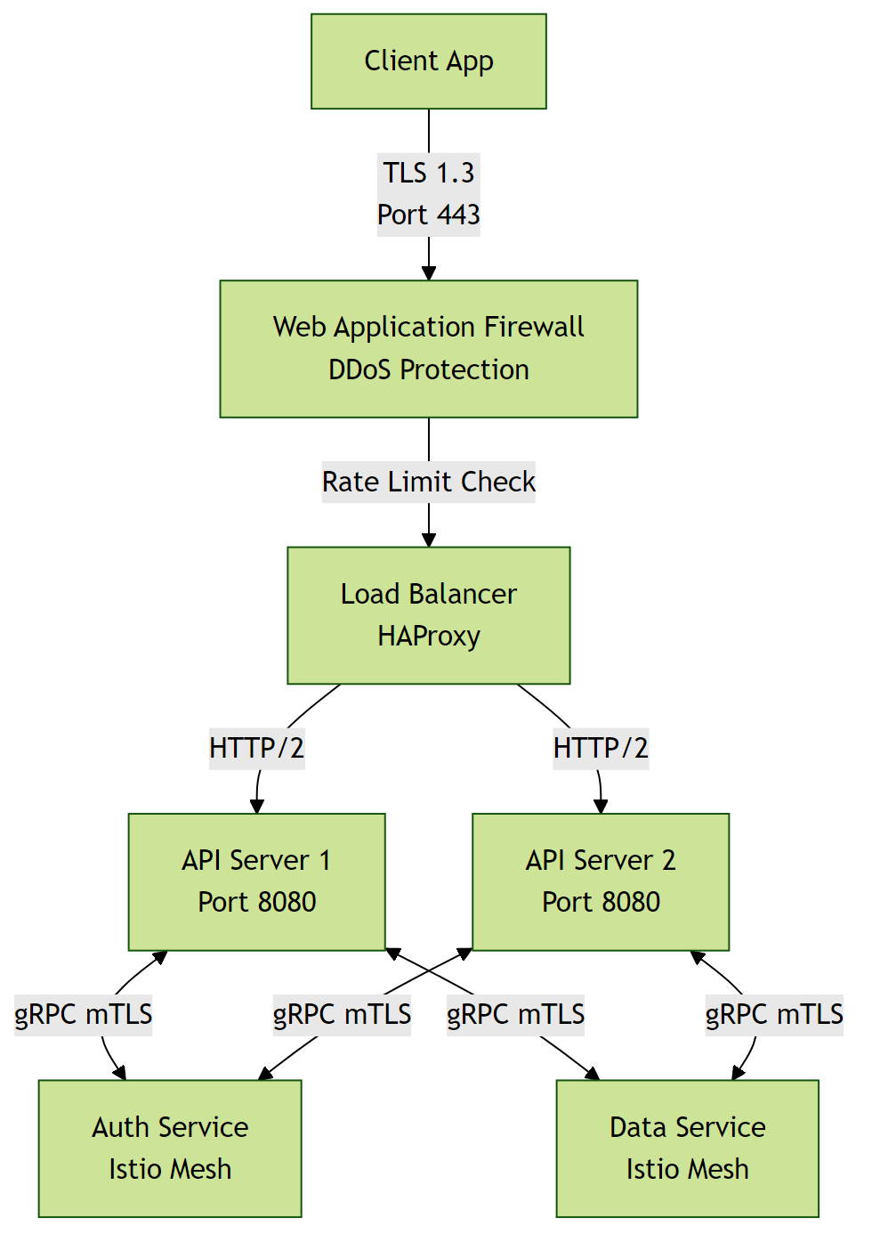

5. Non-Functional Requirements

5.1 Performance Requirements
- The system shall support 100-1,000 concurrent users without performance degradation.
Rationale: To accommodate expected peak traffic from recruiters and administrators.
- The system shall respond to user requests within 2 seconds under normal load.
Rationale: To ensure a responsive user experience for recruiters and administrators.

5.2 Safety Requirements
- The system shall perform automated daily backups of all user data.
Rationale: To prevent data loss in case of system failure or corruption.

5.3 Security Requirements
- The system shall implement GDPR compliance for handling sensitive candidate data.
Rationale: To protect sensitive user information and comply with regulatory requirements.
- The system shall implement authentication and authorization for all users.
Rationale: To ensure that only authorized personnel can access and manage candidate data.

5.4 Quality Attributes
- The application must achieve 99.9% uptime.
Rationale: To ensure reliability for enterprise-level clients.
- The system shall be maintainable with modular architecture and comprehensive documentation.
Rationale: To enable efficient updates and reduce long-term maintenance costs.

6. Glossary

Technical Terms
API: Application Programming Interface - a set of protocols and tools for building software applications.
Microservices: An architectural style that structures an application as a collection of loosely coupled services.
Load Balancing: Distribution of network traffic across multiple servers to ensure no single server is overwhelmed.
Natural Language Processing (NLP): A subfield of artificial intelligence that deals with the interaction between computers and humans in natural language.
Cloud-based Infrastructure: Infrastructure that uses cloud computing to provide scalable and on-demand access to resources.

Acronyms and Abbreviations
NFR: Non-Functional Requirements - operational constraints defining system performance, security, and quality.
AES-256: Advanced Encryption Standard with 256-bit key - a symmetric encryption algorithm for securing data.
OAuth 2.0: Open Authorization 2.0 - an industry-standard protocol for authorization and authentication.
GDPR: General Data Protection Regulation - a regulation in EU law on data protection and privacy.
SQL: Structured Query Language - a language for managing and manipulating data in relational database management systems.
API: Application Programming Interface - a set of protocols and tools for building software applications.

System Components
Authentication Service: Component responsible for verifying user credentials and managing access tokens.
Database Layer: Persistent storage layer managing data operations and ensuring data integrity.
Cloud Service Providers: Third-party services that provide cloud-based infrastructure for deployment and scaling.
Web Application: A software application that runs on a web server and is accessed through a web browser.

Technologies
Python: A high-level, interpreted programming language used for developing the backend of the system.
Cloud Service Providers: Third-party services that provide cloud-based infrastructure for deployment and scaling.
SQL Database: A relational database management system that uses SQL for managing and manipulating data.

Performance Metrics
Concurrent Users: Number of users actively using the system simultaneously without performance degradation.
Response Time: Time elapsed between a user request and the system's response.
Uptime: Percentage of time the system is operational and accessible, typically expressed as 99.9% or similar.

Security Terms
Authentication: Process of verifying the identity of a user or system.
Authorization: Process of determining whether a user has access to a particular resource or functionality.
Encryption: Process of converting plaintext data into unreadable ciphertext to protect it from unauthorized access.

Quality Attributes
Reliability: Ability of the system to perform its required functions under normal operating conditions.
Scalability: Ability of the system to handle increased load or demand without decreasing performance.
Maintainability: Ease with which the system can be maintained, updated, or modified.

7. Assumptions

Assumption 1:
Users have basic computer skills and access to the internet.
Impact: Insufficient digital literacy among users could lead to difficulties in using the system, necessitating additional training or support resources.

Assumption 2:
The cloud service provider will maintain 99.9% uptime for the infrastructure.
Impact: Any significant downtime could impact user access and system reliability, potentially delaying recruitment processes.

Assumption 3:
The SQL database management system will be available and compatible with the system.
Impact: Database unavailability or compatibility issues could hinder data storage and retrieval, affecting system functionality.

Assumption 4:
Python libraries and frameworks required for the system will be maintained and compatible.
Impact: Incompatibility or deprecation of critical libraries could break system functionality, requiring urgent updates or replacements.

Assumption 5:
The system will be deployed on a scalable cloud infrastructure.
Impact: Inadequate scalability could lead to performance degradation under heavy usage, affecting user experience.

Assumption 6:
Recruiters and administrators will have necessary technical support for system maintenance.
Impact: Lack of technical support could lead to prolonged system downtime or unresolved issues, impacting recruitment processes.

Assumption 7:
Users will primarily access the system through modern web browsers.
Impact: Incompatibility with older browsers could limit accessibility for some users, potentially excluding them from the recruitment process.

Assumption 8:
The system will comply with evolving regulatory requirements for data privacy (GDPR, etc.).
Impact: Non-compliance could result in legal penalties and damage to the organization's reputation.

Assumption 9:
The external CRM API (if used) will remain stable and backward compatible.
Impact: Changes in the CRM API could require immediate system updates to maintain integration, potentially causing system downtime.

Assumption 10:
Data storage needs will be met with the allocated database storage capacity.
Impact: Insufficient storage could lead to data loss or system crashes, impacting recruitment operations.

