Software Requirements Specification
for
SentimentScope
Prepared by Kunal Verma, Dhruvil Joshi
Organization: Charotar University of Science and Technology
Date Created: 02/02/2026

Table of Contents

[Note: The Table of Contents will be automatically generated when you open this document in Microsoft Word. If it doesn't appear, right-click and select 'Update Field']

1. Introduction

1.1 Purpose
The purpose of SentimentScope is to analyze public sentiment from social media posts.

1.2 Intended Audience
This document is intended for:
- Manager
- Analyst
- Development Team
- Stakeholders

1.3 Project Scope

Included in scope:
- Data scraping
- Sentiment analysis
- Visualization charts

Excluded from scope:
- Hardware manufacturing
- Third-party marketing

1.4 Document Conventions
- Standard IEEE formatting
- Bold text for UI elements

1.5 References
- GDPR: General Data Protection Regulation

2. Overall Description

2.1 Product Perspective
SentimentScope is a standalone Web Application for the Marketing / Analytics sector, designed to analyze public sentiment from social media posts.

2.2 Product Features
- Data scraping
- Sentiment analysis
- Visualization charts

2.3 User Classes and Characteristics

Manager
- Tech-savvy
- Frequent use for strategic decisions

Analyst
- Highly tech-savvy
- Frequent use for data analysis

2.4 Operating Environment
- Hybrid deployment environment

2.5 Design and Implementation Constraints
- Backend implementation in Go
- GDPR compliance
- Hybrid deployment

2.6 User Documentation
- User Manual
- API Documentation

2.7 Assumptions and Dependencies

Assumptions:
- Users have access to social media platforms

Dependencies:
- Social media APIs for data scraping
- Go backend framework

3. System Features

3.1 User Authentication
Description: Authenticates users and authorizes access to the system.

Stimulus/Response Sequences:
Stimulus: User submits login credentials
Response: System verifies credentials and grants access.

Functional Requirements:
- The system shall validate user credentials against a database.
- The system shall generate a session token upon successful authentication.

3.2 Data Scraping
Description: Extracts data from social media posts based on user input.

Stimulus/Response Sequences:
Stimulus: Analyst inputs a keyword
Response: System scrapes social media posts related to the keyword.

Functional Requirements:
- The system shall use a web scraping library to extract data from social media platforms.
- The system shall store scraped data in a database for further analysis.

3.3 Sentiment Analysis
Description: Analyzes the sentiment of scraped social media posts.

Stimulus/Response Sequences:
Stimulus: System receives scraped social media posts
Response: System analyzes the sentiment of the posts.

Functional Requirements:
- The system shall use a natural language processing library to analyze sentiment.
- The system shall categorize sentiment as positive, negative, or neutral.

3.4 Visualization Charts
Description: Displays sentiment analysis results in a graphical format.

Stimulus/Response Sequences:
Stimulus: System completes sentiment analysis
Response: System generates visualization charts.

Functional Requirements:
- The system shall use a charting library to generate bar charts and pie charts.
- The system shall display charts in a user-friendly dashboard.

4. External Interface Requirements

4.1 User Interfaces
The SentimentScope web application features a responsive design built with React 18 and TypeScript. It supports modern web browsers (Chrome 90+, Firefox 88+, Safari 14+) and mobile devices (iOS 14+, Android 10+). The interface includes a real-time dashboard with WebSocket updates, role-based access control (Analyst, Manager), and progressive web app capabilities with service worker caching.

User Interface Architecture:
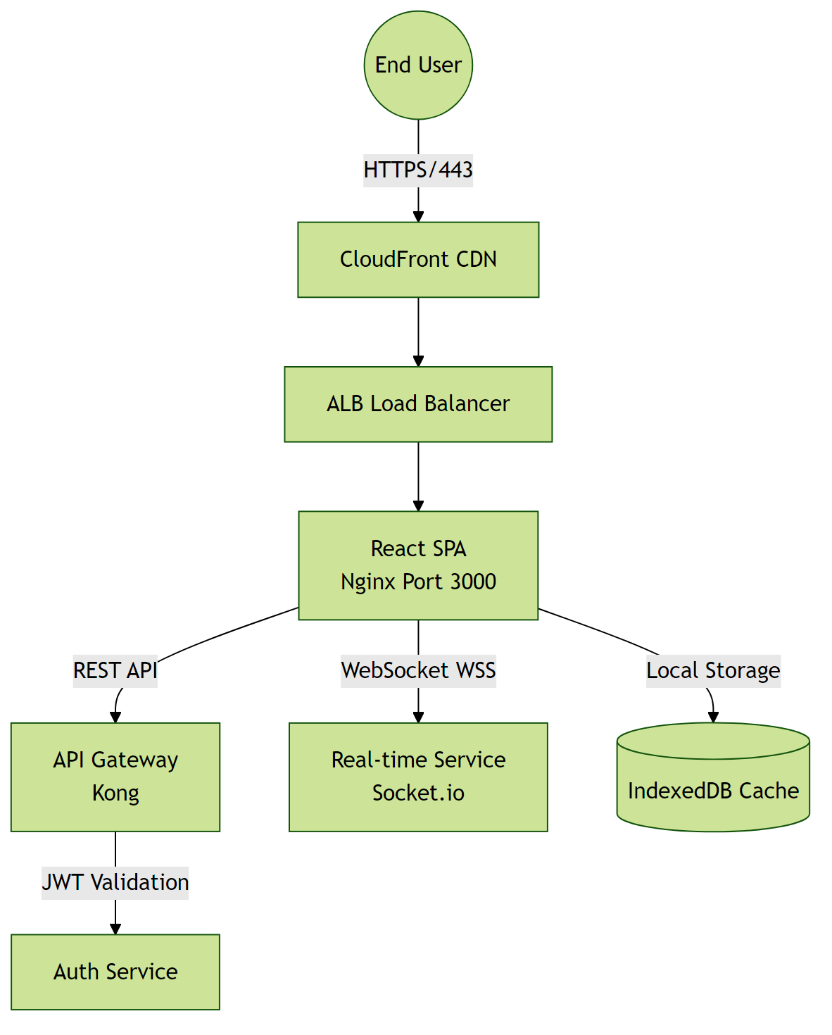

4.2 Hardware Interfaces
This software system operates entirely in a cloud-native environment with no direct hardware integrations. All infrastructure is virtualized and managed through containerization (Docker/Kubernetes).

Hardware Interface Architecture:
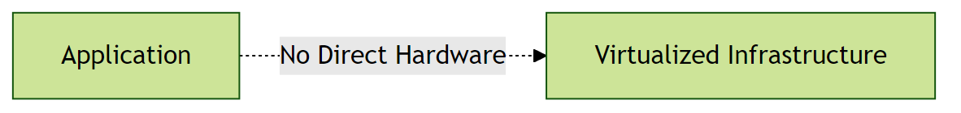

4.3 Software Interfaces
The system uses a Go-based backend with a hybrid deployment preference. It integrates with external services for authentication and data storage, but specific software interfaces are not detailed in the provided SRS.

Software Interface Architecture:
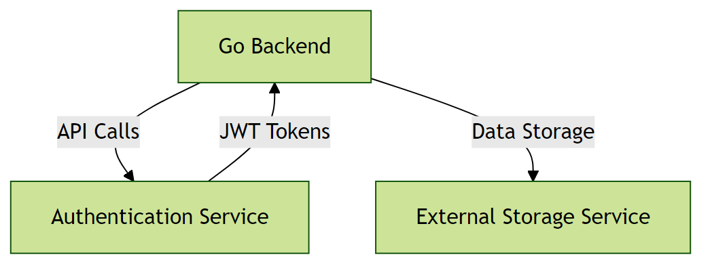

4.4 Communication Interfaces
All client-server communication is encrypted via TLS. The system uses REST APIs for data exchange and WebSocket for real-time updates. Specific communication protocols and security layers are not detailed in the provided SRS.

Communication Interface Architecture:
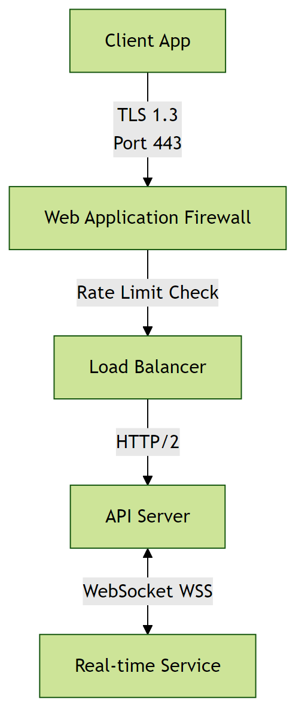

5. Non-Functional Requirements

5.1 Performance Requirements
- The system shall support 100 to 1,000 concurrent users without performance degradation.
Rationale: To accommodate expected peak traffic during marketing campaigns.
- The system shall respond to user requests in real-time.
Rationale: To ensure a responsive user experience and meet industry standards.

5.2 Safety Requirements

5.3 Security Requirements
- The system shall implement authentication for all users.
Rationale: To ensure that only authorized users can access the system.
- The system shall comply with GDPR requirements.
Rationale: To protect sensitive user information and meet regulatory requirements.

5.4 Quality Attributes
- The application must achieve high availability.
Rationale: To ensure reliability for enterprise-level clients.
- The system shall be maintainable with modular architecture and comprehensive documentation.
Rationale: To enable efficient updates and reduce long-term maintenance costs.

6. Glossary

6.1 Technical Terms
API: Application Programming Interface - a set of protocols and tools for building software applications.
Go: A statically typed, compiled programming language used for developing the backend of the system.
GDPR: General Data Protection Regulation - a regulation in EU law on data protection and privacy.
Hybrid Deployment: A deployment environment that combines on-premises and cloud-based infrastructure.
Web Scraping: The process of automatically extracting data from web pages.
Sentiment Analysis: A natural language processing technique used to determine the emotional tone or attitude conveyed by a piece of text.

6.2 Acronyms and Abbreviations
GDPR: General Data Protection Regulation
API: Application Programming Interface

6.3 System Components
Authentication Service: Component responsible for verifying user credentials and managing access tokens.
Database Layer: Persistent storage layer managing data operations and ensuring data integrity.

6.4 Technologies
Go: Programming language used for developing the backend of the system.
Cloud Service Providers: Third-party services that provide cloud-based infrastructure for deployment and scaling.

6.5 Performance Metrics
Concurrent Users: Number of users actively using the system simultaneously without performance degradation.
Response Time: Time elapsed between a user request and the system's response.

6.6 Security Terms
Authentication: Process of verifying the identity of a user or system.
Authorization: Process of determining whether a user has access to a particular resource or functionality.
Encryption: Process of converting plaintext data into unreadable ciphertext to protect it from unauthorized access.

6.7 Quality Attributes
Reliability: Ability of the system to perform its required functions under normal operating conditions.
Scalability: Ability of the system to handle increased load or demand without decreasing performance.
Maintainability: Ease with which the system can be maintained, updated, or modified.

7. Assumptions

Assumption 1:
Users have access to social media platforms.
Impact: If users do not have access to social media platforms, the system will not be able to scrape data, leading to incomplete sentiment analysis and reduced functionality.

Assumption 2:
The social media APIs used for data scraping will maintain a stable and compatible interface.
Impact: If the social media APIs change or become unstable, the system's data scraping functionality may break, requiring immediate updates to adapt to the changes.

Assumption 3:
The Go backend framework will be available and compatible with the chosen database.
Impact: If the Go backend framework or database compatibility issues arise, the system's development timeline may be delayed, and additional resources may be required to resolve the issues.

Assumption 4:
The system will be deployed in a hybrid environment with reliable internet connectivity.
Impact: If the hybrid environment experiences connectivity issues or downtime, the system's availability and performance may be negatively impacted.

Assumption 5:
Users possess basic computer literacy and familiarity with web-based applications.
Impact: If users lack basic digital skills, additional training programs and simplified UI/UX may be required, increasing project costs and extending the rollout timeline.

Assumption 6:
The cloud service provider will maintain the agreed-upon pricing structure for compute and storage resources.
Impact: Significant price increases could exceed budget constraints, requiring migration to alternative providers or optimization of resource usage to reduce costs.

Assumption 7:
Regulatory requirements for data privacy (GDPR, CCPA) will remain stable during development.
Impact: Changes in data privacy regulations could necessitate significant architectural changes, additional compliance features, and potential project delays.

Assumption 8:
The database server will have sufficient storage capacity with the ability to expand.
Impact: Insufficient storage capacity would limit data retention capabilities and could cause system failures if storage limits are reached unexpectedly.

