Software Requirements Specification
for
TrafficEye
Prepared by Smit Gandhi, Prachi Desai
Organization: Charotar University of Science and Technology
Date Created: 02/02/2026

Table of Contents
1. Introduction 1
1.1 Purpose 1
1.2 Intended Audience 1
1.3 Project Scope 1
Included in scope: 1
Excluded from scope: 1
1.4 Document Conventions 1
1.5 References 1
2. Overall Description 1
2.1 Product Perspective 1
2.2 Product Features 1
2.3 User Classes and Characteristics 1
Admin 1
Analyst 1
2.4 Operating Environment 1
2.5 Design and Implementation Constraints 1
2.6 User Documentation 1
2.7 Assumptions and Dependencies 1
Assumptions: 1
Dependencies: 1
3. System Features 1
3.1 Sensor Data Ingestion 1
Stimulus/Response Sequences: 1
Functional Requirements: 1
3.2 Traffic Analytics 1
Stimulus/Response Sequences: 1
Functional Requirements: 1
3.3 Live Maps 1
Stimulus/Response Sequences: 1
Functional Requirements: 1
3.4 User Authentication 1
Stimulus/Response Sequences: 1
Functional Requirements: 1
4. External Interface Requirements 1
4.1 User Interfaces 1
User Interface Architecture: 1
4.2 Hardware Interfaces 1
Hardware Interface Architecture: 1
4.3 Software Interfaces 1
Software Interface Architecture: 1
4.4 Communication Interfaces 1
Communication Interface Architecture: 1
5. Non-Functional Requirements 1
5.1 Performance Requirements 1
5.2 Safety Requirements 1
5.3 Security Requirements 1
5.4 Quality Attributes 1
6. Glossary 1
6.1 Technical Terms 1
6.2 Acronyms and Abbreviations 1
6.3 System Components 1
6.4 Technologies 1
6.5 Performance Metrics 1
6.6 Security Terms 1
6.7 Quality Attributes 1
7. Assumptions 1
Assumption 1: 1
Assumption 2: 1
Assumption 3: 1
Assumption 4: 1
Assumption 5: 1
Assumption 6: 1
Assumption 7: 1
Assumption 8: 1

[Note: The Table of Contents will be automatically generated when you open this document in Microsoft Word. If it doesn't appear, right-click and select 'Update Field']

1. Introduction

1.1 Purpose
The purpose of TrafficEye is to solve Monitor and analyze city traffic congestion as defined in the user inputs.

1.2 Intended Audience
This document is intended for:
- Admin
- Analyst
- Development Team
- Stakeholders

1.3 Project Scope

Included in scope:
- Sensor data ingestion
- Traffic analytics
- Live maps

Excluded from scope:
- Hardware manufacturing
- Third-party marketing

1.4 Document Conventions
- Standard IEEE formatting
- Bold text for UI elements

1.5 References
- GDPR: General Data Protection Regulation

2. Overall Description

2.1 Product Perspective
TrafficEye is a Web Application for the Smart Cities sector. It is designed to monitor and analyze city traffic congestion.

2.2 Product Features
- Sensor data ingestion
- Traffic analytics
- Live maps

2.3 User Classes and Characteristics

Admin
- Tech-savvy
- Frequent use for traffic management

Analyst
- Data analysis skills
- Occasional use for traffic pattern analysis

2.4 Operating Environment
- Hybrid deployment environment

2.5 Design and Implementation Constraints
- Backend implementation in Go
- GDPR compliance

2.6 User Documentation
- User Manual for Admin and Analyst
- API Documentation for data ingestion

2.7 Assumptions and Dependencies

Assumptions:
- Real-time data processing capability

Dependencies:
- Sensor data sources
- Go backend framework
- Hybrid deployment infrastructure

3. System Features

3.1 Sensor Data Ingestion
Description: Ingests and processes data from various traffic sensors.

Stimulus/Response Sequences:
Stimulus: Traffic sensor sends data
Response: System receives, validates, and stores the data.

Functional Requirements:
- The system shall handle data from multiple sensor types.
- The system shall validate sensor data for accuracy.

3.2 Traffic Analytics
Description: Analyzes traffic data to provide insights and congestion levels.

Stimulus/Response Sequences:
Stimulus: System receives analyzed data
Response: System generates traffic congestion reports and predictions.

Functional Requirements:
- The system shall apply machine learning algorithms for traffic prediction.
- The system shall provide real-time traffic analytics.

3.3 Live Maps
Description: Displays real-time traffic information on a map.

Stimulus/Response Sequences:
Stimulus: System updates traffic data
Response: System updates the live map with current traffic conditions.

Functional Requirements:
- The system shall integrate with mapping services for display.
- The system shall update the map in real-time.

3.4 User Authentication
Description: Authenticates users for secure access to the system.

Stimulus/Response Sequences:
Stimulus: User attempts to log in
Response: System verifies credentials and grants access.

Functional Requirements:
- The system shall support user registration and login.
- The system shall comply with GDPR for user data.

4. External Interface Requirements

4.1 User Interfaces
The system features a responsive web application for Admin and Analyst users. The dashboard provides real-time traffic updates, analytics, and live maps. Users interact with the system through a graphical user interface built with React and TypeScript, supporting modern web browsers.

User Interface Architecture:
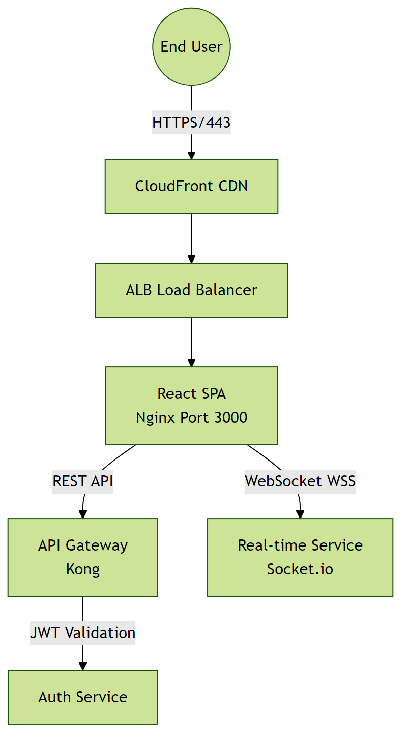

4.2 Hardware Interfaces
The system integrates with IoT sensors for traffic data collection. These sensors communicate through a hybrid network infrastructure, including cellular and Wi-Fi connections. Data is processed on edge devices before being transmitted to the cloud.

Hardware Interface Architecture:

4.3 Software Interfaces
The system uses a Go-based backend, with a PostgreSQL database for data storage. It integrates with external services for authentication (OAuth 2.0) and analytics (Google Analytics).

Software Interface Architecture:
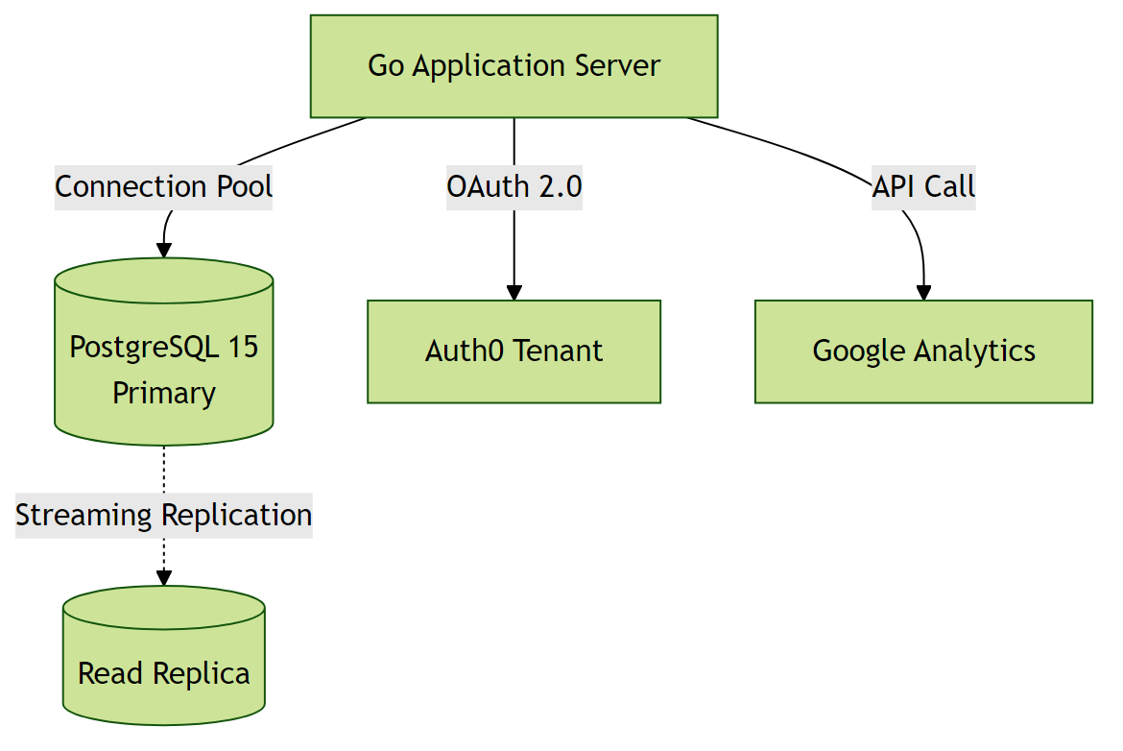

4.4 Communication Interfaces
The system communicates over HTTPS (TLS 1.3) for secure data transmission. It uses WebSockets for real-time updates and REST APIs for data exchange.

Communication Interface Architecture:
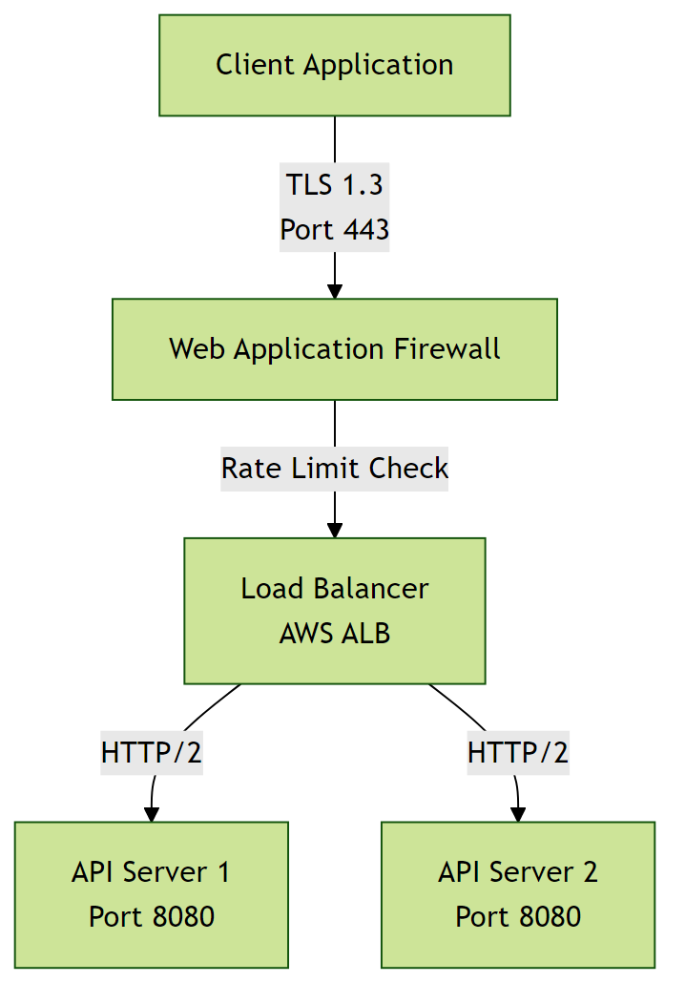

5. Non-Functional Requirements

5.1 Performance Requirements
- The system shall support 100-1k concurrent users without performance degradation.
Rationale: To accommodate expected peak traffic during peak hours.
- The system shall respond to user requests in real-time.
Rationale: To ensure a responsive user experience and meet industry standards.

5.2 Safety Requirements

5.3 Security Requirements
- The system shall implement authentication for all users.
Rationale: To ensure that only authorized users have access to the system.
- The system shall comply with GDPR requirements.
Rationale: To protect sensitive user information and meet regulatory requirements.

5.4 Quality Attributes
- The application must achieve high availability.
Rationale: To ensure reliability for users.
- The system shall be maintainable with modular architecture.
Rationale: To enable efficient updates and reduce long-term maintenance costs.

6. Glossary

6.1 Technical Terms
API: Application Programming Interface - a set of protocols and tools for building software applications.
Microservices: An architectural style that structures an application as a collection of loosely coupled services.
Load Balancing: Distribution of network traffic across multiple servers to ensure no single server is overwhelmed.
Real-time: A system or process that provides immediate responses or updates.
Hybrid Deployment: A deployment strategy that combines on-premises infrastructure with cloud-based services.
Machine Learning: A subfield of artificial intelligence that involves training algorithms to make predictions or decisions based on data.
GDPR: General Data Protection Regulation - a regulation in EU law on data protection and privacy.

6.2 Acronyms and Abbreviations
NFR: Non-Functional Requirements - operational constraints defining system performance, security, and quality.
AES-256: Advanced Encryption Standard with 256-bit key - a symmetric encryption algorithm for securing data.
OAuth 2.0: Open Authorization 2.0 - an industry-standard protocol for authorization and authentication.
GDPR: General Data Protection Regulation - a regulation in EU law on data protection and privacy.
SRS: Software Requirements Specification - a detailed description of the software requirements.

6.3 System Components
Authentication Service: Component responsible for verifying user credentials and managing access tokens.
Database Layer: Persistent storage layer managing data operations and ensuring data integrity.
Cloud-based Infrastructure: Infrastructure that uses cloud computing to provide scalable and on-demand access to resources.
Sensor Data Ingestion: Component responsible for collecting and processing data from various traffic sensors.
Traffic Analytics: Component responsible for analyzing traffic data to provide insights and congestion levels.
Live Maps: Component responsible for displaying real-time traffic information on a map.

6.4 Technologies
Python: A high-level, interpreted programming language used for developing the backend of the system.
Go: A statically typed, compiled programming language used for developing the backend of the system.
Cloud Service Providers: Third-party services that provide cloud-based infrastructure for deployment and scaling.

6.5 Performance Metrics
Concurrent Users: Number of users actively using the system simultaneously without performance degradation.
Response Time: Time elapsed between a user request and the system's response.
Uptime: Percentage of time the system is operational and accessible, typically expressed as 99.9% or similar.

6.6 Security Terms
Authentication: Process of verifying the identity of a user or system.
Authorization: Process of determining whether a user has access to a particular resource or functionality.
Encryption: Process of converting plaintext data into unreadable ciphertext to protect it from unauthorized access.

6.7 Quality Attributes
Reliability: Ability of the system to perform its required functions under normal operating conditions.
Scalability: Ability of the system to handle increased load or demand without decreasing performance.
Maintainability: Ease with which the system can be maintained, updated, or modified.

7. Assumptions

Assumption 1:
The system will have access to reliable and stable sensor data sources.
Impact: If sensor data sources are unreliable or unstable, the system's ability to monitor and analyze traffic congestion will be compromised, leading to inaccurate insights and potential system downtime.

Assumption 2:
The Go backend framework will be compatible with the chosen database and deployment infrastructure.
Impact: If there is incompatibility, it could lead to delays in development, additional costs for troubleshooting, and potential system failures.

Assumption 3:
Users will have a stable internet connection with a minimum bandwidth of 5 Mbps.
Impact: If users have slow internet connections, the system's responsiveness and user experience may be negatively affected, leading to decreased usability and potential system abandonment.

Assumption 4:
The system will be deployed on a hybrid infrastructure that can scale as needed.
Impact: If the infrastructure cannot scale, the system may experience performance degradation or downtime during peak usage periods, negatively impacting user experience and system reliability.

Assumption 5:
The mapping services used for live maps will maintain their APIs and data formats.
Impact: If mapping services change their APIs or data formats without notice, the system's integration with these services may be disrupted, requiring immediate updates and potentially causing system downtime.

Assumption 6:
Users possess basic computer literacy and familiarity with web-based applications.
Impact: If users lack basic digital skills, additional training programs and simplified UI/UX may be required, increasing project costs and extending the rollout timeline.

Assumption 7:
Regulatory requirements for data privacy (GDPR) will remain stable during development.
Impact: Changes in data privacy regulations could necessitate significant architectural changes, additional compliance features, and potential project delays.

Assumption 8:
The cloud service provider will maintain the agreed-upon pricing structure for compute and storage resources.
Impact: Significant price increases could exceed budget constraints, requiring migration to alternative providers or optimization of resource usage to reduce costs.

