Software Requirements Specification
for
validra
Prepared by john doe
Organization: techcorp
Date Created: 02/10/2026

Table of Contents

[Note: The Table of Contents will be automatically generated when you open this document in Microsoft Word. If it doesn't appear, right-click and select 'Update Field']

1. Introduction

1.1 Purpose
The purpose of Validra is to solve data validation as defined in the user inputs.

1.2 Intended Audience
This document is intended for:
- Admin
- Development Team
- Stakeholders

1.3 Project Scope

Included in scope:
- User authentication
- Data uploads and validation

Excluded from scope:
- Hardware manufacturing
- Third-party marketing

1.4 Document Conventions
- Standard IEEE formatting
- Bold text for UI elements

1.5 References
- GDPR: General Data Protection Regulation

2. Overall Description

2.1 Product Perspective
Validra is a standalone Web Application for the Education sector, designed to address the problem of data validation for its target users, primarily Admin personnel.

2.2 Product Features
- User Authentication
- Data Uploads and Validation

2.3 User Classes and Characteristics

Admin
- Tech-savvy
- Frequent use for data management and validation

2.4 Operating Environment
- On-Premise deployment with Python backend and NoSQL database

2.5 Design and Implementation Constraints
- GDPR compliance
- Use of Python as the preferred backend
- NoSQL database preference

2.6 User Documentation
- User Manual for Admin
- System Documentation for Maintenance

2.7 Assumptions and Dependencies

Assumptions:
- The system will be used in an Education sector context

Dependencies:
- Python runtime environment
- NoSQL database system

3. System Features

3.1 User Authentication
Description: Manages user login and authentication.

Stimulus/Response Sequences:
Stimulus: User submits login credentials
Response: System authenticates credentials and grants access.
Stimulus: User attempts to access protected resource without authentication
Response: System redirects to login page.

Functional Requirements:
- The system shall verify user credentials against stored records.
- The system shall generate a session token upon successful authentication.

3.2 Data Upload and Validation
Description: Handles data uploads and performs validation.

Stimulus/Response Sequences:
Stimulus: User uploads data
Response: System validates data and provides feedback.
Stimulus: User submits invalid data
Response: System alerts user to errors and prevents submission.

Functional Requirements:
- The system shall check data against predefined validation rules.
- The system shall store validated data in the database.

4. External Interface Requirements

4.1 User Interfaces
The system features a single-page application (SPA) built with React 18 and TypeScript, supporting web browsers (Chrome 90+, Firefox 88+, Safari 14+) and mobile devices (iOS 14+, Android 10+). The interface includes real-time data uploads and validation features for administrators.

User Interface Architecture:
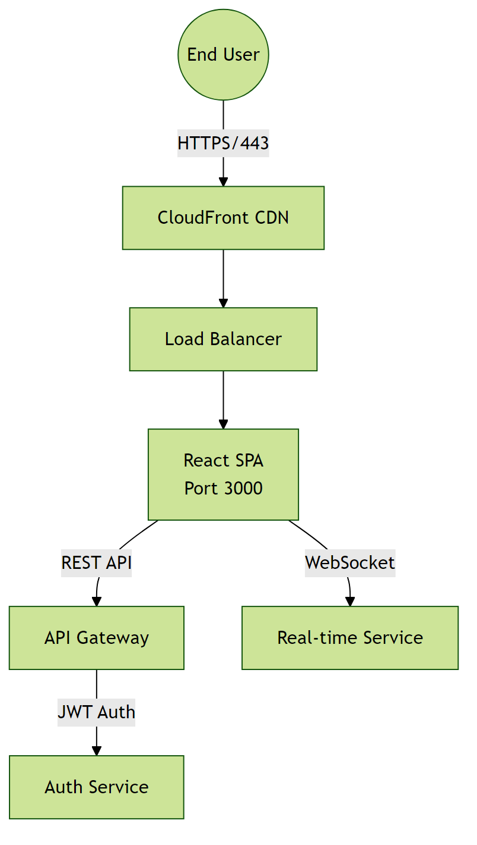

4.2 Hardware Interfaces
Details to be defined during technical design phase

Hardware Interface Architecture:
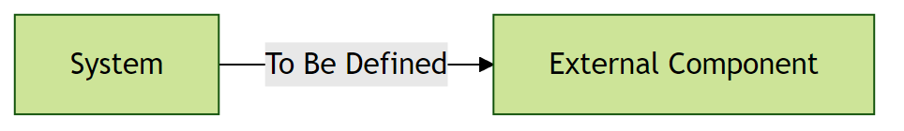

4.3 Software Interfaces
The system uses a NoSQL database (MongoDB) for data storage and a Python backend for business logic. The API gateway handles requests and authentication.

Software Interface Architecture:
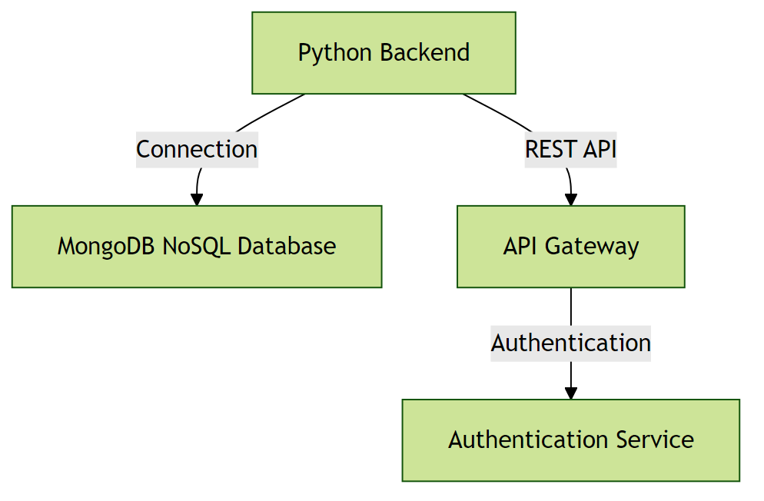

4.4 Communication Interfaces
The system communicates over HTTPS and uses WebSockets for real-time updates. All communication is encrypted and authenticated.

Communication Interface Architecture:
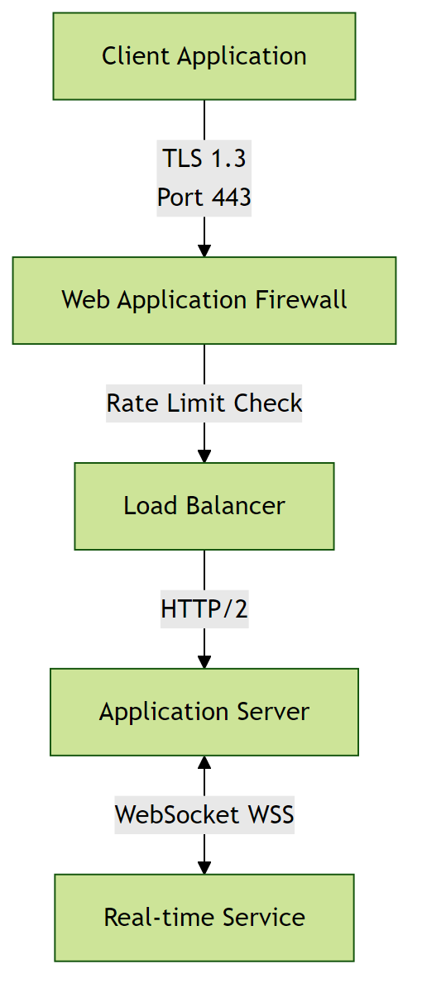

5. Non-Functional Requirements

5.1 Performance Requirements
- The system shall support less than 100 concurrent users without performance degradation.
Rationale: To accommodate expected user scale.
- The system shall respond to user requests within a reasonable time under normal load.
Rationale: To ensure a responsive user experience.

5.2 Safety Requirements
- The system shall perform data validation to ensure data integrity.
Rationale: To prevent data corruption or loss.

5.3 Security Requirements
- The system shall implement authentication for all users.
Rationale: To ensure only authorized access to the system.
- The system shall comply with GDPR requirements.
Rationale: To protect sensitive user information.

5.4 Quality Attributes
- The application must achieve high availability.
Rationale: To ensure reliability for users.
- The system shall be maintainable with modular architecture.
Rationale: To enable efficient updates and reduce long-term maintenance costs.

6. Glossary

6.1 Technical Terms
API: Application Programming Interface - a set of protocols and tools for building software applications.
Microservices: An architectural style that structures an application as a collection of loosely coupled services.
Load Balancing: Distribution of network traffic across multiple servers to ensure no single server is overwhelmed.
Python: A high-level, interpreted programming language used for developing the backend of the system.
NoSQL: A category of database management systems that do not use the traditional table-based relational model.
On-Premise: Software or hardware that is installed and run on the premises of the organization using it.
GDPR: General Data Protection Regulation - a regulation in EU law on data protection and privacy.

6.2 Acronyms and Abbreviations
NFR: Non-Functional Requirements - operational constraints defining system performance, security, and quality.
AES-256: Advanced Encryption Standard with 256-bit key - a symmetric encryption algorithm for securing data.
OAuth 2.0: Open Authorization 2.0 - an industry-standard protocol for authorization and authentication.
SRS: Software Requirements Specification - a detailed description of the software's functionality and constraints.

6.3 System Components
Authentication Service: Component responsible for verifying user credentials and managing access tokens.
Database Layer: Persistent storage layer managing data operations and ensuring data integrity.

6.4 Technologies
Python Backend: The use of Python as the programming language for the system's backend.
NoSQL Database: The use of a NoSQL database for storing and retrieving data.
On-Premise Deployment: The deployment of the system on the premises of the organization.

6.5 Performance Metrics
Concurrent Users: Number of users actively using the system simultaneously without performance degradation.
Response Time: Time elapsed between a user request and the system's response.
Uptime: Percentage of time the system is operational and accessible.

6.6 Security Terms
Authentication: Process of verifying the identity of a user or system.
Authorization: Process of determining whether a user has access to a particular resource or functionality.
Encryption: Process of converting plaintext data into unreadable ciphertext to protect it from unauthorized access.

6.7 Quality Attributes
Reliability: Ability of the system to perform its required functions under normal operating conditions.
Scalability: Ability of the system to handle increased load or demand without decreasing performance.
Maintainability: Ease with which the system can be maintained, updated, or modified.

7. Assumptions

Assumption 1:
The system will be used in an Education sector context.
Impact: If the system is used in a different context, it may not meet the specific needs of the users, leading to reduced adoption and effectiveness.

Assumption 2:
Users have basic computer literacy and familiarity with web-based applications.
Impact: If users lack basic digital skills, additional training programs and simplified UI/UX would be required, increasing project costs and extending the rollout timeline.

Assumption 3:
The organization has an existing infrastructure that can support the deployment of the system.
Impact: If the organization's infrastructure is insufficient, it could lead to performance issues, downtime, or the need for additional infrastructure investments.

Assumption 4:
The system will be deployed on-premise with a Python backend and NoSQL database.
Impact: If the deployment environment differs, it may affect system performance, scalability, and maintenance requirements.

Assumption 5:
The target users are primarily Admin personnel with tech-savvy characteristics.
Impact: If the user base has different characteristics, the system's usability and user experience may need to be adjusted, potentially affecting user adoption and satisfaction.

Assumption 6:
The system must comply with GDPR requirements.
Impact: If GDPR requirements change or are not met, it could result in legal and financial consequences for the organization.

