Software Requirements Specification
for
SmartLibrary_Book_Management
Prepared by Patricia Wilson
Organization: City Public Library
Date Created: 02/11/2026

Table of Contents

[Note: The Table of Contents will be automatically generated when you open this document in Microsoft Word. If it doesn't appear, right-click and select 'Update Field']

1. Introduction

1.1 Purpose
The purpose of SmartLibrary_Book_Management is to solve Library members need a digital system to search books, reserve them online, check borrowing history, and receive overdue notifications without visiting the library desk as defined in the user inputs.

1.2 Intended Audience
This document is intended for:
- Admin
- End User
- Manager
- Development Team
- Stakeholders

1.3 Project Scope

Included in scope:
- Member registration and login
- Search books by title, author, ISBN, or category
- Check book availability status
- Reserve books online
- View borrowing history
- Renew borrowed books
- Receive overdue email reminders
- Pay fines online
- Request new book additions
- Write book reviews and ratings
- Admin dashboard for cataloging books
- Generate borrowing reports
- Barcode scanning for book checkout

Excluded from scope:
- Hardware manufacturing
- Third-party marketing

1.4 Document Conventions
- Standard IEEE formatting
- Bold text for UI elements

1.5 References

2. Overall Description

2.1 Product Perspective
A standalone Web Application for the Education sector, as specified in the project identity.

2.2 Product Features
- Member registration and login
- Search books by title, author, ISBN, or category
- Check book availability status
- Reserve books online
- View borrowing history
- Renew borrowed books
- Receive overdue email reminders
- Pay fines online
- Request new book additions
- Write book reviews and ratings
- Admin dashboard for cataloging books
- Generate borrowing reports
- Barcode scanning for book checkout

2.3 User Classes and Characteristics

Admin
- Tech-savvy
- Frequent use for cataloging and reporting

End User
- Basic computer skills
- Infrequent use for borrowing and reserving books

Manager
- Intermediate tech skills
- Occasional use for monitoring and administrative tasks

2.4 Operating Environment
- Hybrid deployment
- SQL database
- Python backend

2.5 Design and Implementation Constraints
- Use of Python as the preferred backend
- SQL database for data storage
- Hybrid deployment model
- Compliance with authentication requirements

2.6 User Documentation
- User Manual
- Help Guide

2.7 Assumptions and Dependencies

Assumptions:
- Users have basic computer skills
- Library staff are trained on system usage

Dependencies:
- SQL database management system
- Python runtime environment
- Hybrid deployment infrastructure

3. System Features

3.1 Member Registration and Login
Description: Allows library members to register and log in to the system.

Stimulus/Response Sequences:
Stimulus: User submits registration form
Response: System creates a new user account and sends a confirmation email.
Stimulus: User logs in with valid credentials
Response: System authenticates the user and redirects to the dashboard.

Functional Requirements:
- The system shall validate user input data during registration.
- The system shall store user credentials securely.

3.2 Search Books
Description: Enables users to search for books by title, author, ISBN, or category.

Stimulus/Response Sequences:
Stimulus: User submits search query
Response: System displays a list of matching books with their availability status.

Functional Requirements:
- The system shall index book data for efficient search.
- The system shall display search results with book details.

3.3 Check Book Availability Status
Description: Allows users to check the availability status of a book.

Stimulus/Response Sequences:
Stimulus: User searches for a book
Response: System displays the availability status of the book.

Functional Requirements:
- The system shall update book availability status in real-time.
- The system shall display book availability status clearly.

3.4 Reserve Books Online
Description: Enables users to reserve books online.

Stimulus/Response Sequences:
Stimulus: User reserves a book
Response: System sends a confirmation email with pickup details.

Functional Requirements:
- The system shall prevent over-reservation of books.
- The system shall send reservation confirmation emails.

3.5 View Borrowing History
Description: Allows users to view their borrowing history.

Stimulus/Response Sequences:
Stimulus: User requests borrowing history
Response: System displays a list of borrowed books with their status.

Functional Requirements:
- The system shall store borrowing history securely.
- The system shall display borrowing history clearly.

3.6 Renew Borrowed Books
Description: Enables users to renew borrowed books online.

Stimulus/Response Sequences:
Stimulus: User renews a borrowed book
Response: System updates the book's due date and sends a confirmation email.

Functional Requirements:
- The system shall prevent overdue renewals.
- The system shall send renewal confirmation emails.

3.7 Receive Overdue Email Reminders
Description: Sends email reminders for overdue books.

Stimulus/Response Sequences:
Stimulus: Book due date passes
Response: System sends an overdue email reminder to the user.

Functional Requirements:
- The system shall track book due dates.
- The system shall send overdue email reminders automatically.

3.8 Pay Fines Online
Description: Enables users to pay fines online.

Stimulus/Response Sequences:
Stimulus: User pays a fine
Response: System updates the user's account and sends a payment confirmation email.

Functional Requirements:
- The system shall process online payments securely.
- The system shall update user accounts with payment details.

3.9 Request New Book Additions
Description: Allows users to request new book additions.

Stimulus/Response Sequences:
Stimulus: User submits a book request
Response: System sends a confirmation email to the user.

Functional Requirements:
- The system shall store book requests securely.
- The system shall notify users of book request status.

3.10 Write Book Reviews and Ratings
Description: Enables users to write book reviews and ratings.

Stimulus/Response Sequences:
Stimulus: User submits a book review
Response: System displays the review and rating on the book's page.

Functional Requirements:
- The system shall validate user input data for reviews.
- The system shall display book reviews and ratings clearly.

3.11 Admin Dashboard for Cataloging Books
Description: Provides an admin dashboard for cataloging books.

Stimulus/Response Sequences:
Stimulus: Admin logs in to the dashboard
Response: System displays a list of books and their details.

Functional Requirements:
- The system shall authenticate admin credentials.
- The system shall display book cataloging details clearly.

3.12 Generate Borrowing Reports
Description: Enables admins to generate borrowing reports.

Stimulus/Response Sequences:
Stimulus: Admin requests a borrowing report
Response: System generates and displays a borrowing report.

Functional Requirements:
- The system shall store borrowing data securely.
- The system shall generate borrowing reports accurately.

3.13 Barcode Scanning for Book Checkout
Description: Enables barcode scanning for book checkout.

Stimulus/Response Sequences:
Stimulus: User scans a book's barcode
Response: System updates the book's status and sends a confirmation email.

Functional Requirements:
- The system shall validate barcode scans.
- The system shall update book status with barcode scans.

External Interface Requirements for SmartLibrary_Book_Management

4.1 User Interfaces
The SmartLibrary_Book_Management system provides a user-friendly web interface for library members and administrators. The interface is designed to be intuitive, allowing users to easily navigate and perform various actions such as searching books, reserving books, checking borrowing history, and managing account settings.

User Interface Architecture:
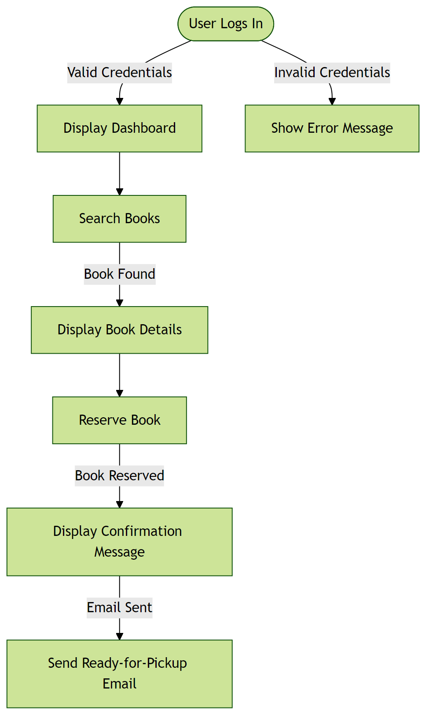

4.2 Hardware Interfaces
The system does not directly interact with hardware devices. All user interactions are through standard computer hardware (keyboard, mouse, display) without requiring specialized devices.

Hardware Interface Architecture:
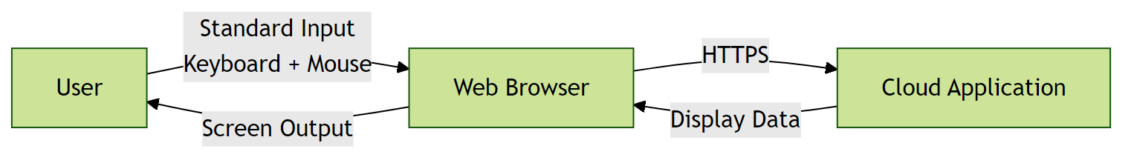

4.3 Software Interfaces
The system interfaces with a SQL database for storing and retrieving data. It also uses Python as the backend programming language and utilizes a hybrid deployment model.

Software Interface Architecture:
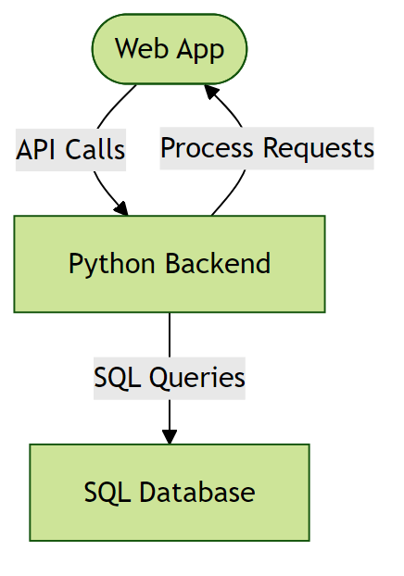

4.4 Communication Interfaces
The system communicates with clients through HTTPS. It uses JSON for data formatting and relies on TCP/IP for network communication.

Communication Interface Architecture:
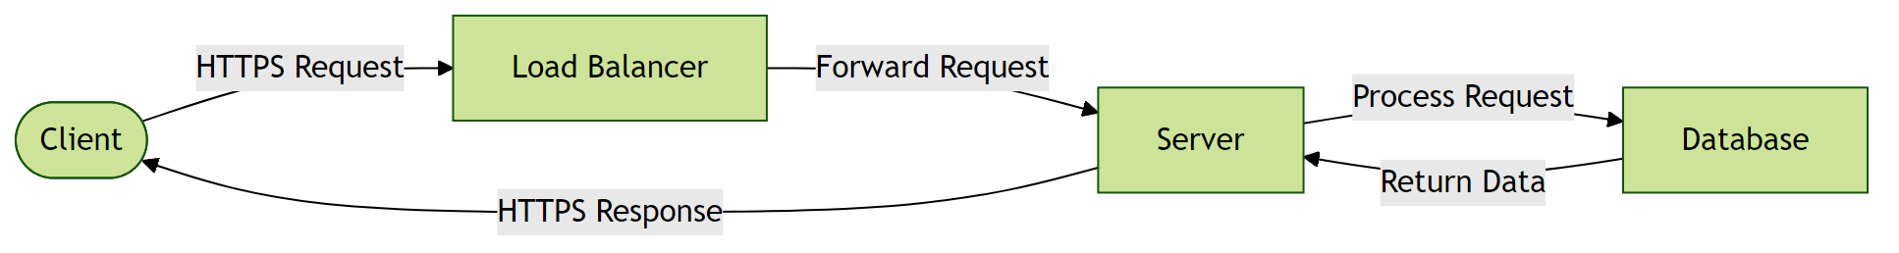

5. Non-Functional Requirements

5.1 Performance Requirements
- The system shall respond to user requests within 2 seconds under normal load.
Rationale: To ensure a responsive user experience and meet industry standards.
- The system shall support at least 100 concurrent users without performance degradation.
Rationale: To accommodate the expected number of users.

5.2 Safety Requirements
- The system shall perform automated daily backups of all user data.
Rationale: To prevent data loss in case of system failure or corruption.

5.3 Security Requirements
- The system shall implement OAuth 2.0 for user authentication.
Rationale: To provide secure and industry-standard authentication mechanism.
- Data at rest must be encrypted using AES-256 encryption.
Rationale: To protect sensitive user information in the event of a database breach.

5.4 Quality Attributes
- The application must achieve 99.9% uptime.
Rationale: To ensure reliability for users.
- The system shall be maintainable with modular architecture and comprehensive documentation.
Rationale: To enable efficient updates and reduce long-term maintenance costs.

6. Glossary

6.1 Technical Terms
API: Application Programming Interface - a set of protocols and tools for building software applications.
Microservices: An architectural style that structures an application as a collection of loosely coupled services.
Load Balancing: Distribution of network traffic across multiple servers to ensure no single server is overwhelmed.
OAuth 2.0: Open Authorization 2.0 - an industry-standard protocol for authorization and authentication.
AES-256: Advanced Encryption Standard with 256-bit key - a symmetric encryption algorithm for securing data.
SQL: Structured Query Language - a programming language for managing and manipulating data in relational database management systems.
Python: A high-level, interpreted programming language used for developing the backend of the system.
Hybrid Deployment: A deployment model that combines on-premises and cloud-based infrastructure for flexible and scalable system deployment.

6.2 Acronyms and Abbreviations
NFR: Non-Functional Requirements - operational constraints defining system performance, security, and quality.
GDPR: General Data Protection Regulation - a regulation in EU law on data protection and privacy.
API: Application Programming Interface - a set of protocols and tools for building software applications.
SQL: Structured Query Language - a programming language for managing and manipulating data in relational database management systems.

6.3 System Components
Authentication Service: Component responsible for verifying user credentials and managing access tokens.
Database Layer: Persistent storage layer managing data operations and ensuring data integrity.
Cloud-based Infrastructure: Infrastructure that uses cloud computing to provide scalable and on-demand access to resources.

6.4 Technologies
Python: A high-level, interpreted programming language used for developing the backend of the system.
Cloud Service Providers: Third-party services that provide cloud-based infrastructure for deployment and scaling.

6.5 Performance Metrics
Concurrent Users: Number of users actively using the system simultaneously without performance degradation.
Response Time: Time elapsed between a user request and the system's response.
Uptime: Percentage of time the system is operational and accessible, typically expressed as 99.9% or similar.

6.6 Security Terms
Authentication: Process of verifying the identity of a user or system.
Authorization: Process of determining whether a user has access to a particular resource or functionality.
Encryption: Process of converting plaintext data into unreadable ciphertext to protect it from unauthorized access.

6.7 Quality Attributes
Reliability: Ability of the system to perform its required functions under normal operating conditions.
Scalability: Ability of the system to handle increased load or demand without decreasing performance.
Maintainability: Ease with which the system can be maintained, updated, or modified.

7. Assumptions

Assumption 1:
Users have basic computer literacy and familiarity with web-based applications.
Impact: If users lack basic digital skills, additional training programs and simplified UI/UX would be required, increasing project costs and extending the rollout timeline.

Assumption 2:
The organization has an existing infrastructure that can support the deployment of the system.
Impact: Without adequate infrastructure, the project would require additional investments in hardware and software, potentially delaying the deployment.

Assumption 3:
Library staff are trained on system usage and can effectively utilize the system.
Impact: If library staff are not adequately trained, the system's adoption and effectiveness could be compromised, leading to reduced usage and potential system abandonment.

Assumption 4:
The system will be developed using Python as the backend and SQL database for data storage.
Impact: If the technology stack needs to be changed, it could lead to significant rework, delays, and potential cost overruns.

Assumption 5:
The system will be deployed on a hybrid model (cloud and on-premises).
Impact: If the deployment model needs to be changed, it could affect system performance, scalability, and maintenance costs.

Assumption 6:
The system will support at least 100 concurrent users without performance degradation.
Impact: If the system cannot support the expected number of concurrent users, it could lead to performance issues, user dissatisfaction, and potential system downtime.

Assumption 7:
The system will perform automated daily backups of all user data.
Impact: If automated backups are not performed, it could lead to data loss in case of system failure or corruption, compromising the integrity of user data.

