NeuroLearn
Synthetic Alchemist
Simulation Intervention — Periodic Table
Chemistry · Grade 11–12 · Moderate Drift 8–20 seconds

1. Concept
Synthetic Alchemist is an element drop game that activates when the student's EEG attention drifts during the Periodic Table lesson. Elements fall from the top of the screen one at a time in atomic number order — H, He, Li, Be, B, C… — synced to the beat of a mnemonic song. The student taps each element as it falls.

Each correct tap plays the mnemonic song chunk for that element. The song is not decorative — it is the memory encoding mechanism. The student hears the element name and tone at the exact moment they physically catch it, creating a paired multi-sensory association between the sound, the symbol, and the tap.

Property | Value
Format | Simulation — one of four intervention formats in NeuroLearn
Drift level | Moderate — confirmed drift 8–20 seconds
Applies to | All 4 sections of the Periodic Table lesson
Time limit | 60 seconds — activity exits automatically after 60 seconds
Visual style | Cyberpunk dark grid — Synthetic Alchemist branding kept exactly as designed
Sequence | Periodic table order by atomic number: H(1) → He(2) → Li(3) → Be(4)…
Win condition | None — student gets as far through the table as possible in 60 seconds
Score | Total elements caught across ALL sessions — persistent across time
Song | Mnemonic song TBD — each element has a unique chunk that plays on correct tap
Difficulty | No progression — same sequence, same speed, same experience every session

2. Visual Reference — Current Screenshot
The screenshot below is the visual reference for all UI decisions in this document. The cyberpunk aesthetic, dark grid background, element tile styling, and panel layout are all kept exactly as shown — with three specific changes noted below.

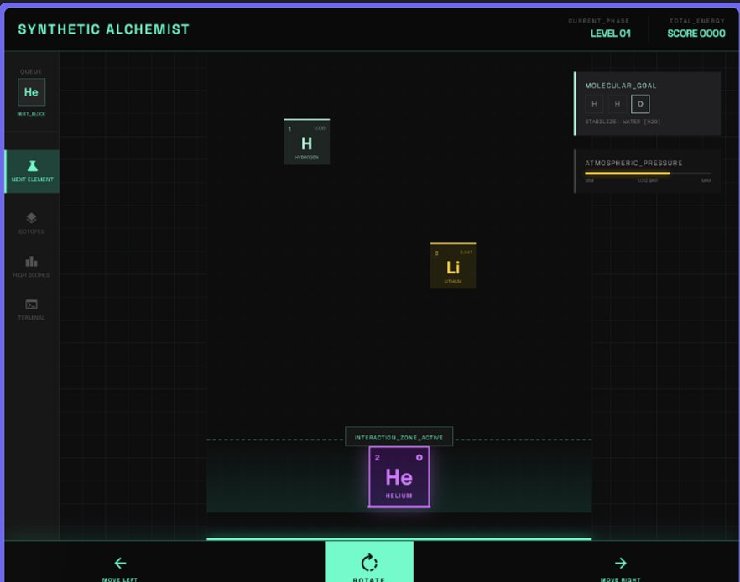

What stays · what changes · what is removed
KEEP: Cyberpunk dark grid · Synthetic Alchemist title · element tile styling · QUEUE panel · NEXT_BLOCK
KEEP: CURRENT_PHASE label · SCORE counter (top right) · INTERACTION_ZONE_ACTIVE strip (bottom)
CHANGE: MOLECULAR_GOAL panel → replaced with CURRENT ELEMENT panel showing element name + atomic number large
REMOVE: ATMOSPHERIC_PRESSURE bar — not needed
REMOVE: MOVE LEFT / ROTATE / MOVE RIGHT controls — student just taps falling element

3. Final Screen Layout

┌───────────────────────────────────────────────────────────────────┐
│ SYNTHETIC ALCHEMIST CURRENT_PHASE SCORE │
│ LEVEL 01 0042 │
├──────────┬──────────────────────────────┬───────────────────────┤
│ QUEUE │ │ CURRENT ELEMENT │
│ ┌────┐ │ │ │
│ │ Li │ │ PLAY AREA │ HELIUM │
│ └────┘ │ (dark cyberpunk grid) │ · 2 · │
│ NEXT_BLK │ │ │
│ │ Element tile falls here └───────────────────────┤
│ [other │ one at a time │
│ icons] │ in atomic number order │
│ │ synced to song beat │
│ │ │
│ │ ┌──────────────────┐ ← current falling element │
│ │ │ 2 4 │ │
│ │ │ He │ │
│ │ │ HELIUM │ │
│ │ └──────────────────┘ │
│ │ │
│ ├───────────────────────────────────────────────────────┤
│ │ INTERACTION_ZONE_ACTIVE │
│ │ (tap element here before it passes) │
└──────────┴───────────────────────────────────────────────────────┘

No move controls at bottom — removed
No atmospheric pressure bar — removed
MOLECULAR_GOAL replaced by CURRENT ELEMENT panel (top right)

4. Core Mechanic — Step by Step

4.1 The sequence
The elements fall in strict periodic table order by atomic number. This is not random — the sequence IS the periodic table. H always falls first, He second, Li third. The mnemonic song plays in the same order. The game and the song are the same thing.

Periodic table sequence (first 20 elements):

Period 1: H(1) → He(2)
Period 2: Li(3) → Be(4) → B(5) → C(6) → N(7) → O(8) → F(9) → Ne(10)
Period 3: Na(11) → Mg(12) → Al(13) → Si(14) → P(15) → S(16) → Cl(17) → Ar(18)
Period 4: K(19) → Ca(20) → ...

Same order every session — no shuffle, no randomisation
Student always starts from H(1) each new activity session

4.2 How one session works

Step 1 EEG drift confirmed (8–20 seconds below attention threshold)
School content pauses at exact timestamp
Synthetic Alchemist activates full screen

Step 2 CURRENT ELEMENT panel shows: HYDROGEN · 1
QUEUE panel shows next element: He
Song begins playing from H

Step 3 H tile falls from top of screen
Fall speed synced to mnemonic song beat

Step 4 Student taps H before it passes INTERACTION_ZONE
→ Correct tap: H glows teal, song chunk for H plays
CURRENT ELEMENT updates: HELIUM · 2
He begins falling on the next beat
→ Miss: H falls again immediately
Song replays H chunk
Student gets another chance — no penalty

Step 5 Student progresses through the table
He → Li → Be → B → C → N → O → F → Ne → Na...
Each correct tap plays that element's song chunk
CURRENT ELEMENT panel always shows what is falling now
QUEUE always shows what is coming next

Step 6 60 seconds elapsed
Activity exits
SCORE updates: total elements caught across all sessions
Recap sentence appears
Returns to lesson at exact timestamp

Why this works
The student drifted while reading about the periodic table. The game brings them back by making them do the exact task the lesson is about — identifying elements in order. The mnemonic song chunk plays at the moment of correct identification, creating a paired association: element symbol + atomic number + sound + physical tap. Every session starts from H and progresses forward — so students who play more sessions gradually build familiarity further and further into the table.

5. All Game States

STATE 1 — CORRECT TAP
→ Student taps element before it reaches bottom of INTERACTION_ZONE
→ Element tile glows teal for 0.3 seconds
→ Mnemonic song chunk for that element plays immediately
→ CURRENT ELEMENT panel updates to next element in sequence
→ QUEUE panel updates to show the element after that
→ Next element falls on the very next beat of the song
→ Sequence advances: student is now one step further into the table

STATE 2 — MISSED TAP (element passes INTERACTION_ZONE)
→ Student does not tap before element passes the zone
→ No reset — no penalty
→ Same element falls again immediately from the top
→ Song replays that element's chunk
→ CURRENT ELEMENT panel stays the same
→ Student gets another chance on the same element
→ This repeats until the student taps it correctly
Note: student cannot advance past an element without tapping it

STATE 3 — TIME LIMIT REACHED (60 seconds)
→ 60 seconds elapsed regardless of how far student has progressed
→ Activity exits gracefully
→ SCORE updates: total elements caught across all sessions increments
→ Recap sentence appears (section-specific — see Section 7)
→ Returns to school content at exact timestamp where lesson paused
Note: partial progress still counts — even catching just H and He is a win

STATE 4 — EEG RECOVERY (mid-activity)
→ Crown detects attention has recovered during the activity
→ Activity exits immediately — time limit does not need to be reached
→ No recap shown — attention is already back, lesson resumes directly
→ Returns to school content at exact timestamp
→ SCORE still updates for elements caught before exit
Note: this is the ideal exit — the activity did its job before time ran out

6. UI Component Specifications

6.1 Falling element tile

Property | Value
Size | Approximately 80×80px — large enough to tap comfortably on iPad
Content | Atomic number (top left, small) · Atomic mass (top right, small) · Symbol (large, centre) · Element name (bottom, small)
Style | Cyberpunk tile border — matches screenshot exactly. Dark background, coloured border per element family.
Fall speed | Synced to mnemonic song beat — constant, not configurable
Fall path | Straight vertical from top of play area to INTERACTION_ZONE
Correct state | Border and background shift to teal glow for 0.3 seconds then disappears
Miss state | Element reaches bottom, briefly flashes amber, then reappears at top of screen

6.2 Current element panel (replaces Molecular Goal)

Property | Value
Position | Top right — same position as MOLECULAR_GOAL was in screenshot
Label | CURRENT ELEMENT in small uppercase cyberpunk font
Content | Two lines: element full name large (e.g. HELIUM) · atomic number below (e.g. · 2 ·)
Purpose | Reinforces the name and atomic number of the element currently falling
Updates | Changes immediately when student successfully catches current element
Style | Same dark panel styling as rest of interface — cyberpunk aesthetic
On miss | Stays the same — still shows current element since student must catch it

6.3 Queue panel

Property | Value
Position | Left sidebar — matches screenshot exactly
Label | QUEUE above, NEXT_BLOCK below tile
Content | Shows the single next element to fall after current one
Purpose | Lets student mentally prepare for the next element
Updates | Updates the moment current element is successfully caught
On miss | Does not change — queue is based on sequence not on student action

6.4 Score counter

Property | Value
Position | Top right beside CURRENT_PHASE — matches screenshot
Label | SCORE / TOTAL_ENERGY — keep cyberpunk label from screenshot
What it counts | Total elements caught across ALL sessions — not just this session
Persistence | Stored in SQLite locally — survives app restarts
Increment | Adds 1 each time an element is successfully caught
Format | 4-digit zero-padded: 0000, 0001, 0042 — matches screenshot style

6.5 INTERACTION_ZONE_ACTIVE strip

Property | Value
Position | Bottom of play area — horizontal strip — matches screenshot
Label | INTERACTION_ZONE_ACTIVE text inside the strip
Function | Tap window — student must tap before element fully passes this zone
Visual | Dashed border strip — teal/cyan colour matching screenshot
On correct tap | Strip briefly pulses teal
On miss | Strip briefly pulses amber — element reappears at top

7. Progression Across Sessions
Every session starts from H. The student always begins at the same place. But because each session is 60 seconds and the mnemonic song has a fixed tempo, a student who plays more sessions will gradually hear and catch more elements — not because the speed changes, but because they recognise earlier elements faster and waste less time on misses.

Sessions played | Typical progress | What the student has heard repeatedly
1–3 sessions | H → He (Period 1 only) | Hydrogen and Helium chunks — now permanently associated
4–8 sessions | H → Ne (all of Period 2) | All 8 Period 2 elements — alkali to noble gas
10+ sessions | H → Na/Mg (into Period 3) | Period 1 and 2 solid, beginning to learn Period 3
20+ sessions | H → K/Ca (deep into Period 3–4) | First 20 elements familiar — foundation of the table

Natural progression without difficulty changes
The game never speeds up or gets harder. Progress happens through familiarity — students who have heard H and He many times will tap them instantly, giving themselves more time to reach Li, Be, and beyond. The song does the work. The more sessions played, the deeper into the table the student's ear recognises.

8. Recap Sentences
One sentence appears after the activity exits (time limit or EEG recovery) before returning to the lesson. It bridges the game back to the exact concept the student drifted on.

Section | Recap sentence
I — History & Organisation | "The elements you just tapped are in order of atomic number — the same principle Mendeleev used to build the table."
II — Element Groups & Families | "Each period you crossed contains a full set of families — from the reactive alkali metal on the left to the unreactive noble gas on the right."
III — Periodic Trends | "Every step right you tapped added one proton — that is exactly why atomic radius decreases across a period."
IV — Reading the Table | "Every element you caught has the same tile structure — atomic number top left, mass bottom, symbol centre. Always the same."

9. EEG Integration

9.1 Entry condition

EEG attention index = (theta + alpha) / beta
Normalised against 30-second personal baseline

Synthetic Alchemist triggers when:
→ attention_level == 'drifting'
→ drift confirmed over 2 consecutive 4-second windows
→ drift duration between 8 and 20 seconds
→ severe drift 20+ seconds triggers Draw Mode or Hand Gesture instead

9.2 Exit conditions — priority order

Priority | Condition | What happens
1st | EEG recovery detected | Exits immediately — score updates — lesson resumes — no recap
2nd | 60 second time limit | Graceful exit — score updates — recap sentence — lesson resumes

9.3 RL reward signal

After Synthetic Alchemist exits:

IF EEG attention recovered within 60 seconds: reward = +1
IF EEG attention did NOT recover: reward = -1

RL agent uses this reward to learn per-student preferences:
Session 1–5: rule-based — always Synthetic Alchemist for moderate drift
Session 6–30: bandit — learns if this student recovers better from
Simulation vs Flashcard
Session 30+: DQN — full personalisation across all formats

NeuroLearn · Synthetic Alchemist · Simulation Intervention · Periodic Table · v2.0 April 2026

