# AIM:

Lab-2:  
Dart Programming Language  
Learning Resources - Introductory Dart Video (Last 2 hrs.)  
  
Practical Task – Library Management System  
Objective:  
Develop a simple console-based library management system for a book collection. The system should allow users to perform various operations while demonstrating the use of conditional statements, loops, functions, classes, inheritance, exception handling, and async programming.Task Requirements:  
Book Class:

* Create a Book class with properties: title, author, yearPublished, and isAvailable (boolean).
* Implement getters and setters for these properties.
* Include a method to display book details.

Library Class:

* Create a Library class that maintains a collection of Book objects.
* Include a method to add a book to the library.
* Include a method to borrow a book (mark it as not available).
* Include a method to return a book (mark it as available).
* Use a constructor to initialize the library with a predefined list of books.

User Interaction:

* Use a loop to present a menu to the user with the following options:
* Add a new book.
* Borrow a book.
* Return a book.
* List all books.
* Exit the system.

Use conditional statements to handle user inputs and navigate the menu.Switch-Case for Menu Operations:

* Use a switch-case statement to process menu selections.

Handling Exceptions:

* Implement exception handling for cases like attempting to borrow a book that is unavailable or returning a book that was not borrowed.

Inheritance:

* Create a subclass EBook that inherits from Book and adds a property fileSize. Override the method that displays book details to include the file size.

Static Methods:

* Implement a static method in the Library class that keeps track of the total number of books in the library.

Abstract Class:

* Create an abstract class User with an abstract method displayUserType(). Create a subclass Member that implements this method.

Use of Async and Await:

* Simulate an asynchronous process for listing books with a method in the Library class that returns a Future<List<Book>> and uses await to simulate a delay.

**THEORY:**

**Comprehensive Overview of Dart Syntax**

Dart is a modern, object-oriented programming language optimized for building fast applications. Below is an overview of its syntax, structured into categories.

**1. Basic Syntax**

**Variables**

* Dart supports var, final, const, and explicit types.

var name = "John"; // Type inferred

String city = "New York"; // Explicit type

final age = 25; // Immutable, runtime constant

const pi = 3.14159; // Compile-time constant

**Data Types**

* Dart includes basic types: int, double, String, bool, List, Set, Map.

int a = 10;

double b = 3.14;

String greeting = "Hello";

bool isLoggedIn = true;

**Printing Output**

dart

Copy code

print("Hello, Dart!");

**2. Control Flow Statements**

**Conditional Statements**

* if, else, and else if blocks for decision-making.

if (a > b) {

print("a is greater");

} else if (a == b) {

print("a and b are equal");

} else {

print("b is greater");

}

**Switch-Case**

* Ideal for handling multiple conditions.

switch (day) {

case 'Monday':

print('Start of the week');

break;

case 'Friday':

print('End of the workweek');

break;

default:

print('Another day');

}

**Loops**

* **For Loop:**

for (int i = 0; i < 5; i++) {

print(i);

}

* **While Loop:**

int i = 0;

while (i < 5) {

print(i++);

}

* **Do-While Loop:**

int i = 0;

do {

print(i++);

} while (i < 5);

* **For-In Loop:**

var numbers = [1, 2, 3];

for (var num in numbers) {

print(num);

}

**3. Functions**

**Basic Function**

int add(int a, int b) {

return a + b;

}

**Arrow Functions**

* A concise syntax for one-line functions.

int square(int x) => x * x;

**Optional Parameters**

* **Positional Parameters:**

void greet(String name, [String title = "Mr/Ms"]) {

print("Hello, $title $name!");

}

* **Named Parameters:**

void display({String? title, int? year}) {

print("$title was released in $year.");

}

}

**4. Object-Oriented Programming**

**Classes and Objects**

class Person {

String name;

int age;

Person(this.name, this.age);

void display() {

print("Name: $name, Age: $age");

}

}

var person = Person("Alice", 25);

person.display();

**Inheritance**

class Employee extends Person {

String jobTitle;

Employee(String name, int age, this.jobTitle) : super(name, age);

}

**Abstract Classes**

abstract class Shape {

void draw();

}

class Circle extends Shape {

void draw() {

print("Drawing a circle");

}

}

**5. Collections**

**List**

List<int> numbers = [1, 2, 3];

numbers.add(4);

print(numbers);

**Set**

Set<String> fruits = {"Apple", "Banana", "Cherry"};

fruits.add("Apple"); // Duplicates are ignored

print(fruits);

**Map**

Map<String, int> ageMap = {"Alice": 30, "Bob": 25};

print(ageMap["Alice"]);

**6. Exception Handling**

try {

int result = 10 ~/ 0; // Throws an exception

} on IntegerDivisionByZeroException {

print("Cannot divide by zero");

} catch (e) {

print("Error: $e");

} finally {

print("Cleanup actions");

}

**7. Async and Await**

**Future**

Future<String> fetchData() async {

return "Data loaded";

}

fetchData().then((data) => print(data));

**Async-Await**

Future<void> loadData() async {

var data = await fetchData();

print(data);

}

**8. Miscellaneous Features**

**Null Safety**

String? nullableVar; // Can be null

nullableVar = "Not Null";

**Type Casting**

dynamic value = "Hello";

String str = value as String;

**Static Members**

class Example {

static int count = 0;

static void displayCount() {

print("Count: $count");

}

}

Example.displayCount();

**Getters and Setters**

class Car {

String _model = "";

String get model => _model;

set model(String model) => _model = model; }

**CODE:**

import 'dart:async';

import 'dart:io';

class Book {

  int _bookId;

  String _title;

  String _author;

  int _yearPublished;

  bool _isAvailable;

  Book(this._bookId, this._title, this._author, this._yearPublished, this._isAvailable);

  // Getters and Setters

  int get bookId => _bookId;

  set bookId(int id) => _bookId = id;

  String get title => _title;

  set title(String newTitle) => _title = newTitle;

  String get author => _author;

  set author(String newAuthor) => _author = newAuthor;

  int get yearPublished => _yearPublished;

  set yearPublished(int year) => _yearPublished = year;

  bool get isAvailable => _isAvailable;

  set isAvailable(bool availability) => _isAvailable = availability;

  // Method to display details

  void displayDetails() {

    print('Book ID: $_bookId');

    print('Title: $_title');

    print('Author: $_author');

    print('Year Published: $_yearPublished');

    print('Available: ${_isAvailable ? "Yes" : "No"}\n');

  }

}

class EBook extends Book {

  double _fileSize;

  EBook(int bookId, String title, String author, int yearPublished, bool isAvailable, this._fileSize)

      : super(bookId, title, author, yearPublished, isAvailable);

  double get fileSize => _fileSize;

  set fileSize(double size) => _fileSize = size;

  @override

  void displayDetails() {

    super.displayDetails();

    print('File Size: ${_fileSize}MB\n');

  }

}

abstract class User {

  void displayUserType();

}

class Member extends User {

  @override

  void displayUserType() {

    print("User Type: Member");

  }

}

class Library {

  final List<Book> _books = [];

  static int _totalBooks = 0;

  Library() {

    // Predefined books

    _books.add(Book(1, "Dart Basics", "John Doe", 2020, true));

    _books.add(Book(2, "Flutter Advanced", "Jane Smith", 2021, true));

    _books.add(EBook(3, "Async Programming", "Alex Brown", 2022, true, 1.5));

    _totalBooks = _books.length;

  }

  // Getters

  List<Book> get books => _books;

  static int get totalBooks => _totalBooks;

  // Methods

  void addBook(Book book) {

    _books.add(book);

    _totalBooks++;

    print("Book added successfully!\n");

  }

  void borrowBook(int bookId) {

    try {

      var book = _books.firstWhere((b) => b.bookId == bookId);

      if (book.isAvailable) {

        book.isAvailable = false;

        print("You borrowed '${book.title}'\n");

      } else {

        throw Exception("Book is currently unavailable!");

      }

    } catch (e) {

      print("Error: $e\n");

    }

  }

  void returnBook(int bookId) {

    try {

      var book = _books.firstWhere((b) => b.bookId == bookId);

      if (!book.isAvailable) {

        book.isAvailable = true;

        print("You returned '${book.title}'\n");

      } else {

        throw Exception("Book was not borrowed!");

      }

    } catch (e) {

      print("Error: $e\n");

    }

  }

  Future<void> listBooks() async {

    print("Fetching book list...");

    await Future.delayed(Duration(seconds: 2));

    print("\n--- Book List ---");

    for (var book in _books) {

      book.displayDetails();

    }

  }

  static void displayTotalBooks() {

    print("Total books in the library: $_totalBooks\n");

  }

}

void main() async {

  Library library = Library();

  while (true) {

    print("=== Library Menu ===");

    print("1. Add a Book");

    print("2. Borrow a Book");

    print("3. Return a Book");

    print("4. List All Books");

    print("5. Display Total Books");

    print("6. Exit");

    print("====================");

    stdout.write("Enter your choice: ");

    int choice = int.parse(stdin.readLineSync()!);

    switch (choice) {

      case 1:

        stdout.write("Enter Book ID: ");

        int id = int.parse(stdin.readLineSync()!);

        stdout.write("Enter Title: ");

        String title = stdin.readLineSync()!;

        stdout.write("Enter Author: ");

        String author = stdin.readLineSync()!;

        stdout.write("Enter Year Published: ");

        int year = int.parse(stdin.readLineSync()!);

        stdout.write("Enter File Size (Enter 0 for physical books): ");

        double fileSize = double.parse(stdin.readLineSync()!);

        if (fileSize > 0) {

          library.addBook(EBook(id, title, author, year, true, fileSize));

        } else {

          library.addBook(Book(id, title, author, year, true));

        }

        break;

      case 2:

        stdout.write("Enter Book ID to borrow: ");

        int bookId = int.parse(stdin.readLineSync()!);

        library.borrowBook(bookId);

        break;

      case 3:

        stdout.write("Enter Book ID to return: ");

        int bookId = int.parse(stdin.readLineSync()!);

        library.returnBook(bookId);

        break;

      case 4:

        await library.listBooks();

        break;

      case 5:

        Library.displayTotalBooks();

        break;

      case 6:

        print("Exiting system. Goodbye!");

        return;

      default:

        print("Invalid choice! Please try again.\n");

    }

  }

}

**OUTPUT:**

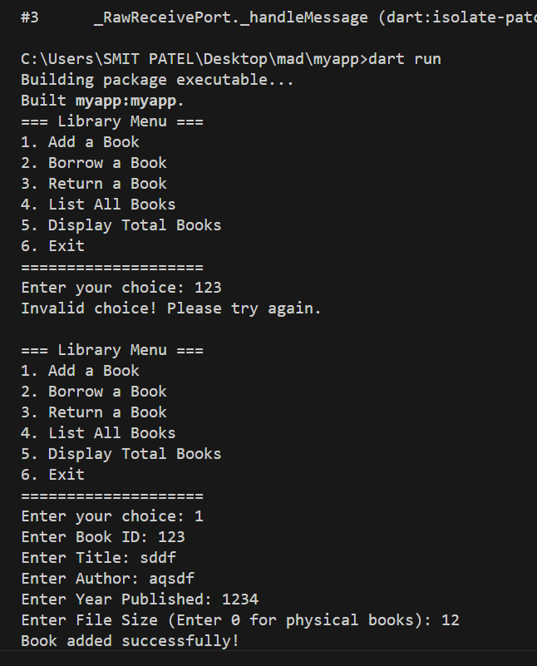

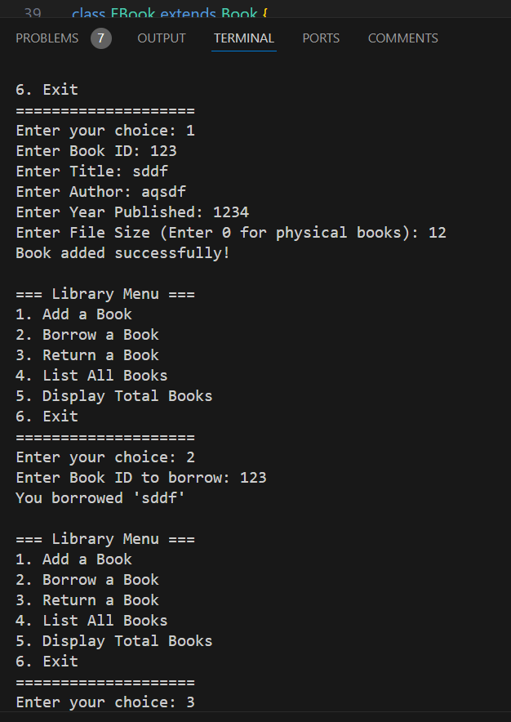

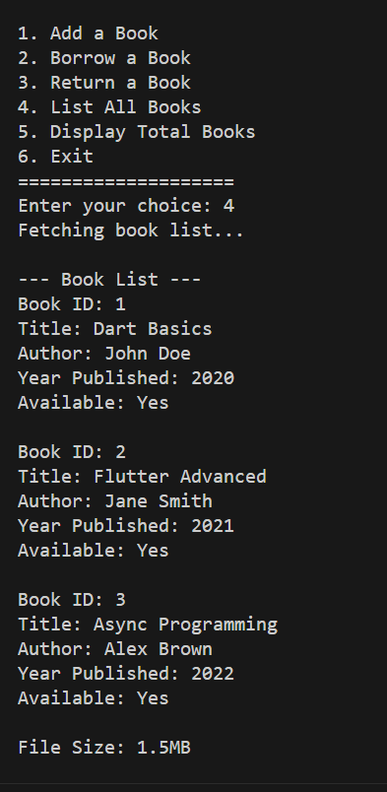

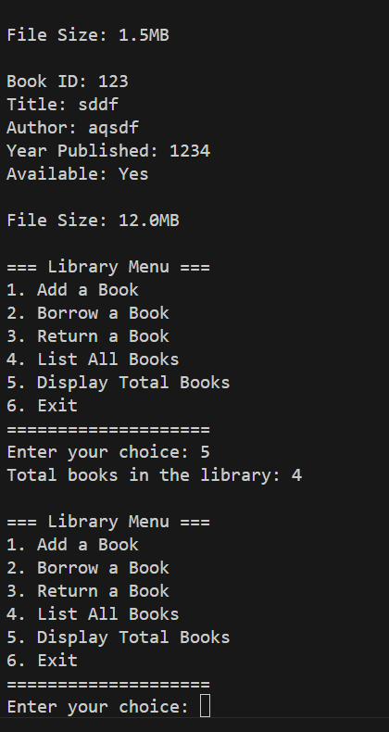

# Latest Applications:

1. **Library Management Systems (LMS):**
   * Forms the basis for more complex LMS applications used in schools, colleges, and public libraries.
2. **E-Book Platforms:**
   * The EBook class showcases how digital resources can be managed alongside physical books, a key feature in platforms like Kindle or OverDrive.
3. **Inventory Systems:**
   * The logic can be adapted to manage inventory in retail, warehouses, or online stores.
4. **Learning Management Systems:**
   * With modifications, this system could manage educational content, such as course materials and user access, in online learning platforms like Moodle or Blackboard.
5. **Async Operations for Cloud Apps:**
   * The asynchronous functionality mimics operations in cloud-based systems, such as fetching large data from a database.
6. **Mobile App Backends:**
   * Acts as a prototype for backend services managing books or digital content for mobile apps developed using Flutter or Dart.
7. **Collaborative Libraries:**
   * Could be extended to support shared libraries for communities, promoting resource sharing in collaborative ecosystems.
8. **Integration with Modern Tech**:
   * Can integrate with databases (e.g., Firebase or MongoDB) and APIs for a fully functional web or mobile application.

# Learning Outcome:

1. **Object-Oriented Programming (OOP):**
   * Understand the principles of OOP, including encapsulation, inheritance, abstraction, and polymorphism.
   * Learn to design reusable and modular code using classes and objects.
2. **Encapsulation:**
   * Implement private properties and access them using getters and setters to maintain data integrity.
3. **Inheritance and Polymorphism:**
   * Explore inheritance by creating a subclass (EBook) and overriding methods to extend functionality.
4. **Exception Handling:**
   * Handle runtime errors gracefully, such as borrowing an unavailable book or returning a non-borrowed book.
5. **Asynchronous Programming:**
   * Use Future and await for simulating asynchronous operations, improving program responsiveness.
6. **Static Methods and Properties:**
   * Understand the concept of class-level methods and variables, such as tracking total books.
7. **Abstract Classes:**
   * Learn abstraction by creating an abstract User class and implementing it in the Member subclass.
8. **Switch-Case for Flow Control:**
   * Use switch-case for efficient menu navigation and user interaction.
9. **Real-World Problem Solving:**
   * Apply theoretical programming concepts to develop a practical system that mimics real-world applications.