## AIM:

Due Today

Lab-1:  
  
Practical Task - Build a simple Hello World app in Flutter.  
  
Topics:  
Widget Hierarchy - Root Widget, Child Widgets, Parent-Child Relationships  
Composition -  Combining Widgets, Nested Layouts  
Widget Types - Stateless Widgets, Immutable Properties, Rendering Pipeline  
  
Learning Resources -  
<https://www.youtube.com/watch?app=desktop&v=gOZrczjHF6g>  
<https://docs.flutter.dev/tools/devtools/inspector>  
<https://medium.com/flutter-community/flutter-widgets-row-column-flex-the-whole-picture-a648cd6e6904>  
<https://www.youtube.com/watch?v=g2E7yl3MwMk>  
<https://www.youtube.com/watch?app=desktop&v=gOZrczjHF6g>  
<https://medium.com/@bosctechlabs/building-dynamic-layouts-with-flutter-flex-da5576180882>  
  
Lab-2:  
Practical Task - 

* **Create an App with list, grids and Scrolling for To-do list App.**

## THEORY:

**About Flutter**

* **Why Flutter?**
  + High performance: Compiles to native code (Dart) for speed.
  + Declarative UI: Inspired by React, widgets are rebuilt only when necessary.
  + Integrated Hot-Reload: Quickly preview changes during development.
* **Advantages**:
  + Simplifies app development compared to web and native apps.
  + Promises smaller codebases and faster development.

**Flutter Project Structure**

* **Key folders**:
  + lib/: Main codebase.
  + pubspec.yml: Dependency manager (like package.json).
  + ios/ & android/: Platform-specific code.
  + test/: Testing files.
* **Entry Point**: main.dart contains the main() function, the starting point of every Flutter app.

**Understanding Widgets**

* **Core Concept**: Everything in Flutter is a widget.
  + Widgets handle UI, themes, and even state management.
* **Basic Widgets**:
  + Text: Displays text. Requires textDirection.
  + Center: Aligns its child widget to the center.
  + Container: Equivalent to HTML's <div>, used for layout and styling.
* **Composition**: Widgets are nested to build complex interfaces.

**Code Examples**

1. **"Hello, World!" Basic App**:

import 'package:flutter/widgets.dart';

main() => runApp(

Text(

'Hello, World!!!',

textDirection: TextDirection.ltr,

),

);

1. **Centering Content**:

import 'package:flutter/widgets.dart';

main() => runApp(

Center(

child: Text(

'Hello, World!',

textDirection: TextDirection.ltr,

),

),

);

1. **Adding Styles**:

import 'package:flutter/widgets.dart';

main() => runApp(

Directionality(

textDirection: TextDirection.ltr,

child: Container(

color: Color(0xFF444444),

child: Center(

child: Text(

'Hello, World!',

style: TextStyle(

color: Color(0xFFFD620A),

fontSize: 32.0,

),

),

),

),

),

);

**Design Philosophy**

* **Declarative Composition**: Combines widgets hierarchically.
* **Reusability**: Widgets can be reused to streamline development.
* **Directionality**: Set global text direction using Directionality widget.

## CODE:

Lab -1

import 'package:flutter/material.dart';

void main() => runApp(MyApp());

class MyApp extends StatelessWidget {

  @override

  Widget build(BuildContext context) {

    return MaterialApp(

      home: Scaffold(

        appBar: AppBar(

          title: Text("Flutter Grid Example"),

        ),

        body: GridViewExample(),

      ),

    );

  }

}

class GridViewExample extends StatelessWidget {

  @override

  Widget build(BuildContext context) {

      return GridView.builder(

      gridDelegate: SliverGridDelegateWithFixedCrossAxisCount(

        crossAxisCount: 12, // Number of columns

        crossAxisSpacing: 1.0, // Spacing between columns

        mainAxisSpacing: 1.0, // Spacing between rows

      ),

      itemCount: 10, // Total number of grid items

      itemBuilder: (BuildContext context, int index) {

        return GridTile(

          child: Container(

            decoration: BoxDecoration(

              color: Colors.blueAccent,

              borderRadius: BorderRadius.circular(8.0),

            ),

            child: Center(

              child: Text(

                "hello world $index",

                style: TextStyle(

                  color: Colors.white,

                  fontSize: 16.0,

                  fontWeight: FontWeight.bold,

                ),

              ),

            ),

          ),

        );

      },

    );

  }

}

Lab -2

import 'package:flutter/material.dart';

void main() {

  runApp(const MyApp());

}

class MyApp extends StatelessWidget {

  const MyApp({super.key});

  @override

  Widget build(BuildContext context) {

    return MaterialApp(

      home: const HomeScreen(),

      debugShowCheckedModeBanner: false,

      theme: ThemeData(primarySwatch: Colors.indigo),

    );

  }

}

class HomeScreen extends StatefulWidget {

  const HomeScreen({super.key});

  @override

  State<HomeScreen> createState() => _HomeScreenState();

}

class _HomeScreenState extends State<HomeScreen> {

  final List<Map<String, String>> todoList = [];

  final GlobalKey<AnimatedListState> listKey = GlobalKey<AnimatedListState>();

  String singleValue = "";

  addString(content) {

    setState(() {

      singleValue = content;

    });

  }

  addList() {

    if (singleValue.trim().isEmpty) return;

    final newItem = {"value": singleValue};

    setState(() {

      todoList.add(newItem);

      listKey.currentState?.insertItem(todoList.length - 1);

    });

  }

  deleteItem(int index) {

    final removedItem = todoList[index];

    setState(() {

      listKey.currentState?.removeItem(

        index,

        (context, animation) => _buildAnimatedItem(removedItem, animation),

      );

      todoList.removeAt(index);

    });

  }

  Widget _buildAnimatedItem(Map<String, String> item, Animation<double> animation) {

    return SizeTransition(

      sizeFactor: animation,

      child: Card(

        margin: const EdgeInsets.symmetric(vertical: 5, horizontal: 10),

        shape: RoundedRectangleBorder(borderRadius: BorderRadius.circular(15)),

        elevation: 5,

        color: Colors.blue[900],

        child: ListTile(

          title: Text(

            item['value']!,

            style: const TextStyle(color: Colors.white, fontWeight: FontWeight.bold),

          ),

          trailing: IconButton(

            icon: const Icon(Icons.delete, color: Colors.red),

            onPressed: () {

              deleteItem(todoList.indexOf(item));

            },

          ),

        ),

      ),

    );

  }

  @override

  Widget build(BuildContext context) {

    return Scaffold(

      appBar: AppBar(

        title: const Text(

          "Todo Application",

          style: TextStyle(fontWeight: FontWeight.bold, fontSize: 25),

        ),

        centerTitle: true,

        toolbarHeight: 75,

        leading: IconButton(

          icon: const Icon(Icons.menu),

          onPressed: () {},

        ),

        elevation: 0,

      ),

      body: Stack(

        children: [

          // Full-Screen Background Image from URL

          Positioned.fill(

            child: Image.network(

              'https://www.pexels.com/photo/timelapse-photography-off-water-fountain-719396/',

               width: 100,

                    height: 100, // URL for the image

              fit: BoxFit.cover,

              loadingBuilder: (context, child, loadingProgress) {

                if (loadingProgress == null) return child;

                return const Center(

                  child: CircularProgressIndicator(),

                );

              },

              errorBuilder: (context, error, stackTrace) {

                return const Center(

                  child: Text(' load image'),

                );

              },

            ),

          ),

          Column(

            children: [

              Expanded(

                flex: 90,

                child: AnimatedList(

                  key: listKey,

                  initialItemCount: todoList.length,

                  itemBuilder: (context, index, animation) {

                    return _buildAnimatedItem(todoList[index], animation);

                  },

                ),

              ),

              Padding(

                padding: const EdgeInsets.all(10),

                child: Row(

                  children: [

                    Expanded(

                      flex: 70,

                      child: TextFormField(

                        onChanged: (content) {

                          addString(content);

                        },

                        decoration: InputDecoration(

                          border: OutlineInputBorder(

                            borderRadius: BorderRadius.circular(15),

                          ),

                          fillColor: Colors.white.withOpacity(0.8),

                          filled: true,

                          labelText: 'Create Task...',

                          labelStyle: TextStyle(

                            color: Colors.indigo[900],

                            fontWeight: FontWeight.bold,

                          ),

                        ),

                      ),

                    ),

                    const SizedBox(width: 10),

                    Expanded(

                      flex: 30,

                      child: ElevatedButton(

                        onPressed: () {

                          addList();

                        },

                        style: ElevatedButton.styleFrom(

                          shape: RoundedRectangleBorder(

                            borderRadius: BorderRadius.circular(15),

                          ),

                          padding: const EdgeInsets.symmetric(vertical: 15),

                        ),

                        child: const Text(

                          "Add",

                          style: TextStyle(fontSize: 18, fontWeight: FontWeight.bold),

                        ),

                      ),

                    ),

                  ],

                ),

              ),

              // Circular Image Example

              Padding(

                padding: const EdgeInsets.all(20),

                child: ClipOval(

                  child: Image.network(

                    'https://images.pexels.com/photos/1366919/pexels-photo-1366919.jpeg?auto=compress&cs=tinysrgb&w=300', // URL for the circular image

                    width: 100,

                    height: 100,

                    fit: BoxFit.cover,

                    loadingBuilder: (context, child, loadingProgress) {

                      if (loadingProgress == null) return child;

                      return const Center(

                        child: CircularProgressIndicator(),

                      );

                    },

                    errorBuilder: (context, error, stackTrace) {

                      return const Center(

                        child: Text('Failed to load image'),

                      );

                    },

                  ),

                ),

              ),

            ],

          ),

        ],

      ),

    );

  }

}

## OUTPUT:

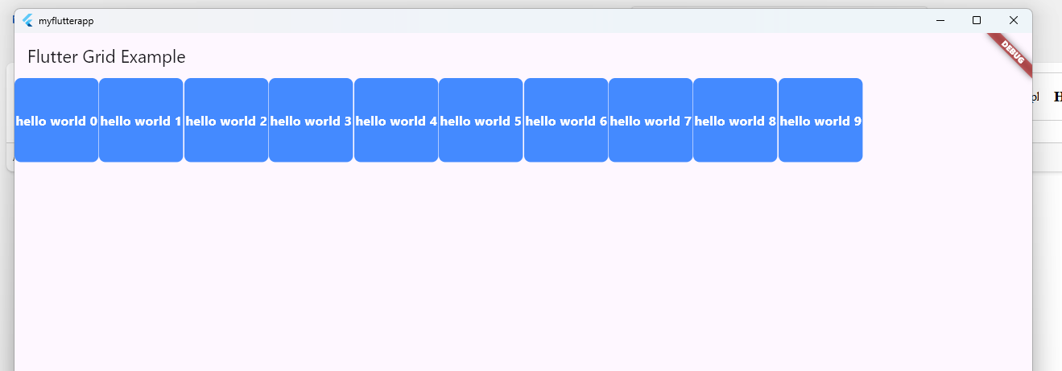

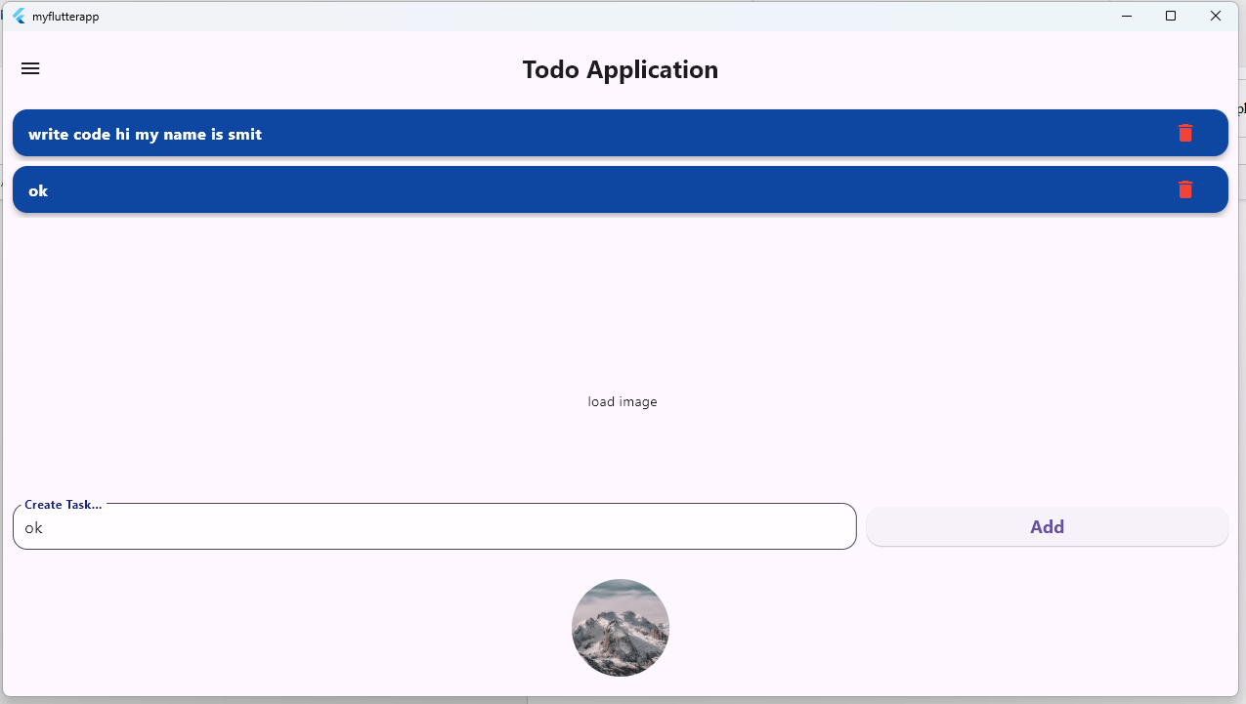

## Latest Applications:

**Latest Applications of Flutter**

Flutter is widely used in various domains due to its flexibility, fast development, and cross-platform compatibility. Here are some **latest applications** of Flutter:

1. **Cross-Platform Development**:
   * Build apps for Android, iOS, Web, Desktop (Windows, macOS, Linux), and Embedded systems from a single codebase.
2. **E-commerce Applications**:
   * Interactive and visually appealing e-commerce platforms like Alibaba, eBay Motors.
   * Supports state management for seamless cart and checkout functionalities.
3. **Finance & Banking Apps**:
   * Applications like Nubank and Google Pay use Flutter for their financial services, ensuring high performance and security.
4. **Social Media Platforms**:
   * Customizable UIs for features like chat, video streaming, and notifications.
5. **Gaming and AR/VR Apps**:
   * Casual games and lightweight interactive applications with immersive UI/UX.
6. **AI and ML Integration**:
   * Apps utilizing TensorFlow Lite for on-device AI processing.
7. **IoT and Wearables**:
   * Flutter apps designed for IoT dashboards and wearable devices.
8. **Enterprise Solutions**:
   * CRM and ERP systems with powerful APIs and responsive designs.

## Learning Outcome:

1. **Understanding Flutter's Core Concepts**:
   * Gain knowledge of the **widget tree** structure, stateful/stateless widgets, and how Flutter builds UI with a declarative approach.
2. **Grid Layout Mastery**:
   * Learn to create responsive and scalable grid-based layouts for dynamic content such as galleries, e-commerce product displays, and dashboards.
3. **Cross-Platform Development Skills**:
   * Build applications that work seamlessly across multiple platforms using a single codebase.
4. **Customization and Reusability**:
   * Implement reusable components and design efficient layouts using Flutter's widgets like GridView and ListView.
5. **Improved Design Skills**:
   * Utilize Flutter's extensive widget library to build aesthetically pleasing and functional UIs.
6. **Performance Optimization**:
   * Understand how to optimize app performance by managing rendering, lazy loading in grids, and widget rebuilding efficiently.
7. **Problem-Solving Using Flutter**:
   * Address common challenges like responsive design, data handling, and asynchronous operations in mobile and web development.
8. **Foundation for Advanced Flutter Development**:
   * Serve as a stepping stone to advanced topics like state management (Provider, Riverpod, Bloc), animations, and platform-specific integrations.