**Paste the command that you require to achieve steps mentioned below and paste the screenshot whenever needed.**

**(You can save a copy of this file and modify it directly!)**

1. See currently started processes in your system.

top

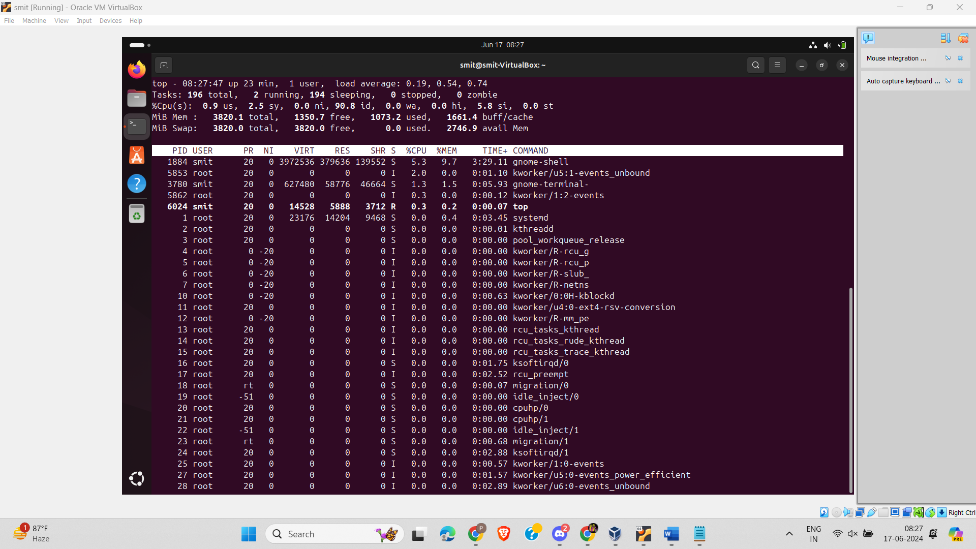

1. Get the snapshot of active processes in your system.

Ps

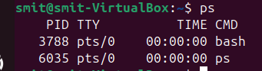

1. Log in as some another user (Maybe you can log in as user, which you have created for previous activity)

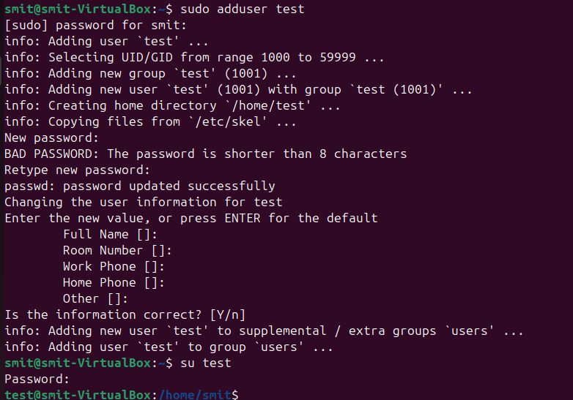

1. Now create background process. (e.g. sleep 50 &)
2. Now observe currently active jobs and note their user id. Can you see some change, if so, describe it with screenshot.

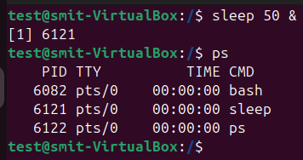

Here the ld number for process which started by test user is starting with 61 and for smit user it starting with 60.

1. Create one background process “sleep 500 &”
2. Switch back to your regular user
3. Now send “SIGKILL” signal to the process, created in step-6.

Sudo kill -sigkill pid

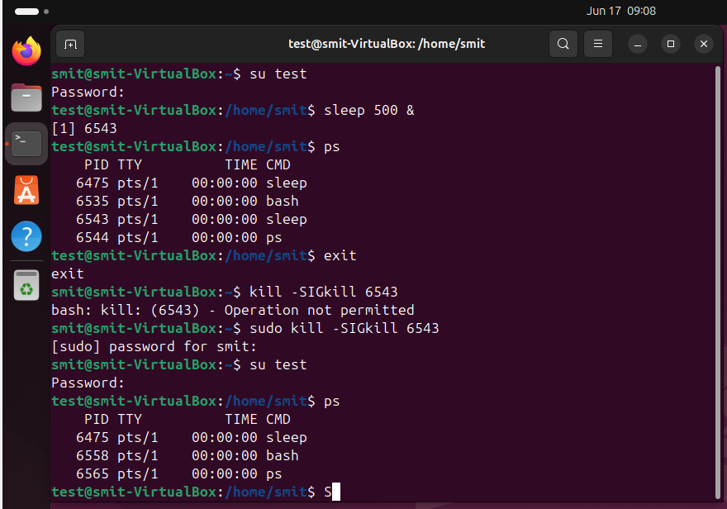

1. Create one background process “sleep 100 &”
2. Stop that process, created in above step-9.
3. Resume that process, stopped in above step – 10.

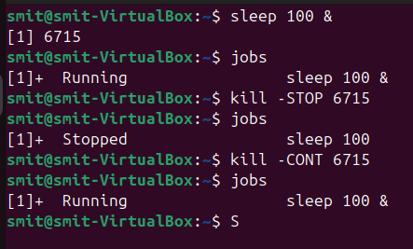

1. Create same process (from step-9), stop that process (followed by step-10) then switch user to some other user and resume that process.
2. Switch back to your regular user and kill that process.

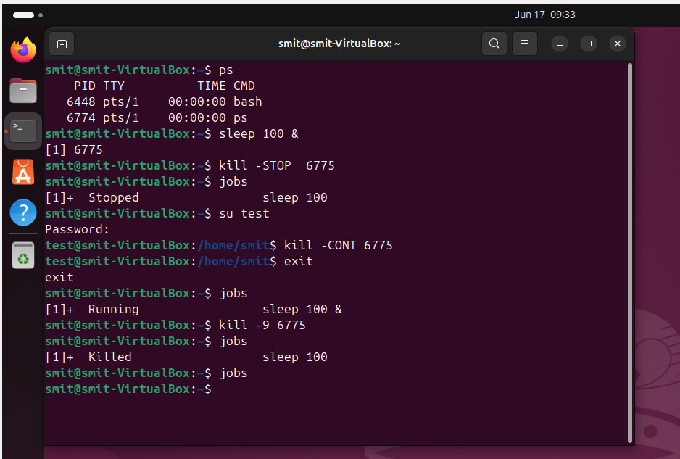

**Paste your cheat sheet here:**

top - display Linux processes

ps

sleep 20 &

ps j

kill pid

man 7 signal

sleep 48

jobs

ps aux

fg

lscpu

system

man systemctl

**Write conclusion in few lines for above activity and today’s session:**

Learn about process management ,process, how process is working with different type of user .