Setting up your Development Environment : Git and Node

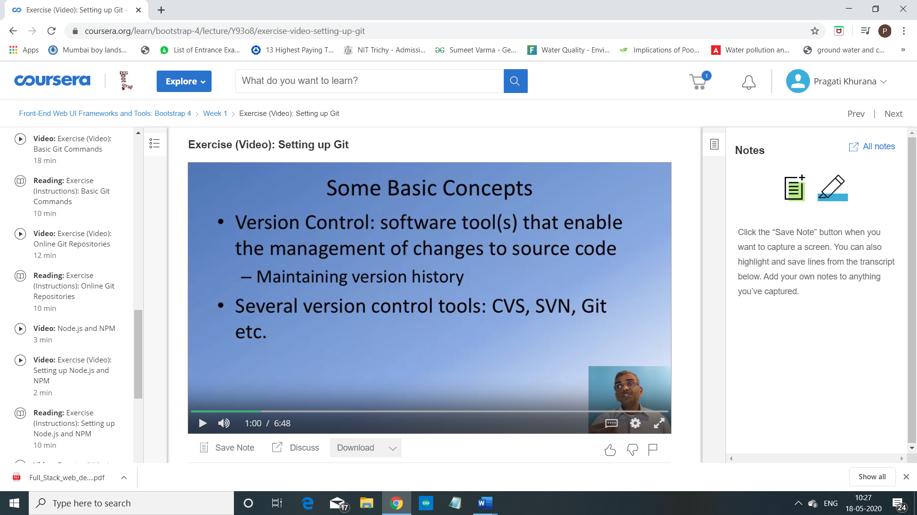

Git is, as I said, a version control system.

This is a software tool that enables us for

the management of changes to source code and maintaining your version history.

So as your source code evolves,

you will be able to check in the code at different points of times so

that you can always have a way of rolling back to a previous version,

in case your updates to the code doesn't work correctly.

There are various version control systems that are in use in the real world,

including CVS, SVN, and

Git being a very popular mechanism for version control these days.

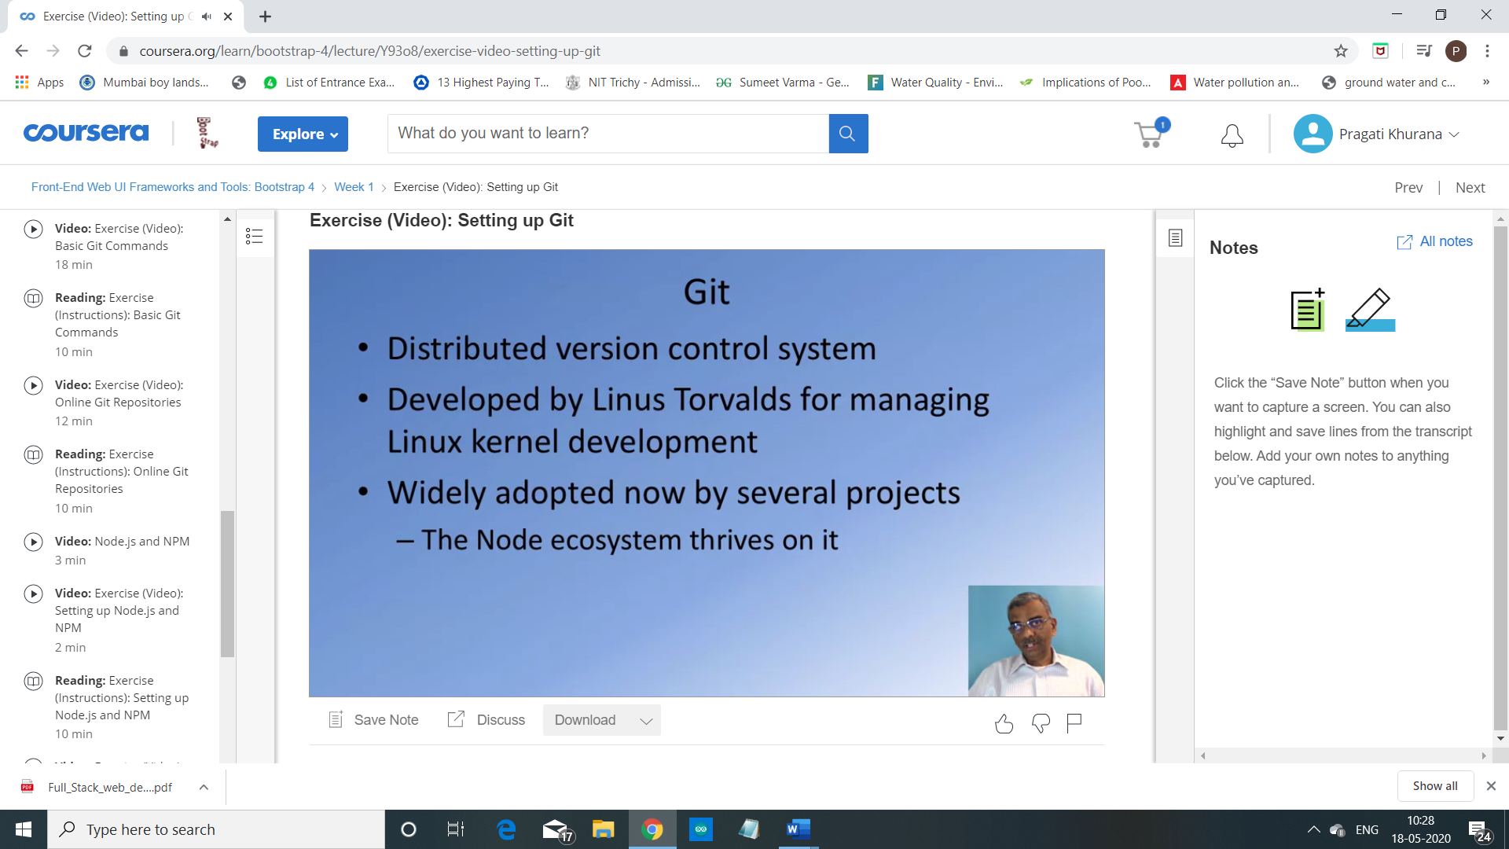

Where did Git originate?

Git was designed by Linus Torvalds, the person behind the Linux Operating System.

Git was designed as a version control system and distributed version control

system for use in Linux kernel development and

it has seen much wider deployment in the real world, these days.

That node ecosystem is very much tied into Git and

that is the reason why we need Git for this specialization.

Setting up of Git :

1 : go to git-scm.com

2 : download git (according to your platform)

For more details…

1 : go to documentation (on the same site)

2 : go to book pro git

3. go to chapter – 1.5 Installing Git

Configuring Git :

To check if its install = in command prompt type

* git --version

Configure identity parameter, username and email address

* git config --global user.name “Pragati Khurana”

To configure email

* git config --global user.email [pragatikhurana07@gmail.com](mailto:pragatikhurana07@gmail.com)

And to insure that this information has been configured

* git config --list

2. Basic Git Commands

Objectives and Outcomes

In this exercise you will get familiar with some basic Git commands. At the end of this exercise you will be able to:

* Set up a folder as a Git repository
* Perform basic Git operations on your Git repository

Basic Git Commands

* At a convenient location on your computer, create a folder named **git-test**.
* Open this git-test folder in your favorite editor.
* Add a file named *index.html* to this folder, and add the following HTML code to this file:

<!DOCTYPE html>

<html>

<head></head>

<body>

<h1>This is a Header</h1>

</body>

</html>

Initializing the folder as a Git repository

* Go to the git-test folder in your cmd window/terminal and type the following at the prompt to initialize the folder as a Git repository:
* git init

Checking your Git repository status

* Type the following at the prompt to check your Git repository's status:
* git status

Adding files to the staging area

* To add files to the staging area of your Git repository, type:
* git add .

Commiting to the Git repository

* To commit the current staging area to your Git repository, type:
* git commit -m “first commit”

Checking the log of Git commits

* To check the log of the commits to your Git repository, type
* git log –oneline

Now, modify the*index.html*file as follows:

<!DOCTYPE html>

<html>

<head></head>

<body>

<h1>This is a Header</h1>

<p>This is a paragraph</p>

</body>

</html>

* Add a sub-folder named **templates** to your **git-test** folder, and then add a file named *test.html* to the templates folder. Then set the contents of this file to be the same as the *index.html* file above.
* Then check the status and add all the files to the staging area.
* Then do the second commit to your repository
* Now, modify the*index.html*file as follows:

<!DOCTYPE html>

<html>

<head></head>

<body>

<h1>This is a Header</h1>

<p>This is a paragraph</p>

<p>This is a second paragraph</p>

</body>

</html>

* Now add the modified index.html file to the staging area and then do a third commit.

Checking out a file from an earlier commit

* To check out the index.html from the second commit, find the number of the second commit using the git log, and then type the following at the prompt:
* git checkout <second commit's number> index.html

Resetting the Git repository

* To discard the effect of the previous operation and restore index.html to its state at the end of the third commit, type:
* git reset HEAD index.html

Then type the following at the prompt:

* git checkout -- index.html
* You can also use *git reset* to reset the staging area to the last commit without disturbing the working directory.

Conclusions

At the end of this exercise you should have learnt some basic Git commands. Experiment with these commands until you fully understand how to use Git.