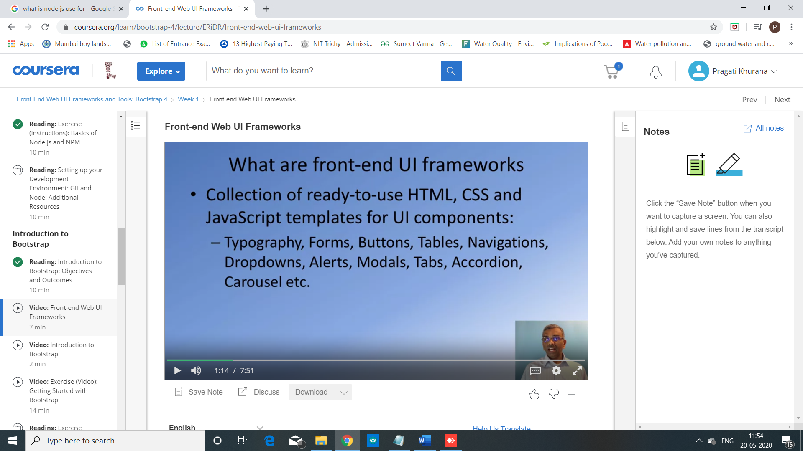

So what are front-end web UI frameworks?

So, here, a front-end web UI framework

may define a bunch of CSS classes that

will enable us to include components like Buttons,

Tables, Navigation bars, Dropdowns, Alerts,

Modals, Tabs, Accordions and many more.

And quickly enable us to design and implement a website.

So this is what a front-end web UI framework accomplishes.

It is a collection of all these components.

Not only that, it gives you a method of defining

consistent typography that you can use for your entire website design.

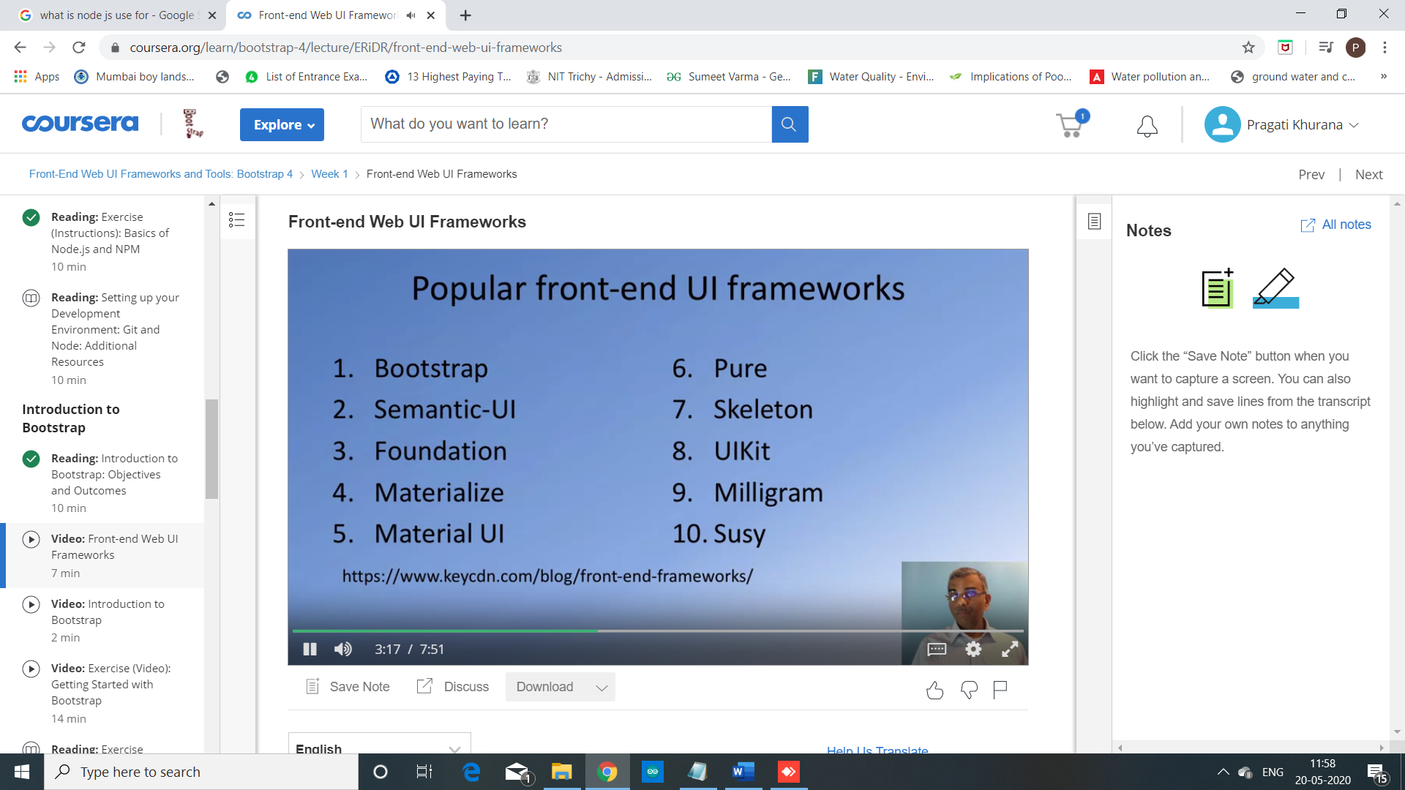

why would you want to use front-end web UI frameworks?

First and foremost, they provide you with a consistent way of designing websites.

And, most of these front-end frameworks

support what is called as responsive web design.

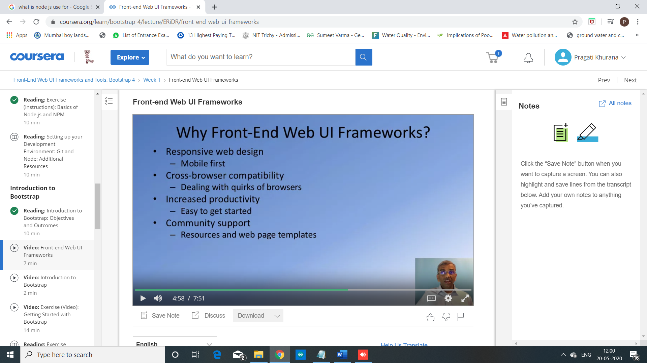

What is bootstrap?

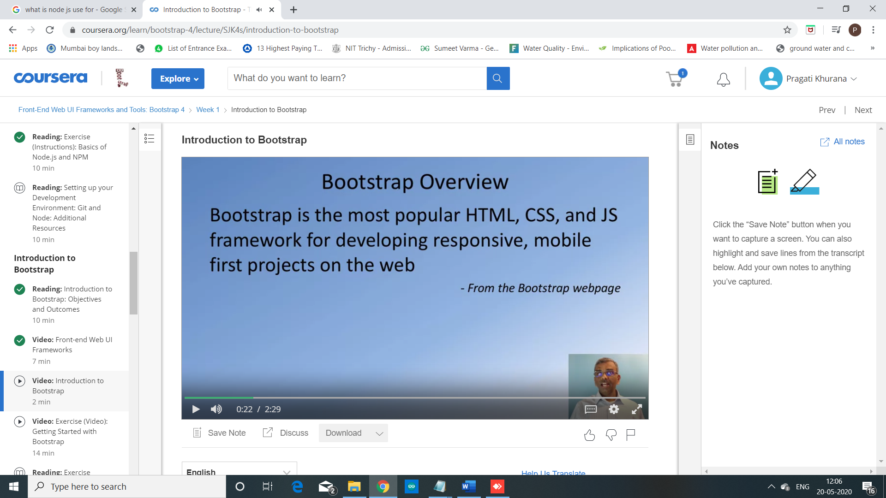

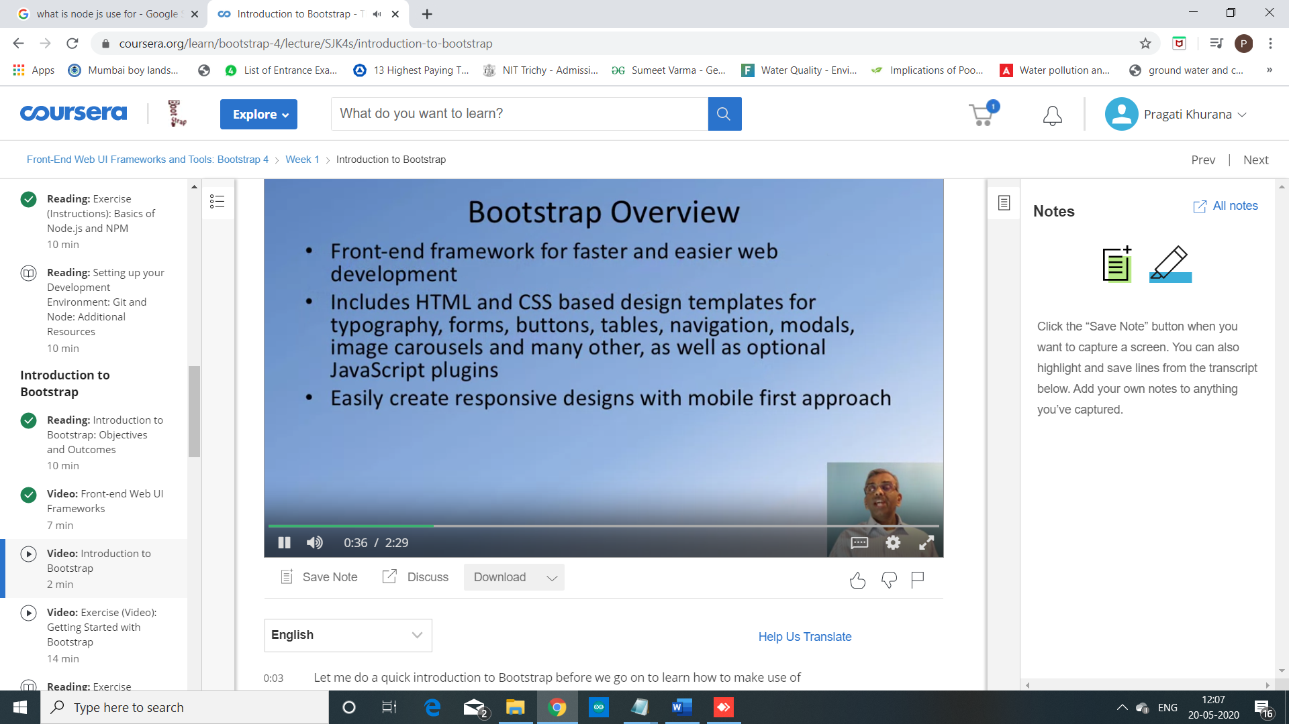

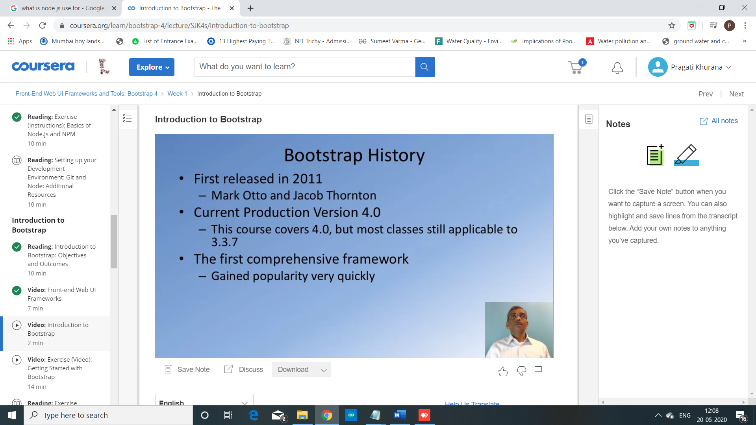

Bootstrap originated around 2011.

It was created by these two people from Twitter.

Hence, you might often hear people talking about Bootstrap as Twitter Bootstrap.

Mark Otto and Jacob Thornton from Twitter designed

Bootstrap for their own internal use and then ended up releasing

it for the rest of the web development community to use for consistent website design.