Responsive design and bootstrap grid system

The mobile first approach instead looks at designing a website for

a mobile device first.

So consider how you would satisfy the screen constraints of your mobile device.

And then as your screen size expands, you would automatically

start an app to your website to the larger and larger screen sizes.

Perhaps, you're willing more and more of the content.

So as to take advantage of the increasing screen real estate.

So the same website when seeing on a mobile device might have only

parts of the information being revealed to the user.

But then when rendered on a full fledge desktop it

might show a lot more detail version of the website.

Now this has to be automatically adapted based upon the information

that you get from the device from which your website is being viewed.

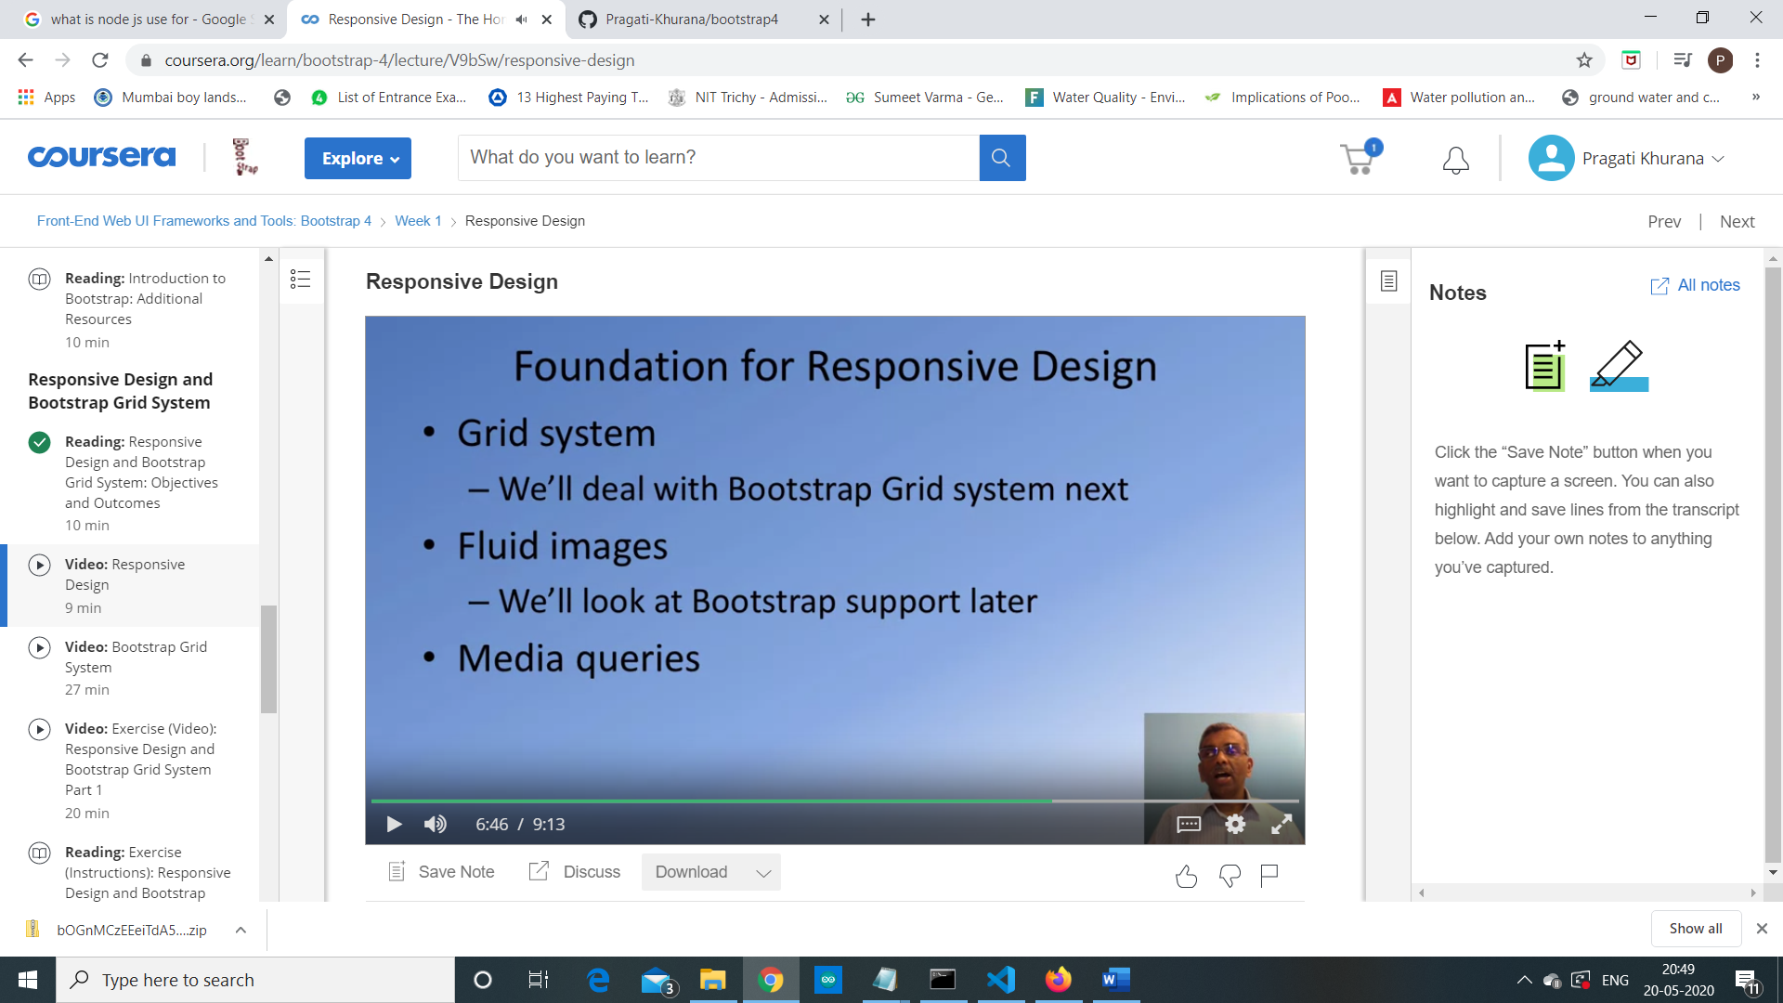

Yeah, how do we go by doing responsive web design?

So there are several concepts that are built in to your frame time

web UI frameworks that come to the aid when you need to do responsive web design.

First and foremost is what is called is a Grid system?

We're going to look at the Bootstrap's Grid system in more detail in the next

lecture.

So that we'll understand exactly how we can leverage that to be able to do

responsive web design.

The second aspect is fluid images, so that your images that you include in your

website will automatically adapt itself to the screen size.

And the third part is what is called a CSS media queries from your CSS code.

You can query the size of the media and then appropriately adjust your CSS classes

to fit the size of the device's screen.

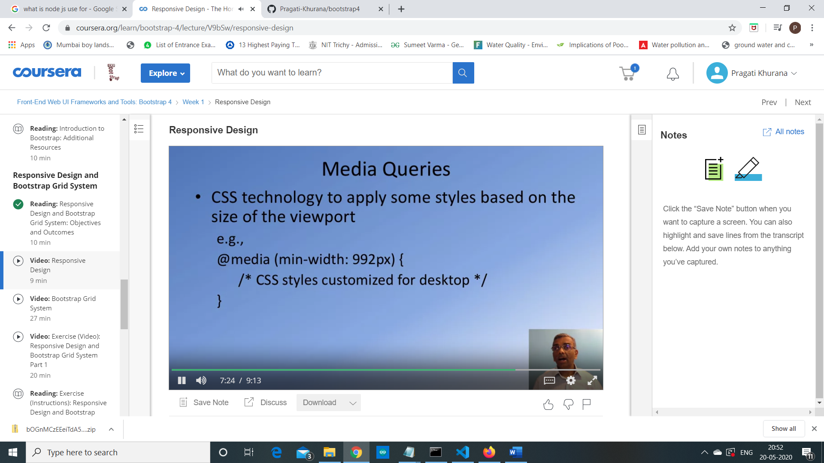

Now how do media queries work?

Let's look at that next.

Media queries are supported in CSS like this.

So the technology allows you to do a media query to specify the minimum width

of the screen under which this particular set of CSS classes will be active.

So this would be specified in your CSS file as @media, and

then within bracket, you specify for example, min-width.

There are a lot more options to the media queries than what I'm showing here.

This is just one example of how you would build a media query in your CSS code.

