**Veer Narmad South Gujarat University, Surat.**

**M.Sc. (Information Technology) Programme**

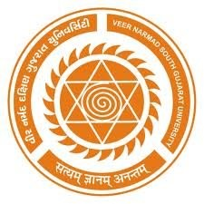

# Project Report

**6th Semester**

**M.Sc. (Information Technology)**

**5 Year Integrated Course**

Year 2018 – 2019

## **“Quick Search”**

|  |  |
| --- | --- |
| **External Guide :**  Mr. Shasank Bansal | **Submitted By :** Dinal Chauhan (010) |
| **Internal Guide :** Dr. Pushpal Desai. |  |

### 

**Credence Technologies.**

208,SNS Arista,opp Safal Square,besides Prime Shopperes,Vesu,Surat.