INFO 7290 Data Warehousing and Business Intelligence

Smit Patil

1. Microsoft SQL Server 2019 Installation Center (To verify that I have installed Microsoft SQL Server 2019).

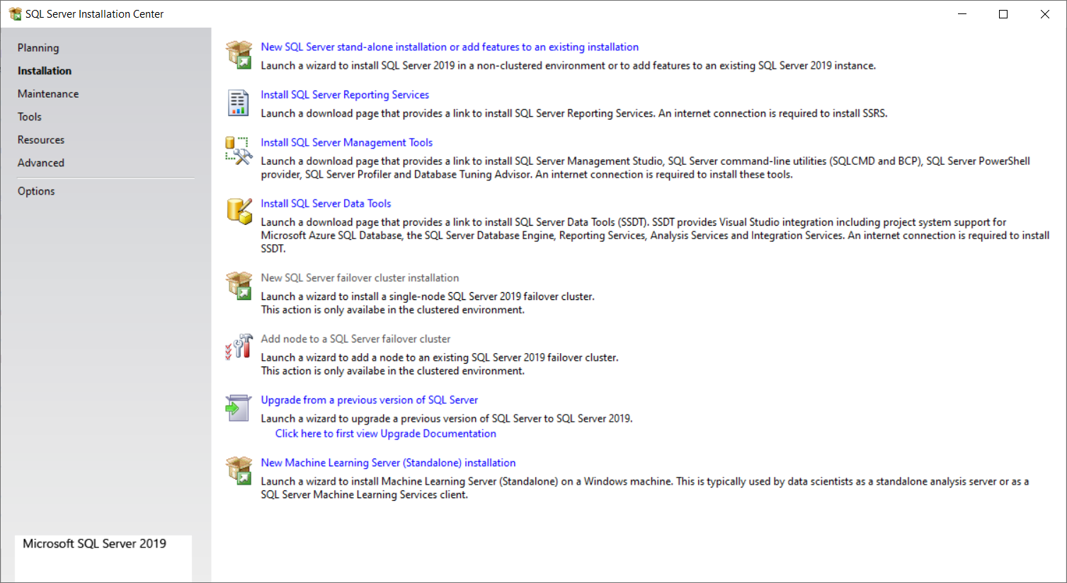

1. Microsoft SQL Server Management Studio (SSMS)

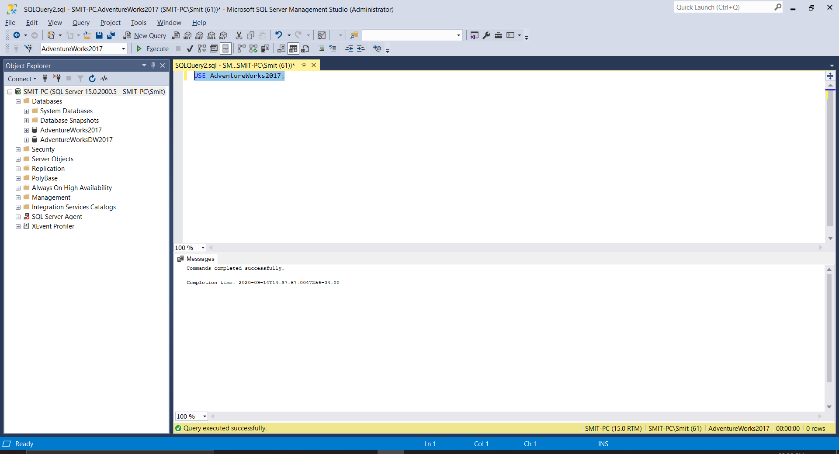

1. Adventure Works 2017 (Both Warehouse and Regular)

1. Visual Studio 2019 with working Integration Services Project

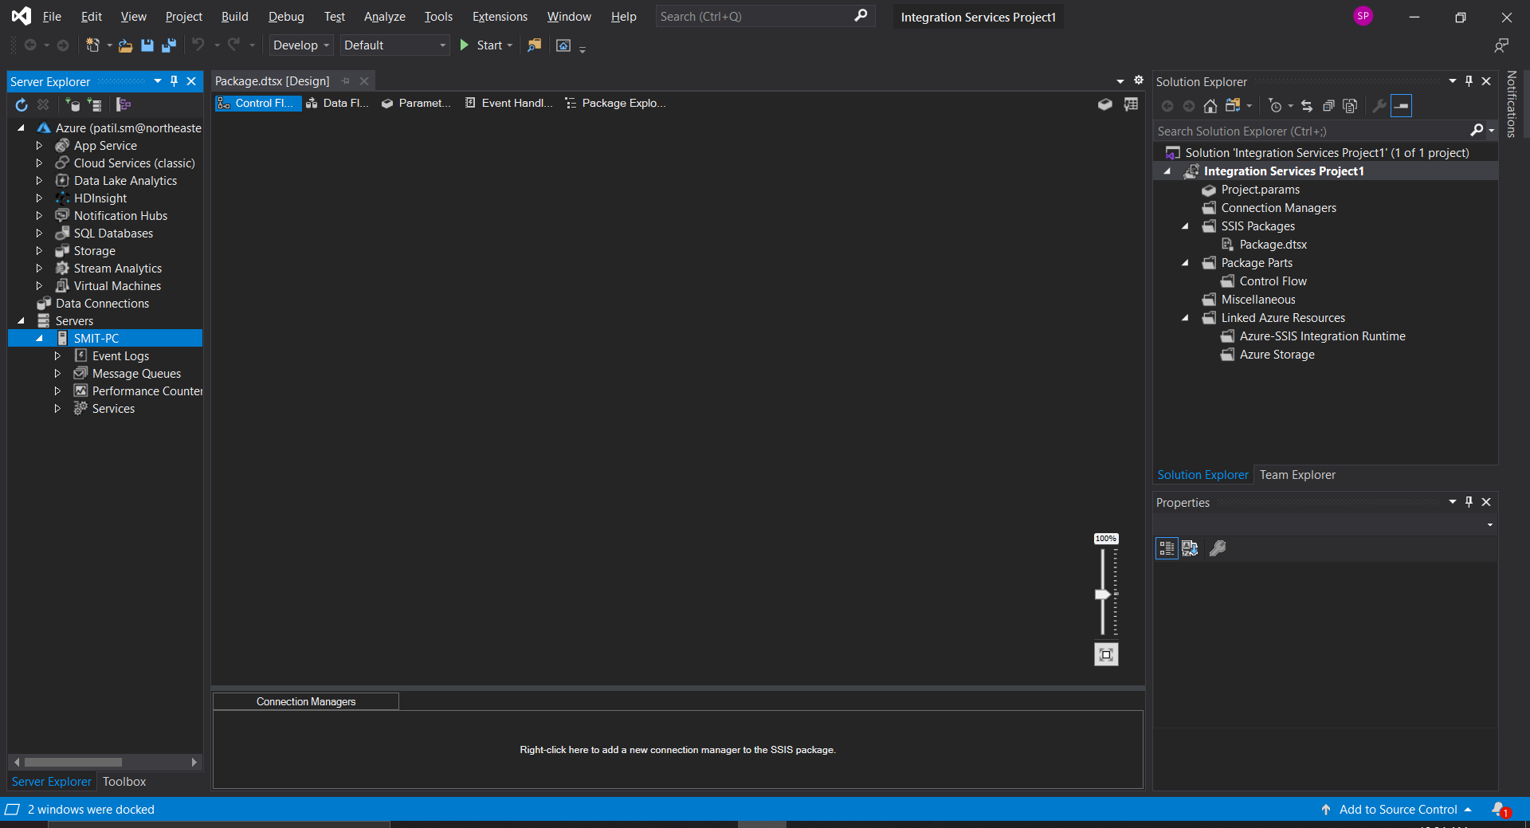

1. SQL Server Data Tools installation verification

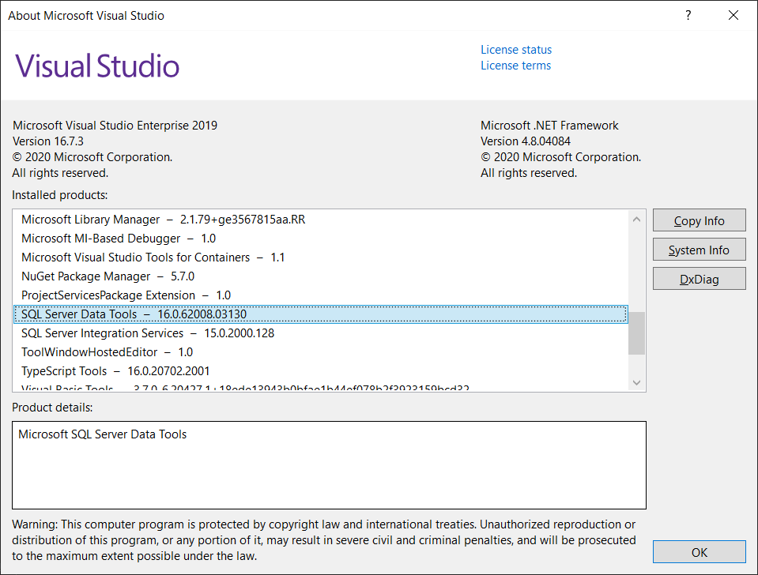 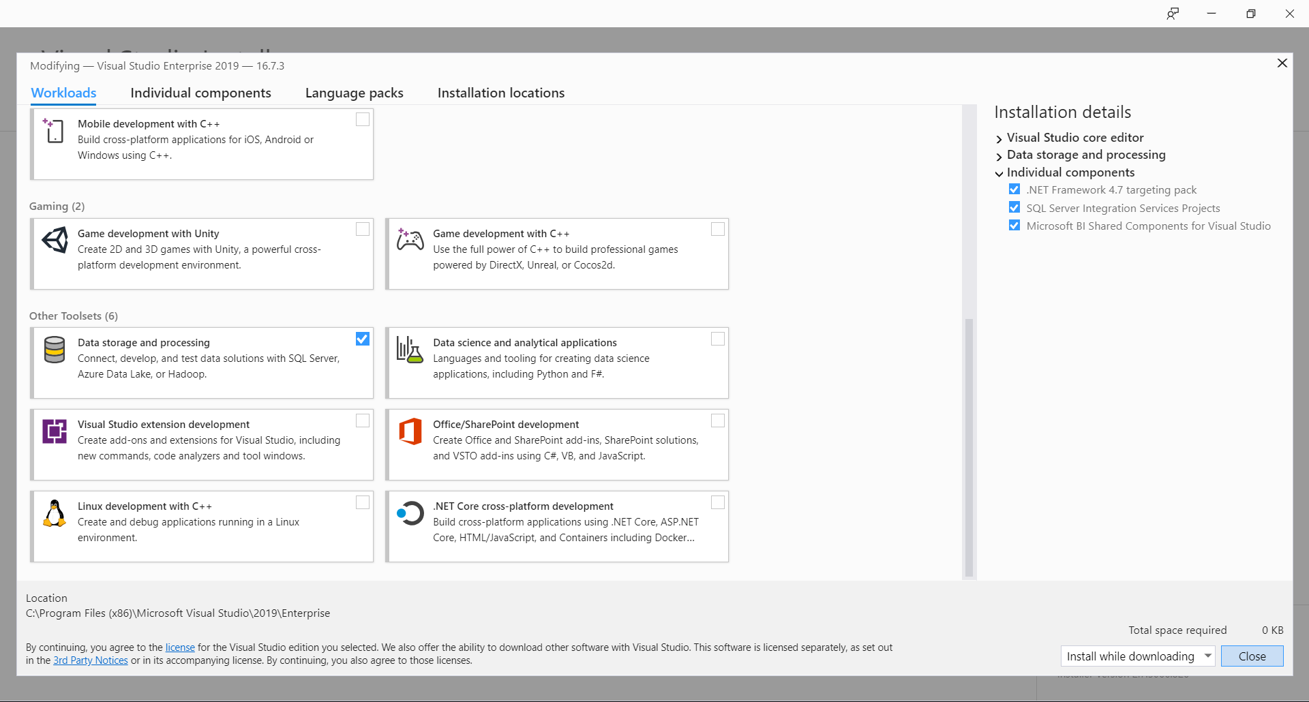

1. ER/Studio Data Architect

