HW07a - SSIS Staging

Smit Patil

1. Successful working of both the Data Flow task in the Control Flow

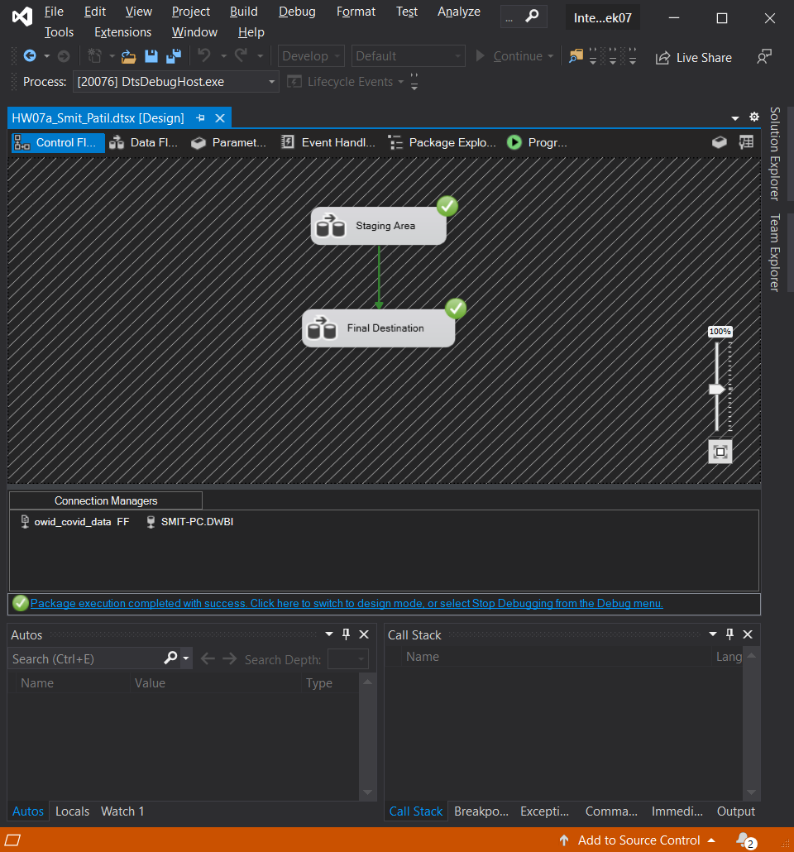

1. The staging table is populated with all the rows

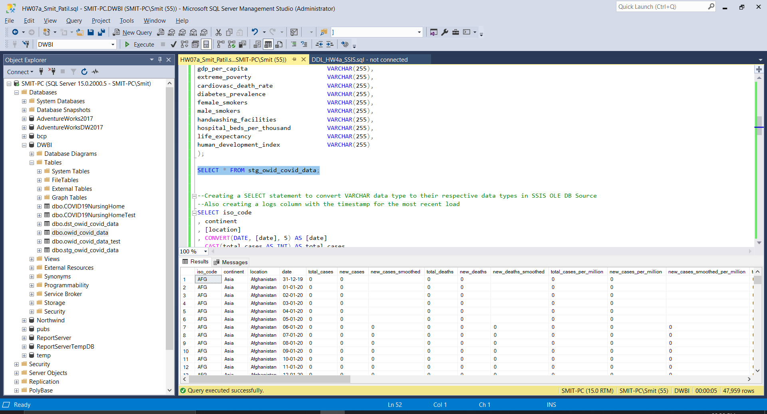

1. The destination table is also populated successfully, including the logs column.

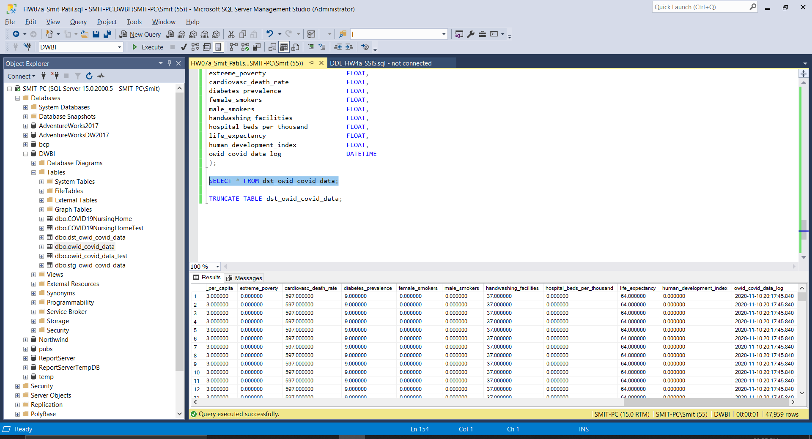

1. Individual screenshot of both the Data Flow tasks for reference.

