HW8a – Error Handling

Smit Patil

1. Loading First File Without Errors into the Staging Area

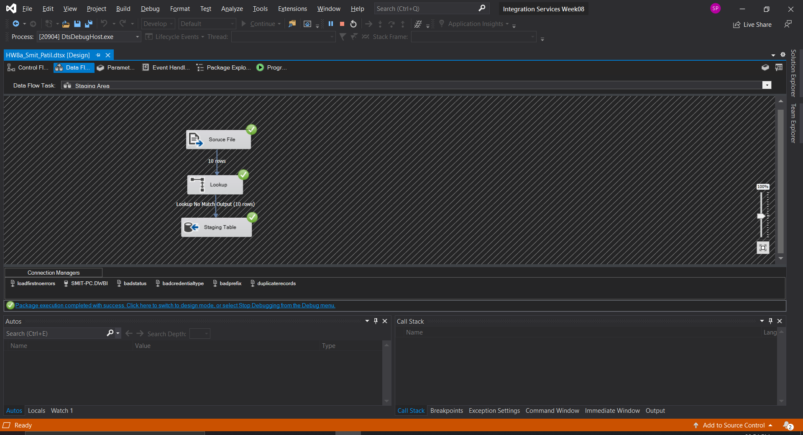

1. Output of the data loaded into the Staging Table

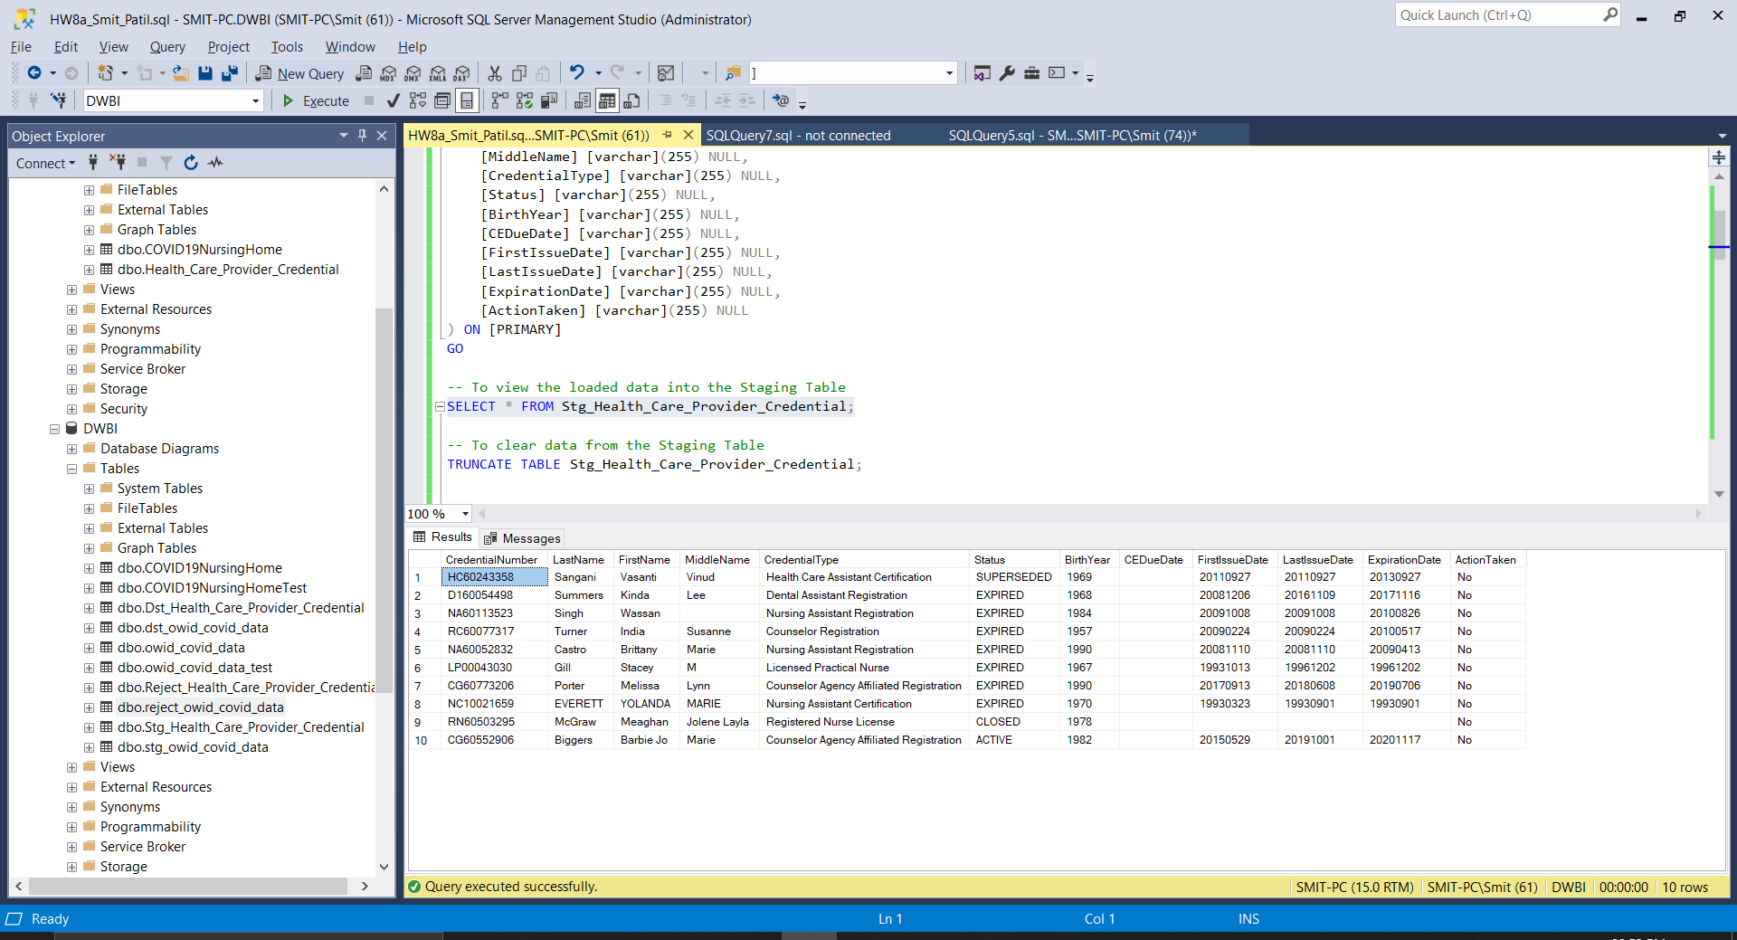

1. Loading the data from Staging Table into Destination Table

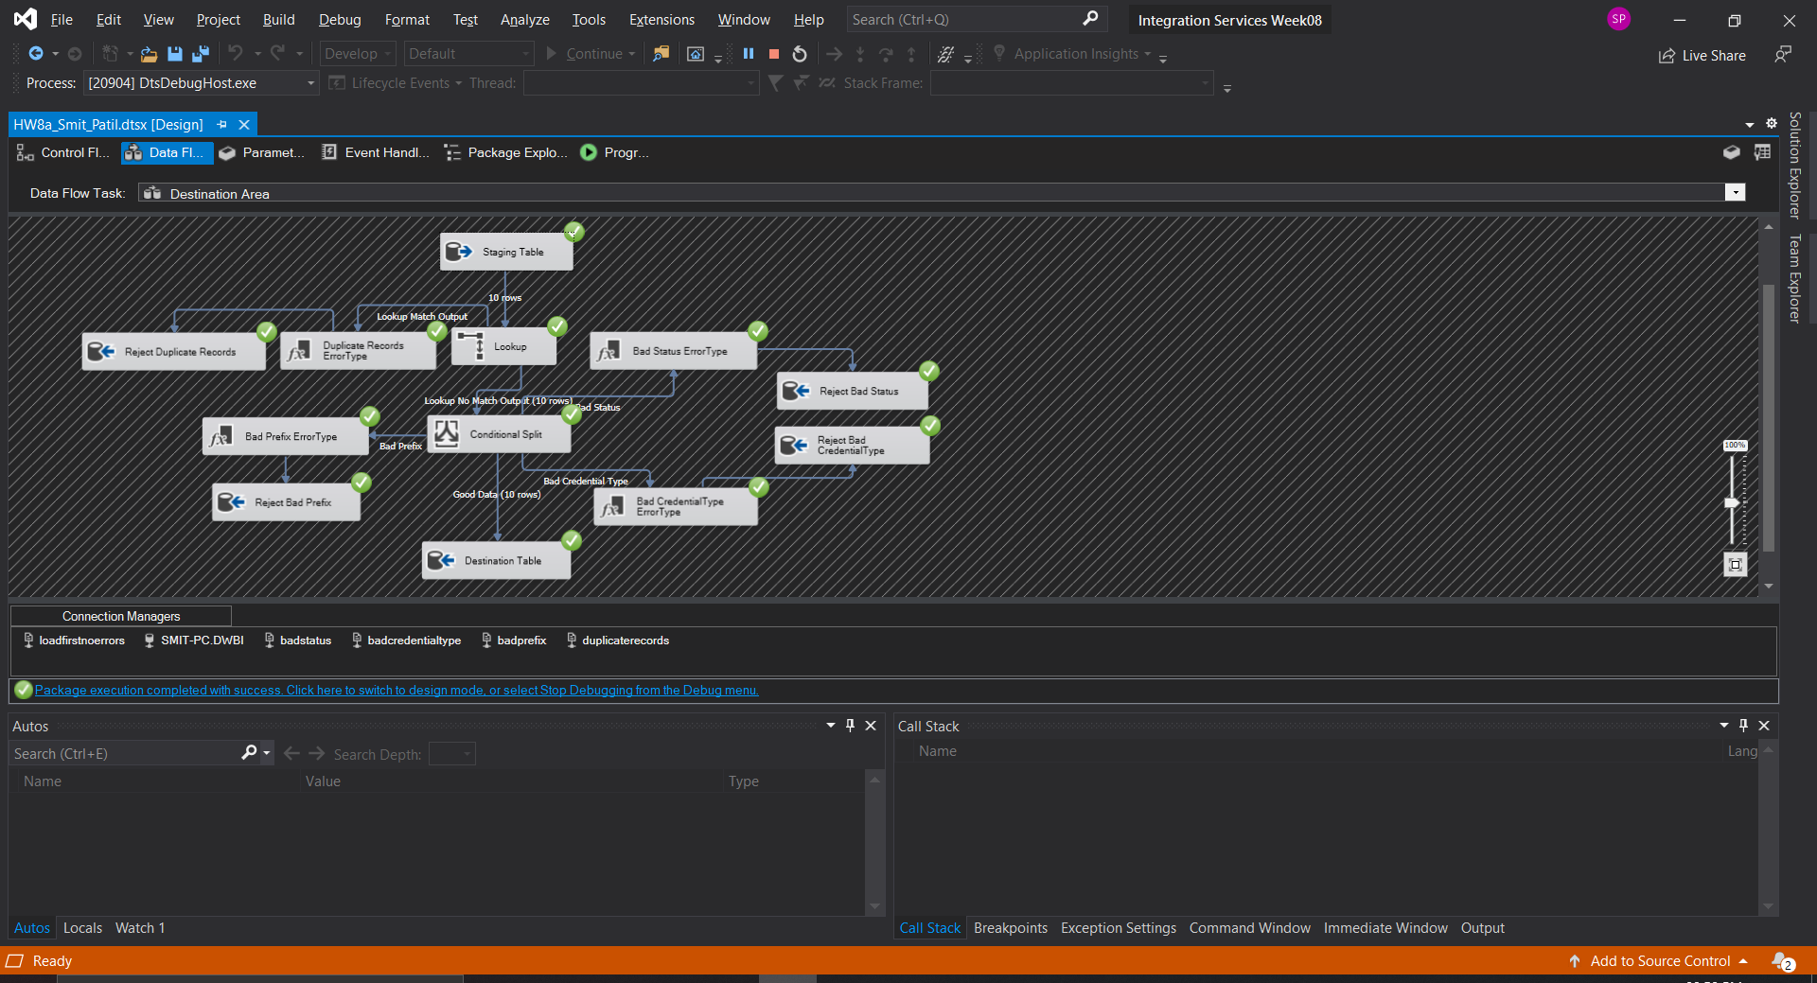

1. Output of Destination Table With all data loaded successfully with proper Data Types

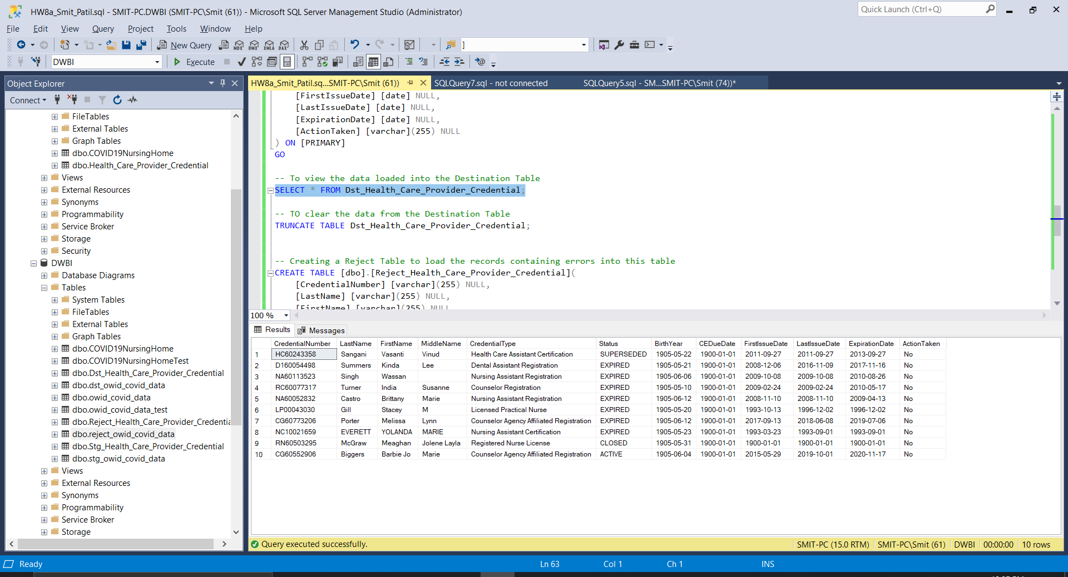

1. Loading Duplicate Records file into the Staging Table

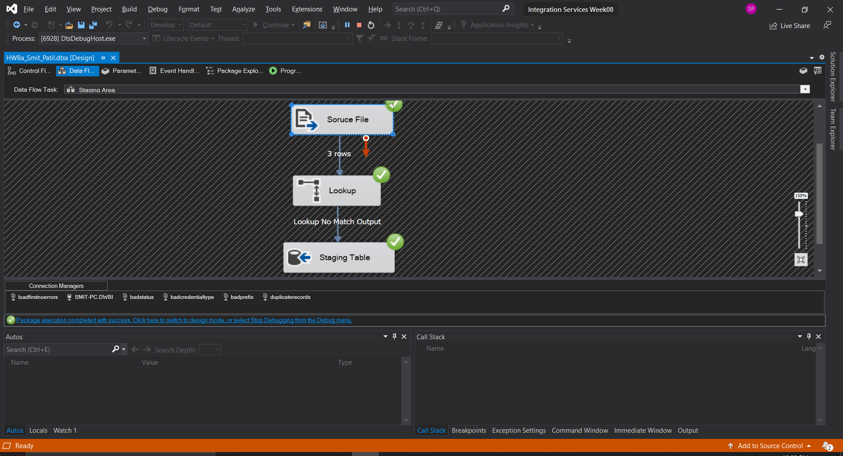

1. Files not loaded as expected, due to Lookup condition.

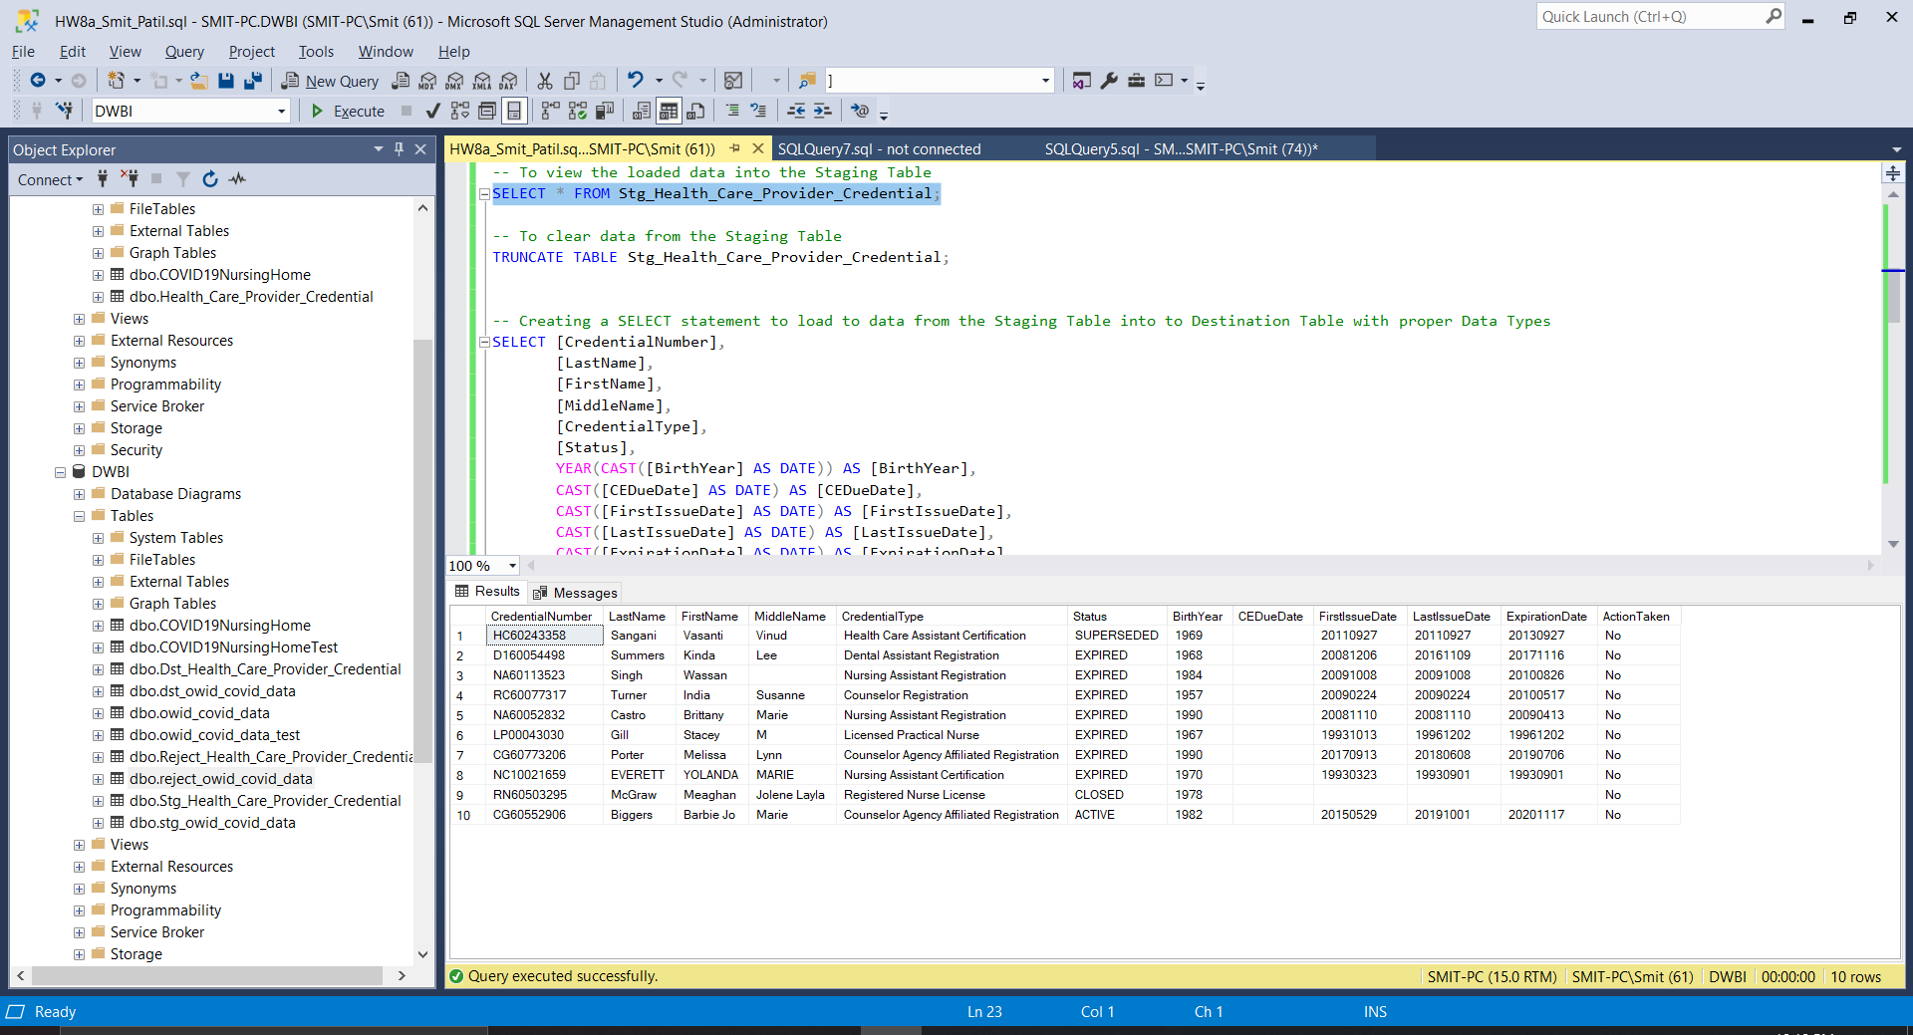

1. The Reject Table is also displaying the rejected duplicate records and their Proper Error Type.

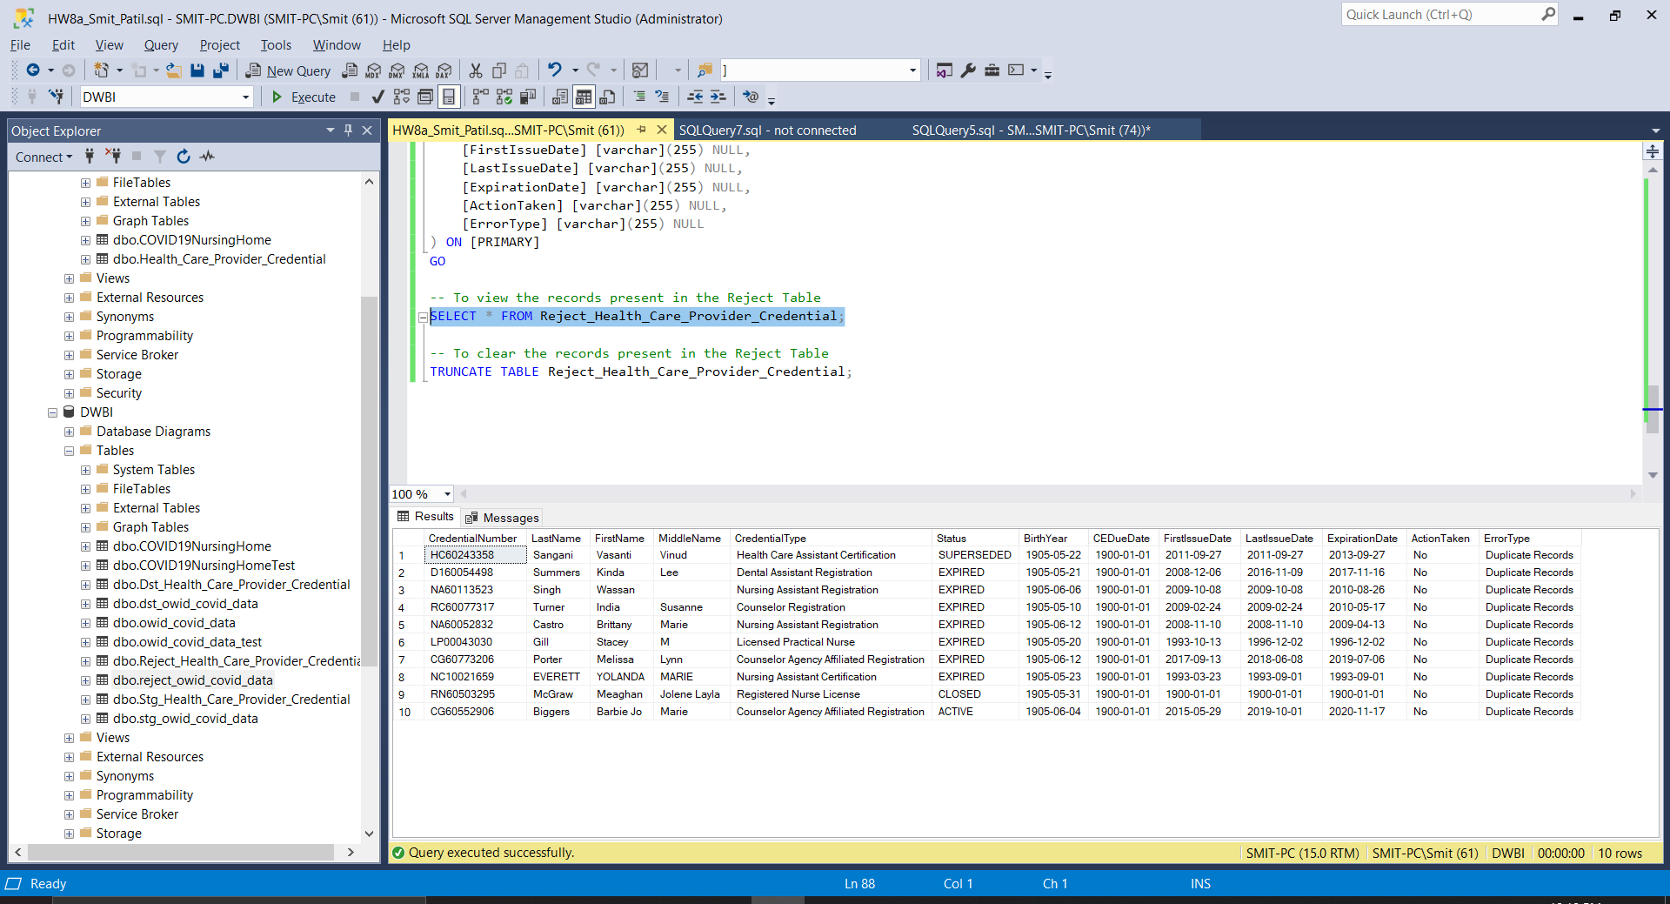

1. Loading Bad Status file into the Tables. We can see that 3 rows were loaded into the Destination table and 1 row was loaded in the Reject Table.

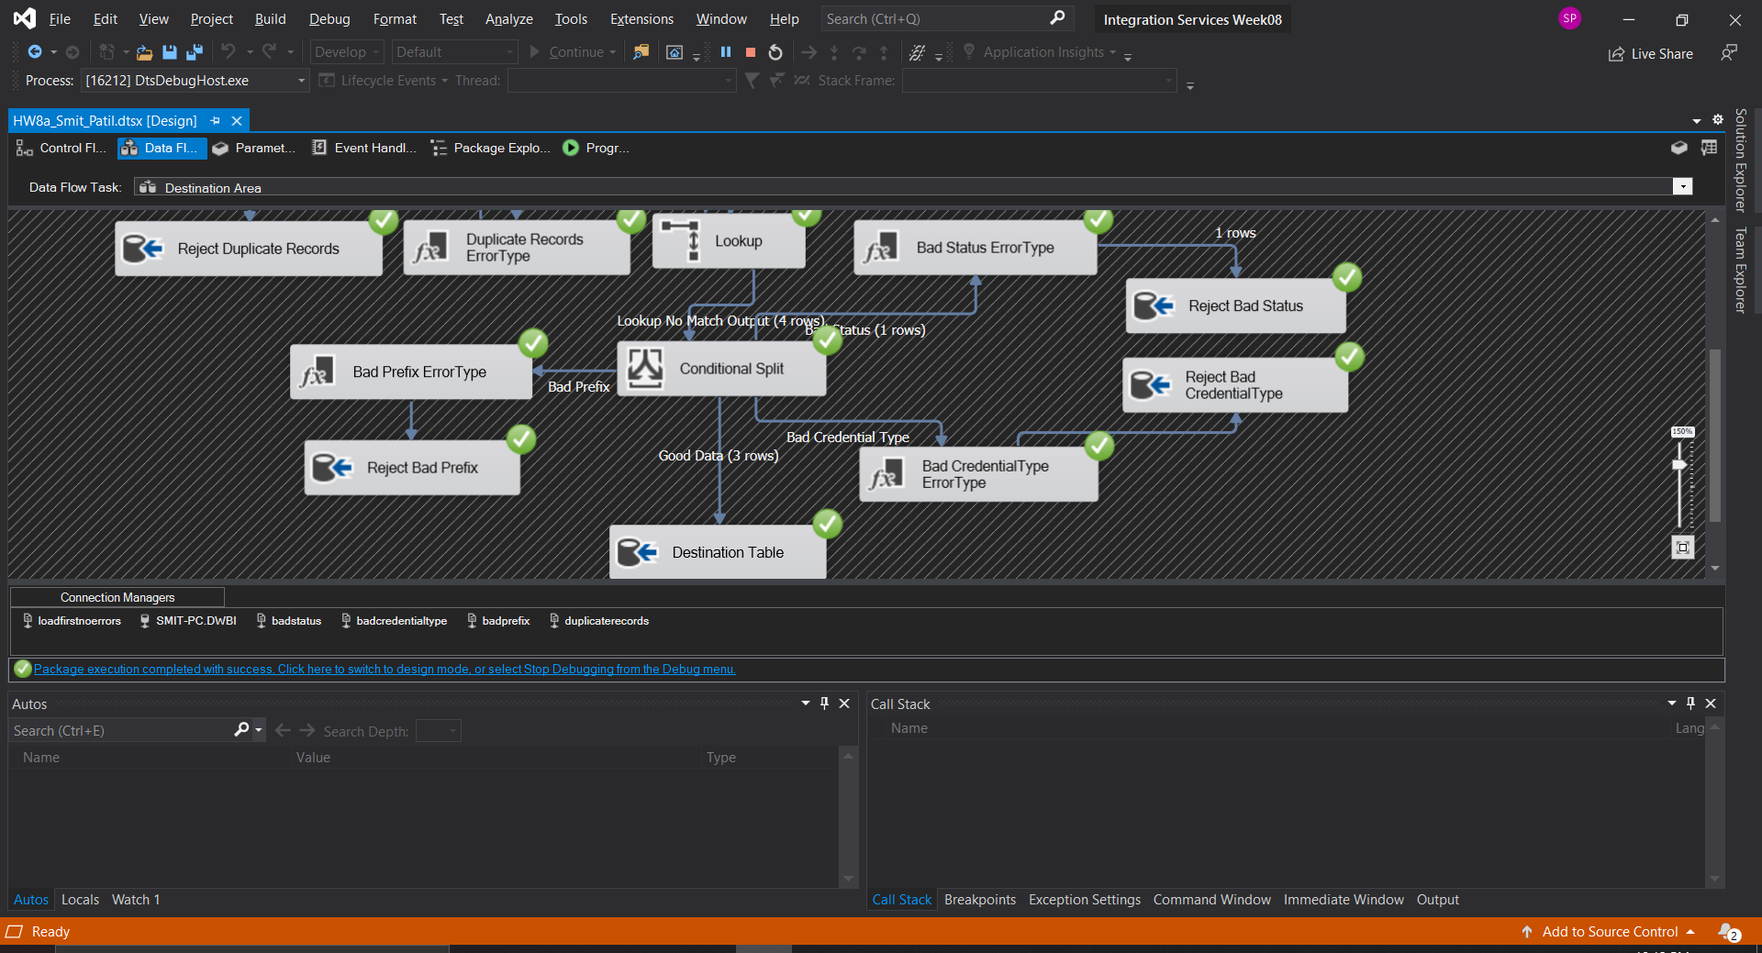

1. Output of the Destination Table with records from the Bad Status File.

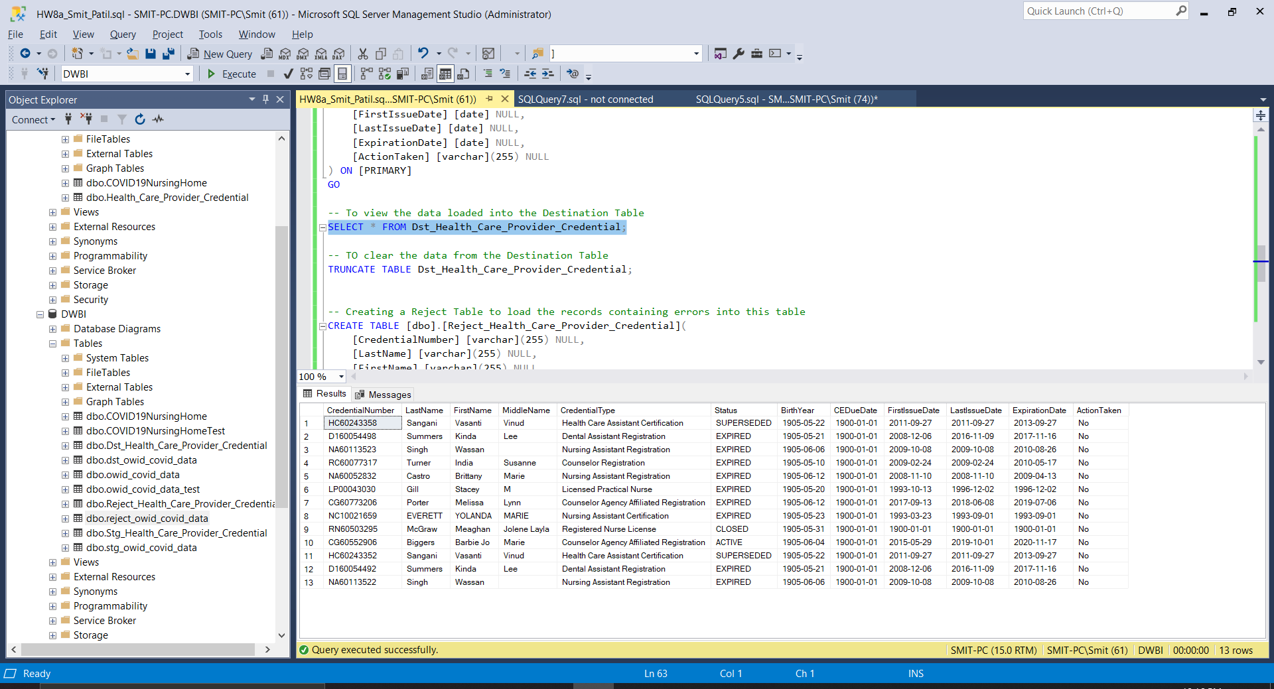

1. Output of the Reject Table with invalid Status values.

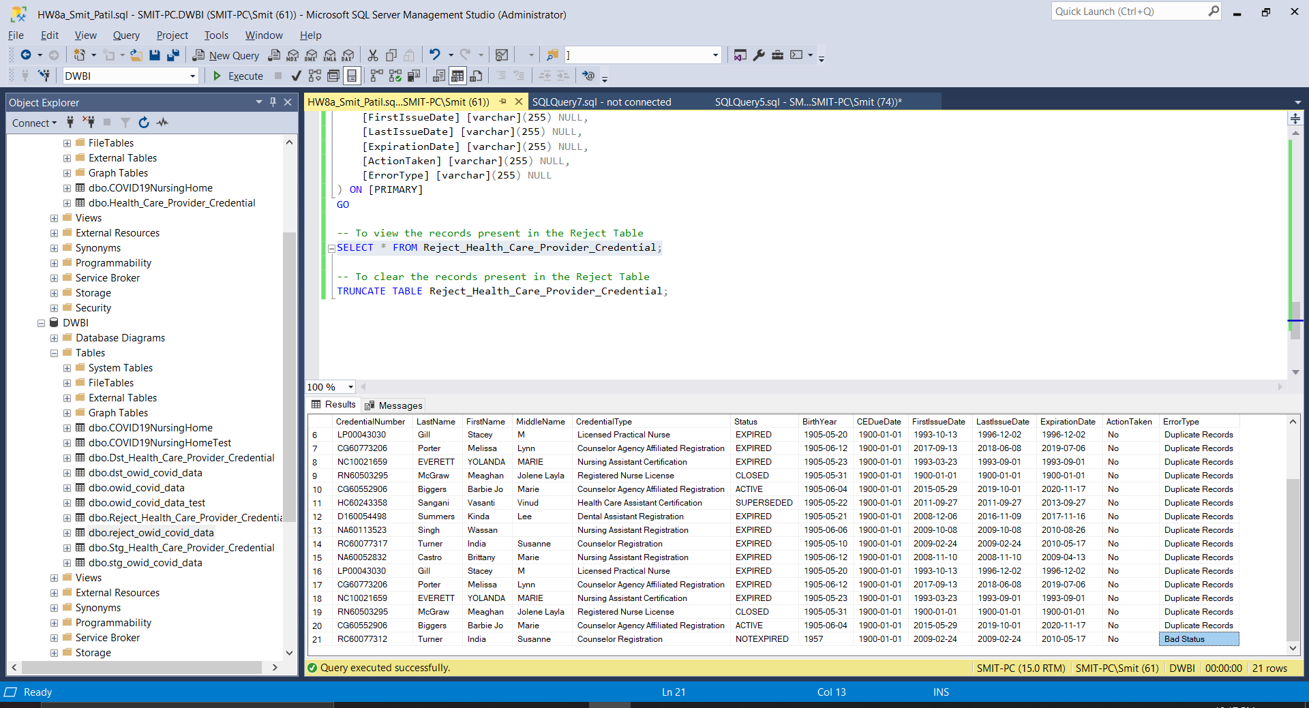

1. Loading Bad Prefix Data into the Staging Table. We can see out of 3 rows only 2 rows were loaded into the Staging Table and 1 Row was rejected due to duplication.

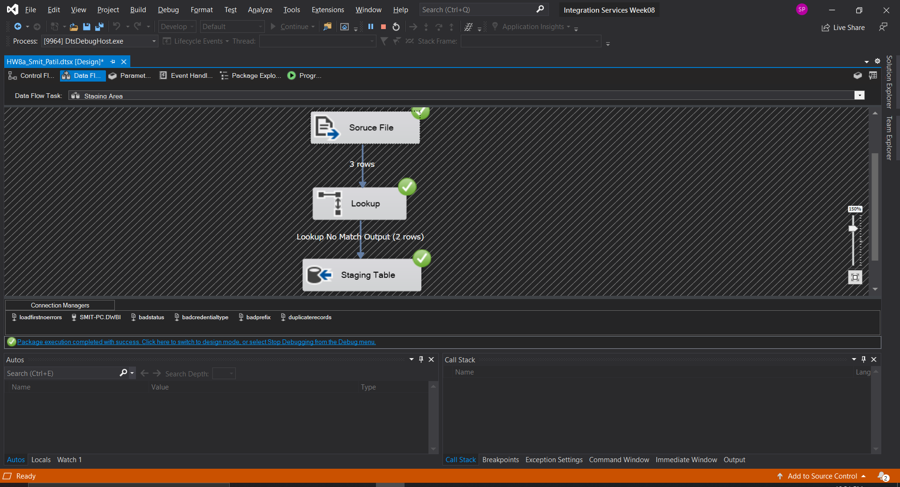

1. Out of the 2 rows from Staging Table only 1 row was loaded into the Destination Table. The other row was rejected due to bad Prefix.

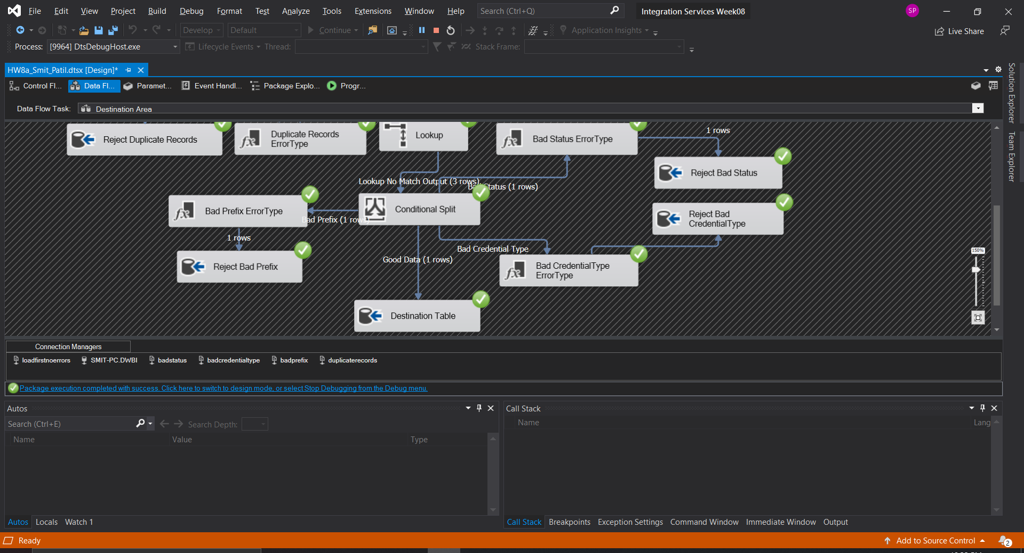

1. Output of the Destination Table.

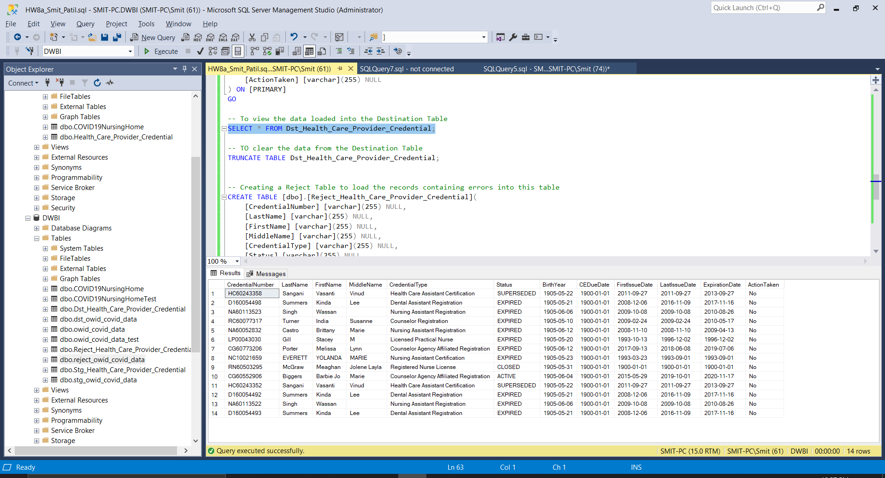

1. Output of the Reject Table with Bad Prefix record.

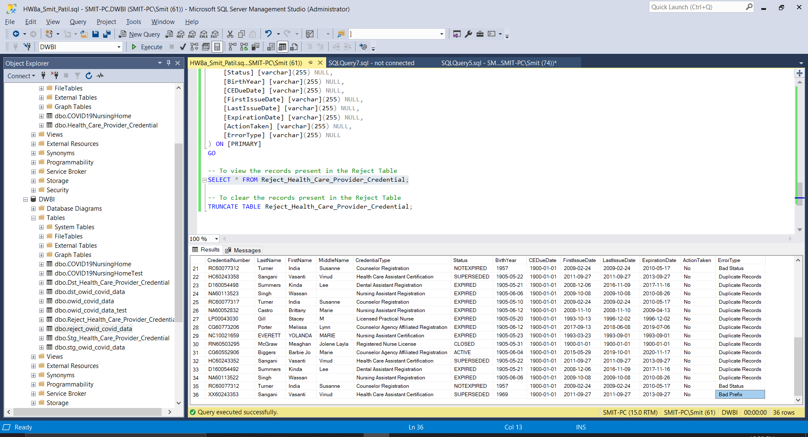

1. Loading Bad Credential Type file into the Tables. We can see that 3 rows were loaded into the Destination table and 1 row was loaded into the Reject Table.

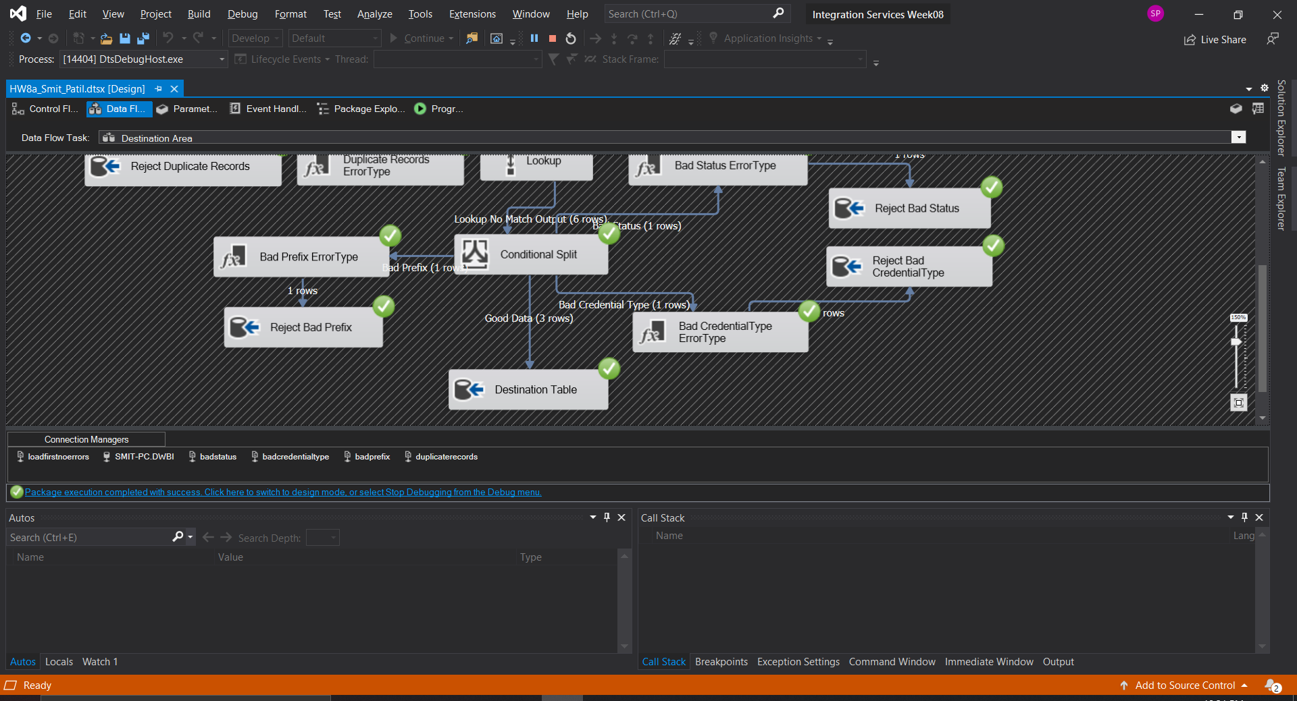

1. Output of the Destination Table.

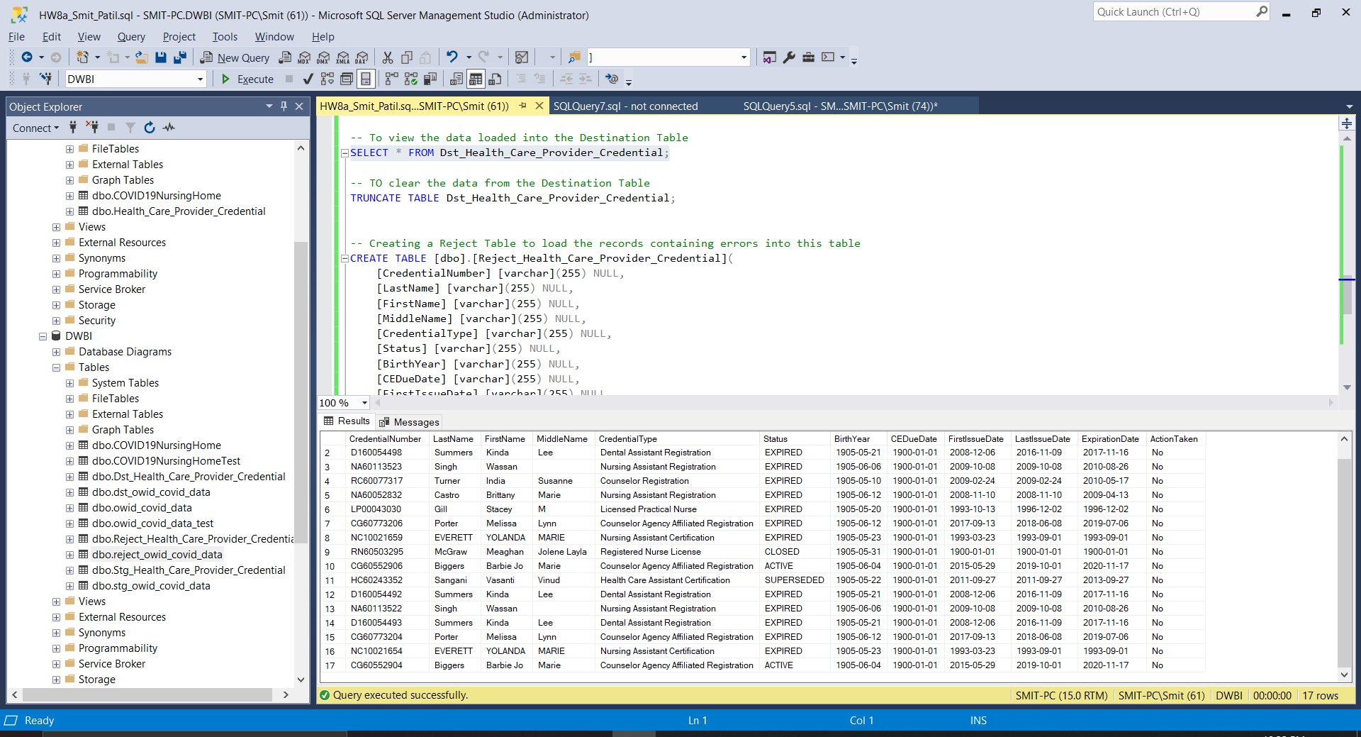

1. Output of the Reject Table with Bad Credential Type Record.

