HW09 – SQL Key Repair

Smit Patil

1. SQL statement to pad keys with “0” to allow them to sort properly

SELECT CASE

WHEN SUBSTRING(id, 4, 5) < 10 THEN LEFT(id, 3) + '0' + SUBSTRING(id, 4, 5)

ELSE id

END AS id

FROM test

ORDER BY 1

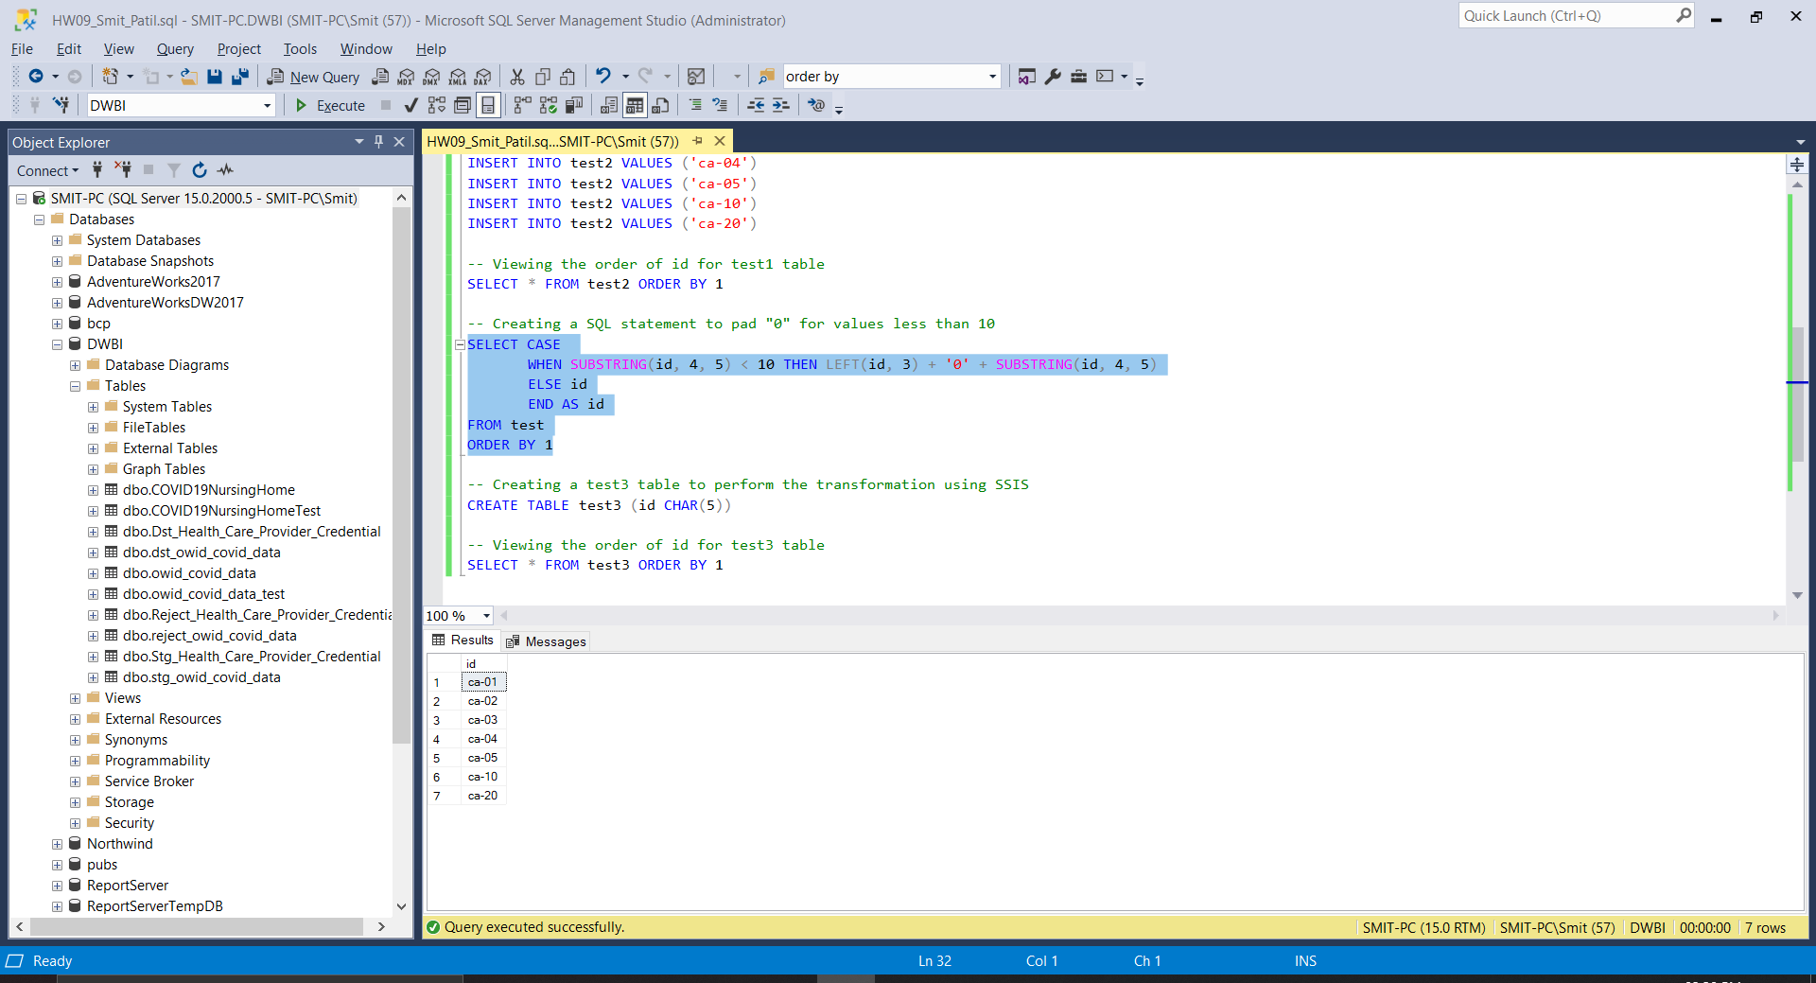

1. SSIS transformation task to pad keys with “0”, running successfully.

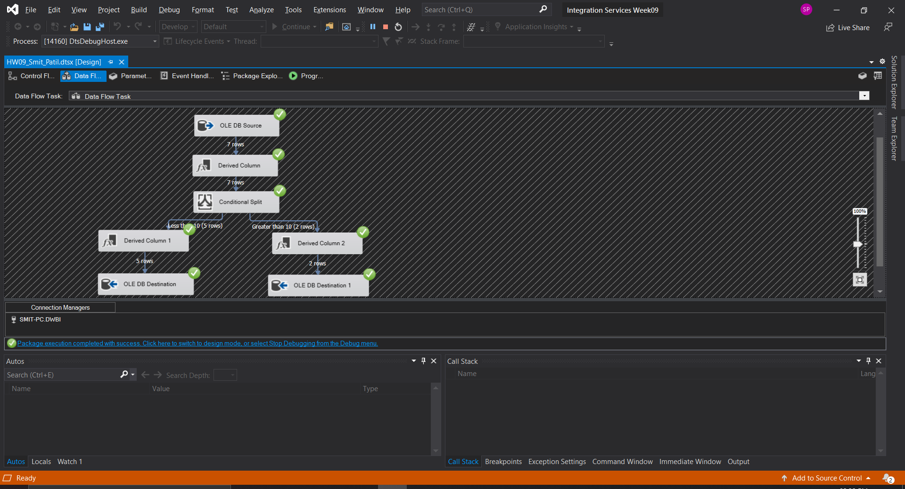

1. The output of the test3 table which was loaded using SSIS. All the required keys were padded and are appropriately sorted.

