HW09 – SCD Processing

Smit Patil

1. Successful loading of the rows in the Staging Table

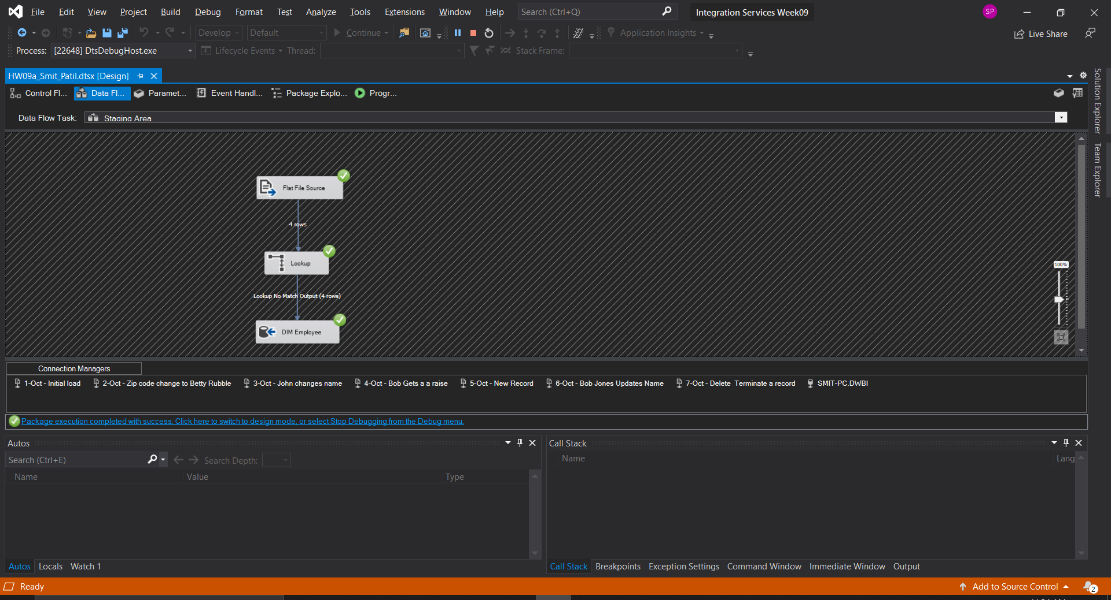

1. Successful loading of the rows in the Employee Dimension Table

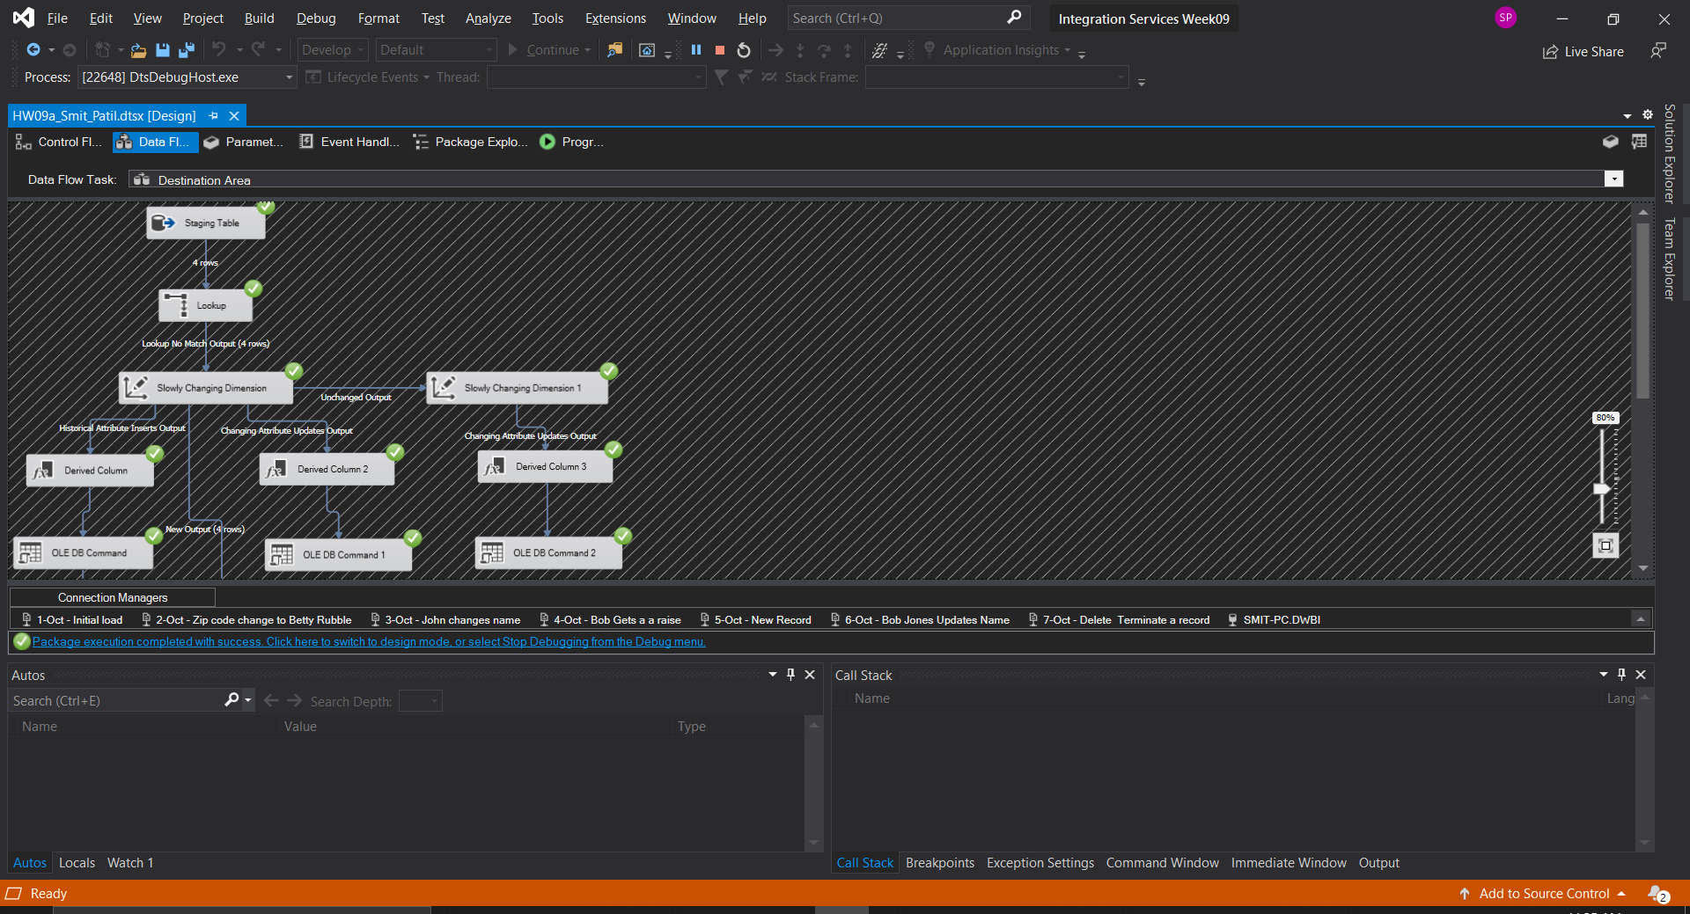

1. Initial Load

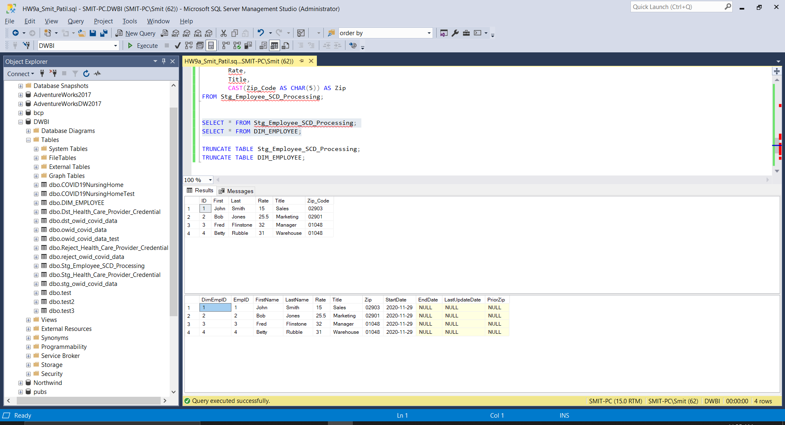

1. Zip code change to Betty Rubble

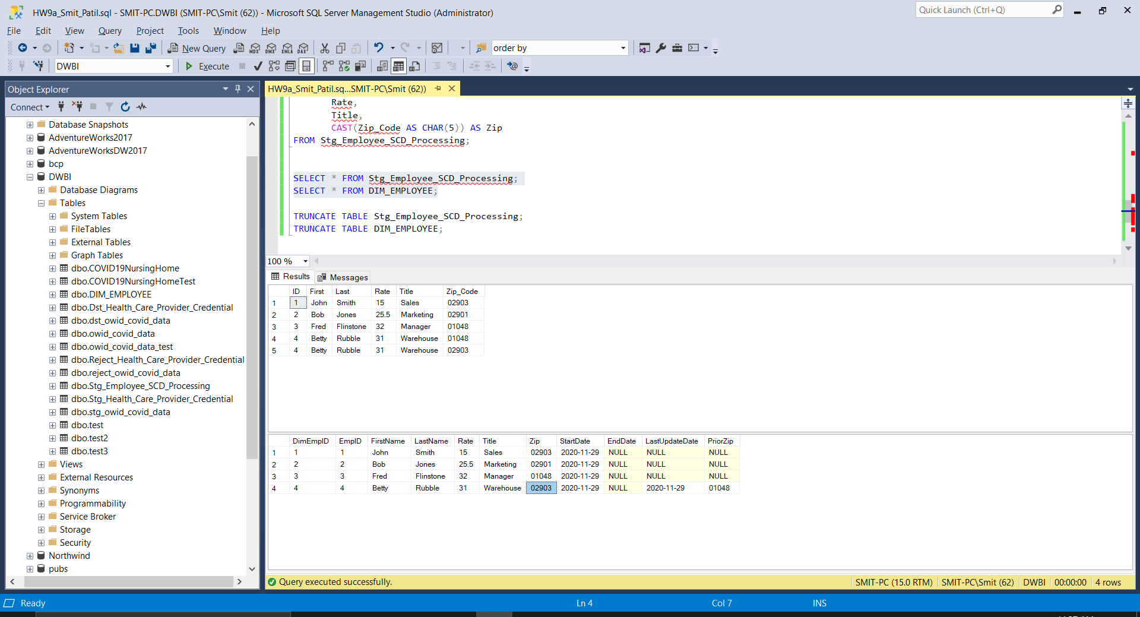

1. John changes name

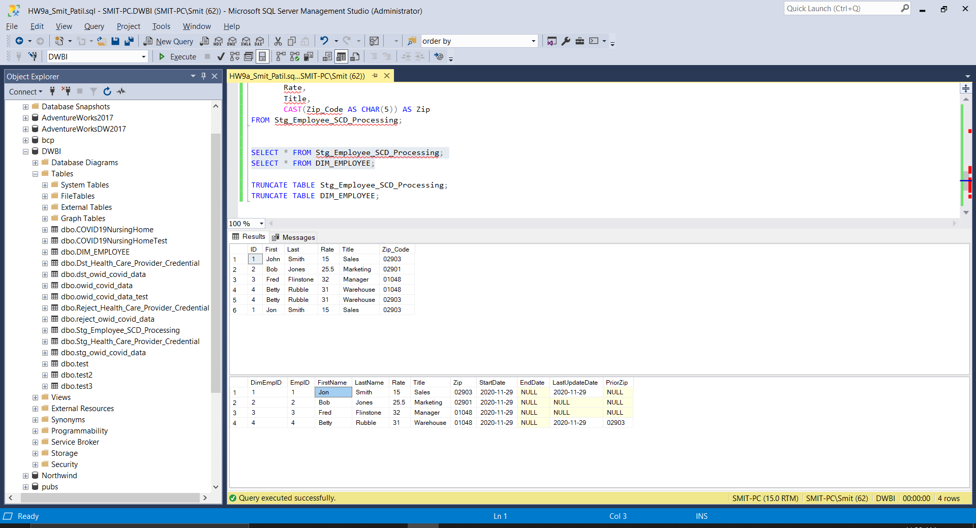

1. Bob Gets a raise

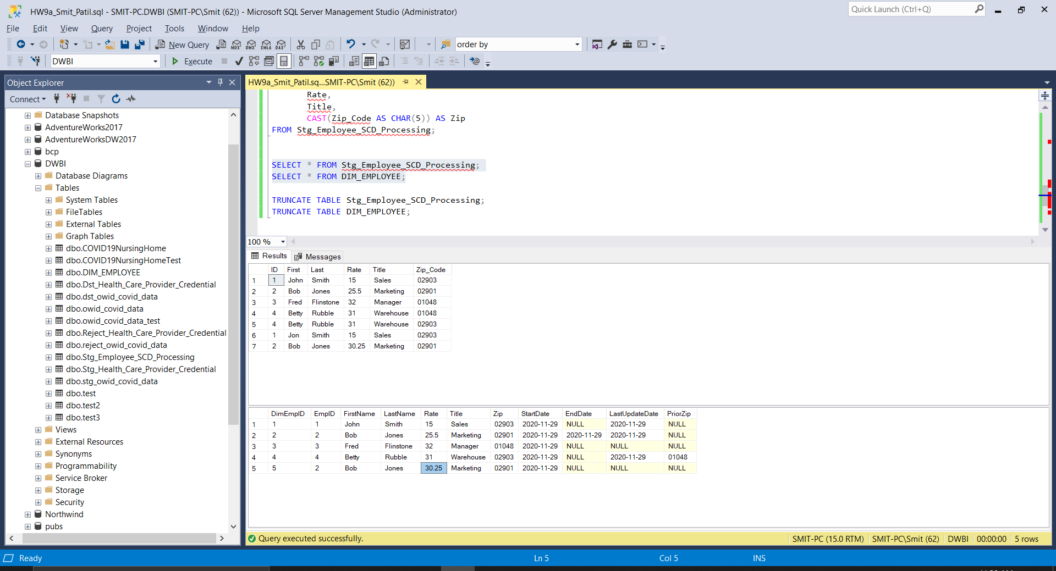

1. New Record

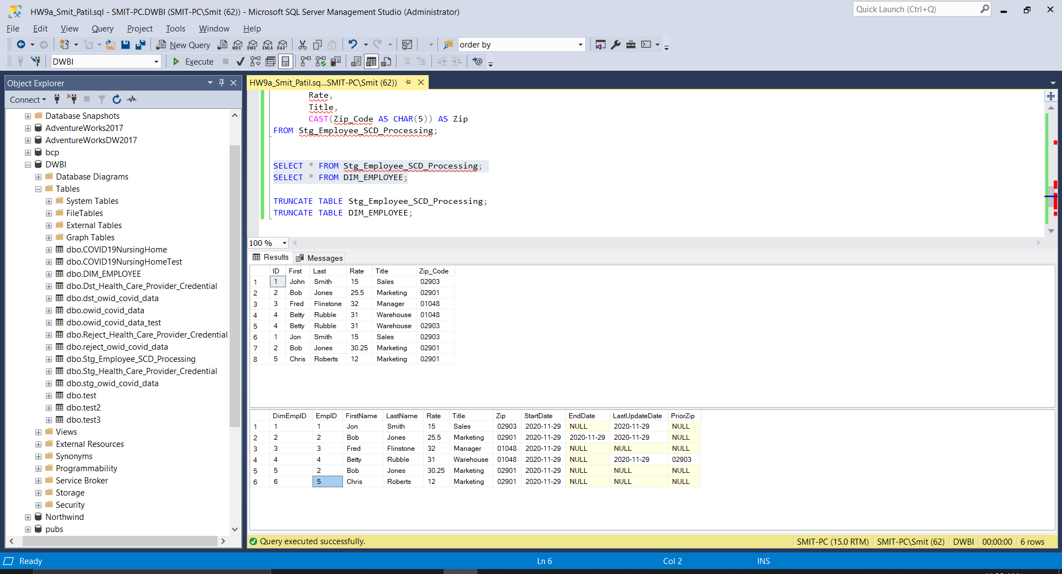

1. Bob Jones Updates Name

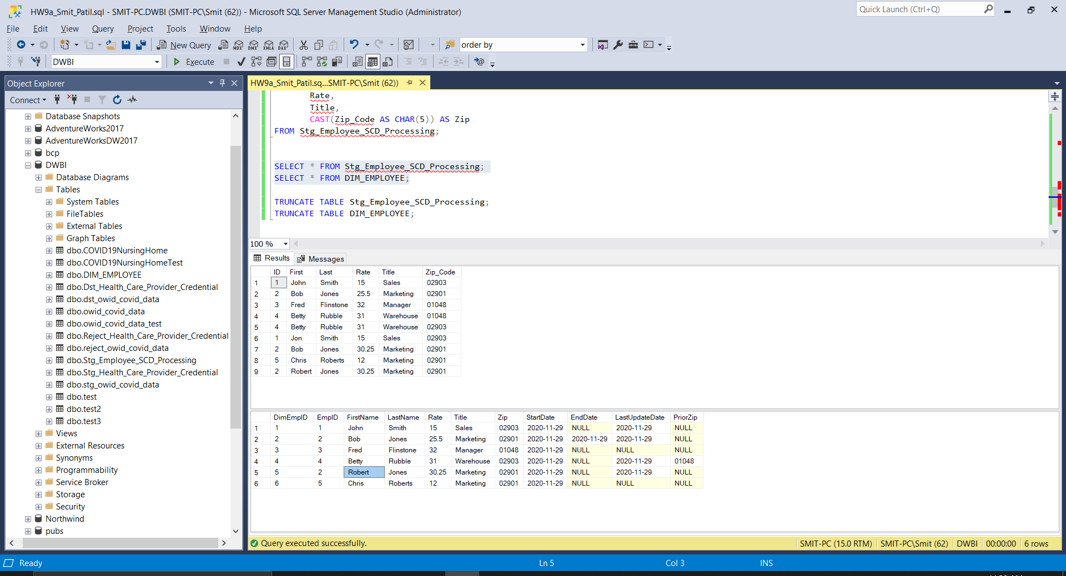

1. Delete / Terminate a record

