HW11a – Lookup Table Buildout

Smit Patil

We can update the rows with missing values with previous values by using the EXCEL functionality of Find and Replace and then pasting the formula =INDIRECT(“A” & ROW() – 1). This formula will update the value in the current row based on the value in previous row.

1. Find and Replace functionality to update values

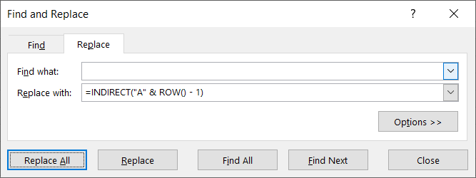

1. Selecting Column A and replacing the missing values in it.

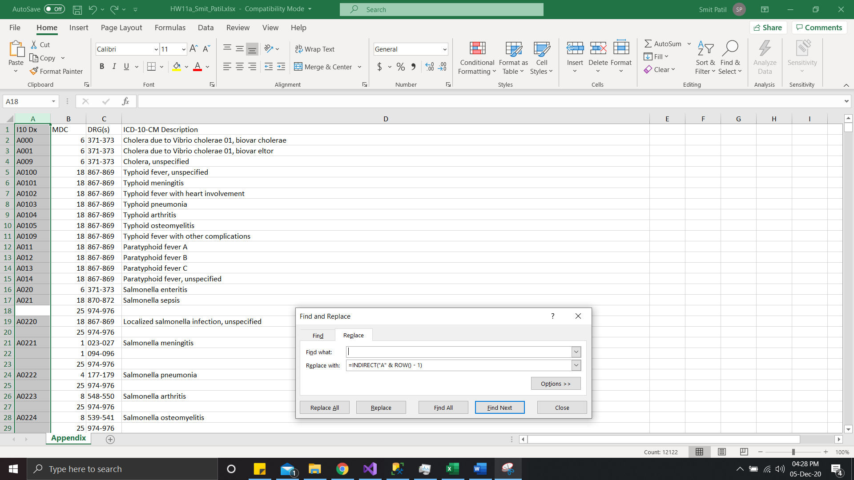

1. Updated all the missing values in Column A as required

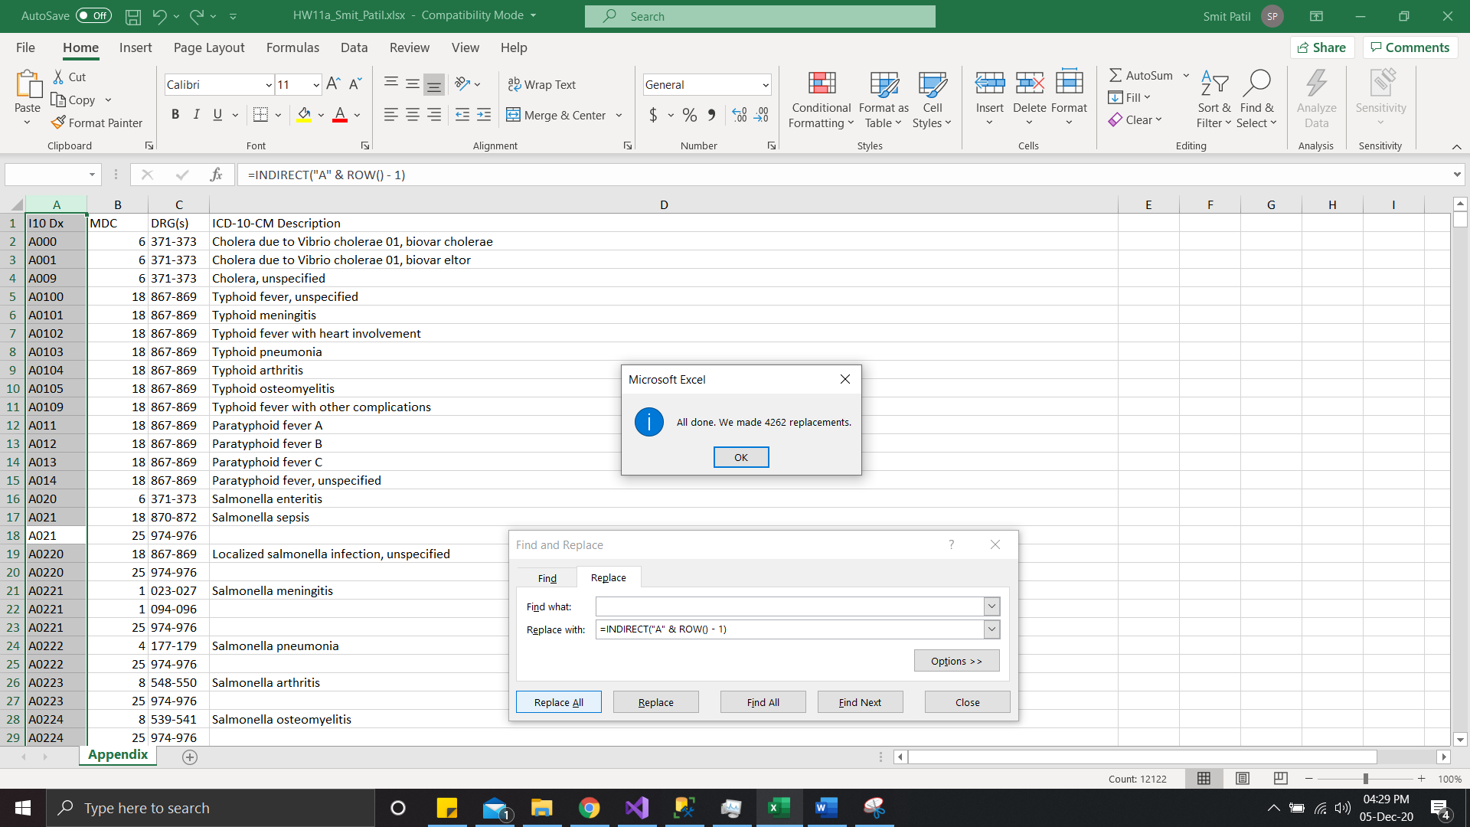

1. Selecting Column B and replacing the missing values in it. Similar to that done

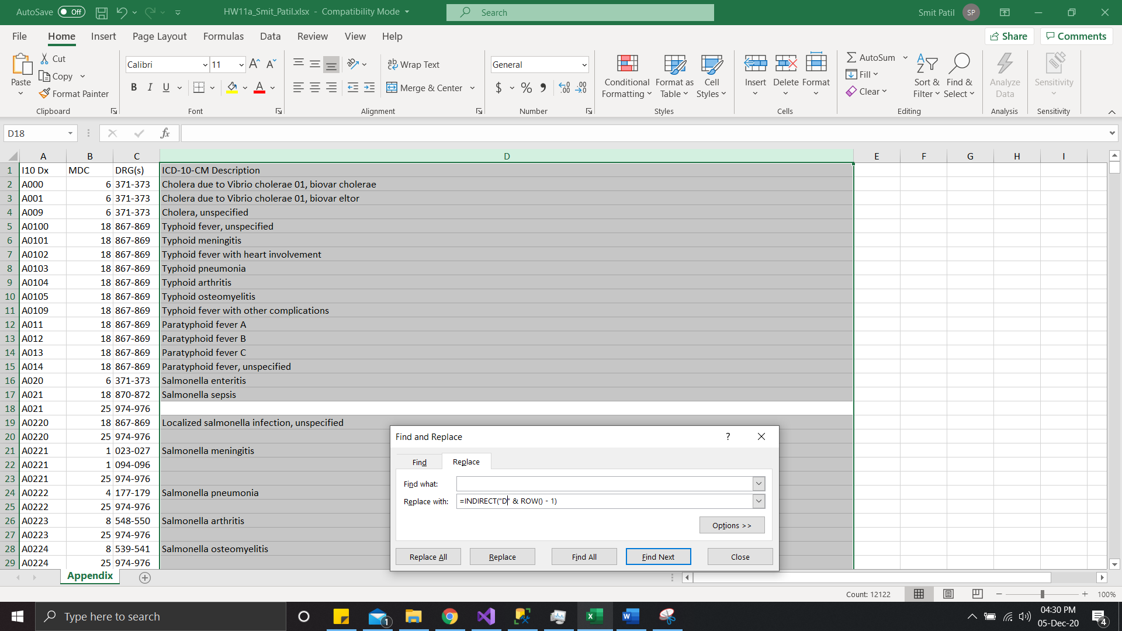

1. Updated all the missing values in Column B as required

