HW12 – SSAS AW 01

Smit Patil

1. Screenshot of the Cube Structure with FactInternetSales as the Fact table.

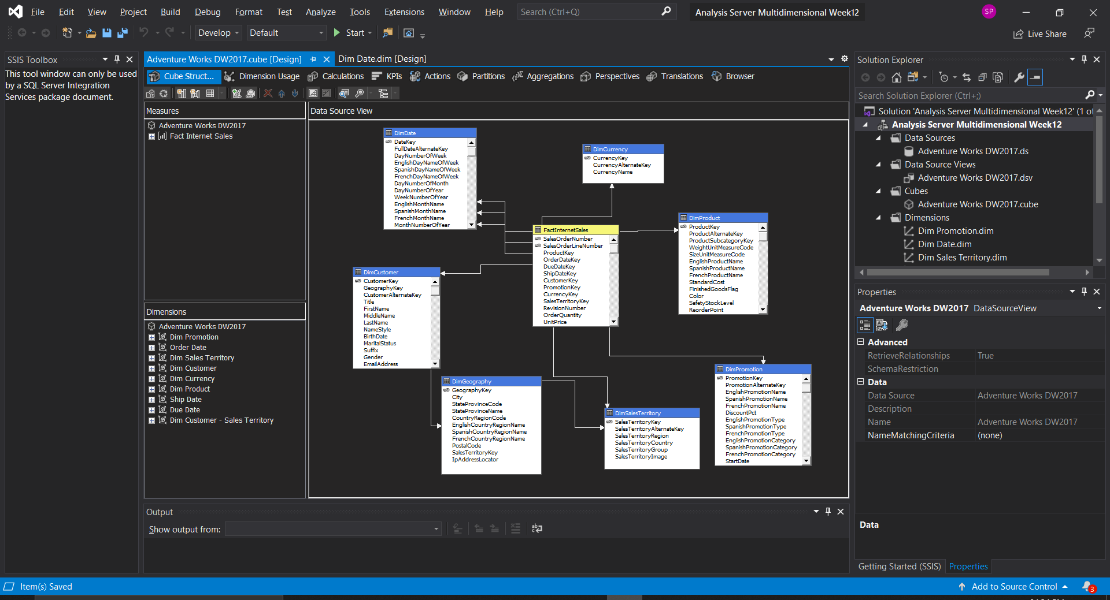

1. Created Hierarchy for DimDate dimension with levels Year>Quarter>Months>Date

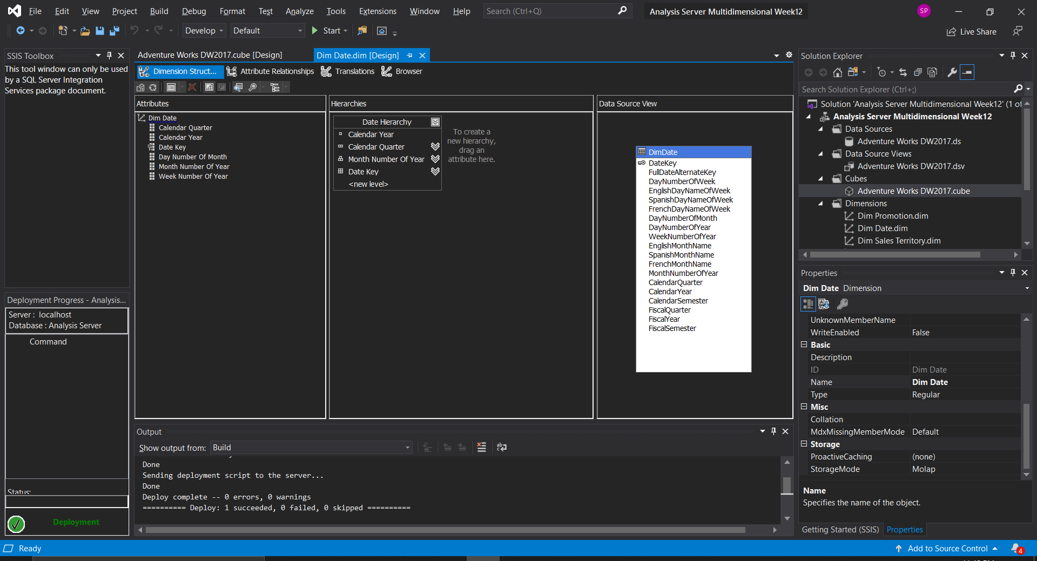

1. Screenshot of the Cube Browser with analysis of the Sales Amount with granularity of Year, Quarter, Month and Date.

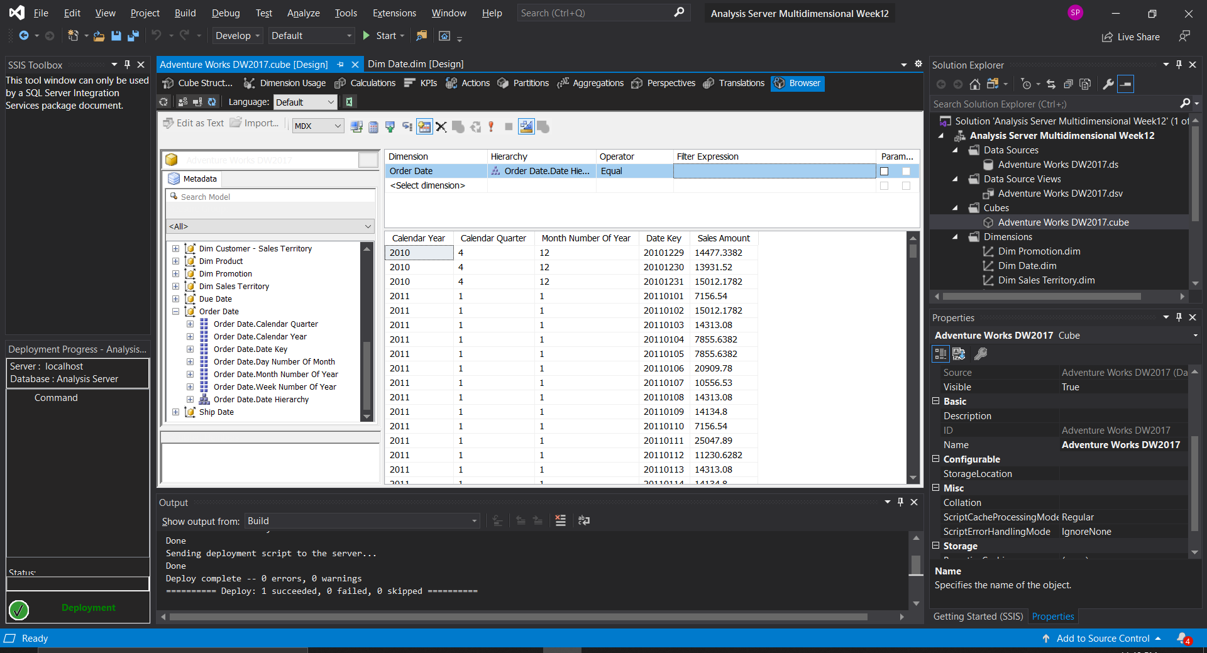

1. Screenshot of process running successfully.

