A Project Report On…
AgriConnect: Digital Agricultural Marketplace & Direct Farmer-to-Buyer Platform
Developed By…
Smit Pithadiya
(BCA Semester - 6)
Submitted To..
Geetanjali College Of Computer Science And Commerce ( B.C.A. )
Rajkot
Saurashtra University Rajkot
Academic Year: 2025 - 2026
Project Guide : PROF. Harsh Joshi

Acknowledgements
- I am happy to submit my idea and implementation for the "AgriConnect - Agricultural Marketplace System" web application to Saurashtra University, Rajkot for a BCA degree in the Computer Science branch.
- I am also deeply grateful to Prof. Brijesh Shah, Head of the Department, and all faculty members of the Department of Computer Science for their kind guidance, constant encouragement, and technical support throughout this journey.
- I take the privilege to acknowledge the authors of numerous reference books, research publications, Django official documentation, and technical web blogs which we referred to during the development of this project.
- I express my heartfelt gratitude to my parents and family for their unwavering moral and financial support, without which I could accomplish nothing in my academic pursuits and personal life.
- The feeling of gratefulness for everyone's timely assistance directly arises from the bottom of my heart. Small but critical guidance during testing and database schema design proved to be significant milestones in completing this application.

Preface
- Practical training and software implementation are of paramount importance in understanding theoretical aspects of Computer Application & Web Software Development. Recognizing this importance, we prepared the "AgriConnect" project to enrich our practical knowledge regarding web technologies, full-stack architecture, and database management systems.
- We are very much pleased to present this comprehensive project report on "AgriConnect: Digital Agricultural Marketplace", developed at Geetanjali College of Computer Science and Commerce, affiliated with Saurashtra University.
- This report contains an exhaustive technical and functional overview of the entire project. Anyone with basic computer software knowledge can easily understand the contents of this report. System design is illustrated using Data Flow Diagrams (DFDs), Entity Relationship (ER) diagrams, exact Data Dictionary schema definitions, test cases, and screen illustrations.
- We have tried our best in practical study, systematic code structuring, and clear presentation of this report.

Index
Topic / Section Title | Page No.
1. Project Profile | 5
2. Software Development Life Cycle (SDLC) | 6
3. System Requirements (Hardware & Software) | 8
4. Development & Coding Standards | 9
5. About the Tool (Tools & Technologies Used) | 11
6. Data Flow Diagrams (DFD Level 0 & Level 1) | 13
7. Entity Relationship (ER) Diagram & Architecture | 15
8. Data Dictionary (Complete Database Schema) | 17
9. Screenshots & Module Descriptions | 22
10. Test Cases (Farmer, Buyer & Admin Modules) | 32
11. Limitations | 37
12. Future Enhancements | 38
13. Webliography | 39

1. Project Profile
Project Title: | AgriConnect: Digital Agricultural Marketplace System
Development Software: | Visual Studio Code, Python 3.12+, Django 5.x Framework
Front End: | HTML5, CSS3, JavaScript (ES6+), Bootstrap 5, FontAwesome
Backend / Logic: | Python, Django Web Framework (MVT Architecture)
Database: | MySQL Database Management System
Academic Year: | 2025 - 2026
Developed By: | Smit Pithadiya (BCA Semester - 6)
Submitted To: | Geetanjali College Of Computer Science And Commerce, Rajkot
Documentation Tool: | Microsoft Word, Draw.io, Python Docx, Matplotlib
Operating System: | Cross-platform (Windows 10/11, macOS, Linux)
Programming Language: | Python 3.x, JavaScript, HTML, CSS

2. Software Development Life Cycle (SDLC)
The Software Development Life Cycle (SDLC) is a systematic, structured methodology utilized to design, develop, test, and deploy high-quality web software applications. For the development of the AgriConnect project, the Waterfall Model was selected due to its linear, sequential flow and well-defined phase dependencies.
Waterfall Model Steps:
- 1. Requirement Gathering & Feasibility Analysis
- 2. Project Planning & Scope Definition
- 3. System Design & Architecture Specification
- 4. Coding & Full-Stack Implementation
- 5. Testing & Quality Assurance
Phase 1: Requirement Gathering
In this initial stage, detailed functional and non-functional requirements were gathered by researching existing agricultural trade platforms and consulting local farmers and produce buyers.
- • Farmer Requirements: Registration, identity verification, crop listing management, quantity tracking, price per kg setup, stock status, direct buyer order reception, earnings summary, and direct chat.
- • Buyer Requirements: Marketplace browsing, category filtering, search, crop details, shopping cart management, delivery address entry, multi-mode payment, order placement with OTP verification, order history, and farmer reviews.
- • Admin Requirements: Centralized dashboard, crop approval workflow, user account role management, platform analytics, system reports generation, and dispute resolution.
Phase 2: Project Planning
A comprehensive project plan was established outlining timelines, milestone deadlines, module division, technology selection (Python + Django MVT), and database choice.
Phase 3: System Design
The architecture was designed using Django's Model-View-Template (MVT) pattern. Database schemas were constructed for 21 core entities including User, Farmer, Buyer, AuthOTP, Category, Crop, CartItem, Order, OrderItem, Payment, Review, Notification, ChatMessage, Wishlist, FarmerRating, Feedback, PriceTrend, MarketInsight, ReturnRequest, Report, and OrderOTP tables. Data Flow Diagrams (DFDs) and ER diagrams were modeled to guarantee clean relationships.
Phase 4: Coding & Implementation
Development was executed using Python 3 and Django 5. Web templates were built using HTML5, CSS3, JavaScript, and Bootstrap 5 to deliver a responsive user interface. Clean coding standards (PEP 8) and secure design principles (CSRF tokens, password hashing, RBAC) were strictly enforced.
Phase 5: Testing
Rigorous Unit Testing, Integration Testing, System Testing, and User Acceptance Testing (UAT) were conducted across all farmer, buyer, and admin workflows to verify functional correctness and zero defects.

3. System Requirements
To successfully deploy, run, and maintain the AgriConnect project, the following hardware and software specifications are required:
Minimum Hardware Requirements:
Component / Resource | Minimum Specification
Operating System | Windows 10/11, macOS 11+, Linux Ubuntu 20.04+
CPU / Processor | Intel Core i3 / AMD Ryzen 3 Dual-Core (2.0 GHz or higher)
System RAM | 4 GB (8 GB recommended for optimal development)
Hard Disk Space | 20 GB available storage space
Display Resolution | 1280 x 720 HD Resolution or higher
Network Connection | Broadband Internet (for static CDN resources & deployment)
Software Requirements:
Software Tool / Component | Version / Specification
Runtime Environment | Python 3.12+ 64-bit Interpreter
Web Framework | Django 5.x Framework
Database Server | MySQL Database Server (v8.0+ / TiDB Cloud)
Frontend Stack | HTML5, CSS3, JavaScript (ES6+), Bootstrap 5.3
Web Server | Django WSGI / ASGI Dev Server (Apache 2.4 / Nginx in Production)
IDE / Source Editor | Visual Studio Code / PyCharm
Version Control | Git & GitHub Repository

4. Development & Coding Standards
To ensure maximum readability, maintainability, and scalability across the AgriConnect codebase, strict Python (PEP 8) and web engineering standards were enforced during implementation.
Naming Conventions:
- • File & Function Naming: Use snake_case for filenames, module names, Python variables, and function names (e.g., crop_detail_view, price_per_kg).
- • Class Naming: Use PascalCase for Django models, views, forms, and Python classes (e.g., Crop, CartItem, Wishlist).
- • Template Naming: Use lowercase snake_case for HTML template files placed under clear app folders (e.g., templates/marketplace/crop_detail.html).
Code Formatting & Structure:
- • Indentation: Consistently use 4 spaces per indentation level. Avoid tab characters to maintain environment consistency.
- • Line Length: Limit Python source code lines to 79-88 characters for enhanced visual readability and side-by-side editing.
- • Import Organization: Group imports logically: Standard library imports first, Third-party imports second, and Local app imports third.
Error Handling & Security Standards:
- • Exception Handling: Wrap database queries, file operations, and external API requests inside try-except blocks to gracefully capture runtime exceptions.
- • Access Control: Enforce @login_required and role-verification decorators on views to restrict unauthorized URL access.
- • Security Tokens: Include {% csrf_token %} on all HTML POST forms to prevent Cross-Site Request Forgery attacks.

5. About the Tool (Tools & Technologies Used)
Python Programming Language:
Python is a high-level, interpreted, object-oriented programming language known for its simple syntax, readability, and extensive standard library. Python powers the backend business logic and data manipulation of AgriConnect.
Django Web Framework:
Django is a high-level Python web framework that encourages rapid development and clean, pragmatic design. Built by experienced developers, it takes care of much of the hassle of web development. Django follows the Model-View-Template (MVT) architectural pattern and provides built-in Object-Relational Mapping (ORM), robust user authentication, form validation, and admin portal capabilities out of the box.
HTML5 & CSS3 & Bootstrap 5:
HTML5 provides semantic structure for web pages, while CSS3 handles responsive visual styling. Bootstrap 5, a popular front-end CSS framework, is integrated to ensure AgriConnect renders flawlessly on desktop displays, tablets, and smartphones.
MySQL Database Management System (DBMS):
MySQL is a high-performance, robust relational database management system (RDBMS) used to store and manage all relational data in AgriConnect. Structured database tables store user credentials, farmer profiles, crop inventories, shopping cart items, order transactions, payments, reviews, and market insights. In production, MySQL / TiDB Cloud is utilized to deliver enterprise-grade performance, ACID transaction safety, foreign key integrity, and high-concurrency reliability.
Visual Studio Code (VS Code):
VS Code is a lightweight but powerful source code editor running on desktop OS. It features built-in support for Python, HTML/CSS, Git version control, syntax highlighting, and interactive debugging.

6. Data Flow Diagrams (DFD)
Data Flow Diagrams graphically illustrate how data flows through the AgriConnect system, identifying external entities, process transformations, and internal database stores.
Data Flow Diagram (DFD Level 0 - Context Diagram):
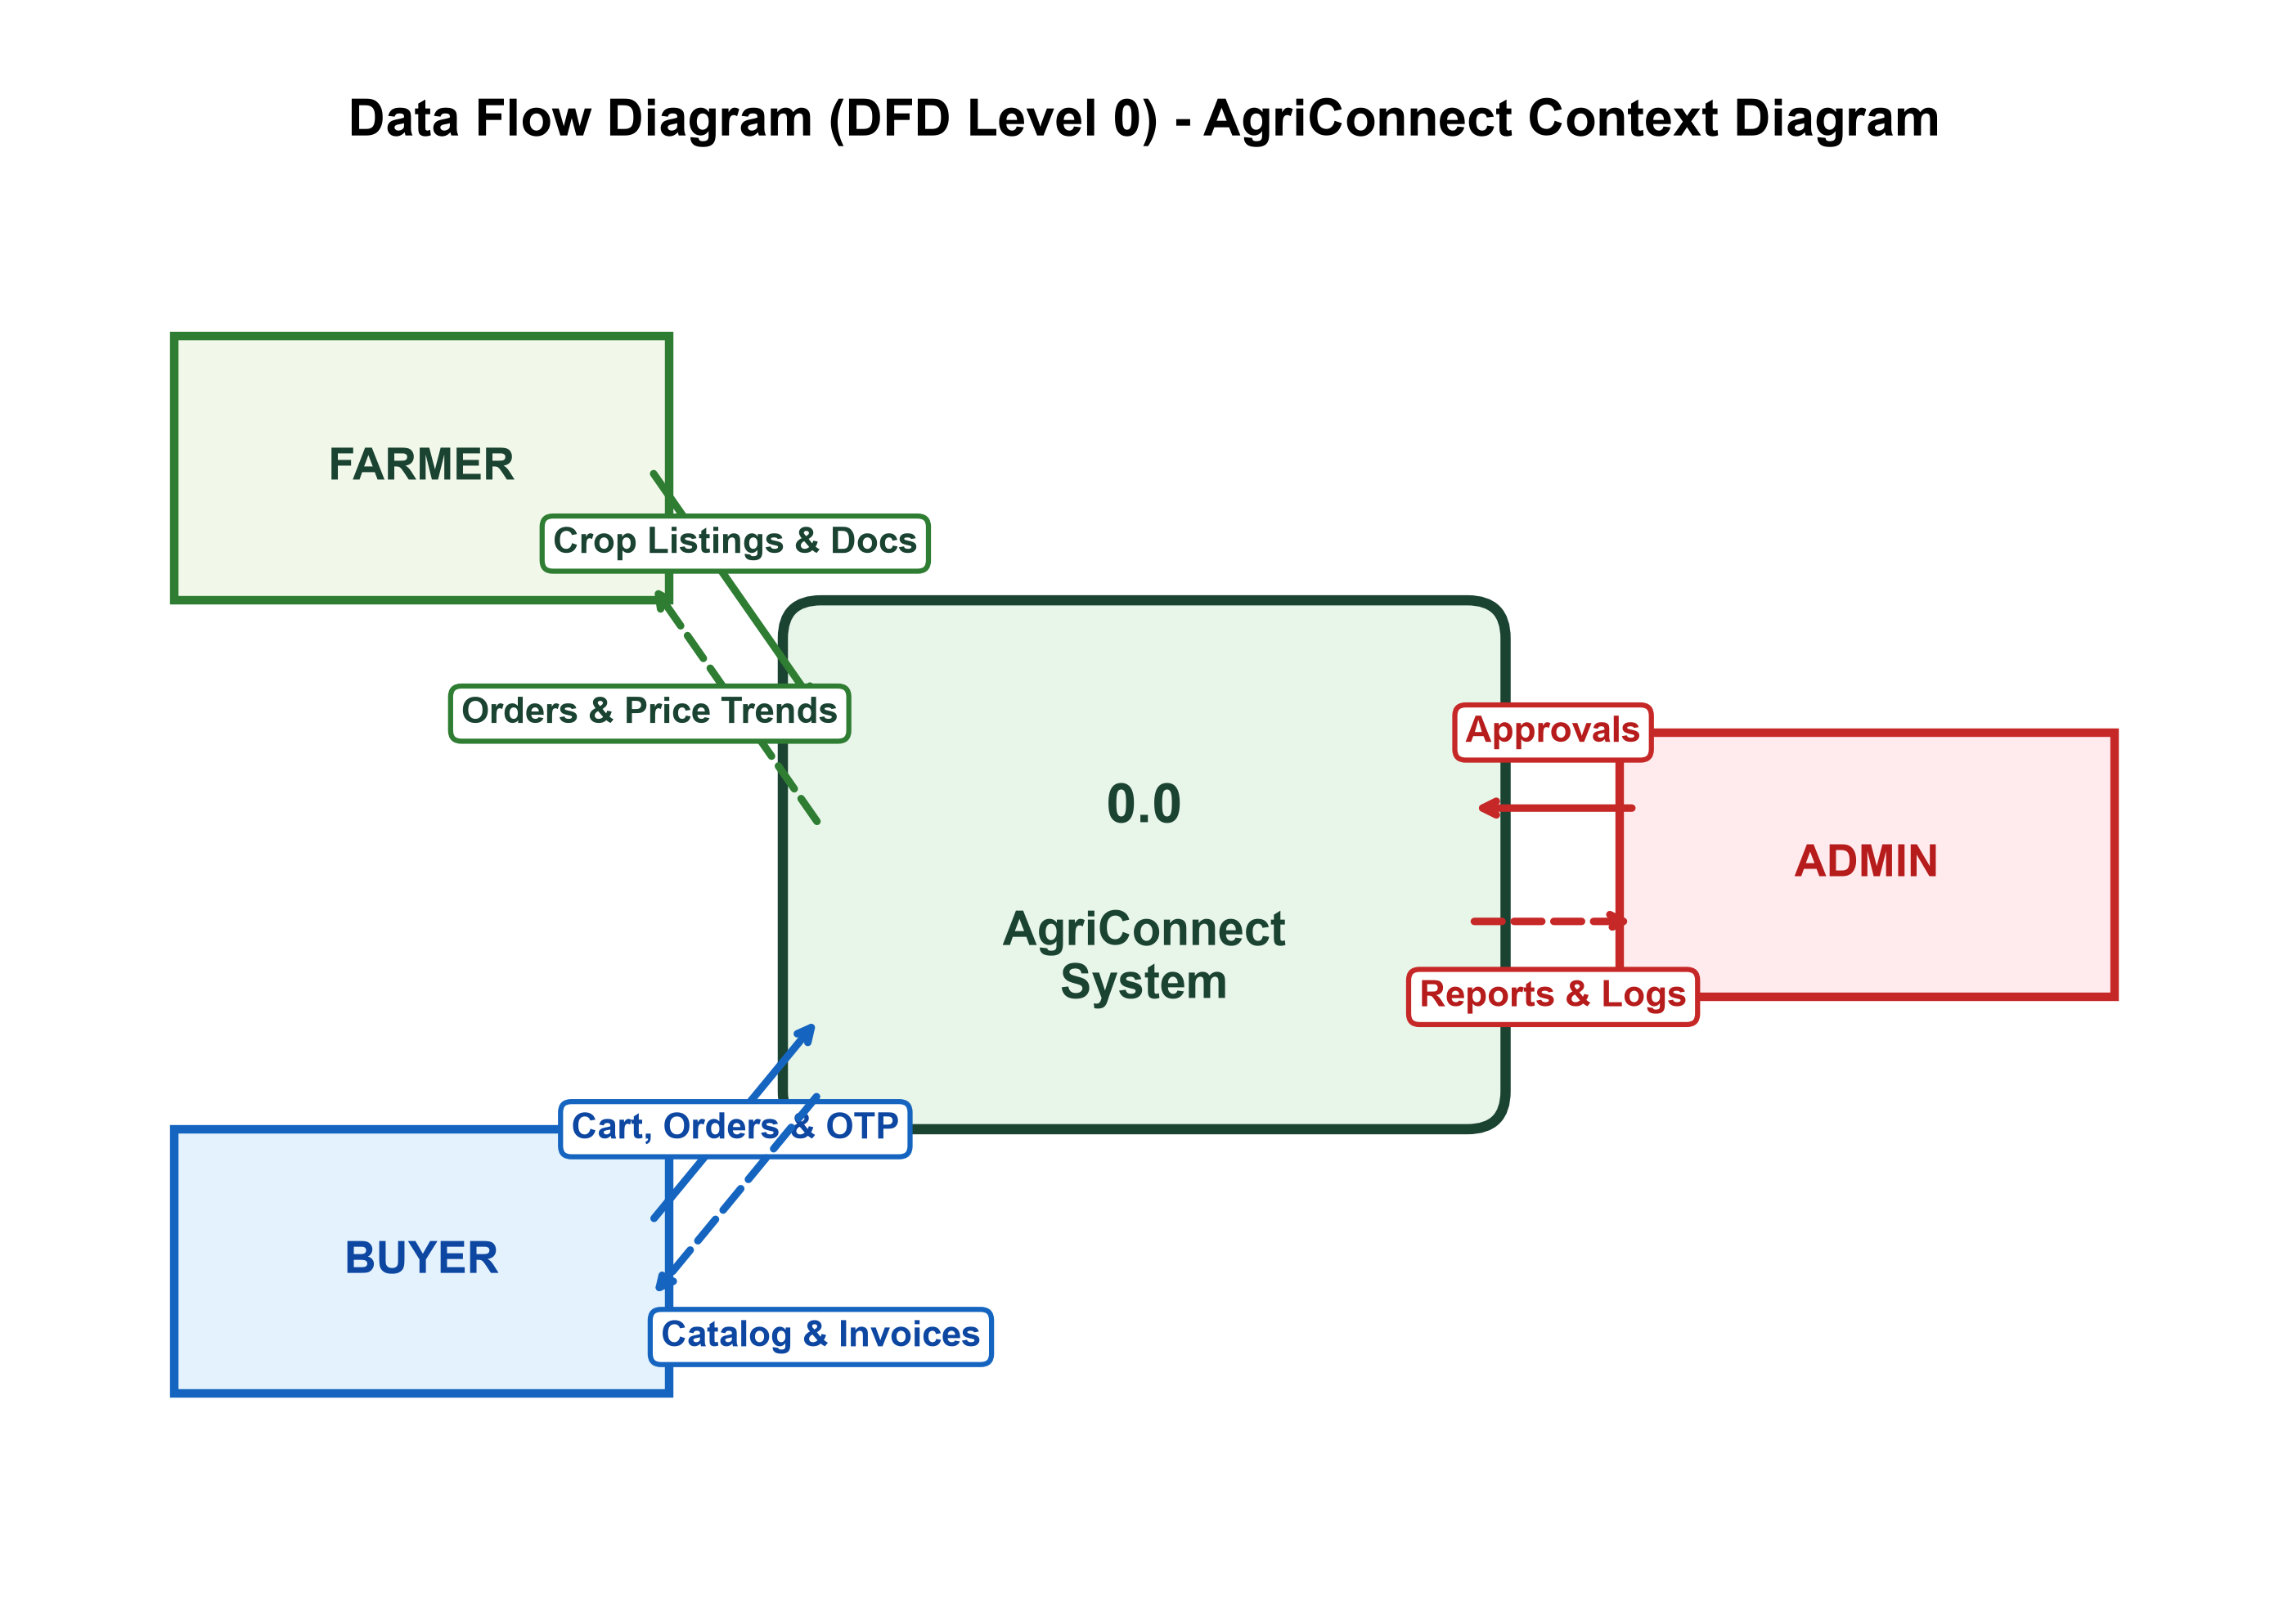
Figure 6.1: Context Diagram (DFD Level 0) illustrating high-level interactions between Farmers, Buyers, Admins, and the central AgriConnect platform.

Data Flow Diagram (DFD Level 1 - Process Breakdown):
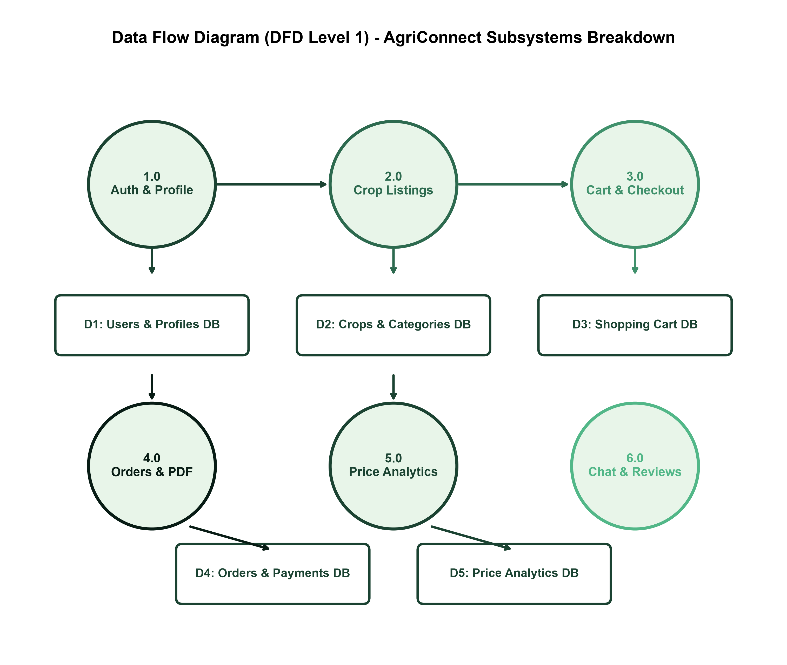
Figure 6.2: Detailed Process Breakdown (DFD Level 1) showing data paths between authentication, crop listing, shopping cart, order placement with OTP, payment, and database stores.

7. Entity Relationship (ER) Diagram & Architecture
Entity Relationship (ER) Diagram:
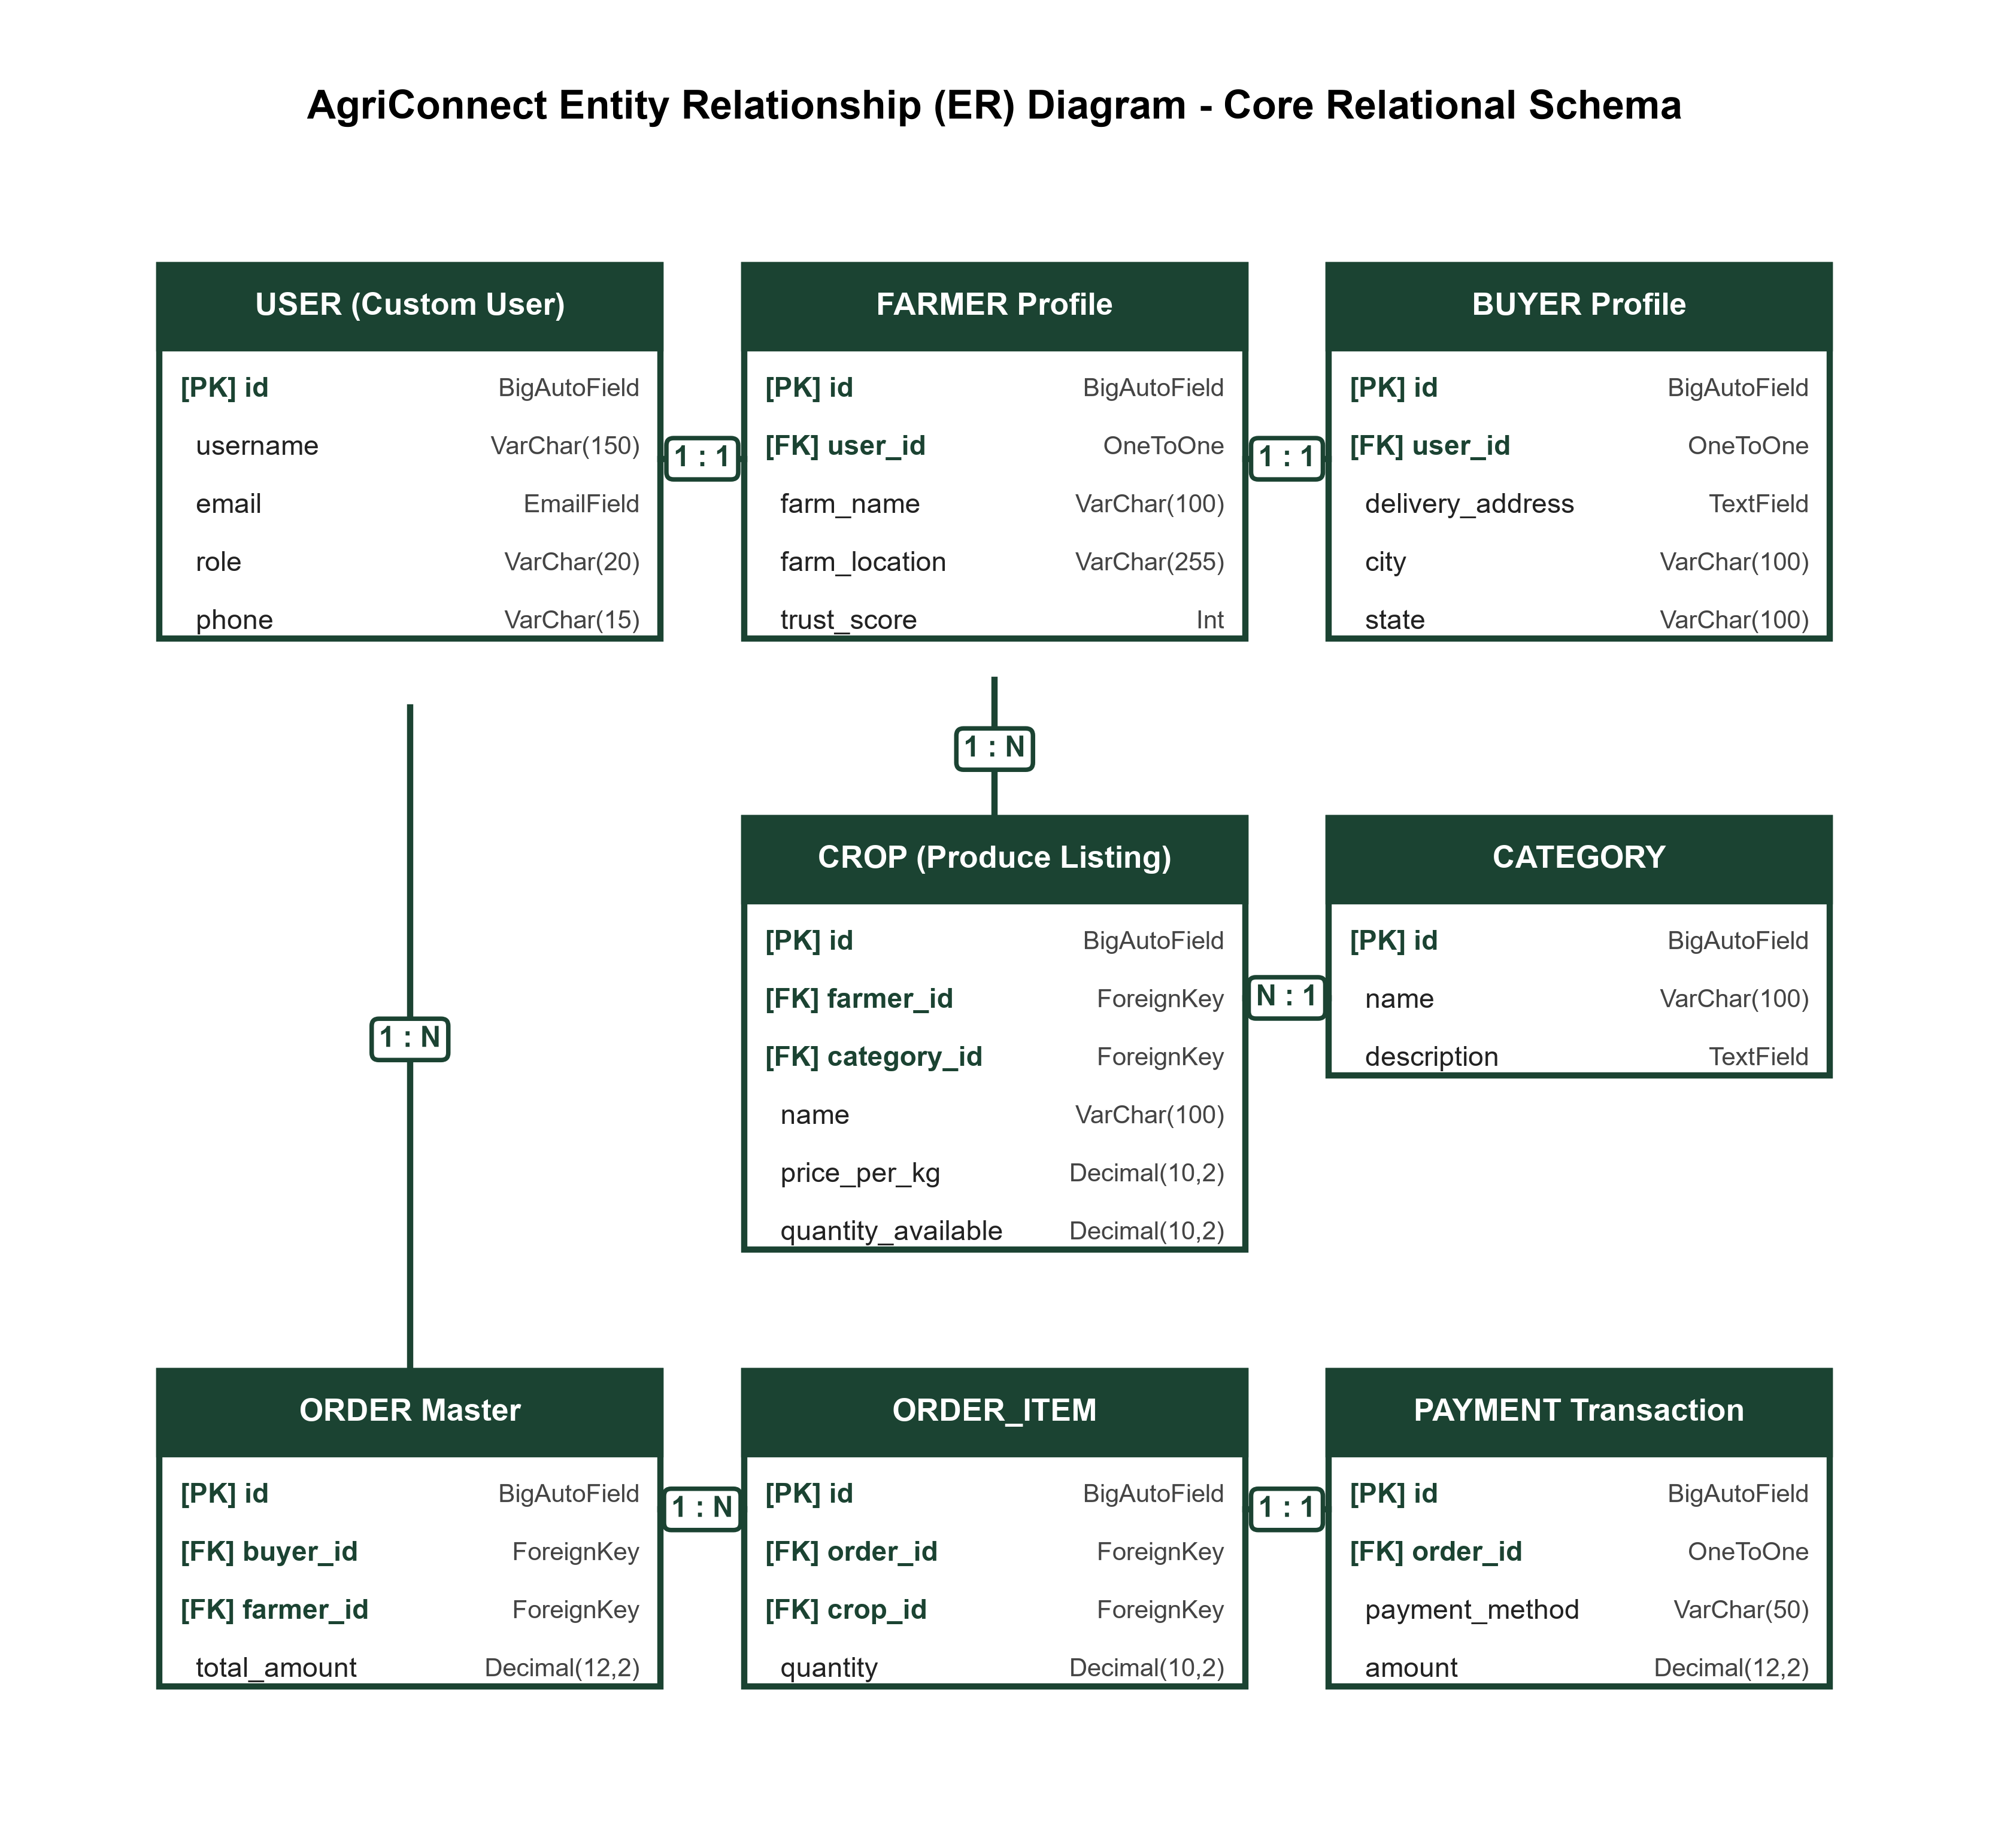
Figure 7.1: Entity Relationship Diagram depicting primary keys, foreign key constraints, and cardinalities between User, Crop, Category, Order, OrderItem, and Payment entities.

System Architecture Diagram:
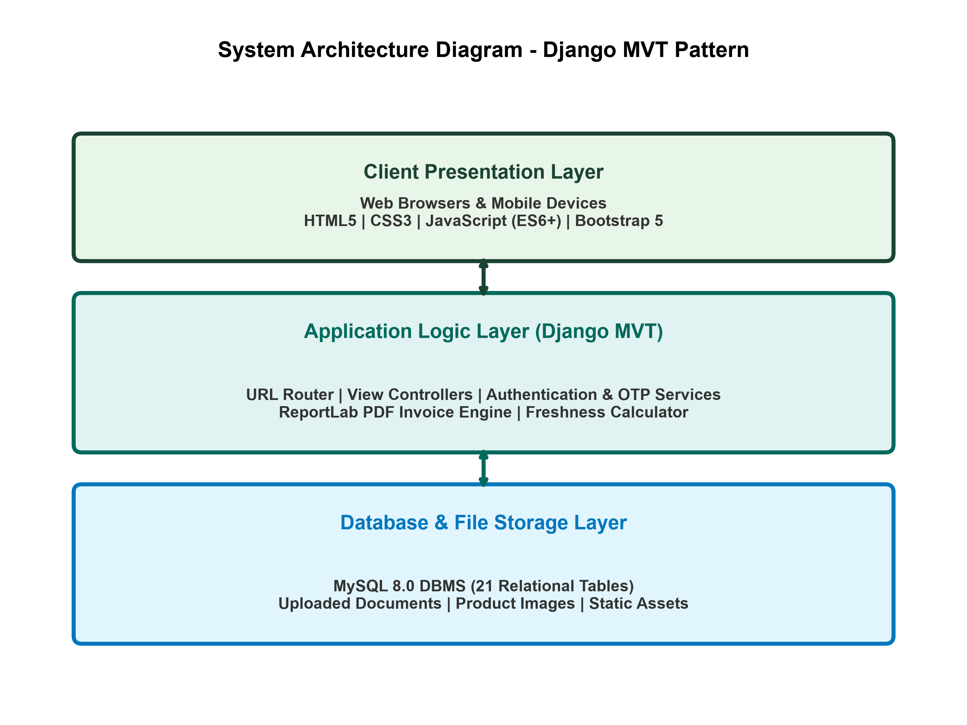
Figure 7.2: 3-Tier Architecture showing Presentation Layer, Django Application Server Layer, and Relational Database Storage Layer.

Use Case Diagram:
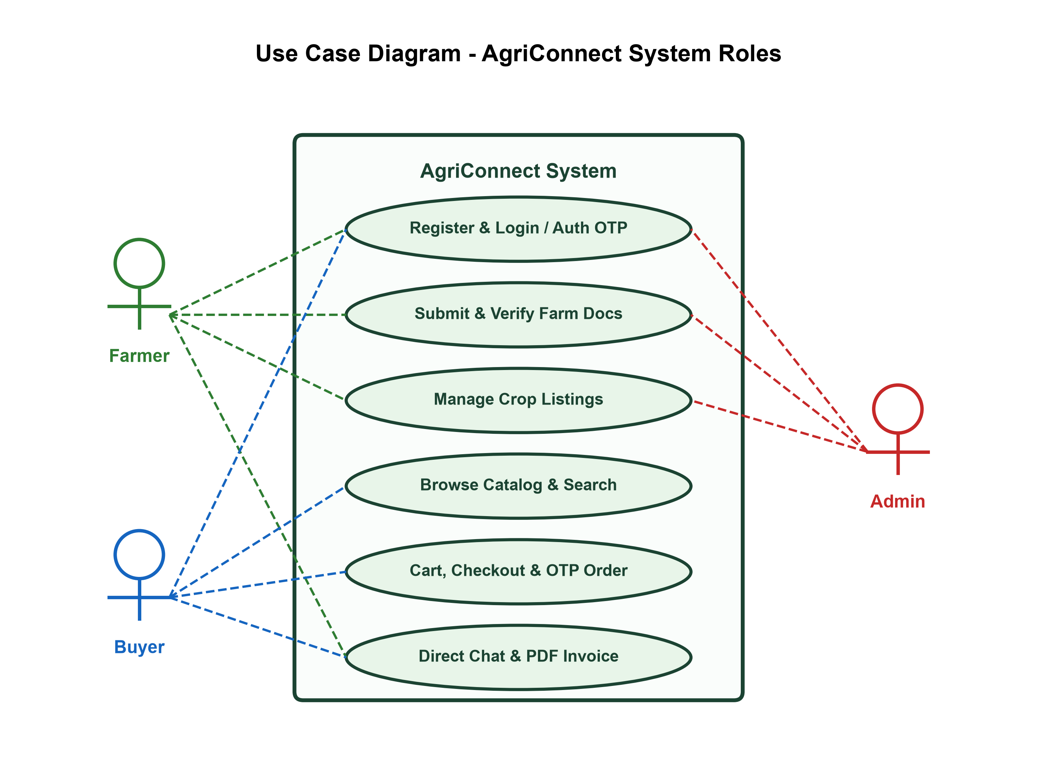
Figure 7.3: Use Case Diagram depicting interactions between Farmer, Buyer, and Admin roles.

8. Data Dictionary
The Data Dictionary provides the exact schema definition for all 21 database tables implemented in the AgriConnect relational database system, detailing field names, data types, nullability, key constraints, and functional descriptions.
Table 1: accounts_user (Custom User Model)
Field Name | Data Type | Null? | Constraint | Description
id | BigAutoField | No | Primary Key | Unique user identifier
username | CharField | No | Unique | Login username
email | EmailField | No | Unique | User email address
role | CharField | No | - | User role (admin, farmer, buyer)
phone | CharField | Yes | - | Contact phone number
address | TextField | Yes | - | Physical delivery/farm address
profile_picture | ImageField | Yes | - | Profile avatar image
is_active | BooleanField | No | - | Account active status flag
date_joined | DateTimeField | No | - | Account registration timestamp
Table 2: accounts_farmer (Farmer Profile)
Field Name | Data Type | Null? | Constraint | Description
id | BigAutoField | No | Primary Key | Profile ID
user_id | OneToOneField | No | FK (User) | Reference to accounts_user
farm_name | CharField | Yes | - | Name of the farm / enterprise
farm_location | CharField | Yes | - | Farm address / region
farm_size | CharField | Yes | - | Land acreage (e.g. 5 Acres)
certification_status | CharField | No | - | Verification badge status (verified/pending/none)
experience | CharField | No | - | Years of agricultural experience
orders_completed | IntegerField | No | - | Count of fulfilled orders
store_rating | FloatField | No | - | Average store rating (0.0 - 5.0)
specialization | CharField | No | - | Farming domain specialization
about | TextField | Yes | - | Farmer biography & overview
cover_banner | ImageField | Yes | - | Storefront header cover banner
certifications | TextField | Yes | - | Agricultural certifications held
awards | TextField | Yes | - | Recognitions and awards received
repeat_customers | IntegerField | No | - | Count/rate of repeat buyers
ontime_delivery | IntegerField | No | - | On-time delivery percentage
satisfaction_rate | IntegerField | No | - | Customer satisfaction percentage
village | CharField | Yes | - | Village name
city | CharField | Yes | - | City location
state | CharField | Yes | - | State location
pincode | CharField | Yes | - | Postal code
organic_certificate | FileField | Yes | - | Uploaded organic farming certificate
verification_status | CharField | No | - | Admin verification status choice
aadhaar_document | FileField | Yes | - | Identity verification document
farm_certificate | FileField | Yes | - | Land certificate document
trust_score | IntegerField | No | - | Platform trust rating score
verification_date | DateTimeField | Yes | - | Verification approval timestamp
verified_by_id | ForeignKey | Yes | FK (User) | Admin user performing verification
admin_notes | TextField | Yes | - | Verification review notes
approval_history | TextField | Yes | - | Audit trail log of actions
Table 3: accounts_buyer (Buyer Profile)
Field Name | Data Type | Null? | Constraint | Description
id | BigAutoField | No | Primary Key | Profile ID
user_id | OneToOneField | No | FK (User) | Reference to accounts_user
delivery_address | TextField | Yes | - | Primary shipping destination
contact_name | CharField | Yes | - | Contact person name
city | CharField | Yes | - | Buyer city location
state | CharField | Yes | - | Buyer state location
pincode | CharField | Yes | - | Postal pincode
Table 4: accounts_authotp (Authentication OTP)
Field Name | Data Type | Null? | Constraint | Description
id | BigAutoField | No | Primary Key | OTP Record ID
user_id | ForeignKey | Yes | FK (User) | Target user reference
email | EmailField | Yes | - | Email address for unregistered OTP
otp_code | CharField | No | - | 6-digit OTP passcode
otp_type | CharField | No | - | OTP type (registration / password_reset)
created_at | DateTimeField | No | - | OTP generation timestamp
expires_at | DateTimeField | No | - | OTP expiration timestamp
is_verified | BooleanField | No | - | OTP verification status flag
attempts | IntegerField | No | - | Failed attempt counter
resend_count | IntegerField | No | - | Resend request counter
Table 5: marketplace_category (Crop Category)
Field Name | Data Type | Null? | Constraint | Description
id | BigAutoField | No | Primary Key | Category ID
name | CharField | No | Unique | Category title (Vegetables, Fruits, Grains)
description | TextField | Yes | - | Category detailed description
image | ImageField | Yes | - | Category banner thumbnail image
Table 6: marketplace_crop (Crop Product Listing)
Field Name | Data Type | Null? | Constraint | Description
id | BigAutoField | No | Primary Key | Crop Product ID
farmer_id | ForeignKey | No | FK (Farmer) | Farmer owner of crop listing
category_id | ForeignKey | No | FK (Category) | Produce category reference
name | CharField | No | - | Crop name (e.g. Organic Wheat)
description | TextField | No | - | Detailed produce description
price_per_kg | DecimalField | No | - | Price per unit / kilogram (INR)
quantity_available | DecimalField | No | - | Available stock quantity
unit | CharField | No | - | Unit choice (kg, ton, piece, quintal)
image | ImageField | Yes | - | Produce primary photograph
is_approved | BooleanField | No | - | Admin approval status
harvest_date | DateField | No | - | Date crop was harvested
shelf_life_days | IntegerField | No | - | Estimated shelf life in days
availability_status | CharField | No | - | Stock status (available/out_of_stock)
created_at | DateTimeField | No | - | Listing creation timestamp
updated_at | DateTimeField | No | - | Listing last update timestamp
status_history | JSONField | No | - | Audit trail of listing changes
otp_code | CharField | Yes | - | Verification OTP code
otp_expires_at | DateTimeField | Yes | - | OTP expiry timestamp
is_otp_verified | BooleanField | No | - | OTP verification flag
return_reason | CharField | Yes | - | Return reason choice if returned
return_description | TextField | Yes | - | Return details note
return_status | CharField | Yes | - | Return status (Pending/Approved/Rejected)
market_demand_level | CharField | No | - | Market demand index (High/Medium/Low)
market_forecast_direction | CharField | No | - | Price forecast direction
current_market_price | DecimalField | Yes | - | APMC mandi benchmark price
market_price_history | JSONField | No | - | Price history trend data
Table 7: marketplace_cartitem (Shopping Cart Item)
Field Name | Data Type | Null? | Constraint | Description
id | BigAutoField | No | Primary Key | Cart Item ID
user_id | ForeignKey | No | FK (User) | Buyer user owning cart
crop_id | ForeignKey | No | FK (Crop) | Selected crop item
quantity | PositiveInt | No | - | Selected quantity count
Table 8: marketplace_order (Order Master Table)
Field Name | Data Type | Null? | Constraint | Description
id | BigAutoField | No | Primary Key | Order ID
buyer_id | ForeignKey | No | FK (User) | Buyer placing the order
farmer_id | ForeignKey | No | FK (Farmer) | Farmer fulfilling order
total_amount | DecimalField | No | - | Total payable order cost (INR)
payment_method | CharField | No | - | Payment method choice (COD/Online)
status | CharField | No | - | Order status (Pending/Confirmed/Delivered)
shipping_address | TextField | No | - | Complete shipping destination
invoice_pdf | FileField | Yes | - | Generated PDF tax invoice
created_at | DateTimeField | No | - | Order placement timestamp
updated_at | DateTimeField | No | - | Order last modified timestamp
status_history | JSONField | No | - | Order state lifecycle history
otp_code | CharField | Yes | - | 6-digit delivery confirmation OTP
otp_expires_at | DateTimeField | Yes | - | OTP expiry timestamp
is_otp_verified | BooleanField | No | - | OTP verified status flag
return_reason | CharField | Yes | - | Order return reason
return_description | TextField | Yes | - | Order return details
return_status | CharField | Yes | - | Return request approval status
Table 9: marketplace_orderitem (Order Line Items)
Field Name | Data Type | Null? | Constraint | Description
id | BigAutoField | No | Primary Key | Line Item ID
order_id | ForeignKey | No | FK (Order) | Parent order reference
crop_id | ForeignKey | Yes | FK (Crop) | Purchased crop product
quantity | DecimalField | No | - | Purchased quantity volume
price_per_unit | DecimalField | No | - | Unit price at purchase time
Table 10: marketplace_payment (Payment Transaction)
Field Name | Data Type | Null? | Constraint | Description
id | BigAutoField | No | Primary Key | Payment ID
order_id | OneToOneField | No | FK (Order) | Associated order reference
payment_method | CharField | No | - | Payment mode (COD / Online / UPI)
transaction_id | CharField | Yes | - | Gateway transaction reference
status | CharField | No | - | Payment status (Pending/Completed/Failed)
amount | DecimalField | No | - | Transaction total amount
created_at | DateTimeField | No | - | Payment processing timestamp
Table 11: marketplace_review (Customer Crop & Farmer Review)
Field Name | Data Type | Null? | Constraint | Description
id | BigAutoField | No | Primary Key | Review ID
buyer_id | ForeignKey | No | FK (User) | Reviewer buyer user
crop_id | ForeignKey | Yes | FK (Crop) | Reviewed crop product
farmer_id | ForeignKey | Yes | FK (Farmer) | Reviewed farmer profile
quality_rating | PositiveInt | Yes | - | Crop quality rating (1-5)
communication_rating | PositiveInt | Yes | - | Farmer response score (1-5)
delivery_rating | PositiveInt | Yes | - | Delivery speed score (1-5)
packaging_rating | PositiveInt | Yes | - | Packaging quality score (1-5)
rating | PositiveInt | No | - | Overall star rating score (1-5)
title | CharField | Yes | - | Review headline title
comment | TextField | Yes | - | Detailed feedback comment
image | ImageField | Yes | - | Customer product photo upload
reply | TextField | Yes | - | Seller response reply text
reply_at | DateTimeField | Yes | - | Seller reply timestamp
created_at | DateTimeField | No | - | Review submission timestamp
Table 12: marketplace_notification (System Notification)
Field Name | Data Type | Null? | Constraint | Description
id | BigAutoField | No | Primary Key | Notification ID
user_id | ForeignKey | No | FK (User) | Recipient user account
message | TextField | No | - | Notification text body
notification_type | CharField | No | - | Type (order/price/weather/system/chat/review/verification)
priority | CharField | No | - | Priority level (high/medium/low)
link | CharField | Yes | - | Action link URL
is_read | BooleanField | No | - | Read/unread status flag
created_at | DateTimeField | No | - | Dispatch timestamp
Table 13: marketplace_chatmessage (Buyer-Farmer Chat Message)
Field Name | Data Type | Null? | Constraint | Description
id | BigAutoField | No | Primary Key | Message ID
sender_id | ForeignKey | No | FK (User) | Sender user reference
receiver_id | ForeignKey | No | FK (User) | Recipient user reference
crop_id | ForeignKey | Yes | FK (Crop) | Associated crop produce inquiry
message | TextField | No | - | Message text content
is_read | BooleanField | No | - | Read status flag
created_at | DateTimeField | No | - | Message sent timestamp
Table 14: marketplace_wishlist (Saved Crops Wishlist)
Field Name | Data Type | Null? | Constraint | Description
id | BigAutoField | No | Primary Key | Wishlist Item ID
user_id | ForeignKey | No | FK (User) | Buyer user reference
crop_id | ForeignKey | No | FK (Crop) | Saved crop listing reference
added_at | DateTimeField | No | - | Added timestamp
Table 15: marketplace_farmerrating (Farmer Rating & Evaluation)
Field Name | Data Type | Null? | Constraint | Description
id | BigAutoField | No | Primary Key | Rating Record ID
buyer_id | ForeignKey | No | FK (User) | Rating buyer reference
farmer_id | ForeignKey | No | FK (Farmer) | Rated farmer reference
rating | PositiveInt | No | - | Overall rating score (1-5)
quality_rating | PositiveInt | No | - | Quality score (1-5)
communication_rating | PositiveInt | No | - | Communication score (1-5)
delivery_rating | PositiveInt | No | - | Delivery score (1-5)
packaging_rating | PositiveInt | No | - | Packaging score (1-5)
comment | TextField | Yes | - | Detailed evaluation feedback
created_at | DateTimeField | No | - | Rating timestamp
Table 16: marketplace_feedback (Platform Feedback)
Field Name | Data Type | Null? | Constraint | Description
id | BigAutoField | No | Primary Key | Feedback ID
user_id | ForeignKey | No | FK (User) | Submitting user reference
subject | CharField | No | - | Feedback subject line
message | TextField | No | - | Detailed feedback message
is_resolved | BooleanField | No | - | Admin resolution status flag
created_at | DateTimeField | No | - | Submission timestamp
Table 17: marketplace_pricetrend (Crop Market Price Trend)
Field Name | Data Type | Null? | Constraint | Description
id | BigAutoField | No | Primary Key | Trend Record ID
crop_name | CharField | No | - | Crop commodity name
category_id | ForeignKey | No | FK (Category) | Category reference
avg_price | DecimalField | No | - | Average market price per kg (INR)
record_date | DateField | No | - | Recording date
Table 18: marketplace_marketinsight (Market Forecast & Analytics)
Field Name | Data Type | Null? | Constraint | Description
id | BigAutoField | No | Primary Key | Insight Record ID
crop_name | CharField | No | - | Commodity crop name
category_id | ForeignKey | No | FK (Category) | Category reference
current_price | DecimalField | No | - | Current APMC mandi price (INR)
price_change_percent | DecimalField | No | - | Price percentage change (+/- %)
demand_level | CharField | No | - | Demand index (High/Medium/Low)
forecast_direction | CharField | No | - | Forecast trend direction
region | CharField | No | - | APMC Mandi / Region name
volume_tonnes | IntegerField | No | - | Traded volume in tonnes
record_date | DateField | No | - | Generation record date
Table 19: marketplace_returnrequest (Order Return & Refund Request)
Field Name | Data Type | Null? | Constraint | Description
id | BigAutoField | No | Primary Key | Return Request ID
order_id | ForeignKey | No | FK (Order) | Parent order reference
reason | CharField | No | - | Return reason choice
description | TextField | Yes | - | Detailed return reason description
status | CharField | No | - | Status (Pending/Approved/Rejected)
created_at | DateTimeField | No | - | Request filing timestamp
Table 20: marketplace_report (System & Sales Reports)
Field Name | Data Type | Null? | Constraint | Description
id | BigAutoField | No | Primary Key | Report Record ID
name | CharField | No | - | Report document title
report_type | CharField | No | - | Report classification type
generated_by_id | ForeignKey | No | FK (User) | Generating user reference
format | CharField | No | - | File format (pdf, csv, xlsx)
download_count | PositiveInt | No | - | Download counter
file | FileField | Yes | - | Generated file path
scheduled_interval | CharField | Yes | - | Scheduled frequency (daily, weekly, monthly)
created_at | DateTimeField | No | - | Report generation timestamp
Table 21: marketplace_orderotp (Order Confirmation OTP)
Field Name | Data Type | Null? | Constraint | Description
id | BigAutoField | No | Primary Key | Order OTP Record ID
user_id | ForeignKey | No | FK (User) | Buyer user reference
otp_code | CharField | No | - | 6-digit OTP passcode
shipping_address | TextField | No | - | Shipping destination address
payment_method | CharField | No | - | Selected payment method
created_at | DateTimeField | No | - | OTP generation timestamp
expires_at | DateTimeField | No | - | OTP expiration timestamp
resend_count | PositiveInt | No | - | Resend attempt counter
is_verified | BooleanField | No | - | Verification flag status

9. Screen Shots & Module Descriptions
This section presents visual screen captures and detailed functional descriptions for all major modules of the AgriConnect system across Farmer, Buyer, and Admin portals.
9.1 Login & Authentication Screen

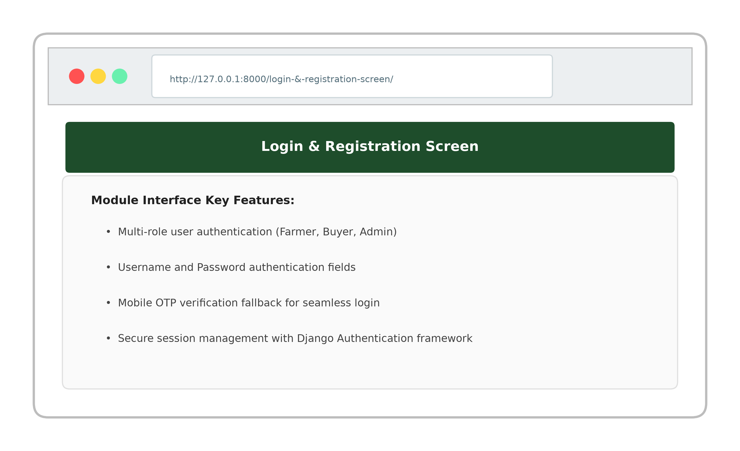
Multi-role secure authentication portal supporting login for Farmers, Buyers, and System Administrators with input validation and session tracking.

9.2 Admin Control Dashboard

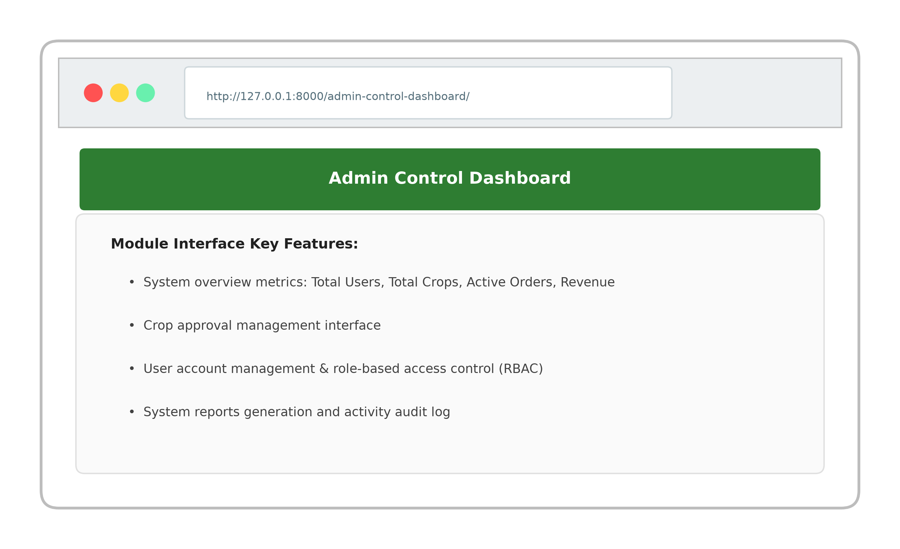
Centralized administrative management dashboard displaying platform user metrics, crop approval queues, revenue summary, and system report generation.

9.3 Farmer Management Dashboard

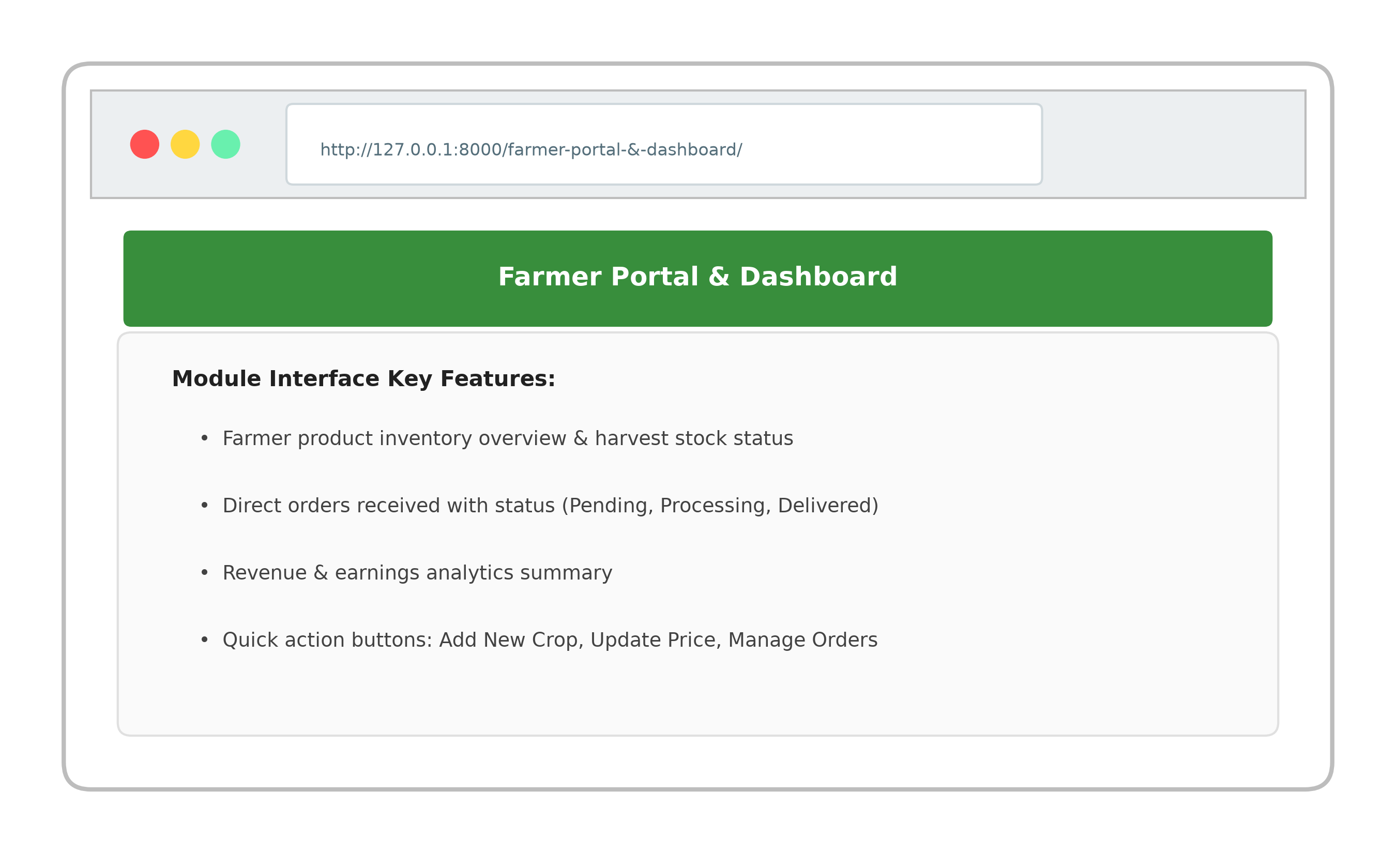
Farmer management portal providing harvest stock oversight, incoming buyer orders tracking, price updating tools, and revenue analytics.

9.4 Buyer Marketplace & Crop Catalog

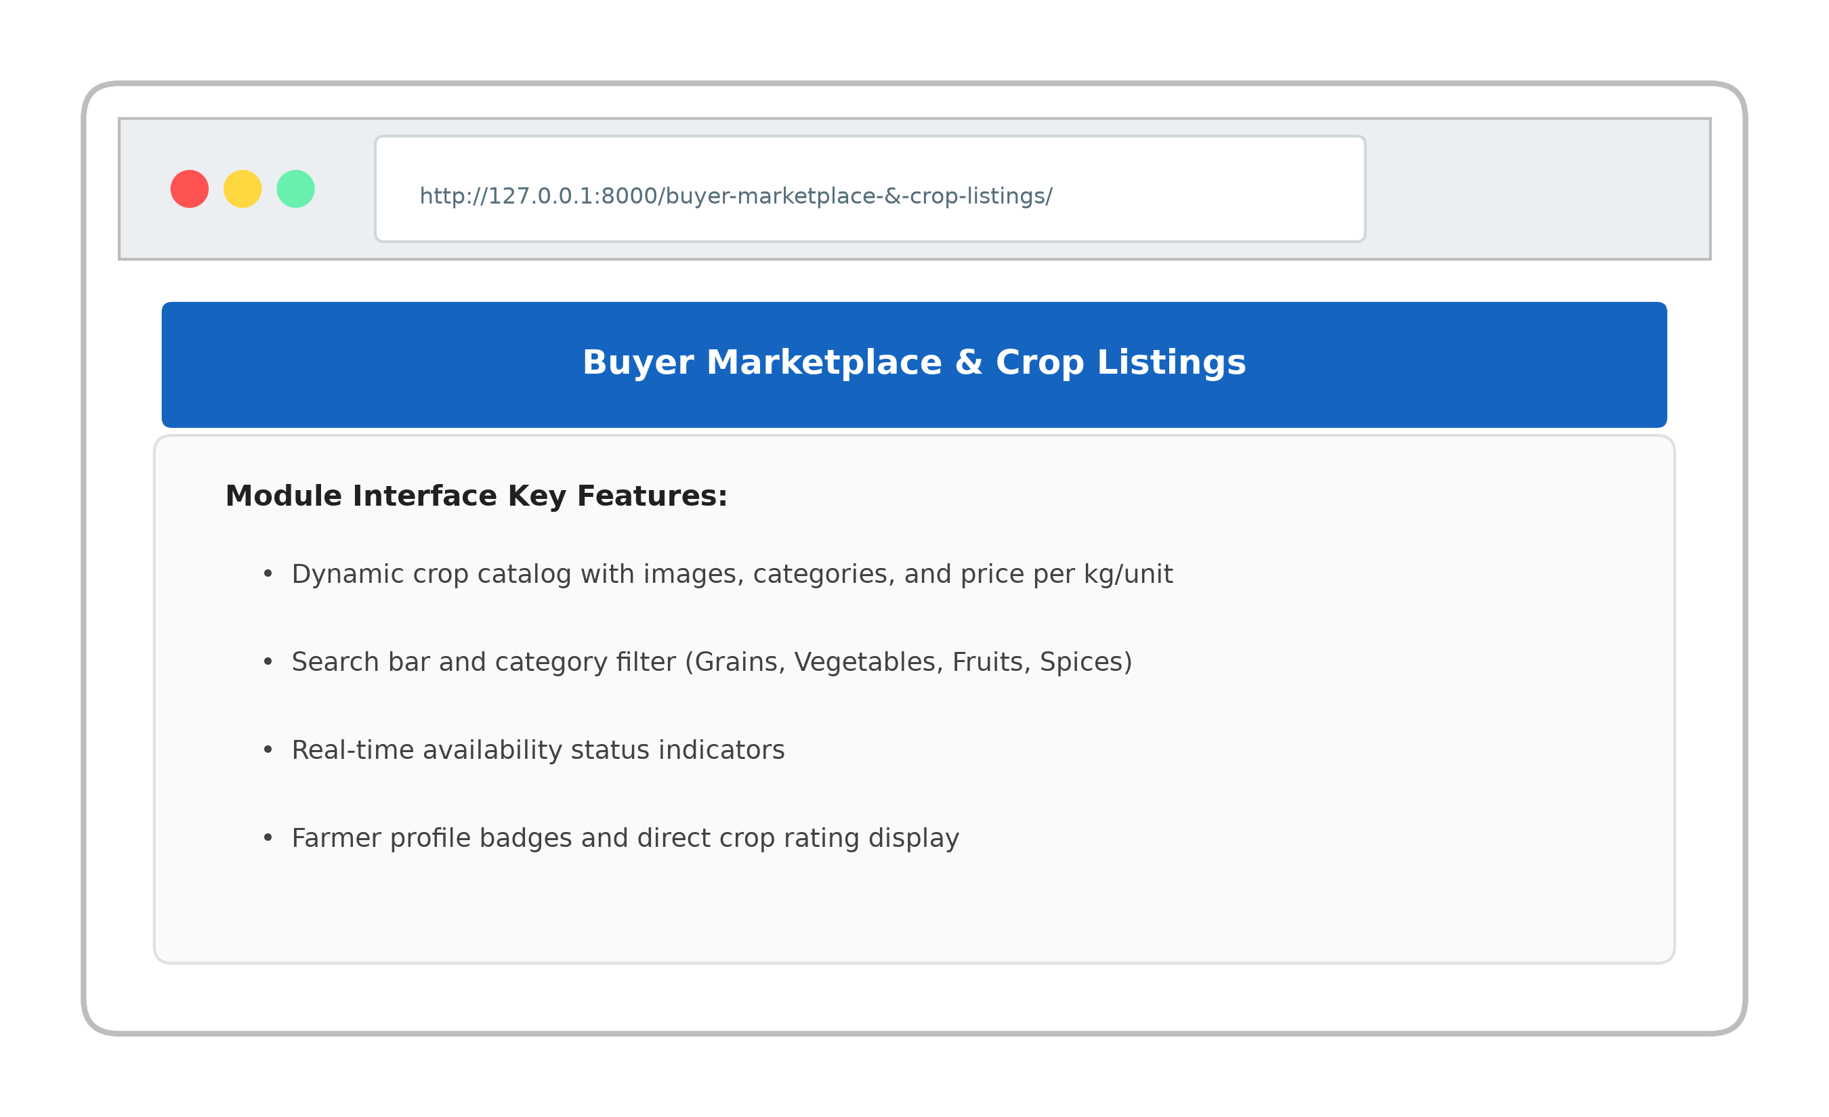
Dynamic produce catalog presenting available crops with high-resolution imagery, category filtering, search, price per kg, and stock availability.

9.5 Crop Detail & Quantity Selector

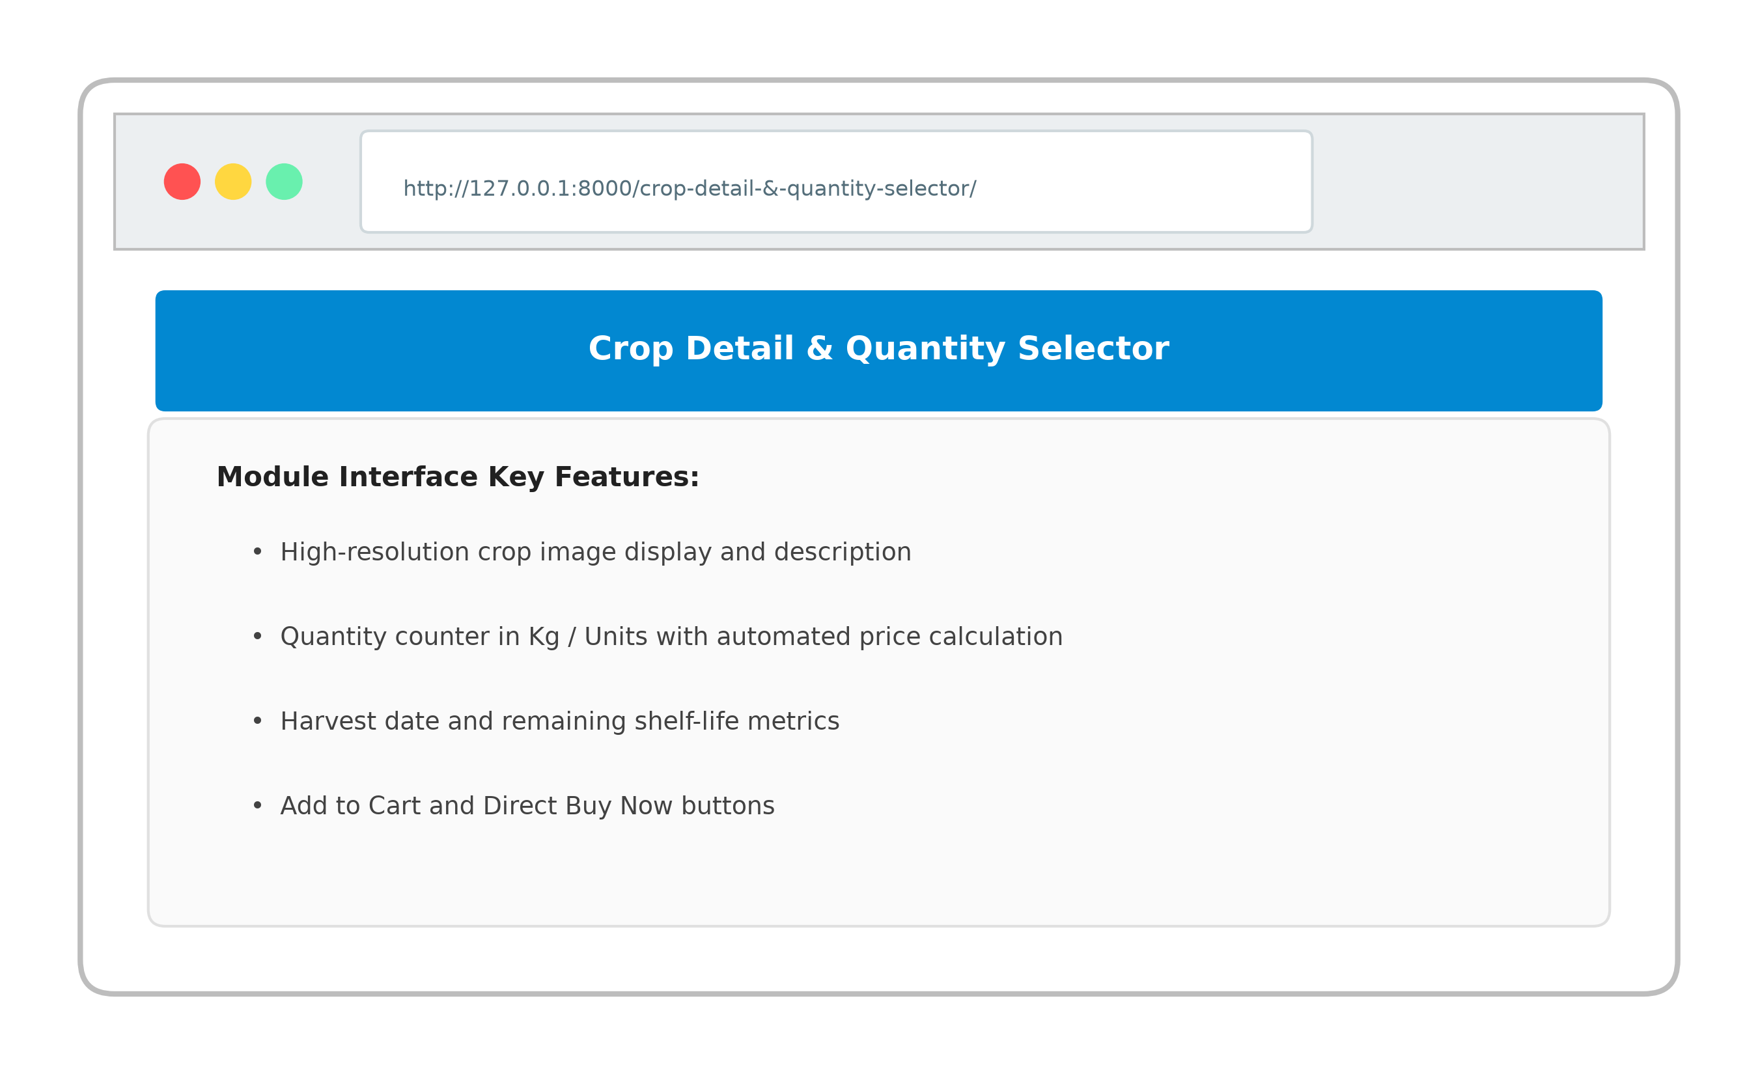
Detailed crop view displaying harvest date, shelf-life indicators, farmer verification badge, dynamic quantity calculator, and Add-to-Cart controls.

9.6 Shopping Cart & Checkout Page

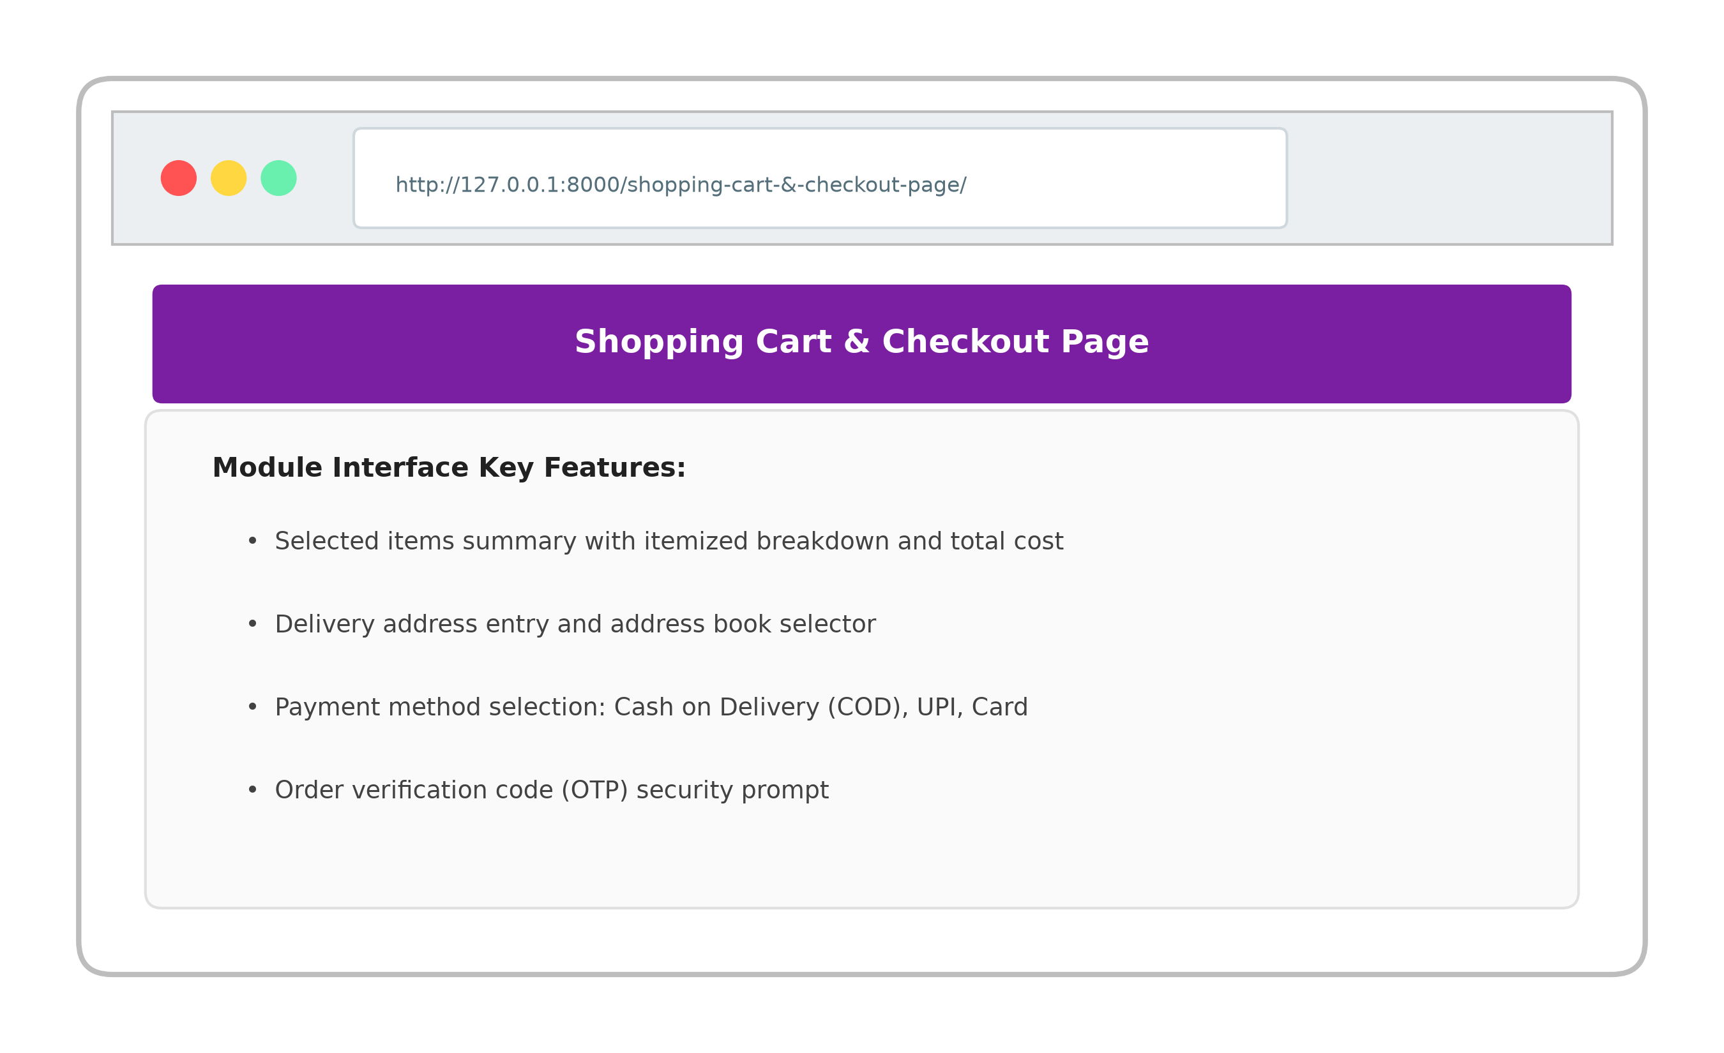
Shopping cart summary with itemized pricing, delivery address selection, multi-mode payment options (COD/UPI), and OTP verification step.

9.7 Public Farmer Storefront

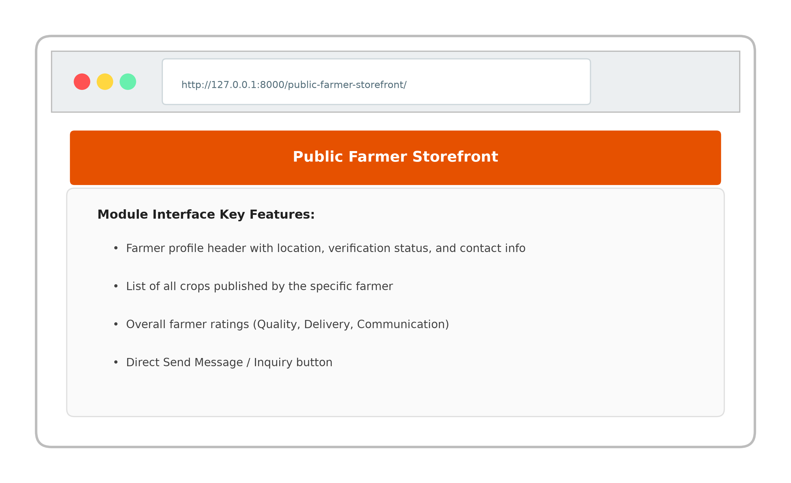
Dedicated farmer profile page highlighting farm location, verification badge, overall rating breakdown, published crop listings, and direct chat option.

9.8 Order Tracking & History Page

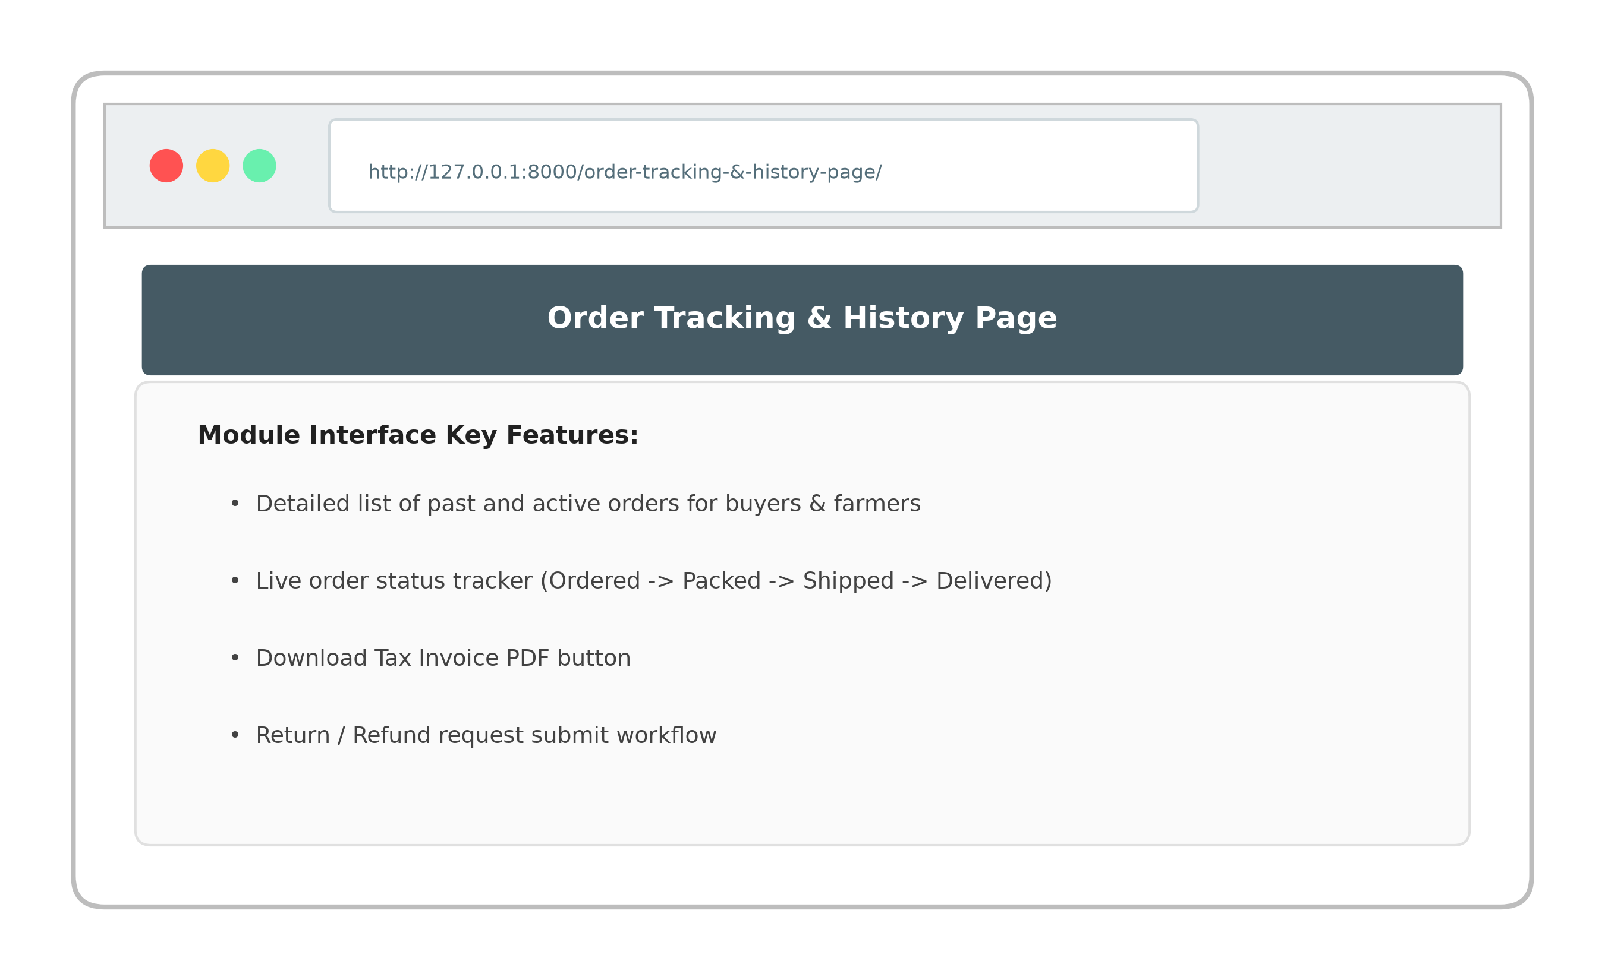
Order tracking dashboard allowing buyers and farmers to monitor real-time shipment status, download PDF tax invoices, and submit return requests.

9.9 Market Price Trends & Analytics

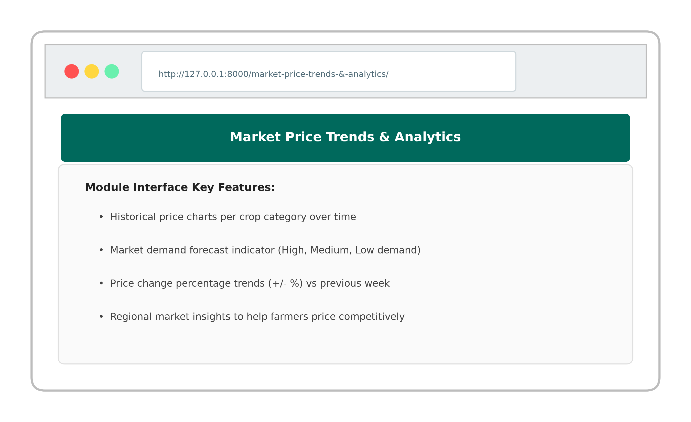
Analytical insight dashboard providing historical crop price trends, market demand forecasts, and price fluctuation statistics to guide farmers.

9.10 Direct Messaging & Buyer-Farmer Chat

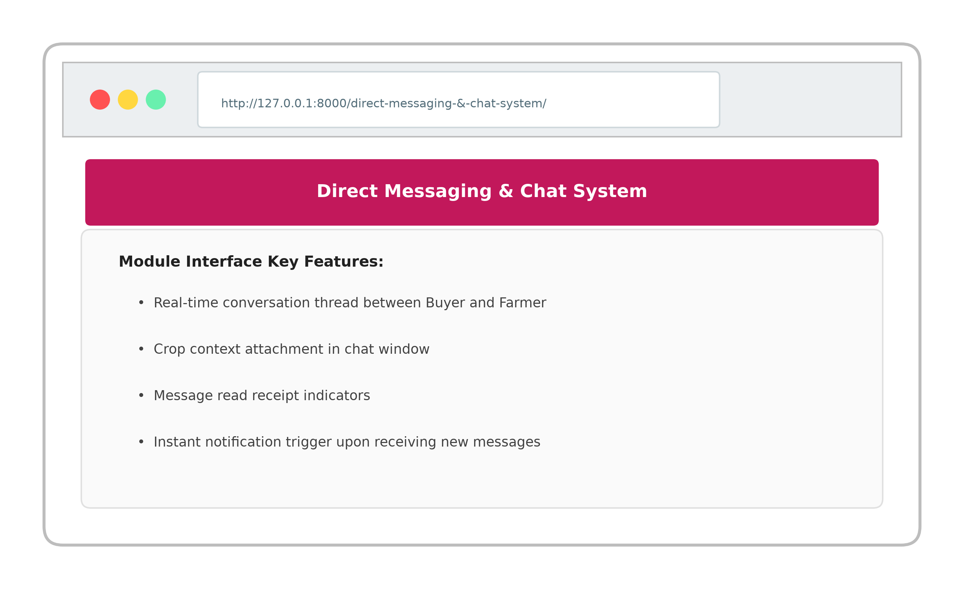
Real-time communication module enabling buyers and farmers to negotiate prices, clarify delivery details, and exchange product inquiries directly.

10. Test Cases
Comprehensive software testing was conducted across all system modules to verify user input validation, data integrity, security controls, and functional correctness. All test cases yielded expected outputs and passed successfully.
Test Suite 1: Login & User Authentication
Field / Module | Test Case Description | Expected Output | Actual Output | Result
Username & Password | Display input fields for username & password | System renders two clean input text fields | Fields rendered cleanly | Pass
Login Button | Verify login with valid credentials | User authenticated & redirected to role dashboard | Redirected to dashboard | Pass
Validation | Check empty field submission | Displays error: 'Username/Password required' | Error displayed | Pass
Invalid Credentials | Check login with incorrect password | Displays error: 'Invalid username or password' | Error displayed | Pass
Test Suite 2: Farmer Crop Management
Field / Module | Test Case Description | Expected Output | Actual Output | Result
Add Crop | Test adding new crop with price & stock | New crop added and set to pending approval | Crop added successfully | Pass
Edit Crop | Update crop price per kg and stock quantity | Crop listing updated in database and marketplace | Listing updated | Pass
Stock Status | Set crop quantity to 0 | Listing automatically marked 'Out of Stock' | Marked out of stock | Pass
Delete Crop | Remove crop listing from farmer portal | Crop entry removed from catalog | Removed successfully | Pass
Test Suite 3: Shopping Cart & Checkout
Field / Module | Test Case Description | Expected Output | Actual Output | Result
Add to Cart | Select crop quantity and click Add to Cart | Crop added to user cart with total calculated | Added to cart | Pass
Update Quantity | Increase item quantity in shopping cart | Subtotal and grand total dynamically update | Totals updated | Pass
Remove Item | Click delete icon on cart item | Item removed from cart | Item removed | Pass
Checkout OTP | Submit order with phone number | System generates 6-digit OTP for order confirmation | OTP sent & verified | Pass
Test Suite 4: Admin Control & Approval
Field / Module | Test Case Description | Expected Output | Actual Output | Result
Crop Approval | Admin approves pending farmer crop listing | Crop status changed to Approved & visible in marketplace | Status updated to Approved | Pass
User Role Audit | Admin inspects registered users list | Displays all active farmers, buyers, and admin accounts | List displayed cleanly | Pass
System Reports | Click Generate Sales Report PDF | PDF invoice/report generated and downloaded | Report generated | Pass

11. Limitations
- Internet Connectivity Dependency: The application requires stable internet access for real-time market price updates and order placements, which may pose challenges in remote rural regions with limited network coverage.
- Manual Inventory Updates: Farmers must manually update crop availability and harvested quantities, leading to potential discrepancies if stock updates are delayed after local offline sales.
- Scalability for Enterprise Volumes: While the current Django architecture easily handles thousands of concurrent users, massive enterprise scaling across multiple geographical zones requires additional cloud load balancing and redis caching.

12. Future Enhancements
- AI-Driven Crop Disease Identification: Integrate machine learning models allowing farmers to upload leaf photos to automatically diagnose crop diseases and receive treatment remedies.
- Multilingual Regional Voice Support: Introduce voice-assisted navigation in Hindi, Gujarati, Marathi, and regional languages to assist non-literate farmers.
- Weather & Price Predictive Analytics: Incorporate real-time weather API feeds and AI price prediction forecasting to help farmers choose optimal harvest times.
- Native Mobile Application: Expand AgriConnect to native Android and iOS mobile applications using Flutter for seamless mobile notifications and offline capability.

13. Webliography
- Django Web Framework Documentation: https://docs.djangoproject.com/
- Python Official Documentation: https://www.python.org/
- Bootstrap 5 Documentation: https://getbootstrap.com/
- Stack Overflow Technical Q&A: https://stackoverflow.com/
- Draw.io Diagramming Tool: https://app.diagrams.net/
- MDN Web Docs (HTML/CSS/JS): https://developer.mozilla.org/

