A Project Report On…
AgriConnect: Digital Agricultural Marketplace & Direct Farmer-to-Buyer Platform

Developed By…
krishna Gohil
(BCA Semester - 5)
Submitted To..
Geetanjali College Of Computer Science And Commerce ( B.C.A. )
Rajkot
Saurashtra University Rajkot
Academic Year: 2025 - 2026
Project Guide : PROF. Kishor Vala

Acknowledgements
- I am happy to submit my idea and implementation for the "AgriConnect - Agricultural Marketplace System" web application to Saurashtra University, Rajkot for a BCA degree in the Computer Science branch.

- I am also deeply grateful to Prof. Brijesh Shah, Head of the Department, and all faculty members of the Department of Computer Science for their kind guidance, constant encouragement, and technical support throughout this journey.

- I take the privilege to acknowledge the authors of numerous reference books, research publications, Django official documentation, and technical web blogs which we referred to during the development of this project.

- I express my heartfelt gratitude to my parents and family for their unwavering moral and financial support, without which I could accomplish nothing in my academic pursuits and personal life.

- The feeling of gratefulness for everyone's timely assistance directly arises from the bottom of my heart. Small but critical guidance during testing and database schema design proved to be significant milestones in completing this application.

Preface
- Practical training and software implementation are of paramount importance in understanding theoretical aspects of Computer Application & Web Software Development. Recognizing this importance, we prepared the "AgriConnect" project to enrich our practical knowledge regarding web technologies, full-stack architecture, and database management systems.

- We are very much pleased to present this comprehensive project report on "AgriConnect: Digital Agricultural Marketplace", developed at Geetanjali College of Computer Science and Commerce, affiliated with Saurashtra University.

- This report contains an exhaustive technical and functional overview of the entire project. Anyone with basic computer software knowledge can easily understand the contents of this report. System design is illustrated using Data Flow Diagrams (DFDs), Entity Relationship (ER) diagrams, exact Data Dictionary schema definitions, test cases, and screen illustrations.

- We have tried our best in practical study, systematic code structuring, and clear presentation of this report.

Index
Topic / Section Title | Page No.
1. Project Profile | 5
2. Software Development Life Cycle (SDLC) | 6
3. System Requirements (Hardware & Software) | 7
4. Development & Coding Standards | 9
5. About the Tool (Tools & Technologies Used) | 10
6. Data Flow Diagrams (DFD Level 0 & Level 1) | 11
7. Entity Relationship (ER) Diagram & Architecture | 13
8. Data Dictionary (Complete Database Schema) | 16
9. Screenshots & Module Descriptions | 24
10. Test Cases (Farmer, Buyer & Admin Modules) | 35
11. Limitations | 37
12. Future Enhancements | 38
13. Webliography | 39

1. Project Profile
Project Title: | AgriConnect: Digital Agricultural Marketplace System
Development Software: | Visual Studio Code, Python , Django Framework
Front End: | HTML5, CSS3, JavaScript , Bootstrap 5, FontAwesome
Backend / Logic: | Python, Django Web Framework (MVT Architecture)
Database: | MySQL Database Management System
Academic Year: | 2025 - 2026
Developed By: | Gohil Krishna (BCA Semester - 5)
Submitted To: | Geetanjali College Of Computer Science And Commerce, Rajkot
Documentation Tool: | Microsoft Word
Operating System: | Cross-platform (Windows 10/11, macOS, Linux)
Programming Language: | Python , JavaScript, HTML, CSS

2. Software Development Life Cycle (SDLC)
SDLC of AgriConnect – Smart Farmer Marketplace
1. Planning Phase
In the planning phase, the idea of developing AgriConnect was identified. The main objective was to create an online platform that connects farmers directly with buyers, reduces the role of middlemen, and provides fair pricing. The project scope, resources, and technologies were also decided.
2. Requirement Analysis Phase
The requirements of the system were collected and analyzed. The system should support three types of users: Admin, Farmer, and Buyer. Important features such as user registration, login, OTP verification, farmer profile management, buyer profile management, and farmer verification were identified.
3. System Design Phase
In this phase, the database structure and system architecture were designed. Tables such as User, Farmer, Buyer, and AuthOTP were created. Relationships between users and profiles were defined. User interface layouts and navigation flow were also planned.
4. Development Phase
The application was developed using Python, Django, MySQL, HTML, CSS, Bootstrap, and JavaScript. Modules for authentication, farmer management, buyer management, OTP verification, and role-based access control were implemented.
5. Testing Phase
The system was tested to ensure all features worked correctly. Registration, login, OTP verification, profile management, and user roles were tested. Errors and bugs found during testing were fixed to improve system reliability.
6. Deployment Phase
After successful testing, the project was deployed on a server. The database was configured, and the application was made accessible through a web browser for end users.
7. Maintenance Phase
After deployment, regular maintenance is performed. This includes fixing bugs, updating security features, improving performance, and adding new functionalities based on user requirements.

3. System Requirements
To successfully deploy, run, and maintain the AgriConnect project, the following hardware and software specifications are required:
Minimum Hardware Requirements:
Component / Resource | Minimum Specification
Operating System | Windows 10/11, macOS 11+, Linux Ubuntu 20.04+
CPU / Processor | Intel Core i3 / AMD Ryzen 3 Dual-Core (2.0 GHz or higher)
System RAM | 4 GB (8 GB recommended for optimal development)
Hard Disk Space | 20 GB available storage space
Display Resolution | 1280 x 720 HD Resolution or higher
Network Connection | Broadband Internet (for static CDN resources & deployment)
Software Requirements:
Software Tool / Component | Version / Specification
Runtime Environment | Python 3.12+ 64-bit Interpreter
Web Framework | Django 5.x Framework
Database Server | MySQL Database Server (v8.0+ / TiDB Cloud)
Frontend Stack | HTML5, CSS3, JavaScript (ES6+), Bootstrap 5.3
Web Server | Django WSGI / ASGI Dev Server (Apache 2.4 / Nginx in Production)
IDE / Source Editor | Visual Studio Code / PyCharm
Version Control | Git & GitHub Repository

4. Development & Coding Standards
To ensure maximum readability, maintainability, and scalability across the AgriConnect codebase, strict Python (PEP 8) and web engineering standards were enforced during implementation.
Naming Conventions:
- • File & Function Naming: Use snake_case for filenames, module names, Python variables, and function names (e.g., crop_detail_view, price_per_kg).
- • Class Naming: Use PascalCase for Django models, views, forms, and Python classes (e.g., Crop, CartItem, Wishlist).
- • Template Naming: Use lowercase snake_case for HTML template files placed under clear app folders (e.g., templates/marketplace/crop_detail.html).
Code Formatting & Structure:
- • Indentation: Consistently use 4 spaces per indentation level. Avoid tab characters to maintain environment consistency.
- • Line Length: Limit Python source code lines to 79-88 characters for enhanced visual readability and side-by-side editing.
- • Import Organization: Group imports logically: Standard library imports first, Third-party imports second, and Local app imports third.
Error Handling & Security Standards:
- • Exception Handling: Wrap database queries, file operations, and external API requests inside try-except blocks to gracefully capture runtime exceptions.
- • Access Control: Enforce @login_required and role-verification decorators on views to restrict unauthorized URL access.
- • Security Tokens: Include {% csrf_token %} on all HTML POST forms to prevent Cross-Site Request Forgery attacks.

5. About the Tool (Tools & Technologies Used)
Python Programming Language:
Python is a high-level, interpreted, object-oriented programming language known for its simple syntax, readability, and extensive standard library. Python powers the backend business logic and data manipulation of AgriConnect.
Django Web Framework:
Django is a high-level Python web framework that encourages rapid development and clean, pragmatic design. Built by experienced developers, it takes care of much of the hassle of web development. Django follows the Model-View-Template (MVT) architectural pattern and provides built-in Object-Relational Mapping (ORM), robust user authentication, form validation, and admin portal capabilities out of the box.
HTML5 & CSS3 & Bootstrap 5:
HTML5 provides semantic structure for web pages, while CSS3 handles responsive visual styling. Bootstrap 5, a popular front-end CSS framework, is integrated to ensure AgriConnect renders flawlessly on desktop displays, tablets, and smartphones.
MySQL Database Management System (DBMS):
MySQL is a high-performance, robust relational database management system (RDBMS) used to store and manage all relational data in AgriConnect. Structured database tables store user credentials, farmer profiles, crop inventories, shopping cart items, order transactions, payments, reviews, and market insights. In production, MySQL / TiDB Cloud is utilized to deliver enterprise-grade performance, ACID transaction safety, foreign key integrity, and high-concurrency reliability.
Visual Studio Code (VS Code):
VS Code is a lightweight but powerful source code editor running on desktop OS. It features built-in support for Python, HTML/CSS, Git version control, syntax highlighting, and interactive debugging.

6. Data Flow Diagrams (DFD)
Data Flow Diagrams graphically illustrate how data flows through the AgriConnect system, identifying external entities, process transformations, and internal database stores.
Data Flow Diagram (DFD Level 0 - Context Diagram):
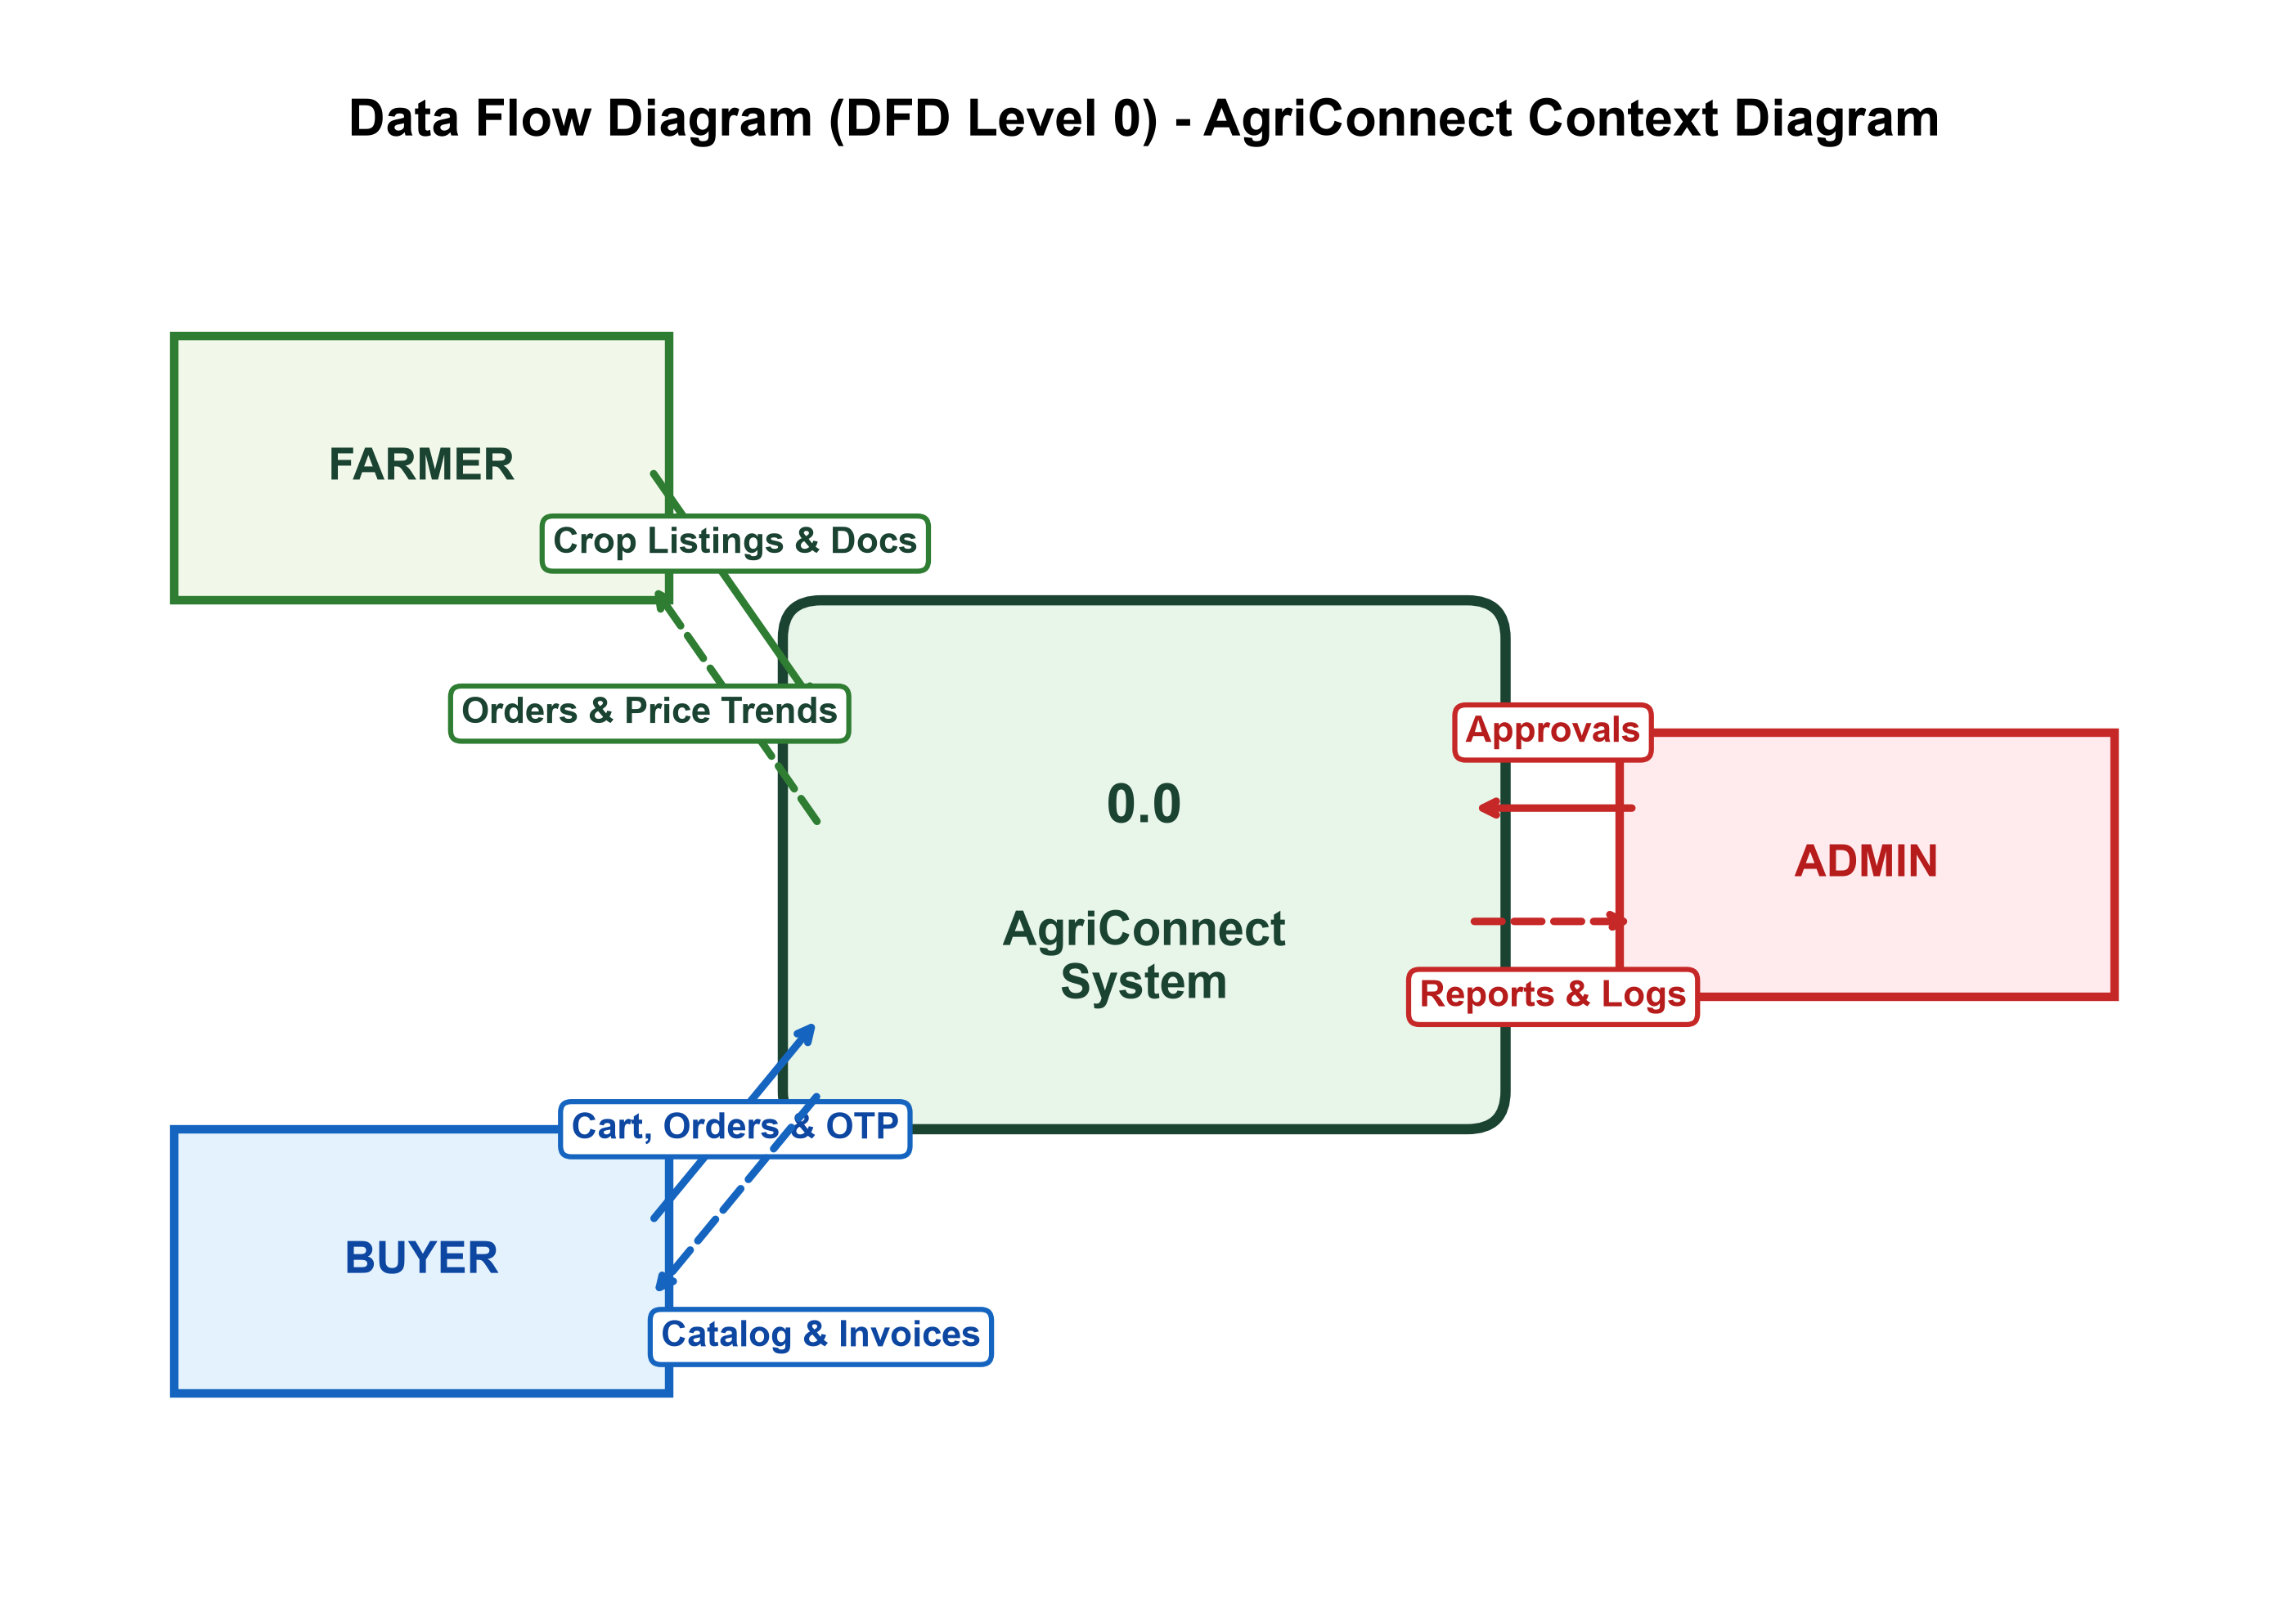
Figure 6.1: Context Diagram (DFD Level 0) illustrating high-level interactions between Farmers, Buyers, Admins, and the central AgriConnect platform.

Data Flow Diagram (DFD Level 1 - Process Breakdown):
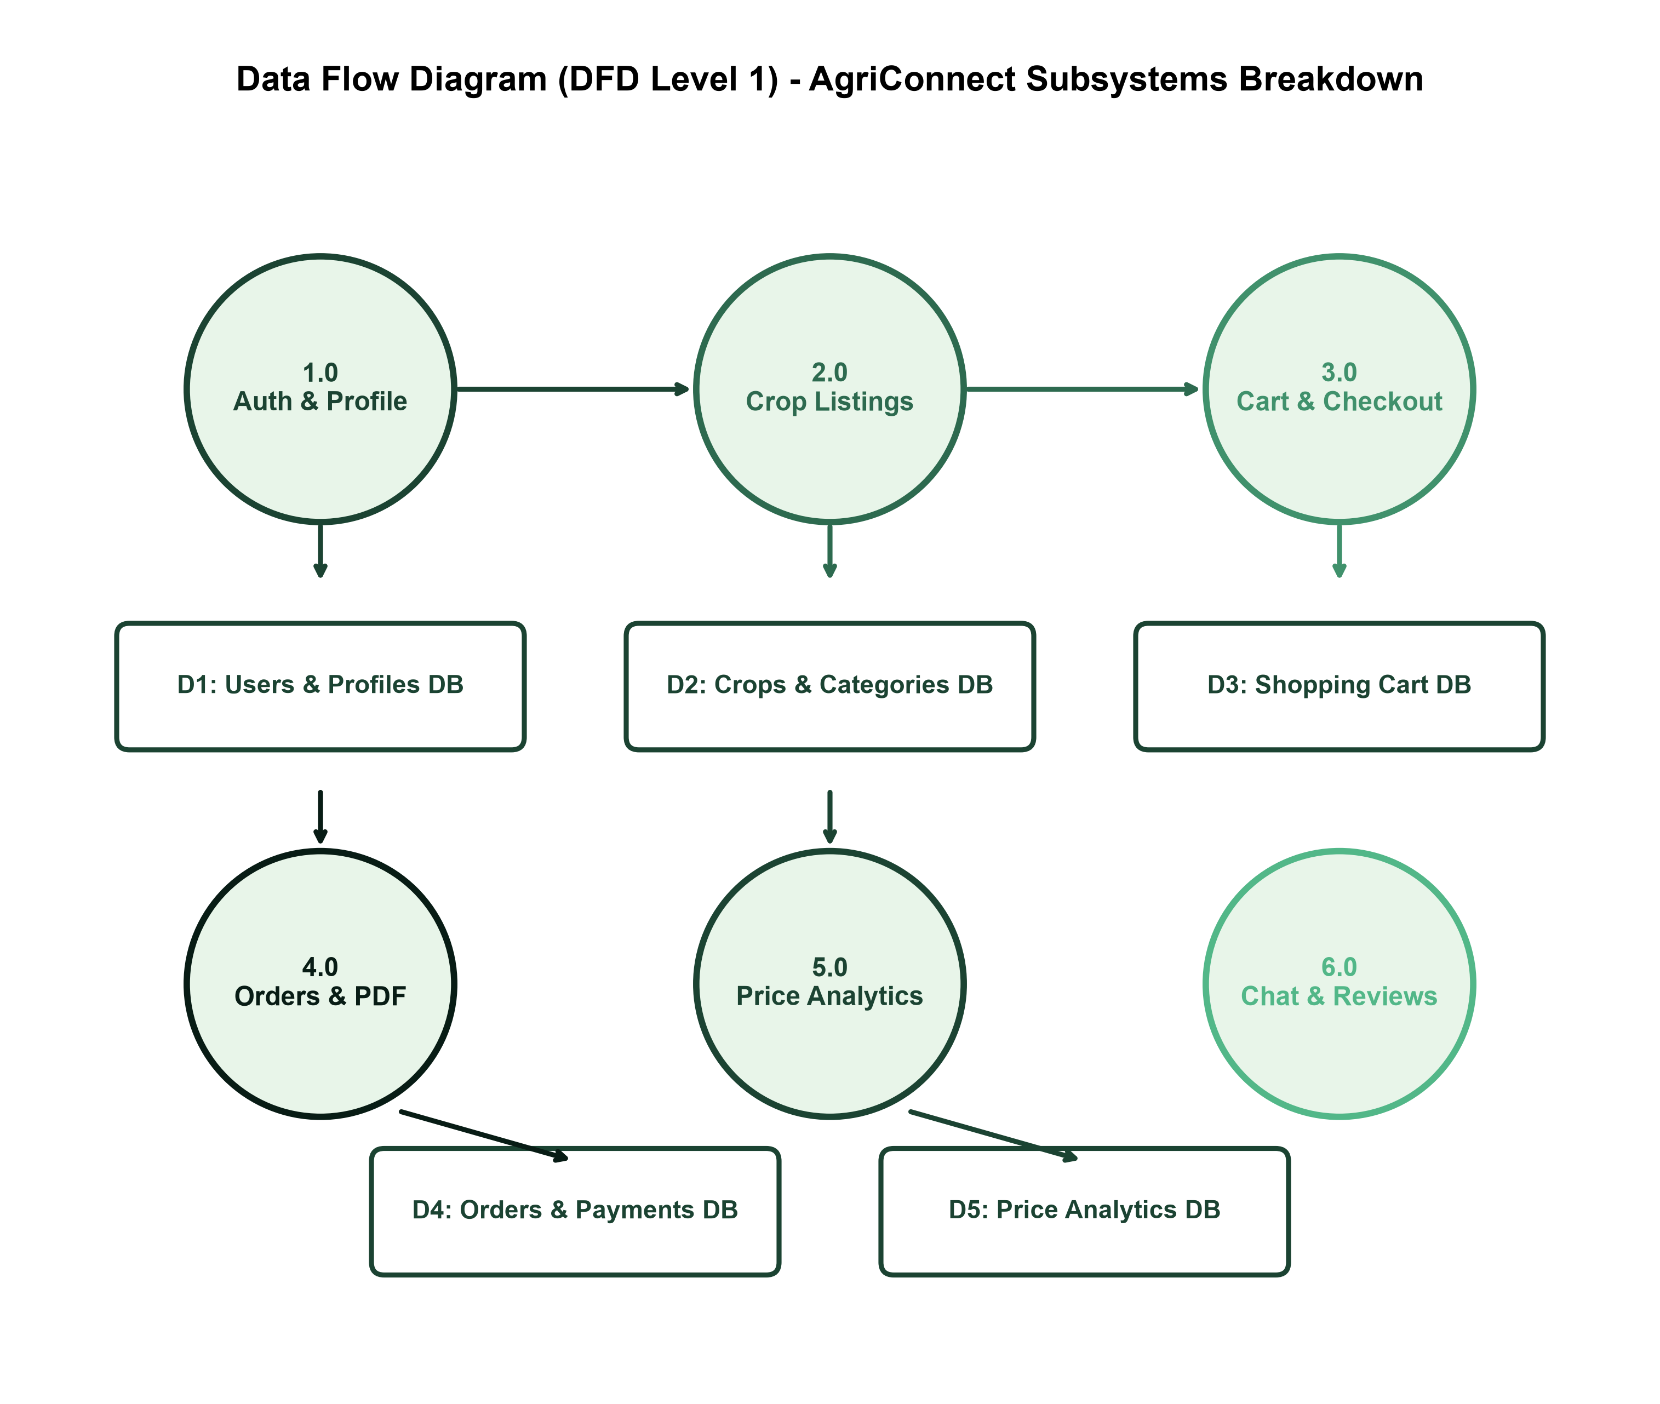
Figure 6.2: Detailed Process Breakdown (DFD Level 1) showing data paths between authentication, crop listing, shopping cart, order placement with OTP, payment, and database stores.

7. Entity Relationship (ER) Diagram & Architecture
Entity Relationship (ER) Diagram:
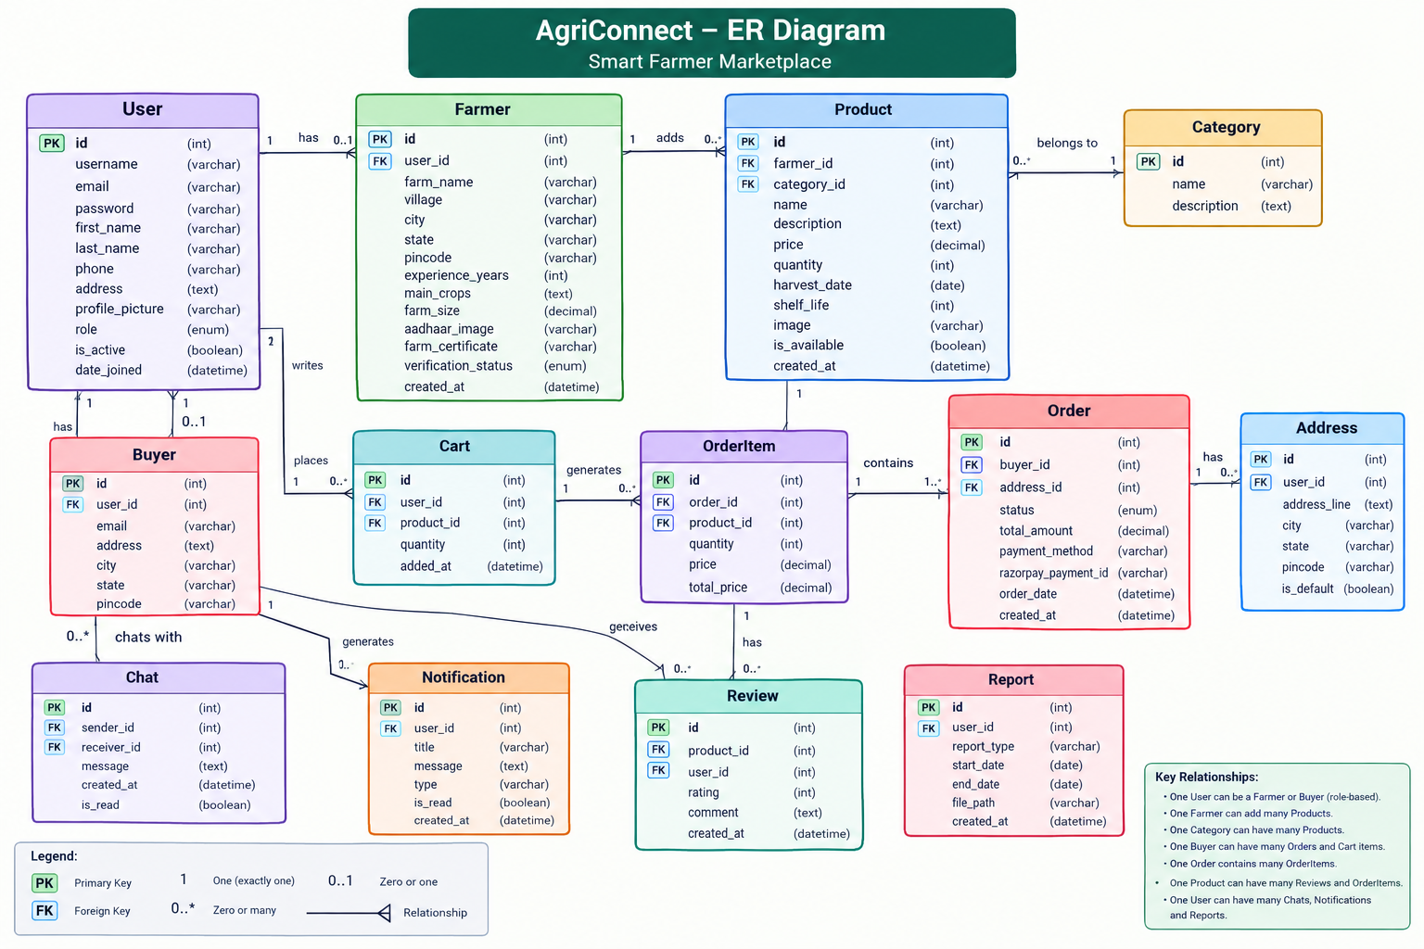

Figure 7.1: Entity Relationship Diagram depicting primary keys, foreign key constraints, and cardinalities between User, Crop, Category, Order, OrderItem, and Payment entities.

System Architecture Diagram:
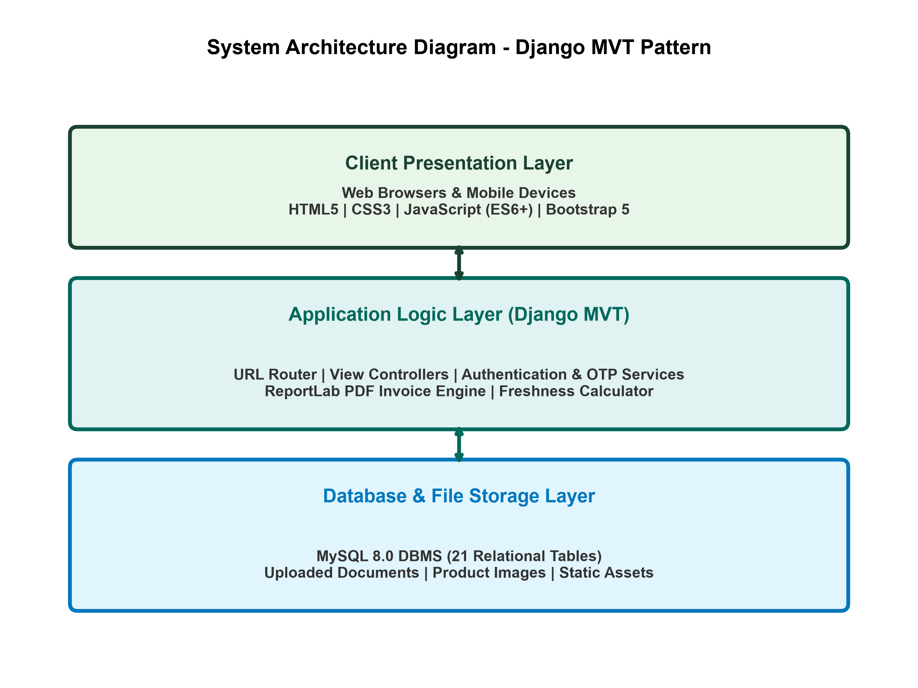
Figure 7.2: 3-Tier Architecture showing Presentation Layer, Django Application Server Layer, and Relational Database Storage Layer.

Use Case Diagram:
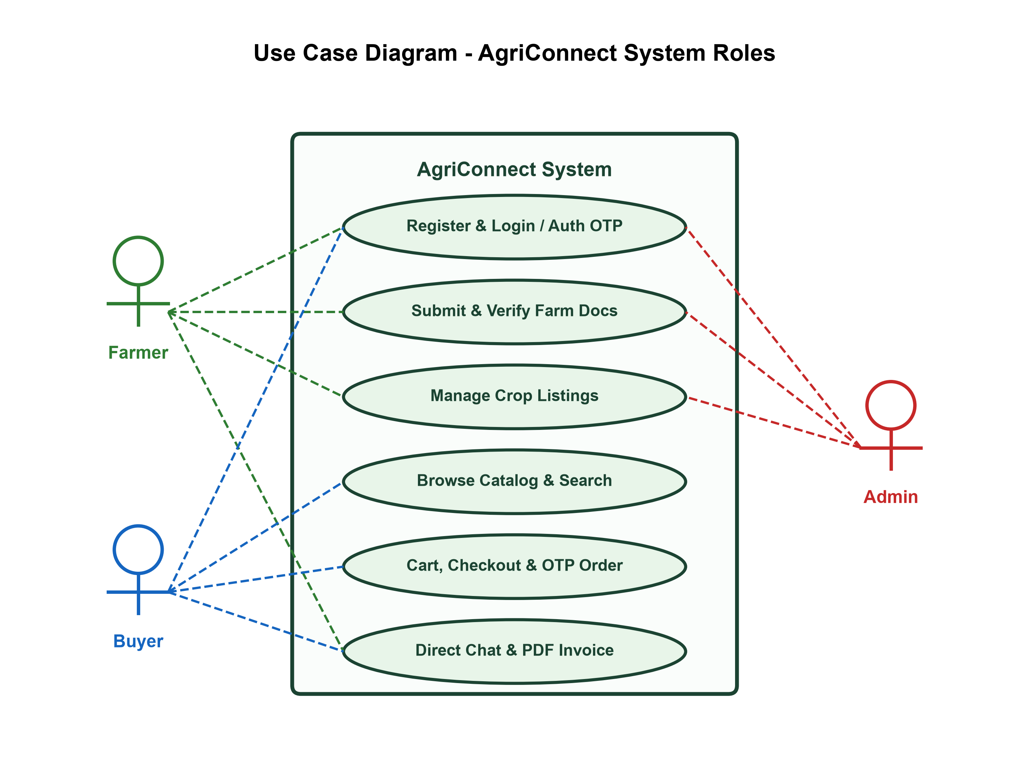
Figure 7.3: Use Case Diagram depicting interactions between Farmer, Buyer, and Admin roles.

8. Data Dictionary
The Data Dictionary provides the exact schema definition for all 25 active database tables used in the AgriConnect system. Each table entry lists column names, data types, and purpose.
Table 1: accounts_user (Custom User Model)
Column Name | Data Type | Null? | Constraint | Description
id | INT (PK, Auto) | No | Primary Key | Unique primary key
username | VARCHAR(150) | No | Unique | Unique login username
email | VARCHAR(254) | No | Unique | User email address
password | VARCHAR(128) | No | - | Hashed password string
first_name | VARCHAR(150) | Yes | - | User's first name
last_name | VARCHAR(150) | Yes | - | User's last name
role | VARCHAR(20) | Yes | - | Role: admin / farmer / buyer
phone | VARCHAR(15) | No | - | Contact phone number (optional)
address | TEXT | No | - | User's full address (optional)
profile_picture | VARCHAR(255) | - | - | File path to uploaded profile image
is_active | BOOLEAN | - | - | Account active/inactive status
is_staff | BOOLEAN | - | - | Django admin staff access flag
date_joined | DATETIME | - | - | Account registration timestamp

Table 2: accounts_farmer (Farmer Profile)
Column Name | Data Type | Null? | Constraint | Description
id | INT (PK, Auto) | No | Primary Key | Unique primary key
user_id | INT (FK → accounts_user) | No | FK (User) | One-to-one link to User record
farm_name | VARCHAR(100) | Yes | - | Name of the farmer's farm
farm_location | VARCHAR(255) | Yes | - | Farm address / location string
farm_size | VARCHAR(50) | Yes | - | Farm land area (e.g., 5 Acres)
specialization | VARCHAR(100) | No | - | Primary crop specialization
experience | VARCHAR(50) | No | - | Years of farming experience
about | TEXT | No | - | Farmer bio / about description
certification_status | VARCHAR(50) | No | - | verified / pending / none
certifications | TEXT | No | - | List of certifications held
awards | TEXT | Yes | - | Awards and recognitions
store_rating | FLOAT | Yes | - | Average customer rating (1.0–5.0)
orders_completed | INT | Yes | - | Total completed orders count
repeat_customers | INT | Yes | - | Count of repeat buyer transactions
ontime_delivery | INT | No | - | On-time delivery percentage (0–100)
satisfaction_rate | INT | No | - | Customer satisfaction percentage (0–100)
trust_score | INT | No | - | Calculated trust score (0–100)
verification_status | VARCHAR(20) | Yes | - | pending / review / approved / rejected / resubmit
verification_date | DATETIME | Yes | - | Date of admin approval
verified_by_id | INT (FK → accounts_user) | Yes | - | Admin who approved the verification
village | VARCHAR(100) | Yes | - | Village name
city | VARCHAR(100) | Yes | - | City name
state | VARCHAR(100) | No | - | State name
pincode | VARCHAR(10) | Yes | - | Postal / PIN code
cover_banner | VARCHAR(255) | Yes | - | File path to farm store cover image
organic_certificate | VARCHAR(255) | No | - | File path to organic certificate
aadhaar_document | VARCHAR(255) | Yes | - | File path to Aadhaar document
farm_certificate | VARCHAR(255) | Yes | FK (User) | File path to farm certificate
admin_notes | TEXT | Yes | - | Admin review notes for verification
approval_history | TEXT | Yes | - | History log of verification actions

Table 3: accounts_buyer (Buyer Profile)
Column Name | Data Type | Null? | Constraint | Description
id | INT (PK, Auto) | No | Primary Key | Unique primary key
user_id | INT (FK → accounts_user) | No | FK (User) | One-to-one link to User record
delivery_address | TEXT | Yes | - | Default delivery/shipping address
contact_name | VARCHAR(100) | Yes | - | Delivery recipient contact name
city | VARCHAR(100) | Yes | - | Buyer's city (used for delivery estimation)
state | VARCHAR(100) | Yes | - | Buyer's state
pincode | VARCHAR(10) | Yes | - | Buyer's postal code

Table 4: accounts_authotp (Authentication OTP)
Column Name | Data Type | Null? | Constraint | Description
id | INT (PK, Auto) | No | Primary Key | Unique primary key
user_id | INT (FK → accounts_user) | Yes | FK (User) | Associated user (nullable for pre-registration)
email | VARCHAR(254) | Yes | - | Target email address
otp_code | VARCHAR(6) | No | - | 6-digit OTP code
otp_type | VARCHAR(20) | No | - | Type: registration / password_reset
created_at | DATETIME | No | - | OTP creation timestamp
expires_at | DATETIME | No | - | OTP expiry timestamp
is_verified | BOOLEAN | No | - | Whether OTP was verified successfully
attempts | INT | No | - | Count of incorrect attempts
resend_count | INT | No | - | Count of OTP resend requests

Table 5: accounts_user_groups (User Groups - Django)
Column Name | Data Type | Null? | Constraint | Description
id | INT (PK, Auto) | No | Primary Key | Unique primary key
user_id | INT (FK → accounts_user) | No | Unique | Associated user
group_id | INT (FK → auth_group) | Yes | - | Associated permission group

Table 6: accounts_user_user_permissions (User Permissions - Django)
Column Name | Data Type | Null? | Constraint | Description
id | INT (PK, Auto) | No | Primary Key | Unique primary key
user_id | INT (FK → accounts_user) | No | FK (Farmer) | Associated user
permission_id | INT (FK → auth_permission) | No | FK (Category) | Associated individual permission

Table 7: marketplace_category (Crop Category)
Column Name | Data Type | Null? | Constraint | Description
id | INT (PK, Auto) | No | Primary Key | Unique primary key
name | VARCHAR(100) | No | FK (User) | Unique category name
description | TEXT | No | FK (Crop) | Optional category description
image | VARCHAR(255) | No | - | File path to category banner image

Table 8: marketplace_crop (Crop Product Listing)
Column Name | Data Type | Null? | Constraint | Description
id | INT (PK, Auto) | No | Primary Key | Unique primary key
farmer_id | INT (FK → accounts_farmer) | No | FK (User) | Farmer who listed the product
category_id | INT (FK → marketplace_category) | No | FK (Farmer) | Product category
name | VARCHAR(100) | No | - | Crop / product name
description | TEXT | No | - | Detailed product description
price_per_kg | DECIMAL(10,2) | No | - | Price per unit (kg/ton/piece/quintal)
quantity_available | DECIMAL(10,2) | No | - | Available stock quantity
unit | VARCHAR(20) | Yes | - | Unit: kg / ton / piece / quintal
image | VARCHAR(255) | No | - | File path to crop product image
is_approved | BOOLEAN | No | - | Admin approval status for listing
harvest_date | DATE | No | - | Crop harvest date
shelf_life_days | INT | Yes | - | Product shelf life duration in days
availability_status | VARCHAR(20) | Yes | - | available / out_of_stock
rating | DECIMAL(3,1) | No | - | Average product rating (1.0–5.0)
market_demand_level | VARCHAR(20) | Yes | - | Market demand: Low / Medium / High
market_forecast_direction | VARCHAR(20) | Yes | - | Price forecast: Stable / Rising / Falling
current_market_price | DECIMAL(10,2) | Yes | - | Current market reference price
market_price_history | JSON | - | - | Array of historical price data points
status_history | JSON | - | - | Admin status change history log
created_at | DATETIME | - | - | Listing creation timestamp
updated_at | DATETIME | - | - | Last modification timestamp

Table 9: marketplace_cartitem (Shopping Cart Item)
Column Name | Data Type | Null? | Constraint | Description
id | INT (PK, Auto) | No | Primary Key | Unique primary key
user_id | INT (FK → accounts_user) | No | FK (Order) | Cart owner
crop_id | INT (FK → marketplace_crop) | Yes | FK (Crop) | Product added to cart
quantity | INT | No | - | Quantity of product selected

Table 10: marketplace_order (Order Master Table)
Column Name | Data Type | Null? | Constraint | Description
id | INT (PK, Auto) | No | Primary Key | Unique primary key
buyer_id | INT (FK → accounts_user) | No | FK (Order) | Buyer who placed the order
farmer_id | INT (FK → accounts_farmer) | No | - | Farmer fulfilling the order
total_amount | DECIMAL(12,2) | Yes | - | Total order value in INR
payment_method | VARCHAR(20) | No | - | COD / Online
status | VARCHAR(20) | No | - | Pending / Confirmed / Out For Delivery / Delivered / Cancelled / Returned
shipping_address | TEXT | No | - | Complete delivery shipping address
invoice_pdf | VARCHAR(255) | - | - | File path to generated invoice PDF
otp_code | VARCHAR(6) | - | - | Delivery confirmation OTP code
otp_expires_at | DATETIME | - | - | OTP expiry timestamp
is_otp_verified | BOOLEAN | - | - | Delivery OTP verified status
return_reason | VARCHAR(50) | - | - | Return reason if applicable
return_description | TEXT | - | - | Detailed return justification text
return_status | VARCHAR(20) | - | - | Return status: Pending / Approved / Rejected
status_history | JSON | - | - | Full timeline of all status changes
created_at | DATETIME | - | - | Order creation timestamp
updated_at | DATETIME | - | - | Last order update timestamp

Table 11: marketplace_orderitem (Order Line Items)
Column Name | Data Type | Null? | Constraint | Description
id | INT (PK, Auto) | No | Primary Key | Unique primary key
order_id | INT (FK → marketplace_order) | No | FK (User) | Parent order reference
crop_id | INT (FK → marketplace_crop) | Yes | FK (Crop) | Crop ordered (SET NULL if crop deleted)
quantity | DECIMAL(10,2) | Yes | FK (Farmer) | Quantity of crop ordered
price_per_unit | DECIMAL(10,2) | Yes | - | Price locked at time of order placement

Table 12: marketplace_payment (Payment Transaction)
Column Name | Data Type | Null? | Constraint | Description
id | INT (PK, Auto) | No | Primary Key | Unique primary key
order_id | INT (FK → marketplace_order) | No | FK (User) | One-to-one link to Order
payment_method | VARCHAR(50) | No | - | Payment method used
transaction_id | VARCHAR(100) | No | - | External payment gateway transaction ID
status | VARCHAR(20) | No | - | Pending / Completed / Failed
amount | DECIMAL(12,2) | Yes | - | Payment amount in INR
created_at | DATETIME | No | - | Payment record creation timestamp

Table 13: marketplace_orderotp (Order Confirmation OTP)
Column Name | Data Type | Null? | Constraint | Description
id | INT (PK, Auto) | No | Primary Key | Unique primary key
user_id | INT (FK → accounts_user) | No | FK (User) | User initiating the checkout
otp_code | VARCHAR(6) | No | FK (User) | 6-digit OTP code
shipping_address | TEXT | Yes | FK (Crop) | Shipping address captured at checkout
payment_method | VARCHAR(50) | No | - | Payment method selected at checkout
created_at | DATETIME | No | - | OTP generation timestamp
expires_at | DATETIME | No | - | OTP expiry timestamp
resend_count | INT | - | - | Number of OTP resend requests
is_verified | BOOLEAN | - | - | True when OTP verified and order placed

Table 14: marketplace_orderstatushistory (Order Status History)
Column Name | Data Type | Null? | Constraint | Description
id | INT (PK, Auto) | No | Primary Key | Unique primary key
order_id | INT (FK → marketplace_order) | No | FK (User) | Parent order being tracked
status | VARCHAR(50) | No | FK (Crop) | New status value applied
changed_at | DATETIME | No | - | Timestamp of the status change
changed_by_id | INT (FK → accounts_user) | - | - | User who triggered the status change

Table 15: marketplace_review (Customer Crop & Farmer Review)
Column Name | Data Type | Null? | Constraint | Description
id | INT (PK, Auto) | No | Primary Key | Unique primary key
buyer_id | INT (FK → accounts_user) | No | FK (User) | Buyer submitting the review
crop_id | INT (FK → marketplace_crop) | No | FK (Farmer) | Reviewed crop listing (nullable)
farmer_id | INT (FK → accounts_farmer) | No | - | Reviewed farmer (nullable)
rating | INT | No | - | Overall star rating (1–5)
quality_rating | INT | No | - | Product quality sub-rating
communication_rating | INT | No | - | Farmer communication sub-rating
delivery_rating | INT | No | - | Delivery speed sub-rating
packaging_rating | INT | Yes | - | Packaging quality sub-rating
title | VARCHAR(200) | No | - | Review headline / title
comment | TEXT | - | - | Full review text body
image | VARCHAR(255) | - | - | File path to review attached image
reply | TEXT | - | - | Farmer's public reply to the review
reply_at | DATETIME | - | - | Timestamp of farmer's reply
created_at | DATETIME | - | - | Review submission timestamp

Table 16: marketplace_review_helpful_votes (Review Helpful Votes)
Column Name | Data Type | Null? | Constraint | Description
id | INT (PK, Auto) | No | Primary Key | Unique primary key
review_id | INT (FK → marketplace_review) | No | FK (User) | Review being voted on
user_id | INT (FK → accounts_user) | No | - | User who marked the review as helpful

Table 17: marketplace_notification (System Notification)
Column Name | Data Type | Null? | Constraint | Description
id | INT (PK, Auto) | No | Primary Key | Unique primary key
user_id | INT (FK → accounts_user) | No | - | Notification recipient
message | TEXT | No | FK (Category) | Notification message content
notification_type | VARCHAR(20) | No | - | Type: order / price / weather / system / review / product / verification
priority | VARCHAR(10) | No | - | Priority: high / medium / low
link | VARCHAR(200) | - | - | Optional action URL link
is_read | BOOLEAN | - | - | Whether user has read the notification
created_at | DATETIME | - | - | Notification creation timestamp

Table 18: marketplace_feedback (Platform Feedback)
Column Name | Data Type | Null? | Constraint | Description
id | INT (PK, Auto) | No | Primary Key | Unique primary key
user_id | INT (FK → accounts_user) | No | - | User who submitted the feedback
subject | VARCHAR(200) | No | FK (Category) | Feedback subject / topic line
message | TEXT | No | - | Detailed feedback message body
is_resolved | BOOLEAN | No | - | Admin resolution status
created_at | DATETIME | No | - | Feedback submission timestamp

Table 19: marketplace_farmerrating (Farmer Rating & Evaluation)
Column Name | Data Type | Null? | Constraint | Description
id | INT (PK, Auto) | No | Primary Key | Unique primary key
buyer_id | INT (FK → accounts_user) | No | FK (Order) | Buyer submitting the rating
farmer_id | INT (FK → accounts_farmer) | No | - | Farmer being rated
rating | INT | Yes | - | Overall farmer rating (1–5)
quality_rating | INT | No | - | Product quality sub-rating
communication_rating | INT | No | - | Communication sub-rating
delivery_rating | INT | - | - | Delivery timeliness sub-rating
packaging_rating | INT | - | - | Packaging quality sub-rating
comment | TEXT | - | - | Optional review comment
created_at | DATETIME | - | - | Rating submission timestamp

Table 20: marketplace_wishlist (Saved Crops Wishlist)
Column Name | Data Type | Null? | Constraint | Description
id | INT (PK, Auto) | No | Primary Key | Unique primary key
user_id | INT (FK → accounts_user) | No | - | Buyer who saved the crop
crop_id | INT (FK → marketplace_crop) | No | - | Saved crop listing
added_at | DATETIME | No | FK (User) | Timestamp when item was bookmarked

Table 21: marketplace_marketinsight (Market Forecast & Analytics)
Column Name | Data Type | Null? | Constraint | Description
id | INT (PK, Auto) | No | Primary Key | Unique primary key
crop_name | VARCHAR(100) | No | FK (User) | Name of the crop
category_id | INT (FK → marketplace_category) | No | - | Associated product category
current_price | DECIMAL(10,2) | No | - | Current market price per unit
price_change_percent | DECIMAL(5,2) | No | - | Percentage price change
demand_level | VARCHAR(20) | No | - | Market demand: Low / Medium / High
forecast_direction | VARCHAR(20) | No | - | Price forecast: Stable / Rising / Falling
region | VARCHAR(100) | No | - | Geographic market region
volume_tonnes | INT | No | - | Trade volume in metric tonnes
record_date | DATE | - | - | Date of market insight record

Table 22: marketplace_pricetrend (Crop Market Price Trend)
Column Name | Data Type | Null? | Constraint | Description
id | INT (PK, Auto) | No | Primary Key | Unique primary key
crop_name | VARCHAR(100) | No | - | Name of the crop
category_id | INT (FK → marketplace_category) | No | FK (Category) | Associated product category
avg_price | DECIMAL(10,2) | No | - | Average market price on record date
record_date | DATE | No | - | Date of the price data record

Table 23: marketplace_report (System & Sales Reports)
Column Name | Data Type | Null? | Constraint | Description
id | INT (PK, Auto) | No | Primary Key | Unique primary key
name | VARCHAR(200) | No | - | Report display name / title
report_type | VARCHAR(50) | No | - | Type: sales / inventory / market / etc.
generated_by_id | INT (FK → accounts_user) | No | FK (User) | User who generated the report
format | VARCHAR(10) | No | - | File format: pdf / csv / xlsx
file | VARCHAR(255) | Yes | - | File path to generated report file
download_count | INT | No | - | Number of times the report was downloaded
scheduled_interval | VARCHAR(20) | Yes | - | Schedule: daily / weekly / monthly
created_at | DATETIME | No | - | Report generation timestamp

Table 24: marketplace_adminactivitylog (Admin Activity Log)
Column Name | Data Type | Null? | Constraint | Description
id | INT (PK, Auto) | No | Primary Key | Unique primary key
admin_id | INT (FK → accounts_user) | No | FK (User) | Admin user who performed the action
action | VARCHAR(255) | No | - | Human-readable description of the action
target_model | VARCHAR(100) | Yes | - | Model / entity affected by the action
target_id | INT | Yes | - | Primary key of the affected record
created_at | DATETIME | No | - | Timestamp of the admin action

Table 25: marketplace_emaillog (Email Delivery Log)
Column Name | Data Type | Null? | Constraint | Description
id | INT (PK, Auto) | No | Primary Key | Unique primary key
recipient | VARCHAR(254) | No | - | Recipient email address
subject | VARCHAR(255) | No | - | Email subject line
status | VARCHAR(20) | No | - | Email status: sent / failed
created_at | DATETIME | No | - | Email dispatch timestamp

9. Screen Shots & Module Descriptions
This section presents visual screen captures and detailed functional descriptions for all major modules of the AgriConnect system across Farmer, Buyer, and Admin porta

. 9.1 Home Page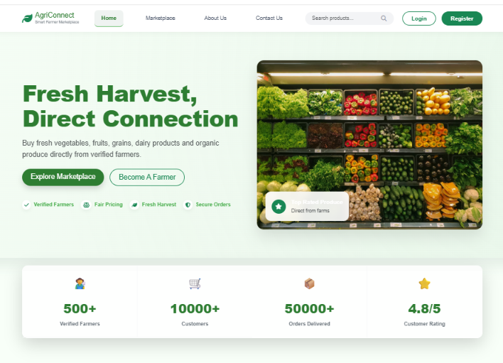
The Home Page provides a user-friendly platform for exploring fresh farm products and connecting farmers directly with buyers.

. 9.2 Registration Page
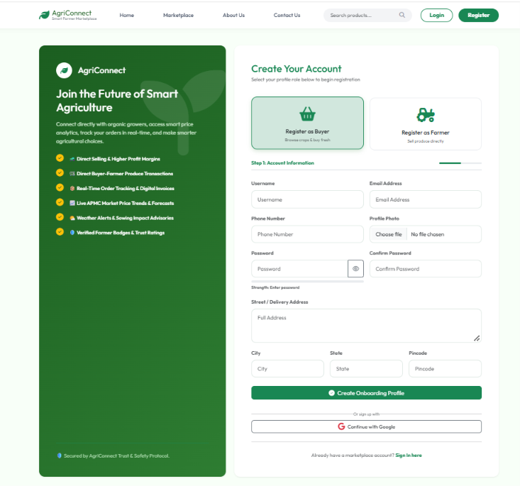
The Registration Page allows buyers and farmers to create an account by entering personal details, selecting their role, and securely joining the AgriConnect marketplace.

9.3 Login & Authentication Screen
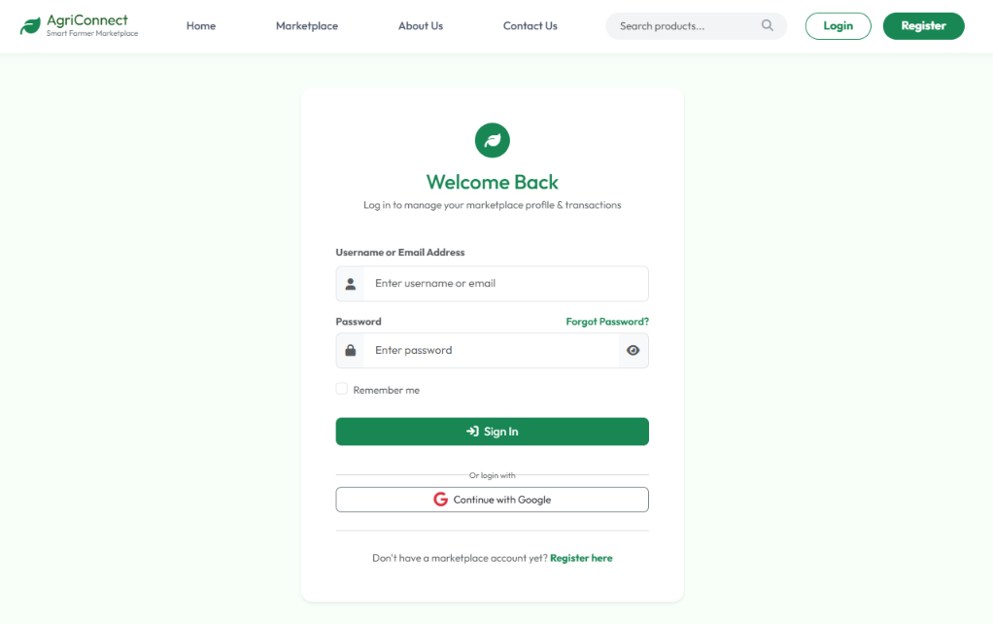
Multi-role secure authentication portal supporting login for Farmers, Buyers, and System Administrators with input validation and session tracking.

9.4 Admin Control Dashboard

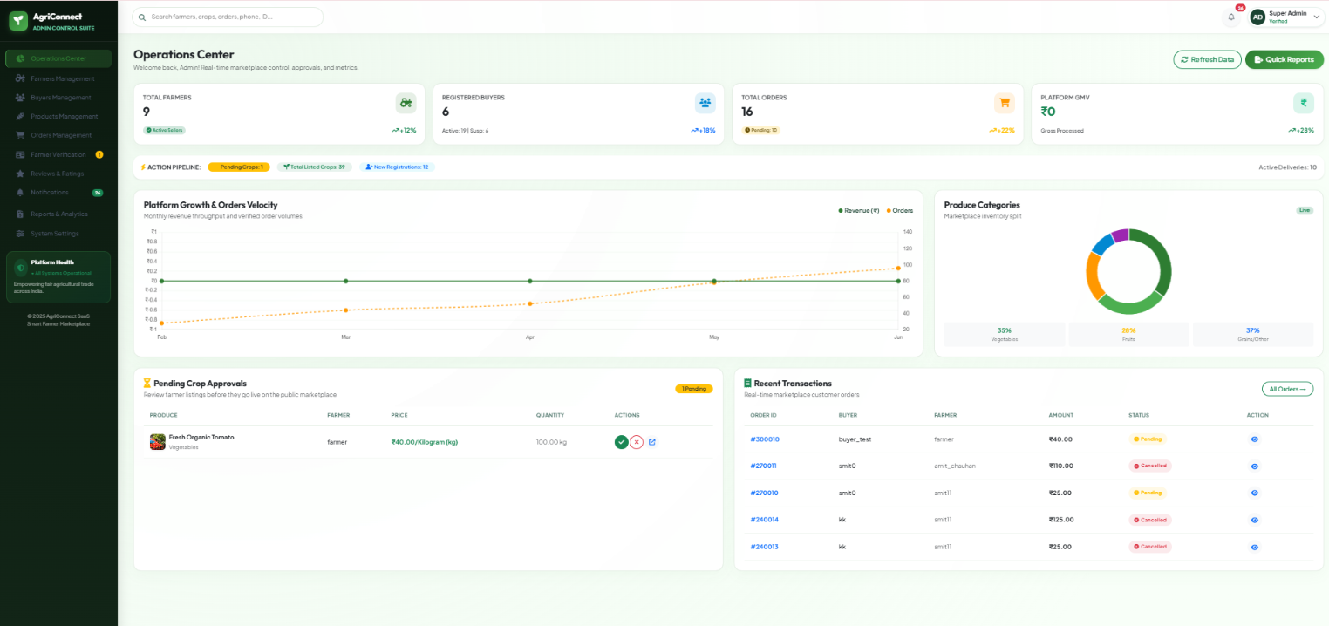
Centralized administrative management dashboard displaying platform user metrics, crop approval queues, revenue summary, and system report generation.

9.5 Farmer Management Dashboard

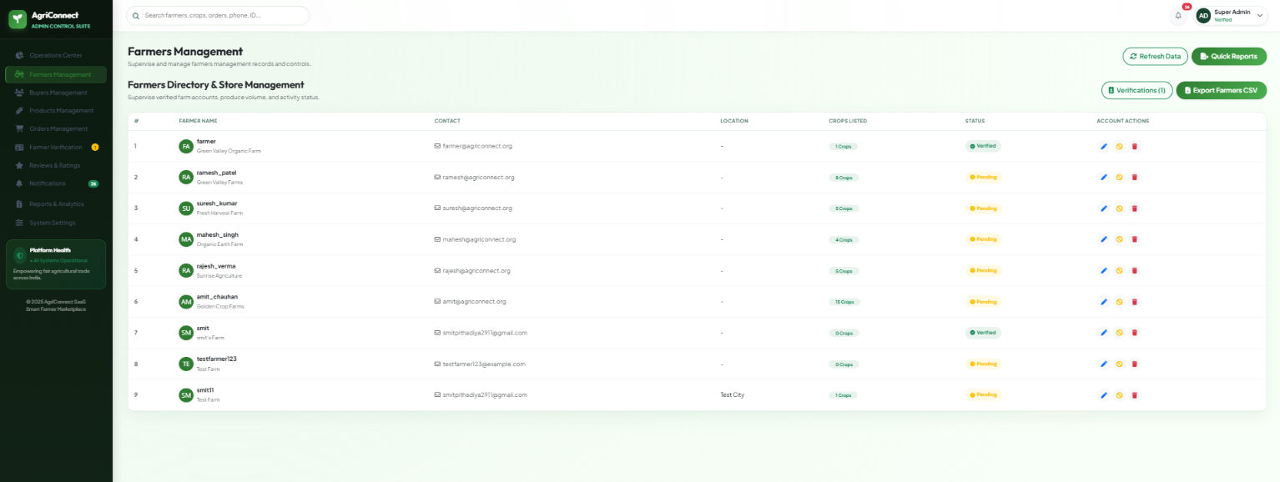
Farmer management portal providing harvest stock oversight, incoming buyer orders tracking, price updating tools, and revenue analytics.

9.6 Buyer Marketplace & Crop Catalog
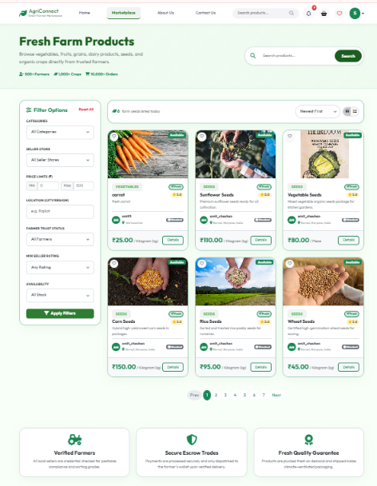

Dynamic produce catalog presenting available crops with high-resolution imagery, category filtering, search, price per kg, and stock availability.

9.7 Crop Detail & Quantity Selector

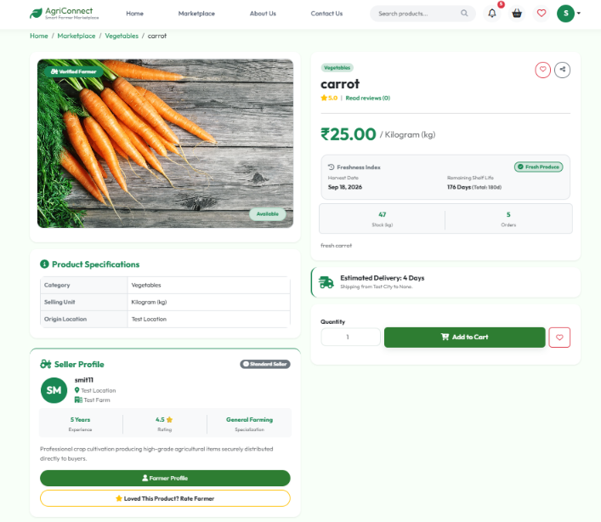
Detailed crop view displaying harvest date, shelf-life indicators, farmer verification badge, dynamic quantity calculator, and Add-to-Cart controls.

9.8 Shopping Cart & Checkout Page

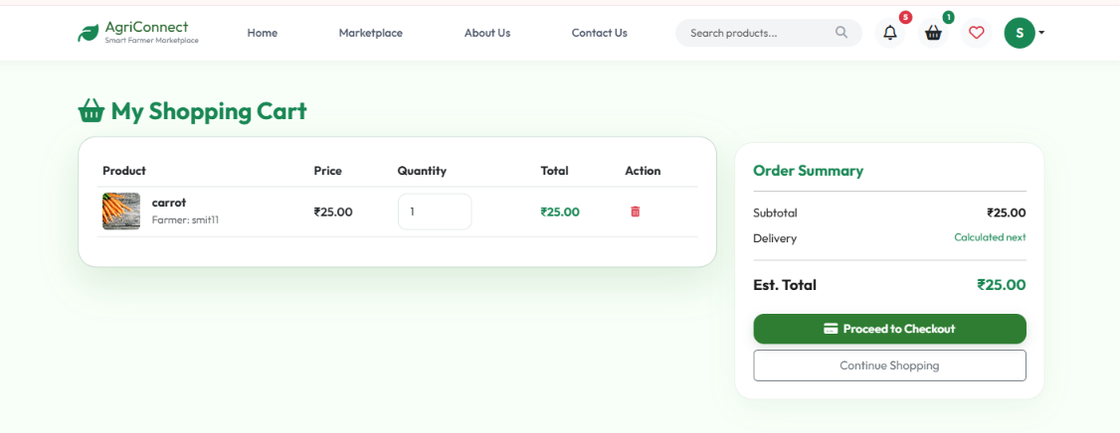
Shopping cart summary with itemized pricing, delivery address selection, multi-mode payment options (COD/UPI), and OTP verification step.

9.9 Order Tracking & History Page

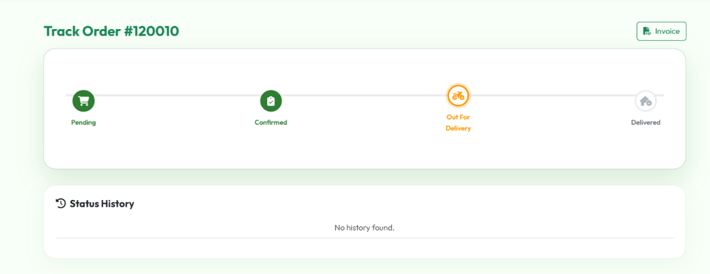
Order tracking dashboard allowing buyers and farmers to monitor real-time shipment status, download PDF tax invoices, and submit return requests.

9.10 Market Price Trends & Analytics

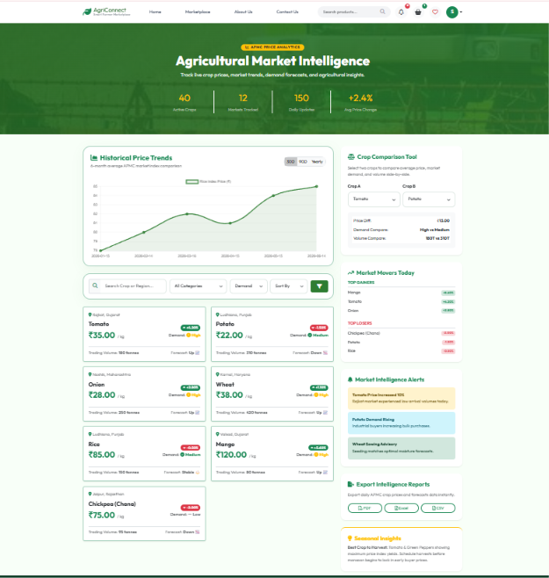
Analytical insight dashboard providing historical crop price trends, market demand forecasts, and price fluctuation statistics to guide farmers.

9.11 order confirm otp verification
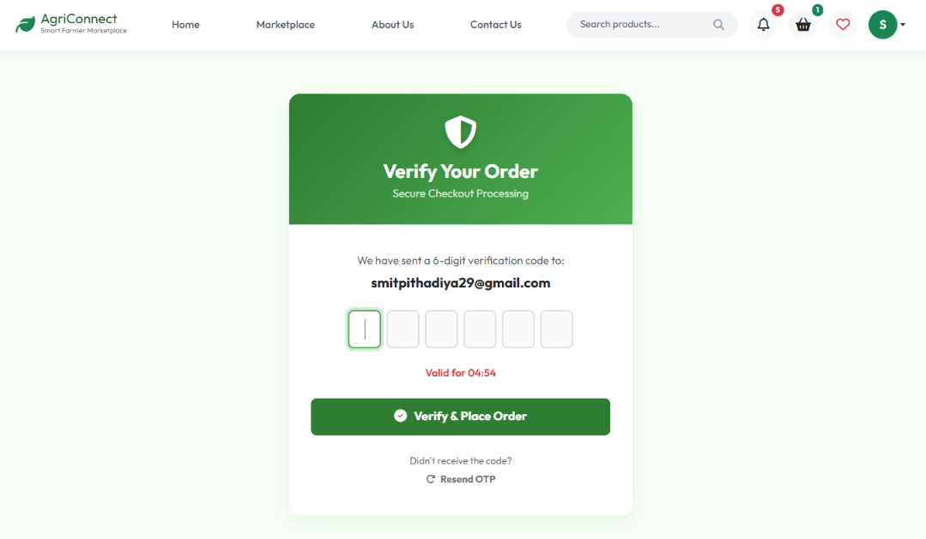

After the order is confirmed, an OTP verification message will be sent to your email and the order will be completed.

9.12 Farmer Control Dashboard
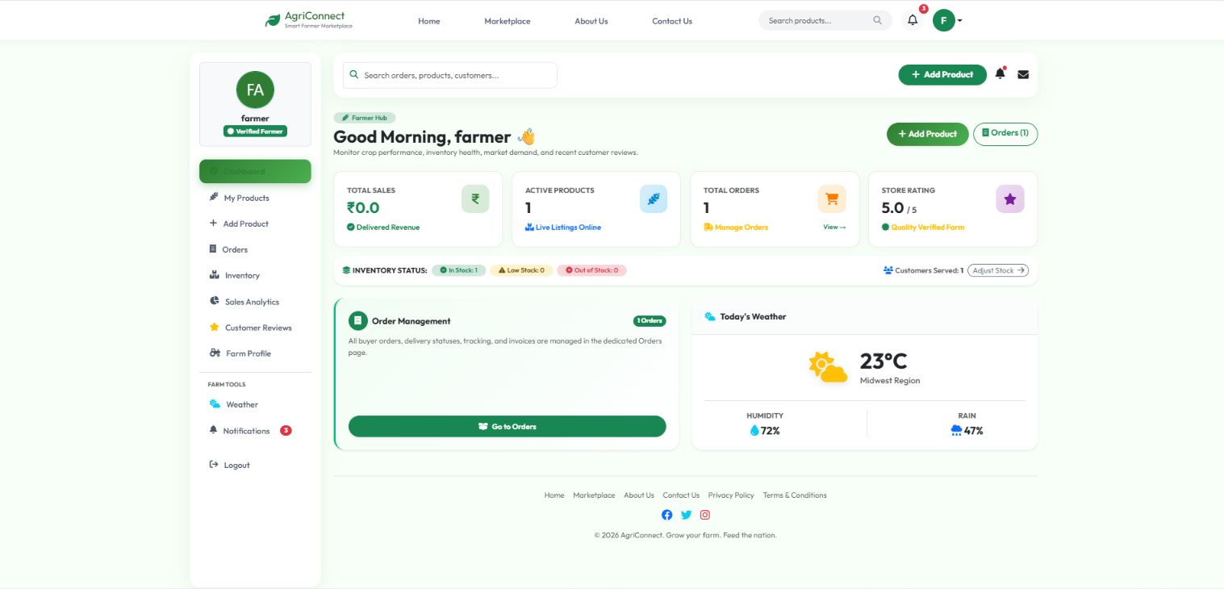
Farmer Dashboard provides farmers with a single platform to manage crops, orders, inventory, sales, weather information, and customer interactions efficiently.

9.13 Buyer Control Dashboard
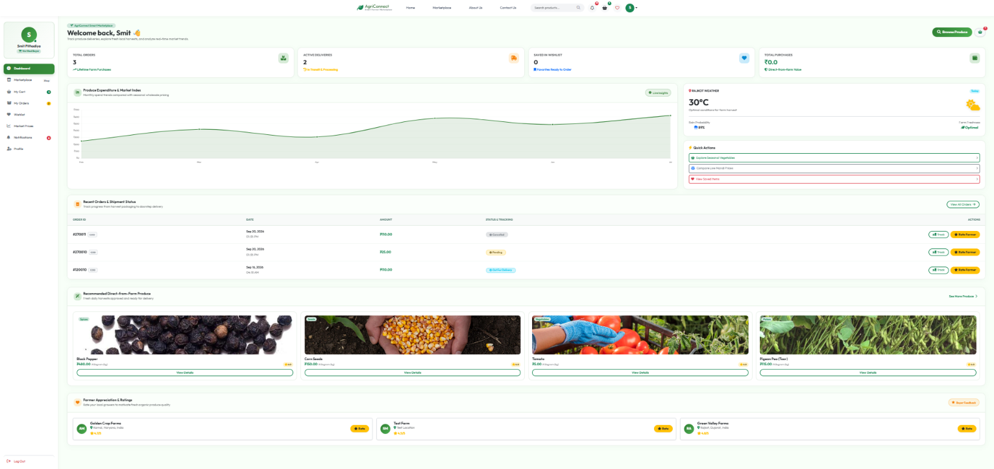 The Buyer Dashboard provides a complete overview of orders, cart, wishlist, market prices, weather updates, and purchase activities for a seamless farm-to-home shopping experience

10. Test Cases
Comprehensive software testing was conducted across all system modules to verify user input validation, data integrity, security controls, and functional correctness. All test cases yielded expected outputs and passed successfully.
Test Suite 1: Login & User Authentication
Field / Module | Test Case Description | Expected Output | Actual Output | Result
Username & Password | Display input fields for username & password | System renders two clean input text fields | Fields rendered cleanly | Pass
Login Button | Verify login with valid credentials | User authenticated & redirected to role dashboard | Redirected to dashboard | Pass
Validation | Check empty field submission | Displays error: 'Username/Password required' | Error displayed | Pass
Invalid Credentials | Check login with incorrect password | Displays error: 'Invalid username or password' | Error displayed | Pass
Test Suite 2: Farmer Crop Management
Field / Module | Test Case Description | Expected Output | Actual Output | Result
Add Crop | Test adding new crop with price & stock | New crop added and set to pending approval | Crop added successfully | Pass
Edit Crop | Update crop price per kg and stock quantity | Crop listing updated in database and marketplace | Listing updated | Pass
Stock Status | Set crop quantity to 0 | Listing automatically marked 'Out of Stock' | Marked out of stock | Pass
Delete Crop | Remove crop listing from farmer portal | Crop entry removed from catalog | Removed successfully | Pass
Test Suite 3: Shopping Cart & Checkout
Field / Module | Test Case Description | Expected Output | Actual Output | Result
Add to Cart | Select crop quantity and click Add to Cart | Crop added to user cart with total calculated | Added to cart | Pass
Update Quantity | Increase item quantity in shopping cart | Subtotal and grand total dynamically update | Totals updated | Pass
Remove Item | Click delete icon on cart item | Item removed from cart | Item removed | Pass
Checkout OTP | Submit order with phone number | System generates 6-digit OTP for order confirmation | OTP sent & verified | Pass
Test Suite 4: Admin Control & Approval
Field / Module | Test Case Description | Expected Output | Actual Output | Result
Crop Approval | Admin approves pending farmer crop listing | Crop status changed to Approved & visible in marketplace | Status updated to Approved | Pass
User Role Audit | Admin inspects registered users list | Displays all active farmers, buyers, and admin accounts | List displayed cleanly | Pass
System Reports | Click Generate Sales Report PDF | PDF invoice/report generated and downloaded | Report generated | Pass

11. Limitations
- Internet Connectivity Dependency: The application requires stable internet access for real-time market price updates and order placements, which may pose challenges in remote rural regions with limited network coverage.

- Manual Inventory Updates: Farmers must manually update crop availability and harvested quantities, leading to potential discrepancies if stock updates are delayed after local offline sales.

- Scalability for Enterprise Volumes: While the current Django architecture easily handles thousands of concurrent users, massive enterprise scaling across multiple geographical zones requires additional cloud load balancing and redis caching.

12. Future Enhancements
- AI-Driven Crop Disease Identification: Integrate machine learning models allowing farmers to upload leaf photos to automatically diagnose crop diseases and receive treatment remedies.

- Multilingual Regional Voice Support: Introduce voice-assisted navigation in Hindi, Gujarati, Marathi, and regional languages to assist non-literate farmers.

- Weather & Price Predictive Analytics: Incorporate real-time weather API feeds and AI price prediction forecasting to help farmers choose optimal harvest times.

- Native Mobile Application: Expand AgriConnect to native Android and iOS mobile applications using Flutter for seamless mobile notifications and offline capability.

13. Webliography
- Django Web Framework Documentation: https://docs.djangoproject.com/
- Python Official Documentation: https://www.python.org/
- Bootstrap 5 Documentation: https://getbootstrap.com/
- Stack Overflow Technical Q&A: https://stackoverflow.com/
- Draw.io Diagramming Tool: https://app.diagrams.net/
- MDN Web Docs (HTML/CSS/JS): https://developer.mozilla.org/

