A Project Report On…
AgriConnect: Digital Agricultural Marketplace & Direct Farmer-to-Buyer Platform

Developed By…
krishna Gohil
(BCA Semester - 5)
Submitted To..
Geetanjali College Of Computer Science And Commerce ( B.C.A. )
Rajkot
Saurashtra University Rajkot
Academic Year: 2025 - 2026
Project Guide : PROF. Kishor Vala

Acknowledgements
- I am happy to submit my idea and implementation for the "AgriConnect - Agricultural Marketplace System" web application to Saurashtra University, Rajkot for a BCA degree in the Computer Science branch.
- I am also deeply grateful to Prof. Brijesh Shah, Head of the Department, and all faculty members of the Department of Computer Science for their kind guidance, constant encouragement, and technical support throughout this journey.
- I take the privilege to acknowledge the authors of numerous reference books, research publications, Django official documentation, and technical web blogs which we referred to during the development of this project.
- I express my heartfelt gratitude to my parents and family for their unwavering moral and financial support, without which I could accomplish nothing in my academic pursuits and personal life.
- The feeling of gratefulness for everyone's timely assistance directly arises from the bottom of my heart. Small but critical guidance during testing and database schema design proved to be significant milestones in completing this application.

Preface
- Practical training and software implementation are of paramount importance in understanding theoretical aspects of Computer Application & Web Software Development. Recognizing this importance, we prepared the "AgriConnect" project to enrich our practical knowledge regarding web technologies, full-stack architecture, and database management systems.
- We are very much pleased to present this comprehensive project report on "AgriConnect: Digital Agricultural Marketplace", developed at Geetanjali College of Computer Science and Commerce, affiliated with Saurashtra University.
Topic / Section Title | Page No.
1. Project Profile | 5
2. Software Development Life Cycle (SDLC) | 6
3. System Requirements (Hardware & Software) | 8
4. Development & Coding Standards | 9
5. About the Tool (Tools & Technologies Used) | 11
6. Data Flow Diagrams (DFD Level 0 & Level 1) | 13
7. Entity Relationship (ER) Diagram & Architecture | 15
8. Data Dictionary (Complete Database Schema) | 17
9. Screenshots & Module Descriptions | 22
10. Test Cases (Farmer, Buyer & Admin Modules) | 32
11. Limitations | 37
12. Future Enhancements | 38
13. Webliography | 39
Project Title: | AgriConnect: Digital Agricultural Marketplace System
Development Software: | Visual Studio Code, Python , Django Framework
Front End: | HTML5, CSS3, JavaScript , Bootstrap 5, FontAwesome
Backend / Logic: | Python, Django Web Framework (MVT Architecture)
Database: | MySQL Database Management System
Academic Year: | 2025 - 2026
Developed By: | Gohil Krishna (BCA Semester - 5)
Submitted To: | Geetanjali College Of Computer Science And Commerce, Rajkot
Documentation Tool: | Microsoft Word
Operating System: | Cross-platform (Windows 10/11, macOS, Linux)
Programming Language: | Python , JavaScript, HTML, CSS
Component / Resource | Minimum Specification
Operating System | Windows 10/11, macOS 11+, Linux Ubuntu 20.04+
CPU / Processor | Intel Core i3 / AMD Ryzen 3 Dual-Core (2.0 GHz or higher)
System RAM | 4 GB (8 GB recommended for optimal development)
Hard Disk Space | 20 GB available storage space
Display Resolution | 1280 x 720 HD Resolution or higher
Network Connection | Broadband Internet (for static CDN resources & deployment)
Software Tool / Component | Version / Specification
Runtime Environment | Python 3.12+ 64-bit Interpreter
Web Framework | Django 5.x Framework
Database Server | MySQL Database Server (v8.0+ / TiDB Cloud)
Frontend Stack | HTML5, CSS3, JavaScript (ES6+), Bootstrap 5.3
Web Server | Django WSGI / ASGI Dev Server (Apache 2.4 / Nginx in Production)
IDE / Source Editor | Visual Studio Code / PyCharm
Version Control | Git & GitHub Repository
Field Name | Data Type | Null? | Constraint | Description
id | BigAutoField | No | Primary Key | Unique user identifier
username | CharField | No | Unique | Login username
email | EmailField | No | Unique | User email address
role | CharField | No | - | User role (admin, farmer, buyer)
phone | CharField | Yes | - | Contact phone number
address | TextField | Yes | - | Physical delivery/farm address
profile_picture | ImageField | Yes | - | Profile avatar image
is_active | BooleanField | No | - | Account active status flag
date_joined | DateTimeField | No | - | Account registration timestamp
Field Name | Data Type | Null? | Constraint | Description
id | BigAutoField | No | Primary Key | Profile ID
user_id | OneToOneField | No | FK (User) | Reference to accounts_user
farm_name | CharField | Yes | - | Name of the farm / enterprise
farm_location | CharField | Yes | - | Farm address / region
farm_size | CharField | Yes | - | Land acreage (e.g. 5 Acres)
certification_status | CharField | No | - | Verification badge status (verified/pending/none)
experience | CharField | No | - | Years of agricultural experience
orders_completed | IntegerField | No | - | Count of fulfilled orders
store_rating | FloatField | No | - | Average store rating (0.0 - 5.0)
specialization | CharField | No | - | Farming domain specialization
about | TextField | Yes | - | Farmer biography & overview
cover_banner | ImageField | Yes | - | Storefront header cover banner
certifications | TextField | Yes | - | Agricultural certifications held
awards | TextField | Yes | - | Recognitions and awards received
repeat_customers | IntegerField | No | - | Count/rate of repeat buyers
ontime_delivery | IntegerField | No | - | On-time delivery percentage
satisfaction_rate | IntegerField | No | - | Customer satisfaction percentage
village | CharField | Yes | - | Village name
city | CharField | Yes | - | City location
state | CharField | Yes | - | State location
pincode | CharField | Yes | - | Postal code
organic_certificate | FileField | Yes | - | Uploaded organic farming certificate
verification_status | CharField | No | - | Admin verification status choice
aadhaar_document | FileField | Yes | - | Identity verification document
farm_certificate | FileField | Yes | - | Land certificate document
trust_score | IntegerField | No | - | Platform trust rating score
verification_date | DateTimeField | Yes | - | Verification approval timestamp
verified_by_id | ForeignKey | Yes | FK (User) | Admin user performing verification
admin_notes | TextField | Yes | - | Verification review notes
approval_history | TextField | Yes | - | Audit trail log of actions
Field Name | Data Type | Null? | Constraint | Description
id | BigAutoField | No | Primary Key | Profile ID
user_id | OneToOneField | No | FK (User) | Reference to accounts_user
delivery_address | TextField | Yes | - | Primary shipping destination
contact_name | CharField | Yes | - | Contact person name
city | CharField | Yes | - | Buyer city location
state | CharField | Yes | - | Buyer state location
pincode | CharField | Yes | - | Postal pincode
Field Name | Data Type | Null? | Constraint | Description
id | BigAutoField | No | Primary Key | OTP Record ID
user_id | ForeignKey | Yes | FK (User) | Target user reference
email | EmailField | Yes | - | Email address for unregistered OTP
otp_code | CharField | No | - | 6-digit OTP passcode
otp_type | CharField | No | - | OTP type (registration / password_reset)
created_at | DateTimeField | No | - | OTP generation timestamp
expires_at | DateTimeField | No | - | OTP expiration timestamp
is_verified | BooleanField | No | - | OTP verification status flag
attempts | IntegerField | No | - | Failed attempt counter
resend_count | IntegerField | No | - | Resend request counter
Field Name | Data Type | Null? | Constraint | Description
id | BigAutoField | No | Primary Key | Category ID
name | CharField | No | Unique | Category title (Vegetables, Fruits, Grains)
description | TextField | Yes | - | Category detailed description
image | ImageField | Yes | - | Category banner thumbnail image
Field Name | Data Type | Null? | Constraint | Description
id | BigAutoField | No | Primary Key | Crop Product ID
farmer_id | ForeignKey | No | FK (Farmer) | Farmer owner of crop listing
category_id | ForeignKey | No | FK (Category) | Produce category reference
name | CharField | No | - | Crop name (e.g. Organic Wheat)
description | TextField | No | - | Detailed produce description
price_per_kg | DecimalField | No | - | Price per unit / kilogram (INR)
quantity_available | DecimalField | No | - | Available stock quantity
unit | CharField | No | - | Unit choice (kg, ton, piece, quintal)
image | ImageField | Yes | - | Produce primary photograph
is_approved | BooleanField | No | - | Admin approval status
harvest_date | DateField | No | - | Date crop was harvested
shelf_life_days | IntegerField | No | - | Estimated shelf life in days
availability_status | CharField | No | - | Stock status (available/out_of_stock)
created_at | DateTimeField | No | - | Listing creation timestamp
updated_at | DateTimeField | No | - | Listing last update timestamp
status_history | JSONField | No | - | Audit trail of listing changes
otp_code | CharField | Yes | - | Verification OTP code
otp_expires_at | DateTimeField | Yes | - | OTP expiry timestamp
is_otp_verified | BooleanField | No | - | OTP verification flag
return_reason | CharField | Yes | - | Return reason choice if returned
return_description | TextField | Yes | - | Return details note
return_status | CharField | Yes | - | Return status (Pending/Approved/Rejected)
market_demand_level | CharField | No | - | Market demand index (High/Medium/Low)
market_forecast_direction | CharField | No | - | Price forecast direction
current_market_price | DecimalField | Yes | - | APMC mandi benchmark price
market_price_history | JSONField | No | - | Price history trend data
Field Name | Data Type | Null? | Constraint | Description
id | BigAutoField | No | Primary Key | Cart Item ID
user_id | ForeignKey | No | FK (User) | Buyer user owning cart
crop_id | ForeignKey | No | FK (Crop) | Selected crop item
quantity | PositiveInt | No | - | Selected quantity count
Field Name | Data Type | Null? | Constraint | Description
id | BigAutoField | No | Primary Key | Order ID
buyer_id | ForeignKey | No | FK (User) | Buyer placing the order
farmer_id | ForeignKey | No | FK (Farmer) | Farmer fulfilling order
total_amount | DecimalField | No | - | Total payable order cost (INR)
payment_method | CharField | No | - | Payment method choice (COD/Online)
status | CharField | No | - | Order status (Pending/Confirmed/Delivered)
shipping_address | TextField | No | - | Complete shipping destination
invoice_pdf | FileField | Yes | - | Generated PDF tax invoice
created_at | DateTimeField | No | - | Order placement timestamp
updated_at | DateTimeField | No | - | Order last modified timestamp
status_history | JSONField | No | - | Order state lifecycle history
otp_code | CharField | Yes | - | 6-digit delivery confirmation OTP
otp_expires_at | DateTimeField | Yes | - | OTP expiry timestamp
is_otp_verified | BooleanField | No | - | OTP verified status flag
return_reason | CharField | Yes | - | Order return reason
return_description | TextField | Yes | - | Order return details
return_status | CharField | Yes | - | Return request approval status
Field Name | Data Type | Null? | Constraint | Description
id | BigAutoField | No | Primary Key | Line Item ID
order_id | ForeignKey | No | FK (Order) | Parent order reference
crop_id | ForeignKey | Yes | FK (Crop) | Purchased crop product
quantity | DecimalField | No | - | Purchased quantity volume
price_per_unit | DecimalField | No | - | Unit price at purchase time
Field Name | Data Type | Null? | Constraint | Description
id | BigAutoField | No | Primary Key | Payment ID
order_id | OneToOneField | No | FK (Order) | Associated order reference
payment_method | CharField | No | - | Payment mode (COD / Online / UPI)
transaction_id | CharField | Yes | - | Gateway transaction reference
status | CharField | No | - | Payment status (Pending/Completed/Failed)
amount | DecimalField | No | - | Transaction total amount
created_at | DateTimeField | No | - | Payment processing timestamp
Field Name | Data Type | Null? | Constraint | Description
id | BigAutoField | No | Primary Key | Review ID
buyer_id | ForeignKey | No | FK (User) | Reviewer buyer user
crop_id | ForeignKey | Yes | FK (Crop) | Reviewed crop product
farmer_id | ForeignKey | Yes | FK (Farmer) | Reviewed farmer profile
quality_rating | PositiveInt | Yes | - | Crop quality rating (1-5)
communication_rating | PositiveInt | Yes | - | Farmer response score (1-5)
delivery_rating | PositiveInt | Yes | - | Delivery speed score (1-5)
packaging_rating | PositiveInt | Yes | - | Packaging quality score (1-5)
rating | PositiveInt | No | - | Overall star rating score (1-5)
title | CharField | Yes | - | Review headline title
comment | TextField | Yes | - | Detailed feedback comment
image | ImageField | Yes | - | Customer product photo upload
reply | TextField | Yes | - | Seller response reply text
reply_at | DateTimeField | Yes | - | Seller reply timestamp
created_at | DateTimeField | No | - | Review submission timestamp
Field Name | Data Type | Null? | Constraint | Description
id | BigAutoField | No | Primary Key | Notification ID
user_id | ForeignKey | No | FK (User) | Recipient user account
message | TextField | No | - | Notification text body
notification_type | CharField | No | - | Type (order/price/weather/system/chat/review/verification)
priority | CharField | No | - | Priority level (high/medium/low)
link | CharField | Yes | - | Action link URL
is_read | BooleanField | No | - | Read/unread status flag
created_at | DateTimeField | No | - | Dispatch timestamp
Field Name | Data Type | Null? | Constraint | Description
id | BigAutoField | No | Primary Key | Message ID
sender_id | ForeignKey | No | FK (User) | Sender user reference
receiver_id | ForeignKey | No | FK (User) | Recipient user reference
crop_id | ForeignKey | Yes | FK (Crop) | Associated crop produce inquiry
message | TextField | No | - | Message text content
is_read | BooleanField | No | - | Read status flag
created_at | DateTimeField | No | - | Message sent timestamp
Field Name | Data Type | Null? | Constraint | Description
id | BigAutoField | No | Primary Key | Wishlist Item ID
user_id | ForeignKey | No | FK (User) | Buyer user reference
crop_id | ForeignKey | No | FK (Crop) | Saved crop listing reference
added_at | DateTimeField | No | - | Added timestamp
Field Name | Data Type | Null? | Constraint | Description
id | BigAutoField | No | Primary Key | Rating Record ID
buyer_id | ForeignKey | No | FK (User) | Rating buyer reference
farmer_id | ForeignKey | No | FK (Farmer) | Rated farmer reference
rating | PositiveInt | No | - | Overall rating score (1-5)
quality_rating | PositiveInt | No | - | Quality score (1-5)
communication_rating | PositiveInt | No | - | Communication score (1-5)
delivery_rating | PositiveInt | No | - | Delivery score (1-5)
packaging_rating | PositiveInt | No | - | Packaging score (1-5)
comment | TextField | Yes | - | Detailed evaluation feedback
created_at | DateTimeField | No | - | Rating timestamp
Field Name | Data Type | Null? | Constraint | Description
id | BigAutoField | No | Primary Key | Feedback ID
user_id | ForeignKey | No | FK (User) | Submitting user reference
subject | CharField | No | - | Feedback subject line
message | TextField | No | - | Detailed feedback message
is_resolved | BooleanField | No | - | Admin resolution status flag
created_at | DateTimeField | No | - | Submission timestamp
Field Name | Data Type | Null? | Constraint | Description
id | BigAutoField | No | Primary Key | Trend Record ID
crop_name | CharField | No | - | Crop commodity name
category_id | ForeignKey | No | FK (Category) | Category reference
avg_price | DecimalField | No | - | Average market price per kg (INR)
record_date | DateField | No | - | Recording date
Field Name | Data Type | Null? | Constraint | Description
id | BigAutoField | No | Primary Key | Insight Record ID
crop_name | CharField | No | - | Commodity crop name
category_id | ForeignKey | No | FK (Category) | Category reference
current_price | DecimalField | No | - | Current APMC mandi price (INR)
price_change_percent | DecimalField | No | - | Price percentage change (+/- %)
demand_level | CharField | No | - | Demand index (High/Medium/Low)
forecast_direction | CharField | No | - | Forecast trend direction
region | CharField | No | - | APMC Mandi / Region name
volume_tonnes | IntegerField | No | - | Traded volume in tonnes
record_date | DateField | No | - | Generation record date
Field Name | Data Type | Null? | Constraint | Description
id | BigAutoField | No | Primary Key | Return Request ID
order_id | ForeignKey | No | FK (Order) | Parent order reference
reason | CharField | No | - | Return reason choice
description | TextField | Yes | - | Detailed return reason description
status | CharField | No | - | Status (Pending/Approved/Rejected)
created_at | DateTimeField | No | - | Request filing timestamp
Field Name | Data Type | Null? | Constraint | Description
id | BigAutoField | No | Primary Key | Report Record ID
name | CharField | No | - | Report document title
report_type | CharField | No | - | Report classification type
generated_by_id | ForeignKey | No | FK (User) | Generating user reference
format | CharField | No | - | File format (pdf, csv, xlsx)
download_count | PositiveInt | No | - | Download counter
file | FileField | Yes | - | Generated file path
scheduled_interval | CharField | Yes | - | Scheduled frequency (daily, weekly, monthly)
created_at | DateTimeField | No | - | Report generation timestamp
Field Name | Data Type | Null? | Constraint | Description
id | BigAutoField | No | Primary Key | Order OTP Record ID
user_id | ForeignKey | No | FK (User) | Buyer user reference
otp_code | CharField | No | - | 6-digit OTP passcode
shipping_address | TextField | No | - | Shipping destination address
payment_method | CharField | No | - | Selected payment method
created_at | DateTimeField | No | - | OTP generation timestamp
expires_at | DateTimeField | No | - | OTP expiration timestamp
resend_count | PositiveInt | No | - | Resend attempt counter
is_verified | BooleanField | No | - | Verification flag status

8. Data Dictionary
The Data Dictionary provides the exact schema definition for all 25 database tables used in the AgriConnect system. Each entry lists field names, data types, and descriptions to aid in development, testing, and maintenance.
Table 1: accounts_user (Custom User Model)
Extends Django AbstractUser. Stores all registered users with role-based access (Admin, Farmer, Buyer) and shared profile fields.
Column Name | Data Type | Description
id | INT (PK) | Auto-incremented primary key
username | VARCHAR(150) | Unique login username
email | VARCHAR(254) | User's email address
password | VARCHAR(128) | Hashed password
first_name | VARCHAR(150) | User's first name
last_name | VARCHAR(150) | User's last name
role | VARCHAR(20) | Role: admin / farmer / buyer
phone | VARCHAR(15) | Contact phone number
address | TEXT | User's address
profile_picture | VARCHAR(255) | Path to uploaded profile image
is_active | BOOLEAN | Account active status
is_staff | BOOLEAN | Django admin staff flag
date_joined | DATETIME | Registration timestamp

Table 2: accounts_farmer (Farmer Profile)
Extended profile for farmer-role users. Stores farm details, performance metrics, and document verification workflow.
Column Name | Data Type | Description
id | INT (PK) | Auto-incremented primary key
user_id | INT (FK → accounts_user) | One-to-one link to User
farm_name | VARCHAR(100) | Name of the farm
farm_location | VARCHAR(255) | Farm address / location
farm_size | VARCHAR(50) | Farm area e.g. 5 Acres
specialization | VARCHAR(100) | Primary crop specialization
experience | VARCHAR(50) | Farming experience duration
about | TEXT | Farmer bio / about section
certification_status | VARCHAR(50) | Certification: verified / pending / none
certifications | TEXT | List of certifications held
awards | TEXT | Awards and recognitions
store_rating | FLOAT | Average customer rating
orders_completed | INT | Total completed orders
repeat_customers | INT | Count of repeat buyer transactions
ontime_delivery | INT | On-time delivery percentage
satisfaction_rate | INT | Customer satisfaction percentage
trust_score | INT | Calculated trust score (0-100)
verification_status | VARCHAR(20) | pending / review / approved / rejected / resubmit
verification_date | DATETIME | Date of verification approval
verified_by_id | INT (FK → accounts_user) | Admin who approved verification
village | VARCHAR(100) | Village name
city | VARCHAR(100) | City name
state | VARCHAR(100) | State name
pincode | VARCHAR(10) | Postal code
cover_banner | VARCHAR(255) | Path to farm cover image
organic_certificate | VARCHAR(255) | Path to organic certificate file
aadhaar_document | VARCHAR(255) | Path to Aadhaar document file
farm_certificate | VARCHAR(255) | Path to farm certificate file
admin_notes | TEXT | Admin review notes
approval_history | TEXT | History of verification actions

Table 3: accounts_buyer (Buyer Profile)
Extended profile for buyer-role users. Stores delivery preferences and location for delivery time estimation.
Column Name | Data Type | Description
id | INT (PK) | Auto-incremented primary key
user_id | INT (FK → accounts_user) | One-to-one link to User
delivery_address | TEXT | Default delivery address
contact_name | VARCHAR(100) | Recipient contact name
city | VARCHAR(100) | Buyer's city
state | VARCHAR(100) | Buyer's state
pincode | VARCHAR(10) | Buyer's postal code

Table 4: accounts_authotp (Authentication OTP)
Stores One-Time Passwords for email verification during registration and password reset.
Column Name | Data Type | Description
id | INT (PK) | Auto-incremented primary key
user_id | INT (FK → accounts_user) | Associated user (nullable)
email | VARCHAR(254) | Target email if user not yet created
otp_code | VARCHAR(6) | 6-digit OTP code
otp_type | VARCHAR(20) | Type: registration / password_reset
created_at | DATETIME | OTP creation timestamp
expires_at | DATETIME | OTP expiry timestamp
is_verified | BOOLEAN | Whether OTP was used successfully
attempts | INT | Number of wrong attempts made
resend_count | INT | Number of times OTP was resent

Table 5: accounts_user_groups (User Groups (System))
Django auto-created junction table linking users to permission groups. Required by the auth system.
Column Name | Data Type | Description
id | INT (PK) | Auto-incremented primary key
user_id | INT (FK → accounts_user) | Associated user
group_id | INT (FK → auth_group) | Assigned permission group

Table 6: accounts_user_user_permissions (User Permissions (System))
Django auto-created junction table for direct user-level permissions. Required by the auth system.
Column Name | Data Type | Description
id | INT (PK) | Auto-incremented primary key
user_id | INT (FK → accounts_user) | Associated user
permission_id | INT (FK → auth_permission) | Assigned permission

Table 7: marketplace_category (Crop Category)
Defines broad agricultural product categories such as Vegetables, Fruits, and Grains.
Column Name | Data Type | Description
id | INT (PK) | Auto-incremented primary key
name | VARCHAR(100) | Unique category name
description | TEXT | Optional category description
image | VARCHAR(255) | Path to category banner image

Table 8: marketplace_crop (Crop Product Listing)
Represents an individual crop or product listed by a farmer for sale on the marketplace.
Column Name | Data Type | Description
id | INT (PK) | Auto-incremented primary key
farmer_id | INT (FK → accounts_farmer) | Listing farmer
category_id | INT (FK → marketplace_category) | Product category
name | VARCHAR(100) | Crop or product name
description | TEXT | Detailed product description
price_per_kg | DECIMAL(10,2) | Price per unit
quantity_available | DECIMAL(10,2) | Stock quantity
unit | VARCHAR(20) | Unit: kg / ton / piece / quintal
image | VARCHAR(255) | Path to crop image
is_approved | BOOLEAN | Admin approval status
harvest_date | DATE | Date of crop harvest
shelf_life_days | INT | Product shelf life in days
availability_status | VARCHAR(20) | available / out_of_stock
rating | DECIMAL(3,1) | Average product rating
market_demand_level | VARCHAR(20) | Market demand: Low / Medium / High
market_forecast_direction | VARCHAR(20) | Price forecast: Stable / Rising / Falling
current_market_price | DECIMAL(10,2) | Current market reference price
market_price_history | JSON | Historical price data
status_history | JSON | Admin status change history
created_at | DATETIME | Listing creation timestamp
updated_at | DATETIME | Last update timestamp

Table 9: marketplace_cartitem (Shopping Cart Item)
Represents an individual product added to a user's active shopping cart before checkout.
Column Name | Data Type | Description
id | INT (PK) | Auto-incremented primary key
user_id | INT (FK → accounts_user) | Cart owner
crop_id | INT (FK → marketplace_crop) | Product in cart
quantity | INT | Quantity selected

Table 10: marketplace_order (Order Master Table)
Represents a finalized purchase. Tracks order status, payment method, shipping address, and OTP verification.
Column Name | Data Type | Description
id | INT (PK) | Auto-incremented primary key
buyer_id | INT (FK → accounts_user) | Buyer who placed the order
farmer_id | INT (FK → accounts_farmer) | Farmer fulfilling the order
total_amount | DECIMAL(12,2) | Total order value
payment_method | VARCHAR(20) | COD / Online
status | VARCHAR(20) | Pending / Confirmed / Out For Delivery / Delivered / Cancelled / Returned
shipping_address | TEXT | Delivery shipping address
invoice_pdf | VARCHAR(255) | Path to generated invoice PDF
otp_code | VARCHAR(6) | Delivery OTP code
otp_expires_at | DATETIME | OTP expiry time
is_otp_verified | BOOLEAN | OTP verification status
return_reason | VARCHAR(50) | Return reason if applicable
return_description | TEXT | Detailed return description
return_status | VARCHAR(20) | Return status: Pending / Approved / Rejected
status_history | JSON | Full status change timeline
created_at | DATETIME | Order creation timestamp
updated_at | DATETIME | Last update timestamp

Table 11: marketplace_orderitem (Order Line Items)
Stores each individual crop line item within an Order, supporting multi-item orders.
Column Name | Data Type | Description
id | INT (PK) | Auto-incremented primary key
order_id | INT (FK → marketplace_order) | Parent order
crop_id | INT (FK → marketplace_crop) | Crop purchased (nullable if deleted)
quantity | DECIMAL(10,2) | Quantity ordered
price_per_unit | DECIMAL(10,2) | Price locked at time of order

Table 12: marketplace_orderotp (Order Confirmation OTP)
Stores OTP for checkout verification before an order is confirmed and placed.
Column Name | Data Type | Description
id | INT (PK) | Auto-incremented primary key
user_id | INT (FK → accounts_user) | User placing the order
otp_code | VARCHAR(6) | 6-digit OTP code
shipping_address | TEXT | Shipping address captured at checkout
payment_method | VARCHAR(50) | Payment method selected
created_at | DATETIME | OTP creation timestamp
expires_at | DATETIME | OTP expiry timestamp
resend_count | INT | Times OTP was resent
is_verified | BOOLEAN | OTP verified and order placed

Table 13: marketplace_orderstatushistory (Order Status History)
Audit trail of every status change on an order with timestamp and the actor who made the change.
Column Name | Data Type | Description
id | INT (PK) | Auto-incremented primary key
order_id | INT (FK → marketplace_order) | Associated order
status | VARCHAR(50) | New status value
changed_at | DATETIME | Timestamp of status change
changed_by_id | INT (FK → accounts_user) | User who made the change

Table 14: marketplace_payment (Payment Transaction)
Tracks payment transaction details and status for each order.
Column Name | Data Type | Description
id | INT (PK) | Auto-incremented primary key
order_id | INT (FK → marketplace_order) | One-to-one link to Order
payment_method | VARCHAR(50) | Payment method used
transaction_id | VARCHAR(100) | External transaction reference ID
status | VARCHAR(20) | Pending / Completed / Failed
amount | DECIMAL(12,2) | Payment amount
created_at | DATETIME | Payment timestamp

Table 15: marketplace_review (Customer Crop and Farmer Review)
Stores buyer reviews and star ratings for crops and farmers, with sub-ratings for quality, delivery, packaging, and communication.
Column Name | Data Type | Description
id | INT (PK) | Auto-incremented primary key
buyer_id | INT (FK → accounts_user) | Review author
crop_id | INT (FK → marketplace_crop) | Reviewed crop (nullable)
farmer_id | INT (FK → accounts_farmer) | Reviewed farmer (nullable)
rating | INT | Overall star rating (1-5)
quality_rating | INT | Quality sub-rating
communication_rating | INT | Communication sub-rating
delivery_rating | INT | Delivery sub-rating
packaging_rating | INT | Packaging sub-rating
title | VARCHAR(200) | Review headline
comment | TEXT | Review text body
image | VARCHAR(255) | Path to review image
reply | TEXT | Farmer reply to review
reply_at | DATETIME | Timestamp of farmer reply
created_at | DATETIME | Review submission timestamp

Table 16: marketplace_review_helpful_votes (Review Helpful Votes)
Many-to-many junction table tracking which users marked a review as helpful.
Column Name | Data Type | Description
id | INT (PK) | Auto-incremented primary key
review_id | INT (FK → marketplace_review) | The review voted on
user_id | INT (FK → accounts_user) | User who voted helpful

Table 17: marketplace_notification (System Notification)
System notifications delivered to users for events like order updates, price alerts, and document verifications.
Column Name | Data Type | Description
id | INT (PK) | Auto-incremented primary key
user_id | INT (FK → accounts_user) | Notification recipient
message | TEXT | Notification content
notification_type | VARCHAR(20) | order / price / weather / system / review / product / verification
priority | VARCHAR(10) | Priority: high / medium / low
link | VARCHAR(200) | Optional URL for action
is_read | BOOLEAN | Read status
created_at | DATETIME | Notification timestamp

Table 18: marketplace_feedback (Platform Feedback)
User-submitted support feedback and contact messages sent to the admin team.
Column Name | Data Type | Description
id | INT (PK) | Auto-incremented primary key
user_id | INT (FK → accounts_user) | Feedback submitter
subject | VARCHAR(200) | Feedback subject line
message | TEXT | Detailed feedback message
is_resolved | BOOLEAN | Resolution status
created_at | DATETIME | Submission timestamp

Table 19: marketplace_farmerrating (Farmer Rating and Evaluation)
Dedicated farmer-level ratings submitted by buyers after delivery, separate from crop-level reviews.
Column Name | Data Type | Description
id | INT (PK) | Auto-incremented primary key
buyer_id | INT (FK → accounts_user) | Buyer submitting the rating
farmer_id | INT (FK → accounts_farmer) | Farmer being rated
rating | INT | Overall rating (1-5)
quality_rating | INT | Product quality sub-rating
communication_rating | INT | Communication sub-rating
delivery_rating | INT | Delivery speed sub-rating
packaging_rating | INT | Packaging quality sub-rating
comment | TEXT | Optional text comment
created_at | DATETIME | Rating submission timestamp

Table 20: marketplace_wishlist (Saved Crops Wishlist)
Tracks crops that a buyer has bookmarked or saved for later purchase consideration.
Column Name | Data Type | Description
id | INT (PK) | Auto-incremented primary key
user_id | INT (FK → accounts_user) | Buyer who saved the item
crop_id | INT (FK → marketplace_crop) | Saved crop listing
added_at | DATETIME | Timestamp when item was saved

Table 21: marketplace_marketinsight (Market Forecast and Analytics)
Stores aggregated market intelligence: current prices, demand levels, and price forecasts by crop and region.
Column Name | Data Type | Description
id | INT (PK) | Auto-incremented primary key
crop_name | VARCHAR(100) | Crop name
category_id | INT (FK → marketplace_category) | Associated category
current_price | DECIMAL(10,2) | Current market price
price_change_percent | DECIMAL(5,2) | Price change percentage
demand_level | VARCHAR(20) | Demand: Low / Medium / High
forecast_direction | VARCHAR(20) | Forecast: Stable / Rising / Falling
region | VARCHAR(100) | Market region
volume_tonnes | INT | Market trade volume in tonnes
record_date | DATE | Date of insight record

Table 22: marketplace_pricetrend (Crop Market Price Trend)
Historical daily price data used for rendering market trend charts and analytics dashboards.
Column Name | Data Type | Description
id | INT (PK) | Auto-incremented primary key
crop_name | VARCHAR(100) | Crop name
category_id | INT (FK → marketplace_category) | Associated category
avg_price | DECIMAL(10,2) | Average price on record date
record_date | DATE | Date of price record

Table 23: marketplace_report (System and Sales Reports)
Tracks generated analytical reports in PDF, CSV, or XLSX format for farmers and administrators.
Column Name | Data Type | Description
id | INT (PK) | Auto-incremented primary key
name | VARCHAR(200) | Report display name
report_type | VARCHAR(50) | Type: sales / inventory / market etc.
generated_by_id | INT (FK → accounts_user) | User who generated the report
format | VARCHAR(10) | File format: pdf / csv / xlsx
file | VARCHAR(255) | Path to generated report file
download_count | INT | Number of times downloaded
scheduled_interval | VARCHAR(20) | Schedule: daily / weekly / monthly
created_at | DATETIME | Report generation timestamp

Table 24: marketplace_adminactivitylog (Admin Activity Log)
Audit log of all significant admin actions performed in the system for accountability and traceability.
Column Name | Data Type | Description
id | INT (PK) | Auto-incremented primary key
admin_id | INT (FK → accounts_user) | Admin user who performed the action
action | VARCHAR(255) | Description of the action performed
target_model | VARCHAR(100) | Model or entity affected
target_id | INT | ID of the affected record
created_at | DATETIME | Timestamp of the action

Table 25: marketplace_emaillog (Email Log)
Log of all transactional emails sent by the system including OTPs, order confirmations, and alerts.
Column Name | Data Type | Description
id | INT (PK) | Auto-incremented primary key
recipient | VARCHAR(254) | Recipient email address
subject | VARCHAR(255) | Email subject
status | VARCHAR(20) | sent / failed
created_at | DATETIME | Email send timestamp

9. Screen Shots & Module Descriptions
This section presents visual screen captures and detailed functional descriptions for all major modules of the AgriConnect system across Farmer, Buyer, and Admin portals.
9.1 Login & Authentication Screen
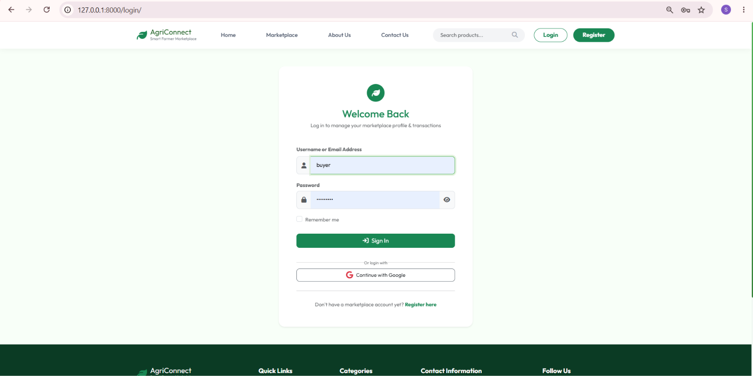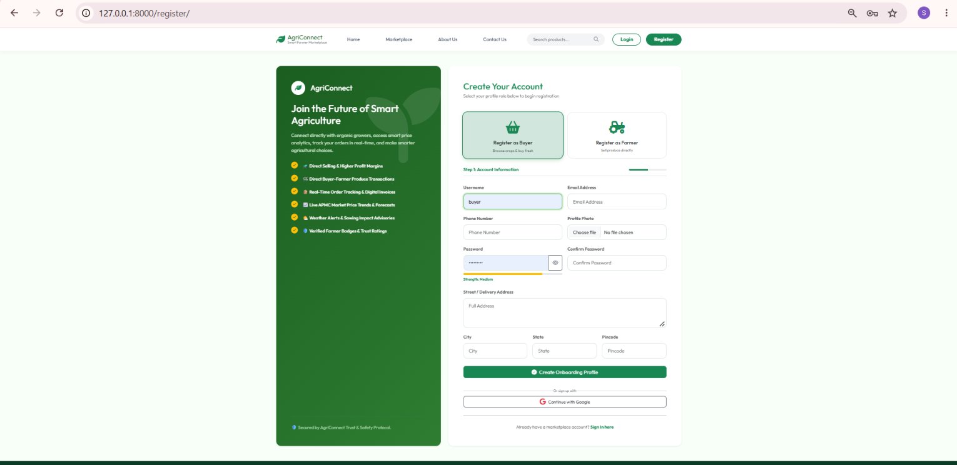
Multi-role secure authentication portal supporting login for Farmers, Buyers, and System Administrators with input validation and session tracking.

9.2 Admin Control Dashboard

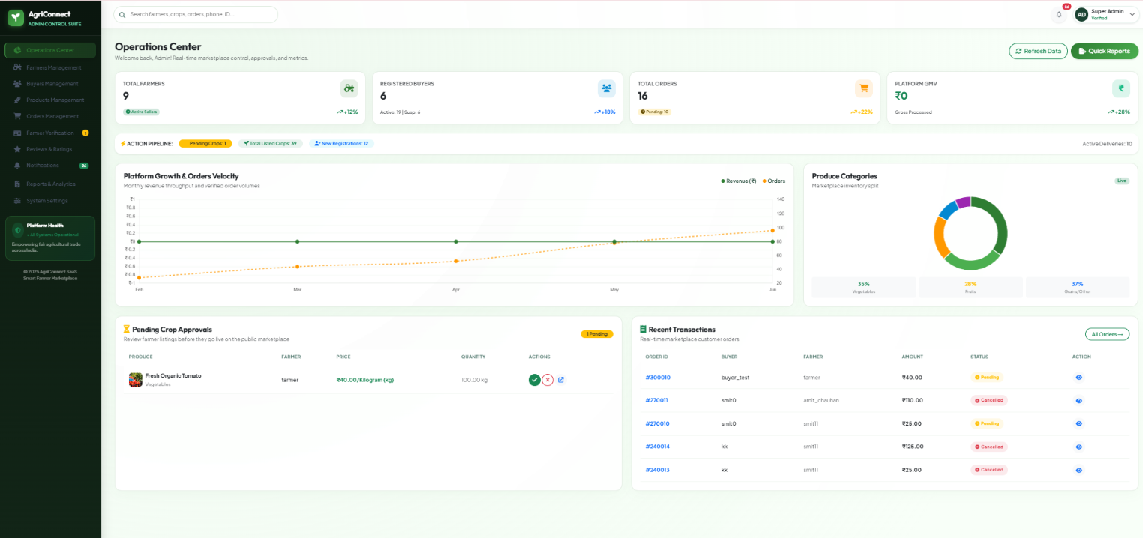
Centralized administrative management dashboard displaying platform user metrics, crop approval queues, revenue summary, and system report generation.

9.3 Farmer Management Dashboard

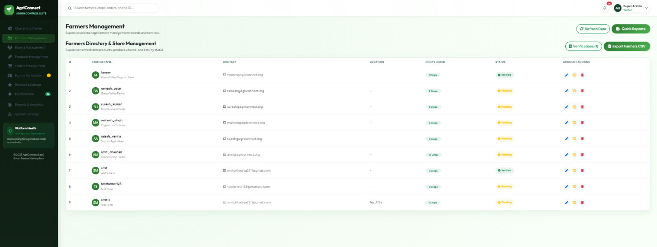
Farmer management portal providing harvest stock oversight, incoming buyer orders tracking, price updating tools, and revenue analytics.

9.4 Buyer Marketplace & Crop Catalog
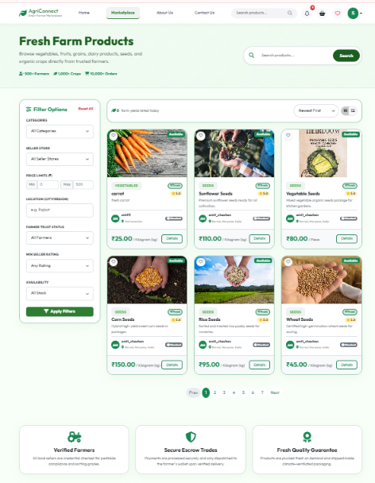

Dynamic produce catalog presenting available crops with high-resolution imagery, category filtering, search, price per kg, and stock availability.

9.5 Crop Detail & Quantity Selector

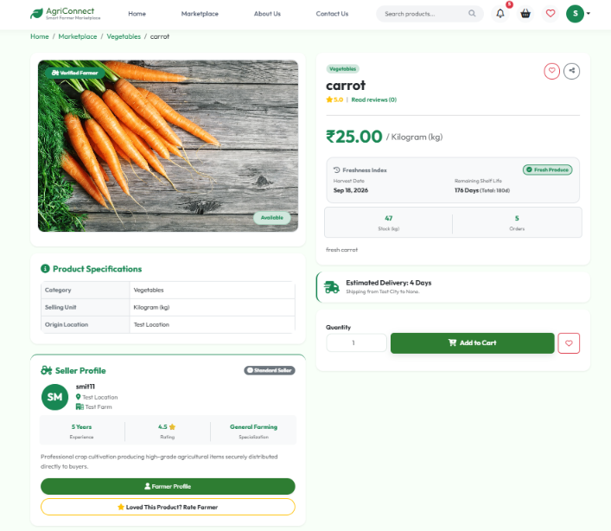
Detailed crop view displaying harvest date, shelf-life indicators, farmer verification badge, dynamic quantity calculator, and Add-to-Cart controls.

9.6 Shopping Cart & Checkout Page

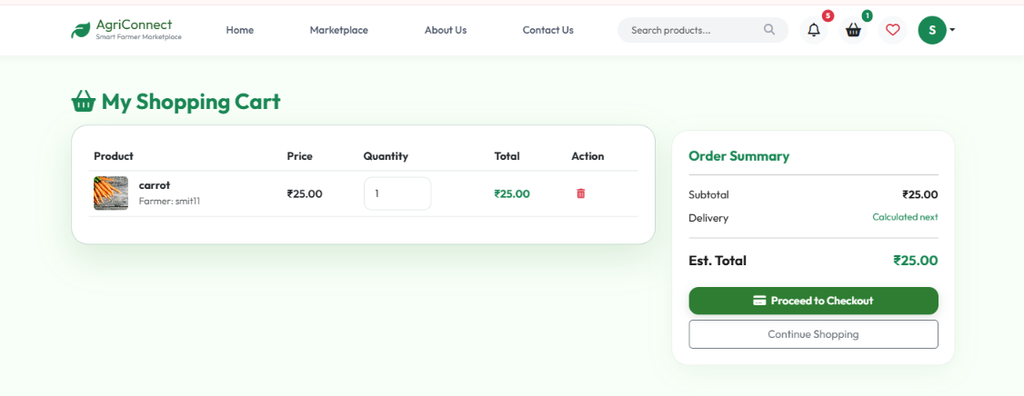
Shopping cart summary with itemized pricing, delivery address selection, multi-mode payment options (COD/UPI), and OTP verification step.

9.7 Order Tracking & History Page

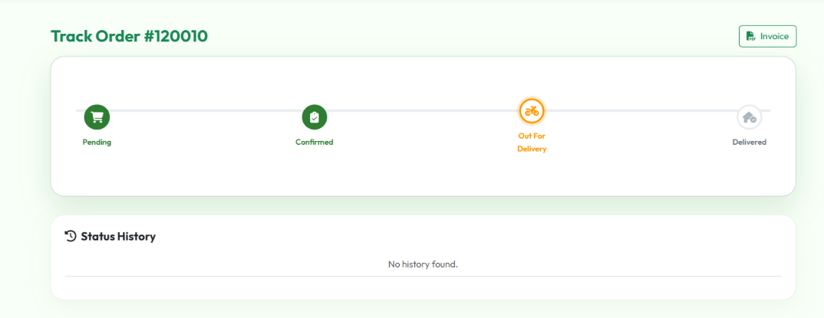
Order tracking dashboard allowing buyers and farmers to monitor real-time shipment status, download PDF tax invoices, and submit return requests.

9.8 Market Price Trends & Analytics

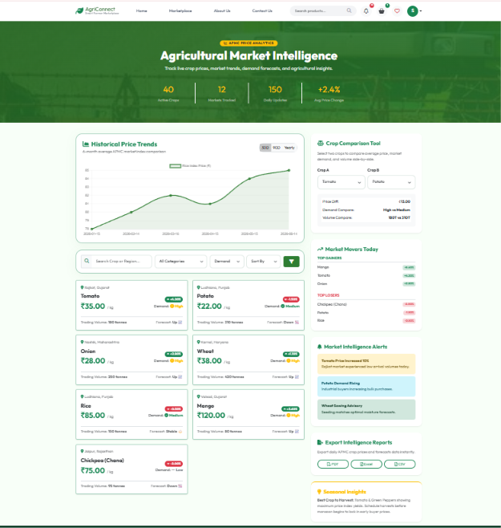
Analytical insight dashboard providing historical crop price trends, market demand forecasts, and price fluctuation statistics to guide farmers.

9.9 order confirm otp verification
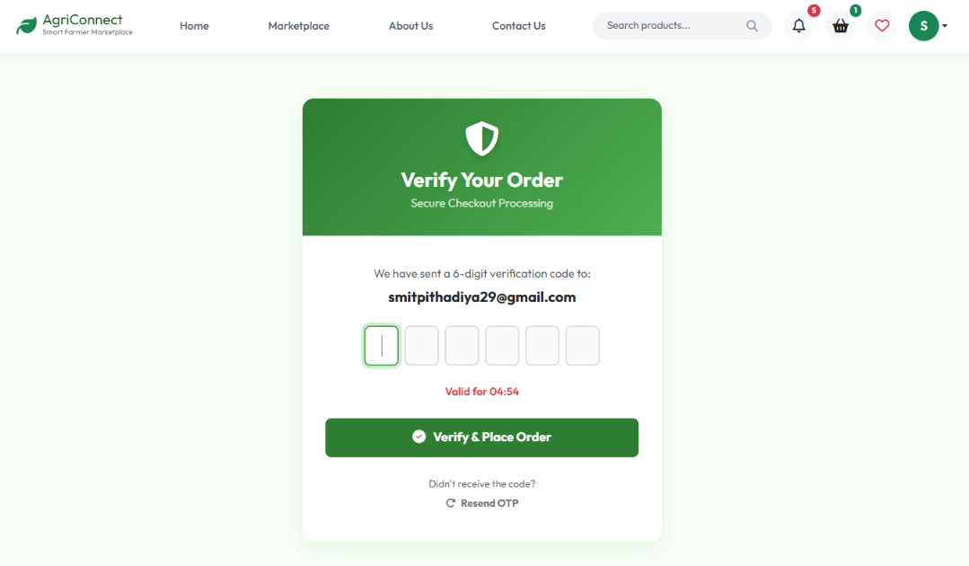

After the order is confirmed, an OTP verification message will be sent to your email and the order will be completed.

9.10 Farmer Control Dashboard
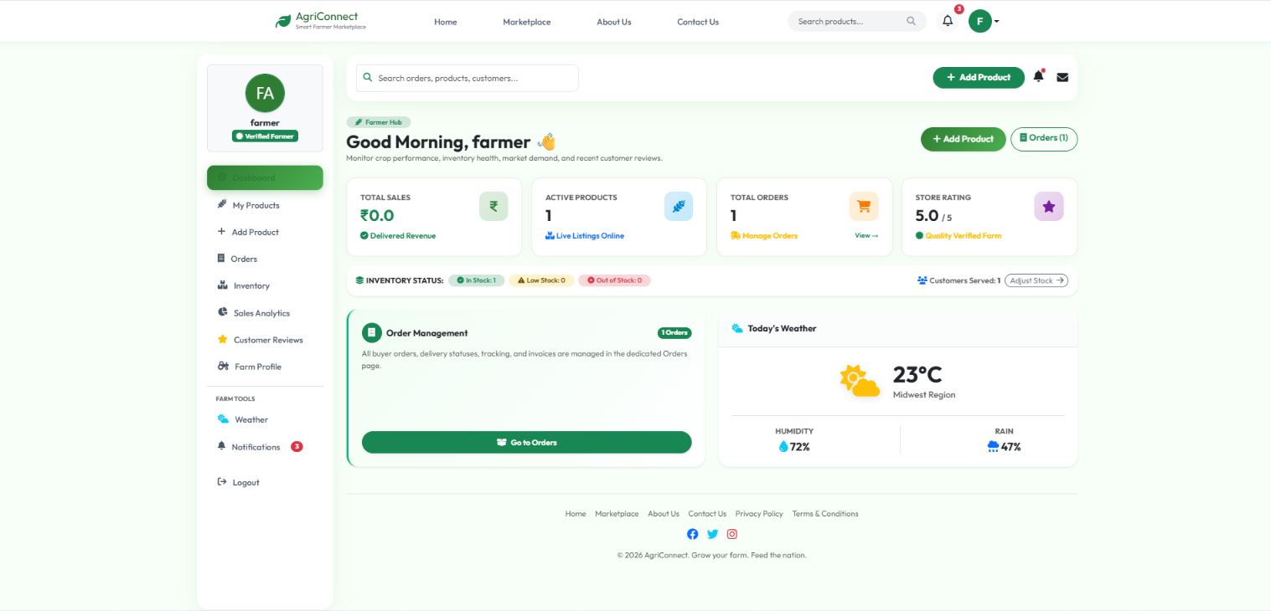
Farmer Dashboard provides farmers with a single platform to manage crops, orders, inventory, sales, weather information, and customer interactions efficiently.

9.10 Buyer Control Dashboard
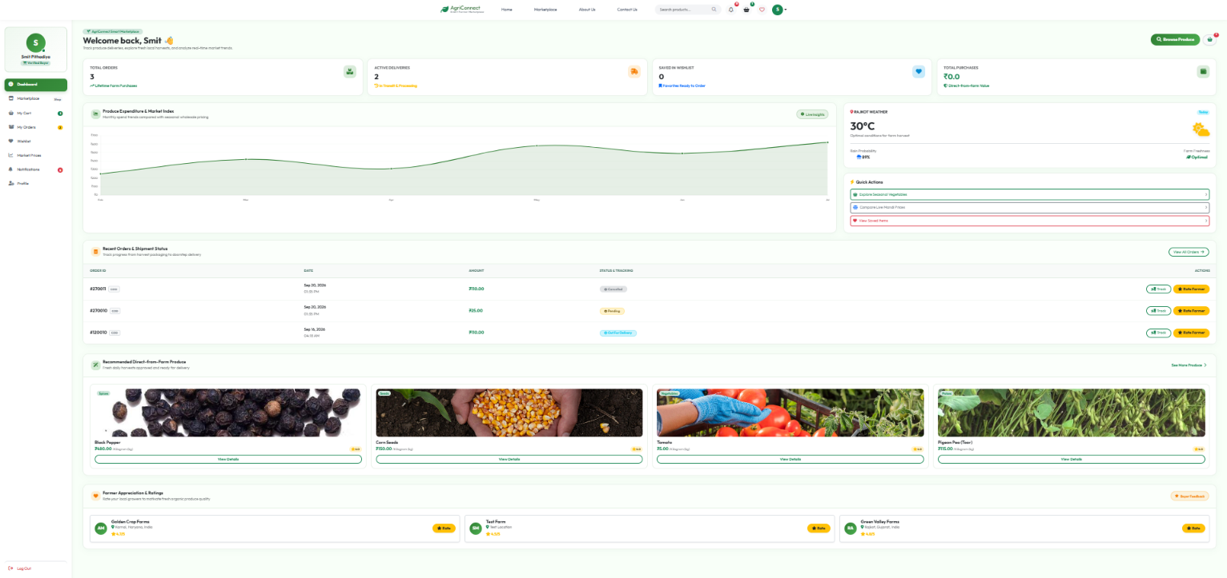 The Buyer Dashboard provides a complete overview of orders, cart, wishlist, market prices, weather updates, and purchase activities for a seamless farm-to-home shopping experience

10. Test Cases
Comprehensive software testing was conducted across all system modules to verify user input validation, data integrity, security controls, and functional correctness. All test cases yielded expected outputs and passed successfully.
Test Suite 1: Login & User Authentication
Field / Module | Test Case Description | Expected Output | Actual Output | Result
Username & Password | Display input fields for username & password | System renders two clean input text fields | Fields rendered cleanly | Pass
Login Button | Verify login with valid credentials | User authenticated & redirected to role dashboard | Redirected to dashboard | Pass
Validation | Check empty field submission | Displays error: 'Username/Password required' | Error displayed | Pass
Invalid Credentials | Check login with incorrect password | Displays error: 'Invalid username or password' | Error displayed | Pass
Test Suite 2: Farmer Crop Management
Field / Module | Test Case Description | Expected Output | Actual Output | Result
Add Crop | Test adding new crop with price & stock | New crop added and set to pending approval | Crop added successfully | Pass
Edit Crop | Update crop price per kg and stock quantity | Crop listing updated in database and marketplace | Listing updated | Pass
Stock Status | Set crop quantity to 0 | Listing automatically marked 'Out of Stock' | Marked out of stock | Pass
Delete Crop | Remove crop listing from farmer portal | Crop entry removed from catalog | Removed successfully | Pass
Test Suite 3: Shopping Cart & Checkout
Field / Module | Test Case Description | Expected Output | Actual Output | Result
Add to Cart | Select crop quantity and click Add to Cart | Crop added to user cart with total calculated | Added to cart | Pass
Update Quantity | Increase item quantity in shopping cart | Subtotal and grand total dynamically update | Totals updated | Pass
Remove Item | Click delete icon on cart item | Item removed from cart | Item removed | Pass
Checkout OTP | Submit order with phone number | System generates 6-digit OTP for order confirmation | OTP sent & verified | Pass
Test Suite 4: Admin Control & Approval
Field / Module | Test Case Description | Expected Output | Actual Output | Result
Crop Approval | Admin approves pending farmer crop listing | Crop status changed to Approved & visible in marketplace | Status updated to Approved | Pass
User Role Audit | Admin inspects registered users list | Displays all active farmers, buyers, and admin accounts | List displayed cleanly | Pass
System Reports | Click Generate Sales Report PDF | PDF invoice/report generated and downloaded | Report generated | Pass

11. Limitations
- Internet Connectivity Dependency: The application requires stable internet access for real-time market price updates and order placements, which may pose challenges in remote rural regions with limited network coverage.

- Manual Inventory Updates: Farmers must manually update crop availability and harvested quantities, leading to potential discrepancies if stock updates are delayed after local offline sales.

- Scalability for Enterprise Volumes: While the current Django architecture easily handles thousands of concurrent users, massive enterprise scaling across multiple geographical zones requires additional cloud load balancing and redis caching.

12. Future Enhancements
- AI-Driven Crop Disease Identification: Integrate machine learning models allowing farmers to upload leaf photos to automatically diagnose crop diseases and receive treatment remedies.

- Multilingual Regional Voice Support: Introduce voice-assisted navigation in Hindi, Gujarati, Marathi, and regional languages to assist non-literate farmers.

- Weather & Price Predictive Analytics: Incorporate real-time weather API feeds and AI price prediction forecasting to help farmers choose optimal harvest times.

- Native Mobile Application: Expand AgriConnect to native Android and iOS mobile applications using Flutter for seamless mobile notifications and offline capability.

13. Webliography
- Django Web Framework Documentation: https://docs.djangoproject.com/
- Python Official Documentation: https://www.python.org/
- Bootstrap 5 Documentation: https://getbootstrap.com/
- Stack Overflow Technical Q&A: https://stackoverflow.com/
- Draw.io Diagramming Tool: https://app.diagrams.net/
- MDN Web Docs (HTML/CSS/JS): https://developer.mozilla.org/

