# I. Prerequisites

1. (For On-Prem Only)Enable Task Catalogs and Tasks features on your Orchestrator   
   *(if you are using UiPath Cloud Orchestrator, these features are enabled by default)*

* Add below keys to <appSetting> tags of **Web.config** file in Orchestrator web application *(default location: C:\Program Files (x86)\UiPath\Orchestrator\Web.config)*

<add key="Tasks.ModuleEnabled" value="true" />

<add key="Tasks.FeatureEnabledByDefault" value="true" />

* Recycle the IIS App Pool or restart IIS Web application so the Orchestrator web app can load this new configuration.
* You will see new menu item in Orchestrator as below

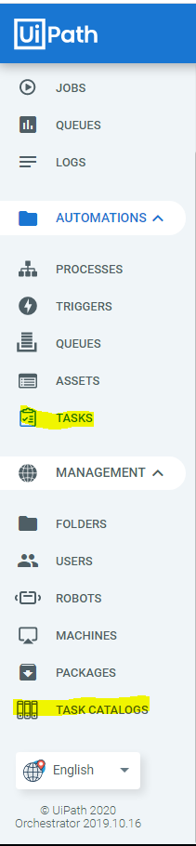

1. Create 2 Task Catalogs as below (will be used in your workflow later).

* High-Value Invoices
* Missing PO Invoices

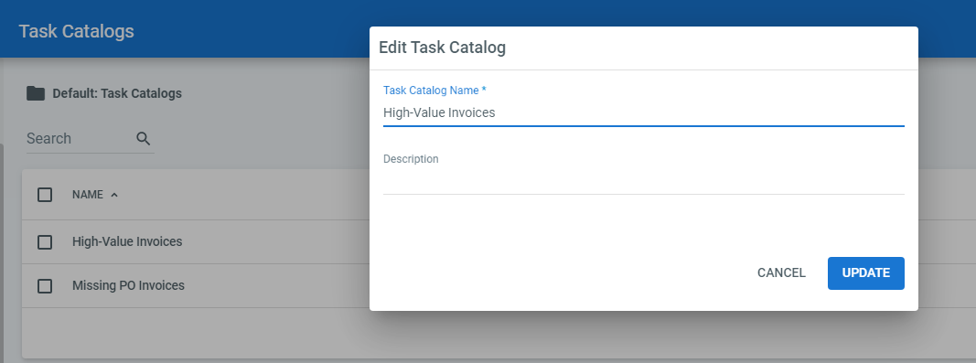

1. UiPath Robot/Studio need to connect to Orchestrator while the process is running

# II. Use case

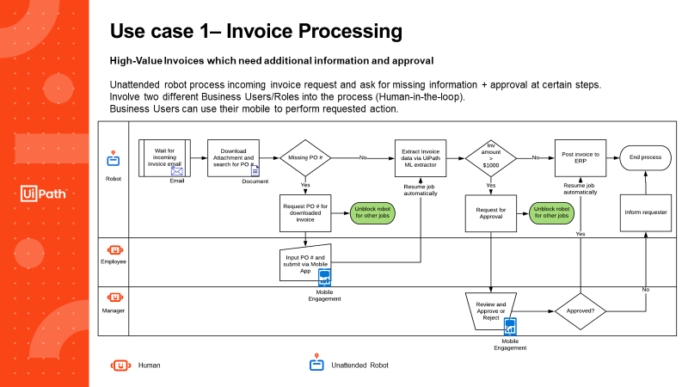

# III. Demo the use case

1. Prepare emails with sample invoice

- Create a folder on your email account: Inbox\Invoices  
- Import emails from InvoiceProcessingHITL\EmailToProcess into the Inbox\Invoices foler.

- There are 2 emails, with and without PO#. Only mark one email as Unread at a time to run the demo.

(*) If you want to use another folder name, you need to change it on the first step “**Invoke DownloadInvoiceFromInbox**”. Pass the folder name to argument “**in_OutlookFolder**”

1. Prepare Excel input form (to demonstrate the data entry steps)

* Open the Excel file “\UC1-InvoiceProcessingHITL\DB\Invoices DB.xlsx”
* If this is the first time you open it, pls go to File>Option>Customize Ribbon
  + Find the Form Commands from “All Commands” box
  + Create a New Tab
  + Rename the Tab to Data Entry
  + Add the Form command to new created Group

=> Click OK. You will see new Ribbon tab (Data Entry) on the Excel Ribbon Menu

(*) Make sure to close the excel file before going to the demo

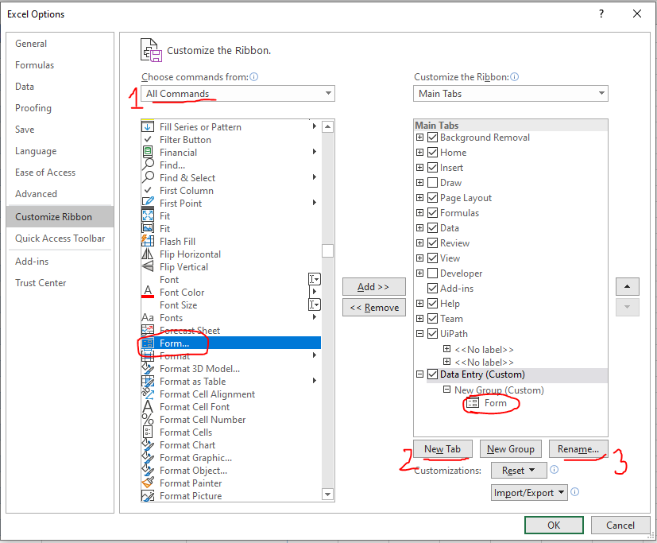

1. Publish the given project to Orchestrator or locally to the Robot

(*) It’s recommended to publish the given workflow to Orchestrator or Robot then start the process from there instead of from Studio. Because if you start the project in Studio, the execution will be paused while robot is waiting for Task to be completed, we will have to resume the execution in Studio after completing the task on Orchestrator (which doesn’t really look like *“Auto-Resume”*)

1. Start the process and perform requested action (see demo video)

**(*) Note**: If you have access to SAP system of UiPath, you can post the invoice to SAP by set in_UseSAP argument in the Main workflow to True. With this, the last step - Post Invoice will simulate the post invoice to SAP system with the Invoice-PO matching steps also.

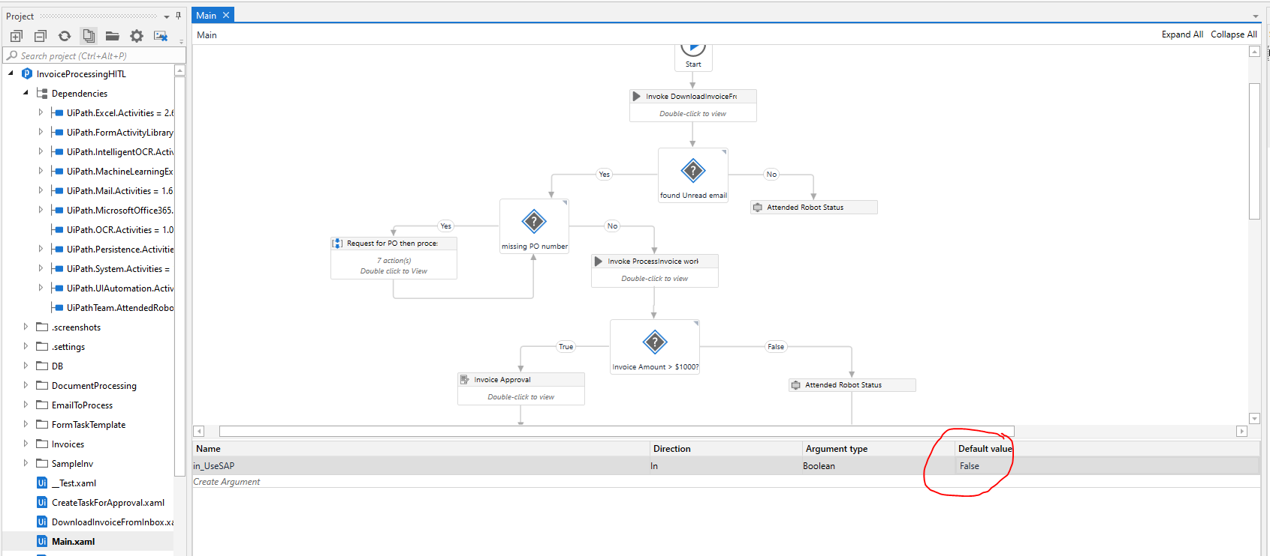

Please note: In the Main.xaml file 🡪 Inside the “Process Invoice Sequence” you will need to add the URL/Endpoint and API key for the machine learning model from the community cloud or the enterprise cloud.

