LAB EXERCISE

Module 1 – Overview of IT Industry
Write a simple "Hello World" program in two different programming languages of your choice. Compare the structure and syntax.
Ans: 1. Python Program:
# Hello World in Python
Print ("Hello, World!")

2. C Program:
// Hello World in C
#include <stdio.h>
int main() {
printf("Hello, World!");
return 0;
}
Comparison of Structure and Syntax: C vs Python
Feature | C | Python
Program structure | Fixed structure | Flexible structure
Entry point | main() function required | No fixed entry point
Header files | Required (e.g., stdio.h) | Not required
Number of lines | More lines | Fewer lines
Syntax style | Strict and complex | Simple and readable
Statement ending | Semicolon (;) required | No semicolons
Code blocks | Curly braces {} | Indentation
Ease of learning | Moderate | Easy

Research and create a diagram of how data is transmitted from a client to a server over the internet.

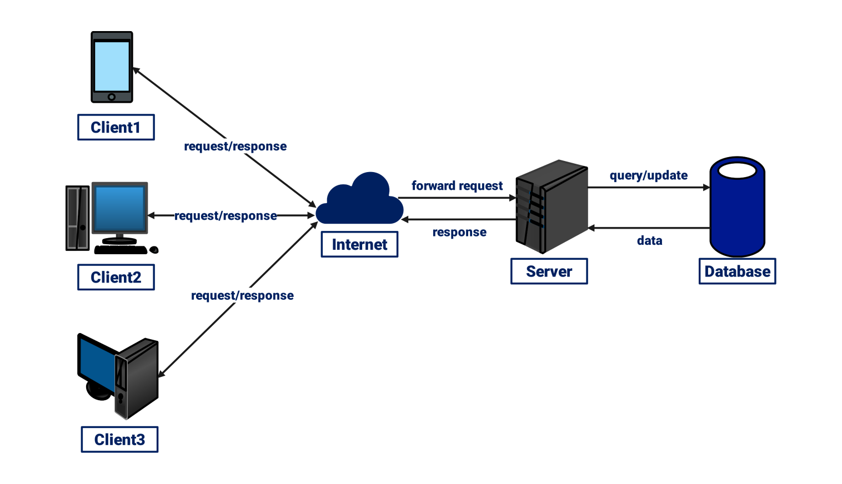

Design a simple HTTP client-server communication in any language.
Ans:
language: Python

from http.server import BaseHTTPRequestHandler, HTTPServer
class SimpleHandler(BaseHTTPRequestHandler):
def do_GET(self):
self.send_response(200)
self.send_header("Content-type", "text/plain")
self.end_headers()
self.wfile.write(b"Hello from the server!")

if __name__ == "__main__":
server_address = ("localhost", 8080)
httpd = HTTPServer(server_address, SimpleHandler)
print("Server running on http://localhost:8080")
httpd.serve_forever()

import requests
response = requests.get("http://localhost:8080")
print("Server says:", response.text)

Research different types of internet connections (e.g., broadband, fiber, satellite) and list their pros and cons.
Types of Internet Connections and Their Pros & Cons:
1. Broadband (DSL / Cable)
- Description: High-speed internet that uses existing telephone lines (DSL) or cable TV lines (Cable).
- Pros:
  - Widely available in urban areas.
  - Good speed for browsing, streaming, and gaming.
  - Affordable compared to newer technologies.
- Cons:
  - Speeds may vary depending on the number of users in the area.
  - DSL can be slower than cable.
  - Not available in some rural areas.

2. Fiber Optic
- Description: Internet delivered via fiber-optic cables that use light signals to transmit data.
- Pros:
  - Extremely fast speeds (up to 1 Gbps or more).
  - Reliable and stable connection.
  - Low latency, ideal for online gaming and video conferencing.
- Cons:
  - Expensive compared to DSL or cable.
  - Limited availability in rural or remote areas.
  - Installation can be complex.

3. Satellite
- Description: Internet delivered via communication satellites orbiting the Earth.
- Pros:
  - Available almost anywhere, even in remote or rural areas.
  - No need for physical cables to homes.
- Cons:
  - High latency (delay), not ideal for gaming or real-time video calls.
  - Speeds can be lower than fiber or cable.
  - Affected by weather conditions like heavy rain or storms.

4. Mobile / Cellular (3G, 4G, 5G)
- Description: Internet access using mobile networks via SIM cards or hotspots.
- Pros:
  - Portable; can use anywhere with network coverage.
  - 5G offers very high speeds and low latency.
  - No need for wired installation.
- Cons:
  - Data limits or expensive plans.
  - Speeds vary depending on signal strength and network congestion.
  - Coverage may be limited in rural areas.

5. Dial-Up
- Description: Internet over a standard telephone line using a modem.
- Pros:
  - Very cheap.
  - Works anywhere with a phone line.
- Cons:
  - Extremely slow (max 56 kbps).
  - Ties up the phone line while connected.
  - Not suitable for modern applications like streaming or video calls.

Simulate HTTP and FTP requests using command line tools (e.g., curl).
1. Simulating an HTTP Request Using curl
Command:
curl http://example.com
Explanation:
• This command sends an HTTP GET request to the server at example.com.
• The server responds with the HTML content of the page.
• Useful for testing websites or APIs.

2. Simulating an FTP Request Using curl
Command (to download a file):
curl ftp://ftp.example.com/file.txt --user username:password
Explanation:
• Connects to an FTP server.
• Logs in with provided username and password.
• Downloads the file file.txt from the FTP server.
Identify and explain three common application security vulnerabilities. Suggest possible solutions.
Ans: Common Application Security Vulnerabilities and Solutions:
1. SQL Injection (SQLi)
- What it is:
SQL Injection happens when attackers insert malicious SQL code into input fields so that it changes how the database query runs. This can let attackers view, delete, or modify sensitive data. OWASP 10
- Example: A login form where a user enters "' OR '1'='1" to bypass authentication.
- Solution:
  - Use parameterized queries or prepared statements instead of building SQL commands directly with user input.
  - Validate and sanitize all user input to remove harmful characters.
  - Apply least privilege to database accounts so they cannot perform unauthorized actions.

2. Cross-Site Scripting (XSS)
- What it is:
XSS occurs when attackers inject malicious scripts (usually JavaScript) into web pages that other users view. This can steal session cookies, hijack accounts, or redirect users to dangerous websites. OWASP 10
- Example: A comment box that doesn’t filter input allows <script>alert('Hacked!')</script> to run in another user’s browser.
- Solution:
  - Escape and encode all output before it’s rendered in the browser.
  - Use web frameworks or libraries that automatically handle XSS protection.
  - Implement a Content Security Policy (CSP) to restrict what scripts the browser will run.

3. Broken Authentication
- What it is:
Broken authentication occurs when login systems or session management are not implemented securely, allowing attackers to impersonate users or gain unauthorized access. OWASP Foundation
- Example: Storing passwords in plain text or using predictable session tokens that can be guessed.
- Solution:
  - Store passwords using strong hashing algorithms (e.g., bcrypt, Argon2).
  - Require multi-factor authentication (MFA) to reduce reliance on passwords alone.
  - Use secure session management, including random, time-limited session tokens.
  - Implement rate limiting to prevent brute-force attacks.

Identify and classify 5 applications you use daily as either system software or application software.
Classification of Daily Software
Software / App | Type | Explanation
1. Windows / macOS / Android | System Software | Operating system that manages computer or phone hardware and provides basic functions.
2. Google Chrome (Web Browser) | Application Software | A program used to browse the internet and run web applications.
3. WhatsApp / Telegram | Application Software | Messaging apps used to send texts, make calls, and share media.
4. Microsoft Word / Google Docs | Application Software | Software used to create, edit, and format documents.
5. Antivirus Software (e.g., Windows Defender) | System Software | Security program that protects the computer from malware and threats.

Explanation (Short)
- Windows / macOS / Android
  - System Software: It controls hardware, allows other software to run, and manages system resources.
- Google Chrome
  - Application Software: A user program used for browsing the internet but does not manage hardware.
- WhatsApp / Telegram
  - Application Software: Used for communication and does not control system hardware.
- Microsoft Word / Google Docs
  - Application Software: Used for word processing tasks.
- Antivirus Software (Windows Defender, etc.)
  - System Software: Works closely with the OS to protect the system from threats.

Design a basic three-tier software architecture diagram for a web application.
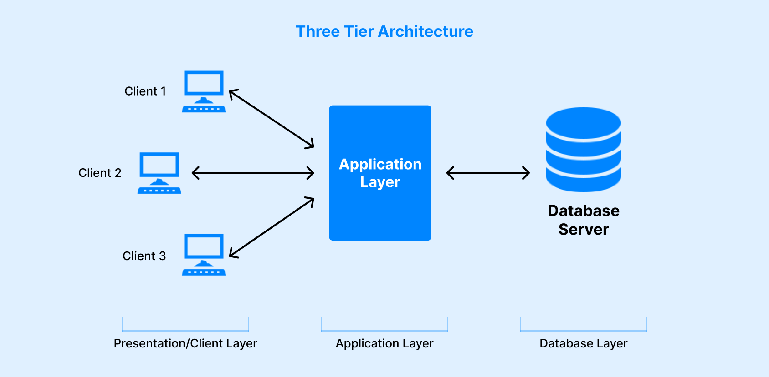

Create a case study on the functionality of the presentation, business logic, and data access layers of a given software system.
1. Presentation Layer (Frontend / UI)
Role: This is what the user interacts with.
• User browses restaurants and food items
• Adds food to cart
• Enters delivery details
• Makes payment
Technologies Used:
HTML, CSS, JavaScript, React, Flutter (for mobile)
2. Business Logic Layer (Application Layer)
Role: This handles all decision-making and rules.
• Processes order and verify payment
• Applies discounts and taxes
• Matches user with nearby delivery agents
• Calculates estimated delivery time
Technologies Used:
Node.js, Java, PHP, Python
3. Data Access Layer (Database Layer)
Role: Deals with storing and retrieving data.
• Saves user profiles, orders, and payment info
• Fetches list of restaurants and menus
• Tracks real-time delivery status
• Stores feedback and reviews
Technologies Used:
MySQL, MongoDB, PostgreSQL

Explore different types of software environments (development, testing, production). Set up a basic environment in a virtual machine.
Types of Software Environments
- Development Environment
This is where developers write, edit, and debug code. It is usually set up on a developer’s machine or in a dedicated server space. Developers test individual features and make changes frequently. Examples of tools used include code editors, version control systems, and debugging tools.
- Testing Environment
Also called the QA (Quality Assurance) environment, this is where the full software is tested after development. It is used to find bugs and verify whether the application works as expected before it is released. Testers run different types of testing such as functional, integration, and performance testing.
- Production Environment
This is the live environment where the application is made available to real users. It uses real data, needs to be stable, secure, and fast. Only thoroughly tested and approved code is deployed in this environment to avoid failures for end users.

Setting Up a Basic Environment in a Virtual Machine
A virtual machine (VM) is software that creates an isolated computer environment within your computer. You can install an operating system and necessary software inside the VM to create a separate environment for development or testing.
Steps to Set Up a Basic Environment in a Virtual Machine:
- Install Virtualization Software
Download and install virtualization software such as VirtualBox or VMware Workstation on your computer.
- Create a New Virtual Machine
Open VirtualBox or VMware and click “New.” Enter a name for your VM, select the operating system you want to install (e.g., Ubuntu Linux or Windows), and assign memory (RAM) and disk space.
- Install the Operating System
Attach the OS installation file (ISO) to the VM and start it. Follow the on-screen instructions to install the chosen operating system inside the VM.
- Install Software Tools
Once the OS is installed, install the software tools you need, such as a code editor (e.g., Visual Studio Code), programming languages (e.g., Python, Node.js), and a database (e.g., MySQL or MongoDB).
- Configure the Environment
Set environment variables, project folders, and network settings as needed. Customize the VM to match your development or testing needs.
- Verify the Environment
Run a simple program or check software versions to confirm that everything is working correctly inside the VM.

Write and upload your first source code file to Github.
1. Write a Simple Code File
Create a simple file named hello.py:
# hello.py
print("Hello, GitHub!")
2. Create a Repository on GitHub
• Go to https://github.com
• Click New Repository
• Name it (e.g., first-code)
• Add a description (optional)
• Choose Public
• Click Create repository

3. Upload the Code Using Git (Command Line)
Open terminal or Git :
git init
git add hello.py
git commit -m "Add hello.py"
git branch -M main
git remote add origin https://github.com/your-username/first-code.git
git push -u origin main

Create a Github repository and document how to commit and push code changes.
Step 1: Create a GitHub Repository
1. Go to https://github.com
2. Click on “New” to create a new repository
3. Enter a repository name (e.g., my-first-repo)
4. (Optional) Add a description
5. Choose Public or Private
6. Click Create repository
Step 2: Prepare Your Project Locally
Create a folder and add a file (e.g., main.py):
python
# main.py
print("This is my first commit!")

Step 3: Use Git to Commit and Push Code
Open Git or Terminal, then run:
git init # Initialize Git in the folder
git add . # Stage all files
git commit -m "Initial commit" # Commit changes with a message
git branch -M main
# Rename default branch to main
git remote add origin https://github.com/your-username/my-first-repo.git
git push -u origin main # Push changes to GitHub
Replace your-username with your actual GitHub username.

Summary:
• You created a GitHub repository
• Committed code using Git
• Pushed it to GitHub successfully

Create a student account on Github and collaborate on a small project with a classmate.
1. Create a Student GitHub Account
- Go to https://github.com/
- Click Sign up.
- Enter your email, username, and password.
- Choose the Free plan.
- Verify your email address by clicking the verification link sent to your email.
- Your GitHub student account is now ready!

2. Create a Repository for Collaboration
- After logging in, click the “+” icon at the top right of the GitHub page.
- Select “New repository.”
- Give the repository a name (e.g., student-project).
- Add a description (optional).
- Choose Public or Private (public is okay for class projects).
- Add a README.md file.
- Click Create repository.

3. Invite Your Classmate to Collaborate
- Go to your repository page.
- Click on Settings.
- Click on Collaborators.
- Enter your classmate’s GitHub username or email.
- Click Add collaborator.
- Your classmate will receive an invitation — they should accept it.

4. Work Together on a Small Project
- Both you and your classmate can now add code files to the repository.
- You can create folders such as src, docs, or images.
- Example project:
  - A simple HTML website with index.html, style.css, and script.js.
  - Or a Python program with main.py and helper modules.
- Your classmate can edit, upload, and push changes to the repository.

Create a list of software you use regularly and classify them into the following categories: system, application, and utility software.
Table: List of Software Used Regularly
Software Name | Category | Description / Purpose
Windows 11 | System Software | Controls computer hardware and manages system resources
iOS | System Software | Mobile operating system used on iPhones
Visual Studio Code | Application Software | Writing and editing source code
Google Chrome | Application Software | Accessing websites and web applications
Microsoft Excel | Application Software | Performing calculations and data analysis
Zoom | Application Software | Online meetings and video conferencing
Adobe Photoshop | Application Software | Editing and designing images
Windows Defender | Utility Software | Protects the system from viruses and threats
Disk Cleanup | Utility Software | Removes unnecessary files to improve performance
7-Zip | Utility Software | Compressing and extracting files

Follow a GIT tutorial to practice cloning, branching, and merging repositories.
GIT Tutorial: Cloning, Branching, and Merging
First, a Git repository was cloned to the local system using the git clone command. This created a local copy of the remote repository where changes could be made safely.
git clone https://github.com/git-guides/git-practice.git
After cloning, a new branch was created to work independently without affecting the main branch. The branch was created and switched to using the following command:
git checkout -b feature-branch
Changes were then made to files in the new branch. After making the changes, the files were added and committed to the repository.
git add .
git commit -m "Made changes in feature branch"
Once the work was completed, the branch was merged back into the main branch. This combined the changes from the feature branch into the main codebase.
git checkout main
git merge feature-branch
This process helped in understanding how Git manages versions, allows parallel development using branches, and safely merges changes into the main repository.

Write a report on the various types of application software and how they improve productivity.
Report: Types of Application Software and Their Role in Improving Productivity
Introduction
Application software is a type of computer program designed to help users perform specific tasks. These programs make work faster, easier, and more efficient, thereby improving productivity in personal, educational, and professional settings.

Types of Application Software
- Word Processing Software
  - Example: Microsoft Word, Google Docs
  - Purpose: Creating, editing, and formatting text documents
  - Productivity Benefit: Speeds up writing reports, letters, and assignments while providing tools like spell check and templates.
- Spreadsheet Software
  - Example: Microsoft Excel, Google Sheets
  - Purpose: Organizing data, performing calculations, and creating charts
  - Productivity Benefit: Simplifies complex calculations, data analysis, and financial planning.
- Presentation Software
  - Example: Microsoft PowerPoint, Google Slides
  - Purpose: Creating slideshows for presentations
  - Productivity Benefit: Helps communicate ideas clearly and visually, saving time in preparing professional presentations.
- Database Management Software (DBMS)
  - Example: MySQL, Microsoft Access
  - Purpose: Storing, organizing, and managing large amounts of data
  - Productivity Benefit: Allows quick access and retrieval of information, making data management more efficient.
- Multimedia Software
  - Example: VLC Media Player, Adobe Photoshop
  - Purpose: Editing images, videos, and audio
  - Productivity Benefit: Enhances creativity and communication through high-quality visual and audio content.
- Web Browsers and Email Clients
  - Example: Google Chrome, Mozilla Firefox, Outlook
  - Purpose: Accessing the internet and managing communications
  - Productivity Benefit: Facilitates quick research, online collaboration, and instant communication.

Create a flowchart representing the Software Development Life Cycle (SDLC).
Software Development Life Cycle (SDLC)

┌───────────┐
│ Start │
└─────┬─────┘
│
▼
┌──────────────────────────┐
│ Requirement Analysis │
│ (Gather user needs) │
└─────┬────────────────────┘
│
▼
┌──────────────────────────┐
│ System Design │
│ (Architecture & Models ) │
└─────┬────────────────────┘
│
▼
┌──────────────────────────┐
│ Implementation / Coding │
│ (Develop the software) │
└─────┬────────────────────┘
│
▼
┌──────────────────────────┐
│ Testing │
│ (Find & fix defects) │
└─────┬────────────────────┘
│
▼
┌───────────────┐
│ Is software │
│ working as │
│ expected? │
└───┬─────┬─────┘
│Yes │No
▼ ▼
┌──────────────┐ ┌────────────────────┐
│ Deployment │ │ Fix Issues / │
│ (Release) │ │ Re-testing │
└─────┬────────┘ └──────────┬─────────┘
│ │
▼ └───► Back to Coding
┌──────────────────────────┐
│ Maintenance & Support │
│ (Updates & enhancements) │
└─────┬────────────────────┘
│
▼
┌───────────┐
│ End │
└───────────┘

Write a requirement specification for a simple library management system.
1. Introduction
The Library Management System (LMS) is designed to manage the day-to-day operations of a library. It helps librarians keep track of books, members, and borrowing activities efficiently.
2. Functional Requirements
- User Management:
  - Register new members with details like name, contact info, and membership ID.
  - Allow members to update their personal information.
- Book Management:
  - Add new books with details such as title, author, ISBN, and category.
  - Update book information or remove books from the system.
- Borrowing and Returning:
  - Allow members to borrow available books and record the borrowing date.
  - Track due dates for borrowed books and send reminders for overdue books.
  - Process book returns and update book availability.
- Search Functionality:
  - Enable searching for books by title, author, or category.
- Reports:
  - Generate reports of issued books, overdue books, and member activities.

3. Non-Functional Requirements
- Usability:
The system should be user-friendly and easy to operate for librarians and members.
- Performance:
The system should handle multiple users and quick search operations without delay.
- Security:
Ensure that member data and book records are secure and only accessible to authorized users.
- Reliability:
The system should be available with minimal downtime.

4. Constraints
- The system will be used primarily on desktop computers by library staff.
- Internet access is optional but recommended for future updates.

5. Assumptions
- Members will have unique membership IDs.
- Books will have unique ISBN numbers.

Perform a functional analysis for an online shopping system.
Introduction:
An Online Shopping System allows users to browse, select, and purchase products over the internet. It helps customers shop conveniently from anywhere while enabling sellers to manage products, orders, and payments efficiently.
Functional Analysis for an Online Shopping System
1. User Registration and Login
- Users can create accounts with personal details.
- Users can log in securely using email/username and password.
- Forgot password and password reset functionality is included.

2. Product Catalog Management
- Display a list of products with categories, prices, images, and descriptions.
- Admin can add, update, or remove products from the catalog.
- Users can search products by name, category, or price.
3. Shopping Cart
- Users can add items to the cart before purchase.
- Update the quantity or remove items from the cart.
- Display total price and applicable discounts.
4. Order Management
- Users can place orders for the items in the cart.
- Admin can view and manage all orders.
- Users can track order status (processing, shipped, delivered).
5. Payment Processing
- Supports multiple payment methods like credit/debit cards, UPI, or wallets.
- Secure processing of transactions.
- Generate payment confirmation and receipt.
6. Reviews and Ratings
- Users can rate and review products they purchased.
- Admin can moderate reviews to maintain quality and authenticity.
7. Notifications
- Users receive email or app notifications about order status, offers, and discounts.
8. Security and Privacy
- User data and payment information are protected and encrypted.
- Access control for users and admin to prevent unauthorized actions.

Design a basic system architecture for a food delivery app.
System Architecture for a Food Delivery App
1. Overview
The food delivery app connects customers, restaurants, and delivery personnel through a central platform. The system allows users to browse restaurants, place orders, and track deliveries in real-time.

2. Components of the System
- User Interface (UI) Layer
  - Customer App: Browse restaurants, view menu, place orders, make payments, and track delivery.
  - Restaurant App: Manage menu, receive orders, and update order status.
  - Delivery App: Receive delivery assignments, update status, and navigation support.
- Application / Business Logic Layer
  - Order Management: Handles order placement, updates, and tracking.
  - Payment Processing: Integrates payment gateway for secure transactions.
  - Notification System: Sends push notifications and updates to users, restaurants, and delivery personnel.
  - User Management: Manages profiles, authentication, and access control.
- Database Layer
  - User Database: Stores customer, restaurant, and delivery personnel information.
  - Orders Database: Tracks order details, status, and history.
  - Menu Database: Stores restaurant menus and item details.
  - Payment Database: Records payment transactions securely.
- External Services / APIs
  - Payment Gateway API: Handles online payments.
  - Maps / GPS API: Provides delivery route optimization and tracking.
  - SMS/Email API: Sends notifications to users.

System Architecture Diagram (Text Version)
[Customer App] [Restaurant App] [Delivery App]

\ | /
\ | /
\ | /
-------------------------------
| Application / Busines |
| Logic Layer |
| (Orders, Payment, |
| Notifications, User Mgmt) |
-------------------------------
| |
| |
-----------------------------
| Database Layer |
| User, Orders, Menu, Payment |
-----------------------------
| |
[External APIs/Services]
(Payment Gateway, Maps/GPS, Notifications)

Develop test cases for a simple calculator program.

Test Cases for a Simple Calculator Program
Test Case ID | Function | Input | Expected Output | Description
TC01 | Addition | 5 + 3 | 8 | Check if addition works for positive integers
TC02 | Addition | -2 + 7 | 5 | Check addition with negative and positive number
TC03 | Subtraction | 10 - 4 | 6 | Check subtraction of two positive numbers
TC04 | Subtraction | 5 - 9 | -4 | Check subtraction resulting in negative number
TC05 | Multiplication | 6 × 7 | 42 | Check multiplication of positive numbers
TC06 | Multiplication | -3 × 4 | -12 | Check multiplication with negative number
TC07 | Division | 20 ÷ 5 | 4 | Check division of two positive numbers
TC08 | Division | 10 ÷ 0 | Error / “Cannot divide by zero” | Check division by zero handling
TC09 | Division | -12 ÷ 3 | -4 | Check division with negative numerator
TC10 | Mixed Operations | 5 + 3 × 2 | 11 | Check correct order of operations (BODMAS)

Document a real-world case where a software application required critical maintenance.
Case Study: Critical Maintenance of the Boeing 737 MAX Flight Control Software
Background
The Boeing 737 MAX is a widely used commercial aircraft. It included a software system called MCAS (Maneuvering Characteristics Augmentation System), which was designed to automatically adjust the aircraft’s stabilizers to prevent stalls.

Issue
- In 2018 and 2019, two Boeing 737 MAX planes crashed due to MCAS malfunction, leading to 346 deaths.
- The problem was caused by incorrect sensor data, which triggered the system to push the nose of the plane down unexpectedly.
- This made the software a critical safety risk, requiring immediate maintenance and updates.

Critical Maintenance Actions
- Software Update: Boeing updated the MCAS software to consider data from multiple sensors, not just one, to reduce risk of erroneous activation.
- Enhanced Testing: Extensive testing was performed on simulators and real flights to ensure the software behaves correctly under all scenarios.
- Pilot Training: Updated manuals and simulator training were provided to pilots to handle any unexpected system behavior.
- Certification & Verification: The software underwent strict verification by aviation authorities before planes returned to service.

Outcome
- The maintenance and updates restored safety and trust in the Boeing 737 MAX.
- The case highlighted the importance of critical software maintenance in systems where failure can have catastrophic consequences.

Create a DFD for a hospital management system:
Data Flow Diagram (DFD) for Hospital Management System
1. Overview
A Hospital Management System (HMS) manages patient records, appointments, staff, billing, and pharmacy operations. It connects patients, doctors, administrative staff, and the pharmacy through a central system.

2. Components
External Entities:
- Patient: Requests appointments, receives bills, and provides medical history.
- Doctor: Views patient records, updates treatment, and prescribes medications.
- Reception/Admin: Manages appointments, patient registration, and billing.
- Pharmacy: Provides prescribed medicines and updates stock.
Processes:
- Patient Registration: Registers new patients and stores personal and medical info.
- Appointment Scheduling: Books, updates, or cancels appointments.
- Medical Records Management: Maintains patient history, treatment, and prescriptions.
- Billing & Payment: Calculates charges, generates invoices, and processes payments.
- Pharmacy Management: Handles medicine inventory and prescription fulfilment.
Data Stores:
- Patient Database: Stores patient personal details and medical history.
- Staff Database: Stores doctor and staff information.
- Billing Database: Stores invoices and payment records.
- Pharmacy Database: Stores medicines, prescriptions, and stock info.

┌───────────┐
│ Patient │
└─────┬─────┘
│ Patient Details
▼
┌─────────────────────────┐
│ 1. Manage Patient Info │
└──────────┬──────────────┘
│
▼
┌────────────┐
│ D1: Patient │
│ Records │
└────────────┘

Patient Appointment Request
│
▼
┌─────────────────────────┐
│ 2. Manage Appointments │◄─────────┐
└──────────┬──────────────┘ │
│ │ Doctor Availability
▼ │

┌──────────────┐ ┌──────────────┐
│ D3: Appointment │ │ Doctor │
│ Records │ │ │
└──────────────┘ └──────────────┘

Doctor Diagnosis / Treatment
│
▼
┌─────────────────────────┐
│ 3. Manage Medical Data │
└──────────┬──────────────┘
│
▼
┌──────────────┐
│ D2: Doctor │
│ Records │
└──────────────┘

Billing Information
│
▼

┌─────────────────────────┐
│ 4. Manage Billing │
└──────────┬──────────────┘
│
▼

┌──────────────┐
│ D4: Billing │
│ Records │
└──────────────┘

▲
│ Bills / Payment Info
┌───────────┐
│ Admin │
└───────────┘

Build a simple desktop calculator application using a GUI library.
Python Tkinter Calculator
import tkinter as tk

# Create main window
window = tk.Tk()
window.title("Simple Calculator")
window.geometry("300x400")
window.resizable(False, False)

# Entry widget to display calculations
display = tk.Entry(window, font=("Arial", 20), borderwidth=5, relief="ridge", justify="right")
display.pack(fill="both", padx=10, pady=10)

# Function to add text to display
def button_click(value):
display.insert(tk.END, value)

# Function to clear display
def clear_display():
display.delete(0, tk.END)

# Function to evaluate expression
def calculate():
try:
result = eval(display.get())
display.delete(0, tk.END)
display.insert(tk.END, result)
except:
display.delete(0, tk.END)
display.insert(tk.END, "Error")

# Frame for buttons
buttons_frame = tk.Frame(window)
buttons_frame.pack()

# Button layout
buttons = [
("7", 0, 0), ("8", 0, 1), ("9", 0, 2), ("/", 0, 3),
("4", 1, 0), ("5", 1, 1), ("6", 1, 2), ("*", 1, 3),
("1", 2, 0), ("2", 2, 1), ("3", 2, 2), ("-", 2, 3),
("0", 3, 0), (".", 3, 1), ("=", 3, 2), ("+", 3, 3),
]

# Create buttons
for (text, row, col) in buttons:
if text == "=":
btn = tk.Button(buttons_frame, text=text, width=5, height=2,
font=("Arial", 14), command=calculate)
else:
btn = tk.Button(buttons_frame, text=text, width=5, height=2,
font=("Arial", 14), command=lambda t=text: button_click(t))
btn.grid(row=row, column=col, padx=5, pady=5)

# Clear button
clear_btn = tk.Button(window, text="Clear", font=("Arial", 14),
command=clear_display)
clear_btn.pack(fill="both", padx=10, pady=10)

# Run the application
window.mainloop()

Draw a flowchart representing the logic of a basic online registration system.
Online Registration System – Flowchart
┌───────────┐
│ Start │
└─────┬─────┘
│
▼
┌────────────────────┐
│ Display Registration │
│ Form │
└─────┬──────────────┘
│
▼
┌────────────────────┐
│ User Enters Details │
│ (Name, Email, Pass) │
└─────┬──────────────┘
│
▼
┌────────────────────┐
│ Validate Input Data │
└─────┬──────────────┘
│
▼
┌───────────────┐
│ Is Data Valid? │
└───┬─────┬─────┘
│Yes │No
| |
| |
▼ ▼

┌──────────────┐ ┌────────────────────┐
│ Check if User │ │ Show Error Message │
│ Already Exists │ │ & Ask to Re-enter │
└─────┬────────┘ └──────────┬─────────┘
│ │
▼ └───► (Back to Form)
┌───────────────┐
│ User Exists? │
└───┬─────┬─────┘
│Yes │No
▼ ▼

┌──────────────┐ ┌────────────────────┐
│ Show "Account │ │ Save User Data │
│ Already Exists │ │ in Database │
└──────────────┘ └──────────┬─────────┘
│
▼
┌────────────────────┐
│ Show Success Message │
└──────────┬─────────┘
│
▼
┌─────────┐
│ End │
└─────────┘

