REAL-TIME OBJECT DETECTION
USING YOLO
A Project Report
submitted for the course
Image Processing and Computer Vision
Submitted by
Name | Roll Number
Yogesh Dixit | 20233362
Sumitabh Ahirwar | 20233280
Smit Thakkar | 20233570
Vishal Prabhu | 20233582

September 2026

Abstract
Object detection is the task of finding which objects are present in an image and where they are. It is used in many places, for example in traffic cameras, driver-assistance systems, security cameras and self-checkout counters. In this project we built a simple application that detects objects in real time using a laptop webcam.
The application reads frames from the webcam with OpenCV, passes each frame to a pretrained YOLO (You Only Look Once) model, and draws a bounding box, the class name and a confidence score for every object it finds. The processed video is shown in a basic web interface made with Streamlit, together with the frames per second (FPS) and a simple count of the objects in the current frame. We used the YOLO11n (nano) model provided by Ultralytics. Ultralytics had already trained it on the COCO dataset, which has 80 common object classes. We did not train or change the model. Our work was integrating it with OpenCV and a user interface, and testing how the complete system behaves.
On our test laptop (Apple M3, 8 GB RAM, no separate GPU) the application ran at about 22–24 FPS, and the model alone took about 31 ms per 640x480 frame. In the live webcam feed a person was detected with confidence scores between 0.77 and 0.94. The application also handled an empty scene and an unavailable camera without crashing. We looked at how the confidence threshold changes the output, and used simple OpenCV simulations to see how low light and object distance affect detection.
We also deployed the application online on Streamlit Community Cloud. A cloud server has no webcam, so for the online version the browser sends the viewer's webcam video to the app with WebRTC (the streamlit-webrtc component). Detection stays real-time. In a test with a 30 fps test video, the online version mostly ran at 15–24 FPS. The project shows that a working real-time detector can be built with a small amount of understandable Python code.
Keywords: object detection, YOLO, OpenCV, Streamlit, WebRTC, real-time video, computer vision, image processing.

Contents
Abstract
1. Introduction
2. Problem Statement
3. Objectives
4. Background
5. YOLO (You Only Look Once)
6. Proposed System
7. System Architecture
8. Methodology
9. Technologies Used
10. Implementation
11. User Interface
12. Testing
13. Results
14. Limitations
15. Future Scope
16. Conclusion
References

1. Introduction

1.1 Computer Vision
Computer vision is the part of computer science that tries to make computers understand images and videos. A person can look at a desk and immediately say that there is a laptop, a bottle and a phone on it. For a computer, the same picture is only a large grid of numbers (pixel values). Computer vision methods try to turn these numbers into useful information, such as “there is a person in the left half of the image”.
Computer vision has improved a lot in the last ten years, mainly because of deep learning. Convolutional neural networks (CNNs) can learn useful features directly from large collections of labelled images. Today such networks are used in mobile phones, cars, hospitals, shops and factories.

1.2 Object Detection
Object detection is one of the basic tasks in computer vision. For a given image it answers two questions: what objects are present, and where they are. The answer is a list of bounding boxes. Each box is a rectangle around one object, together with a class name (for example “person” or “bottle”) and a confidence score between 0 and 1 that shows how sure the model is. Figure 1.1 shows an example produced by our application.
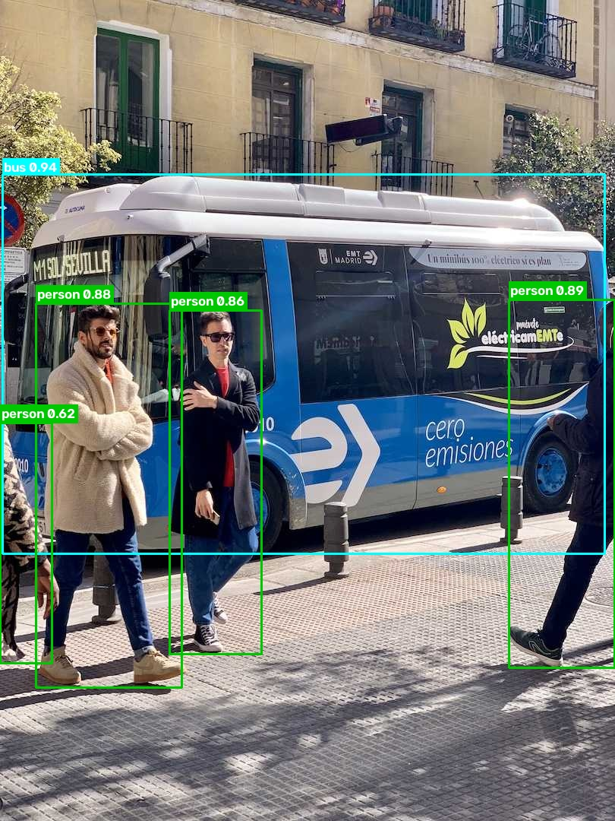
Figure 1.1: Output of our application on the Ultralytics sample image bus.jpg. Every object has a box, a class name and a confidence score.

1.3 Motivation
Real-time detection is needed whenever a decision has to be taken while something is happening. A car must notice a pedestrian at once, and a security camera must raise an alert when a person enters a restricted area. In these cases a result that comes after a few seconds is not useful.
For students, a webcam-based detector is a good way to see how the theory from an image processing course (pixels, colour spaces, resizing, drawing) comes together with a neural network in a working system. Good pretrained models such as YOLO are now freely available. The interesting part is to understand how they work and to connect them correctly to a camera and a display.

1.4 Organisation of the Report
Chapters 2 and 3 describe the problem and our objectives. Chapter 4 covers the background on images and object detection, and Chapter 5 explains YOLO. Chapters 6 to 8 present the proposed system, its architecture and the step-by-step method. Chapters 9 to 11 cover the technologies, the implementation and the user interface. Chapters 12 and 13 report our tests and results. Chapters 14 to 16 discuss limitations, future work and the conclusion.

2. Problem Statement
Given a live video stream from a laptop webcam, the system has to automatically identify common objects in each frame and find where they are. It then has to show the result immediately, with a clear indication of how confident it is about each detection.
This is not trivial for the following reasons:
- Frames arrive continuously (a webcam typically gives up to about 30 frames per second), so each frame must be processed quickly.
- Objects appear at different sizes, positions and angles, and under different lighting.
- The system should run on a normal student laptop without a dedicated graphics card (GPU).
- The output should be easy to understand for a person who does not know programming.
We did not aim to invent a new detection algorithm. The problem we address is building a small, reliable and understandable system around an existing pretrained detector, and checking how well it works in practice.

3. Objectives
The objectives of the project are:
- To capture live frames from the laptop webcam using OpenCV.
- To detect objects in each frame using a pretrained, lightweight YOLO model.
- To draw bounding boxes, class names and confidence scores on every frame.
- To show the processed video in a simple Streamlit web interface.
- To let the user start and stop detection and change the confidence threshold.
- To calculate and display the actual FPS and a simple per-frame object count.
- To handle common problems, such as a missing webcam or an empty scene, without crashing.
- To test the system in different situations and report the results honestly.
- To keep the code simple enough that it can be explained line by line.
- To make the application available online, with real-time detection from the viewer's webcam.

4. Background

4.1 Digital Images and Image Processing
A digital image is a two-dimensional array of pixels. In a grayscale image each pixel is a single number, normally from 0 (black) to 255 (white). A colour image stores three numbers per pixel, one for each colour channel. A 640x480 colour frame from a webcam is therefore an array of shape 480 x 640 x 3, which is 921,600 numbers for one frame.
Image processing means applying operations to these arrays, such as changing brightness and contrast, resizing, converting colour spaces, removing noise, finding edges and drawing shapes [13]. Several of these operations are used in our project:
- Colour space conversion: OpenCV stores colour images in BGR order (blue, green, red), but Streamlit and most other libraries expect RGB. We convert every frame from BGR to RGB before displaying it. Without this, red and blue objects would appear with swapped colours.
- Resizing and padding: before a frame enters the network it is resized so that its longer side is 640 pixels, keeping the aspect ratio, and padded with grey borders if needed. This is called letterbox resizing and is done inside the Ultralytics library.
- Normalisation: pixel values are scaled from the range 0–255 to 0–1 before they enter the network. This is also done by Ultralytics.
- Drawing: we draw the bounding boxes, filled label backgrounds and text directly on the image with OpenCV functions.
- Brightness scaling: in our tests we darkened images by multiplying every pixel by a factor such as 0.1, to simulate low light.

4.2 Computer Vision Tasks
Object detection is often confused with related tasks. Table 4.1 shows the difference.
Table 4.1: Common computer vision tasks
Task | Question it answers | Output
Image classification | What is in this image? | One label for the whole image
Object detection | Which objects are there, and where? | Boxes + class labels + confidence scores
Semantic segmentation | Which class does each pixel belong to? | One class label per pixel
Instance segmentation | Which pixels belong to each separate object? | One mask per object

This project works on object detection only.

4.3 Approaches to Object Detection
Classical methods. Before deep learning, detectors used hand-designed features. The Viola–Jones detector [15] used simple rectangular (Haar-like) features and a cascade of classifiers to find faces quickly. Histograms of Oriented Gradients (HOG) combined with a linear SVM [16] became popular for detecting people. These methods worked well for one type of object but were hard to extend to many classes.
Two-stage deep learning detectors. R-CNN [5] and later Faster R-CNN [6] first generate candidate regions that might contain an object and then classify each region with a CNN. They are accurate, but the two separate stages make them slower.
Single-stage detectors. YOLO [1] treats detection as a single problem. One network looks at the whole image once and directly predicts all boxes and class probabilities. This makes it much faster and suitable for live video, which is why we chose a YOLO model for this project.

4.4 Important Terms
- Bounding box: a rectangle around an object. In our code it is stored as (x1, y1, x2, y2), the pixel coordinates of the top-left and bottom-right corners.
- Confidence score and threshold: the model gives each box a score between 0 and 1. Only boxes with a score above the threshold are shown (Section 5.5).
- Intersection over Union (IoU): a measure of how much two boxes overlap: IoU = (area of overlap) / (area of union). It is 1 for identical boxes and 0 for boxes that do not touch. It is used by NMS (Section 5.6) to remove duplicate boxes.
- FPS (frames per second): how many frames the whole system processes and shows in one second.
- COCO dataset: a large public dataset of everyday scenes with labelled objects [7]. Its detection task uses 80 object categories such as person, car, dog, bottle, cup, chair, laptop and cell phone. The model we use was trained on COCO.

5. YOLO (You Only Look Once)

5.1 What is YOLO?
YOLO is a family of real-time object detection models. The first version was published by Joseph Redmon and co-authors in 2016 [1]. The name describes the main idea: the network “looks” at the image only once, in a single forward pass, and predicts all objects together. Since then many improved versions have been released by different researchers and companies, for example YOLOv2 [2], YOLOv3 [3] and YOLOv4 [4], and the Ultralytics versions YOLOv5, YOLOv8 and YOLO11 [8]. All of them keep the same basic idea of fast, single-stage detection.
Important: we did not develop YOLO or any part of it, and we did not train it. We used the pretrained YOLO11 model that Ultralytics provides, exactly as it is.

5.2 Basic Working Principle
In the original YOLO paper [1], the input image is divided into an S x S grid (7 x 7 in the paper). Each grid cell is responsible for the objects whose centre falls inside that cell. For every cell, the network predicts a few bounding boxes, a confidence score for each box, and the probabilities of the different classes. All of these values come out of one convolutional neural network in one pass, so the whole image is handled at once instead of region by region. Figure 5.1 illustrates the idea.
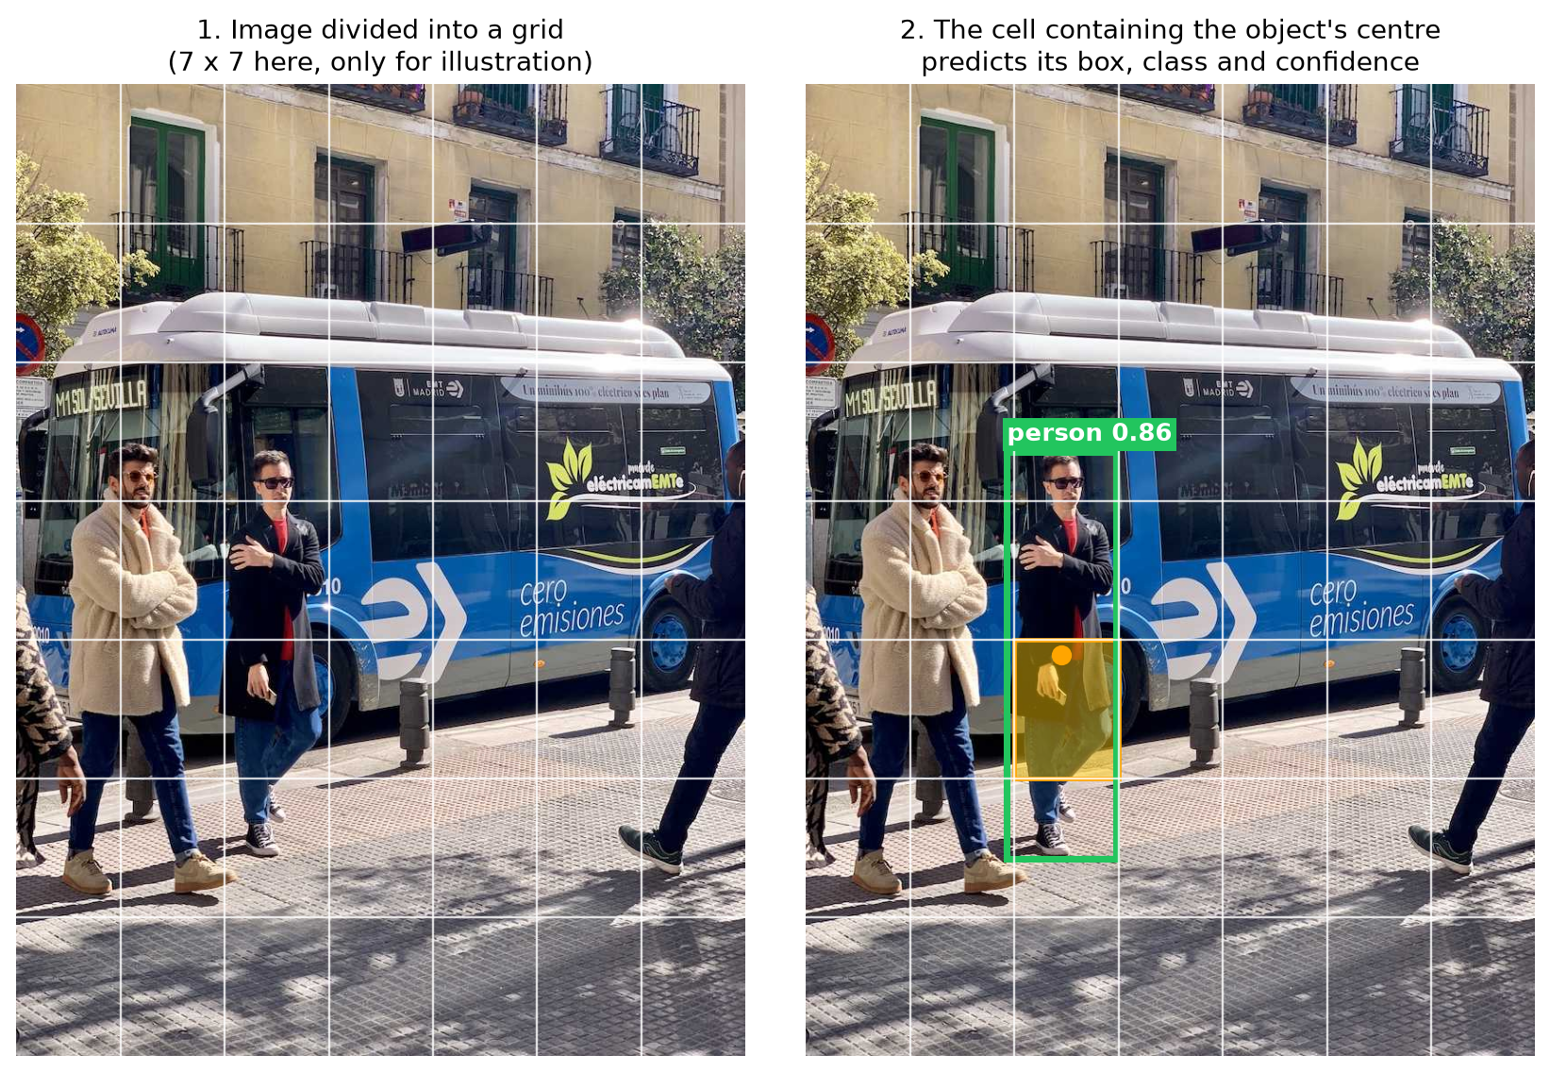
Figure 5.1: The grid idea behind YOLO, drawn on a sample image. The 7 x 7 grid is only an illustration. The green box is the one our program actually detected for this person.
Newer versions such as YOLO11 use a more advanced design. They predict at three different scales, which helps them find both small and large objects. They are also anchor-free, meaning they predict box positions directly instead of adjusting a fixed set of reference boxes. The principle stays the same: one network and one pass produce many boxes.

5.3 Bounding Boxes
A bounding box can be written either as the centre point plus width and height (x, y, w, h), or as two corners (x1, y1, x2, y2). Both carry the same information. Ultralytics provides both formats. Our program uses the corner format (box.xyxy) because the OpenCV function cv2.rectangle needs exactly these two corner points.

5.4 Class Prediction
For every box the model outputs a score for each of the 80 COCO classes, and the class with the highest score becomes the label. This also means the model can only recognise the 80 classes it was trained on. An object from outside this list is either missed or given the label of the most similar class. We saw this in our own tests: a wristwatch is not a COCO class, and the model labelled it “clock” and, in one frame, “bottle” (Section 13.4).

5.5 Confidence Scores and the Threshold
The confidence score tells how sure the model is about a detection. We only keep detections whose score is greater than or equal to a threshold. A low threshold shows more objects, including weak and wrong detections. A high threshold shows only strong detections, but some real objects may be hidden. Our application uses 0.50 as the default and lets the user choose any value from 0.10 to 1.00 with a slider.

5.6 Non-Maximum Suppression (NMS)
The network often predicts several overlapping boxes for the same object. NMS cleans this up. It keeps the box with the highest score, then removes other boxes of the same class that overlap it too much (IoU above a limit). This repeats until no duplicates are left. Ultralytics does this automatically after inference, with a default IoU limit of 0.7. We kept this default setting.

5.7 The Model Used: YOLO11n
Ultralytics provides YOLO11 in five sizes: n (nano), s (small), m (medium), l (large) and x (extra large). Bigger models are more accurate but slower. We selected the nano model, as summarised in Table 5.1.
Table 5.1: Details of the pretrained model
Property | Value
Model | YOLO11n (nano), Ultralytics [8]
Trained by / on | Ultralytics, on the COCO dataset (80 classes). Not trained by us.
Input size | 640 pixels
Parameters | about 2.6 million (2,624,080 reported by model.info())
Accuracy (reported by Ultralytics) | 39.5 mAP50-95 on the COCO validation set [9]. We did not measure this ourselves.
Weights file | yolo11n.pt, about 5.4 MB, downloaded automatically on first run into models/
Measured speed on our laptop | about 31 ms per 640x480 frame on the CPU (Section 13.2)

We chose the nano model because it is the smallest and fastest of the five sizes and runs in real time on a laptop CPU. Its accuracy is good enough for common objects such as people, bottles, cups and phones. It is also downloaded automatically, so a new user does not have to set anything up by hand.

6. Proposed System

6.1 Overview
The proposed system is a single Python application. It has three small source files: app.py (user interface and webcam modes), src/detector.py (YOLO) and src/utils.py (drawing and helper functions). The user starts it with one command, streamlit run app.py, and the interface opens in the web browser. The same code is also deployed online on Streamlit Community Cloud at https://realtime-object-detection-yolo.streamlit.app.
There are two ways to get webcam frames. In the Local webcam (OpenCV) mode the Python program reads the webcam directly with OpenCV, so the video never leaves the laptop. This mode only works when the app runs on the computer that has the webcam. In the Browser webcam (real-time) mode, the browser captures the webcam and sends the video to the app with WebRTC. This works both locally and in the online version.

6.2 Main Features
The system offers real-time detection from the webcam, with bounding boxes, class names and confidence scores drawn on the video. It has start/stop controls and an adjustable confidence threshold. It shows the FPS, calculated from the real processing time, and a per-frame count for each class (for example “person: 1”). An optional image upload mode is useful for testing without a webcam, and a clear error message appears if the webcam cannot be opened. The app is available online.

6.3 Scope
To keep the project simple and easy to explain, the following are intentionally not part of the system:
- Training or fine-tuning a model, or creating a dataset.
- Object tracking (giving the same ID to an object across frames).
- Separate backend servers, REST APIs, databases or user accounts.
- Any front-end framework other than Streamlit. streamlit-webrtc is a ready-made Streamlit component, so no custom JavaScript is written.

6.4 Advantages
The system runs on a normal laptop without a GPU and needs only five Python packages. The code is short (about 390 lines including comments), so every part can be explained. The model can be replaced by changing one line (DEFAULT_MODEL in src/detector.py), and anyone can try the online version without installing anything.

7. System Architecture
Figure 7.1 shows the architecture of the system in the local webcam mode. Data flows from top to bottom for every frame, and the loop repeats until the user switches detection off. The browser webcam mode used online changes only how frames arrive and leave (Section 7.2).
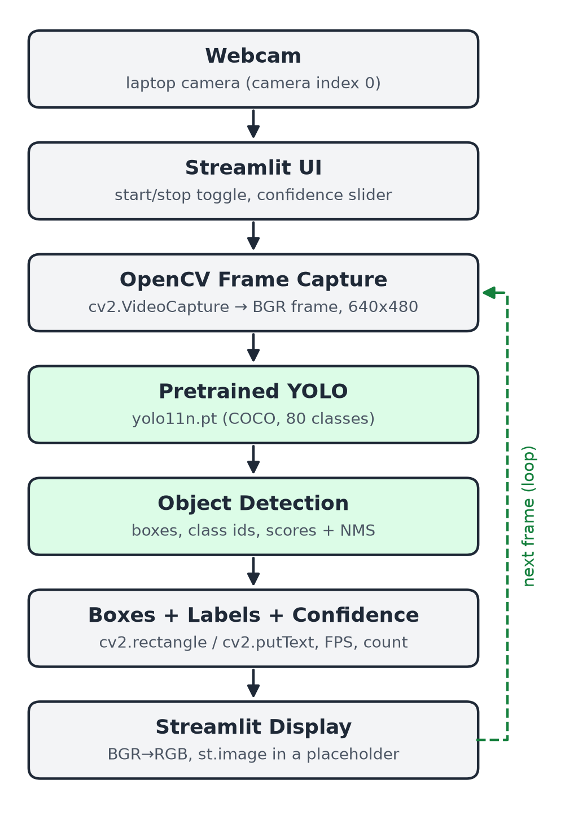
Figure 7.1: System architecture
The blocks are:
- Webcam: the built-in laptop camera (camera index 0) or an external USB camera.
- Streamlit UI: the page in the browser where the user chooses the input source, sets the confidence threshold and switches detection on or off.
- OpenCV Frame Capture: cv2.VideoCapture opens the camera and cap.read() returns one frame at a time as a BGR image (NumPy array), requested at 640x480.
- Pretrained YOLO: the YOLO11n model, loaded once when the app starts.
- Object Detection: the model predicts boxes, classes and scores. NMS and the confidence threshold remove duplicate and weak boxes.
- Boxes + Labels + Confidence: our code draws a rectangle and a “label score” text for every detection, and calculates the FPS and object counts.
- Streamlit Display: the frame is converted from BGR to RGB and shown in the page. The FPS and counts are shown next to it.
Table 7.1: Mapping of architecture blocks to code
Architecture block | Where it is in the code
Webcam, OpenCV capture | run_webcam() in app.py (cv2.VideoCapture, cap.read())
Browser webcam (WebRTC, online) | run_browser_webcam() and process_frame() in app.py (webrtc_streamer)
Streamlit UI | sidebar widgets at the end of app.py
Pretrained YOLO | ObjectDetector.__init__() in src/detector.py, cached by load_detector()
Object detection | ObjectDetector.detect() in src/detector.py
Boxes, labels, FPS, count | draw_detections(), calculate_fps(), count_objects() in src/utils.py
Streamlit display | frame_box.image() and show_stats() in app.py

7.1 How Continuous Webcam Video Works in Streamlit
Streamlit has a widget called st.camera_input(), but it only takes a single photo when the user clicks a button, so it cannot give continuous video. Instead, our script opens the camera with OpenCV and runs a loop. In each loop iteration it reads a frame, processes it and replaces the image inside one st.empty() placeholder. Because the image is replaced many times per second, the user sees a live video.
When the user switches the toggle off, Streamlit stops the running script and starts it again from the top. The finally block around the loop then calls cap.release(), so the camera is freed. This approach needs no extra libraries, but the webcam must be connected to the same computer that runs streamlit run app.py. That is fine for a laptop demo, but it cannot work on a cloud server, which has no webcam.

7.2 Real-Time Webcam in the Online Version (WebRTC)
For the online version we added the Browser webcam (real-time) mode using streamlit-webrtc. The flow becomes: browser webcam → WebRTC video stream → app on the server → our process_frame() function (OpenCV image → YOLO → boxes and labels) → WebRTC stream back → video shown in the browser. WebRTC is the standard browser technology for real-time video, used for example by video-call websites. The browser and the server first exchange connection details through Streamlit. Google's public STUN server helps them find a network path. On networks that block direct connections, a TURN relay server is needed. streamlit-webrtc can use one automatically if its credentials are stored as app secrets.
streamlit-webrtc calls process_frame() for every frame in a separate thread, and it drops frames that arrive while YOLO is still busy (async_processing=True). This keeps the video real-time even on a slow server. Streamlit functions cannot be used in that thread, so the latest FPS and detections are stored in a small dictionary protected by a lock, and the page reads them twice per second. Because several viewers can use the online app at the same time, ObjectDetector.detect() also uses a lock, so the shared model processes one frame at a time.

8. Methodology
The processing is done in ten steps, described below. Figure 8.1 at the end of this chapter shows the same steps as a flowchart.

Step 1: Load the model
When the app starts, load_detector() creates an ObjectDetector, which loads models/yolo11n.pt. If the file is not there, Ultralytics downloads it first. The function is decorated with @st.cache_resource, so the model is loaded only once and reused on every rerun of the script. A “Loading YOLO model...” spinner is shown while this happens.

Step 2: Open the webcam
When the user switches on Start detection, cv2.VideoCapture(camera_index) opens the camera, and we request a 640x480 resolution. If cap.isOpened() is false, the app shows “Unable to access webcam. Please check your camera permissions or connected webcam.” and stops there instead of crashing.

Step 3: Capture a frame
cap.read() returns a success flag and the frame. The frame is a NumPy array of shape (480, 640, 3) in BGR order. If reading fails (for example, if the camera is unplugged), the same error message is shown and the loop ends.

Step 4: Pre-processing
We pass the BGR frame directly to the model. Ultralytics does the pre-processing itself: letterbox resizing to the network input size, BGR to RGB channel order, and scaling the pixel values to 0–1. We did not add any other pre-processing, so the webcam image reaches the model unchanged.

Step 5: Run YOLO inference
self.model(frame, conf=confidence, verbose=False) runs the network on the frame. The conf argument applies the user's confidence threshold, and verbose=False stops Ultralytics from printing a log line for every frame.

Step 6: Post-processing
Ultralytics applies NMS and the threshold and returns a Results object. Our detect() method converts it into a plain Python list. Each item is a dictionary with the box corners, class id, class name and confidence. This keeps the rest of the code independent of the Ultralytics data types.

Step 7: Draw boxes and labels
draw_detections() loops over the list. For each detection it draws a rectangle with cv2.rectangle, measures the label text with cv2.getTextSize, draws a filled rectangle behind the text so it stays readable on any background, and writes the text (for example “person 0.92”) with cv2.putText. Each class always gets the same colour, chosen as class_id % 8 from a small list of colours.

Step 8: FPS and object count
FPS is calculated from the actual time taken by one complete loop iteration (capture, detection, drawing and display):
FPS = 1 / (current_time − previous_time)
For example, if one iteration takes 0.042 seconds, FPS = 1 / 0.042 ≈ 23.8. The object count uses Python's collections.Counter on the class names of the current frame, which gives values such as {"person": 1, "bottle": 1}. This is a per-frame count only. The program does not know whether a person in this frame is the same person as in the previous frame.

Step 9: Display
The annotated frame is converted with cv2.cvtColor(output, cv2.COLOR_BGR2RGB) and shown with frame_box.image(...). The FPS, total count and per-class counts are shown in the right-hand column.

Step 10: Stop
When the toggle is switched off, Streamlit interrupts the loop, the finally block releases the camera, and the page shows the start message again. Pressing Ctrl + C in the terminal stops the whole Streamlit server.
Image mode. If the user selects Image as the input source and uploads a JPG or PNG file, the file bytes are converted to a NumPy array and decoded with cv2.imdecode. Steps 5 to 9 then run once on that image. No FPS is shown in this mode, because there is no video.
Browser webcam mode. Steps 2, 3, 9 and 10 are done by streamlit-webrtc. The user clicks START and allows camera access, and the browser streams the video to the app. For each frame, process_frame() converts the WebRTC frame to an OpenCV BGR array with frame.to_ndarray(format="bgr24"), runs Steps 5 to 8, and converts the result back with av.VideoFrame.from_ndarray(). The browser then shows it. STOP ends the stream.
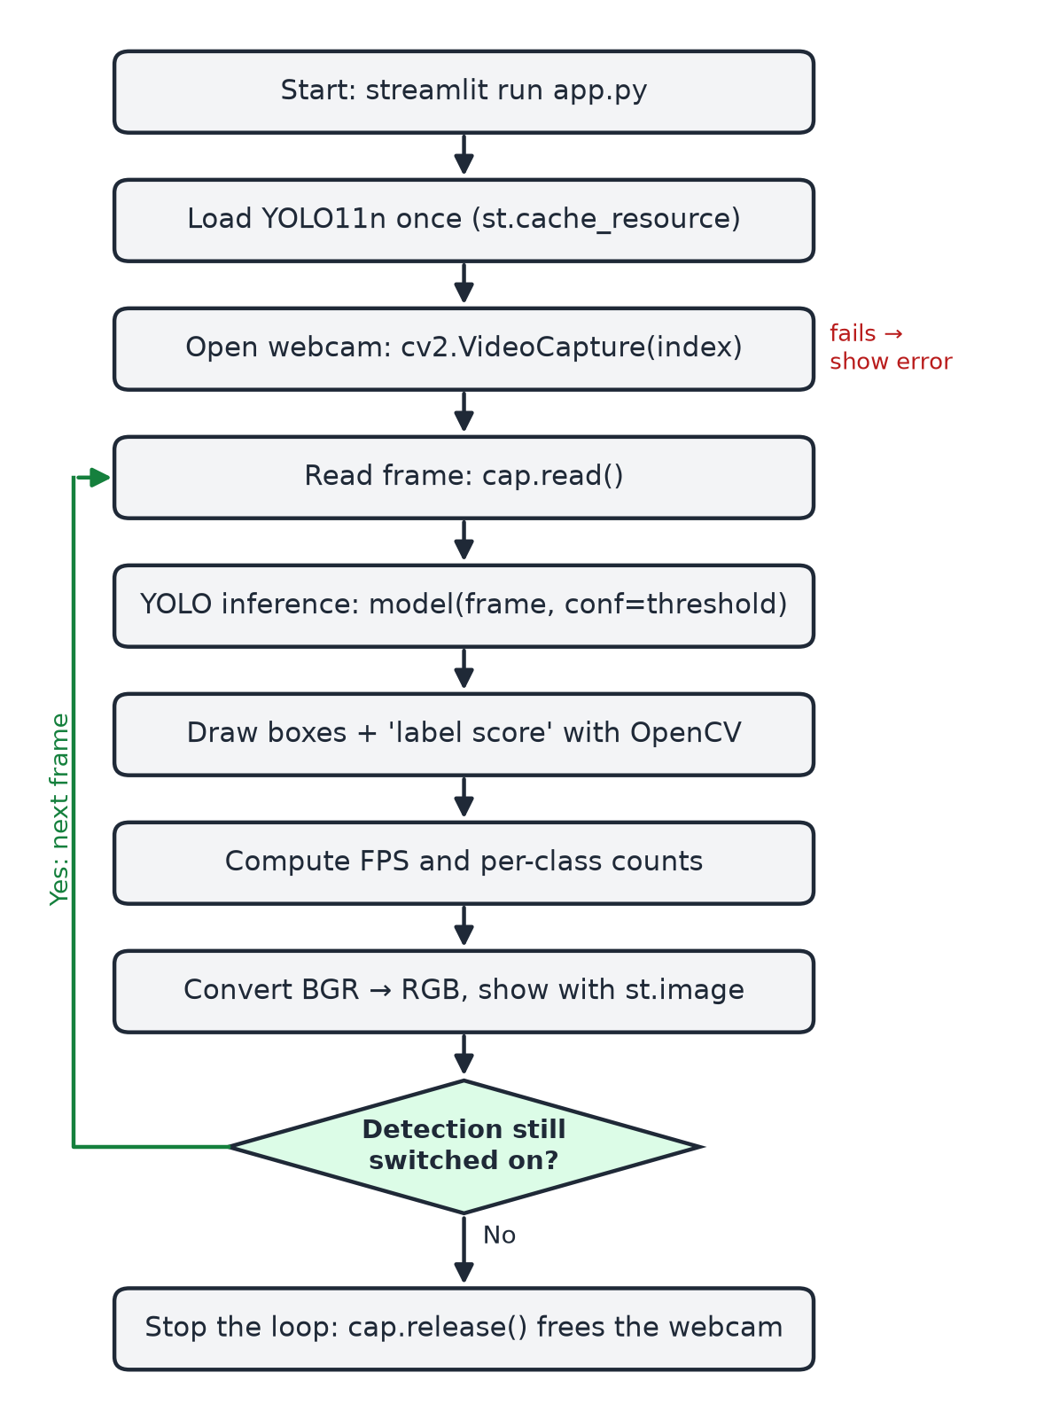
Figure 8.1: Flowchart of the processing loop

9. Technologies Used
The project uses a small set of well-known open-source tools. Table 9.1 lists them and what each one does in our project.
Table 9.1: Technologies used and their role
Technology | What it is | How we use it
Python | Programming language | The whole project is written in Python. It is easy to read, and the main computer vision and deep learning libraries are available for it.
OpenCV [10], [11] | Open-source library for image processing and computer vision | Open the webcam and read frames (VideoCapture), draw boxes and text (rectangle, getTextSize, putText), convert BGR to RGB (cvtColor), decode uploaded images (imdecode). In our tests we also used it to change brightness (convertScaleAbs) and resize images.
Ultralytics YOLO [8], [9] | Python package that provides the YOLO models | YOLO("yolo11n.pt") loads the pretrained model and downloads the weights if needed. Calling the model on a frame returns the detections. We use only prediction, no training.
PyTorch [17] | Deep learning framework | Runs the YOLO network. It is installed automatically with Ultralytics, and our code never calls it directly. On our laptop it ran on the CPU.
Streamlit [12] | Python library for simple web apps | Builds the whole UI in Python: title, sidebar slider and toggle, and an st.empty() placeholder that is updated with each new frame. No HTML, CSS or JavaScript. Streamlit Community Cloud [19] hosts the online version.
streamlit-webrtc [18] | Streamlit component for real-time video over WebRTC | Streams the viewer's browser webcam to the app and the processed video back, so detection is real-time in the online version. It installs aiortc (WebRTC for Python) and PyAV.
NumPy | Library for numerical arrays | OpenCV images are NumPy arrays. We use NumPy directly only to turn the bytes of an uploaded image into an array.

9.1 Test Environment
Table 9.2: Hardware and software used for testing
Item | Details
Laptop | MacBook Air, Apple M3 chip, 8 GB RAM (no separate GPU used)
Operating system | macOS 26.5.1
Camera | Built-in FaceTime HD camera
Python | 3.11.9
Libraries | Streamlit 1.64.0, streamlit-webrtc 0.78.1, OpenCV 5.0.0, Ultralytics 8.4.167, PyTorch 2.14.0 (CPU), NumPy 2.4.6
Browser | Google Chrome
Online version | Streamlit Community Cloud (Linux, Python 3.14.7, PyTorch 2.14.0+cpu), shared CPU

10. Implementation

10.1 Project Structure
The code is split into three Python files: app.py (Streamlit page and webcam modes), src/detector.py (YOLO) and src/utils.py (drawing, FPS and counting). Together they have about 390 lines, including comments and blank lines. The models/ folder receives the downloaded weights, outputs/ holds the screenshots and result images, and requirements.txt lists the five packages: streamlit, streamlit-webrtc, opencv-python, ultralytics and numpy. packages.txt lists one Linux system library needed by OpenCV on the cloud server. The full folder layout is shown in the README file.

10.2 detector.py: Loading YOLO and Detecting Objects
This file contains one small class. The constructor loads the model from the models/ folder. The detect() method runs the model on one frame and returns a simple list of dictionaries. The core of the method is:
results = self.model(frame, conf=confidence, verbose=False)
result = results[0] # one frame in -> one result out

detections = []
for box in result.boxes:
x1, y1, x2, y2 = box.xyxy[0].tolist()
class_id = int(box.cls[0])
score = float(box.conf[0])
detections.append({
"box": (int(x1), int(y1), int(x2), int(y2)),
"class_id": class_id,
"label": self.class_names[class_id],
"confidence": score,
})
return detections
self.class_names is the dictionary model.names, which maps class ids to names (0 → “person”, 39 → “bottle”, and so on).

10.3 utils.py: Drawing, FPS and Counting
draw_detections() draws on a copy of the frame, so the original frame is not changed:
for det in detections:
x1, y1, x2, y2 = det["box"]
color = COLORS[det["class_id"] % len(COLORS)]
text = format_label(det["label"], det["confidence"]) # 'person 0.92'
cv2.rectangle(output, (x1, y1), (x2, y2), color, 2) # the box
(tw, th), base = cv2.getTextSize(text, cv2.FONT_HERSHEY_SIMPLEX, 0.6, 2)
... # filled label background
cv2.putText(output, text, (x1 + 2, label_y - base - 2),
cv2.FONT_HERSHEY_SIMPLEX, 0.6, (255, 255, 255), 2)
The label is placed just above the box. If the box touches the top of the image, the label is moved down so that it stays inside the image. The FPS and counting helpers are very short:
def calculate_fps(previous_time):
current_time = time.time()
elapsed = current_time - previous_time
fps = 1.0 / elapsed if elapsed > 0 else 0.0
return fps, current_time

def count_objects(detections):
return dict(Counter(det["label"] for det in detections))

10.4 app.py: User Interface and Webcam Loop
app.py builds the page (title, description, sidebar controls and two columns) and contains the webcam loop:
cap = cv2.VideoCapture(camera_index)
if not cap.isOpened():
frame_box.error(WEBCAM_ERROR)
return
cap.set(cv2.CAP_PROP_FRAME_WIDTH, 640)
cap.set(cv2.CAP_PROP_FRAME_HEIGHT, 480)

previous_time = time.time()
try:
while True:
success, frame = cap.read()
if not success:
frame_box.error(WEBCAM_ERROR)
break
detections = detector.detect(frame, confidence)
output = draw_detections(frame, detections)
fps, previous_time = calculate_fps(previous_time)
output_rgb = cv2.cvtColor(output, cv2.COLOR_BGR2RGB)
frame_box.image(output_rgb, width="stretch")
show_stats(stats_box, fps, detections)
finally:
cap.release()

10.5 Browser Webcam Mode (streamlit-webrtc)
The browser webcam mode reuses the same detection and drawing functions. Only the way frames arrive and leave is different:
def process_frame(frame): # called for every video frame
image = frame.to_ndarray(format="bgr24") # WebRTC frame -> OpenCV array
detections = detector.detect(image, confidence)
output = draw_detections(image, detections)
with live["lock"]: # share results with the page
live["fps"], live["previous_time"] = calculate_fps(live["previous_time"])
live["detections"] = detections
return av.VideoFrame.from_ndarray(output, format="bgr24")

ctx = webrtc_streamer(key="browser-webcam", mode=WebRtcMode.SENDRECV,
video_frame_callback=process_frame,
media_stream_constraints={"video": {"width": 640,
"height": 480}, "audio": False},
async_processing=True)

10.6 Important Design Decisions
- Drawing with OpenCV ourselves. Ultralytics can draw results with result.plot(), but we wrote our own drawing function so that the image processing part is visible and easy to explain.
- Model cached once. Loading the model takes a few seconds, so @st.cache_resource keeps it in memory between reruns.
- 640x480 capture. YOLO resizes the input to 640 pixels anyway. Asking the camera for a larger image would only make capture, drawing and display slower.
- Plain dictionaries for detections. They are easy to print, test and explain, and they keep Ultralytics-specific types out of the UI code.
- Honest FPS. FPS is measured on every loop iteration, and the value is shown exactly as calculated, without smoothing or fixed numbers.
- Simple error handling. Only the cases that really happen are handled: the camera does not open, a frame cannot be read, or an uploaded file is not an image.

10.7 How to Run and Deploy
python -m venv venv
venv\Scripts\activate (Windows)
source venv/bin/activate (macOS / Linux)
pip install -r requirements.txt
streamlit run app.py
Streamlit then opens the app in the browser, usually at http://localhost:8501.
For the online version we connected the GitHub repository to Streamlit Community Cloud (branch main, main file app.py). Every push to GitHub redeploys the app. Two small changes were needed for the Linux cloud server. First, requirements.txt points pip to the CPU-only PyTorch builds, which avoids a download of several gigabytes of GPU libraries. Second, packages.txt installs libgl1, a system library that OpenCV needs. The model weights are downloaded automatically on the first start, just as they are locally.

11. User Interface
The interface is kept intentionally simple. It has a sidebar with the settings on the left and the output on the right. Figure 11.1 shows the current version running online in the browser webcam mode. The input for this test was Chrome's fake camera playing a video of the sample images. Figures 11.2 and 11.3 were taken earlier, before the browser webcam option was added, so their sidebar shows only “Webcam” and “Image”.
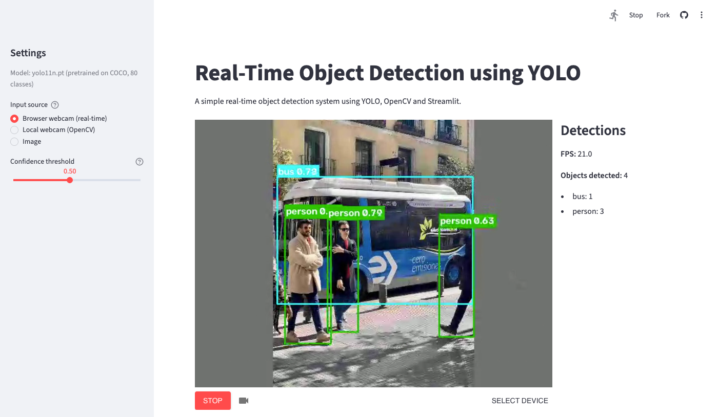
Figure 11.1: Current interface, online on Streamlit Community Cloud, browser webcam (real-time) mode
Table 11.1: Elements of the user interface
UI element | Purpose
Title and description | “Real-Time Object Detection using YOLO”, with a one-line description
Model caption | Shows which model is used (yolo11n.pt, COCO, 80 classes)
Input source | Browser webcam (real-time, default), Local webcam (OpenCV) or Image
Confidence threshold | Slider from 0.10 to 1.00, default 0.50
START / STOP, SELECT DEVICE | Browser webcam mode: start and stop the video stream, choose a camera
Camera index, Start detection | Local webcam mode: choose the camera and switch the detection loop on or off
Video area | Processed frame with boxes, labels and scores, or messages and errors
Detections panel | FPS, total number of objects, and count per class

Figure 11.2 shows the app during live webcam detection in the local (OpenCV) webcam mode. The person in front of the laptop is detected as “person 0.88”, and the panel on the right shows FPS 23.4 and one detected object.
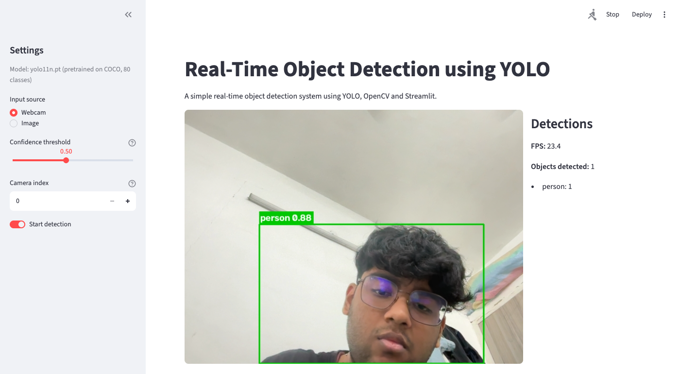
Figure 11.2: Live webcam detection in the Streamlit interface (real screenshot from our test)
In the image mode, the uploaded photo is shown with its boxes in the same place, and the panel lists the counts, for example “bus: 1” and “person: 4” for bus.jpg (Figure 1.1 shows that result). If the webcam cannot be opened, the error message is shown inside the video area and the rest of the page keeps working (Figure 11.3). We saw this message in a real situation: during testing, the program was first started from a process that did not have camera permission on macOS.
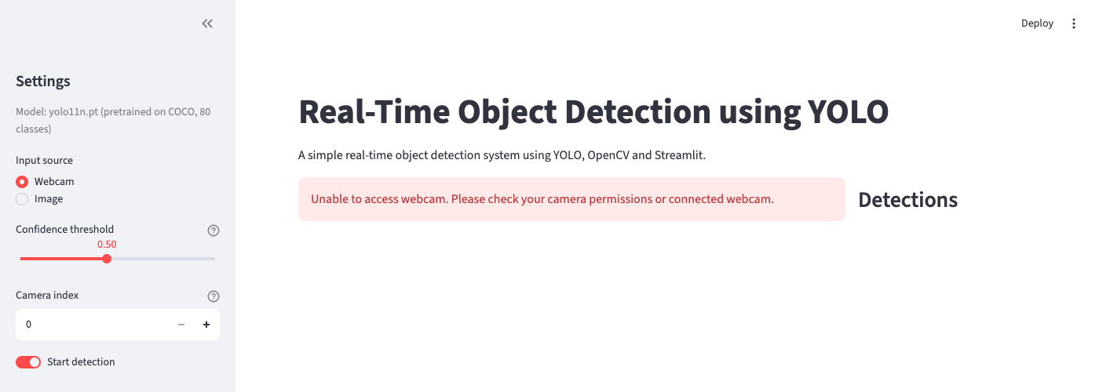
Figure 11.3: Error message shown when the webcam cannot be accessed

12. Testing

12.1 How the Tests Were Done
All tests were run on the laptop described in Table 9.2. The online tests used the deployed app on Streamlit Community Cloud. We used four kinds of tests:
- Live webcam tests: the app was running with the built-in camera in the local (OpenCV) webcam mode, and screenshots of the browser page were saved automatically while it ran.
- Browser webcam and online tests: Chrome's built-in fake camera played a test video made from the sample images: a bus scene, two people, then an empty grey frame. Chrome sent it through WebRTC exactly like a real webcam, both to the app on our laptop and to the online version. This is repeatable, but it is not a real camera.
- Image mode tests: the two sample images that come with the Ultralytics package (bus.jpg and zidane.jpg), and a crop of a webcam frame that shows only the wall and ceiling, were uploaded to the app.
- Simulations with OpenCV: to study lighting and distance in a controlled and repeatable way, we darkened an image by scaling its pixel values, and made objects smaller by shrinking the image. These are clearly marked as simulations in the results.
Some situations need a physical setup: several household objects in front of the camera at once, a second person, and a dark room. These were not captured during our recorded webcam session. For these cases we used the sample images and the simulations instead, and Table 12.1 states this clearly. We did not want to report results that we had not actually observed.

12.2 Test Cases
Table 12.1: Test cases and results
ID | Test case | How tested | Actual result | Status
TC1 | Webcam opens | Live | Video shown in the app at about 22–24 FPS | Pass
TC2 | One object | Live: one person in front of the camera | “person 0.88”, objects detected: 1 | Pass
TC3 | Multiple objects | Image mode: bus.jpg | 5 objects: 1 bus, 4 persons | Pass
TC4 | Different object classes | Image mode + live at threshold 0.25 | bus, person, tie (0.46), clock (0.33) | Pass
TC5 | Different distances | Live near/far + simulated shrinking | Live: person 0.94 (near), 0.93 (far). Simulated: detected down to x0.25 scale, nothing at x0.125 | Pass (limit found)
TC6 | Different lighting | Simulated: brightness 100% → 5% | All 5 objects kept down to 25% brightness. At 5% the bus was missed. | Pass (limit found)
TC7 | Empty scene | Image mode: wall-only crop; all-black frame | 0 objects, “No objects above the threshold.”, app kept working | Pass
TC8 | Multiple people | Image mode: bus.jpg, zidane.jpg | 4 and 2 persons, each in its own box | Pass
TC9 | Confidence threshold | zidane.jpg at 0.25 / 0.50 / 0.80; live at 0.25 | 3 → 2 → 1 detections. Live: extra low-score detections at 0.25. | Pass
TC10 | Boxes, labels and scores correct | All of the above | Boxes around the objects, “label score” text readable | Pass
TC11 | UI shows processed frames | Live | Continuous annotated video in the page | Pass
TC12 | Webcam unavailable | App started without camera permission | Error message in the video area, no crash | Pass
TC13 | Stop detection | Toggle switched off | Loop stopped, and the next run could open the camera again (camera was released) | Pass
TC14 | Browser webcam mode (local) | Chrome fake camera, 10 fps video, app on our laptop | WebRTC connected; bus + 3 persons, then 2 persons; about 10 FPS (limited by the 10 fps input) | Pass
TC15 | Online real-time detection | Deployed app, Chrome fake camera, 30 fps video | Mostly 15–24 FPS; bus, persons, tie detected; 0 objects on empty frames | Pass
TC16 | Local webcam mode online | Deployed app, Local webcam (OpenCV) | Error message with a hint to use the browser webcam (server has no camera) | Pass
TC17 | Image mode online | Deployed app, bus.jpg | 5 objects: 1 bus, 4 persons (same as locally) | Pass

We have not yet tested the online version with a real webcam in a browser on another network. That is left for the team's final demo.

12.3 Problems Found During Testing
Testing also showed a few problems, which we fixed or documented:
- FPS and count on one line. In the first version, “FPS” and “Objects detected” appeared on the same line because Markdown joins lines that are not separated by a blank line. We fixed this by adding blank lines between them.
- Error message position. The webcam error first appeared below the two columns. We moved it into the video area so that the user sees it where the video would be.
- Two browser tabs. When the app was open in two browser tabs with detection running in both, each tab ran its own loop and FPS dropped to about 10–14. We documented this in the README. Only one tab should run detection.
- Camera permission on macOS. The camera could only be opened when the app was started from a terminal that had camera permission. This is added to the troubleshooting section of the README.
- No webcam on the cloud server. As expected, the local OpenCV webcam mode cannot work online. The error message now also tells the user to choose the browser webcam mode.

13. Results
All results in this chapter come from our own runs of the application and the test scripts on the laptop in Table 9.2. The screenshots are real and were not edited.

13.1 Live Webcam Detection
In the live webcam tests the person in front of the camera was detected in all 52 frames that we saved, with confidence scores between 0.77 and 0.94 (most of them between 0.82 and 0.93) at the default threshold of 0.50. The box followed the person as they moved, including when they leaned closer to or further from the camera (Figure 13.1).
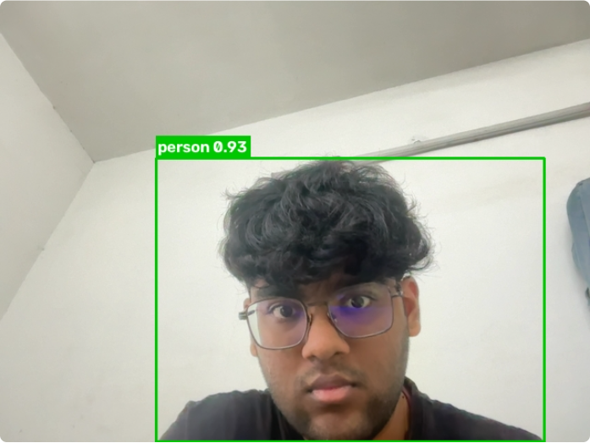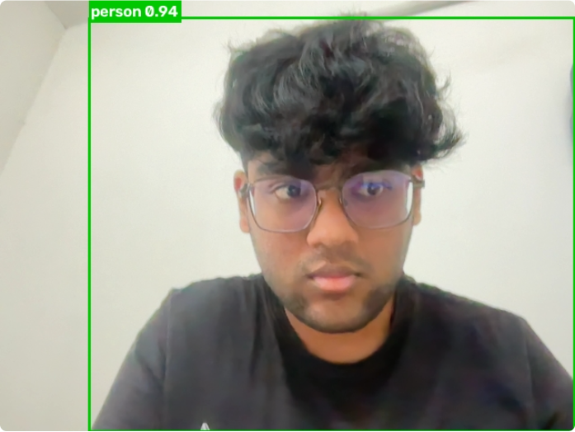
Figure 13.1: Live webcam frames: person further from the camera (left, “person 0.93”) and close to it (right, “person 0.94”)

13.2 Speed
Table 13.1: Measured speed on our test laptop and online
Measurement | Result
FPS shown in the app, one browser tab running detection | about 22–24 FPS
FPS shown in the app, two browser tabs running detection at the same time | about 10–14 FPS
YOLO11n inference only, 640x480 frame, CPU (50 runs after warm-up) | mean 31.3 ms (min 29.3 ms, max 34.0 ms)
Online version, browser webcam mode, Chrome fake camera with a 10 fps video | about 8–17 FPS readings (input was only 10 fps)
Online version, browser webcam mode, Chrome fake camera with a 30 fps video | mostly 15–24 FPS (single readings down to about 3)

An inference time of 31.3 ms means the model alone could handle about 32 frames per second. The full loop reached about 22–24 FPS. The extra time is spent reading the frame from the camera, drawing, converting colours and sending the image to the browser. These numbers are only for our laptop. A laptop without an Apple M-series chip or with an older CPU may be slower.
In the online version the video travels over the internet and YOLO runs on a shared cloud CPU. With a 30 fps test video the app still showed mostly 15–24 FPS, which looks like live video. Because the FPS is measured frame by frame, single readings jump around more online, where frames sometimes arrive in bursts over the network. At that speed the bus in the test video was sometimes labelled “truck”, a similar-looking COCO class.

13.3 Sample Images
With the default threshold of 0.50, the sample image bus.jpg gave 5 detections: bus 0.94 and four persons (0.89, 0.88, 0.86, 0.62), see Figure 1.1. The image zidane.jpg gave two persons (0.84 and 0.77).

13.4 Effect of the Confidence Threshold
Table 13.2: Number of detections for different thresholds
Image | Threshold 0.25 | Threshold 0.50 | Threshold 0.80
bus.jpg | 5 (bus, 4 persons) | 5 (bus, 4 persons) | 4 (bus, 3 persons)
zidane.jpg | 3 (2 persons, tie 0.46) | 2 (2 persons) | 1 (person 0.84)

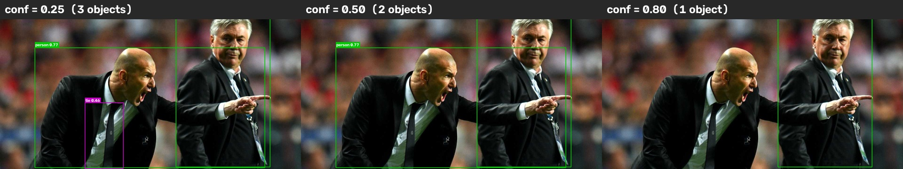
Figure 13.2: The same image at thresholds 0.25, 0.50 and 0.80
A lower threshold shows more objects, but some of them are wrong. In the live webcam test at threshold 0.25, a wristwatch was detected as “clock 0.33” in one frame and wrongly as “bottle 0.25” in another (Figure 13.3). A wristwatch is not one of the 80 COCO classes, so the model picked the closest classes it knows. At the default threshold of 0.50 these weak detections were not shown.
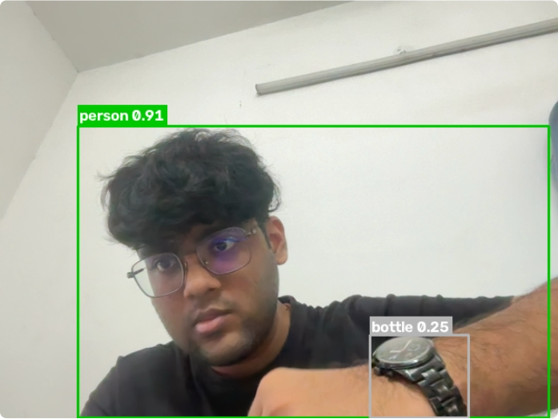
Figure 13.3: Live frame at threshold 0.25: a wristwatch wrongly labelled “bottle 0.25” (false positive)

13.5 Simulated Low Light
To study lighting, we multiplied all pixel values of bus.jpg by a factor (100%, 50%, 25%, 10% and 5%) with cv2.convertScaleAbs and ran detection at threshold 0.50. This is a simulation. Real low light also adds noise and blur, which this simple scaling does not model.
Table 13.3: Detections under simulated low light
Brightness | Mean pixel value | Detections
100% | 117.1 | 5: bus 0.94, person 0.89 / 0.88 / 0.86 / 0.62
50% | 58.6 | 5: bus 0.94, person 0.88 / 0.87 / 0.86 / 0.62
25% | 29.3 | 5: bus 0.95, person 0.89 / 0.87 / 0.86 / 0.55
10% | 11.7 | 4: bus 0.90, person 0.89 / 0.87 / 0.83
5% | 5.8 | 3: person 0.86 / 0.84 / 0.64 (bus missed)

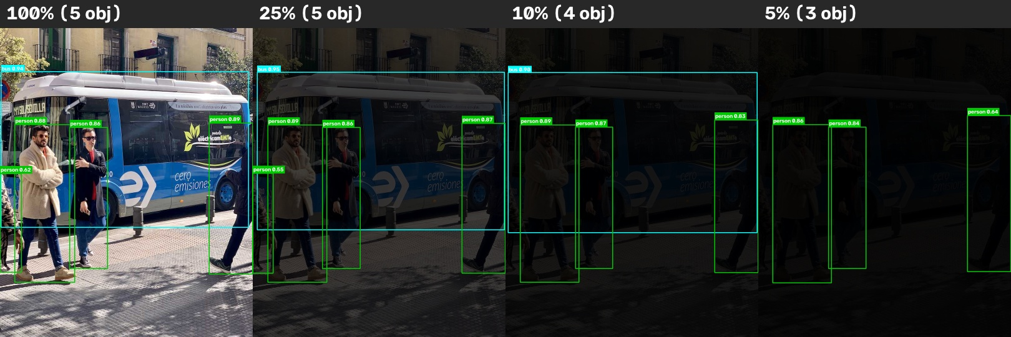
Figure 13.4: Simulated low light: 100%, 25%, 10% and 5% brightness
Detection stayed stable down to about 25% brightness. Below that, the weakest detections disappeared first, and at 5% even the large bus was missed.

13.6 Simulated Distance
To study distance, we shrank bus.jpg to half, a quarter and an eighth of its size and placed it in the middle of a grey image of the original size. The objects then look as if they were further away. This is also a simulation.
Table 13.4: Detections under simulated distance
Scale | Detections
x1.0 | 5: bus 0.94, 4 persons
x0.5 | 4: bus 0.88, 3 persons
x0.25 | 4: bus 0.84, 3 persons (0.79 / 0.59 / 0.58)
x0.125 | 0: nothing detected

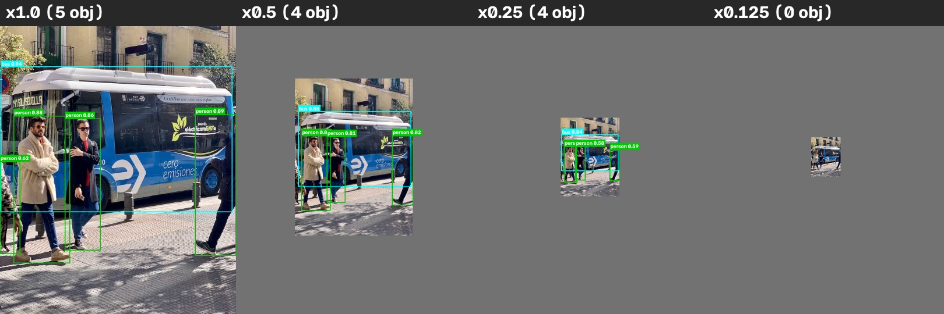
Figure 13.5: Simulated distance: the same scene at scale x1, x0.5, x0.25 and x0.125

13.7 Observations
- The pretrained YOLO11n model detected people reliably in the live webcam feed on an ordinary laptop, without a GPU.
- The application ran at about 22–24 FPS, which looks like smooth live video.
- The confidence threshold works as expected. 0.50 was a good default, because lower values started to show wrong labels.
- Detection quality drops for very dark images and very small (far away) objects.
- Objects outside the 80 COCO classes can get wrong labels, which is a limitation of the pretrained model, not of the code.
- With WebRTC, the same real-time detection also works online on a free shared cloud server, at mostly 15–24 FPS in our 30 fps test.

14. Limitations
- Hardware dependent speed. FPS depends on the laptop's CPU. Older laptops may get a much lower FPS.
- Camera quality. Low resolution, motion blur and auto-exposure changes of the webcam affect the results.
- Lighting. Our simulation showed that very dark images lose detections. Real low light, with noise, is likely to be worse.
- Small and distant objects. Objects that cover only a few pixels are missed (nothing was detected at scale x0.125).
- Fixed set of classes. The model knows only the 80 COCO classes. Other objects are missed or mislabelled (for example the watch labelled “bottle”).
- False positives at low thresholds. Values below about 0.4 start to show wrong detections.
- No tracking. The object count is per frame only. The same object is not followed across frames.
- Local OpenCV mode needs a local camera. The local webcam mode only works on the computer that runs the Streamlit app. Online, the browser webcam mode must be used.
- Online version depends on the network. Speed depends on the shared cloud CPU and the viewer's internet connection. Some networks, such as strict college or office firewalls, block direct WebRTC connections and need a TURN relay server.
- Several viewers share one model. Every browser tab runs its own stream, but the model processes one frame at a time, so FPS drops when several people use the app together.
- Privacy. In the browser webcam mode the video is sent to the server running the app. It is only processed in memory and not saved, but users should know this.
- Limited live testing. Some live situations (many objects, several people, a dark room) were tested only with sample images and simulations, not with the webcam. The online version was tested with Chrome's fake camera, not a real webcam.

15. Future Scope
- Better models: use a larger pretrained model (YOLO11s or YOLO11m) or a GPU for higher accuracy.
- Custom training: train the model on our own images to detect objects that are not in COCO, such as lab equipment or specific products.
- Object tracking: give every object an ID across frames, so that people or vehicles can be counted without double counting.
- Mobile and edge deployment: run the detector on a phone or a small device such as a Raspberry Pi or NVIDIA Jetson.
- Performance optimisation: export the model to ONNX or another optimised format, use a smaller input size, or process every second frame to increase FPS on slow laptops.
- More live testing: repeat the lighting and distance tests with a real camera in a controlled room.

16. Conclusion
In this project we built a real-time object detection application using a pretrained YOLO11n model, OpenCV and a simple Streamlit interface. The application reads frames from the laptop webcam, detects objects in every frame, draws bounding boxes with class names and confidence scores, and shows the result live in the browser together with the measured FPS and a per-frame object count.
On our test laptop the system ran at about 22–24 FPS without a GPU, and it detected a person in the live feed with confidence scores between 0.77 and 0.94. It detected several objects and classes in the sample images, handled an empty scene and an unavailable webcam correctly, and responded to the confidence threshold as expected. The tests also showed the limits of the approach: very dark images, very small objects and objects outside the 80 COCO classes.
We also deployed the application online at https://realtime-object-detection-yolo.streamlit.app. For this, we added a browser webcam mode that streams the viewer's camera to the app with WebRTC. In our test the online version stayed real-time, mostly at 15–24 FPS.
We did not train or develop the YOLO model. A pretrained model from Ultralytics was used for detection. Our contribution is integrating it with OpenCV and Streamlit into a working real-time system, and testing and documenting that system honestly. The final code is short and easy to explain, and it gave us a practical understanding of how image processing and deep learning work together in a real computer vision application.

References
[1] J. Redmon, S. Divvala, R. Girshick and A. Farhadi, “You Only Look Once: Unified, Real-Time Object Detection,” in Proc. IEEE Conference on Computer Vision and Pattern Recognition (CVPR), 2016, pp. 779–788.
[2] J. Redmon and A. Farhadi, “YOLO9000: Better, Faster, Stronger,” in Proc. IEEE Conference on Computer Vision and Pattern Recognition (CVPR), 2017, pp. 7263–7271.
[3] J. Redmon and A. Farhadi, “YOLOv3: An Incremental Improvement,” arXiv preprint arXiv:1804.02767, 2018.
[4] A. Bochkovskiy, C.-Y. Wang and H.-Y. M. Liao, “YOLOv4: Optimal Speed and Accuracy of Object Detection,” arXiv preprint arXiv:2004.10934, 2020.
[5] R. Girshick, J. Donahue, T. Darrell and J. Malik, “Rich Feature Hierarchies for Accurate Object Detection and Semantic Segmentation,” in Proc. IEEE Conference on Computer Vision and Pattern Recognition (CVPR), 2014, pp. 580–587.
[6] S. Ren, K. He, R. Girshick and J. Sun, “Faster R-CNN: Towards Real-Time Object Detection with Region Proposal Networks,” in Advances in Neural Information Processing Systems (NeurIPS), 2015, pp. 91–99.
[7] T.-Y. Lin, M. Maire, S. Belongie, J. Hays, P. Perona, D. Ramanan, P. Dollár and C. L. Zitnick, “Microsoft COCO: Common Objects in Context,” in Proc. European Conference on Computer Vision (ECCV), 2014, pp. 740–755.
[8] G. Jocher and J. Qiu, “Ultralytics YOLO11,” version 11.0.0, 2024. [Online]. Available: https://github.com/ultralytics/ultralytics
[9] Ultralytics, “YOLO11 – Ultralytics YOLO Docs.” [Online]. Available: https://docs.ultralytics.com/models/yolo11/
[10] G. Bradski, “The OpenCV Library,” Dr. Dobb's Journal of Software Tools, 2000.
[11] OpenCV, “OpenCV Documentation.” [Online]. Available: https://docs.opencv.org/
[12] Streamlit, “Streamlit Documentation.” [Online]. Available: https://docs.streamlit.io/
[13] R. C. Gonzalez and R. E. Woods, Digital Image Processing, 4th ed. Pearson, 2018.
[14] R. Szeliski, Computer Vision: Algorithms and Applications, 2nd ed. Springer, 2022.
[15] P. Viola and M. Jones, “Rapid Object Detection using a Boosted Cascade of Simple Features,” in Proc. IEEE Conference on Computer Vision and Pattern Recognition (CVPR), 2001.
[16] N. Dalal and B. Triggs, “Histograms of Oriented Gradients for Human Detection,” in Proc. IEEE Conference on Computer Vision and Pattern Recognition (CVPR), 2005, pp. 886–893.
[17] A. Paszke et al., “PyTorch: An Imperative Style, High-Performance Deep Learning Library,” in Advances in Neural Information Processing Systems (NeurIPS), 2019.
[18] Y. Tachibana (Tsuchiya), “streamlit-webrtc,” software (MIT licence), GitHub repository. [Online]. Available: https://github.com/whitphx/streamlit-webrtc
[19] Streamlit, “Streamlit Community Cloud Documentation.” [Online]. Available: https://docs.streamlit.io/deploy/streamlit-community-cloud

