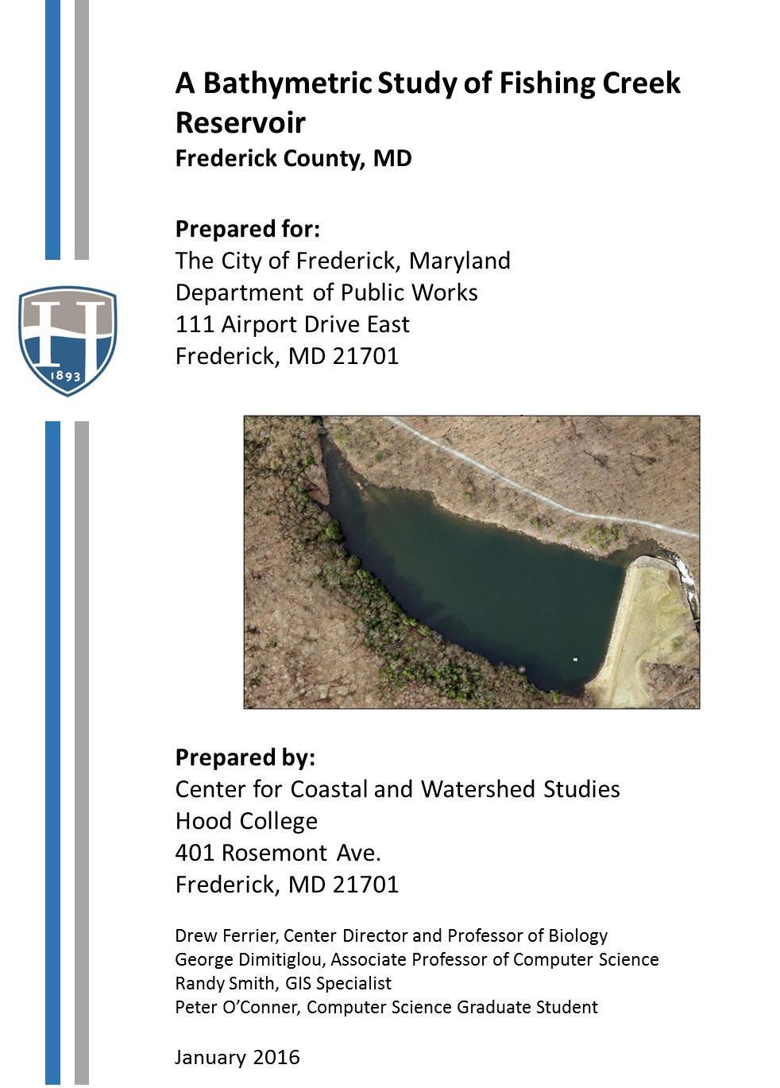

**Introduction**

Fishing Creek Reservoir is approximately a 10-acre impoundment owned by the City of Frederick, MD and operated as part of the city’s drinking water system. Located at GPS coordinates of Lat. 39.525894N and Long. 77.4647993W, the reservoir currently supplies approximately 11.2% of the potable water for the city (Frederick City Annual Summary, 2014). The impoundment was constructed in the mid-1920’s, approximately 90 years ago. Originally designed to store approximately 60 million gallons (MG) of water, the reservoir underwent modifications in 1973 and again in 1981 which resulted in a current storage capacity estimate of 50MG. Visual inspections during recent draw-downs have indicated that over the years sediment has accumulated in the lake basin and possibly diminished that capacity of the impoundment as a water storage structure. The aim of this study was to assess the current bathymetry of the impoundment, compare it to the original reservoir basin size, and ascertain the degree of sedimentation that has occurred.

**Overview of the Assessment**

The specific objectives of the study were threefold:

1. To establish baseline bathymetrics for Fishing Creek reservoir based upon the 1923 renderings of the original reservoir construction.

2. To conduct a bathymetric survey of the reservoir and create an updated map of the lake basin.

3. To establish current bathymetry for the reservoir and to estimate the differences in reservoir volume that would indicate the degree of sedimentation that has taken place since construction of the reservoir.

**Methods**

**Establishing Baseline Bathymetry**

Using the original engineering plans for the reservoir which indicate the basin’s topography before flooding and the assumed water surface elevation of 710 ft., we constructed a bathymetric map of the impoundment. The original rendering of the reservoir was digitized, georeferenced, and overlaid on a current aerial photo of the reservoir (Figure 1). Based on the original engineering plans, 5-ft depth contour intervals were digitized. GIS analysis was employed to determine the total surface area of the lake, as well as lake areas at each 5-ft depth contour interval (Figure 2). From this information we estimated the segment volumes within each 5-ft depth stratum of the impoundment and the cumulative lake volume at the time of construction.

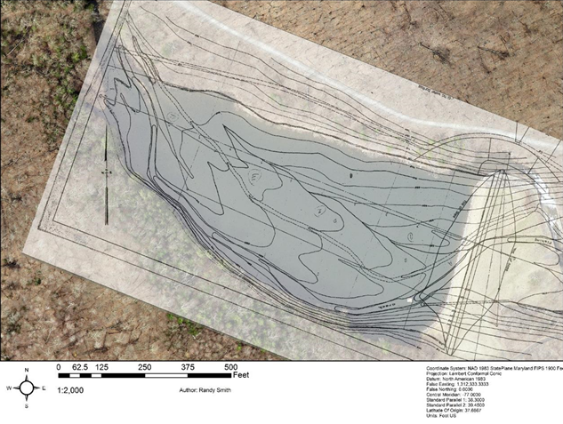

**Figure 1. Georeferenced, digitized copy of the original engineering drawings overlaid on an aerial photograph of Fishing Creek reservoir, Frederick County, MD.**

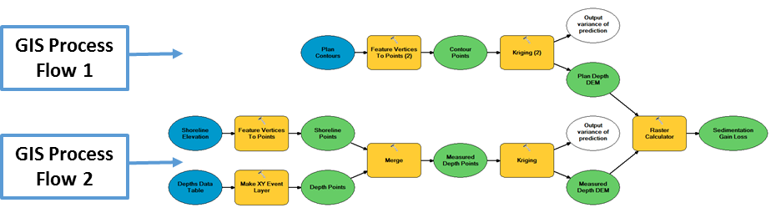

**Figure 2. GIS data reduction and mapping processes used in this study. GIS process flow 1 was employed for the original engineering drawings. GIS process flow 2 was used for data collected during the study.**

**Field Data Collection**

In order to determine the current shape of the lake basin, we deployed an automated boat capable of programmable navigation to collect depth soundings throughout the impoundment. The autonomous surface vehicle (ASV) is built on a prefabricated 1.1 m fiberglass hull and possesses a single, inboard motor (Figure 3).

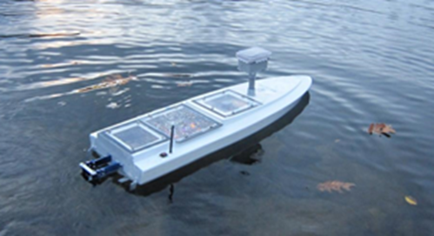

**Figure 3. Image of the ASV during deployment for the Fishing Creek reservoir bathymetric study.**

The hull is outfitted with a 160 kHz, Garmin Intelliducer, Depth/Temp, NMEA 0183 thru-hull transducer. This transducer is able to measure depth from 3 to 700 feet. The accuracy of depth measurements varies with sampling depth, with increasing accuracy as depth increases. (The accuracy of depth measurements was assessed by comparisons with manual chain soundings before deploying the survey craft in the reservoir.) The ASV also possesses two on-board GPS receivers – one for navigation and the other for collecting location data associated with each depth sounding. These GPS units have locational accuracy within approximately 2 meters. Navigation and control of the sensor payload are performed by a pair of on-board microcontrollers. The on-board data collection capacity can accommodate thousands of depth observations and their associated location information.

The ASV was programmed to navigate a series of transects for the collection of depth measurements throughout the reservoir. Depth soundings were collected along 38 north/south oriented transects (Figure 4A). Depth readings were repeated along 22 perpendicular transects (east/west orientation; Figure 4B). All parallel transects were approximately 3.9m apart. The ASV was navigated at an average speed of 0.98 m s-1 and collected over 10,000 depth measurements. The shallow northwest portion of the basin was surveyed manually using a SeaTech Handheld depth finder. All depth readings were associated with point locations derived from GPS.

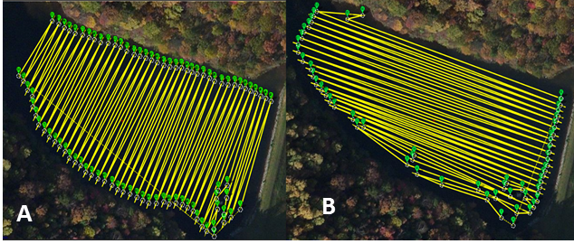

**Figure 4. Transects programmed into the ASV for collecting depth measurements throughout the Fishing Creek reservoir, Frederick Co., MD.**

Using ArcGIS we constructed a current bathymetric map of the reservoir from the GPS/depth measurements (See Figure 2, GIS Process Flow 2). GIS analysis was employed to determine the total surface area of the lake, as well as subsurface areas at each 5-ft depth contour interval. Using these area determinations, we calculated lake depth-segment volumes for the reservoir.

Once we established the original and updated bathymetry and lake volumes for Fishing Creek reservoir, we calculated accumulated sediment volumes (and the loss of water storage capacity) within the basin using the original map as a reference. By inspecting changes in basin contours, we also estimated the locations of the accumulated sediment to aid plans for any future remediation that might be considered for the lake. Finally, we calculated the amount of storage volume that would be regained by selective sediment removal.

**Results of the Bathymetric Study**

Baseline bathymetry derived from the digitized original engineering plans for the reservoir is shown in Figure 5A. Depth isopleths in this map indicate the reservoir gradually deepened from the inflow of Fishing Creek toward the dam, with the greatest depths located in the area surrounding the water intake tower in the southeast portion of the basin. The submerged streambed of Fishing Creek can readily be seen paralleling the basin’s southern shoreline.

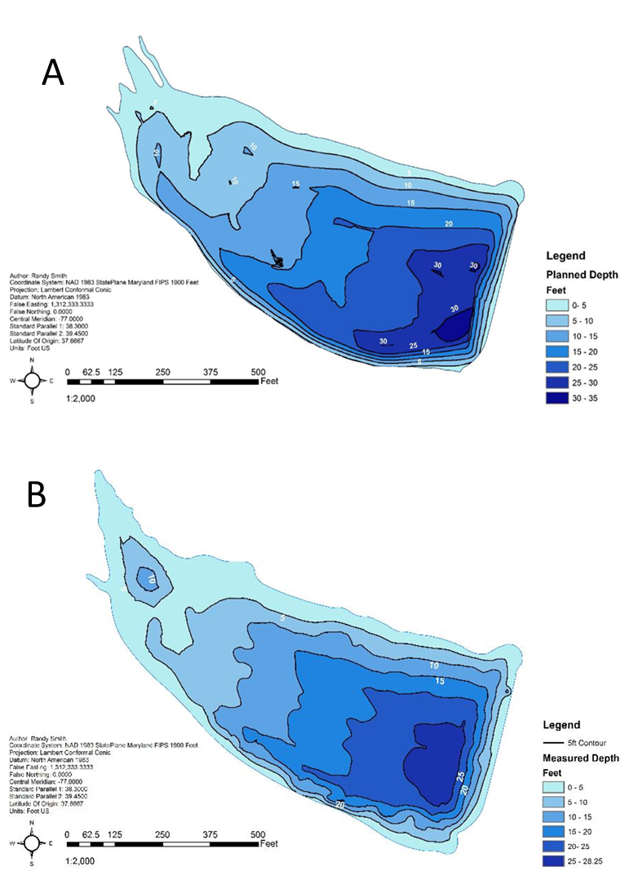

**Figure 5. Bathymetric maps of Fishing Creek reservoir, Frederick County, MD. A. A map based upon the 1923 engineering drawings for the construction of the reservoir. B. Map of the reservoir based upon depth soundings collected in November 2015.**

Three alternate interpolation methods (IDW raster interpolation, TIN, and Kriging) were used to create digital elevation models of the reservoir basin and the results of all three corresponded very closely. The output of the Kriging method (Figure 5A) was carried forward in all subsequent measurements of the original basin. Based on this map the original water storage capacity of the reservoir was 50.04 MG. This value correspond very closely to historic estimates of the reservoir volume given elsewhere (MD Dept. of the Environment, date unknown).

The ASV collected over 10,000 geo-located depth sounding within the reservoir which were used to construct a current bathymetric map of the basin. The location of data points measured during the study are represented on the map in Figure 6.

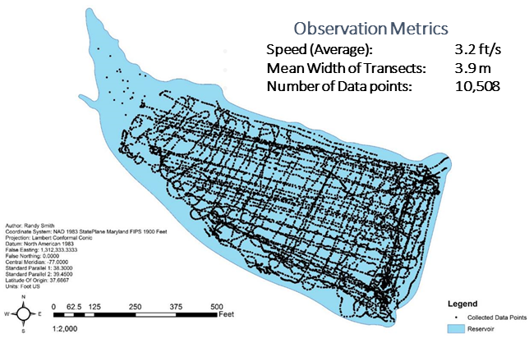

**Figure 6. Depth data points measured via the ASV and manual collection.**

Current reservoir bathymetry is shown in Figure 5B. Bathymetric parameters for the current basin are given in Table 1. Surface areas and cumulative volumes for different surface water elevations calculated for both the original impoundment and the current reservoir are provided in Appendix I.

By comparing the two maps in Figure 5, changes in lake morphometry since the reservoir’s creation can be discerned. Over the last 91 years, the shape of the shoreline has been altered somewhat in the area where Fishing Creek enters the reservoir, as well as along the southwest shoreline, where it appears that the inflowing stream has naturally eroded the bank. This shoreline change has resulted in a slight enlargement of the impoundment surface area from 10.6 acres at construction to 10.9 acres in 2015. The general shape of the bottom contours has changed little; however, the overall depth of the reservoir has lessened. This is particularly true in the submerged streambed and the deepest areas of the reservoir where the depth of the current basin are much as 5 to 10 ft shallower than the original map would indicate.

|  |  |
| --- | --- |
| **Bathymetric Statistics** |  |
| Surface Area (ft2) | 476574.1 |
| Maximum Length (ft) | 1321.3 |
| Maximum Width (ft) | 582.1 |
| Mean Length (ft) | 360.6 |
| Mean Width (ft) | 818.6 |
| Mean Depth (ft) | 11.6 |
| Maximum Depth (ft) | 28.2 |
| Relative Depth | 3.62 |
| Shoreline Length (ft) | 3476.2 |
| Shoreline Development | 1.42 |

**Table 1. Summary statistics for Fishing Creek Reservoir calculated**

**from current depth measurements.**

**Interpretations and Recommendations**

A comparison of volume - depth curves for the originally constructed reservoir versus its current status indicates that Fishing Creek reservoir has lost approximately 7.9 MG in storage volume when the water elevation is at 710 ft (Figure 7). This represents 15.8% of the reservoir’s original storage capacity.

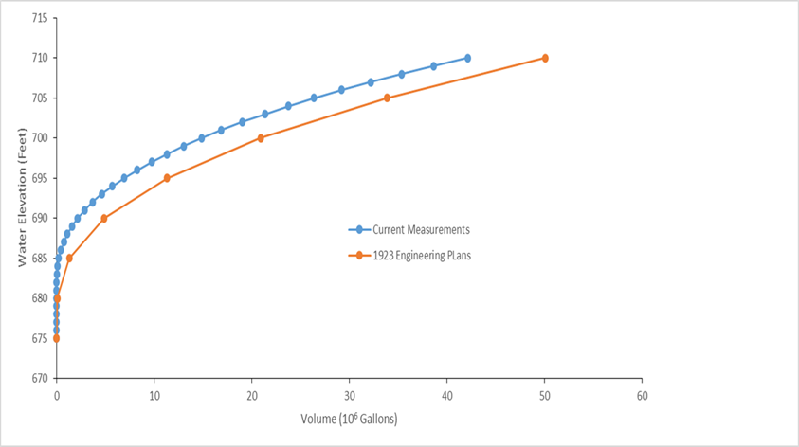

**Figure 7. Fishing Creek reservoir volume vs depth curves based upon the 1923 engineering drawings for impoundment construction and current depth sounding conducted during this study.**

In the 91 years since construction, we estimate that the reservoir has accumulated 34,023.3 yd3 of sediment which accounts for the loss of water storage capacity state above. While 0 to 4 ft of sediment have accumulated over most of the bottom of the impoundment, much more sediment has collected in the submerged streambed of Fishing Creek which parallels the southern shoreline of the reservoir and has also accumulated at the base of the dam (Figure 8).

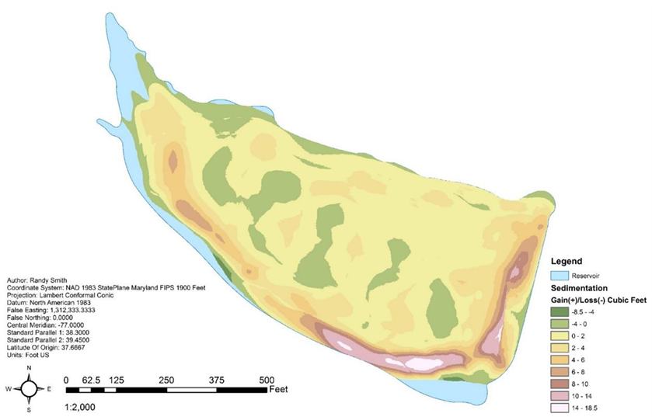

**Figure 8. Current map of the Fishing Creek reservoir, Frederick County, MD showing the location of deposited sediments.**

Original engineering drawings indicate that, when the reservoir is completely filled (surface elevation = 710 ft), water intake valves are located at depths of 4.3 ft and 24.3 ft along the intake tower. Originally, this lower intake valve was nearly 11 ft from the reservoir bottom. Sedimentation near the dam has reduced bottom depth by 8.4 ft since construction, resulting in the lower intake valve now being positioned 2.3 ft above the bottom. Given a calculated average rate of depth decrease of 0.09 ft per year, it will be approximately 25 more years (2040) until the lower intake valve is compromised by the rising bottom sediments.

Given the location of accumulated sediments, the primary focus of any partial dredging operations undertaken to restore water storage capacity in the reservoir should target the submerged streambed (along the southern shore) and the area along the base of the dam. Figure 9 outlines these proposed areas of targeted dredging. If those areas were dredged following original contours to remove 5 ft of sediment, an estimated 2.9 MG of storage capacity would be gained. Similarly, a dredge of those areas to 10 ft would provide about 5.9 MG of additional storage in the reservoir. These gains represent a return to 90.0% and 95.9% of the original storage capacity, respectively.



**Figure 9. Current map of the Fishing Creek reservoir, Frederick County, MD showing the location of deposited sediments. The area outlined in red represents the suggested boundaries of a partial dredge operation that would optimize recovery of water storage capacity.**

**Summary**

Reservoir bathymetry was analyzed from both the 1923 engineering plans and current depth soundings and the two resulting basins were compared. In the nine decades since the Fishing Creek reservoir was constructed, it has lost approximately 7.9 MG of storage volume due to sediment deposition within the impoundment. Much of this sediment has accumulated in the submerged streambed parallel to the south shoreline and at the base of the dam. The lower valve on the water intake tower may be impacted by accumulating sediment within the next 25 years. Partial dredging of the impoundment along the dam and southern shoreline will restore much of the original storage volume of the impoundment, as well as increasing the water depth surrounding the intake tower.

**Literature Cited**

City of Frederick. 2014. Annual Drinking Water Report, 2014 Summary. Http: o [www.cityoffrederick.com/ccr](http://www.cityoffrederick.com/ccr) Accessed 30 May 2015.

MD Dept. of the Environment. Source water assessments for Frederick City, Frederick County, MD <http://www.mde.state.md.us/programs/Water/Water_Supply/Source_Water_Assessment_Program/Documents/www.mde.state.md.us/assets/document/watersupply/SWAPS/Frederick/City%20of%20Frederick.pdf> Accessed 15 March 2016.

**Appendix I**

**Reservoir Surface Areas and Cumulative Volumes**

|  |  |  |  |
| --- | --- | --- | --- |
| **Reservoir Surface Elevation (ft)** | **Surface Area (ft2)** | **Volume (x 103 ft3)** | **Volume**  **( x 106 Fluid Gallons, US)** |
| 710 | 462545.6 | 6689.5 | 50.041 |
| 705 | 395621.3 | 4524.4 | 33.845 |
| 700 | 304072.8 | 2794.9 | 20.907 |
| 695 | 220502.2 | 1512.4 | 11.313 |
| 690 | 142111.5 | 649.8 | 4.861 |
| 685 | 66269.6 | 172.1 | 1.287 |
| 680 | 15419.0 | 8.4 | 0.063 |
| 675 | 0 | 0 | 0 |

**Table A. Fishing Creek Reservoir surface areas and cumulative volumes for different surface water elevations. These values were calculated from original engineering plans.**

**.**

|  |  |  |  |  |  |  |
| --- | --- | --- | --- | --- | --- | --- |
| **Reservoir Surface Elevation (ft)** | **Surface Area (ft2)** | | | **Volume (x 103 ft3)** | | **Volume**  **( x 106 Fluid Gallons, US)** |
| 710 | | 476574.1 | 5630.6 | | 42.119 | | |
| 705 | | 361401.4 | 3525.1 | | 26.369 | | |
| 700 | | 257856.2 | 1987.9 | | 14.870 | | |
| 695 | | 171239.9 | 924.2 | | 6.913 | | |
| 690 | | 87016.1 | 288.1 | | 2.155 | | |
| 685 | | 22869.9 | 29.1 | | 0.218 | | |
| 680 | | 0.0 | 0.0 | | 0.000 | | |
| 675 | | 0.0 | 0.0 | | 0.000 | | |

**Table B. Fishing Creek Reservoir surface areas and cumulative volumes for different surface water elevations. These values were calculated from depth soundings collected in November 2015.**