1 Introduction:

* 1. Introduction to analytical method development:[2]

Analytical chemistry is often described as the “area of chemistry responsible for Characterizing the composition of matter, both qualitatively (what is present) and quantitatively (how much is present)”. Analytical chemistry is not a separate branch of chemistry, but simply the application of chemical knowledge. In other words, Analytical Chemistry is defined as “the science and the art of determining the composition of materials in terms of the elements or compounds contained.”

Analytical method development can be defined as the procedure for selection of an accurate assay method for determination of the constitution present in the formulation. Analytical method development is widely used procedure for demonstration of acceptability of analytical methods utilized in laboratory for measurement of concentration of the sample. Method of analysis should be utilized within Good Manufacturing Practice and Good Laboratory Practice criteria. Development of analytical method must follow the protocols and criteria for acceptance which is mentioned in International Conference on Harmonization guideline that is Q2(R1).

Physico-chemical methods are useful in study of physical phenomenon that generates as a result of chemical reactions. Optical and chromatographic methods are most important from all of the physico-chemical methods. Mandatory requirements for modern pharmaceutical analysis:

1. The analysis should be less tedious.
2. Pharmacopoeial criteria for accuracy should be fulfilled by the selected method of analysis.

3. The method of analysis should not be too costly.

4. The nature of analysis method which is selected should be selective and precise.

Physico-chemical methods of analysis are able to meet these requirements, having advantage of their universal nature that can be utilized for analysis of organic compounds with their diverse structure. Small scale industries generally prefer visible spectrophotometry as the method of analysis mainly due to these two reasons:

i) Low cost of equipment used.

ii) Maintenance problems are minimal.

Need for analytical method:

The quantity of drugs launched into the market is continuously enhancing per year. The launched drugs may be a kind of either new entities or partial structural changes or improvement of the already available drug. Sometimes, there are so much year passing from the date of establishment of drug molecule to their entry or registration in pharmacopoeias. During this time period, analytical methods as well as standard parameters for this kind of drugs may not be included in the pharmacopoeias. Development of new analytical method becomes a mandatory requirement for this kind of drugs in brief, the reasons for the development of newer methods of drug analysis are:

• A proper analytical procedure for the drug may not be available in the literature due to patent regulations.

• Analytical methods for the quantification of the drug in biological fluids may not be available.

• The drug or drug combination may not be official in any pharmacopoeias.

• Analytical procedures may not be given for the drug in the form of a formulation because of the intervention created due to excipients used in formulation.

• No methods are available for the drug with combination of another drugs.

• Costly reagents and solvents are utilized in present analytical procedure available for drug.

• Analytical techniques that are generally used for drug analysis are biological and microbiological methods, radioactive methods, physical methods and miscellaneous techniques like conventional titrimetric, gravimetric and polarimetric methods.

* 1. Introduction of UV spectrophotometry as method of analysis[1, 3-9]
     1. Principle of UV spectroscopy:

Molecules having π electrons or atoms which carrying unshared electron pairs generally absorbs electromagnetic radiation having the range between 200 nm to 800 nm and it forms the basis for ultraviolet-visible spectroscopy. UV spectroscopy mainly concerned with valence electrons. Now, some pharmaceutical and biological substance which contain valence electrons are more preferred to absorb UV-visible radiation. So, in pharmaceutical Analysis, UV-Vis spectrophotometry is one of the most widely used technique. Area of concern in ultraviolet spectroscopy it to measure the amount of radiation which is absorbed through a substance present in the solution either in ultraviolet region i.e. 190 nm to 380 nm or visible region i.e. 380 nm to 800 nm.

Valence electrons which are present in organic compound are of three types:

(1) σ – electrons

(2) π – electrons

(3) η – electrons.

When irradiation of UV-Visible light is carried out on molecules, absorption of light takes place only when the energy of light reaches the similar level of energy that is required by molecule to induce electronic transition. The instruments which are utilized for measurement of the intensity ratio of two beams of light in the UV Visible region are known as UV-Visible spectrophotometers.

Lambert’s Law and Beer’s law are two separate laws governing absorption by UV radiation.

Lambert’s Law:

Statement: When monochromatic light travels through a transparent medium, intensity of light which is emitted decreases as the thickness of the medium increases.

In dI0/dIt = kl

Where,

I0 = Intensity of the incident light

It = Intensity of the transmitted light

l = Thickness of the medium

k = Proportionality factor

Beer’s Law:

Statement: When monochromatic light travels through a transparent medium, intensity of light which is emitted decreases as the concentration of the absorbing substance increases.

Log I0/It = act

Where,

I0 = Intensity of the incident light

It = Intensity of the transmitted light

t = Thickness of the medium

c = Concentration of the analyte

a = Constant which depends upon the method of expression of the conc.

Where thickness(t) can also be denoted as path length(b) and logarithmic ratio of I0 and it is known as absorbance (A).

A = abc

A strong relationship between the amount of light absorbed and concentration of analyte creates the base for most of the analytical application of the spectroscopy deals with molecular electronic absorption. The properties of absorbance spectra like:

• Spectral position

• Molar absorptivity

• Breadth and shape of the absorption band

are directly connected to environment and structure of the molecule. Therefore, they are used to perform the estimation qualitatively. Physical as well as chemical contents of the radiation absorbing molecule can be determined by changes in the absorption spectra as a result of any alteration and modification of the molecule.

* + 1. Basic instrumentation of UV spectrophotometer:

Figure 1. Block diagram of UV spectrophotometer

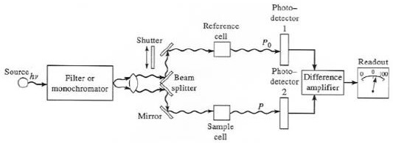

* + 1. Different methods for analysis of single component and multi component samples by UV spectroscopy:

Both single component as well as multi component samples can be estimated by UV spectroscopy. Different methods of analysis for estimation of this kind of samples are available.

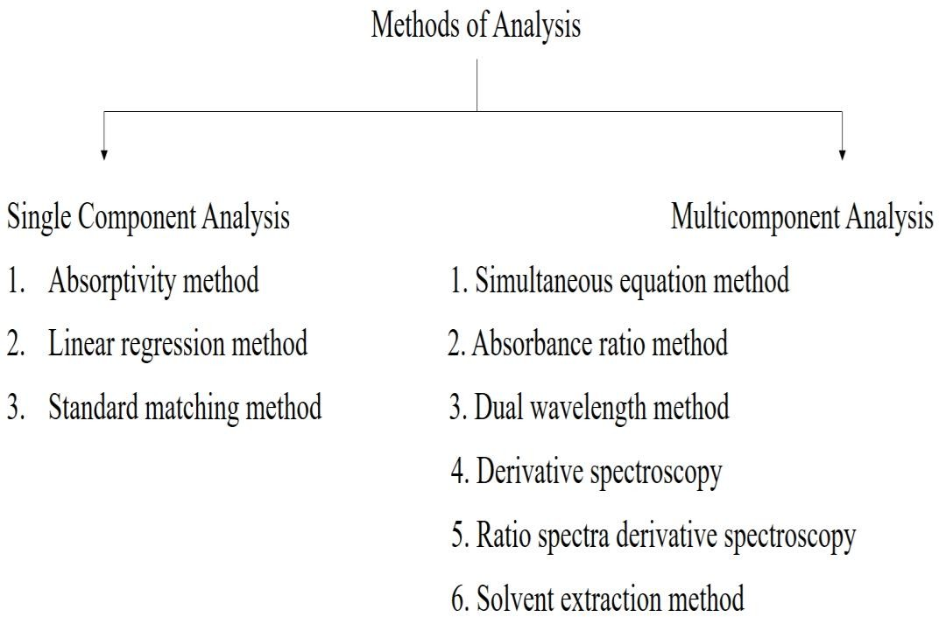

Figure 2: Overview of different methods of analysis

* + 1. Multicomponent Analysis method: Fact behind most of the spectroscopic methods which is used for the determination of multicomponent sample is the property that,

On most of the wavelength:

i) Solution’s total absorbance is composed of the sum of individual component’s absorbance. ii) Final absorbance = difference of solution’s total absorbance in reference cell and solution’s total absorbance in sample cell.

Different types of Spectrophotometric techniques are used for the analysis of multicomponent sample.

* + - 1. Vierordt’s method (Simultaneous Equation Method):

In case of sample having two absorbing drugs (suppose X and Y) individual of them gives absorbance on λmax of another

(Figure 2, λ1 and λ2), determination of both drugs is possible with the help of simultaneous equation method

(Vierordt’s method).

Cy = (A1 aX2 - A2 aX1) / (aY1 aX2 - aY2 aX1)

Cx = (A2 aY1 – A1 aY2) / (aY1 aX2 - aY2 aX1)

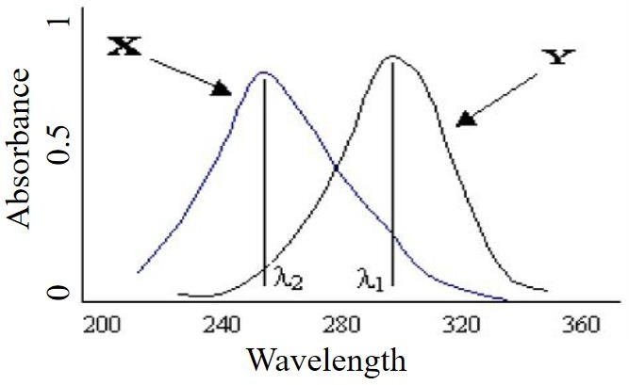

Figure 3: Overview of simultaneous equation method

Where,

λ1 = λmax of component X

λ2 = λmax of component Y

aX1 = absorptivity of component X at λ1.

aX2 = absorptivity of component X at λ2.

aY1 = absorptivity of component Y at λ1.

aY2 = absorptivity of component Y at λ2.

A1 = absorbance of diluted sample of mixture at λ1.

A2 = absorbance of diluted sample of mixture at λ2.

Cx = concentration of X.

Cy = concentration of Y.

The criteria are as follows:

1) For the precise determination of Y and X the respectively ratios (A2/A1) / (aX2/aX1) and (aY2/aY1) / (A2/A1) should lie outside the range of 0.1-2.0. The condition when λmax of the two components are reasonably dissimilar is able to satisfy these criteria.

2) Two components do not interact chemically, thereby negating the initial assumption that the total absorbance is the sum of the individual absorbance.

* + - 1. Q-Absorbance Method (Absorbance Ratio Method):

If substance follows Beer's law at all wavelength, ‘the value which indicates the ratio of measured absorbance at any of the two wavelengths is a persistent and it does not depend on concentration or path length’ is the property which forms the basis of this Q-Absorbance method for multicomponent sample. For example, the same absorbance ratio A1/A2 is obtained by two individual dilution of the similar substance. Concentration of two drugs in the mixture can be calculated using following equations:

CX = [(QM - QY) / (QX -QY)] × A1/aX1

CY = (A1/aX1) – CX

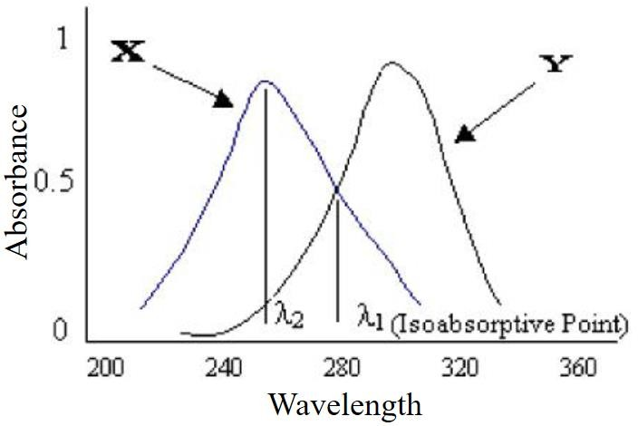

Figure 4: Overview of Q-Absorbance method

Where,

QM = A2 / A1,

QX = aX2 / aX1

QY = aY2/aY1.

A1 = absorbance of mixture at iso absorptive point.

A2 = absorbance of mixture at λmax of one drug component.

aX1 and aY1 = absorptivities of drug X and drug Y respectively at iso absorptive point.

aX2 and aY2 = absorptivities of drug X and drug Y respectively at λmax of one drug component.

In the USP, this ratio is referred to as Q value.

* + - 1. Dual Wavelength Method:

Dual wavelength method of analysis for multicomponent sample is used to calculate concentration of compound of interest from the sample mixture. The sample mixture is made up of both that is compound of interest as well as undesirable interfering compound. Concentration of compound of interest can be carried out with the help of taking difference of 2 points on the spectra of sample mixture, which is proportional to the compound of interest, and independent of undesirable interfering compound.

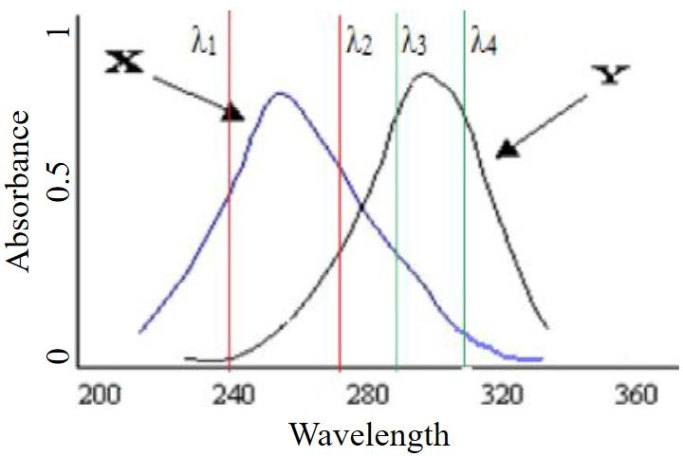

Figure 5: Overview of Dual wavelength method Essential requirement for dual wavelength method:

➢ Selection of two wavelengths with taking care that the interfering component gives the same absorbance while the component of interest gives remarkable difference of absorbance with concentration. Estimation of drug:

➢ Graph of difference in the absorbance VS concentration is plotted and from the regression equation amount of drugs present in the mixture can be calculated.

* + - 1. Derivative Spectroscopy:

Transformation of a standard spectra to its first derivative, second derivative or higher derivative spectra provides the base for derivative spectroscopy. First derivative D1 spectra = Plot of the slope of fundamental spectra versus wavelength OR plot of the rate of change in absorbance with wavelength against wavelength OR a plot of dA/dλ vs. λ.

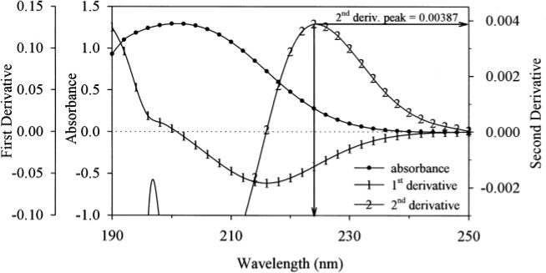

Figure 6: Overview of Derivative spectroscopy method

Second derivative D2 spectra = Plot of the curvature of the D0 spectrum against wavelength OR a plot of d2A/dλ2 vs. λ. Likewise, third and fourth derivatives are prepared as per requirements. For single drug molecule, we can use simple UV method which involves use of Double Beam Spectrophotometer.

* + - 1. Ratio spectra derivative spectroscopy:

This method of analysis for estimation of multicomponent sample have mathematical base that if the spectra of mixture containing two components X and Y is divided by spectra of a solution of say X (solution of X = divisor solution), the spectra which is obtained is the ratio spectra of Y. If determination of the first derivative of this ratio spectra is performed, the amplitude generated by the signals are directly proportional to the concentration of Y in the mixture solution. By following the same procedure but this time, use solution of Y as a divisor solution so it will provide data for determination of concentration of X in the mixture solution. Merits of derivative ratio spectra spectroscopy:

• Uncomplicated measurement on separate peaks.

• Analytical signals having higher values.

* + - 1. Solvent extraction method:

In this method of analysis, measurement of each drug in combination is likely to be carried out with the help of separation of individual drug. This process of separation is generally based on selective solubility of drug and followed by spectrophotometric measurement. If other absorbing substance creates interference in large amount, separation of absorbing substance which causes interference from analyte is possible with the help of solvent extraction method. This method of analysis for multicomponent sample is extremely suitable for analysis of acidic and basic drug, solvent partitioning behavior of them can be determined with the help of their ionization state.

* 1. Partial Least Square (PLS) Method[10-32]

1.3.1 History of partial least square:

Herman wold was developed partial least square model in 1960’s for the use of econometrical technique, but some of its most eager proponents (including wold’s son svante) are chemical engineers and chemometricians. Partial least square has been applied to monitoring and controlling industrial processes, and it can be easily having hundreds of controllable variables and dozens of outputs. These are all about spectrometric calibration.

1.3.2 Introduction of partial least square:

In the field of chemometrics, PLS has received great amount of attention due to its importance. The algorithm is used as a standard tool for processing a wide spectrum of chemical data problems. Due to its great success it possesses a wide variety of application in other scientific areas including bioinformatics, food search, medicine, pharmacology, social science, physiology and in other work areas.

Generally, PLS creates orthogonal score vectors in its general form, which is also known as latest vectors or components. This vector is created by maximizing the covariance between different sets of variables. In this topic, PLS dealing with two blocks of variables is considered, although the PLS extension to model relations among a higher number of sets exist. PLS is somewhat related to canonical correlation analysis (CCA), in which latent vector with maximal correlation are extracted. Now, to extract this latent vectors, various PLS techniques are used, and each of them gives rise to a variant of PLS.

PLS can be naturally extended in the form of regression problems. In which the prediction and predicted variables are each considered as a block of variables. After that PLS extract the score vectors which can serve as a representation of new predictor and on this new predictor, it regresses the response variables. The natural asymmetry between predictor and response variables is reflected in such a way in which the score vectors are computed. These variants are known as PLS1 (one response variable) and PLS2 (at least two response variable). PLS is considered asa rigorous statistical model, and its use is overlooked by statisticians. Interest in the statistical properties of PLS has been risen from last few years. PLS is also related to other regression methods like principal component regression (PCR) and ridged regression (RR). So, these all methods fall under a unique approach which is known as continuum regression. The effectiveness of PLS can be theoretically studied in terms of its variance and its shrinkage properties. In several simulation studies, the performance of PLS can be investigated.

PLS can be also be applied to classification problems by encoding the class membership in an appropriate indicator matrix. PLS possess a close connection for classification to fisher discriminant analysis (FDA). As similar to PCA, the PLS can be as a discrimination tool and dimension reduction method. An appropriate classifier can be applied after relevant latent vectors are extracted.

At last, the powerful machinery of kernel – based learning can be applied to PLS. these kernel methods are an elegant way of extending linear data analysis tools to non – linear problems.

1.3.3 Partial least square:

Consider the general setting of a linear PLS algorithm to model the relation between two data sets (blocks of variables). Denote by X R N an N-dimensional space of variables representing the first block and similarly by Y RM a space representing the second block of variables. PLS models the relations between these two blocks by means of score vectors. After observing n data samples from each block of variables, PLS decomposes the (n × N) matrix of zero-mean variables X and the (n × M) matrix of zero-mean variables Y into the form,

X = TPT +E

Y = UQT +F

Where the T, U are (n × p) matrices of the p extracted score vectors (components, latent vectors), the (N × p) matrix P and the (M × p) matrix Q represent matrices of loadings and the (n × N) matrix E and the (n × M) matrix F are the matrices of residuals. The PLS method, which in its classical form is based on the non lineariterative partial least squares (NIPALS) algorithm, finds weight vectors w, c such that,

[cov (t, u)]2 = [cov (Xw, Yc)]2 = max|r|=|s|=1[cov (Xr, Ys)]2

where cov (t, u) =tTu/n denotes the sample covariance between the score vectors t and u. The NIPALS algorithm starts with random initialization of the Y-space score vector u and repeats a sequence of the following steps until convergence.

1. 𝑊 = 𝑋𝑇𝑢(𝑢𝑇𝑢)

2. ‖𝑊‖ → 1

3. t = Xw

4. 𝑐 = 𝑌𝑡𝑇⁄(𝑡𝑇𝑡)

5. ‖𝐶‖ → 1

6. u = Yc

Note that u = y if M = 1, that is, Y is a one-dimensional vector that we denote by y.

For a data analysis and regression by PLS, many software available, that are XLSTAT, camo, Unscrambler®, smartPLS, SPSS, WarpPLS, LISRET, etc.

* 1. Introduction to UV Spectrophotometric

UV-Vis spectroscopy is an analytical technique that measures the amount of discrete wavelengths of UV or visible light that are absorbed by or transmitted through a sample in comparison to a reference or blank sample. This property is influenced by the sample composition, potentially providing information on what is in the sample and at what concentration. Since this spectroscopy technique relies on the use of light, let’s first consider the properties of light.

Light has a certain amount of energy which is inversely proportional to its wavelength. Thus, shorter wavelengths of light carry more energy and longer wavelengths carry less energy. A specific amount of energy is needed to promote electrons in a substance to a higher energy state which we can detect as absorption. Electrons in different bonding environments in a substance require a different specific amount of energy to promote the electrons to a higher energy state. This is why the absorption of light occurs for different wavelengths in different substances. Humans are able to see a spectrum of visible light, from approximately 380 nm, which we see as violet, to 780 nm, which we see as red.1 UV light has wavelengths shorter than that of visible light to approximately 100 nm. Therefore, light can be described by its wavelength, which can be useful in UV-Vis spectroscopy to analyze or identify different substances by locating the specific wavelengths corresponding to maximum absorbance (see the Applications of UV-Vis spectroscopy section).

1.4.1 Instrumentation

Whilst there are many variations on the UV-Vis spectrophotometer, to gain a better understanding of how an UV‑Vis spectrophotometer works, let us consider the main components, depicted in Figure 1.

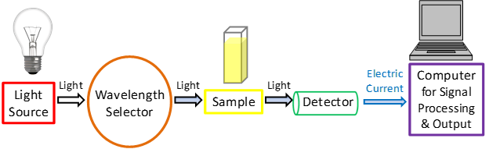

**figure 1:** A simplified schematic of the main components in a UV-Vis spectrophotometer. *Credit: Dr. Justin Tom.*

### Light source

As a light-based technique, a steady source able to emit light across a wide range of wavelengths is essential. A single xenon lamp is commonly used as a high intensity light source for both UV and visible ranges. Xenon lamps are, however, associated with higher costs and are less stable in comparison to tungsten and halogen lamps.

For instruments employing two lamps, a tungsten or halogen lamp is commonly used for visible light,[2](https://doi.org/10.1016/S1046-2023(02)00204-9" \t "_blank) whilst a deuterium lamp is the common source of UV light.[2](https://doi.org/10.1016/S1046-2023(02)00204-9" \t "_blank) As two different light sources are needed to scan both the UV and visible wavelengths, the light source in the instrument must switch during measurement. In practice, this switchover typically occurs during the scan between 300 and 350 nm where the light emission is similar from both light sources and the transition can be made more smoothly.

### Wavelength selection

In the next step, certain wavelengths of light suited to the sample type and analyte for detection must be selected for sample examination from the broad wavelengths emitted by the light source. Available methods for this include:

**Monochromators** - A monochromator separates light into a narrow band of wavelengths. It is most often based on diffraction gratings that can be rotated to choose incoming and reflected angles to select the desired wavelength of light.1,[2](https://doi.org/10.1016/S1046-2023(02)00204-9" \t "_blank) The diffraction grating's groove frequency is often measured as the number of grooves per mm. A higher groove frequency provides a better optical resolution but a narrower usable wavelength range. A lower groove frequency provides a larger usable wavelength range but a worse optical resolution. 300 to 2000 grooves per mm is usable for UV-Vis spectroscopy purposes but a minimum of 1200 grooves per mm is typical. The quality of the spectroscopic measurements is sensitive to physical imperfections in the diffraction grating and in the optical setup. As a consequence, ruled diffraction gratings tend to have more defects than blazed holographic diffraction gratings.[3](https://doi.org/10.1016/B978-012617560-8/50018-9" \t "_blank) Blazed holographic diffraction gratings tend to provide significantly better quality measurements.[3](https://doi.org/10.1016/B978-012617560-8/50018-9" \t "_blank)

* **Absorption filters**- Absorption filters are commonly made of colored glass or plastic designed to absorb particular wavelengths of light.[2](https://doi.org/10.1016/S1046-2023(02)00204-9" \t "_blank)
* **Interference filters** -Also called dichroic filters, these commonly used filters are made of many layers of dielectric material where interference occurs between the thin layers of materials. These filters can be used to eliminate undesirable wavelengths by destructive interference, thus acting as a wavelength selector.1,[2](https://doi.org/10.1016/S1046-2023(02)00204-9" \t "_blank)
* **Cutoff filters** - Cutoff filters allow light either below (shortpass) or above (longpass) a certain wavelength to pass through. These are commonly implemented using interference filters.
* **Bandpass filters** -Bandpass filters allow a range of wavelengths to pass through that can be implemented by combining shortpass and longpass filters together.
* Monochromators are most commonly used for this process due to their versatility. However, filters are often used together with monochromators to narrow the wavelengths of light selected further for more precise measurements and to improve the signal-to-noise ratio.

### Sample analysis

* Whichever wavelength selector is used in the spectrophotometer, the light then passes through a sample. For all analyses, measuring a reference sample, often referred to as the "blank sample", such as a cuvette filled with a similar solvent used to prepare the sample, is imperative. If an aqueous buffered solution containing the sample is used for measurements, then the aqueous buffered solution without the substance of interest is used as the reference. When examining bacterial cultures, the sterile culture media would be used as the reference. The reference sample signal is then later used automatically by the instrument to help obtain the true absorbance values of the analytes.

It is important to be aware of the materials and conditions used in UV‑Vis spectroscopy experiments. For example, the majority of plastic cuvettes are inappropriate for UV absorption studies because plastic generally absorbs UV light. Glass can act as a filter, often absorbing the majority of UVC (100‑280 nm)[2](https://doi.org/10.1016/S1046-2023(02)00204-9" \t "_blank) and UVB (280‑315 nm)[2](https://doi.org/10.1016/S1046-2023(02)00204-9" \t "_blank) but allowing some UVA (315‑400 nm)[2](https://doi.org/10.1016/S1046-2023(02)00204-9" \t "_blank) to pass through. Therefore, quartz sample holders are required for UV examination because quartz is transparent to the majority of UV light. Air may also be thought of as a filter because wavelengths of light shorter than about 200 nm are absorbed by molecular oxygen in the air. A special and more expensive setup is required for measurements with wavelengths shorter than 200 nm, usually involving an optical system filled with pure argon gas. Cuvette-free systems are also available that enable the analysis of very small sample volumes, for example in DNA or RNA analyses.

### Detection

After the light has passed through the sample, a detector is used to convert the light into a readable electronic signal. Generally, detectors are based on photoelectric coatings or semiconductors.

A **photoelectric coating** ejects negatively charged electrons when exposed to light. When electrons are ejected, an electric current proportional to the light intensity is generated. A photomultiplier tube (PMT)[4](https://micro.magnet.fsu.edu/primer/digitalimaging/concepts/photomultipliers.html" \t "_blank) is one of the more common detectors used in UV‑Vis spectroscopy.[2](https://doi.org/10.1016/S1046-2023(02)00204-9" \t "_blank),[5](https://doi.org/10.1515/psr-2018-0008" \t "_blank) A PMT is based on the photoelectric effect to initially eject electrons upon exposure to light, followed by sequential multiplication of the ejected electrons to generate a larger electric current.[4](https://micro.magnet.fsu.edu/primer/digitalimaging/concepts/photomultipliers.html" \t "_blank) PMT detectors are especially useful for detecting very low levels of light.

When **semiconductors** are exposed to light, an electric current proportional to the light intensity can pass through. More specifically, photodiodes[6](https://www.electronicshub.org/photodiode-working-characteristics-applications/" \t "_blank) and charge‑coupled devices (CCDs)[7](https://www.jstor.org/stable/24950003?refreqid=excelsior%3Ad3d10f6a91e7adf39f7c1291356ba3aa&seq=1" \t "_blank) are two of the most common detectors based on semiconductor technology.[2](https://doi.org/10.1016/S1046-2023(02)00204-9" \t "_blank),[5](https://doi.org/10.1515/psr-2018-0008" \t "_blank)

After the electric current is generated from whichever detector was used, the signal is then recognized and output to a computer or screen. Figures 2 and 3 show some simplified example schematic diagrams of UV-Vis spectrophotometer arrangements.

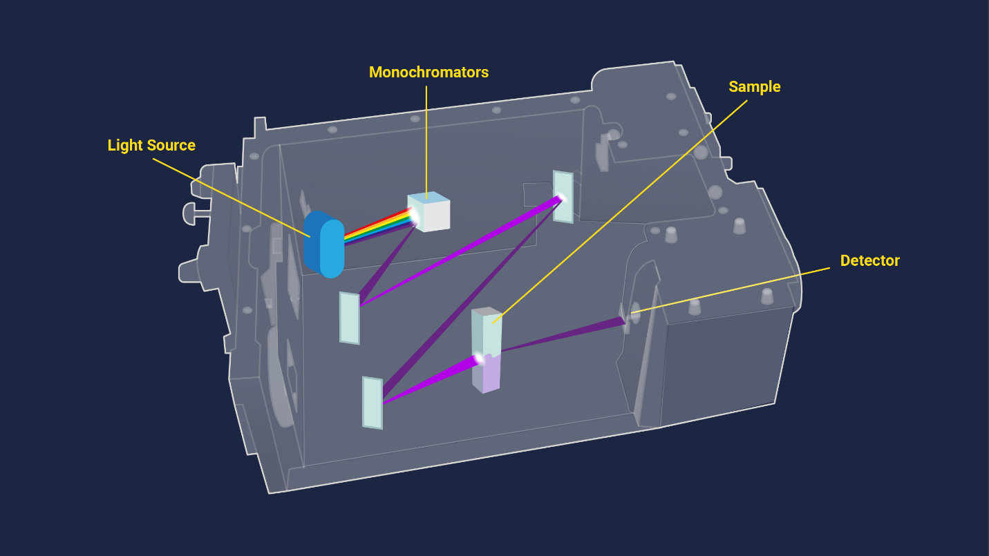

## Strengths and limitations of UV-Vis spectroscopy

No single technique is perfect and UV‑Vis spectroscopy is no exception. The technique does, however, have a few main strengths listed below that make it popular.

* The technique is**non‑destructive**, allowing the sample to be reused or proceed to further processing or analyses.
* Measurements can be made **quickly**, allowing easy integration into experimental protocols.
* Instruments are **easy to use**, requiring little user training prior to use.
* Data analysis generally requires **minimal processing**, again meaning little user training is required.
* The instrument is generally **inexpensive** to acquire and operate, making it accessible for many laboratories.

1.4.2.Qualification  
Although the strengths of this technique seem overwhelming, there are also certain weaknesses:

* **Stray light** - In a real instrument, wavelength selectors are not perfect and a small amount of light from a wide wavelength range may still be transmitted from the light source,1 possibly causing serious measurement errors.[9](https://doi.org/10.1021/ac00266a003" \t "_blank) Stray light may also come from the environment or a loosely fitted compartment in the instrument.1
* **Light scattering** - Light scattering is often caused by suspended solids in liquid samples, which may cause serious measurement errors. The presence of bubbles in the cuvette or sample will scatter light, resulting in irreproducible results.
* **Interference from multiple absorbing species** - A sample may, for example, have multiple types of the green pigment chlorophyll. The different chlorophylls will have overlapping spectra when examined together in the same sample. For a proper quantitative analysis, each chemical species should be separated from the sample and examined individually.
* **Geometrical considerations** - Misaligned positioning of any one of the instrument's components, especially the cuvette holding the sample, may yield irreproducible and inaccurate results. Therefore, it is important that every component in the instrument is aligned in the same orientation and is placed in the same position for every measurement. Some basic user training is therefore generally recommended to avoid misuse.

## 1.4.3.Applications of UV-Vis spectroscopy

UV‑Vis has found itself applied to many uses and situations including but not limited to:

### DNA and RNA analysis

Quickly verifying the purity and concentration of RNA and DNA is one particularly widespread application. A summary of the wavelengths used in their analysis and what they indicate are given in Table 1. When preparing DNA or RNA samples, for example for downstream applications such as sequencing, it is often important to verify that there is no contamination of one with the other, or with protein or chemicals carried over from the isolation process.

The 260 nm/280 nm absorbance (260/280) ratio is useful for revealing possible contamination in nucleic acid samples, summarized in Table 2.Pure DNA typically has a 260/280 ratio of 1.8, while the ratio for pure RNA is usually 2.0. Pure DNA has a lower 260/280 ratio than RNA because thymine, which is replaced by uracil in RNA, has a lower 260/280 ratio than uracil. Samples contaminated with proteins will lower the 260/280 ratio due to higher absorbance at 280 n

### Pharmaceutical analysis

One of the most common uses of UV-Vis spectroscopy is in the [pharmaceuticals](https://www.technologynetworks.com/analysis/lists/uvvisible-spectroscopy-in-the-development-of-biopharmaceuticals-330978" \t "_blank) industry.[12](https://doi.org/10.1016/j.microc.2012.05.012" \t "_blank),[13](https://doi.org/10.1016/j.aca.2012.07.010" \t "_blank),[14](https://doi.org/10.1080/10408347.2019.1586519" \t "_blank),[15](https://doi.org/10.1016/j.jpba.2008.08.014" \t "_blank),[16](https://doi.org/10.1007/s00216-012-6073-9" \t "_blank),[17](https://doi.org/10.1016/j.aca.2008.12.039" \t "_blank) In particular, processing UV-Vis spectra using mathematical derivatives allows overlapping absorbance peaks in the original spectra to be resolved to identify individual pharmaceutical compounds.[12](https://doi.org/10.1016/j.microc.2012.05.012" \t "_blank),[17](https://doi.org/10.1016/j.aca.2008.12.039" \t "_blank) For example, benzocaine, a local anesthetic, and chlortetracycline, an antibiotic, can be identified simultaneously in commercial veterinary powder formulations by applying the first mathematical derivative to the absorbance spectra.[17](https://doi.org/10.1016/j.aca.2008.12.039" \t "_blank) Simultaneous quantification of both substances was possible on a microgram per milliliter concentration range by building a calibration function for each compound.[17](https://doi.org/10.1016/j.aca.2008.12.039" \t "_blank)

### Bacterial culture

UV-Vis spectroscopy is often used in [bacterial culturing](https://www.technologynetworks.com/immunology/articles/an-introduction-to-culturing-bacteria-355566" \t "_blank). OD measurements are routinely and quickly taken using a wavelength of 600 nm to estimate the cell concentration and to track growth.[18](https://doi.org/10.1038/srep38828" \t "_blank)600 nm is commonly used and preferred due to the optical properties of bacterial culture media in which they are grown and to avoid damaging the cells in cases where they are required for continued experimentation.

### Beverage analysis

The identification of particular compounds in drinks is another common application of UV-Vis spectroscopy. Caffeine content must be within certain legal limits,1,[19](https://www.doi.org/10.11648/j.ajac.20160402.14" \t "_blank) for which UV light can facilitate quantification. Certain classes of colored substances, such as anthocyanin found in blueberries, raspberries, blackberries, and cherries, are easily identified by matching their known peak absorbance wavelengths in [wine](https://www.technologynetworks.com/applied-sciences/infographics/wine-analysis-from-grape-to-glass-316316" \t "_blank)for quality control using UV-Vis absorbance.[20](https://doi.org/10.1080/05704928.2017.1352511" \t "_blank)

### Other applications

This technique may also be used in many other industries. For example, measuring a color index is useful for monitoring transformer oil as a preventative measure to ensure electric power is being delivered safely.[21](https://doi.org/10.3390/s18072175" \t "_blank) Measuring the absorbance of hemoglobin to determine hemoglobin concentrations may be used in cancer research.[22](https://doi.org/10.1016/j.copbio.2009.02.004" \t "_blank) In wastewater treatments, UV-Vis spectroscopy can be used in kinetic and monitoring studies to ensure certain dyes or dye by‑products have been removed properly by comparing their spectra over time.[23](http://www.doi.org/10.1016/j.dyepig.2003.10.009" \t "_blank) It also finds great utility in [food authenticity analysis](https://www.technologynetworks.com/applied-sciences/lists/food-authenticity-and-spectroscopy-323842" \t "_blank) and [air quality monitoring](https://www.technologynetworks.com/applied-sciences/infographics/air-quality-monitoring-303060" \t "_blank).

UV‑Vis spectroscopy is also qualitatively useful in some more specialized research. Tracking changes in the wavelength corresponding to the peak absorbance is useful in examining specific structural protein changes[24](https://doi.org/10.1021/jf300278k" \t "_blank),[25](https://doi.org/10.1016/S0167-4838(01)00336-3" \t "_blank),[26](https://doi.org/10.1021/acs.analchem.8b00117" \t "_blank) and in determining battery composition.[27](https://doi.org/10.1002/cssc.201300142" \t "_blank) Shifts in peak absorbance wavelengths can also be useful in more modern applications such as characterization of very small nanoparticles.[28](https://doi.org/10.1080/10408347.2018.1451299" \t "_blank),[29](https://doi.org/10.1039/C4NR00580E" \t "_blank) The applications of this technique are varied and seemingly endless.

* 1. Introduction to Analytical method validation[37]

Analytical method validation describes the potential of a specific method to give test result consistently and continuously as per predetermined specifications. Analytical method validation is a part that has been included in many pharmacopoeias like United States Pharmacopoeia, British Pharmacopoeia and as a separate guideline in International conference on harmonization. The WHO has given principles as, Validation of analytical procedures used in the examination of pharmaceutical materials.

’This guideline had been appeared in 1992 when 32nd report of WHO committee was issued. The section is becoming of importance as it sets standards necessary for appropriate method development and there by ensure a quality product. ICH has issued guideline for quality which are adopted by nations like US, Japan and European countries.

Two guidelines are available under title of- ‘Q2A: Text on validation of Analytical procedures’ and ‘Q2B: validation of Analytical Procedures Methodology’, USP (2004) has a section describing requirements of validation of analytical methods. This guideline has not been included in Indian Pharmacopoeia.

Method validation is documented evidence that a particular method is performing for intended purpose according predetermined specifications one can adjudge consistency and reliability of method from results of validation.

Range and Linearity:

It is potential of method to produce results that are directly proportional to the concentration of component in given samples. It is demonstrated by particular mathematical transformations.

1. It may be directly performed on the substance under examination and/or using standard and suitably diluting by proposed method.

2. It can be performed by determining at least 5 injections in series of standards. Concentrations may be 80–120 percent of the proposed range.

3. The response of sample to the concentration must be demonstrated by mathematical equation 4. A significant zero intercept must be obtained when linear regression method is applied and if it is not obtained then one has to prove that there is no significant effect on accuracy.

One other approach can be utilized that is response factor, which can be obtained by dividing response with corresponding concentration that will give relative response. A graph of relative response vs concentration is plotted on a logarithmic scale. So, the horizontal line obtained must ne linear over the entire range. Usually negative deviation occurs at higher concentrations. A horizontal line is drawn parallel to x axis on the graph corresponding, 95 to 105 percent of the horizontal line. The response is linear to concentration till the point where the horizontal line intersects the 95 percent line.

It is the interval of concentration between which Quantitation can be performed with adequate accuracy and precision and method is linear. The range of analytical method is expressed in the same units (e.g., PPM or %).

Figure 9: Diagrammatical representation of Linearity

Figure 10: Diagrammatical representation of Range

**Reproducibility and Precision**

It is defined as degree of closeness among the test results when method is performed on several samplings of a same sample. Relative standard deviation or C.V. can be used to express it. It can be further divided in to reproducibility, repeatability and intermediate precision Repeatability is potential of an analytical method to generate similar test results when method is carried out in similar environment by same operator over a shortperiod of time. It can be expressed as R.S.D. here minimum 3 concentrations are taken and analysis is performed on each for at least 6 time and R.S.D. is calculated. At least 6 replications must be analyzed covering 100 % of target concentration or 9 repetitions covering entire linear range. (i.e. 3 replications for each of 3 concentrations)

The reproducibility is potential of an analytical method to generate similar test results when method is applied on homogenous sample in different conditions and by different analyst. Operation conditions are different but difference is still within the limits. It is quite important validation parameter if method has to be operated in different conditions.

**Accuracy and Recovery:**

It potential of method to produce results near to the true or standard value (Standard value may be reference value given in official compendia). Selected concentration for accuracy studies must cover entire concentration range (i.e. one may the lowest concentration, one may the middle and one may be the last of range).

Accuracy is performed by performing recovery studies by spiking in 2 ways:

1. Spiking of sample with standard (in case placebo are not available).

2. Spiking of placebo with standard.

It can be performed at different level like 50, 100 and 150 % of test concentration or 80, 100, 120% of test concentration.

**Limit of Quantification and Limit of Detection:**

It refers to the ability of analytical method to detect analyte in presence of matrix with adequate accuracy and precision. Method can detect the analyte but may not be able to perform quantification. One might be confused between the sensitivity of method and LOD. Sensitivity may differentiate small difference in concentrations. One can say that it is the slope of regression line.

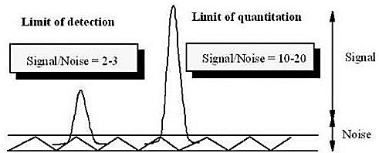

Following methods are available other than signal to noise ratio that are as follows:

## Figure 11: General representation of LOD and LOQ

1. Visual determination: it can be determined by manually injecting lowest known concentration which can be detected but not quantified by mathematical transformations.

2. Standard deviation of response based on standard deviation of blank: it can be measured by analyzing number of blank samples and obtaining S.D of these blank responses. This method gives idea about the ability of a method to give response other than analyte.

3. Utilizing slope of regression line for measuring S.D. of response: here one can measure the S.D. of regression line of a given calibration curve or can utilize S.D. of intercept.

4. It can be also calculated by mathematical equations that are explained below:

L𝑖𝑚𝑖𝑡 𝑜𝑓 𝐷𝑒𝑡𝑒𝑐𝑡𝑖𝑜𝑛 = 3.3 × 𝜎 \𝑆

𝐿𝑖𝑚𝑖𝑡 𝑜𝑓 𝑄𝑢𝑎𝑛𝑡𝑖𝑓𝑖𝑐𝑎𝑡𝑖𝑜𝑛 = 10 × 𝜎 \𝑆

**Ruggedness:**

Exact definition of ruggedness has not been included in guidelines but it has similar interpretation as reproducibility that is same response obtained under different environment (i.e. different labs, environmental conditions, equipment and or analyst). So, one can say that ruggedness is the degree of reproducibility under normal variable conditions.

It gives idea of reproducibility of obtained response under routine, expected analytical conditions varying in different lab as well as different analyst. For performing ruggedness of method homogenous sample aliquots are estimated in different condition and degree of difference can be estimated by T-test.

**Robustness:**

It is potential of a method that it should not affected by small but deliberate changes in operational conditions but still these changes are within the range. Influences of these changes are measured on response obtained by the method. By performing robustness one can determine that weather there is a need of revalidation or not. Various method parameter that can be changed are like flow rate, mobile phase composition, pH of mobile phase, detection wavelength. This change can be within the limits (i.e. 2-5% of original value) One may identify the critical method parameter which can actually identify the susceptibility of method towards the changes and must be documented as per ICH guidelines. However, it is not a part required for registration.

**Solvent stability:**

Numerous examples show that certain molecules in solution readily decompose prior to analysis. They might decompose at various stages of treatment like sample preparation, solvent extraction, or sample storage (i.e. in automatic samplers or during preservation in refrigerator). Under such conditions one must assess the stability of standard and sample. One must assess the stability of sample and standard under such conditions for at least 48 hours. For determining stability of standard and sample one must analyze same sample at small intervals over 48 hours. R.S.D is calculated for test response obtained at various intervals and it must not above at least 20 % from system precision.

**Data elements required for analytical method validation**

For determination of pharmaceutical material there are various analytical methods. But all above mentioned validation parameter are not considered for a particular method. Analytical methods are classified in different categories which are as follows:

• **Category I:**

Includes quantification methods of active substance from matrix or major components like preservatives from finished dosage form

• **Category II:**

Includes quantification methods of impurities either from matrix or quantification of degradation products from finished dosage from.

• **Category III**:

Methods which can determine or present performance of the system (example: release of drug, dissolution).

1.6 Introduction to Drug Profile

1.6.1 Introduction of Oloptadine Hydrochloride

|  |  |
| --- | --- |
| Drug Information | |
| Therapeutic category | Mast cell stabilizers |
| Therapeutic indication | Olopatadine is indicated for the symptomatic treatment of ocular itching associated with allergic conjunctivitis as ophthalmic solution |
| Mechanism of action | Blocking the effects of histamine  It is a structural analog of doxepin, which has a minimal anti-allergic activity. 10 Olopatadine works by blocking the effects of histamine, which is a primary inflammatory mediator that causes inflammatory and allergic reactions |
| Chemical Structure |  |
| Nomenclature | |
| Chemical name | (Z)-2-(11-(3-(dimethylamino)propylidene)-6,11-dihydrodibenzo[b,e]oxepin-2-yl)acetic acid hydrochloride |
| Empirical formula | C21H24ClNO3 |
| Molecular weight  (gm/mol) | 373.88 |
| **PHYSICOCHEMICAL PROPERTIES** | |
| Appearance | White powder |
| Solubility | Freely soluble in Water |

1.6.2 Introduction to Ketorolac

|  |  |
| --- | --- |
| Drug Information | |
| Therapeutic category | Non-steroidal anti-inflammatory drug (NSAID) and has antipyretic, analgesic and anti-inflammatory properties. |
| Therapeutic indication | moderate to severe acute onset pain |
| Mechanism of action | ketorolac is non-selective and inhibits both COX-1 and COX-2 enzymes, it's clinical efficacy is derived from it's COX-2 inhibition. The COX-2 enzyme is inducible and is responsible for converting arachidonic acid to prostaglandins that mediate inflammation and pain. |
| Chemical Structure |  |
| Nomenclature | |
| Chemical name | 2-amino-2-(hydroxymethyl)propane-1,3-diol;5-benzoyl-2,3-dihydro-1H-pyrrolizine-1-carboxylic acid |
| Empirical formula | C19H24N2O6 |
| Molecular weight  (gm/mol) | 376.4 |
| **PHYSICOCHEMICAL PROPERTIES** | |
| Appearance | A solid |
| Solubility | ≥13.1 mg/mL in DMSO; ≥9.9 mg/mL in EtOH with ultrasonic; ≥92.8 mg/mL in H2O |
| |  |  | | --- | --- | | Melting point |  | | |  |  | | --- | --- | |  | 143-144.5oC | |

1.6.3 Marketed Formulation

Table 1-4 Marketed Formulation

|  |  |
| --- | --- |
| Proprietary Name | OKT Opthalmic Solution |
| Marketed by | Micro Labs LT |
| Content | Oloptadine Hydrochloride…….1mg  Ketorolac Tromethamine……….4mg |
| Indication | Allergic conjutivites |

5 Instrument Specification:

5.1 Instrumental Specification of Double Beam Spectrophotometer:

|  |  |
| --- | --- |
| **Make** | Shimadzu |
| **Model** | UV1900*i* |
| **Type** | Double Beam Spectrophotometer |
| **Detector** | Photodiode |
| **Scanning range** | 190-1100 nm |
| **Output** | % T and Absorbance |
| **Software** | U.V. Probe |

* 1. **Instrumental Specification of Weighing Balance:**
  2. **Table 5-3 Instrumental Specification of Weighing Balance**

|  |  |
| --- | --- |
| **Make** | Mettler Toledo |
| **Sensitivity** | 0.1 mg |
| **Minimum Weighing capacity** | 1 mg |

## Identification of Drug

## Identification of Diltiazem malate (DIL) and Enalapril malate (ENA):

## Identification by Melting point:

Melting point of OLO and KETO was measured by Digital melting point apparatus.

* Take two different onside closed capillary and filled with OLO and KETO, API respectively.
* Put in to the melting point apparatus and observed melting point of OLO and KETO
* Measure melting point of OLO and KETO from the starting of melting to the complete melting.
* Observed melting was compared against standard melting point.

**Table 6-1 identification by Melting point**

|  |  |  |  |
| --- | --- | --- | --- |
| **Sr.**  **no.** | **Drug** | **Reported melting point** | **Observed melting point** |
| 1 | OLO |  |  |
| 2 | KETO |  |  |

## Identification by solubility:

**Identification by UV Spectra:**

1. For KETO
   * Transfer an accurately weighed quantity about 1mg of Diltiazem malate to 10ml volumetric flask and make up to the mark with water. (100µg/mL)

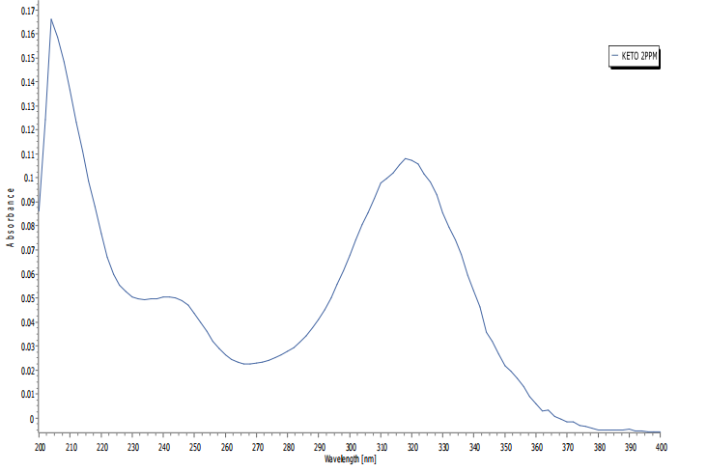

(2) For OLO

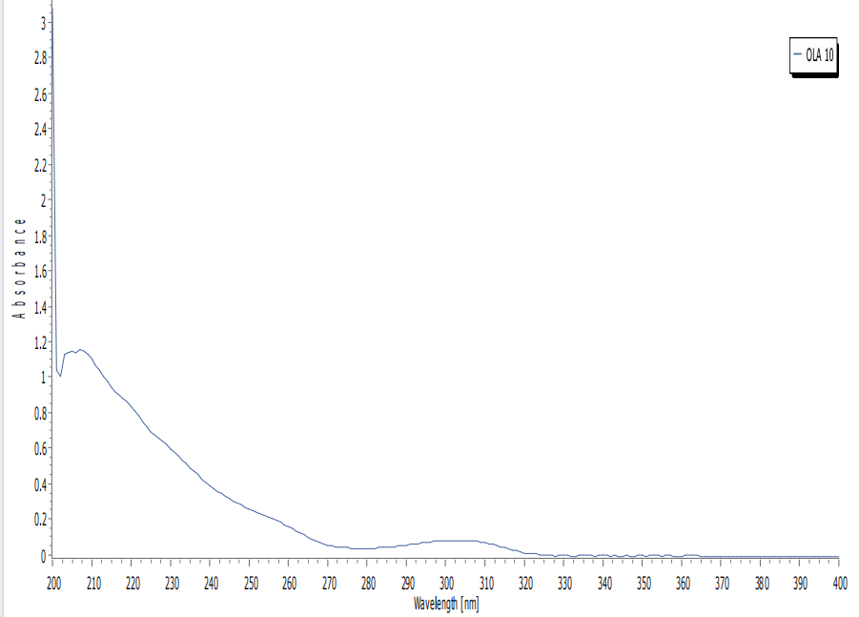

7 **Materials and Methods:**

**7.1 Preparation of dilution scheme for Ketorolac:**

**Table 7-1 Dilution scheme of Ketorolac**

|  |  |  |  |
| --- | --- | --- | --- |
| **Sample Preparation** | | | |
| **Stock solution**: 25mg Drug Dissolved in 25ml of Distilled Water (1000µg/mL) | | | |
| **Master stock solution**: 1 ml of stock solution is diluted to 50ml with distilled water (20µg/mL) | | | |
| **Concentration of master stock solution (µg/mL)** | **Volume of master stock solution taken (mL)** | **Volume of diluents taken (mL)** | **Concentration of final mixture (µg/mL)** |
| 20 | 1 | 9 | 2 |
| 2 | 8 | 4 |
| 3 | 7 | 6 |
| 4 | 6 | 8 |
| 5 | 5 | 10 |

All above solution were scanned between 200 – 400nm.

7.**2 Preparation of dilution scheme for Olopatadine Hydrochloride:**

**Table 7-2 Dilution scheme of Olopatadine Hydrochloride**

|  |  |  |  |
| --- | --- | --- | --- |
| **Sample Preparation** | | | |
| **Stock solution**: 25mg Drug Dissolved in 25ml of Distilled Water (1000µg/mL) | | | |
| **Master stock solution**: 5 ml of stock solution is diluted to 50ml with distilled water (100µg/mL) | | | |
| **Concentration of master stock solution (µg/mL)** | **Volume of master stock solution taken (mL)** | **Volume of diluents taken (mL)** | **Concentration of final mixture (µg/mL)** |
| 100 | 1 | 9 | 10 |
| 2 | 8 | 20 |
| 3 | 7 | 30 |
| 4 | 6 | 40 |
| 5 | 5 | 50 |

All above solution were scanned between 200 – 400nm.

7.3 **Design of mixture for Partial Least Square Method (PLS):**

The multivariate calibration requires a suitable experimental design of the standard composition of calibration set to provide the best prediction. The factorial design method was used to construct the calibration set. Application of two factorial design led to construction and optimization of PLS model. Thus, two binary set of the drug present in random ratio were prepared, one set with 5 samples so that total 25 samples were employed for optimization by PLS method: (Table)

7.3.1 **Composition of calibration sample:**

Table 7-3 composition of calibration sample of KETO and OLOP.

|  |  |  |
| --- | --- | --- |
| **Sample** | **Concentration(µg/mL)** | |
| **Sr. no.** | **KETO** | **OLOP** |
| 1 | 2 | 10 |
| 2 | 4 | 10 |
| 3 | 6 | 10 |
| 4 | 8 | 10 |
| 5 | 10 | 10 |
| 6 | 2 | 20 |
| 7 | 4 | 20 |
| 8 | 6 | 20 |
| 9 | 8 | 20 |
| 10 | 10 | 20 |
| 11 | 2 | 30 |
| 12 | 4 | 30 |
| 13 | 6 | 30 |
| 14 | 8 | 30 |
| 15 | 10 | 30 |
| 16 | 2 | 40 |
| 17 | 4 | 40 |
| 18 | 6 | 40 |
| 19 | 8 | 40 |
| 20 | 10 | 40 |
| 21 | 2 | 50 |
| 22 | 4 | 50 |
| 23 | 6 | 50 |
| 24 | 8 | 50 |
| 25 | 10 | 50 |

Preparation of stock solution for Ketorolac: (For PLS)

|  |
| --- |
| **Preparation of Master Stock solution** |
| Master stock solution: 1 mg Drug Dissolved in 50ml of Distilled Water (20µg/mL) |

Preparation of stock solution for Oloptadine Hydrochloride: (For PLS)

|  |
| --- |
| **Preparation of Master Stock solution** |
| Master stock solution: 5 mg Drug Dissolved in 50ml of Distilled Water (100µg/mL) |

Table 7-4 Preparation of Set 1

|  |  |  |  |  |
| --- | --- | --- | --- | --- |
| **Concentration of master stock solution (µg/mL) (KETO + OLOP)** | **Volume of master stock solution taken (mL)**  **(KETO)** | **Volume of master stock solution taken (mL)**  **(OLOP)** | **Volume of diluents taken (mL)** | **Concentration of mixture (µg/mL) (KETO + OLOP)** |
| Ketorolac (100µg/mL) Olopatadine Hydrochloride (100µg/mL) | 1 | 1 | 8 | 2:10 |
| 2 | 1 | 7 | 4:10 |
| 3 | 1 | 6 | 6:10 |
| 4 | 1 | 5 | 8:10 |
| 5 | 1 | 4 | 10:10 |

Table 7-5 Preparation of Set 2

|  |  |  |  |  |
| --- | --- | --- | --- | --- |
| **Concentration of master stock solution (µg/mL) (KETO + OLOP)** | **Volume of master stock solution taken (mL)**  **(KETO)** | **Volume of master stock solution taken (mL)**  **(OLOP)** | **Volume of diluents taken (mL)** | **Concentration of mixture (µg/mL) (KETO + OLOP)** |
| Ketorolac (100µg/mL) Olopatadine Hydrochloride (100µg/mL) | 1 | 2 | 7 | 2:20 |
| 2 | 2 | 8 | 4:20 |
| 3 | 2 | 5 | 6:20 |
| 4 | 2 | 4 | 8:20 |
| 5 | 2 | 3 | 10:10 |

Table 7-6 Preparation of Set 3

|  |  |  |  |  |
| --- | --- | --- | --- | --- |
| **Concentration of master stock solution (µg/mL) (KETO + OLOP)** | **Volume of master stock solution taken (mL)**  **(KETO)** | **Volume of master stock solution taken (mL)**  **(OLOP)** | **Volume of diluents taken (mL)** | **Concentration of mixture (µg/mL) (KETO + OLOP)** |
| Ketorolac (100µg/mL) Oloptadine Hydrochloride (100µg/mL) | 1 | 3 | 6 | 2:30 |
| 2 | 3 | 5 | 4:30 |
| 3 | 3 | 4 | 5:30 |
| 4 | 3 | 3 | 6:30 |
| 5 | 3 | 2 | 7:30 |

Table 7-7 Preparation of Set 4

|  |  |  |  |  |
| --- | --- | --- | --- | --- |
| **Concentration of master stock solution (µg/mL) (KETO + OLOP)** | **Volume of master stock solution taken (mL)**  **(KETO)** | **Volume of master stock solution taken (mL)**  **(OLOP)** | **Volume of diluents taken (mL)** | **Concentration of mixture (µg/mL) (KETO + OLOP)** |
| Ketorolac (100µg/mL) Oloptadine Hydrochloride (100µg/mL) | 1 | 4 | 5 | 2:40 |
| 2 | 4 | 4 | 4:40 |
| 3 | 4 | 3 | 6:40 |
| 4 | 4 | 2 | 8:40 |
| 5 | 4 | 1 | 10:40 |

Table 7-8 Preparation of Set 5

|  |  |  |  |  |
| --- | --- | --- | --- | --- |
| **Concentration of master stock solution (µg/mL) (KETO + OLOP)** | **Volume of master stock solution taken (mL)**  **(KETO)** | **Volume of master stock solution taken (mL)**  **(OLOP)** | **Volume of diluents taken (mL)** | **Concentration of mixture (µg/mL) (KETO + OLOP)** |
| Ketorolac (100µg/mL) Oloptadine Hydrochloride (100µg/mL) | 1 | 5 | 4 | 2:50 |
| 2 | 5 | 3 | 4:50 |
| 3 | 5 | 2 | 6:50 |
| 4 | 5 | 1 | 8:50 |
| 5 | 5 | 0 | 10:50 |

7.4 **Optimization by PLS method:**

From above scheme, all the sets of solutions were prepared and the spectra were recorded in UV 1900*i* between the range of 200-400nm.

↓

All the recorded UV spectra were observed in UV probe (Ver. 2.42) and the range of wavelength is selected between 220-290nm by observing each spectrum.

↓

The interval of wavelength is kept 2nm, and all the calibration data are gathered by data print option.

↓

Now, the calibration data obtained from experimental were gathered in a matrix data by Microsoft Office Excel (Ver. 1811) (all the data were transpose in Microsoft office Excel).

↓

Then these all data are subjected to PCR treatment by XLSTAT (ver.2019)

↓

And these all data are subjected to PLS treatment by Minitab

**7.5 Preparation of validation set for diltiazem malate an enalapril malate:**

**Table 7-9 Preparation of validation set for DIL and ENA**

|  |  |  |  |  |
| --- | --- | --- | --- | --- |
| **Concentration of Master stock solution**  **(µg/ml)** | **Volume of master stock (ml)**  **ENA** | **Volume of master stock solution (ml) DIL** | **Volume of diluents taken (ml)** | **Concentration of Mixture (µg/ml)** |
| 100 | 0.1 | 4.6 | 5.3 | 1 + 46 |
| 0.2 | 4.6 | 5.2 | 2 + 46 |
| 0.2 | 5.6 | 4.2 | 2 + 56 |
| 0.3 | 5.6 | 4.1 | 3 +56 |
| 0.3 | 6.6 | 3.1 | 3 + 66 |
| 0.4 | 4.6 | 5 | 4 + 46 |
| 0.4 | 5.6 | 4 | 4 + 56 |
| 0.4 | 6.6 | 3 | 4 + 66 |
| 0.5 | 6.6 | 2.9 | 5 + 66 |

7.6 Accuracy study of Diltiazem malate and Enalapril malate:

Table 7-10 Accuracy study of DIL and ENA

|  |  |  |  |  |  |  |  |
| --- | --- | --- | --- | --- | --- | --- | --- |
| Preparation of master stock solution | | | | | | | |
| **Standard solution**: 2.5mg DIL and 2.5mg ENA dissolved in 25ml distilled water, individually 100µg/ml of DIL and ENA. | | | | | | | |
| **Level of spiking** | **Blank (mL)** | **Volume of standard solution (mL)** | | **Volume of diluents taken (mL)** | | **Final concentration (µg/ml)** | |
| KETO | OLOP | KETO | OLOP | KETO | OLOP |
| Unspiked |  |  |  |  |  |  |  |
| 80% |  |  |  |  |  |  |  |
| 100% |  |  |  |  |  |  |  |
| 120% |  |  |  |  |  |  |  |

7.7 Assay preparation of DIL and ENA by PLS method:

Table 7-11 Assay preparation table for DIL and ENA

|  |  |
| --- | --- |
| **Content Ratio of** **mixture**: 5mg of ENA and 180mg of DIL | |
| **Sample preparation** | |
| **Master stock solution:** | 25mg ENA and 25mg DIL dissolved in 25ml Distilled water, 1000µg/ml of ENA and DIL. |
| **Stock solution:** | Withdraw 2.5ml from master stock solution from each 25ml volumetric flask which contain 100µg/ml. |

All above solution were scanned between 200 – 400 nm.

Table 7-12 Test Solution of KETOL and OLOP

|  |
| --- |
| **Test solution of KETO**: withdraw 0.2ml from stock solution, in 10ml of volumetric flask and make up the volume with Distilled water. (2µg/ml) |
| **Test solution of OLO**: withdraw 4.6ml from stock solution, in 10ml of volumetric flask and make up the volume with Distilled water. (46µg/ml) |