Anime Review Forum

COMP 1536 Set C

Nick Milton

Sean Miyaoka

Simon Chen

Stephanie Reed

Adam Hsu

Table of Contents

**Table of Contents1**

**Milestone 44**

Javascript Validation5

Type chapter title (level 3)6

Form Testing5

Third Party Widget5

Javascript Disabled Testing5

Site Publication5

**Appendix A4**

Milestone 15

Milestone 25

Milestone 35

**Milestone 4**

**Javascript Validation**

|  |  |  |
| --- | --- | --- |
| **FORM on page**: register.html | | |
| Field ID | Data Format or RegExp | Explanation |
| register_email | /^[\w!#$%&’*+\-/=?\^`{|}~]+(\.[\w!#$%&’*+\-/=?\^`{|}~]+)*@([a-zA-Z0-9-]+\.)+[a-zA-Z0-9-]{2,}$/ | The user needs to register with a valid email address.  This is a mandatory field. |
| register_username | The username must contain one or more characters that are numbers or letters. | The user’s chosen username must not be blank and can only contain numbers or letters.  This is a mandatory field. |
| register_password | 8 or more characters that are letters, numbers, or the !, @, #, $, %, ^, &, * symbols. | The user’s new password must be 8 or more characters that are letters, numbers, or the !, @, #, $, %, ^, &, * symbols.  This is a mandatory field. |
| register_password2 | Must equal register_password | The user must retype their password to ensure they know it.  This is a mandatory field. |

|  |  |  |
| --- | --- | --- |
| **FORM on page**: account.html | | |
| Field ID | Data Format or RegExp | Explanation |
| manage_new_image | .png, .jpg, .jpeg, or .gif file | The new avatar image must be an image file.  This is a mandatory field for its respective form. |
| manage_new_email | /^[\w!#$%&’*+\-/=?\^`{|}~]+(\.[\w!#$%&’*+\-/=?\^`{|}~]+)*@([a-zA-Z0-9-]+\.)+[a-zA-Z0-9-]{2,}$/ | The user needs to register with a valid email address.  This is a mandatory field for its respective form. |
| manage_password_for_email | Must be the password for the account. | The user’s password must be provided to change the email address.  This is a mandatory field for its respective form. |
| manage_new_password | 8 or more characters that are letters, numbers, or the !, @, #, $, %, ^, &, * symbols. | The user’s new password must be 8 or more characters that are letters, numbers, or the !, @, #, $, %, ^, &, * symbols.  This is a mandatory field for its respective form. |
| manage_new_password2 | Must equal manage_new_password2 | The user must retype their password to ensure they know it.  This is a mandatory field for its respective form. |
| manage_password_for_password | Must be the password for the account. | The user’s current password must be provided to change the password.  This is a mandatory field for its respective form. |
| manage_deletion_password | Must be the password for the account. | The user’s password must be provided to delete their account.  This is a mandatory field for its respective form. |

**Form Testing**

|  |  |  |
| --- | --- | --- |
| **TEST DOCUMENTATION on FORM on page**: register.html | | |
| FIELD LEVEL TESTING | | |
| Field ID | Problem | Improvements Made |
| register_email | Invalid emails did not produce error messages. | The RegExp used for email validation was expanded to accommodate the buggy cases. |
| FORM LEVEL TESTING | | |
| Field ID | Problem | Improvements Made |
|  |  |  |

|  |  |  |
| --- | --- | --- |
| **TEST DOCUMENTATION on FORM on page**: account.html | | |
| FIELD LEVEL TESTING | | |
| Field ID | Problem | Improvements Made |
| manage_new_email | Invalid emails did not produce error messages. | The RegExp used for email validation was expanded to accommodate the buggy cases. |
| FORM LEVEL TESTING | | |
| Field ID | Problem | Improvements Made |
|  |  |  |

**Third Party Widget**

[Document why this widget was chosen and the advantages of doing so]

**Javascript Disabled Testing**

When javascript was disabled, the forms still sent the input data.

**Site Publication**

[Include a statement in your milestone report on success/problems faced with the publish and test.]

**Appendix A**

**Milestone 1**

**Purpose**

The purpose of the website is anime reviews and reports, to promote Fandom discussion, allow the community to share first impressions and thoughts, poll opinions, and submit reviews. The vision is for the site to become the Rotten tomatoes for anime.

**Function**

As a public forum we will need a User login/verification system. This will allow users to submit posts or reviews about their favourite anime under an account. It will also allow posting to the discussion forum.

To aggregate content, a user has access to a Like/Dislike or Upvote/Downvote function. Summaries of reviews with the most Upvotes will make it to the front page with a link on each review that directs to the full content. A writing template will be available as a means to enhance the structural consistency between different reviews composed by users for a more pleasurable reading experience. Also, to attract more daily user visit, a schedule of the current anime season will be displayed on the front page, as well as a polling section that provides a chart of result as feedback once a user submits their vote.

Lastly the Terms of Service, Legal Disclaimer, and Privacy Policy will appear in the footer of each page.

**Target Audience**

We will strive to adhere to universal design principles but the content and aesthetic will be orientated towards the following

* + Watchers of anime
  + Teens
  + Young Adults
  + Any gender
  + North American
  + English readers

**Site Resources**

The site will provide access to anime posters and links to trailers. The user submitted content (reviews) will be made available in a searchable format.

**Goals**

If the site builds a thriving community it will be a success, and it will have existential purpose. As a user, the site should be friendly, informative, engaging, good-looking and most importantly comfortable to navigate. As site owners/admins, we intend to have zero bugs, no copyright complaints, and to offer an excellent overall user experience.

**Critiques of Similar Websites**

MyAnimeList.net is an existing website that focuses on anime reviews. However, the site’s visual appearance, which consists of solid blue navigation menus and a white background, is particularly plain. The front page is dominated by official anime artwork and large advertisements, all of which draw the user’s attention away from the site’s navigation bar. Furthermore, each anime series or film is ranked by its average review score, which does not necessarily reflect production quality or audience popularity.

Rotten Tomatoes is an existing website that focuses on American film and television. On this site, reviews and audience ratings are used to calculate the percentage of viewers who liked a film or series. This achieves what we hope to implement with the like and dislike system. However, the site does not cover anime series and films. Rotten Tomatoes, like MyAnimeList.net, uses a plain layout with solid colours. Also, Rotten Tomatoes’ front page heavily emphasizes their news articles, which are accompanied with large images. The rest of the front page is primarily text.

MyAnimeList - <https://myanimelist.net/>

Rotten Tomatoes - <https://www.rottentomatoes.com/>

**Limitations**

The one limitation that maybe out of our hands as developers is that the site requires mods to oversee user content from the community. They would be responsible for continuing to police legal issues, mean people, off-topic discussion, spambots and generally keeping the content to a higher standard.

**Work Plan**

We will employ the following procedures to ensure good work flow and meeting of deadlines. We will communicate task progress daily through Slack. In case of emergency we will text or call group members.

We will install a meeting schedule that consists of meeting on Friday mornings during the break and finishing each milestone 48 hours prior to deadline. Tasks will be divided at the start of the cycle and group members will reach out to other members in case of unreasonable workload. Communication is important.

**Milestone 2**

**Site Map**

Figure Anime Forum Site Map

**Wireframe**

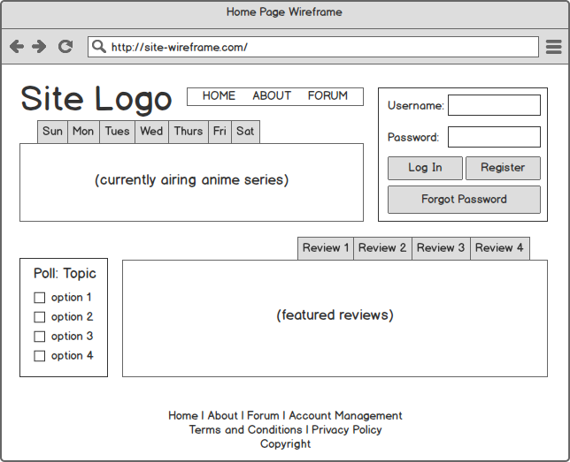

Figure Home Page Wireframe

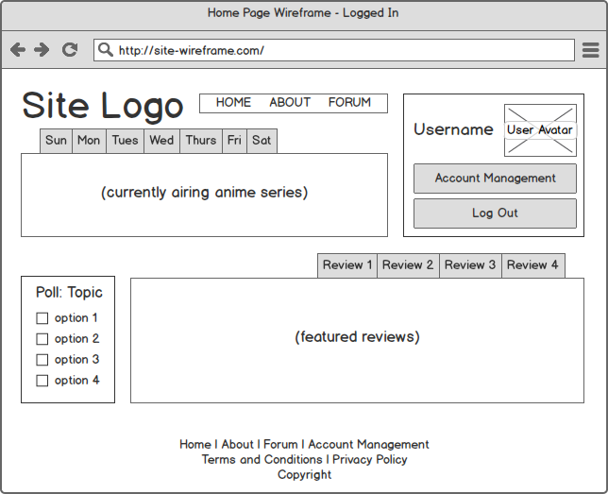

Figure User logged in wireframe

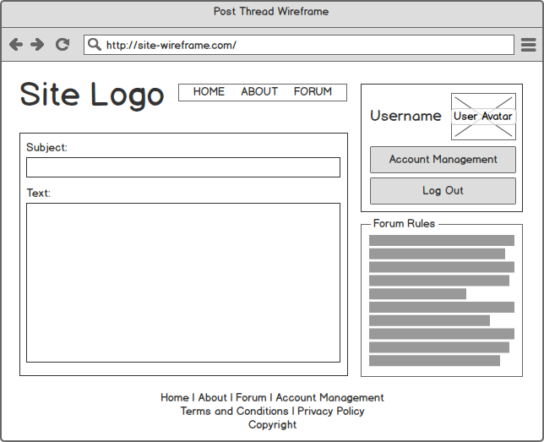

Figure Post thread wireframe

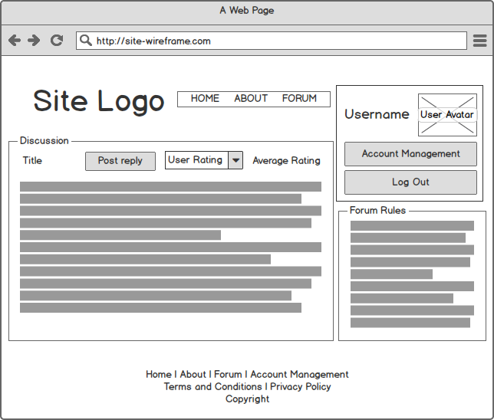

Figure User view post

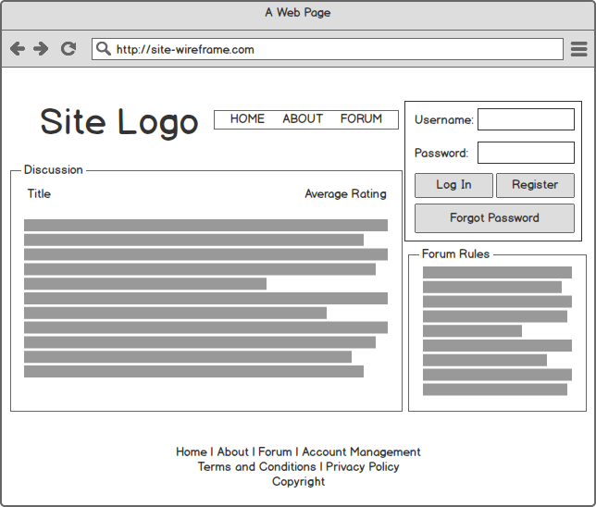

Figure Anonymous view post

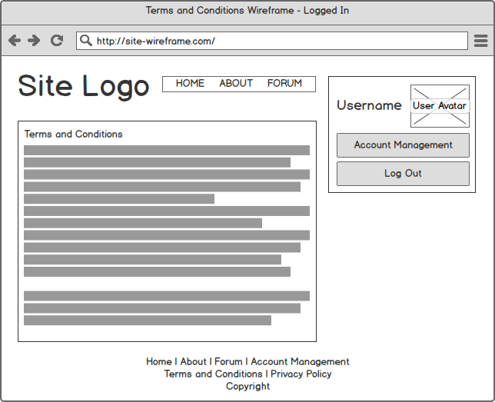

Figure User logged in Terms and Conditions Wireframe

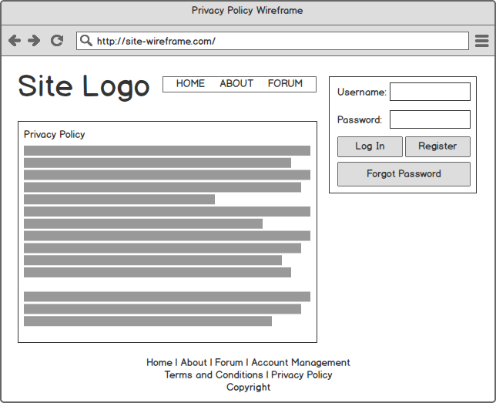

Figure Privacy Policy Wireframe

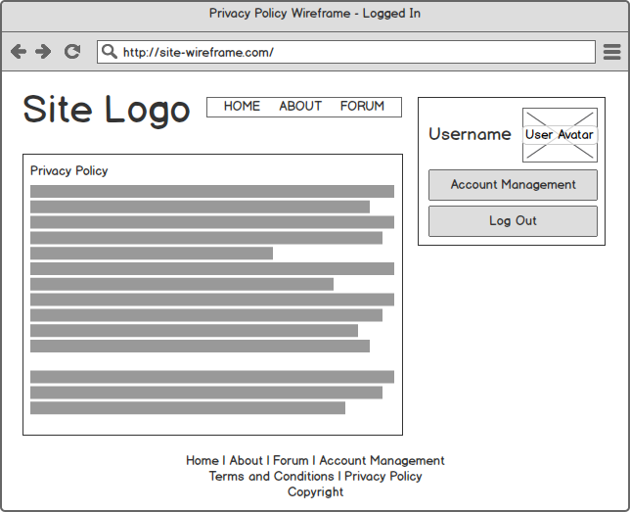

Figure User logged in Privacy Policy Wireframe

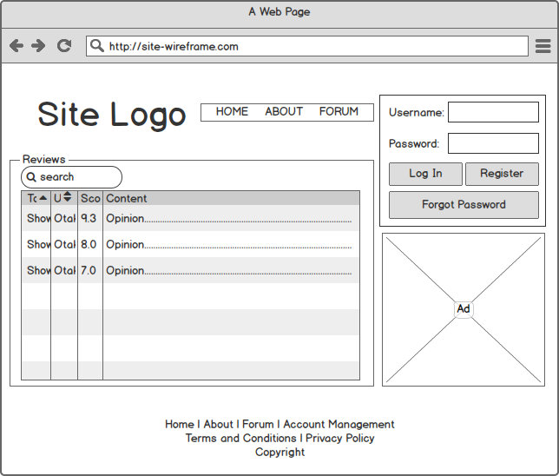

Figure Anonymous reviews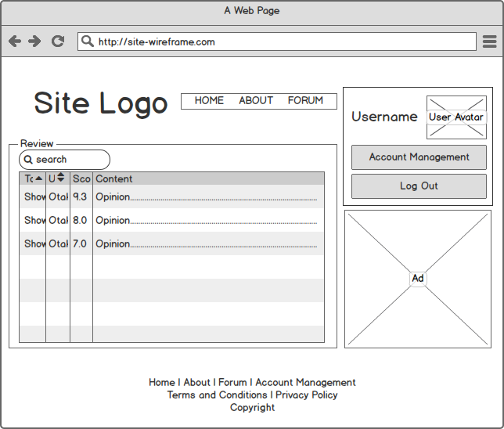

Figure 12 User logged in Reviews

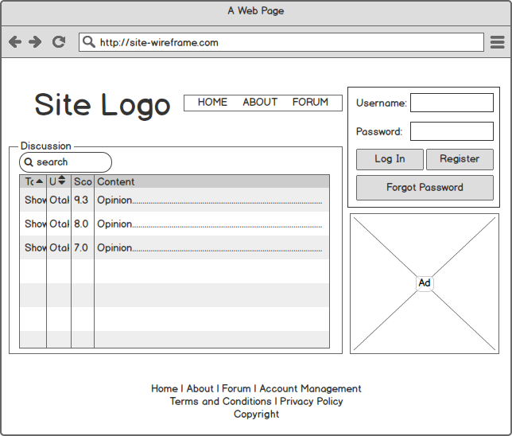

Figure Anonymous Discussions

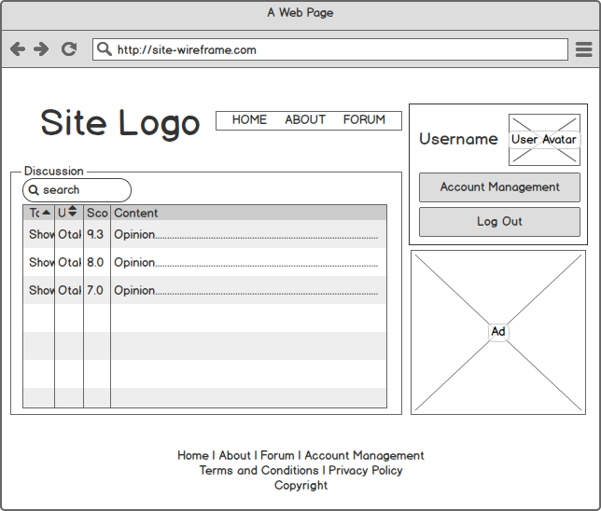

Figure 14 User logged in Discussion

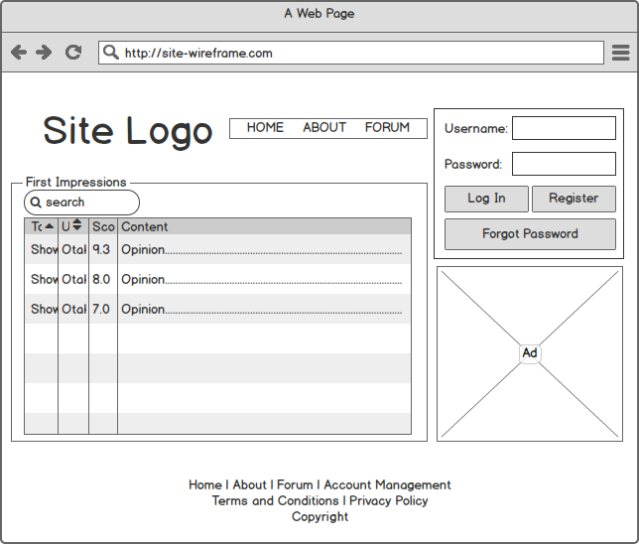

Figure User logged in First Impressions

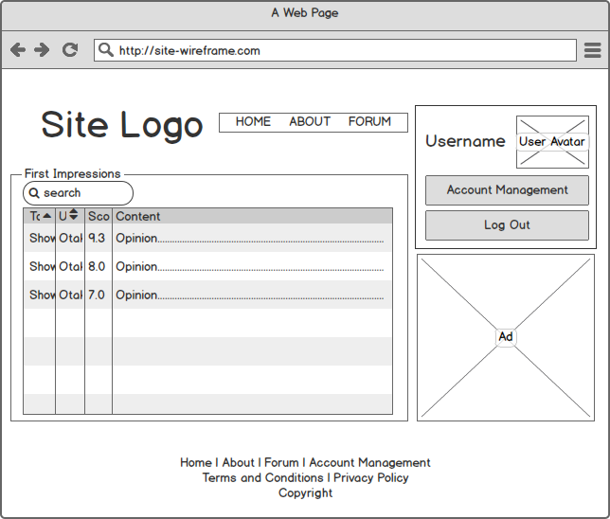

Figure 16 Anonymous First Impressions

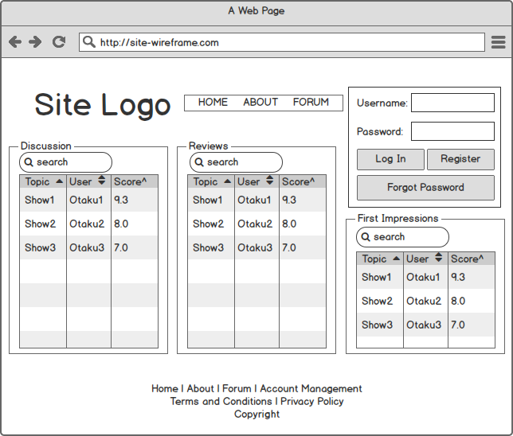

Figure 17 Anonymous Forum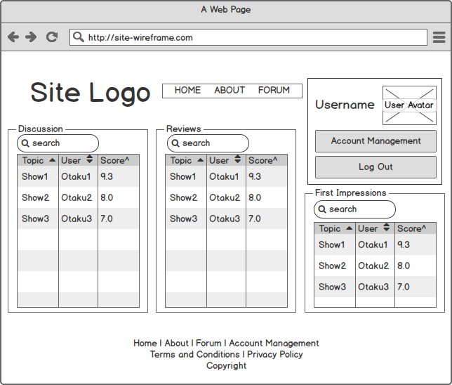

Figure 18 User logged in Forum

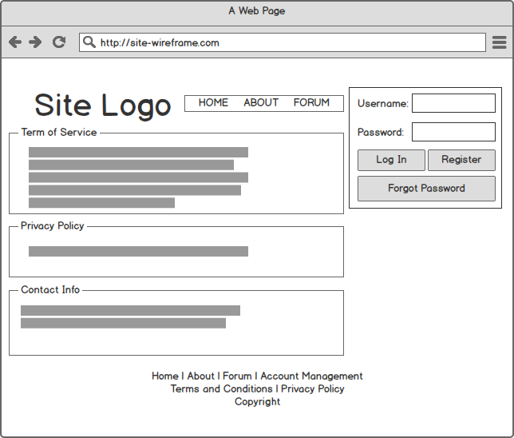

Figure Anonymous About page

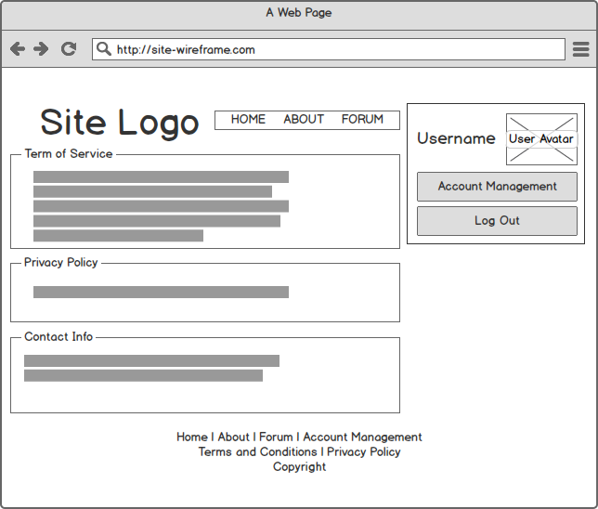

Figure User logged in About page

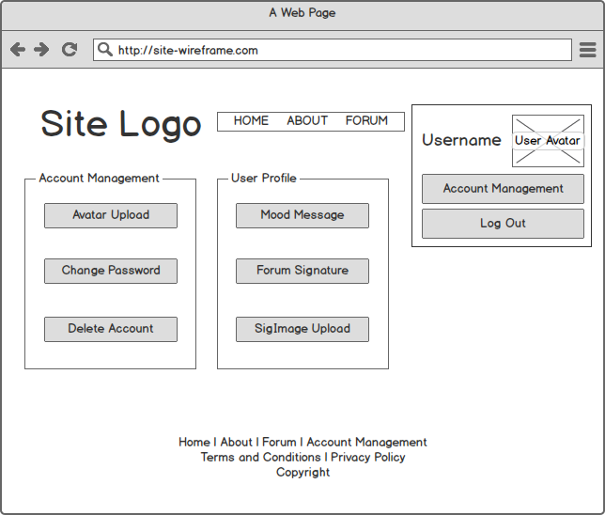

Figure Account Management

**Milestone 3**

**URL**

Project Hamster: <http://students.bcitdev.com/A00863917/G4/index.html>

**List of items completed for this milestone**

* Create prototype page
* Create style sheet (base.css)
* Color design
* Create pages
  + Home (index.html)
  + About
  + Forum
  + Discussion
  + Review
  + Post reply template pages
* Fulfill the website design
  + Login box
  + Header
  + Footer
  + Navigation
  + Anime schedule section (Upper part body)
  + Information section (Lower part body)
* Link pages
* Create logo
* A/B testing

**Additional work**

* Graphic design of own logo (Using Corel Paint)
* Use of Java Script

**Key issues**

* The Login system and the poling system requires server side processing
* Rating system requires both java script server side processing, the posts and reviews with the highest rating should appear on the front page instead
* Forum posts are not automatically generating URL links

**Deviations on previous Milestone**

* Improved layout design
  + Have login box from side bar into header
  + Merge vote section and review section together in body
* Added dropdown menu for sorting on the first impression page in the forum.
* Reworked the page format of the account management page due the re-positioning of the login box.
* Added way to give a rating score

**Page 2**

**Document of works(Screenshots)**

**Front page:**

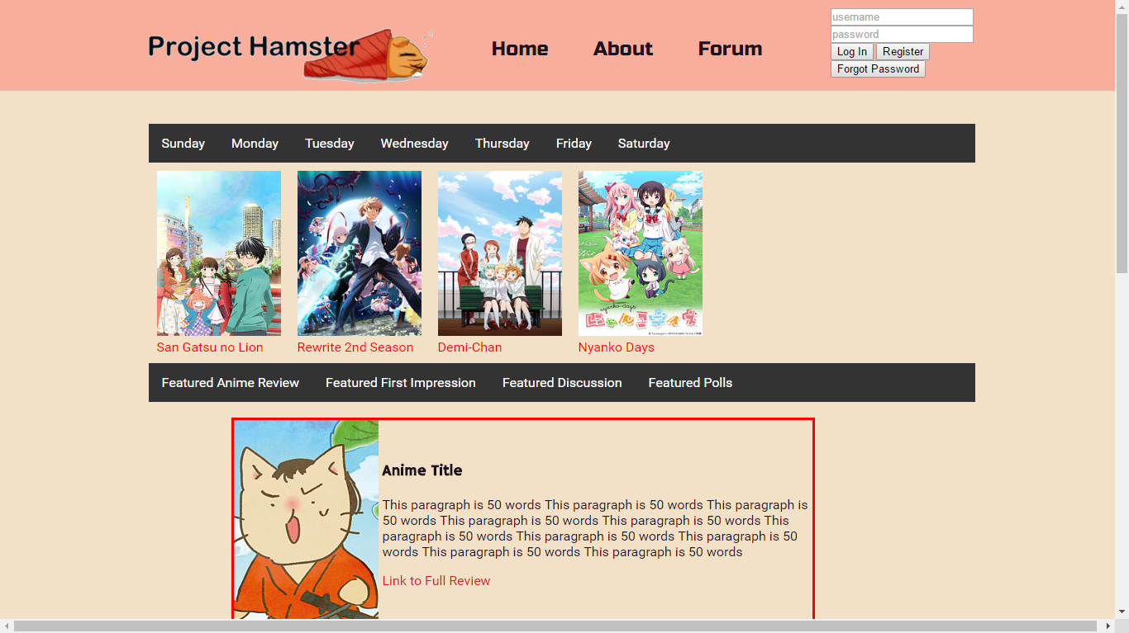

**Required display table:**

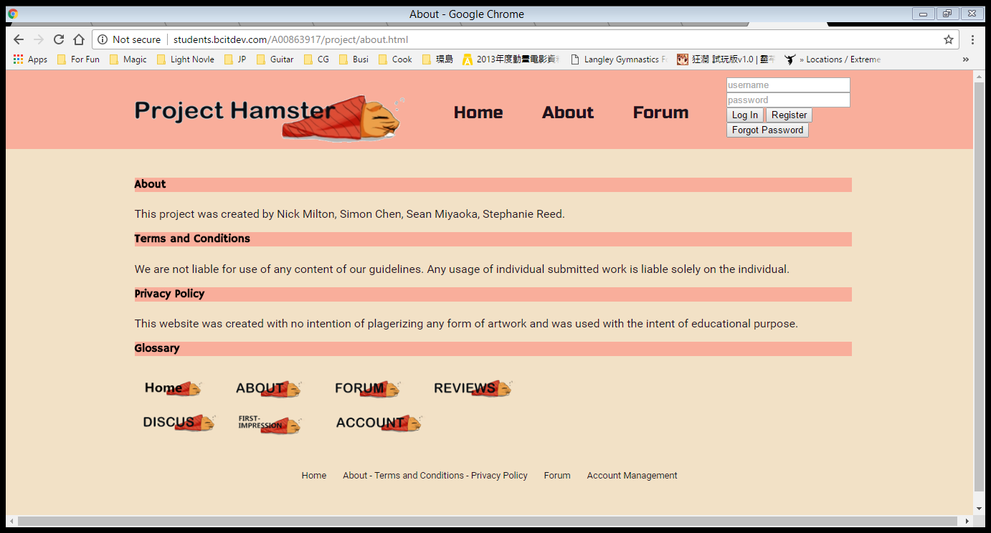

**Page 3**

A/B testing

**A:**

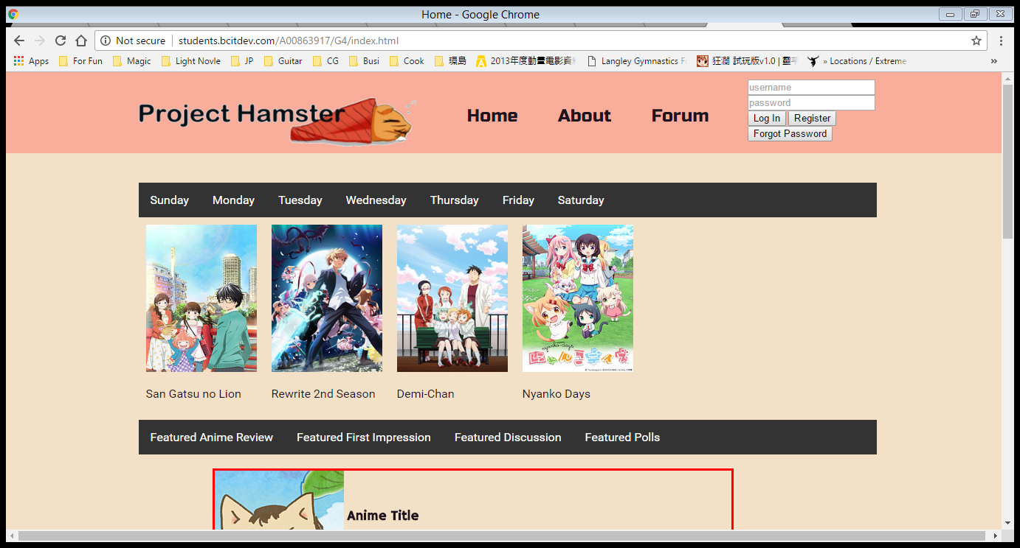

**B:**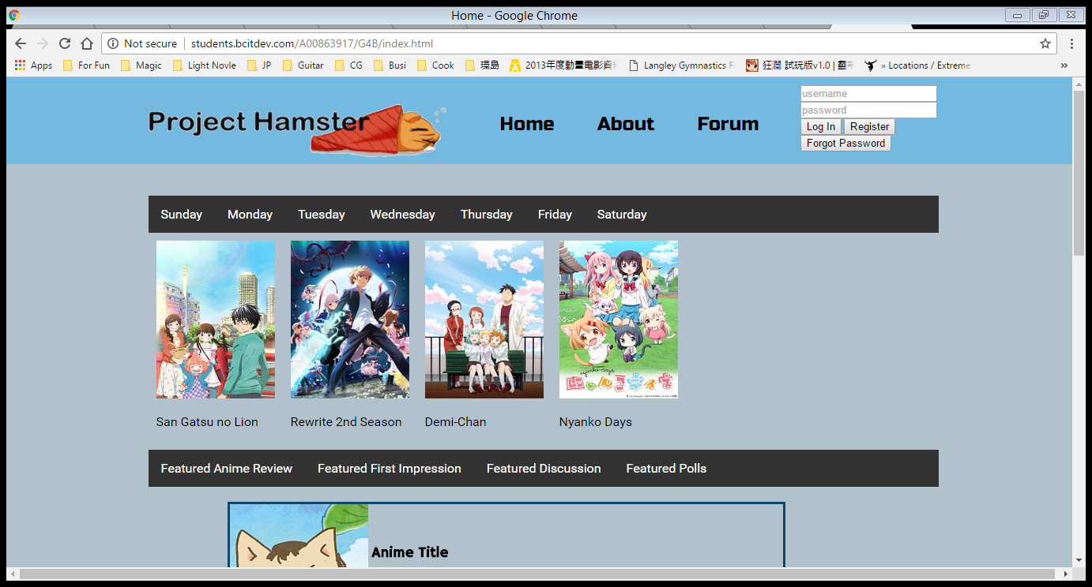

**Page 4**

**Result:**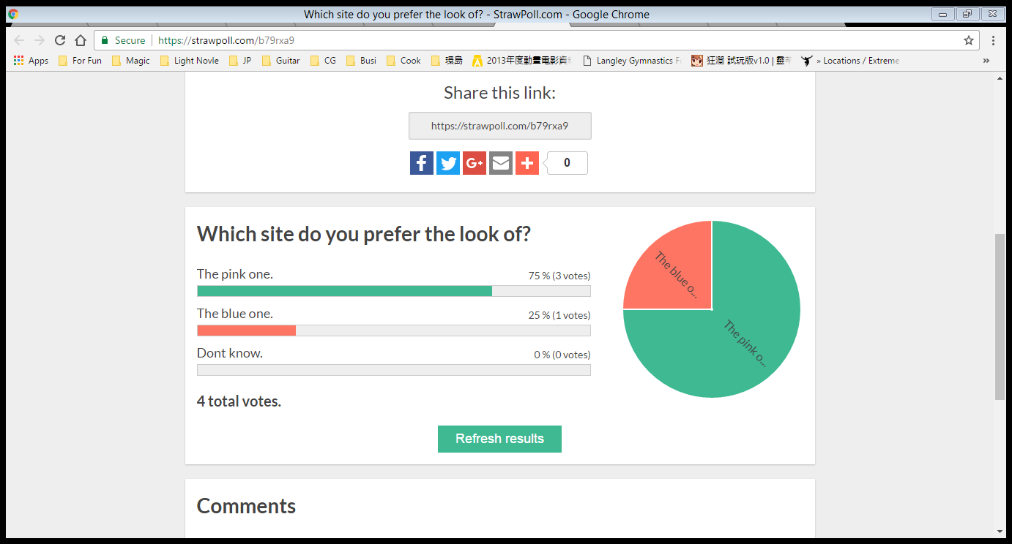

**Change to last Milestone**

|  |  |
| --- | --- |
| Dropbox Feedback Print layout?  Color scheme? |  |

**Print Layout**

**Home:**

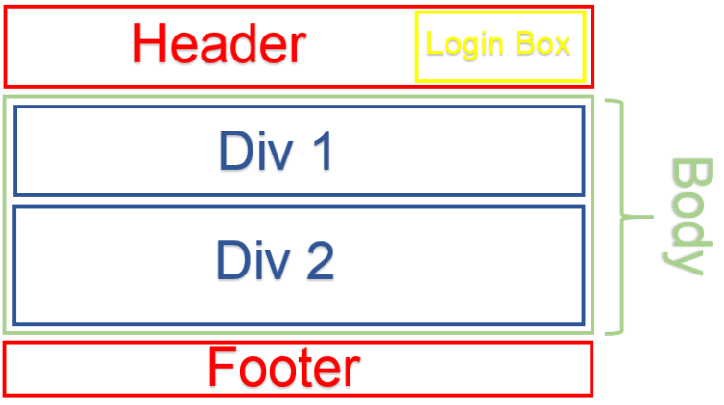

**Page 5**

**About:** 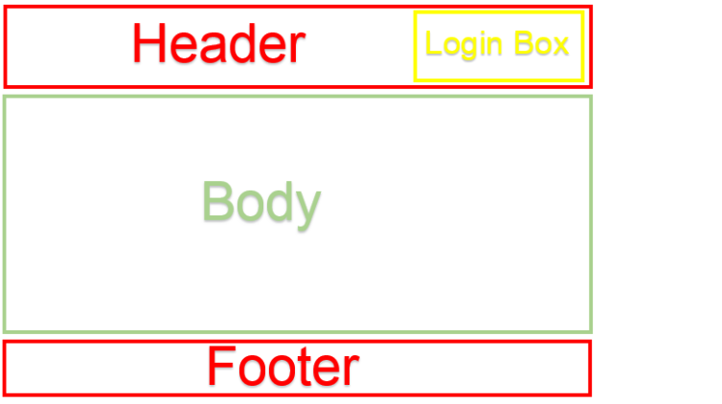

**Discussion / Forum / First Impression / Reviews:**

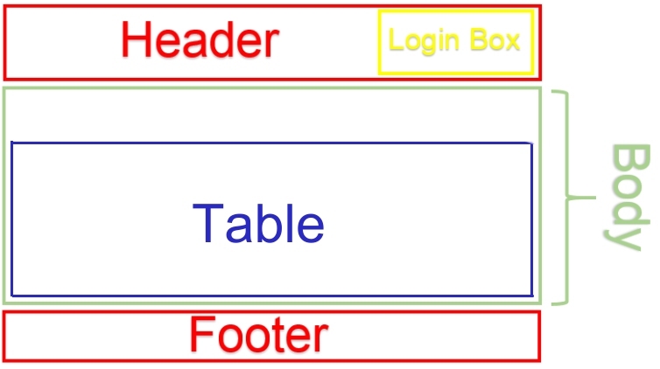

**Page 6**

**Account:**

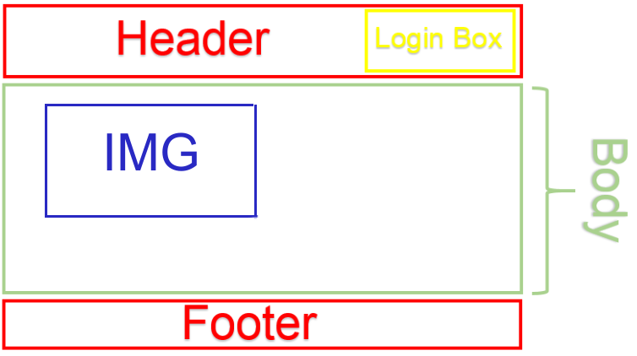

**Post reply template pages:**

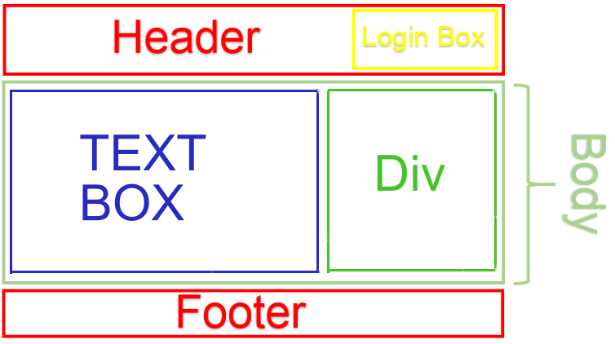

**Page 7**

**Color scheme**

**Header/Footer/|Body:** 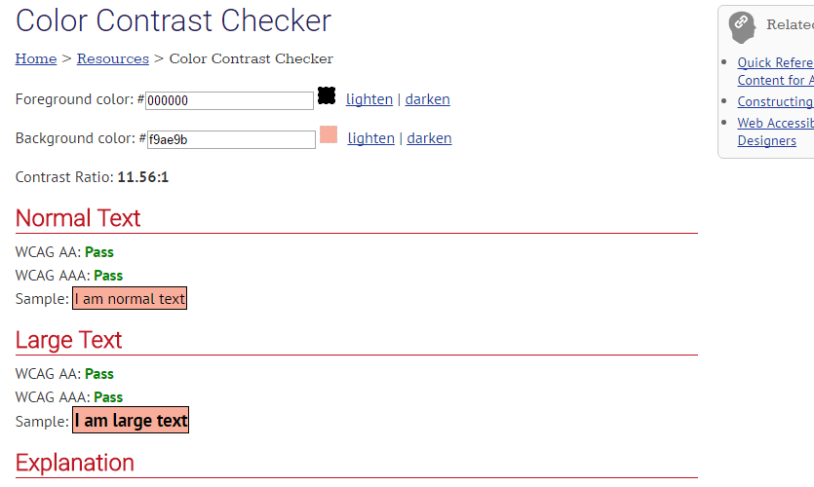

**Navigation:**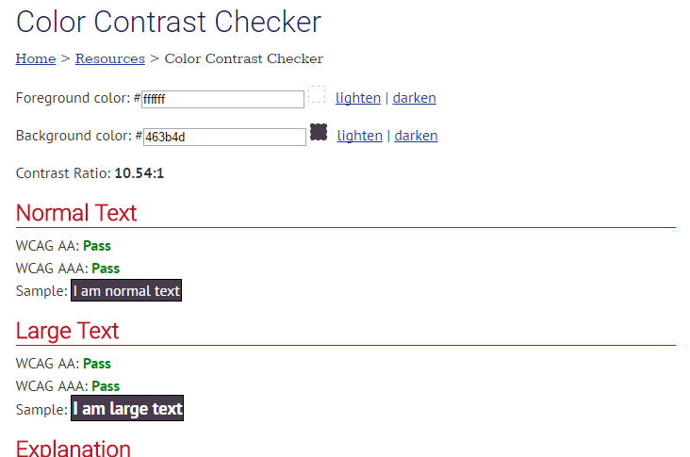

**Page 8**

**Hyperlink:**