BR_LMS_08 — User Registration
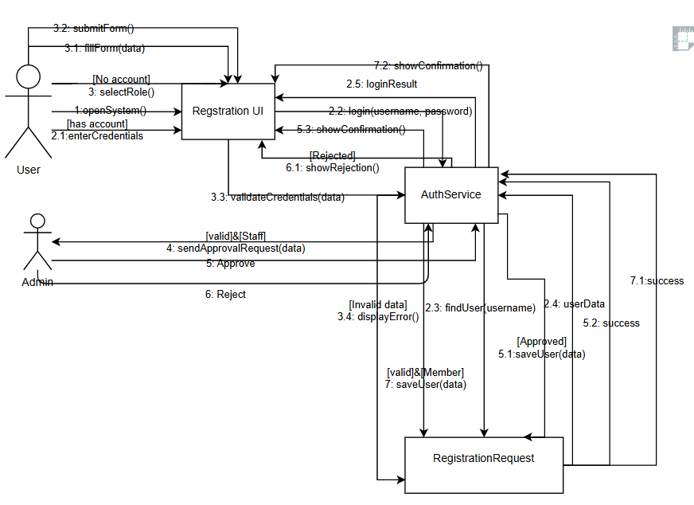

BR_LMS_09 — Administrator Account Management
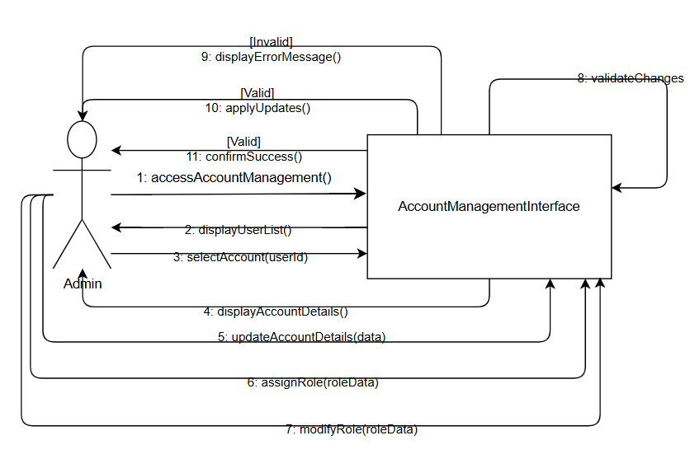

BR_LMS_10 — Manage User Profile
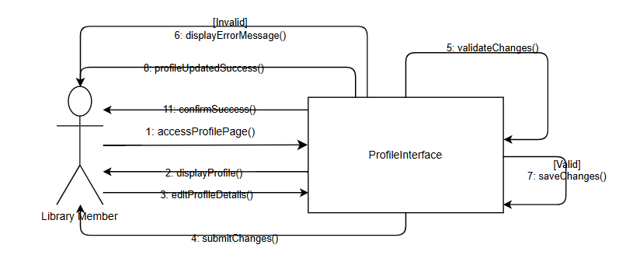

BR_LMS_11 — Track System Activity
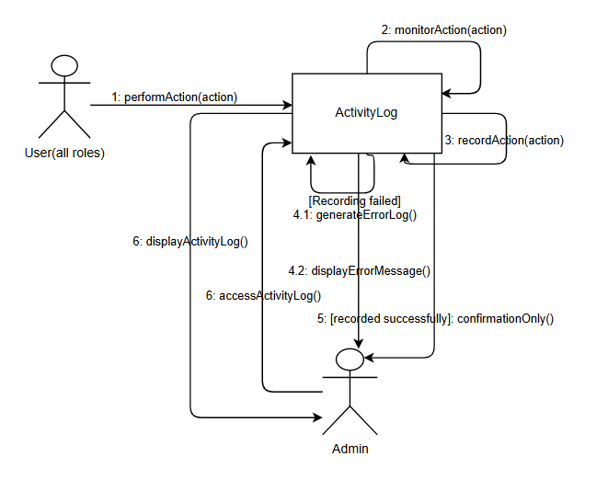

BR_LMS_12 — Library Event Management
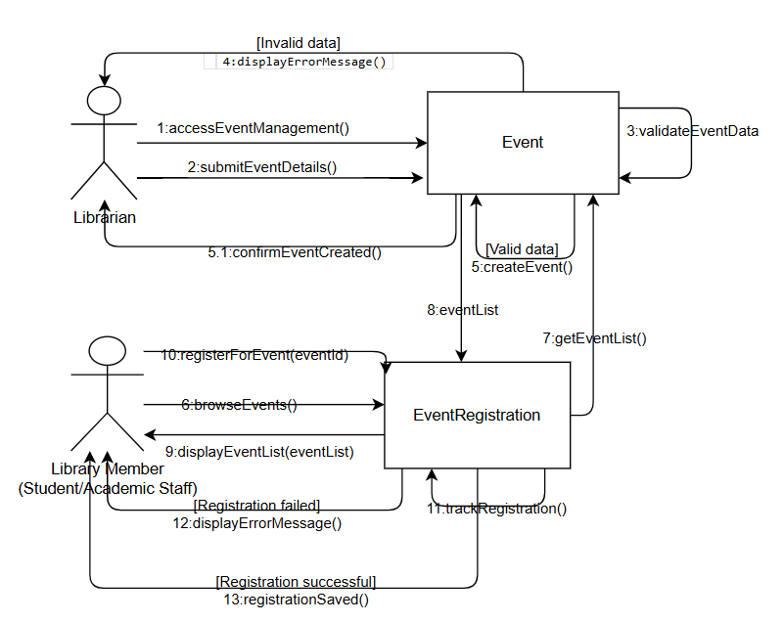
BR_LMS_13 — Manage Lost and Found Items
