BR_LMS_33 - Student Review Submissions
Activity Diagram
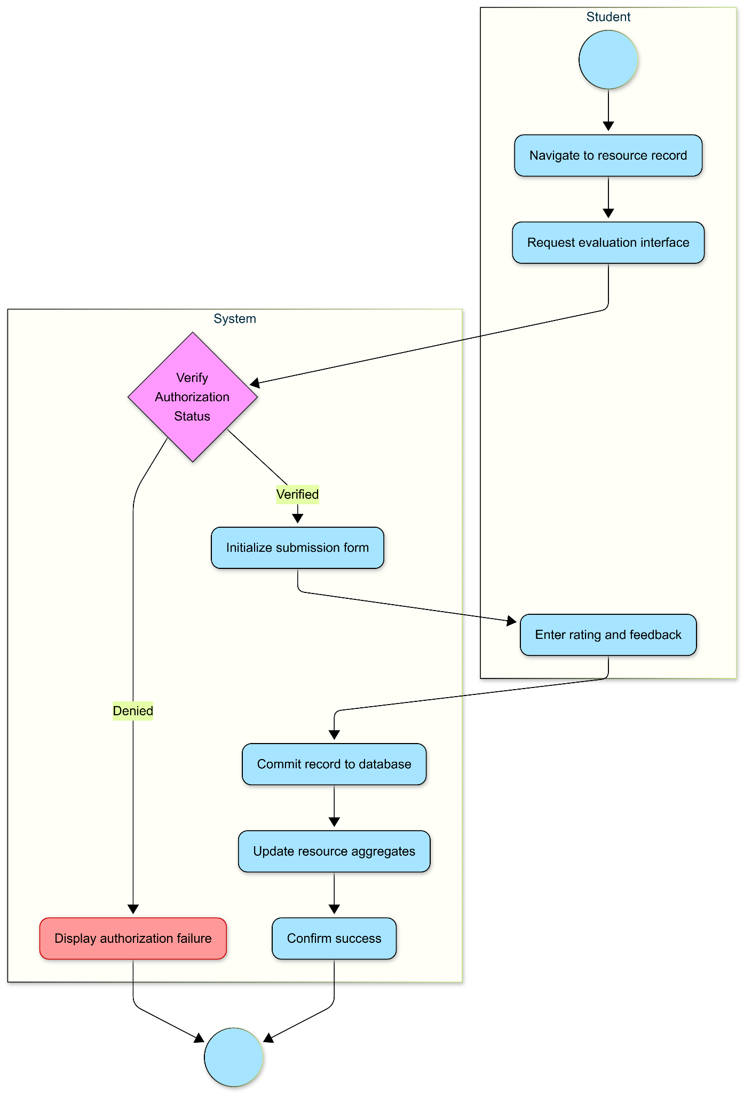

State diagram
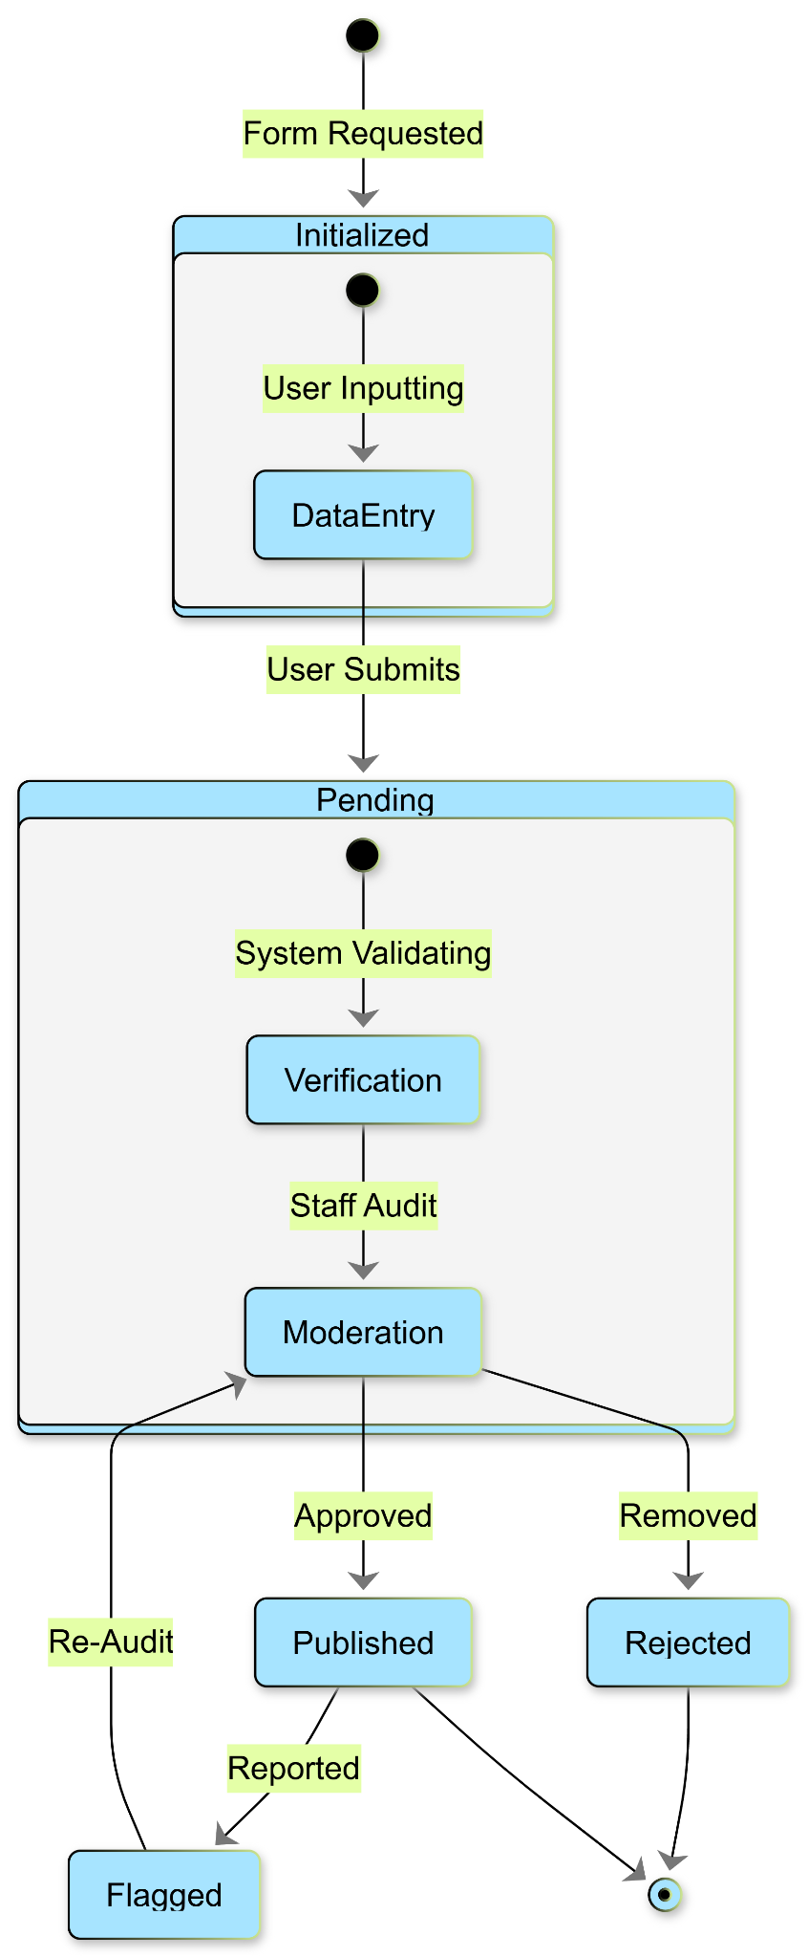
BR_LMS_34 - Faculty Advanced Research
Activity Diagram
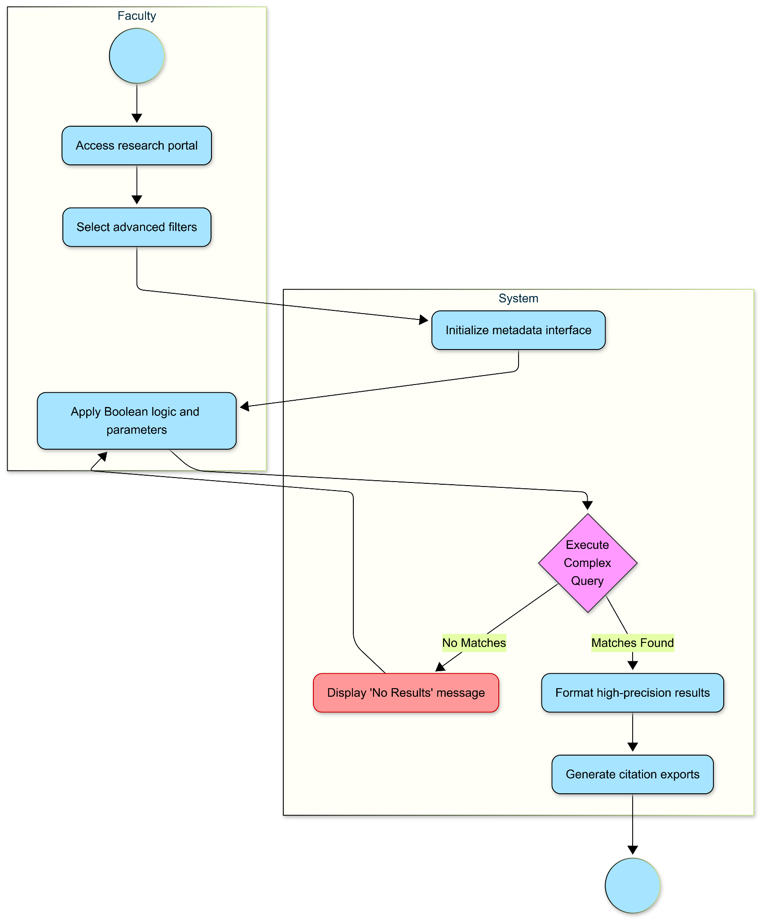

State Diagram
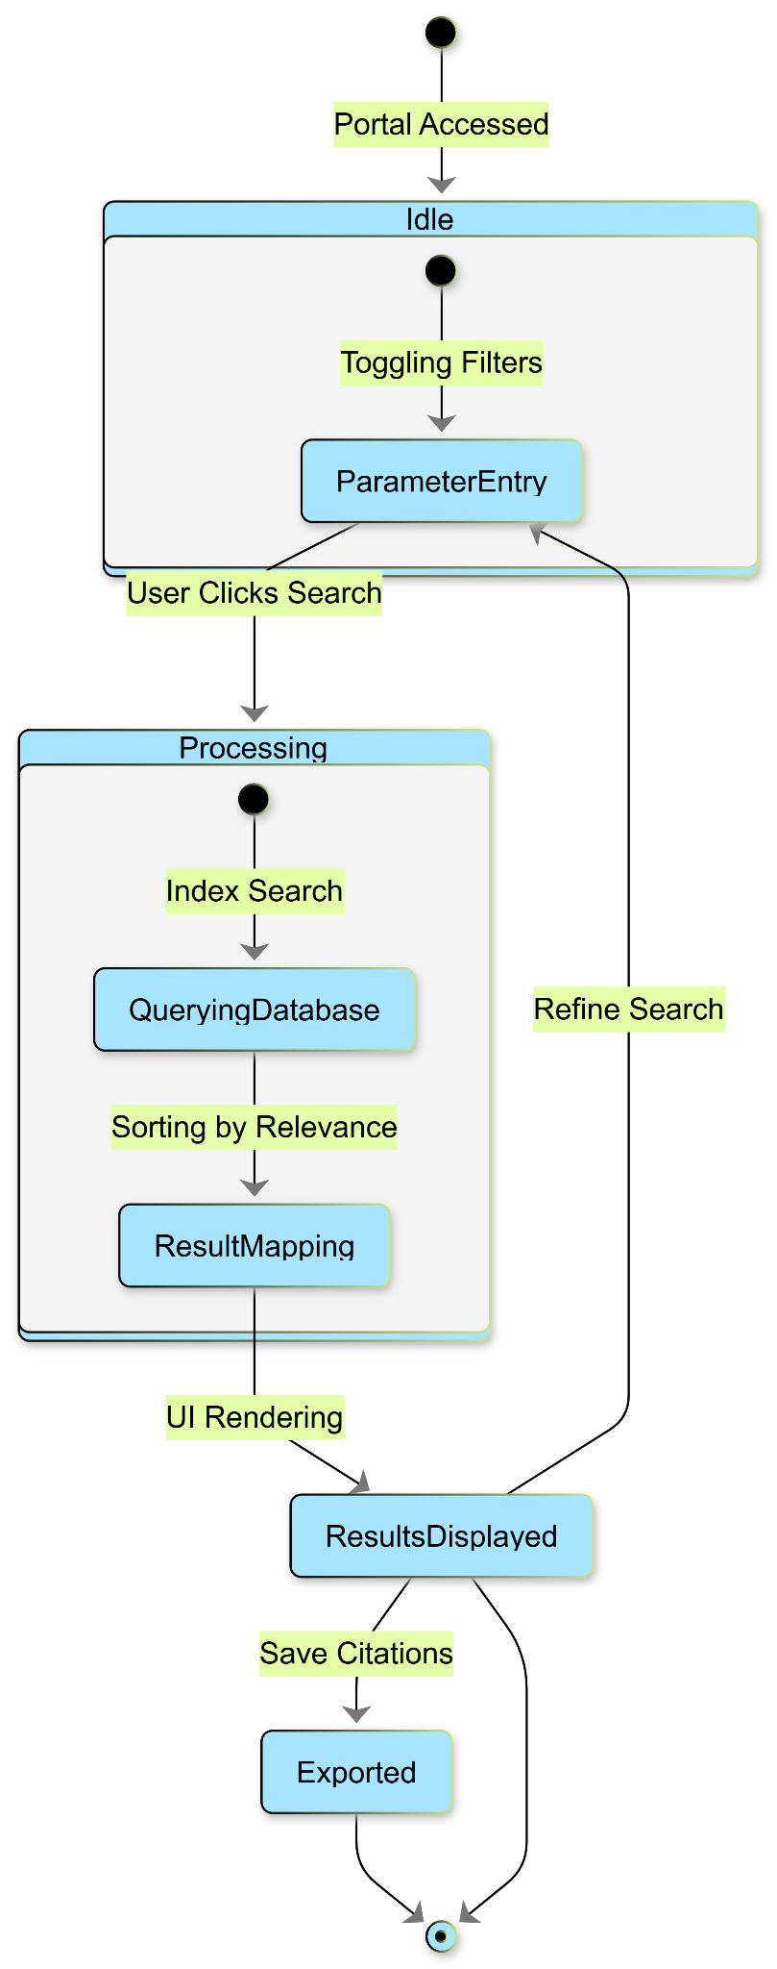
BR_LMS_35 - Library Staff Moderation
Activity Diagram
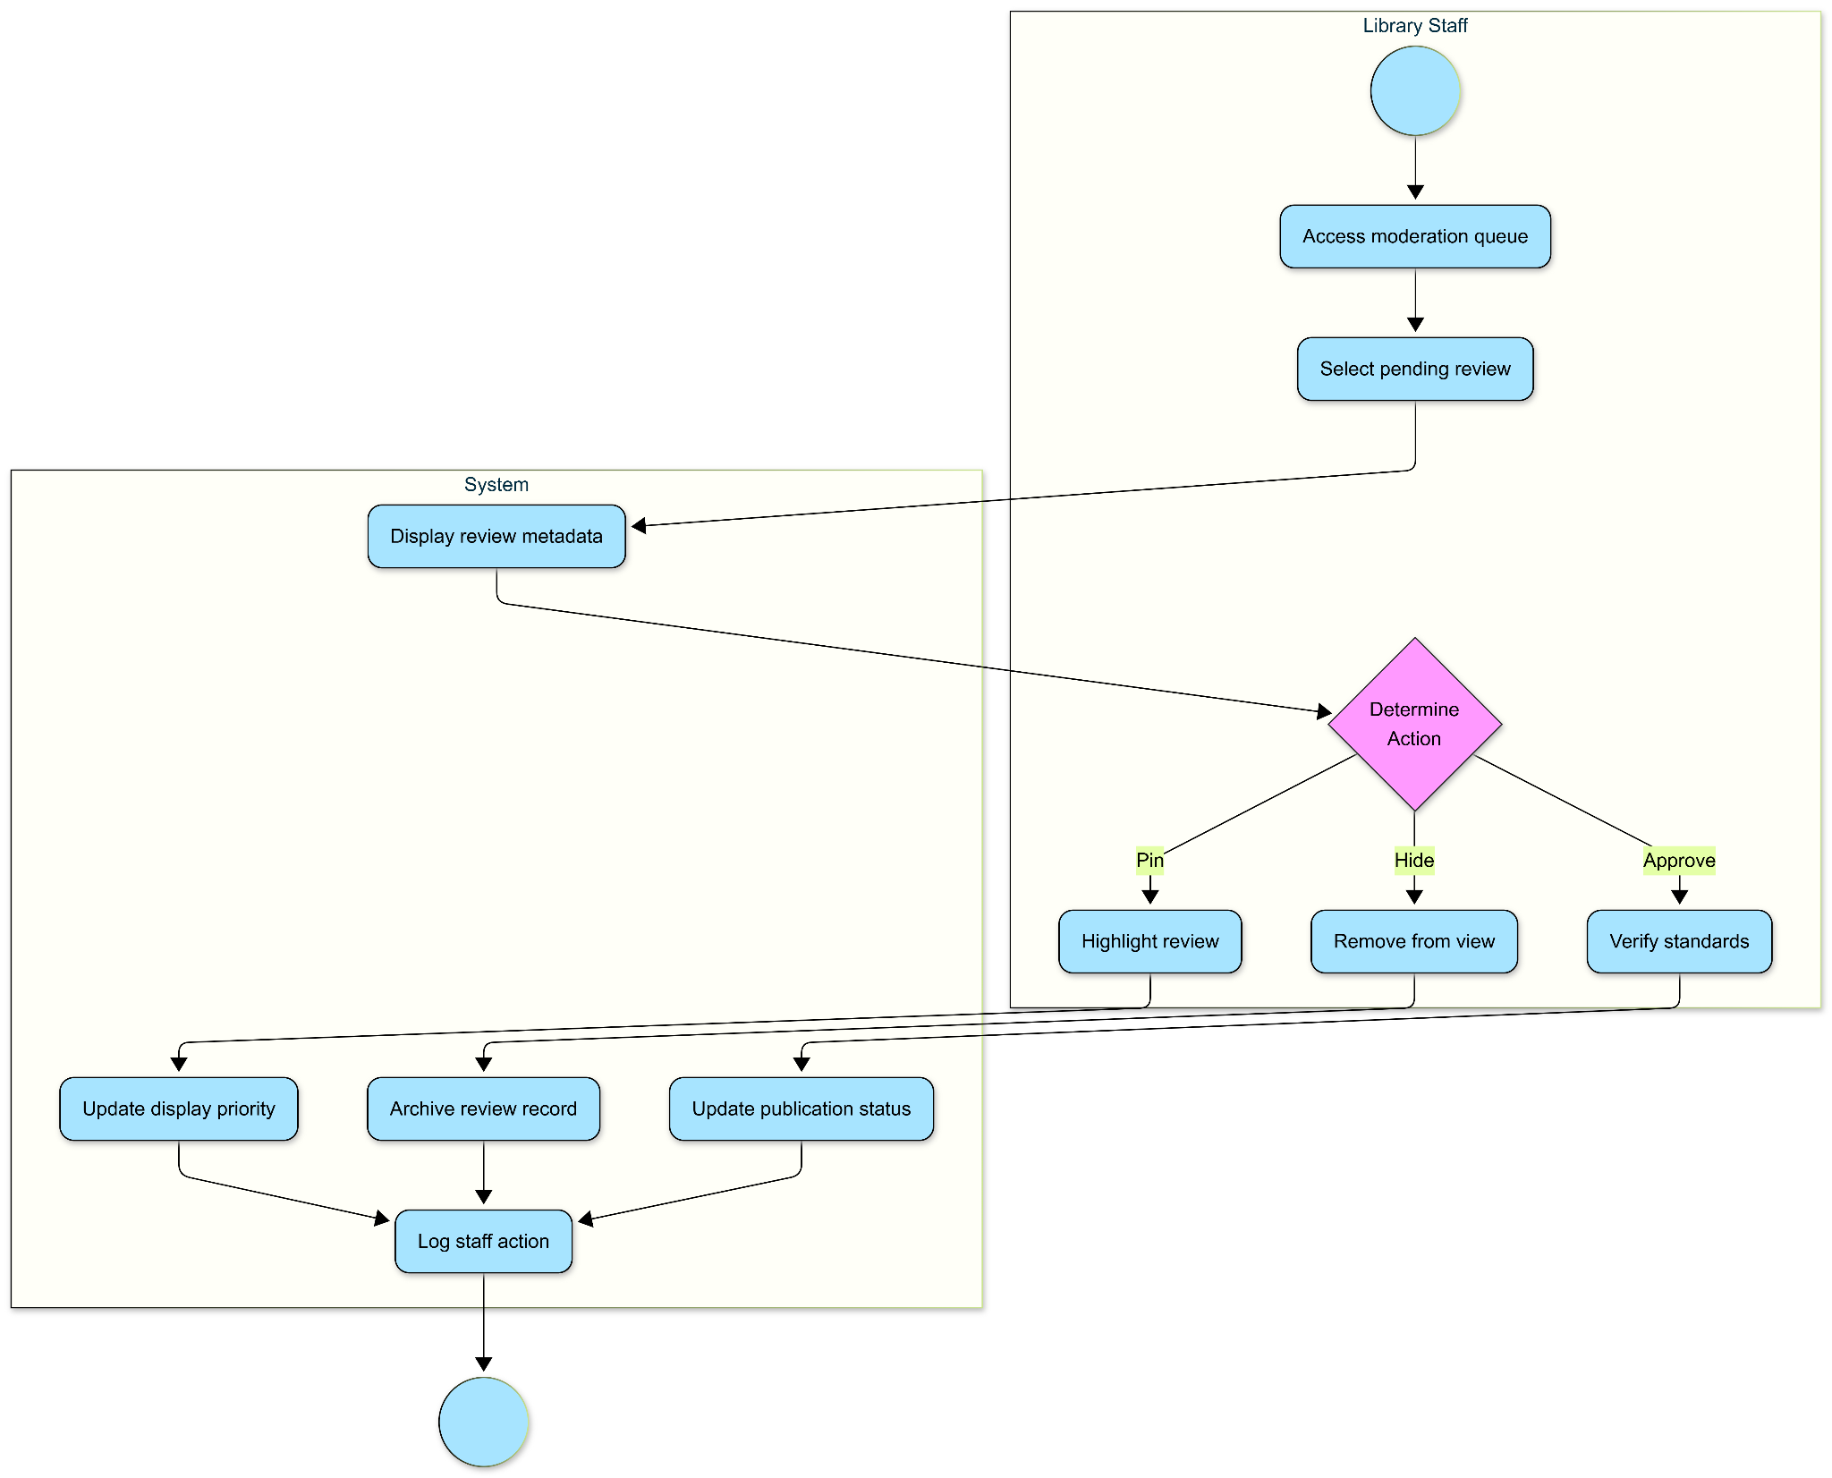

State Diagram
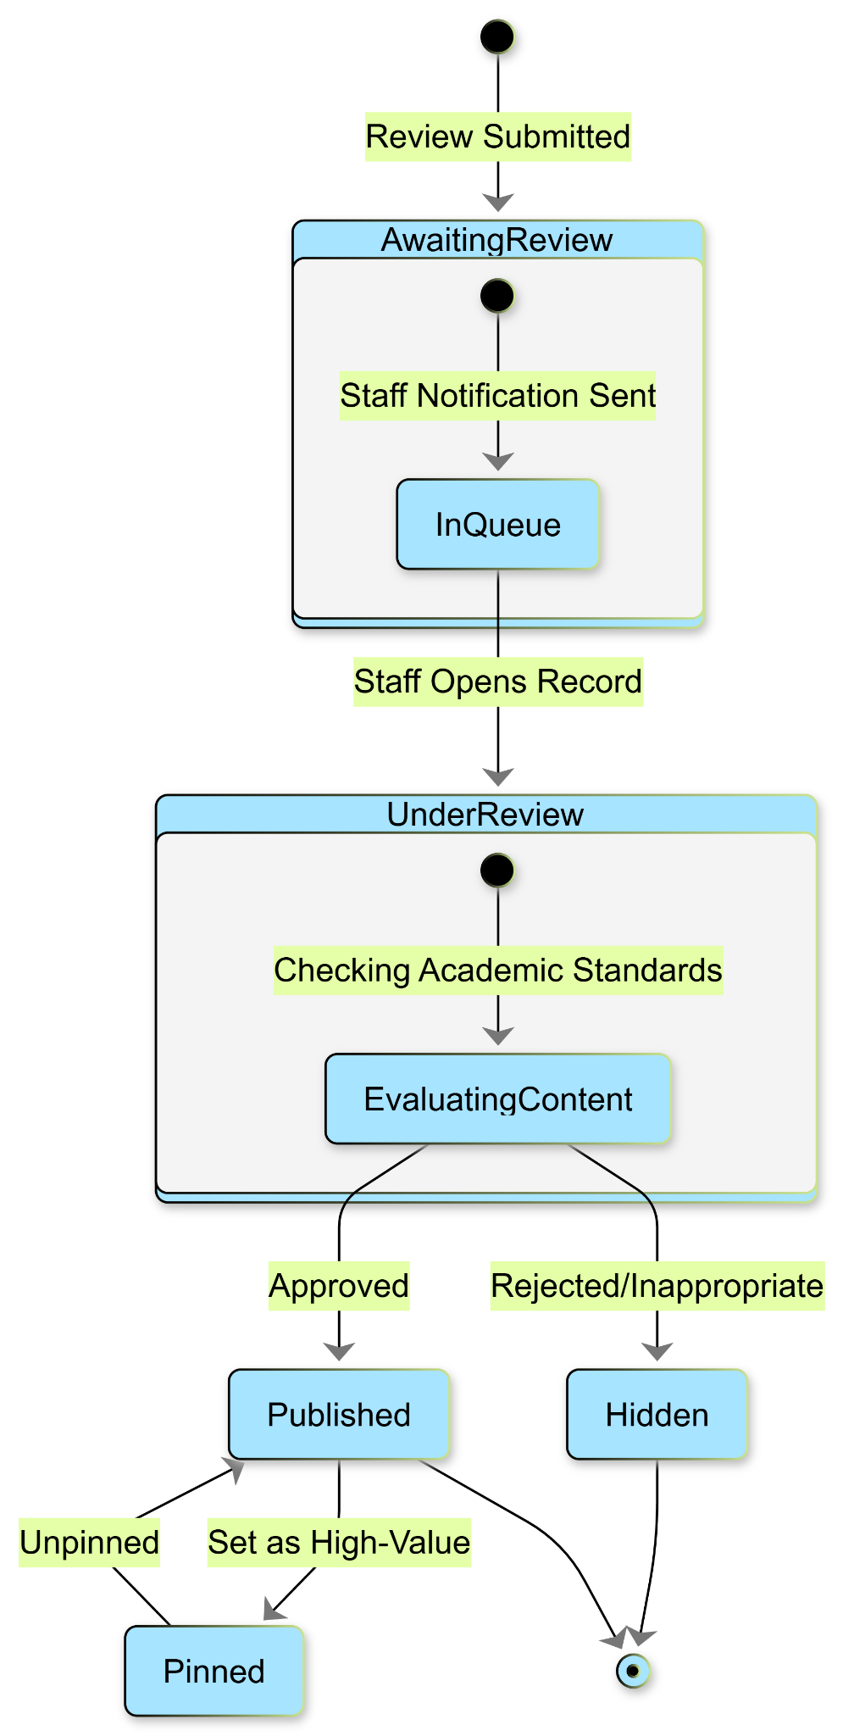

BR_LMS_36 - Revenue Auditing & Report Generation
Activity Diagram
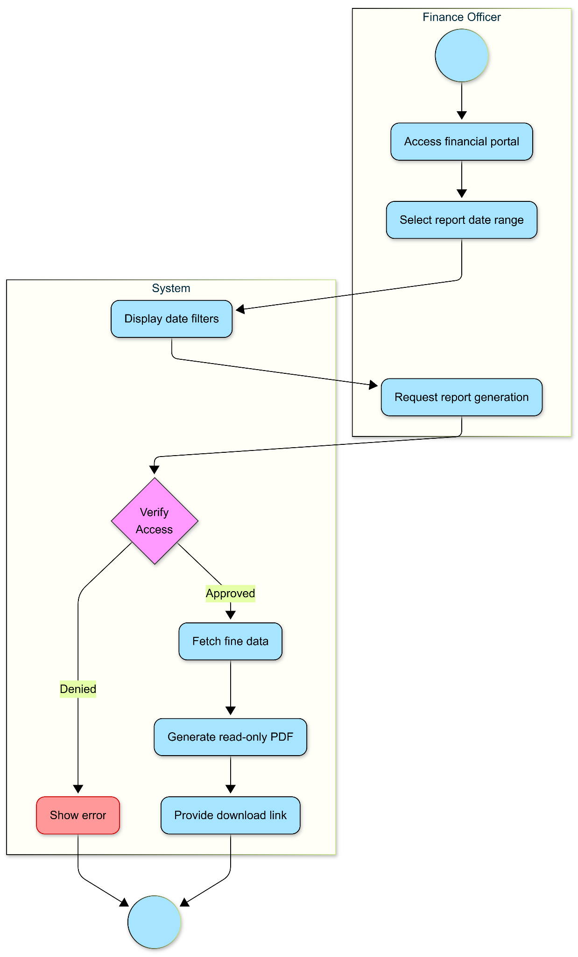

State Diagram
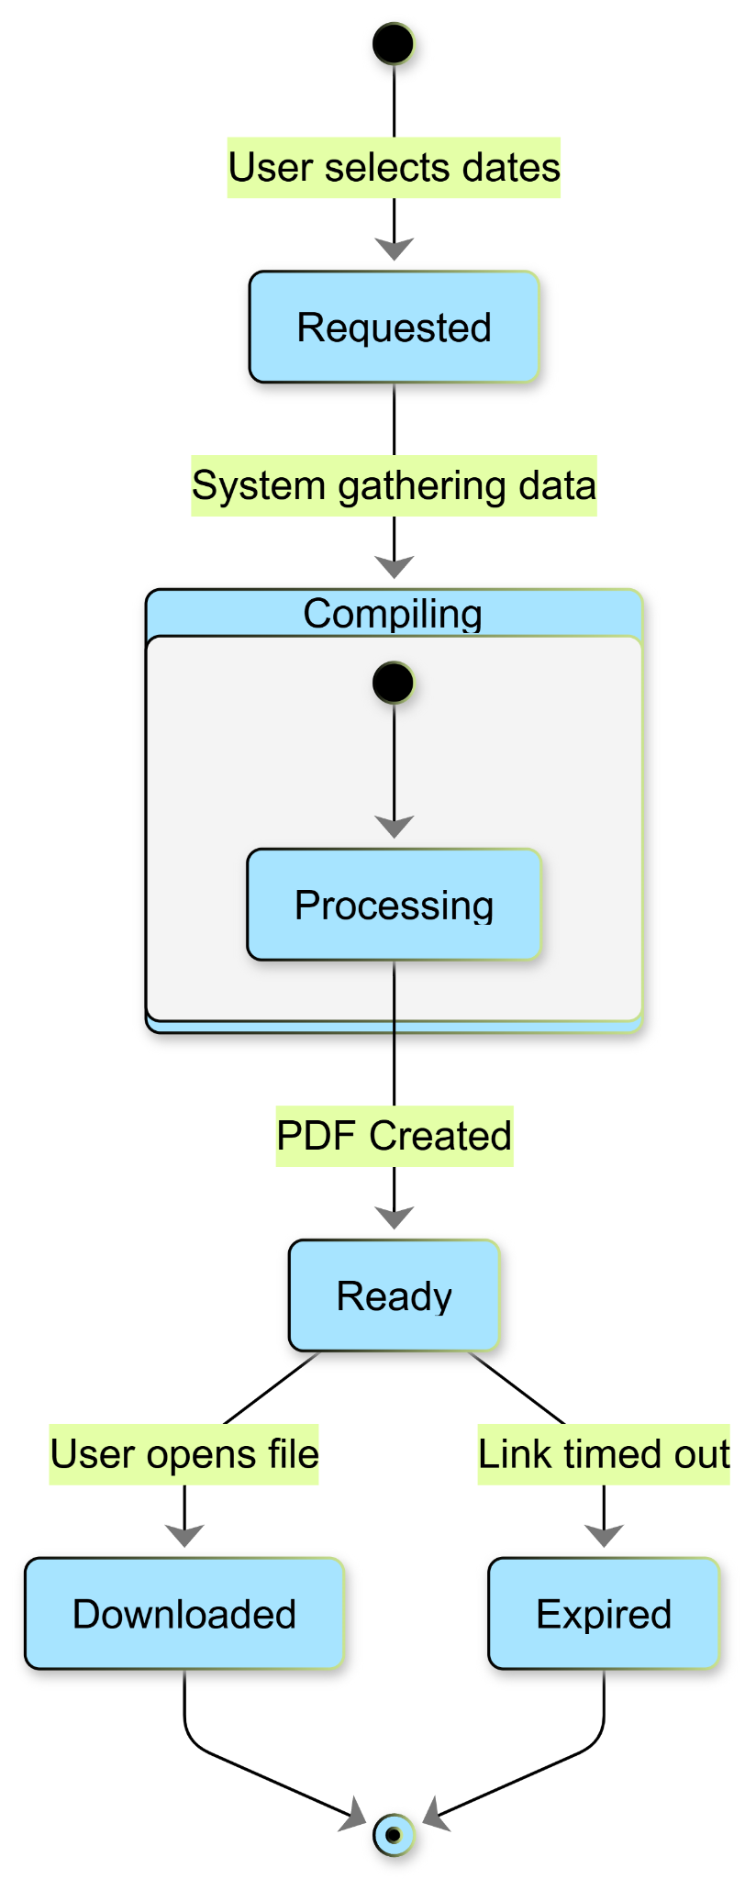
BR_LMS_37 - Bug Reporting Workflow
Activity Diagram
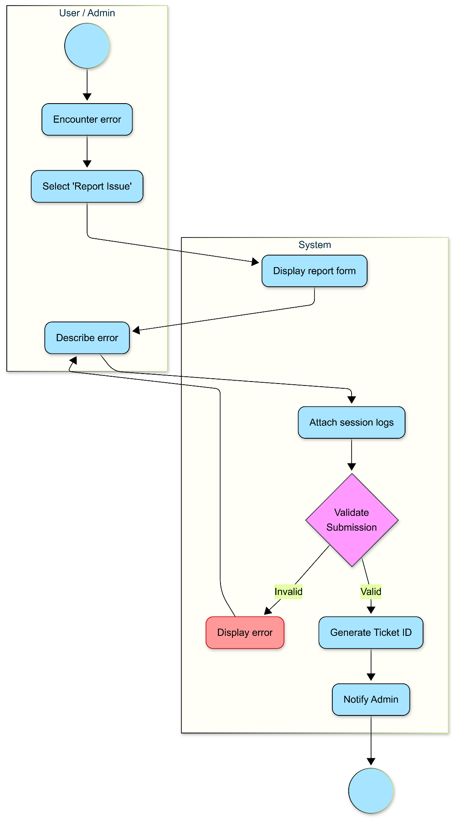

State Diagram
